FT4222H support lib 1.4.5 - Revision Comments

The files included in a standard support lib release are:
- D2XX Interface
  - ftd2xx.h
  - Dynamic library
    - ftd2xx.lib (32-bit)
    - ftd2xx.lib (64-bit)
- FT4222H Interface
  - LibFT4222.h
  - Dynamic library
    - LibFT4222.dll (32-bit)
    - LibFT4222.lib (32-bit)
    - LibFT4222-64.dll (64-bit)
    - LibFT4222-64.lib (64-bit)

  - Static library
    - LibFT4222.lib (32-bit)
    - LibFT4222-64.lib (64-bit)

- Sample codes
  - In Sample folder, LibFT4222_examples.sln can be used to browser all samples.
  - This Sample code is linked to Dynamic library

On making a new release the files will be posted on FTDI’s web site http://www.ftdichip.com/Products/ICs/FT4222H.html in ZIP file format.

If the version is lower than or equal to 1.4.4. Libft4222 bases on Microsoft Visual C++ 2010 x86 and x64 Redistributable package.
Please install the below package on the target machine.
https://docs.microsoft.com/en-us/cpp/windows/latest-supported-vc-redist?view=msvc-170
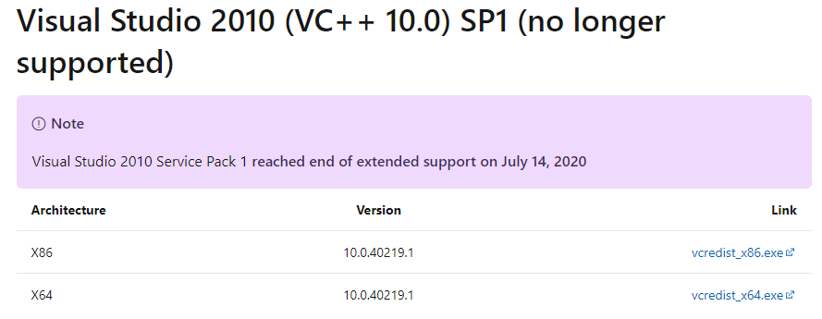
If the version is higher than or equal to 1.4.5. Microsoft Visual C++ 2010 runtime library is built in LibFt4222. The user does not need to install Microsoft Visual C++ 2010 x86 and x64 Redistributable package on the target machine.
Release version
1.4.5 (June 14, 2022)
Maintenance release.

Release Fixes

- Support Chip version “A”, “B”, “C” and “D”.
  - Remove libboost linking.
  - Add Feature. Add API FT4222_SPIMaster_SetMode. It can change the polarity and
  - Change the member names in enum SPI_ChipSelect
  - Add event trigger in interrupt example
  - Microsoft Visual C++ 2010 runtime library is already built in

Release version
1.4.4 (Nov 12, 2020)
Maintenance release.

Release Fixes

- Support Chip version “A”, “B”, “C” and “D”.
  - Fix issue. Frequency 100K~400K in I2C Master is not accurate.
  - Add Feature. Add API FT4222_I2CMaster_ResetBus. This function can reset i2c bus when it is abnormal.
  - Add Feature. Add API FT4222_SPIMaster_SetCS. It can determine the CS is high or low when SPI bus is active. The default value is active-low.
  - Remove Feature. Remove API FT4222_SPISlave_RxQuickResponse. It may cause data lost sometimes.
  - Add Feature. Add license announce in libft4222.h.
  - Add Feature. Add static library, need to define FT4222_STATIC during building.

Release version
1.4.3 (Mar 19, 2020)
Maintenance release.

Release Fixes

- Support Chip version “A”, “B”, “C” and “D”.
  - Fix issue. FT4222_I2CMaster_WriteEx does not return correct sizeTransferred.
  - Fix issue. FT4222_SPIMaster_MultiReadWrite does not return correct sizeOfRead when multiReadBytes equal to zero.

Release version
1.4.2 (Dec 5, 2018)
Maintenance release.

Release Fixes

- Support Chip version “A”, “B”, “C” and “D”.
  - Function changed. Now I2c master can send larger than 512 bytes.
  - Function changed. Adopt FT_SetTimeouts to be the default timeout of FT4222_I2CMaster_Read.

Release version
1.4.1 (Mar 15, 2018)
Maintenance release.

Release Fixes

- Support Chip version “A”, “B”, “C” and “D”.
  - Fix FT4222_GetClock get error issue.
  - Fix issue. Repeated_START does not work in API. FT4222_I2CMaster_WriteEx.
  - Fix issue. FT4222_UnInitialize hang on linux platform in SPI Slave Mode.
  - Fix issue. SPI slave cannot receive more than 8192 bytes in SPI with protocol mode.
  - FT4222_I2CMaster_Init can support speed < 60K bps.
  - Add API FT4222_ChipReset.
  - Add API FT4222_SPISlave_SetMode.
  - Add API FT4222_GPIO_SetWaveFormMode(only available in Chip Rev D).
  - Add API FT4222_SPISlave_RxQuickResponse (only available in Chip Rev D).
  - Add SPI flash access examples.
  - Add SPI Slave sample(NO protocol, Master/Slave side).

1.4 (May 26, 2017)
Maintenance release.

Release Fixes

- Support Chip version “A”, “B” and “C”.
- Fix GPIO as interrupt sampling issue. Now trigger times can be observed in every fetch.
- Fix performance issue on SPI Slave Receiving and GPIO receiving.
- FT4222_I2CMaster_WriteEx can send 65531 bytes in one transition (previous is 508 bytes)

1.3 (Aug 8, 2016)
Maintenance release.

Release Fixes

- Support Chip version “A”, “B” and “C”
- Add API FT4222_I2CSlave_SetClockStretch/FT4222_I2CSlave_SetRespWord.
- Add API FT4222_SPISlave_Init_Ex
- SPI Master provide CLK_2 option.
- interrupt status can be read by FT4222_GPIO_Read and FT4222_GPIO_ReadTriggerQueue

1.2 (Aug 24, 2015)
Maintenance release.

Release Fixes

- Support Chip version “A” and “B”
- add API I2CMaster ReadEx/WriteEx/GetStatus

1.1 (Sep 4, 2014)
Maintenance release.

Release Fixes

- Support Chip version “A”

