G1 step climbing through imitation learning
Experiment recorded 25 September 2026 | Single 35 cm step | CPU simulation
This document outlines our team's methodology, training pipeline, and validation results for teaching the Unitree G1 robot to climb a single 35 cm step in a MuJoCo simulation.
1. Architecture and Pipeline
Our solution utilizes a teacher-student framework where the student absorbs a collection of learned local feedback controllers from an expert teacher. Once the student is trained, the teacher is disabled during physical execution.
Part | What it does
Motion schedule | Specifies when to shift weight, lift a foot and stand on top. This schedule is designed in code.
Teacher | Uses Pinocchio joint positioning and a physics-based torque optimizer to perform the step.
Training data | Records a successful trajectory and asks the teacher for torques at nearby poses and velocities.
Student | Fits local corrective feedback from those labels and applies it to the actual simulated state.
MuJoCo | Advances the free robot under gravity, contacts and bounded motor torques.

2. Environment and Teacher Configuration
The teacher prioritizes supplying useful, physics-grounded examples. Pinocchio solves for joint positions that meet foot and center-of-mass targets, while a whole-body QP chooses accelerations and contact forces consistent with the model’s inertia. We deliberately preserved the original physical constraints of the robot without anchoring the base or altering hardware limits to artificially simplify the climb.
Simulation property | Value
Robot | Original G1 29 DOF model; 29 actuated joints and a floating base
Mass and gravity | 35.112142 kg; gravity 9.81 m/s² downward
Physics and control | 2 ms physics steps; a new torque command every 10 ms
Step geometry | One box; 0.35 m high, 1.0 m deep and 1.3 m wide; front at world x = 0.20 m
Contact representation | Original robot collision geometry; four small collision spheres on each foot
Preserved properties | Original masses, inertias, joint ranges, friction, armature and motor limits

The planned sequence
The step climbing sequence spans 23 seconds and is broken down into specific operational phases.
Time in seconds | Action
0 to 2 | Settle on the floor
2 to 5 | Transfer weight toward the right supporting foot
5 to 9 | Lift the left foot clear of the riser, move it forward and land
9 to 13 | Transfer weight onto the raised left leg and shift the waist
13 to 17 | Bring the right foot up while raising the body
17 to 23 | Centre the body and hold both feet on top

For the higher step, the foot rises before crossing the vertical face. The teacher also uses temporary waist roll and pitch targets, reaching about −0.45 and +0.40 radians at full transfer. These targets fade as the trailing foot comes up. The robot’s physical properties are not changed to make the climb easier.
During a physical rollout, the controller acts through motor torques; MuJoCo resolves gravity and contacts. The base is not welded or anchored and its pose is not repeatedly overwritten. Offline label generation does set nearby poses in a separate probe simulator; those queries are training calculations, not a claimed physical climb.

3.Data collection
This successful 35 cm feedback run did not use a downloaded human motion dataset, jazz dance recording, PMT checkpoint or MimicKit. Its data was generated locally from the working physics teacher on the repository G1. Earlier experiments in the project used other data; they are separate from this checkpoint.
After five teacher qualification trials, collection used reset seed 300 for one successful 23-second teacher trajectory. It selected 251 anchor states: approximately one every 0.1 seconds, with extra samples near phase transitions. Each anchor stores the pose, velocity, nominal torque and phase.
The robot has 36 pose entries but 35 independent pose directions because its base orientation uses a four-value quaternion. Together with 35 velocity entries, there are 70 local state coordinates. For each coordinate the collector asks the teacher for one positive and one negative perturbation, changing only that coordinate.
Quantity | Exact value
Trajectory anchors | 251
Coordinates perturbed per anchor | 35 pose directions plus 35 velocities = 70
Teacher queries per anchor | 70 positive plus 70 negative = 140
Total labelled nearby states | 251 × 140 = 35,140
Pose perturbation magnitude | 0.002 m for base translation; 0.002 rad for rotations and joints
Velocity perturbation magnitude | 0.02 m/s for linear velocity; 0.02 rad/s for angular and joint velocity
Output of each query | 29 teacher motor torques in newton metres

The 35,140 labels are not 35,140 successful episodes. They are local, synthetic queries around one successful trajectory. The probe state is set to the anchor plus one perturbation, MuJoCo updates its derived quantities, and the teacher computes torques. The collector does not simulate a full recovery from every queried state.
4. Validation Results
A successful pass strictly requires completing 23 seconds without failure. Furthermore, after second 20, both feet must register >20 N of vertical contact load on the step, and the pelvis up-direction dot product must exceed 0.95 continuously for at least 2.9 seconds. Falls are flagged if pelvis uprightness drops below 0.65 or base height drops below 0.45 m.
Final Evaluation:
Evaluation | Seeds | Successful climbs
Teacher qualification | 101 to 105 | 5 of 5
Raw student selection | 9001 to 9003 | 0 of 3
Adjusted student selection | 9001 to 9003 | 3 of 3
Adjusted student final tests | 99001 to 99005 | 5 of 5

The raw student selection and student damping 1 groups in results.json repeat the same seed outcomes. They are not two independent sets of failures. The final seeds were separate from the candidate-selection seeds.
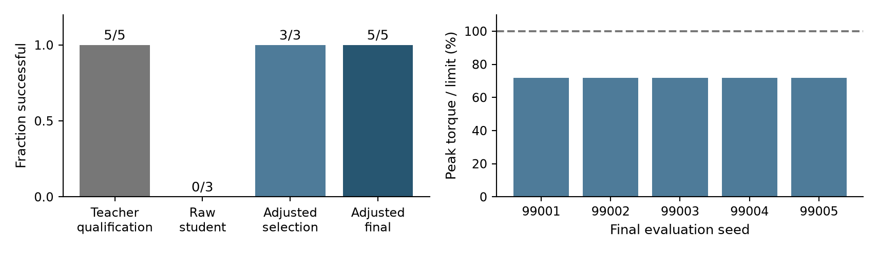
Recorded 35 cm run. Torque percentage is the largest absolute command relative to that motor’s positive torque limit; it is not energy consumption or total motor loading.
Final seed | Completed seconds | Top hold seconds | Peak torque limit used
99001 | 23.01 | 3.01 | 71.74%
99002 | 23.01 | 3.01 | 71.95%
99003 | 23.01 | 3.01 | 71.70%
99004 | 23.01 | 3.01 | 71.74%
99005 | 23.01 | 3.01 | 71.86%

The trial must complete at least 23 seconds without a failure. After second 20, both feet must each register more than 20 N of vertical contact load on the step, and the pelvis up-direction dot product must exceed 0.95. These conditions must hold continuously for at least 2.9 seconds. The accepted final trials held for 3.01 seconds.
A fall is flagged when pelvis uprightness falls below 0.65 or base height drops below 0.45 m. The code also stops for invalid state, controller errors, or a required single-support foot carrying less than 20 N for over 0.15 seconds. The final minimum pelvis up-dot values were approximately 0.9902.
Each reset uses only small joint-angle noise with standard deviation 0.0005 rad. The tests share the same step geometry, dynamics and schedule. Five successes are evidence for this narrow task, not a broad reliability estimate for arbitrary stairs, pushes or hardware.

6. Another approach
Besides Imitation Learning, we also implemented a Reinforcement Learning pipeline as a comparative baseline against our supervised imitation learning approach. This allowed us to evaluate the trade-offs in training time and adaptability.
Algorithm and State-Action Space
We utilized Proximal Policy Optimization, an industry standard for continuous continuous control tasks in robotics. The RL agent was trained directly within the MuJoCo simulation environment.
- Observation Space: The policy receives a continuous stream of proprioceptive data, including the robot's base orientation (quaternions), joint positions, joint velocities, and a phase variable to synchronize the gait cycle.
- Action Space: The network outputs target joint positions, which are then converted into motor torques via a low-level Proportional-Derivative (PD) controller operating at the 2 ms physics step limit.
Reward Function Design
Unlike our imitation learning method—which simply minimizes the mean-squared error against an expert teacher's torque commands—the RL approach required a carefully tuned reward function to encourage successful step climbing without falling. The reward structure included:
- Task Progress Reward: Positive reinforcement for elevating the center of mass and moving the base forward toward the step plateau.
- Stability Penalty: Heavy penalties for large deviations in pelvis uprightness (roll and pitch) to prevent the robot from tipping.
- Energy and Smoothness Penalty: Negative rewards applied to high motor torques and rapid changes in action commands to prevent jittery, hardware-damaging behaviors.
- Contact Reward: Small positive signals for maintaining the correct foot sequence on the step surface.
Sim-to-Real Transfer and Domain Randomization
To address industrial deployment maturity and safety, the RL environment incorporated Domain Randomization (DR). We injected noise into the simulation during training to ensure the policy did not overfit to perfect simulated conditions. This included:
- Adding small random perturbations to the robot's mass and center of gravity.
- Varying the floor and step surface friction coefficients between episodes.
- Applying random external force pushes (e.g., 5-10 N) to the robot's pelvis to train recovery and robust balance.

