Name:manisai.b
Roll :23bd1a1273
Elastic File Storage
Amazon Elastic File System (EFS) is a scalable and fully managed file storage service provided by Amazon Web Services (AWS). It allows you to create and configure file systems that can be accessed concurrently from multiple EC2 instances, providing a highly available and scalable storage solution for your applications and workloads.
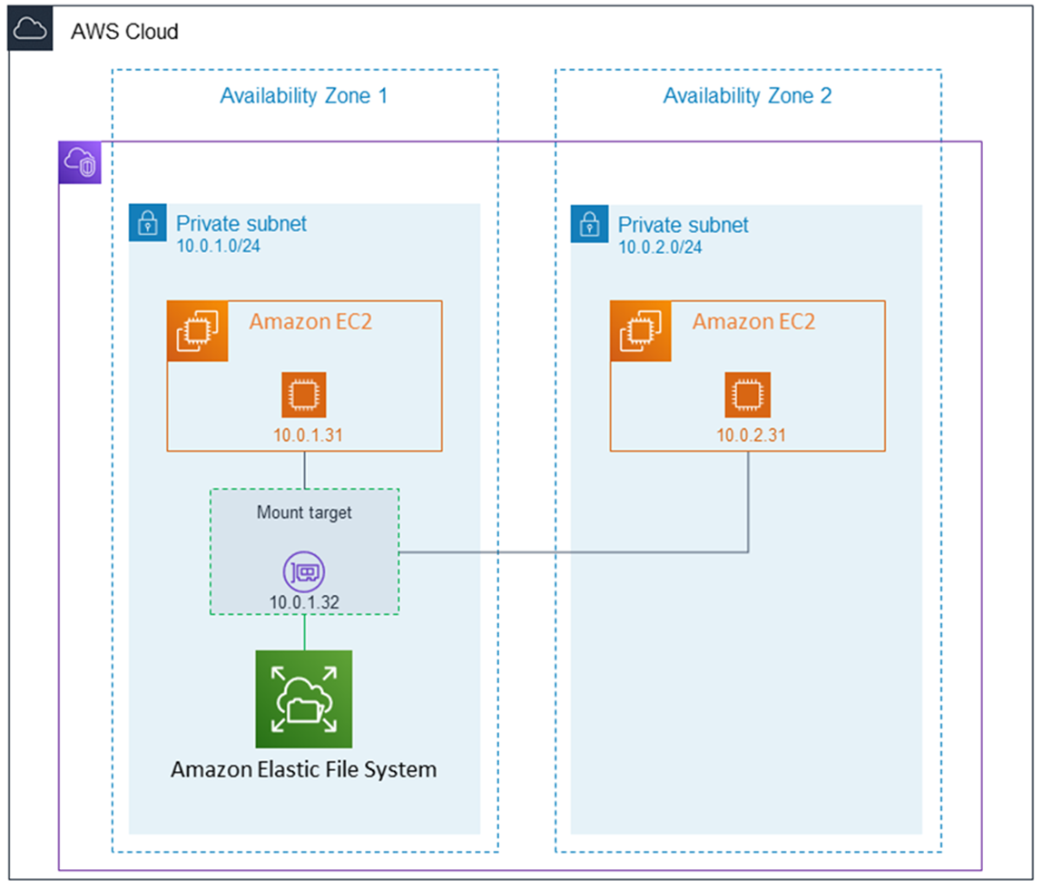
Amazon EFS supports for only Amazon Linux instance:
Step 1: Launching EC2 Instances
1. Sign in to AWS Management Console.
2. Go to the EC2 dashboard.
3. Click on "Launch Instance".
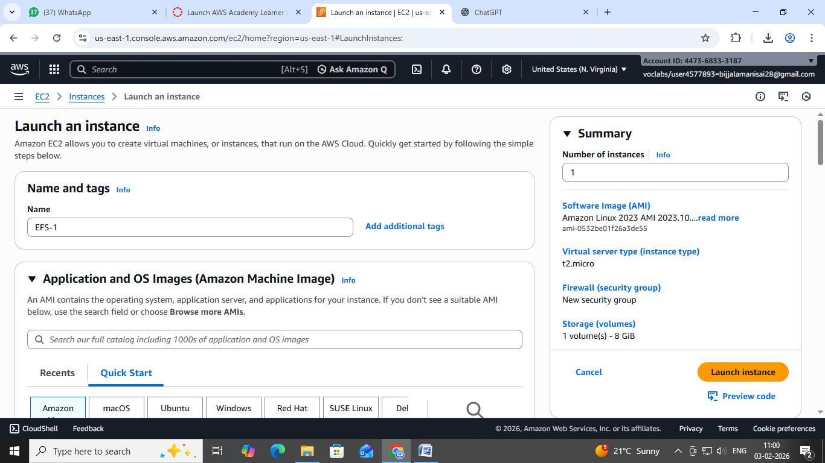
4. Configure instance details:
- Instance Name: EFS-1
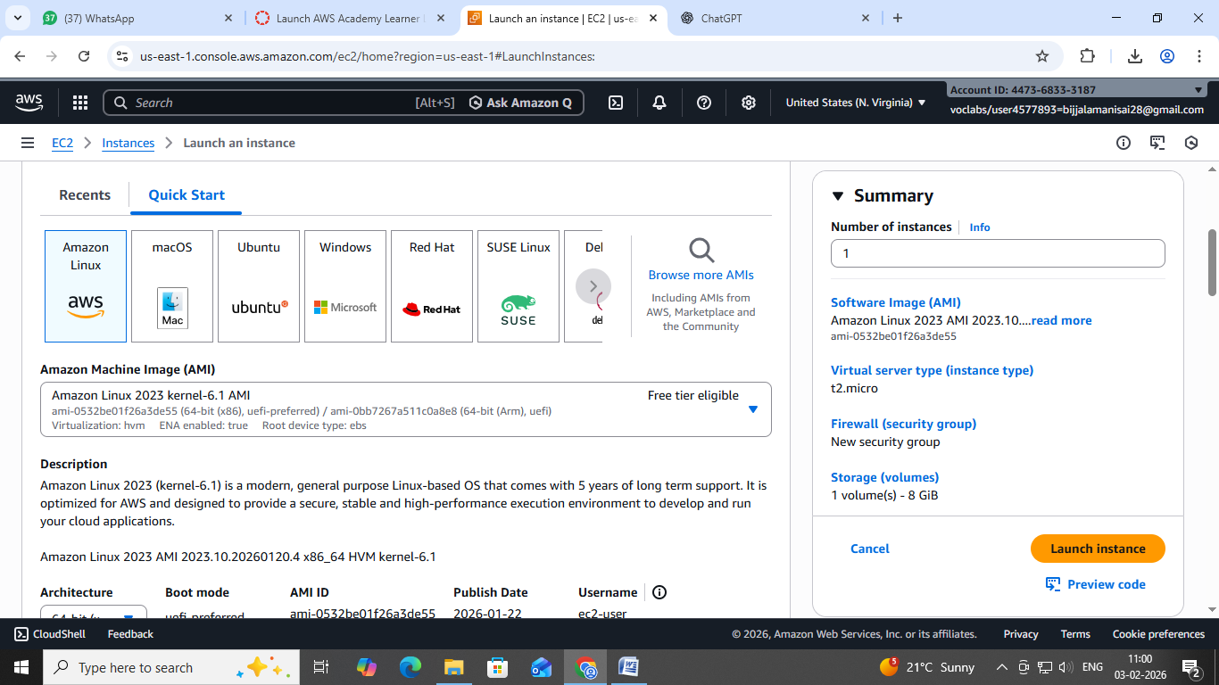
5. Choose an Amazon Machine Image (AMI) for Linux.
6. Select instance type: t2.micro.

- Key Pair: EFS
- Network: Choose Subnet-1a
- Security Group: Create a new security group (SG) and add NFS and allow from anywhere.
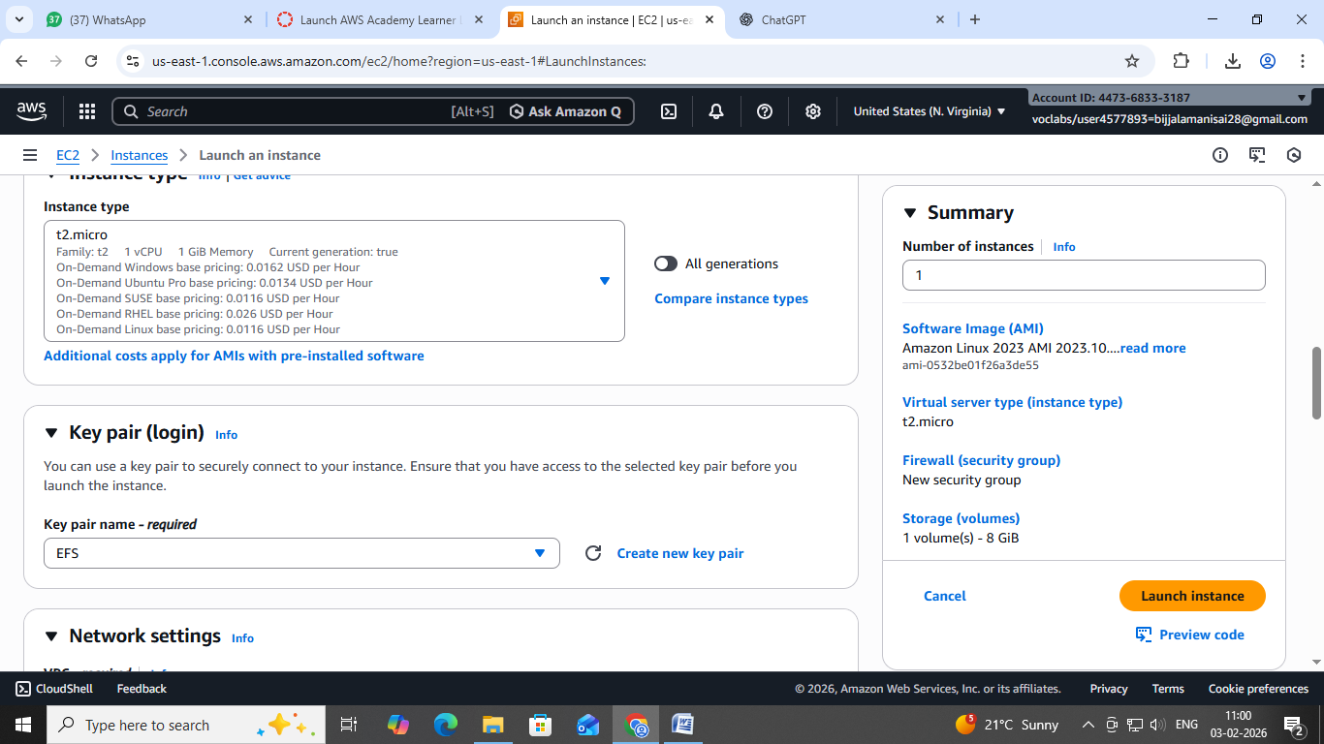
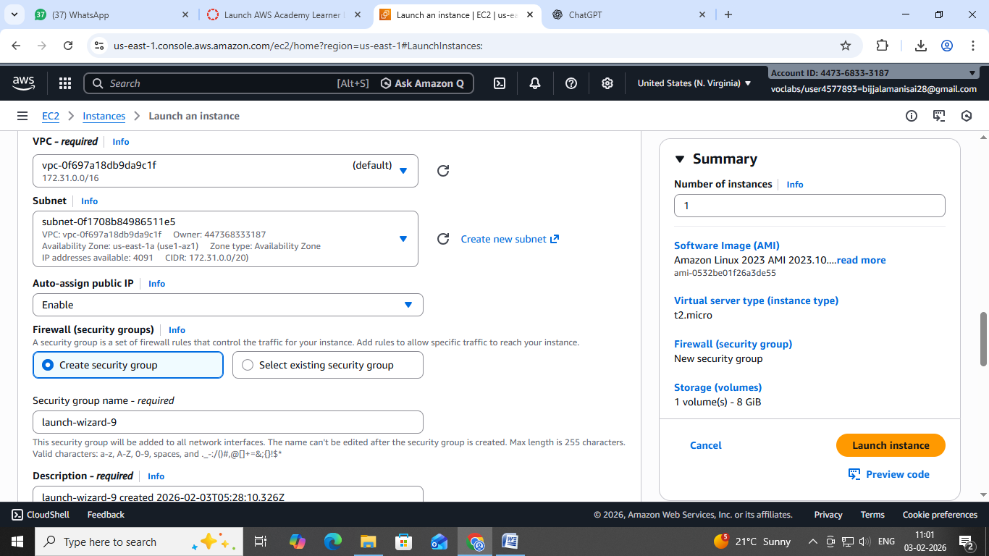
7. Launch the instance.
8. Repeat the above steps to launch another instance named EFS-2 in Subnet-1bwith the same configuration.
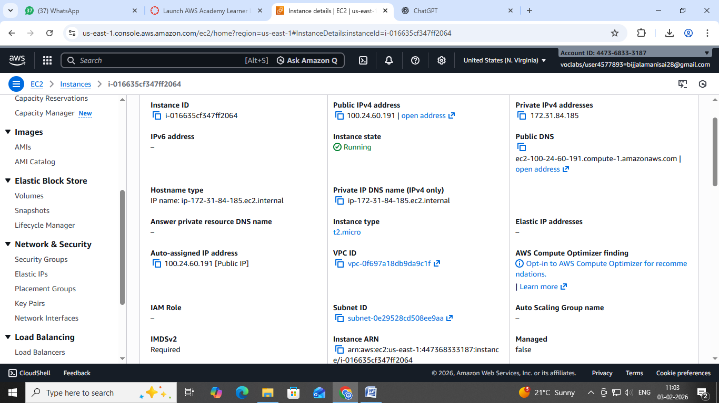
Step 2: Creating an EFS File System
1. Go to the EFS service in the AWS Management Console.
2. Click on "Create file system".
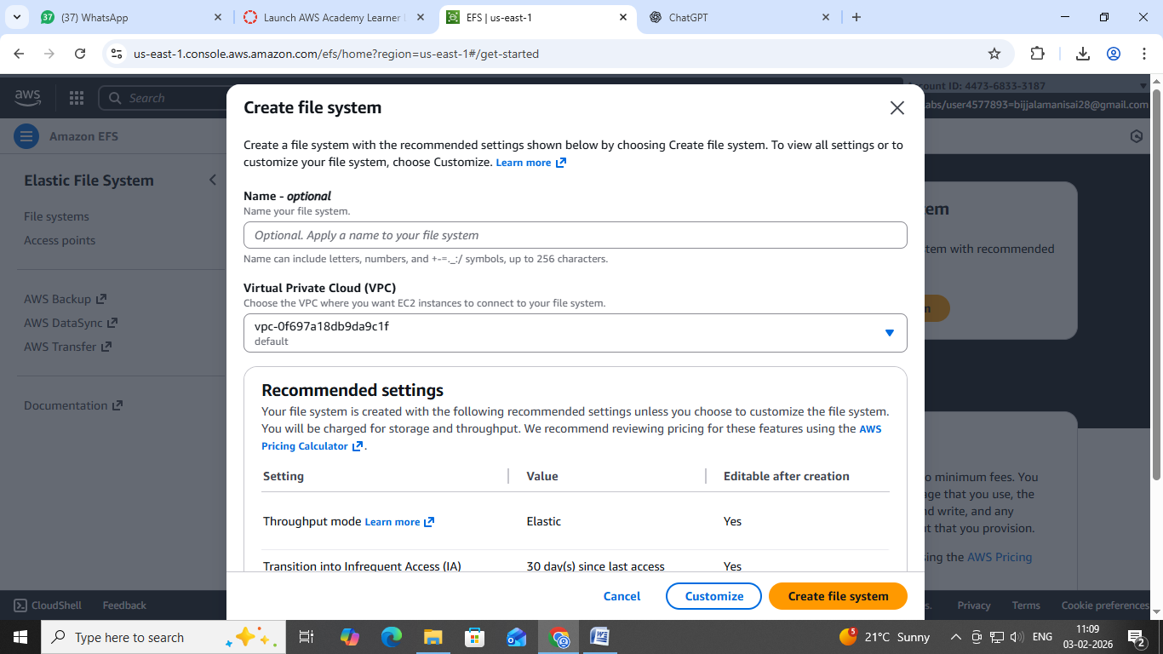
3. Specify details:
- Name: Optional
- VPC: Default
- Enable region button.
Click on "Next".
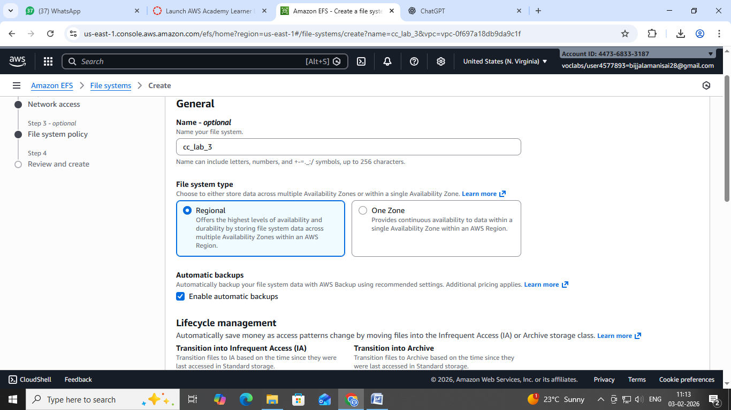
4. In the Network settings:
- Delete all security groups.

- Select the newly created security group (NFS).---which is created while creating instance
Click on "Next" and review the configuration.
Click on "Create file system".
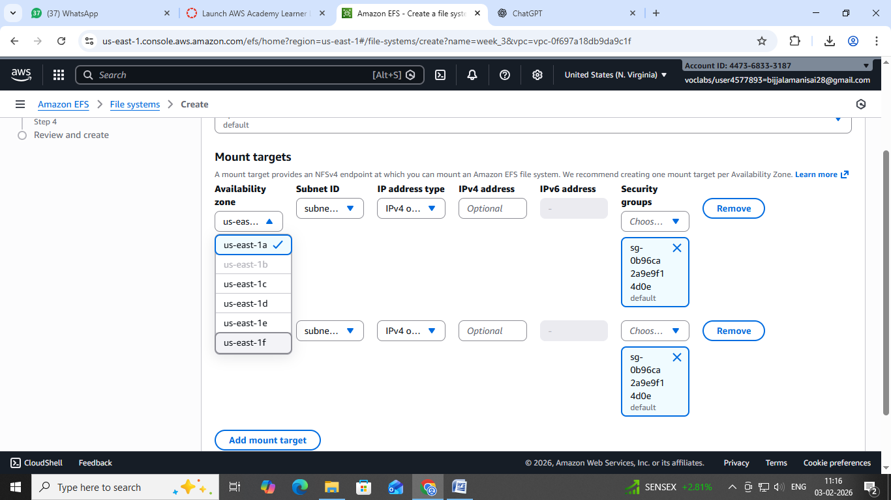
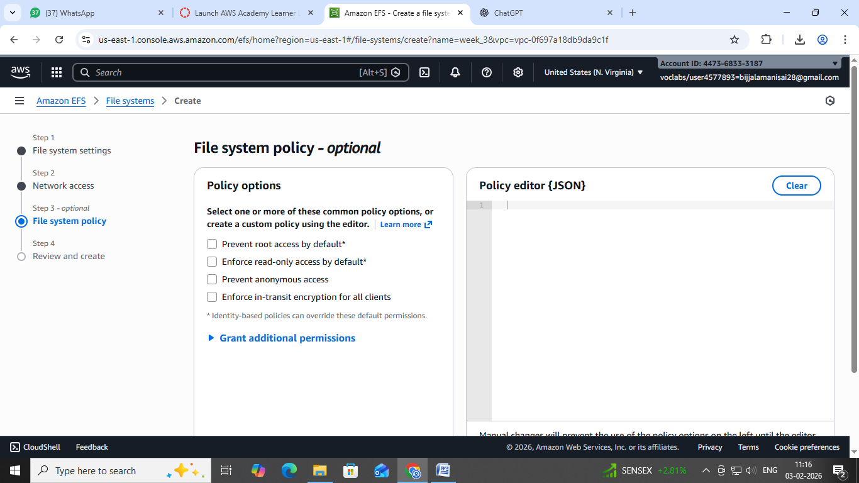
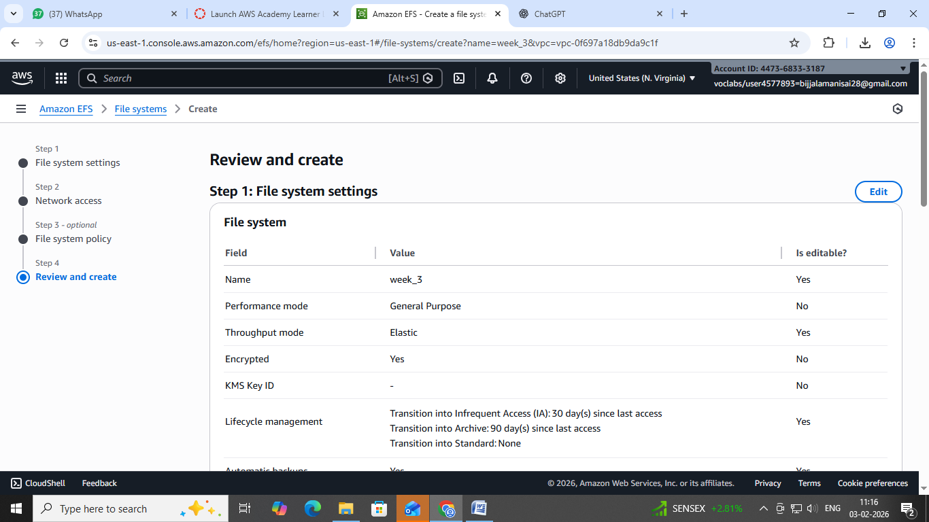
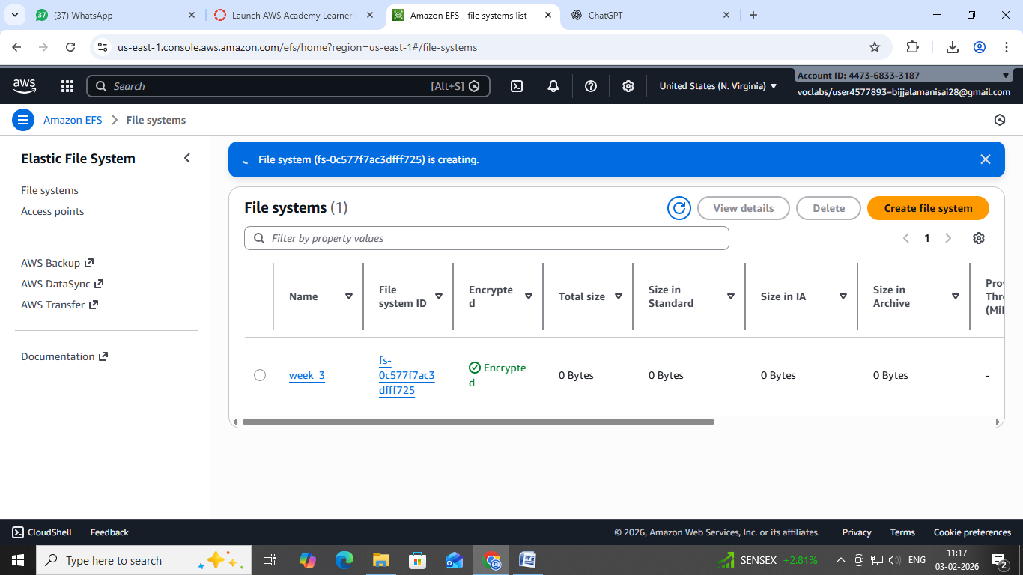
Step 3: Accessing the two EC2 instances named EFS-1& EFS -2 in two different PowerShell sessions and performing the specified tasks:
Accessing EFS-1 Instances in Two Different PowerShell Sessions:
1. Open Two PowerShell Sessions:
- Open two separate PowerShell windows or tabs on your local machine.
For each Instance:
2. SSH into the Instance:
- Use the SSH command to connect to the EFS-1 instance
ssh -i [path-to-your-keypair.pem] ec2-user@[instance-public-ip]
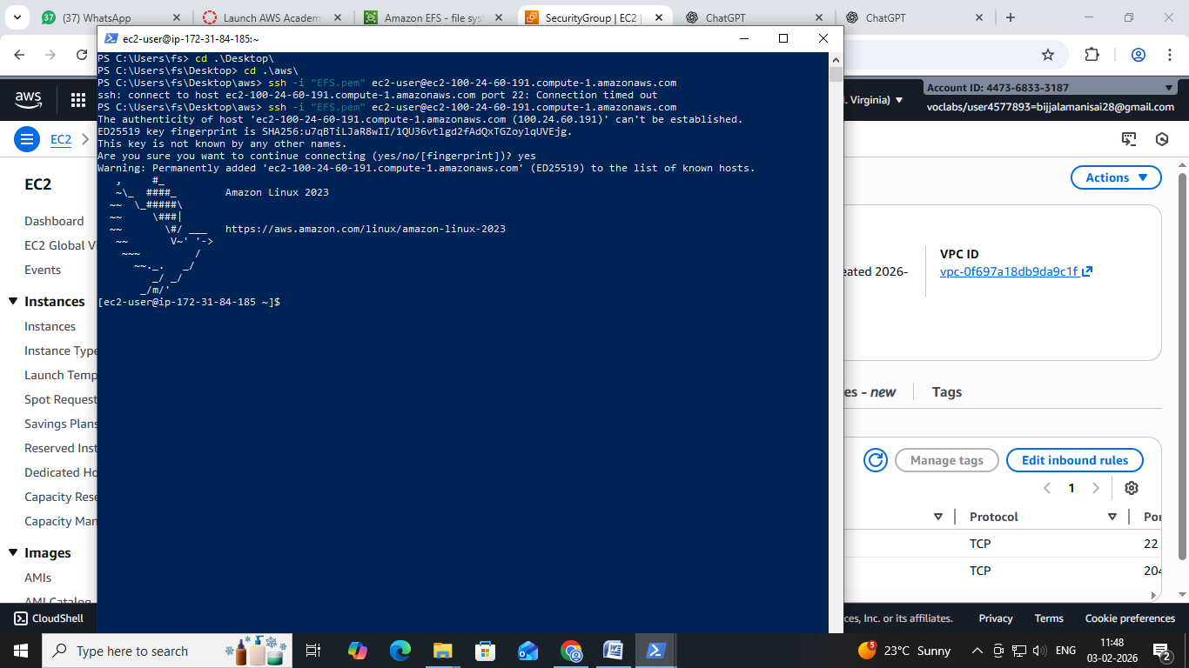
3. Switch to Root User:
- Gain root access by executing the following command:
sudosu
4. Create a Directory:
- Make a directory named "efs" using the following command:
Mkdirefs
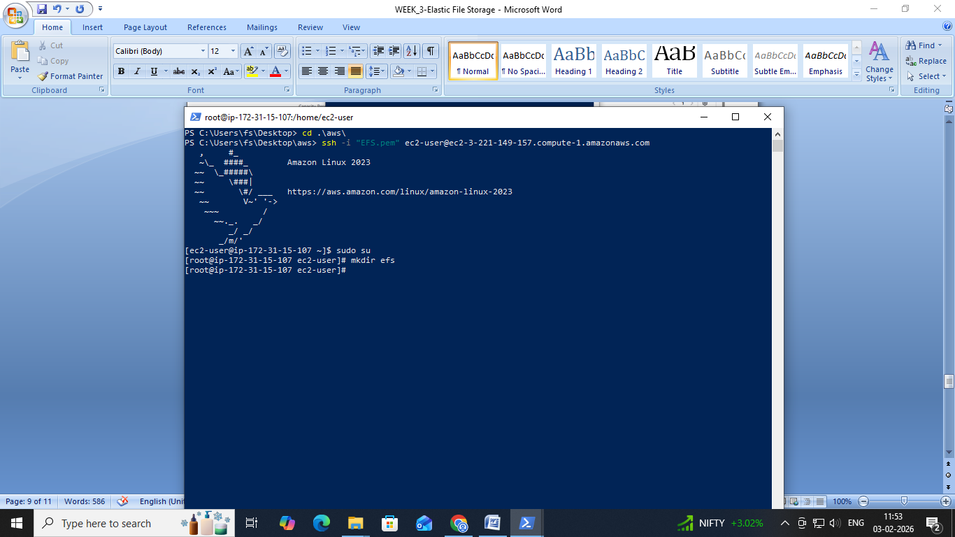
5. Install Amazon EFS Utilities:
- Use yum package manager to install the Amazon EFS utilities:
yum install -y amazon-efs-utils
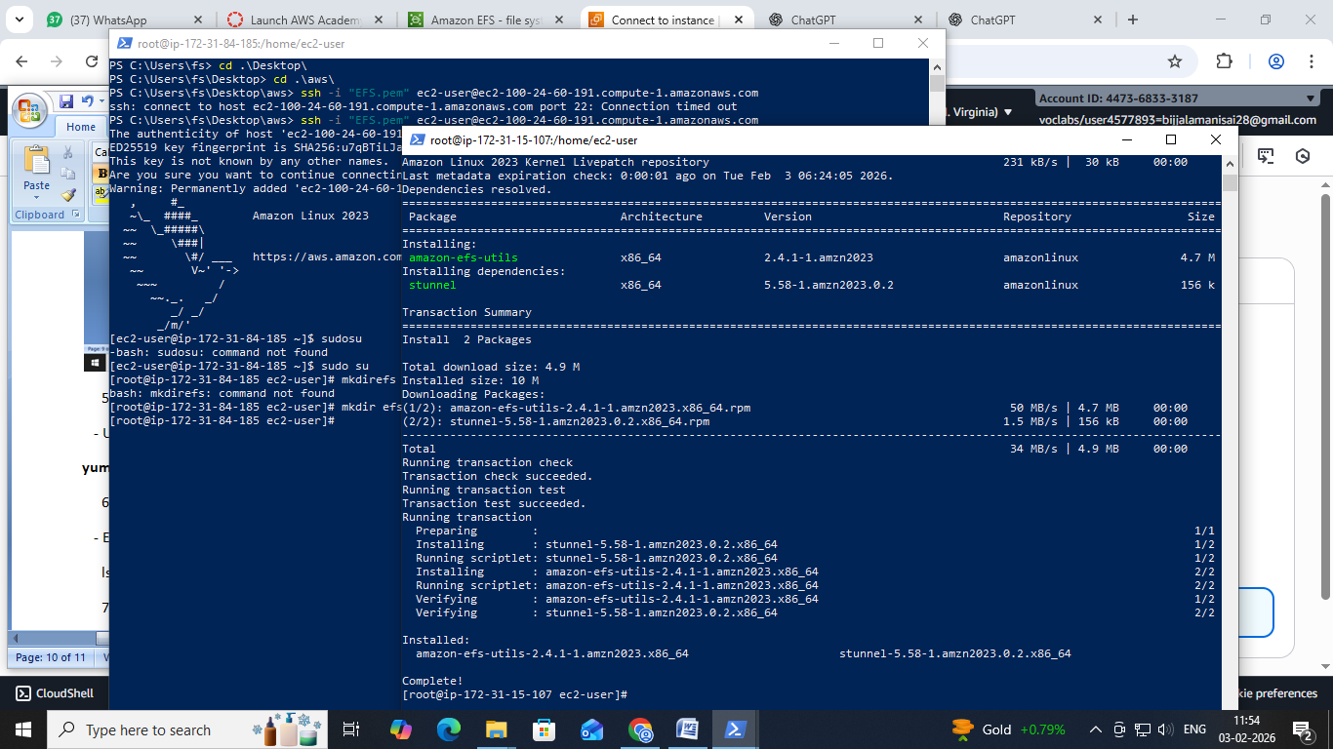
6. List Files:
- Execute the following command to list files in the current directory:
Ls
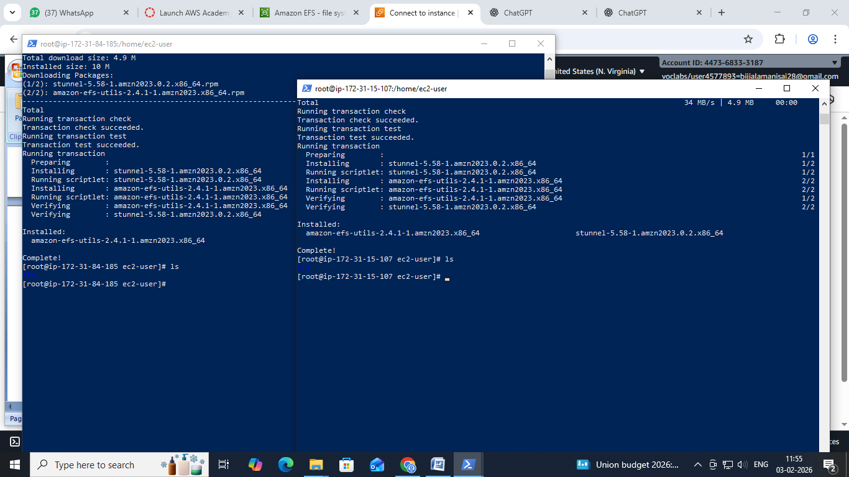
7. Verify Installation (Optional):
- Optionally, you can verify the installation of the Amazon EFS utilities by checking the version:
efs-utils –version
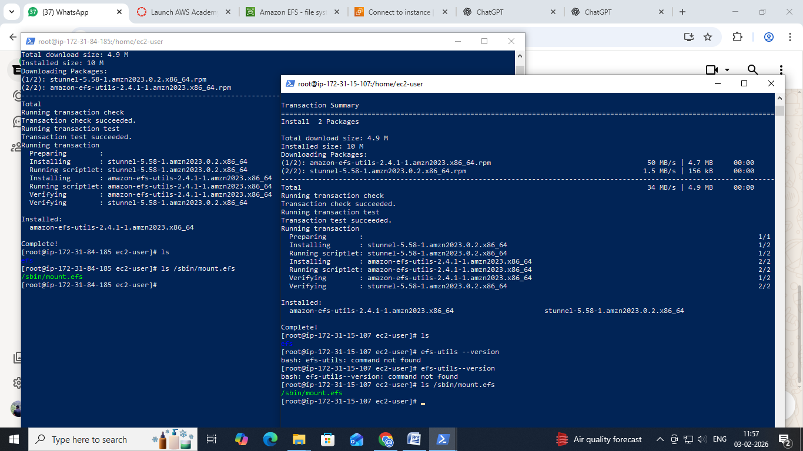
Repeat Steps 2-7 for ------------------------- EFS-2 Instance.
By following these steps, you'll have accessed each EFS-1 instance in separate PowerShell sessions, switched to the root user, created a directory named "efs," installed the Amazon EFS utilities, and listed files in the directory. This setup allows you to configure and manage each instance individually as needed.
Step 4: Attaching EFS to EC2 Instances
1. Go to the EFS service in the AWS Management Console.
2. Click on the target EFS file system.
3. Click on the "Attach" button.
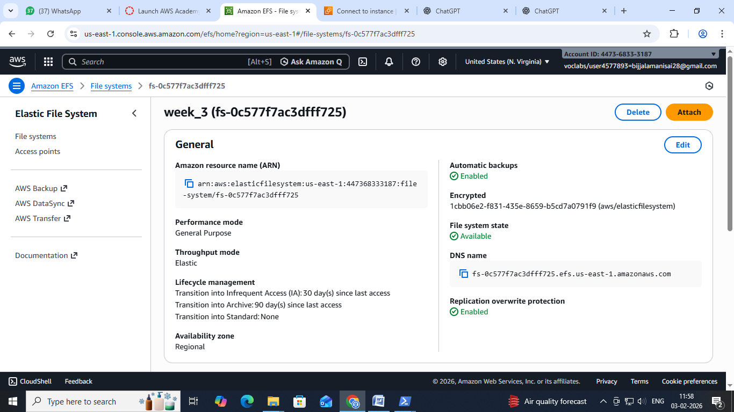
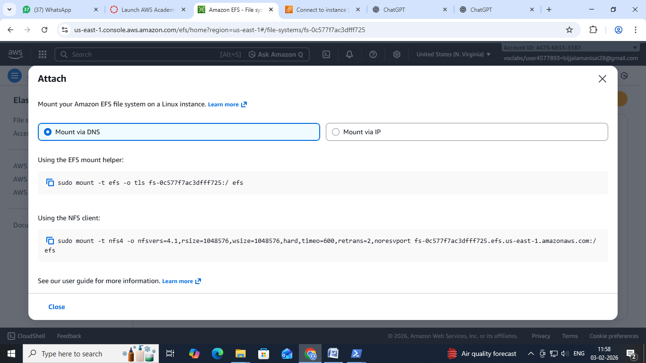
4. Choose "Mount via DNS" option.
5. Copy the displayed command.,on both ec2 instances(powershell)
6. Paste and execute the copied command in the terminal to mount the EFS file system onto the instance.
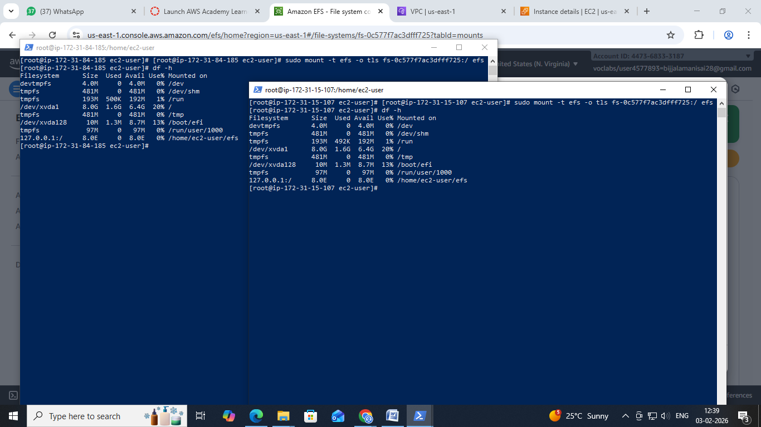
Step 5: Verify and Test EFS
1. Change the directory to EFS on both instances.
2. Create a file on one instance.
3. Verify that the file automatically synchronizes and appears on the other instance.
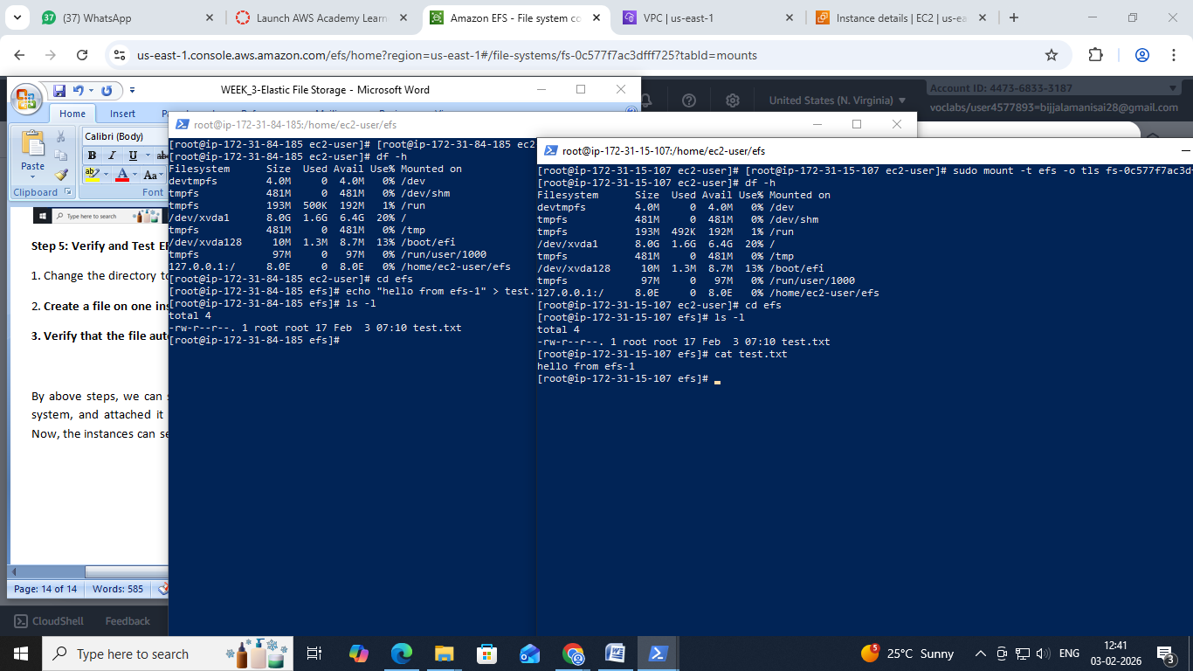
By above steps, we can successfully create EC2 instances, configured them, created an EFS file system, and attached it to the instances in the same availability zone in the Mumbai region. Now, the instances can seamlessly access and share files stored in the EFS file system.
Scenario-Based Questions on Amazon
EFS
1. Multiple EC2 instances across different Availability Zones must read and write the same files
at the
same time. Which AWS storage service fits this requirement and why?
Answer: Amazon EFS. EFS is a fully managed, scalable, and highly available file system that can
be
mounted concurrently by multiple EC2 instances across different AZs, allowing simultaneous
read and
write operations.
2. An application running on EC2 in three different AZs needs a shared file system with low
operational
overhead. How would EFS support this setup?
Answer: EFS automatically provides a network file system accessible from EC2 instances in
multiple AZs.
It handles scaling, replication across AZs, and maintenance, reducing operational overhead.
3. You mounted an EFS file system on one EC2 instance. Can another EC2 instance modify the
same file
simultaneously? What happens in such a scenario?
Answer: Yes, multiple EC2 instances can access and modify the same file simultaneously. EFS
supports
concurrent read/write, but applications should handle file locking or coordination to avoid data
conflicts.
4. Your team tried to attach an EFS file system to an EC2 instance, but the mount command
timed out.
What networking components would you check first?
Answer: Check the VPC subnet, security groups (ensure NFS TCP 2049 is allowed), route tables,
and DNS
settings to ensure the EC2 can reach the EFS mount targets.
5. An EC2 instance in a private subnet is unable to mount EFS. What configuration might be
missing at
the subnet or VPC level?
Answer: The subnet might lack a NAT gateway or internet access for DNS resolution, or DNS
hostnames
and DNS resolution might be disabled in the VPC.
6. You created an EFS file system but forgot to create mount targets in all AZs. How will this
affect EC2
instances in those AZs?
Answer: EC2 instances in AZs without mount targets will be unable to mount the EFS filesystem,
causing
DNS resolution or connectivity failures.
7. Why does EFS require mount targets in each Availability Zone, and what happens if one AZ
goes
down?
Answer: Mount targets provide network access to EC2 instances in that AZ. If an AZ goes down,
EFS
remains available via mount targets in other AZs, ensuring high availability.
8. Two applications in different subnets need access to the same EFS file system. How should
the EFS
networking and security groups be configured?
Answer: Create mount targets in each subnet’s AZ. Use a security group for EFS that allows
inbound NFS
(TCP 2049) from the EC2 instances’ security groups.
9. Your security team wants only specific EC2 instances to access EFS. How can security groups
be used
to enforce this?
Answer: Attach a security group to the EFS mount target that only allows inbound NFS (TCP
2049) from
the specific EC2 instances’ security groups.
10. While mounting EFS, the command specifies -t nfs4. Why does EFS use NFS, and what
advantage
does it provide?
Answer: EFS uses NFSv4 because it is a standard, widely supported network file system protocol
that
allows multiple clients to read/write concurrently and supports file permissions and metadata.
11. An organization wants to migrate from EBS to EFS because multiple EC2 instances need
concurrent
access to data. What limitation of EBS is driving this decision?
Answer: EBS volumes can only be attached to a single EC2 instance at a time (except for EBS
Multi
Attach with certain restrictions). This prevents true concurrent access, which EFS supports.
12. An application team complains about increased latency when accessing EFS from EC2. What
factors
related to networking or AZ placement should be considered?
Answer: Latency may increase if EC2 instances and EFS mount targets are in different AZs, if the
network
is congested, or if security groups/route tables are misconfigured. Placement within the same
AZ
reduces latency.
13. Can an EFS file system be accessed from EC2 instances in different VPCs? If yes, what
networking
setup is required?
Answer: Yes, using **VPC peering**, **Transit Gateway**, or **AWS PrivateLink (EFS mount
targets
with interface endpoints)** to allow network traffic between VPCs while ensuring security
groups allow
NFS traffic.

