Name: K.ROHITH
ROLLNO: 23BD1A1291
3rd year IT-B
1.Creation of Amazon EC2 Instances (Linux and Windows) and Establishing Secure Connections Using SSH from Local Machine, PuTTY (.pem & .ppk), AWS CloudShell, and Remote Desktop Protocol (RDP)

🧾 PREREQUISITES
Make sure you have:
- ✅ EC2 Ubuntu instance running
- ✅ .ppk private key file
- ✅ PuTTY installed (Windows)-- https://putty.org/index.html (INSTALL FIRST ONE)

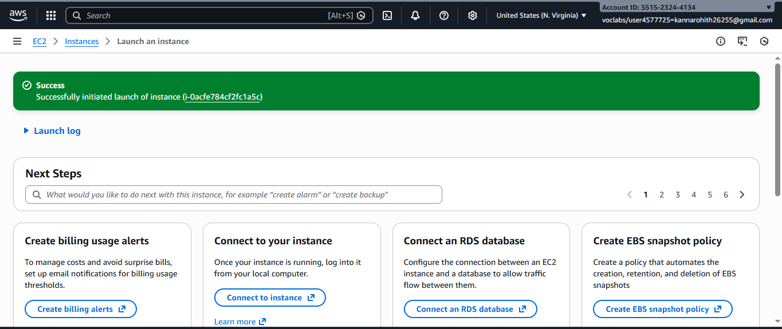
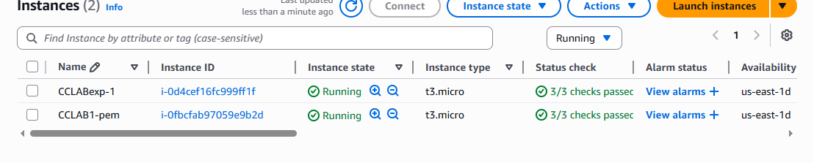
🔹 STEP 1: Check Security Group
Go to EC2 → Security Groups → Inbound rules
Ensure this rule exists:
Type: SSH
Port: 22
Source: My IP
❌ If SSH is blocked → connection will fail
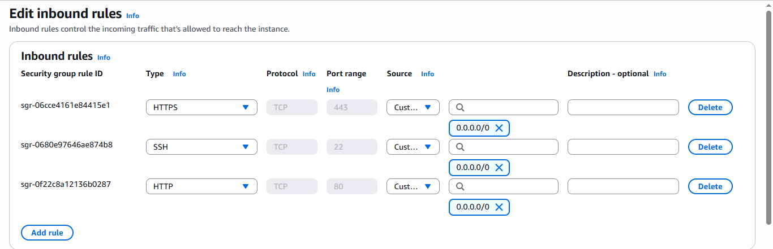
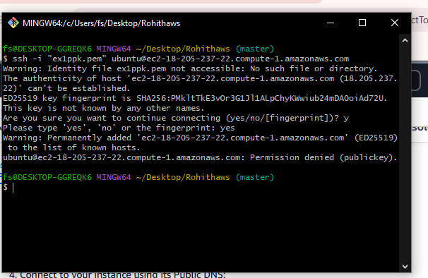

🔹 STEP 2: Open PuTTY
- Launch PuTTY
- In Session screen:
Host Name (or IP address): EC2—CONNECT—COPY (DNS NAME)
ubuntu@<PUBLIC-IP>
Example:
ubuntu@3.110.xxx.xxx
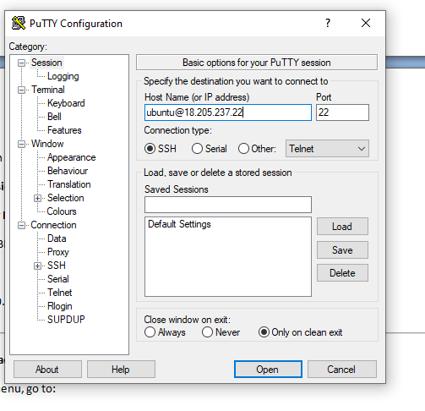

🔹 STEP 3: Attach the .ppk Key
In PuTTY left menu, go to:
Connection → SSH → Auth → Credentials
- Click Browse
- Select your .ppk file
- Click Open
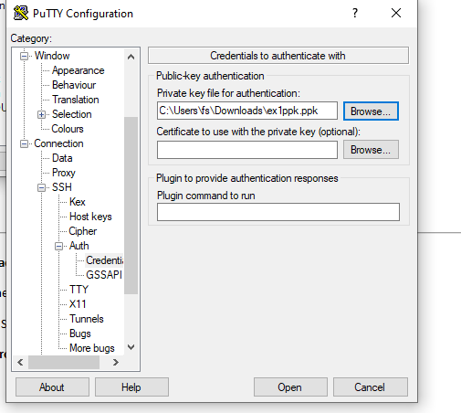

🔹 STEP 4: Connect to EC2
Click Open
- First time → click Yes (security alert)
- PuTTY will log in automatically as:
Ubuntu
🎉 You are now connected to your Ubuntu EC2 instance
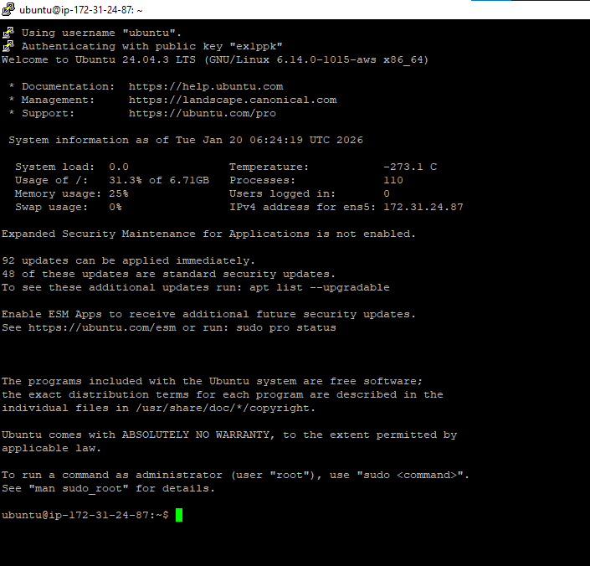

🧪 VERIFY CONNECTION
Run:
whoami
Output should be:
Ubuntu
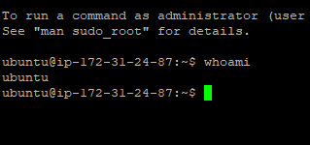

Connect EC2 Ubuntu Instance Using PuTTY (Windows) ---USING PEM KEYPAIR

PREREQUISITES
You must have:
- ✅ EC2 Ubuntu instance running
- ✅ Public IPv4 address (or Elastic IP)
- ✅ Key pair (.pem file) used while launching EC2
- ✅ PuTTY & PuTTYgen installed
👉 Download PuTTY:
https://www.putty.org

🔹 STEP 1: Convert .pem to .ppk using PuTTYgen
PuTTY cannot use .pem directly.
Steps:
- Open PuTTYgen
- Click Load
- Select your .pem file
(change file type to All Files)
- Click Open
- Click Save private key
- Save as keyname.ppk
✔ Conversion done
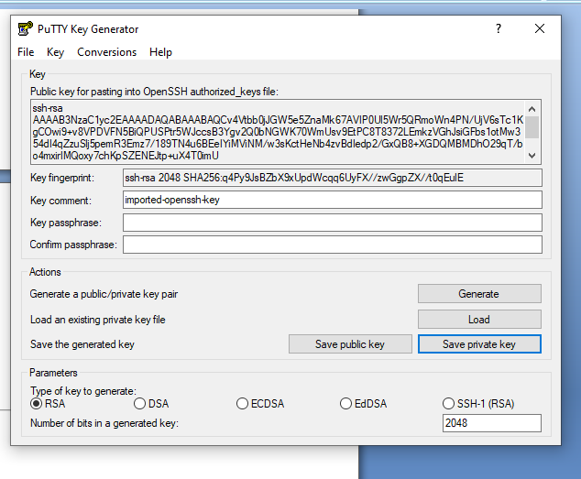
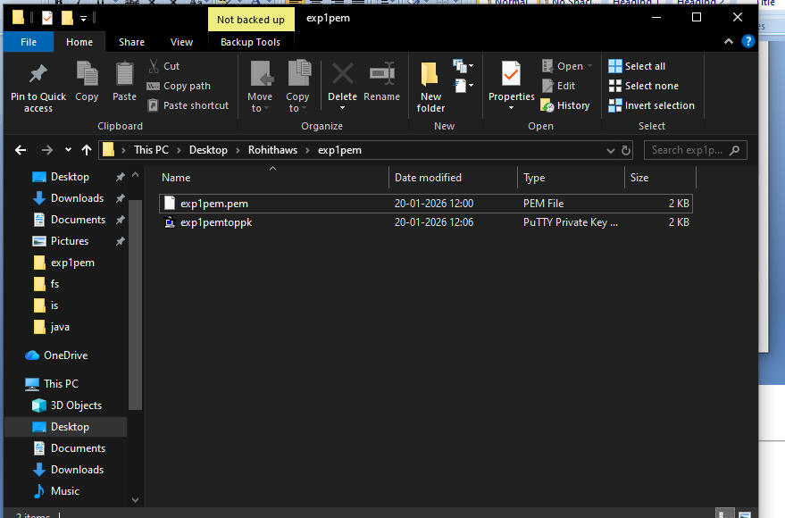

🔹 STEP 2: Get EC2 Public IP
Go to:
AWS Console → EC2 → Instances---CONNECT –COPY DNS NAME
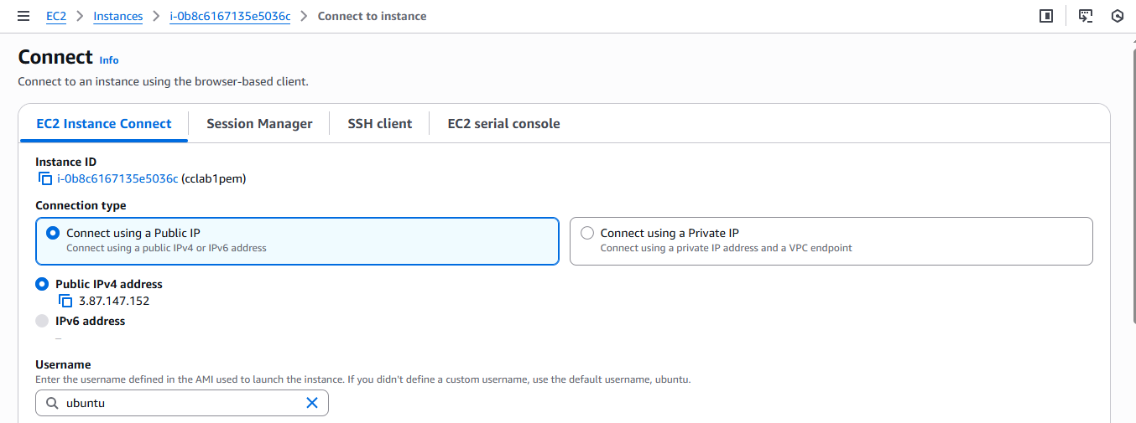

🔹 STEP 3: Configure PuTTY
1️⃣ Open PuTTY
Session:
- Host Name (or IP address): dns name
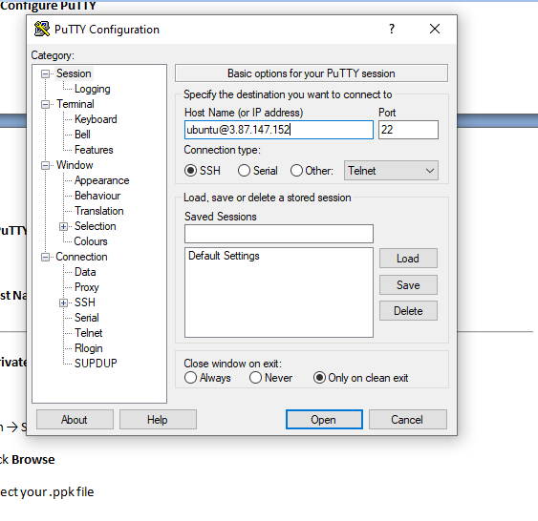

2️⃣ Load Private Key
Go to:
Connection → SSH → Auth → Credentials
- Click Browse
- Select your .ppk file
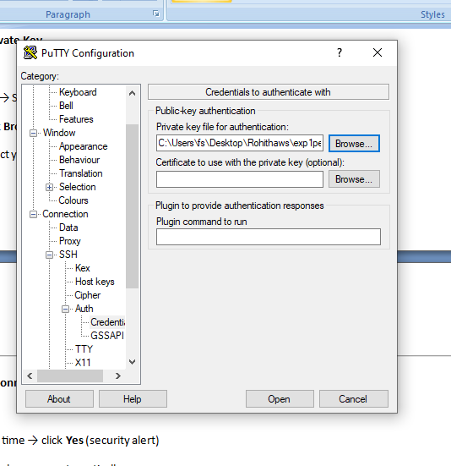

🔹 STEP 4: Connect
Click Open
- First time → click Yes (security alert)
- Login happens automatically as:
ubuntu
🎉 You are now connected to Ubuntu EC2

🧪 VERIFY CONNECTION
Run:
whoami
Output:
Ubuntu
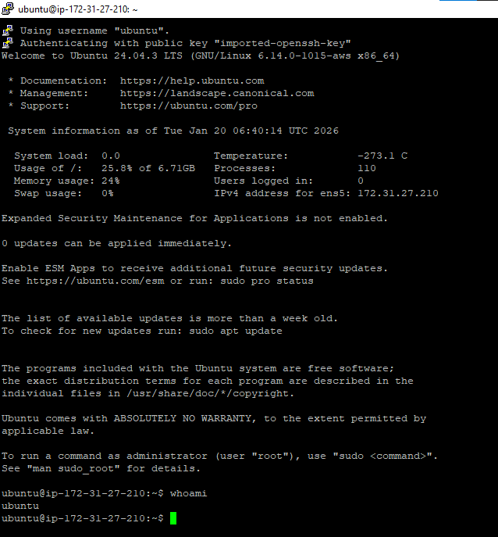

):

Connecting to EC2 Using AWS CloudShell
- Create the EC2 instance using a key pair (.pem).
- Log in to AWS Console and click on the CloudShell icon (terminal icon on the top-right).
- Once CloudShell opens, go to AWS Services → EC2.
- Select your EC2 instance and click Connect.
- Choose the SSH client tab.
- Copy the ssh -i command shown there.
- Paste the command in CloudShell and try to run it.
❌ It will fail with an error like:
“key pair is not available / no such file or directory”
(because the key file is not yet in CloudShell).
- Now, in CloudShell, click on the “+” (Actions) icon on the right side.
- Select Upload file and upload the key pair (.pem) from your local machine.
- After upload, copy the ssh -i command again from EC2 → Connect → SSH client.
- Paste and execute the command in CloudShell.
- ✅ You are now successfully connected to the EC2 instance.
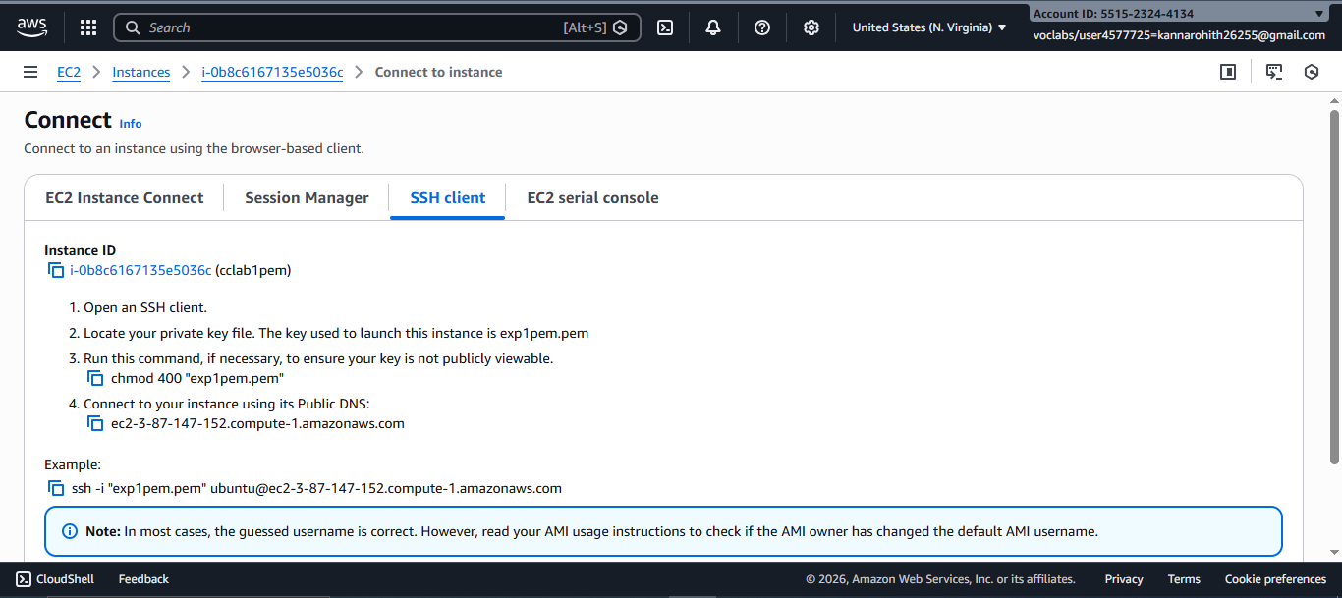
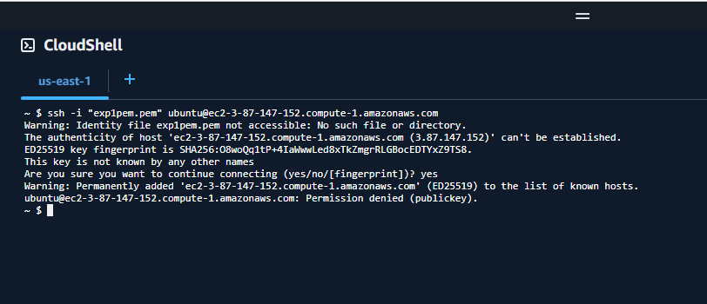
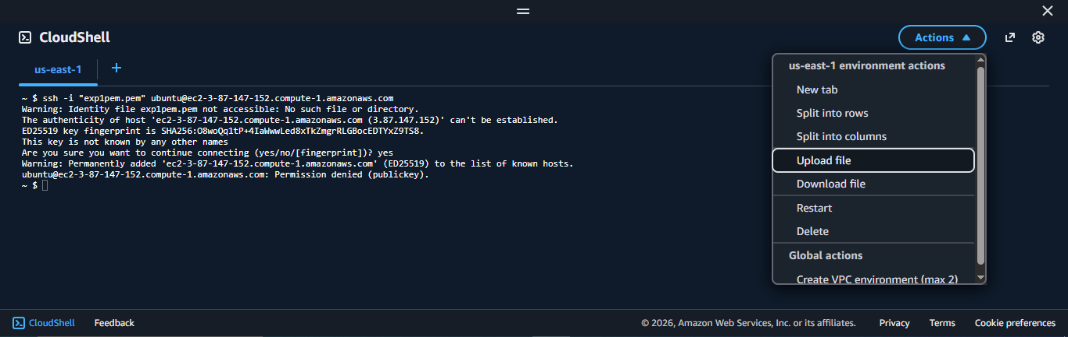
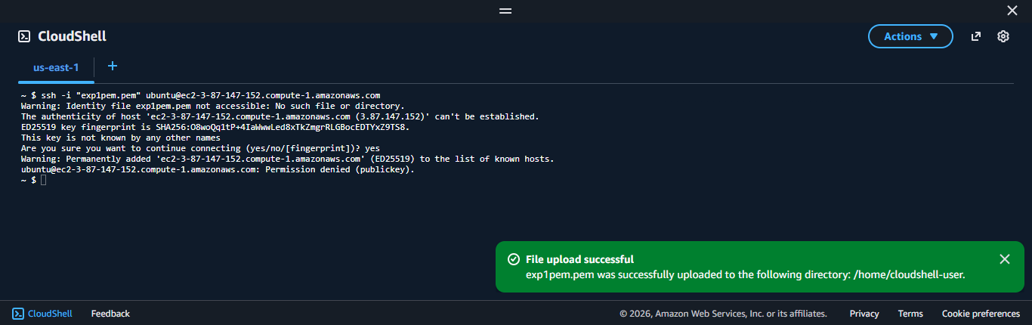
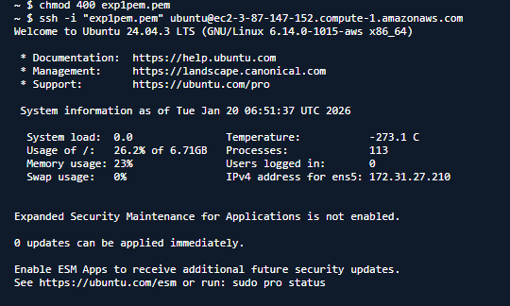
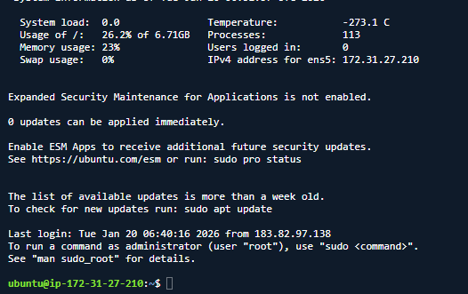

Step-by-Step: Create Windows EC2 Instance and Connect via RDP
Step 1: Launch a Windows EC2 Instance
- Log in to your AWS Management Console.
- Navigate to EC2 → Instances → Launch Instances.
- Select an Amazon Machine Image (AMI):
  - Choose a Windows Server AMI (e.g., Windows Server 2019 or 2022).
- Choose an Instance Type (e.g., t2.micro for free tier or as per your requirement).
- Configure Instance Details as needed.
- Add Storage if required (default is usually sufficient).
- Configure Security Group:
  - Ensure RDP port 3389 is allowed.
  - Source can be My IP (for security) or a wider range if needed.
- Select or create a new Key Pair:
  - Download the .pem file (keep it safe; it’s needed to decrypt the password).
- Click Launch Instance.
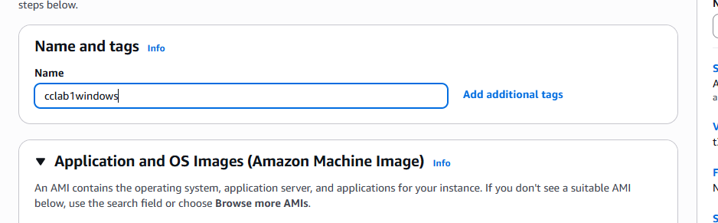
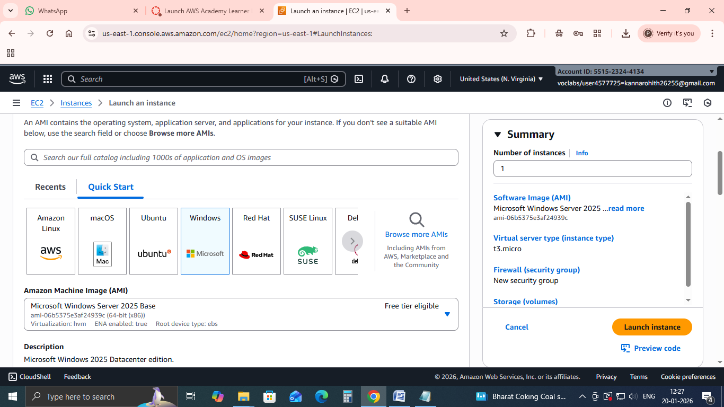
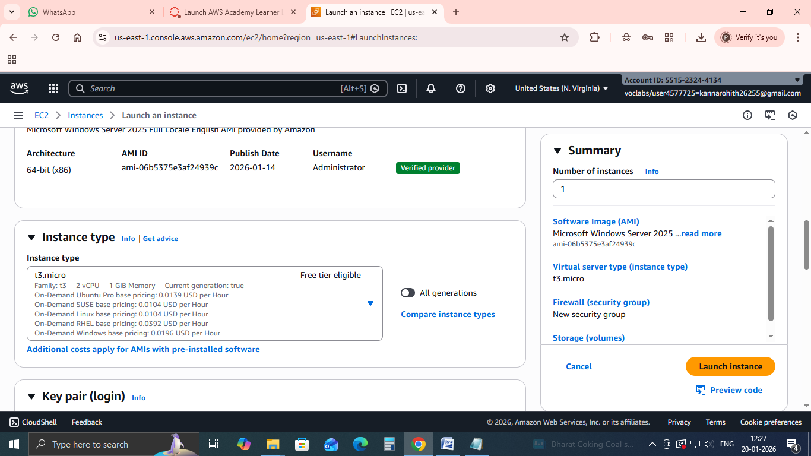
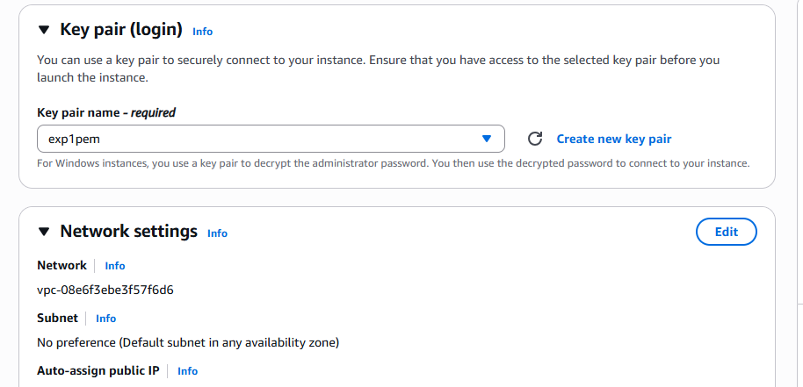
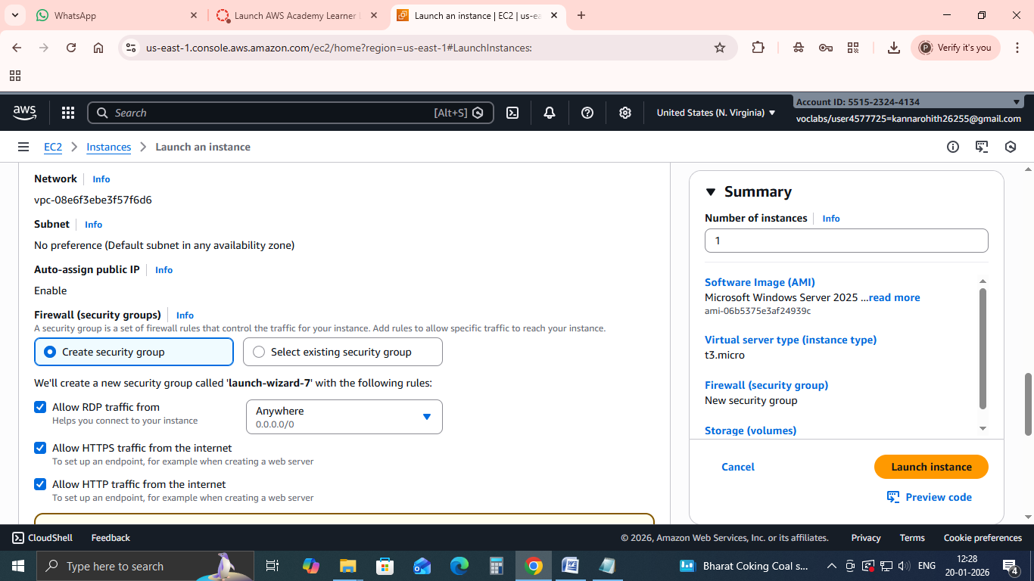
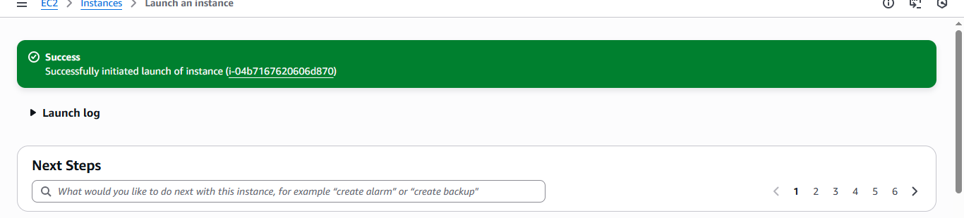

Step 2: Get the Public DNS / IP
- After the instance is running, go to EC2 → Instances.
- Select your instance and note the Public DNS (IPv4) or Public IP.

Step 3: Retrieve the Windows Administrator Password
- Select your instance → Click Connect → RDP Client.
- Click Get Password.
- Upload your Key Pair (.pem) file.
- Click Decrypt Password.
- Copy the Administrator password shown.
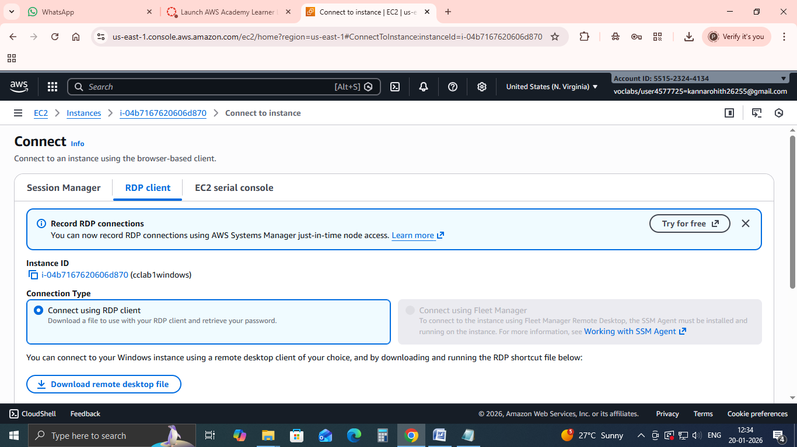
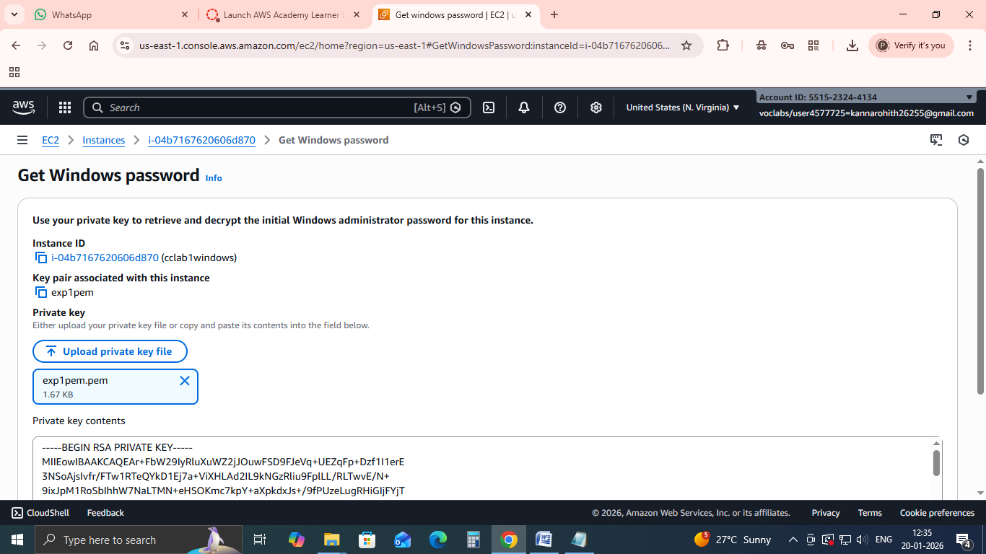
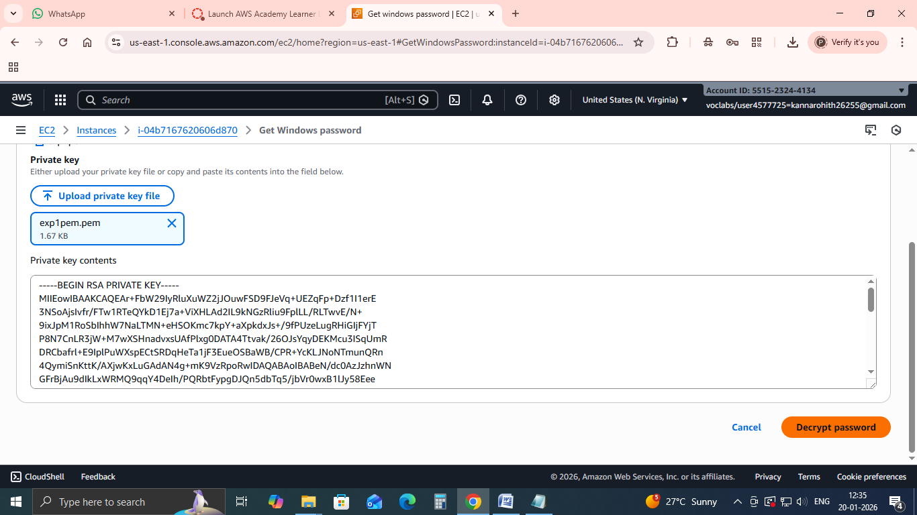
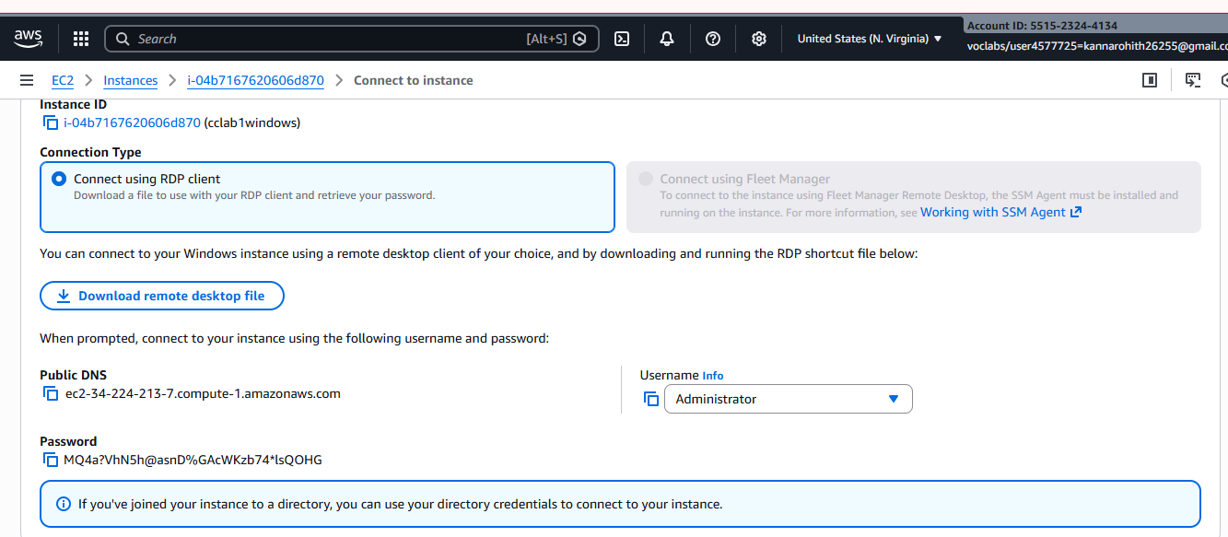

Step 4: Connect via RDP
- On your local Windows machine, open Remote Desktop Connection (mstsc).
- In the Computer field, enter the Public DNS or IP address of the EC2 instance.
- Click Connect.
- In the login prompt:
  - Username: Administrator
  - Password: Paste the decrypted password from Step 3.
- Click OK.
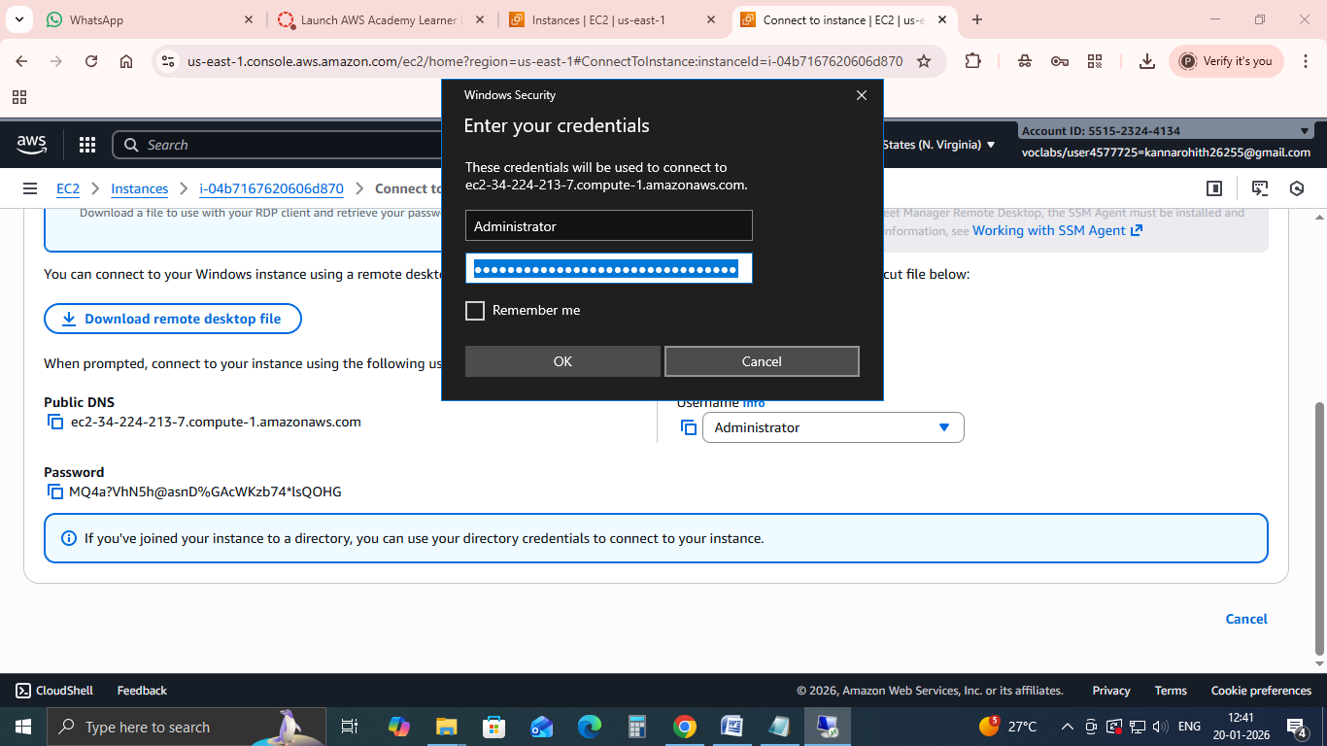

Step 5: You’re connected
- Your Windows EC2 instance desktop should appear.
- You can now use it as a normal Windows machine.
