NYC YELLOW TAXI
ANALYTICS
Consolidated Project Documentation
February 2026 dataset | SQL analytics | Power BI reporting

PROJECT PURPOSE
Turn NYC Yellow Taxi trip records into documented analytical datasets, reusable KPIs, and business-facing dashboard insights.

Contents
- Executive Overview
- Business Problem and Objectives
- Scope and Analytical Layers
- Data Processing and Quality Notes
- KPI Dictionary and Interpretation
- Power BI Report Structure
- Validation and Evidence Status
- Business Insights and Recommended Actions
- Output Screens
- Limitations and Assumptions
- Project Deliverables and Handover Checklist
- Appendix A. Pipeline Reconciliation

1. Executive Overview
This project analyzes NYC Yellow Taxi trip data for February 2026 using a MySQL Workbench-to-Power BI workflow. The project converts trip-level records into a cleaned analytical dataset, a business-focused dataset, supporting summary tables, and dashboard views intended to help users explore demand, recorded trip amounts, pickup locations, route directionality, and illustrative scenarios.
The business table contains 3,329,782 trips and a documented SUM(total_amount) of $100,340,136.16. An important coverage caveat is that February 23, 2026 is absent from the business table: the user confirmed that a query for that date returned zero rows. The reason for the absence is not established by the available evidence.

2. Business Problem and Objectives
The project aims to make a large taxi-trip dataset more useful for analysis by structuring data preparation in SQL, defining reusable business metrics, and presenting results through Power BI.
- Summarize trip volume and recorded trip amounts.
- Explore demand patterns across dates and hours.
- Compare pickup locations and the documented airport pickup-zone segment.
- Review route-directionality differences using the available route analysis.
- Present hypothetical revenue-uplift scenarios with clear assumptions.
- Document data-quality rules, pipeline row counts, KPI definitions, and validation caveats.
The exact stakeholder list, formal business success targets, and agreed service-level requirements were not provided in the available project notes; this document does not invent them.

3. Scope and Analytical Layers
The project scope documented here is February 2026 NYC Yellow Taxi analysis. The main processing sequence is represented by four tables:
Stage | Table | Documented row count
Source | analytics_yellow_taxi | 3,399,850
Cleaned | analytics_yellow_taxi_cleaned | 3,359,607
Final | analytics_yellow_taxi_final | 3,355,645
Business | analytics_yellow_taxi_business | 3,329,782

Supporting tables documented in the project include analytics_daily_summary, analytics_hourly_summary, analytics_pickup_location_summary, route_directionality_analysis, revenue_scenario_analysis, revenue_scenarios, and taxi_zone_lookup.
Exact column definitions, primary/foreign keys, join predicates, and refresh/connectivity configuration have not been independently reviewed here. The accompanying data dictionary and SQL transformation documentation should be used for the field-level detail available in the project.

4. Data Processing and Quality Notes
The documented source-to-business row reduction is 70,068 rows, approximately 2.06% of the source count. The stage-to-stage differences are reconciliation figures; they should not be interpreted as a count of erroneous records without examining the rule applied at each stage.
Documented rule or observation | Recorded result | Interpretation caveat
Vendor 7 identical-timestamp rule | 40,241 records associated with the rule | Identical timestamps alone do not prove that records are duplicates; exact SQL predicate was not independently reviewed.
Negative trip duration | 2 records | Exact duration expression and SQL predicate were not independently reviewed.
Trips longer than 120 minutes | 3,962 trips | The 120-minute cutoff is a project-defined threshold, not asserted as a universal TLC rule.
February 23 coverage gap | 0 rows in business table, confirmed by user | The cause is not established by the available evidence.

Documented raw-stage counts around February 23 are 85,555 for February 22, 26,019 for February 23, and 104,315 for February 24. This pattern warrants investigation but does not prove whether the cause is source-data availability, filtering, transformation logic, or another process.
Recommended control: compare date coverage and row counts at every pipeline stage, retain query outputs, and document the reason for any date-level exclusion.

5. KPI Dictionary and Interpretation
KPI / measure | Documented value or formula | Interpretation
Trips in business table | 3,329,782 | Count of rows in the documented business table.
Total recorded amount | SUM(total_amount) = $100,340,136.16 | Recorded total amount; not automatically equivalent to profit, driver earnings, or platform revenue.
Average total amount | AVG(total_amount) = $30.13 | Rounded to two decimal places.
Aggregate amount per mile | SUM(total_amount) / SUM(trip_distance) ≈ $4.78 | Weighted aggregate ratio; not the average of per-trip ratios.
Average trip duration | 17.64 minutes | Duration field/formula not independently inspected here.
JFK + LaGuardia pickup-zone revenue | Approximately $14.33M | Pickup-zone scope only; not all airport-related activity or drop-off revenue.
High route-imbalance rows | 14 where imbalance_pct >= 50 | Flagged rows merit contextual review; threshold meaning depends on the documented metric definition.
Absolute route revenue difference | SUM(ABS(revenue_difference)) ≈ $3.51M | Gross absolute magnitude; not recoverable revenue, profit, or guaranteed opportunity.

The project documents 1%, 2%, 3%, and 5% revenue-uplift scenarios. These are illustrative what-if calculations, not forecasts. They should not be presented as expected outcomes or net profit without additional assumptions and cost/margin analysis.

6. Power BI Report Structure
The documented report inventory contains six pages:
- Executive Dashboard
- Executive Overview
- Demand & Time Intelligence
- Location Intelligence
- Route & Airport Intelligence
- Business Opportunities
The dashboard is intended to communicate summary KPIs and allow exploration of demand, location, route, airport pickup-zone, and scenario analysis. The actual Power BI file, exact visual inventory, slicers, interactions, DAX measures, relationships, and refresh settings were not independently inspected while preparing this consolidated document. Those implementation details should be verified against the PBIX before final handover.

7. Validation and Evidence Status
The project validation record separates user-confirmed results from documented values and checks that still require direct evidence.
- User-confirmed: the four pipeline row counts listed in Section 3.
- User-confirmed: the query for February 23 in analytics_yellow_taxi_business returned zero rows.
- Documented but not independently re-executed here: KPI values, cleaning-rule counts, route-analysis results, and scenario assumptions.
- Pending direct verification: Power BI visual-to-SQL reconciliation, visibility of the February 23 coverage caveat, and a complete local-folder audit.
A validation workbook is provided separately. It records test cases, evidence references, pipeline reconciliation, and status definitions. This consolidated document does not claim that every SQL test was freshly executed or that the PBIX was independently inspected.

8. Business Insights and Recommended Actions
- Investigate the February 23 absence across source, cleaned, final, and business stages; record the root cause or clearly document that it remains unresolved.
- Reconcile dashboard KPI cards with approved SQL outputs using consistent definitions and date coverage.
- Keep definitions for total_amount, trip_distance, trip duration, airport pickup-zone scope, and route imbalance visible to readers.
- Review route flags with trip counts, sample sizes, signed differences, and time segmentation before recommending operational changes.
- Label 1%, 2%, 3%, and 5% uplift outputs as illustrative scenarios, not forecasts.
- Retain reusable date-coverage and row-count checks, plus query outputs or screenshots as evidence.
The analysis supports hypotheses for further investigation; it does not by itself prove causes of route imbalance, achievable revenue uplift, profit, or operational savings.

Output Screens

9.1 - EXECUTIVE DASHBOARD

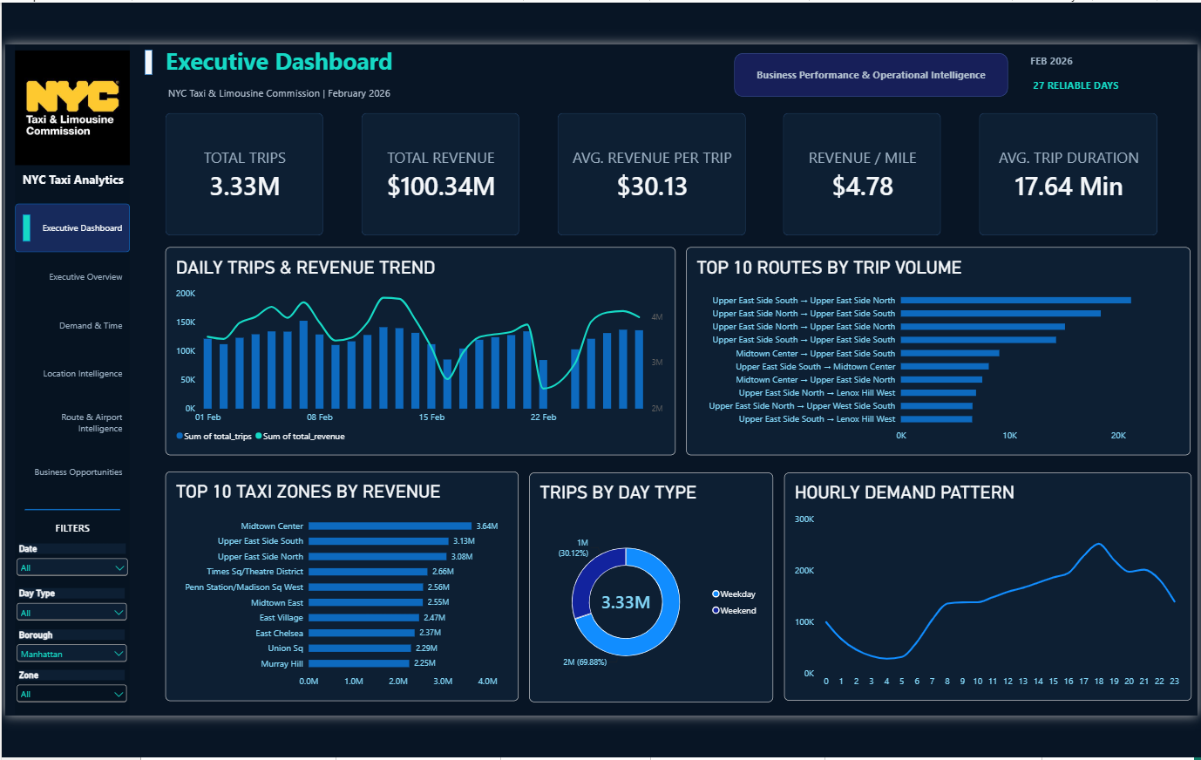

9.2 - EXECUTIVE OVERVIEW

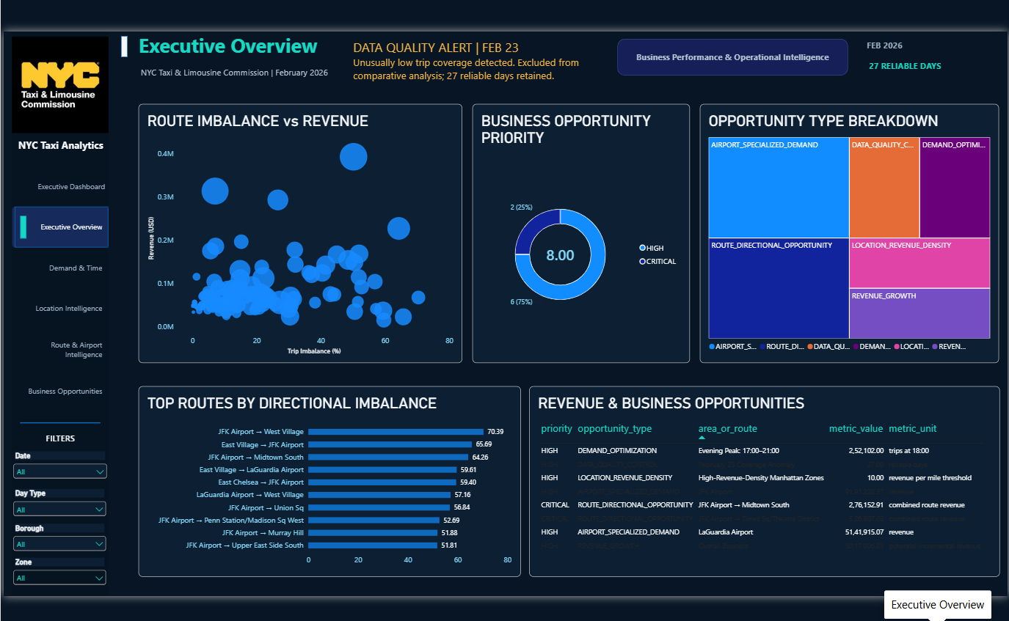

9.3 - DEMAND & TIME INTELLIGENCE

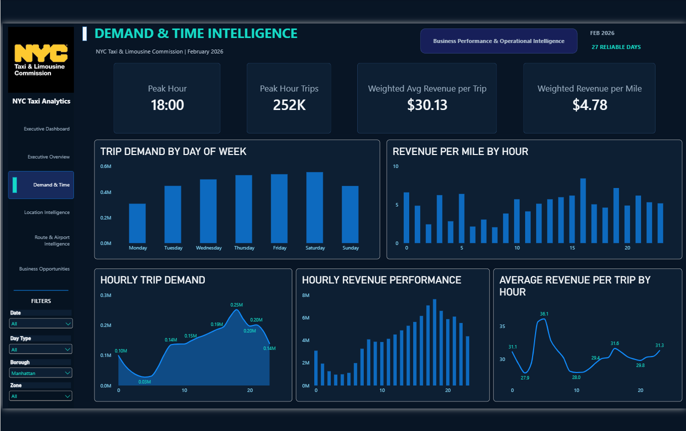

9.4 - LOCATION INTELLIGENCE

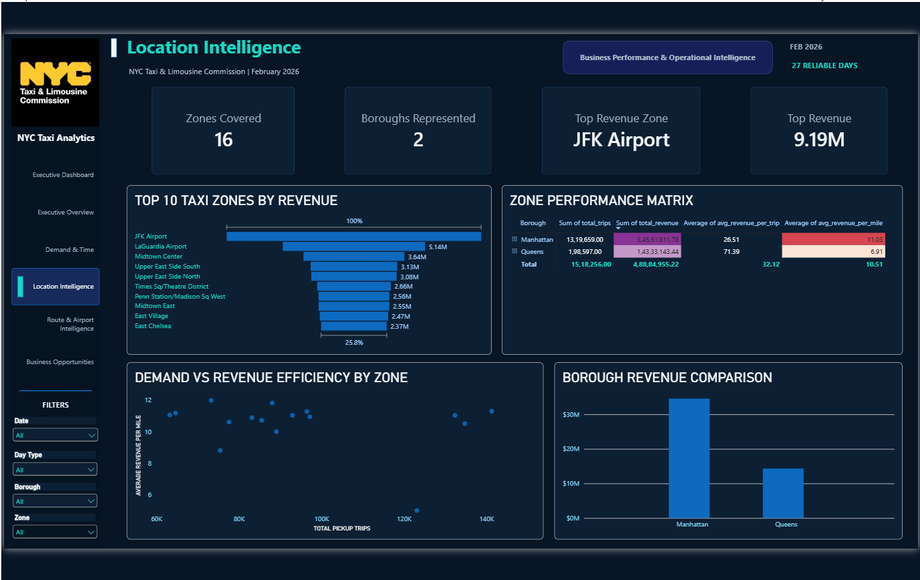

9.5 - ROUTE & AIRPORT INTELLIGENCE

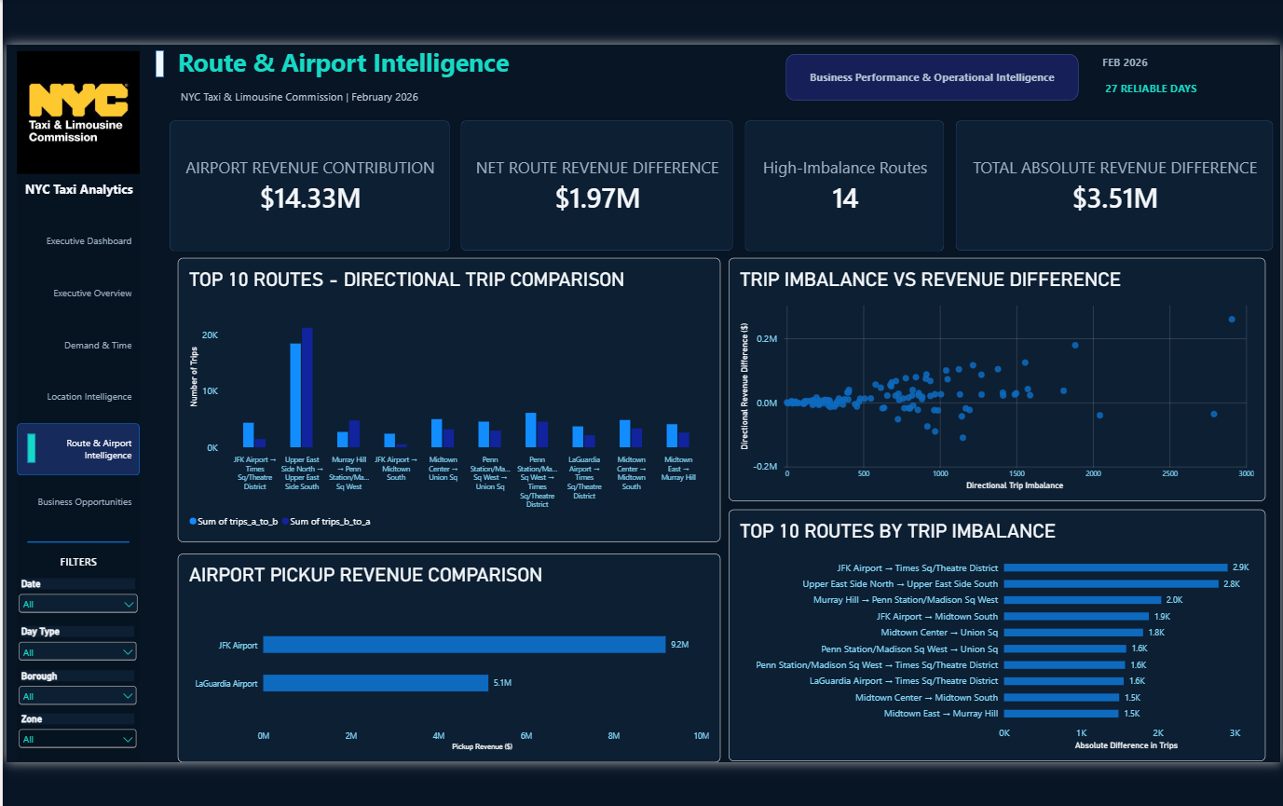

9.6 - BUSINESS OPPORTUNITIES

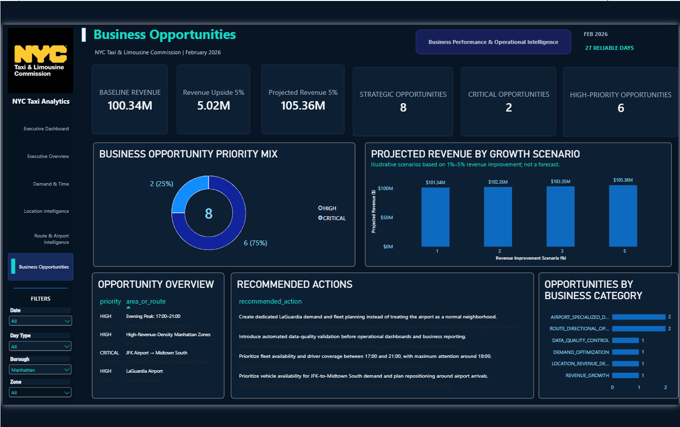

10. Limitations and Assumptions
- The business table excludes February 23 according to the user-confirmed query result.
- Row-count reductions are not automatically erroneous records.
- Exact SQL predicates for cleaning rules have not been independently reviewed in this consolidated document.
- All documented KPI figures have not been independently recalculated from raw data for this document.
- The Power BI file was not independently inspected for this document.
- Airport revenue refers to the documented JFK + LaGuardia pickup-zone analysis.
- Absolute route differences are not recoverable revenue or profit.
- Scenario uplifts are illustrative, not forecasts.

11. Project Deliverables and Handover Checklist
- Business Requirements Document and Stakeholder/Scope notes.
- Functional Requirements Document and Requirements Traceability Matrix.
- Data Dictionary, Data Quality Report, and KPI Dictionary.
- System Architecture, Data Flow Diagram, Database Data Model, and SQL Transformation Documentation.
- Power BI Dashboard Specification, Dashboard User Guide, and dashboard screenshots.
- Testing and Validation Report with evidence log and pipeline reconciliation.
- Business Insights Report and Executive Summary.
- README and deployment/refresh instructions.

Appendix A. Pipeline Reconciliation
Stage | Row count | Reduction from prior stage | Reduction % of prior stage
Source | 3,399,850 | — | —
Cleaned | 3,359,607 | 40,243 | 1.18%
Final | 3,355,645 | 3,962 | 0.12%
Business | 3,329,782 | 25,863 | 0.77%
Source to business total | 70,068 net reduction | 70,068 | 2.06% of source

Percentages are rounded. The total reduction is a reconciliation measure and should not be described as the number of bad records.

