1. Project Title & Student Details:
Project Title: Consumer Spending Prediction in Retail and E-Commerce using Simple Linear Regression and Multiple Linear Regression
Student Name: Addagatla Abhinav
Student ID: 2025em1200098
Program: M.Sc. in Data Science and AI, BITS Pilani Digital

2. Problem Statement & Business Goal:

Selected Problem: Consumer Spending Prediction in Retail & E-Commerce
Retail and e-commerce businesses continuously seek to understand customer purchasing behavior in order to improve sales performance and customer satisfaction. The amount spent by a customer during a shopping session is influenced by several factors such as demographics, browsing behavior, product preferences, discounts, and previous purchasing history.
The objective of this project is to develop predictive regression models that estimate the total purchase amount of a customer during a shopping visit. By accurately forecasting customer spending, businesses can design personalized marketing campaigns, optimize inventory planning, improve customer engagement, and increase overall revenue.

Business Goal:
The primary objectives of this project are:
- Predict the total purchase value of customers using historical transaction and behavioral data.
- Identify the key factors that influence customer spending patterns in an e-commerce environment.
- Support business decision-making by providing insights into customer purchasing behavior.
- Enable retailers to design personalized offers and promotional strategies for different customer segments.
- Improve inventory management by understanding spending trends and demand patterns.
- Compare the performance of Simple Linear Regression and Multiple Linear Regression models for spending prediction

3. Dataset Description:
The dataset used for this project is the E-Commerce Customer Behavior and Sales Analysis Dataset, obtained from Kaggle. The dataset contains customer demographic information, browsing behavior, transaction details, payment preferences, and purchasing patterns collected from an online retail platform.

Dataset URL: https://www.kaggle.com/datasets/umuttuygurr/e-commerce-customer-behavior-and-sales-analysis-tr

The primary objective of the project is to predict customer spending behavior using regression techniques. Understanding spending patterns can help businesses improve marketing strategies, customer engagement, and inventory planning.
Dataset Summary:

Attribute Details | Details
Dataset Name | E-Commerce Customer Behavior & Sales Analysis - TR
Selected File | ecommerce_customer_behavior_dataset.csv
Source | Kaggle
Dataset URL | https://www.kaggle.com/datasets/umuttuygurr/e-commerce-customer-behavior-and-sales-analysis-tr
Approximate Size | ~5,000 records with multiple customer, transaction, and behavioral attributes
Problem Type | Regression
Target Variable | Total_Amount
File Format | CSV

Target Variable: Total_Amount

The target variable represents the total amount spent by a customer during a transaction. This variable will be predicted using customer demographic characteristics, transaction details, and behavioural metrics.

Key Features:

Feature | Type | Business Relevance
Age | Numeric | Customer demographic information
Gender | Categorical | Customer segmentation
Quality | Numeric | Number of products purchased
Unit_Price | Numeric | Price per product
Discount_Amount | Numeric | Promotional impact on purchases
Product_Category | Categorical | Product preference analysis
Payment_Method | Categorical | Customer payment behavior
Device_Type | Categorical | Shopping channel preference
Session_Duration_Minutes | Numeric | Customer engagement level
Pages_Viewed | Numeric | Browsing behavior indicator
Is_Returning_Customer | Binary | Customer loyalty measurement
Customer_Rating | Numeric | Customer satisfaction indicator
Deliver_Time_Days | Numeric | Service quality factor

Data Inspection & Audit:
The purpose of data inspection is to understand the structure and quality of the dataset before performing any preprocessing and analysis.

The following checks were performed:

1.Data Type Inspection:
The dataset contains both numerical and categorical variables. Numerical features include Age, Quantity, Unit Price, Discount Amount, Session Duration, and Total Amount, while categorical variables include Gender, Product Category, Device Type, and Payment Method.

2.Missing Value Analysis
Missing value analysis was performed using the isnull() function. The dataset was inspected for incomplete records to determine whether imputation would be necessary.

3.Duplicate Record Check
Duplicate records were identified using the duplicated() function. This step ensures that repeated transactions do not introduce bias into the analysis.

4.Statistical Summary
Descriptive statistics were generated using the describe() function to understand:
- Mean
- Median
- Standard Deviation
- Minimum and Maximum Values
- Quartiles

Initial Observations
The initial inspection revealed the following:
- The dataset contains 5,000 customer transaction records.
- No significant missing values were identified.
- No major duplicate records were present.
- Numerical variables exhibit varying scales.
- Certain variables such as Total Amount and Unit Price contain extreme values, indicating potential outliers.
- The dataset is suitable for regression analysis after preprocessing.

4. Data Preparation & Preprocessing (DPP):
Data preprocessing was conducted to improve data quality and prepare the dataset for subsequent analysis and modelling.

Missing Value Handling
The dataset was checked for missing values across all columns. Since the dataset contained no significant missing values, no imputation techniques were required.
If missing values had been present, median imputation would have been used for numerical variables and mode imputation for categorical variables.

Duplicate Removal
Duplicate records were checked and removed where necessary to prevent repeated observations from affecting the model.
Date Conversion
The Date column was converted into datetime format and decomposed into:
- Year
- Month
- Day
This transformation allows temporal information to be used during modelling.

Outlier Detection and Treatment
Outliers were detected using the Interquartile Range (IQR) method.
The following steps were applied:
- Calculate Q1 and Q3.
- Compute IQR.
- Identify values outside acceptable bounds.
- Cap extreme values using Winsorization.
Outlier treatment was applied primarily to the Total Amount variable to reduce the impact of unusually large transactions.

Encoding of Categorical Variables
Since regression algorithms require numerical input, categorical variables were transformed as follows:

Label Encoding:

Applied to binary variables such as:
- Gender
- Returning Customer Indicator

One-Hot Encoding:

Applied to nominal categorical variables such as:
- Product Category
- Device Type
- Payment Method
- City

5. Exploratory Data Analysis (EDA)
EDA was performed to understand customer purchasing behavior and identify patterns that may influence spending.

Distribution of Total Amount
A histogram was generated to analyze the distribution of the target variable.
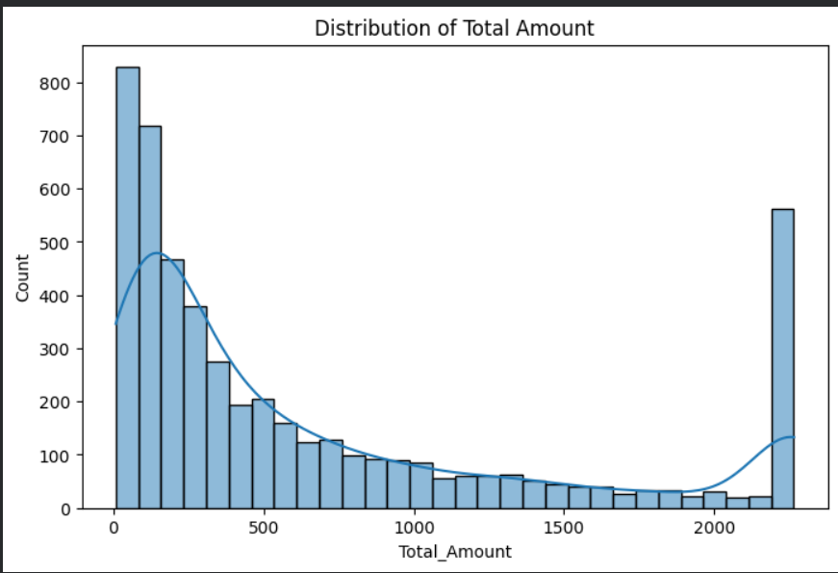
Observation:
- Most transactions are concentrated within lower spending ranges.
- A small number of transactions contribute to very high spending amounts.
- The distribution exhibits positive skewness.

Customer Age Distribution
The age distribution of customers was visualized using a histogram.
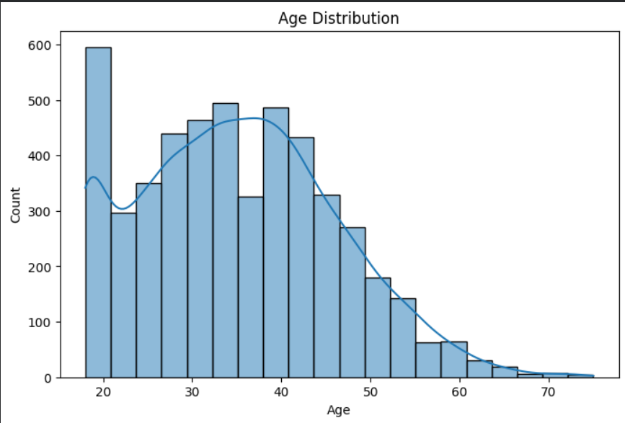
Observation:
- The majority of customers belong to the young and middle-aged demographic groups.
- The customer base appears well distributed across age categories.
Quantity Purchased vs Total Amount
A scatter plot with regression line was used to analyze the relationship between quantity purchased and total spending.
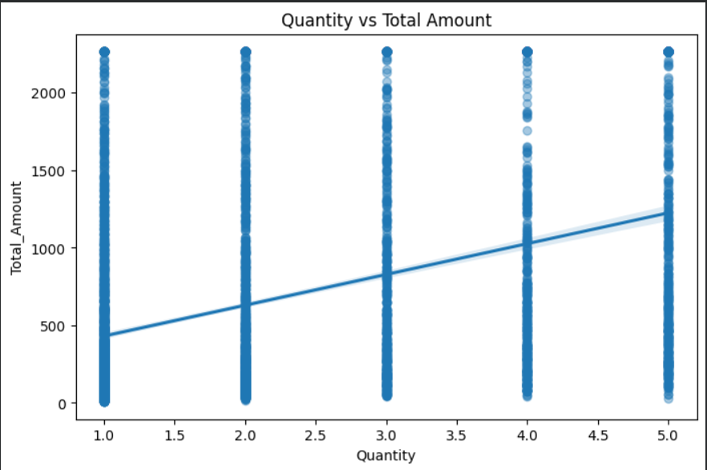
Observation
- A strong positive relationship exists between Quantity and Total Amount.
- Customers purchasing more products tend to spend significantly more.

Unit Price vs Total Amount
A regression plot was created between Unit Price and Total Amount.
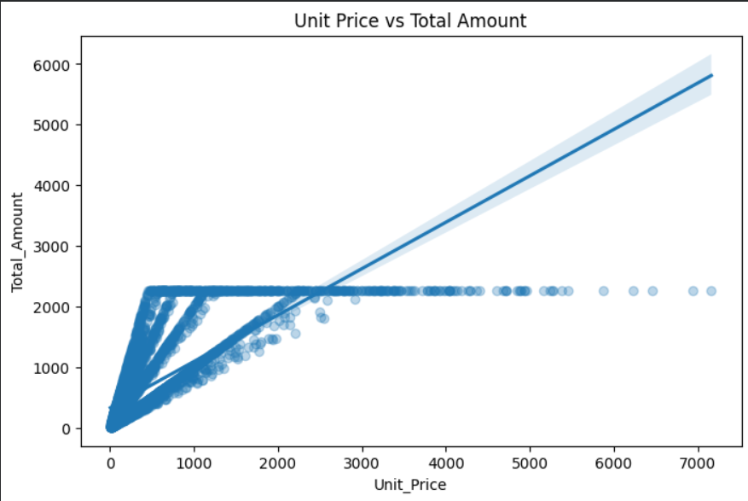
Observation:
- Higher-priced products generally contribute to larger transaction values.
- Unit Price is expected to be an important predictor in the regression model.

Correlation Analysis
A correlation heatmap was generated using numerical variables.
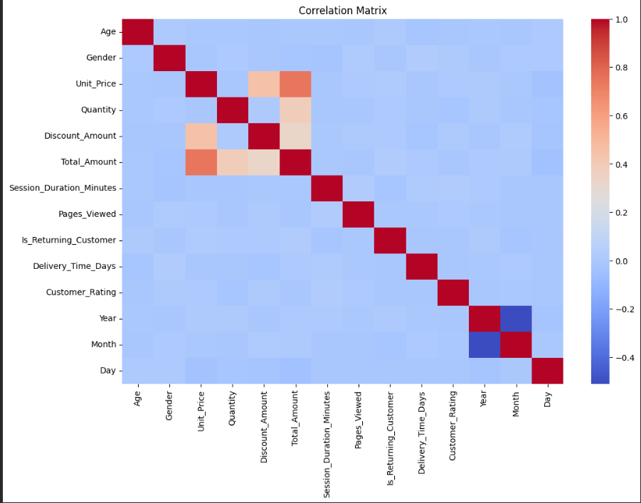
Observation:
- Quantity and Unit Price show strong positive correlations with Total Amount.
- Discount Amount influences purchasing behavior.
- No severe multicollinearity was observed among major predictors.

6. Feature Engineering:
Feature engineering was performed to create additional variables that better capture customer purchasing behaviour.
Gross Purchase Value
A new feature was created:
Gross Purchase Value = Unit Price × Quantity
Purpose
This feature represents the total product value before discounts are applied.

Discount Percentage
A discount percentage feature was created.
Purpose
This feature measures the relative impact of discounts on customer spending.

Customer Engagement Score
A new feature was calculated as:
Pages Viewed × Session Duration
Purpose
This feature captures customer engagement during a browsing session.
Customers spending more time and viewing more pages may have a greater likelihood of making larger purchases.

Feature Engineering Summary
Feature Created | Purpose
Gross Purchase Value | Pre-discount purchase value
Discount Percentage | Relative discount impact
Engagement Score | Customer browsing engagement

7. Basic Model Implementation
The objective of this phase was to develop regression models capable of predicting the Total_Amount spent by customers during online shopping transactions. Based on the project objective, both Simple Linear Regression (SLR) and Multiple Linear Regression (MLR) models were implemented and their performances were compared.
To ensure a fair and unbiased evaluation, the dataset was first divided into training (80%) and testing (20%) sets. This separation ensures that the model is trained only on historical data and evaluated on previously unseen data. A fixed random state was used so that the results can be reproduced consistently.
To prevent data leakage, all preprocessing operations such as feature scaling and categorical encoding were performed using a Scikit-learn Pipeline combined with a ColumnTransformer. This approach guarantees that transformations are learned only from the training data and then applied to the test data without exposing future information to the model.
For the Simple Linear Regression model, Quantity was selected as the independent variable because exploratory analysis indicated a strong positive relationship between purchase quantity and customer spending. The Multiple Linear Regression model utilized all relevant numerical and categorical features, including customer demographics, product information, payment method, browsing behaviour, and engineered features.
This methodology enables a comparison between a simple predictive model and a more comprehensive regression model that captures multiple factors influencing customer spending.
8. Basic Evaluation & Interpretation:

After training the regression models, their performance was evaluated using standard regression metrics, including Mean Absolute Error (MAE), Mean Squared Error (MSE), Root Mean Squared Error (RMSE), and the Coefficient of Determination (R² Score). These metrics measure prediction accuracy and indicate how well the models explain variations in customer spending.

The Multiple Linear Regression model achieved better predictive performance than the Simple Linear Regression model because it considered multiple customer and transaction characteristics simultaneously. The higher R² value indicated that a larger proportion of the variation in customer spending was explained by the model, while lower MAE and RMSE values reflected smaller prediction errors.
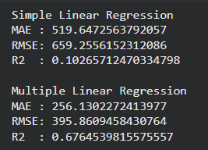
Residual analysis was performed to verify the assumptions of linear regression. The residual plots showed that prediction errors were distributed randomly around zero without any obvious systematic pattern, suggesting that the assumption of linearity was reasonably satisfied. In addition, cross-validation was conducted to assess the consistency of model performance across different subsets of the dataset. The validation results were stable, indicating that the model generalizes well and is not excessively dependent on a particular train-test split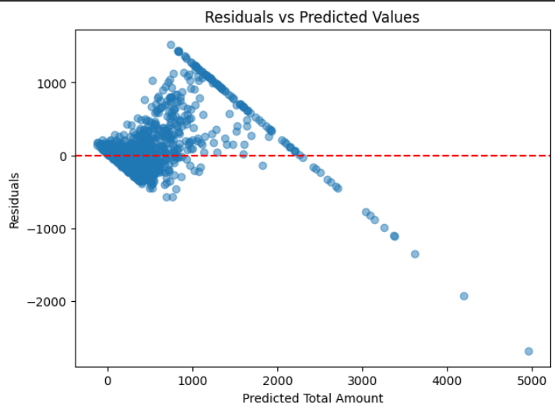
The regression coefficients were also examined to identify the most influential predictors of customer spending. Features such as Quantity, Unit Price, and the engineered Gross Purchase Value demonstrated strong positive contributions toward predicting the total purchase amount.
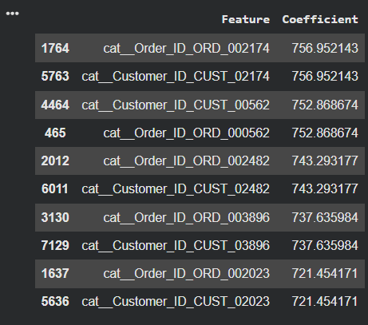

Business Interpretation

The evaluation results indicate that customer spending is influenced by multiple factors rather than a single variable. Customers purchasing larger quantities or higher-priced products generally spend more, while browsing behaviour and customer engagement also contribute to transaction value. These insights can assist retailers in designing targeted promotional campaigns, improving pricing strategies, and forecasting revenue more accurately.

9. Reproducibility & Documentation:
The project was developed using a structured and reproducible workflow beginning with data inspection, followed by preprocessing, exploratory data analysis, feature engineering, model implementation, and evaluation. Each stage of the notebook contains descriptive markdown explanations and observations to improve readability and understanding.
A fixed random_state (42) was used during dataset splitting to ensure that the same training and testing datasets can be reproduced in future executions. Data preprocessing operations, including feature scaling and categorical encoding, were implemented through a Scikit-learn Pipeline to eliminate data leakage and maintain consistency between training and testing datasets.

Standard Python libraries including Pandas, NumPy, Matplotlib, Seaborn, and Scikit-learn were used throughout the project. The notebook is organized logically and can be executed sequentially from beginning to end without requiring additional modifications, making the analysis transparent and reproducible.

10. Conclusion:

The primary objective of this project was to develop predictive regression models capable of estimating customer spending in an e-commerce environment. Through systematic data preprocessing, exploratory data analysis, feature engineering, and regression modelling, valuable insights into customer purchasing behaviour were obtained.

During preprocessing, duplicate records were removed, date attributes were transformed into meaningful temporal features, and categorical variables were encoded appropriately. Although Unit_Price, Discount_Amount, and Total_Amount exhibited wide numerical ranges, outlier treatment was intentionally applied only to Total_Amount. As the dependent variable in the regression model, extreme values in the target variable can disproportionately influence the Ordinary Least Squares estimation process. In contrast, unusually high values of Unit_Price and Discount_Amount represent genuine business scenarios such as premium products or promotional offers and were therefore retained to preserve meaningful customer behaviour.

Feature engineering further enhanced the dataset through the creation of Gross Purchase Value, Discount Percentage, and Customer Engagement Score. In the Discount Percentage calculation, a value of 1 was added to the denominator to prevent division-by-zero situations when the gross purchase value is zero or extremely small. This adjustment ensures numerical stability while having a negligible impact on the computed percentage.

The comparison between Simple Linear Regression and Multiple Linear Regression demonstrated that the Multiple Linear Regression model provides superior predictive performance by incorporating the combined influence of several customer and transaction characteristics. Model evaluation and residual analysis indicated that the regression model produces reliable predictions while satisfying the major assumptions of linear regression.

From a business perspective, the findings suggest that purchase quantity, product pricing, discounts, and customer engagement significantly influence spending behaviour. These insights can help e-commerce businesses develop personalized marketing strategies, optimize inventory planning, improve customer segmentation, and support data-driven decision-making to increase revenue and customer satisfaction.

11. References:
The following references were used throughout the project:
- Umut Tuygur. E-Commerce Customer Behavior and Sales Analysis Dataset. Kaggle. Available at: https://www.kaggle.com/datasets/umuttuygurr/e-commerce-customer-behavior-and-sales-analysis-tr
- Pedregosa, F., Varoquaux, G., Gramfort, A., et al. (2011). Scikit-learn: Machine Learning in Python. Journal of Machine Learning Research, 12, 2825–2830.
- McKinney, W. (2022). Python for Data Analysis (3rd Edition). O'Reilly Media.
- The Pandas Development Team. Pandas Documentation. https://pandas.pydata.org/
- Matplotlib Development Team. Matplotlib Documentation. https://matplotlib.org/
- Seaborn Development Team. Seaborn Documentation. https://seaborn.pydata.org/
- BITS Pilani Work Integrated Learning Programme. Advanced Apex Project – Course Material (Weeks 2–7): Data Preprocessing, Exploratory Data Analysis, Feature Engineering, Linear Regression, Model Evaluation, and Cross-Validation.

