TECHNICAL PROJECT DOCUMENTATION
Secure Employee Document Portal
Using AWS Secrets Manager, KMS, S3, IAM, EC2, MongoDB & Terraform

Prepared by: Cloud / DevOps Engineer
Document Version: 1.0
Classification: Technical Review / Portfolio
Date: June 2026

Python Flask | AWS S3 + KMS | Secrets Manager | MongoDB | Terraform

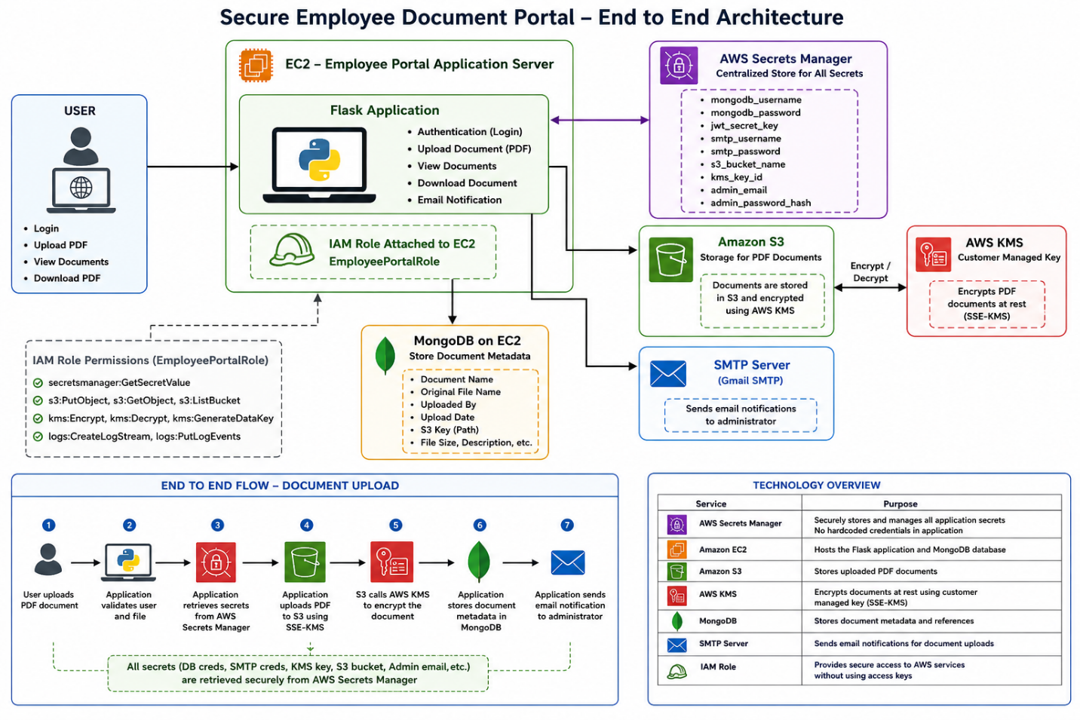

1. Executive Summary
This document presents a comprehensive technical overview of the Secure Employee Document Portal, a cloud-native web application engineered for secure management of sensitive employee records within enterprise environments. The solution is built on a Python Flask backend, deployed on Amazon EC2, and integrates multiple AWS security services to deliver a production-ready, security-first architecture.

The portal enables authorized administrators to upload, store, and retrieve employee documents — including contracts, certificates, and confidential HR files — with strong guarantees around data confidentiality, access control, and operational auditability. Every design decision in this project prioritizes eliminating insecure practices such as hardcoded credentials, while embracing cloud-native patterns like IAM role-based authentication, envelope encryption via AWS KMS, and dynamic secret retrieval through AWS Secrets Manager.

Key outcomes delivered by this project:
- Zero hardcoded credentials — all secrets managed centrally via AWS Secrets Manager
- End-to-end encryption of uploaded documents using AWS KMS Customer Managed Keys
- Fully reproducible infrastructure deployment via Terraform Infrastructure as Code
- Scalable, highly durable document storage on Amazon S3 with versioning enabled
- Least-privilege IAM role architecture eliminating the need for long-lived access keys

2. Architecture Overview
The application follows a classic two-tier architecture where a Flask application server communicates with a dedicated MongoDB metadata store, both residing within an AWS Virtual Private Cloud (VPC). Document files themselves are offloaded to Amazon S3, decoupling binary storage from application logic. All credential and secret handling is abstracted through AWS Secrets Manager, which the application queries at startup rather than reading from environment files or configuration.

Component | Role in Architecture
Application EC2 (Flask) | Hosts the web application; authenticates users; orchestrates S3 uploads and metadata writes
MongoDB EC2 | Stores document metadata: filename, uploader, S3 key, file size, content type, upload timestamp
Amazon S3 | Durable, scalable binary storage for uploaded documents with server-side KMS encryption
AWS KMS (CMK) | Manages encryption keys for S3 server-side encryption; enforces key policies for least-privilege access
AWS Secrets Manager | Centralized store for all runtime secrets; supports versioning and future automated rotation
IAM Roles & Policies | Grants EC2 instances scoped access to S3, KMS, and Secrets Manager without long-lived credentials
Terraform | Provisions and configures all AWS infrastructure resources in a declarative, repeatable manner

The application server never holds a static AWS access key. At runtime, it assumes the IAM role attached to its EC2 instance, which the AWS SDK resolves transparently via the EC2 Instance Metadata Service. This pattern eliminates the most common cloud security anti-pattern — credential exposure — from the ground up.

3. Detailed Component Explanation

3.1 Application EC2 Instance (Flask + Gunicorn)
The application tier runs Python Flask served by Gunicorn, a production-grade WSGI server. At startup, the application bootstraps by calling AWS Secrets Manager to retrieve all runtime configuration, including database credentials, SMTP settings, JWT signing keys, and S3/KMS identifiers. This approach ensures that secrets exist only in application memory during execution and are never written to disk, version control, or log streams.

The EC2 instance is configured with an IAM instance profile that grants precisely the permissions needed to:
- Read the designated secret from Secrets Manager (secretsmanager:GetSecretValue)
- Call KMS for data key generation (kms:GenerateDataKey, kms:Decrypt)
- Perform S3 operations on the target bucket (s3:PutObject, s3:GetObject, s3:ListBucket)

3.2 MongoDB EC2 Instance
A separate EC2 instance hosts the MongoDB database responsible for storing document metadata. Separating the database from the application tier follows the principle of separation of concerns and simplifies future horizontal scaling of either tier independently. The MongoDB instance is placed in a private subnet (or with a security group allowing inbound traffic only from the application instance's security group), ensuring it is not directly reachable from the public internet.

The metadata document schema stored per upload includes:
- filename — original name of the uploaded file
- upload_date — ISO 8601 timestamp of the upload event
- uploader — authenticated administrator who performed the upload
- s3_object_key — full S3 key used to retrieve the file
- file_size — size in bytes for quota and auditing purposes
- content_type — MIME type of the document (e.g., application/pdf)

3.3 AWS Secrets Manager
Secrets Manager serves as the single source of truth for all application credentials and configuration values. This eliminates the risk of secrets being accidentally committed to source control, visible in process environment listings, or exposed through application logs.

Secrets Stored in AWS Secrets Manager
mongodb_host, mongodb_port, mongodb_username, mongodb_password
jwt_secret_key — used to sign and verify authentication tokens
smtp_username, smtp_password — for email notification capability
s3_bucket_name — target bucket for document storage
kms_key_id — CMK ARN used for S3 server-side encryption
admin_email, admin_password_hash — hashed administrator credentials

At application startup, a single API call to GetSecretValue retrieves the entire secret bundle as a JSON object, which is parsed and stored in memory. This pattern also enables secret rotation: Secrets Manager can be configured to automatically rotate credentials (e.g., MongoDB passwords) using Lambda rotation functions, with zero changes required to the application code — the next cold start will pick up fresh values.

3.4 AWS KMS — Key Management Service
The project uses a Customer Managed Key (CMK) rather than the default AWS-managed key. CMKs provide full control over key policies, enabling granular definition of who can use the key for encryption and decryption — separate from who can administer the key itself. This satisfies enterprise audit requirements where the security team and the application team may have different permission boundaries.

S3 server-side encryption with KMS (SSE-KMS) uses envelope encryption: when a file is uploaded, S3 calls KMS to generate a Data Encryption Key (DEK). S3 uses the DEK to encrypt the object, then stores the encrypted DEK alongside the object. The plaintext DEK is never persisted — it exists only in memory during the encryption operation. On download, S3 calls KMS again to decrypt the envelope key before decrypting the object. This means that even if raw S3 object data were exfiltrated, it would be unreadable without KMS access.

3.5 Amazon S3 — Document Storage
Amazon S3 provides the primary storage layer for uploaded employee documents. The bucket is configured with server-side encryption using the KMS CMK, meaning every object written to the bucket is encrypted at rest by default — no application-level encryption logic is required. Versioning is enabled on the bucket so that overwrite or delete operations do not permanently destroy previous document versions, supporting accidental deletion recovery and audit trail requirements.

Public access is blocked at the bucket policy level. All access occurs through the application's IAM role, ensuring that document retrieval requires valid AWS credentials scoped to the correct role. S3's eleven-nines (99.999999999%) durability guarantee makes it suitable for long-term storage of critical HR documents.

3.6 IAM Roles and Least Privilege
Rather than distributing AWS access keys to the application, the EC2 instance is assigned an IAM Instance Profile. The AWS SDK running inside the application automatically retrieves short-lived, automatically rotating session credentials from the EC2 Instance Metadata Service endpoint. This eliminates the entire class of security incidents caused by leaked access keys.

The IAM policy attached to the instance role follows the principle of least privilege: it grants access only to the specific S3 bucket (not all buckets), only to the specific KMS CMK (not all keys), and only to the specific Secrets Manager secret ARN (not all secrets). This ensures that a compromise of the application layer cannot be leveraged to access unrelated AWS resources.

3.7 Terraform Infrastructure as Code
The entire AWS infrastructure is defined in Terraform configuration files. This Infrastructure as Code (IaC) approach provides several operational advantages: the infrastructure is version-controlled alongside application code, peer-reviewed before deployment, and reproducible across multiple environments (development, staging, production) without manual click-through configuration.

Terraform provisions and manages the following resources:
- VPC, subnets, internet gateway, and route tables for network isolation
- Security Groups controlling inbound/outbound traffic at the instance level
- Application and MongoDB EC2 instances with appropriate AMI and instance type
- IAM Role, Instance Profile, and attached least-privilege policy document
- KMS Customer Managed Key with a key policy restricting usage to the application role
- S3 Bucket with versioning, server-side encryption, and public access block configuration
- Secrets Manager secret with the initial secret value populated at provision time

4. End-to-End Workflow

4.1 Secrets Retrieval Flow (Application Startup)
This flow executes once when the Flask application initializes:
- Flask application process starts on the EC2 instance via Gunicorn
- AWS SDK detects no static credentials and automatically queries the EC2 Instance Metadata Service to obtain temporary IAM role credentials
- Application calls Secrets Manager GetSecretValue API using the IAM role credentials
- Secrets Manager returns a JSON payload containing all configured secrets
- Application parses the JSON and loads values into in-memory configuration (MongoDB URI, SMTP credentials, KMS key ID, S3 bucket name, admin credentials)
- Application is now fully initialized and ready to serve requests

4.2 Admin Login Flow
- Administrator navigates to the login page and submits email and password credentials
- Flask receives the POST request and retrieves the stored admin_password_hash from the in-memory secrets loaded at startup
- The submitted password is hashed and compared against the stored hash using a constant-time comparison function (preventing timing attacks)
- Upon successful validation, a JWT (JSON Web Token) is generated and signed using the jwt_secret_key from Secrets Manager
- The signed JWT is returned to the client (stored as an HTTP-only cookie or Authorization header)
- Subsequent requests present the JWT; Flask validates the signature before processing any protected route

4.3 Document Upload Flow
- Authenticated administrator selects a file through the portal interface and submits the upload form
- Flask validates the request: confirms JWT authenticity, checks file type and size constraints
- A unique S3 object key is generated (e.g., documents/{timestamp}/{filename}) to avoid collisions
- Flask calls the S3 PutObject API, specifying ServerSideEncryption: 'aws:kms' and the KMS CMK ARN
- S3 calls KMS to generate a Data Encryption Key; the file is encrypted in transit (TLS) and at rest (KMS SSE) before being stored
- Flask constructs a metadata document and writes it to MongoDB via the authenticated connection
- A success response is returned to the administrator with the document reference

5. Security Implementation
Security was treated as a first-class architectural concern rather than an afterthought. The following table summarizes the primary security controls implemented and the threat they mitigate:

Security Control | Implementation | Threat Mitigated
No Hardcoded Credentials | All secrets in Secrets Manager; IAM role auth | Credential leakage via source control or logs
IAM Instance Profile | EC2 role with short-lived auto-rotating credentials | Long-lived access key theft and misuse
KMS Envelope Encryption | CMK-managed SSE-KMS on every S3 object | Data exposure from S3 bucket exfiltration
Least Privilege IAM | Scoped to specific bucket, key, and secret ARNs | Lateral movement after application compromise
Security Group Isolation | MongoDB SG allows traffic only from app SG | Direct internet access to database tier
JWT Authentication | HMAC-signed tokens with expiry; secret from KMS | Session hijacking and replay attacks
S3 Public Access Block | Bucket policy denies all public access | Accidental public data exposure
S3 Versioning | All object versions retained on overwrite/delete | Accidental or malicious data destruction

6. Business Value and Use Case
This portal was designed to solve a real operational problem faced by HR and administrative teams in mid-to-large organizations: the need to store sensitive employee documents — employment contracts, non-disclosure agreements, professional certifications, payroll records — in a location that is both accessible to authorized personnel and protected from unauthorized access.

The solution directly addresses several compliance and operational concerns:
- All documents encrypted with KMS-managed keys; satisfies data protection requirements under frameworks such as SOC 2 and ISO 27001: Encryption at Rest
- MongoDB metadata records and S3 access logs provide a complete audit trail of who uploaded what and when: Audit Trail
- Eliminates password sprawl; the security team manages one Secrets Manager secret rather than credential files on individual servers: Centralized Secret Management
- S3 scales automatically with document volume; no storage provisioning required as the organization grows: Scalable Storage
- Terraform enables spinning up a parallel environment for disaster recovery or regional expansion in minutes: Reproducible Infrastructure
- IAM role authentication and automatic credential rotation reduce the blast radius of any individual component compromise: Reduced Operational Risk

7. Challenges Faced and Resolutions
Challenge | Resolution Applied
MongoDB Connectivity | Resolved by correctly configuring the MongoDB connection URI using the host and port retrieved from Secrets Manager; confirmed network reachability via security group rules allowing port 27017 from the application instance
Security Group Configuration | Initial over-permissive rules replaced with scoped inbound rules: MongoDB SG restricted to application SG source; application SG restricted to port 443/80 from internet
KMS Permission Errors | IAM role policy lacked kms:GenerateDataKey and kms:Decrypt; resolved by adding explicit Allow statements for the specific CMK ARN in both the role policy and the KMS key policy
Secrets Manager Integration | Initial implementation used environment variables as fallback; refactored to require Secrets Manager as the sole secrets source, with application failing fast if the secret is unreachable
IAM Role Propagation | Role policy changes required several minutes to propagate; resolved by adding retry logic with exponential backoff in the startup secrets retrieval code
Terraform Dependency Management | IAM role must exist before EC2 instance; KMS key must exist before S3 bucket. Resolved by using Terraform depends_on meta-arguments and resource data sources to enforce correct creation ordering

8. Future Enhancements
The current implementation represents a strong v1.0 foundation. The following enhancements are planned for subsequent iterations:

- Extend authentication to support multiple user roles (Admin, HR Manager, Viewer) with Role-Based Access Control enforced at the API layer: Multi-User Support with RBAC
- Integrate TOTP-based multi-factor authentication for the admin login flow to reduce credential-based attack surface: MFA Authentication
- Configure Secrets Manager to rotate MongoDB credentials automatically using a Lambda rotation function, eliminating manual rotation toil: Automated Secret Rotation
- Instrument the application with CloudWatch metrics and set alarms for anomalous upload volumes, failed login attempts, and KMS API error rates: CloudWatch Monitoring & Alerting
- Place an ALB in front of the EC2 instance to enable SSL termination, health checks, and seamless horizontal scaling: Application Load Balancer
- Replace the single application EC2 with an Auto Scaling Group so the portal scales automatically under load and self-heals on instance failure: Auto Scaling Group
- Replace the self-managed MongoDB EC2 with Amazon DocumentDB (MongoDB-compatible) or RDS, eliminating database operational overhead: RDS Migration for Metadata
- Implement a CodePipeline or GitHub Actions pipeline to automate testing, Terraform plan/apply, and application deployment on code merge: CI/CD Pipeline

9. Conclusion
The Secure Employee Document Portal demonstrates how modern cloud security principles can be applied holistically across every layer of an application — from infrastructure provisioning through to runtime secret management and data encryption. By eliminating hardcoded credentials, enforcing IAM role-based access, encrypting all documents at rest with customer-managed KMS keys, and automating infrastructure deployment through Terraform, the project addresses the real-world security challenges that organizations face when handling sensitive employee records.

The architecture is cloud-native and modular: each component — S3, KMS, Secrets Manager, MongoDB, EC2 — fulfills a clearly defined responsibility and is replaceable or scalable independently. The Terraform IaC foundation means that the entire environment can be reproduced in a new AWS region or account within minutes, satisfying disaster recovery and multi-environment requirements that enterprise stakeholders demand.

This project is directly applicable to enterprise HR portals, compliance document repositories, financial record management systems, and any other workload where data confidentiality, access control, and auditable storage are non-negotiable requirements. It demonstrates not just the ability to build a working application, but the engineering discipline to build one that is secure, maintainable, and ready for production.

Project Summary — At a Glance
Security Architecture: Zero hardcoded credentials | IAM role authentication | KMS envelope encryption
Cloud Services: EC2 | S3 | KMS | Secrets Manager | IAM — all integrated and scoped by least privilege
Backend: Python Flask + Gunicorn | JWT authentication | Dynamic secret loading at startup
Database: MongoDB on EC2 | Metadata-only storage | Network-isolated via security groups
Infrastructure: Fully Terraform-managed | Reproducible | Version-controlled | Environment-agnostic
Business Fit: HR document portals | Compliance repositories | Enterprise file management platforms

For Reference:

AbhinavBabu/secret-manager-demo

