**LINK LENGTH/ANGLE CALCULATOR**

**A calculator which would enable us to determine all three angles formed by the RA while being able to control the horizontal distance between the base and object, vertical height of the object, ratio between the two links and all the values of link lengths for that ratio.**

1. How to launch:
   1. If you don’t have node download it from <https://nodejs.org/en/>
   2. Go to the folder containing the source files click on the address bar, type cmd and press enter

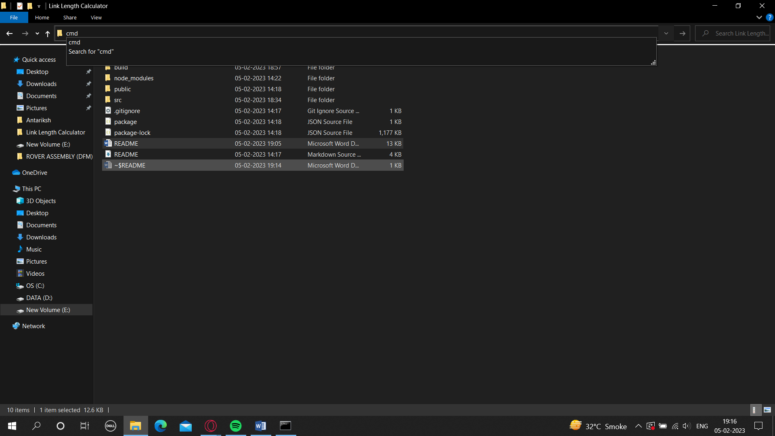

* 1. Type npm start and press enter



1. How to operate:
   1. Horizontal distance is the distance between the base of RA and the maintenance panel/object. The distance between the object and start of the wheel would be horizdist – 120mm.
   2. Vertical height is the height needed to reach by the RA’s end effector
   3. Ratio is the ratio between link 1 and link 2 with link 2 always being 1. Therefore, a ratio of 1.1 would mean link 1 is 1.1 times bigger than link 2.
   4. Range of link 2 is defined by range start and range end. This would enable us to change link lengths while maintaining the same ratio. For example say a ratio of 1.1 is chosen and a range of 400-500 is chosen, then all values of link lengths with the same ratio of 1.1 in the range 400-500 will be calculated for.
2. Logic:

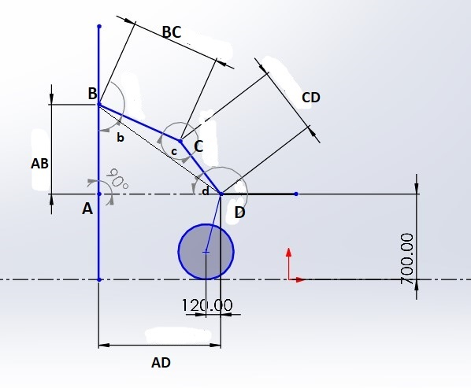

The Hypotenuse BD can be found through Pythagoras Theorem.

Then the angle BCD (c) can be found through the law of cosines:

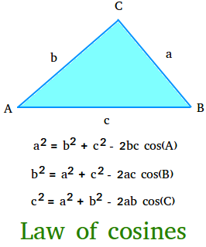

After finding the angle BCD we can find angles ADB and ABD by definition of sin (opp/hypt).

And the angles DBC and BDC can be found by the law of sines:

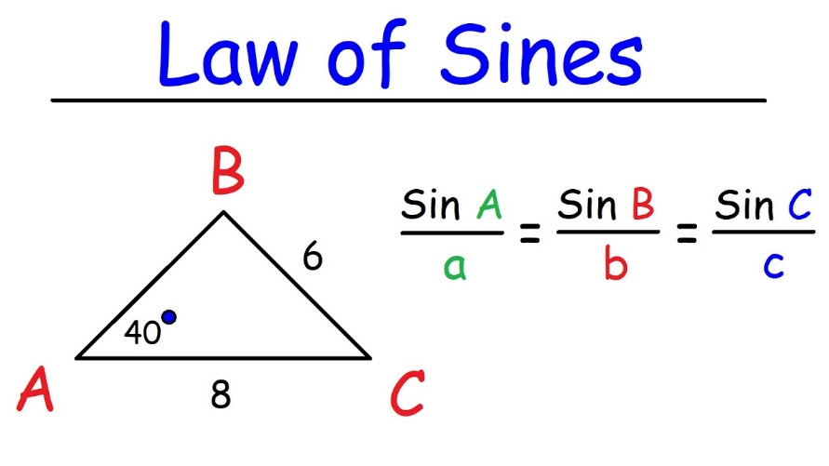

After adding ABD and DBC we get angle b and after adding angles ADB and BDC we get angle d. Thus the general formulas for them are:

