***F28WP Web Programming***

***Lab report***

***Lab 2***

**Student full name**: Abhinav Bhudarapu

**Student HWU username**: H00348223

**Student’s GitHub URL of the Lab**: https://github.com/AbhinavBhudarapu/F28wp-Lab02

**Demonstrated to Lab helper**: Gosain, Gaurav

**Mode of demonstration**: Online

**Date of demonstration**: 02/11/2021

**Time of demonstration**: 10:51 AM

Part 1: **HTML/CSS**

Final Web Page:

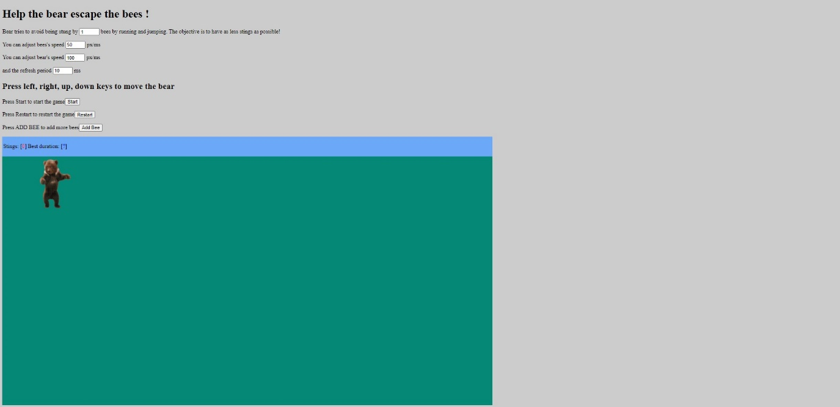

**Fig - 1.1**

Changes in HTML:

* Added the Start, Restart, Add bee Buttons
* Added an input field for adjusting the bear speed

Changes in CSS:

* Changes the background colour
* Resized the board and changed the colour

Part 2: **Bear motion**

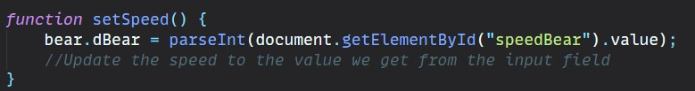

**Fig – 2.1**

First we make a function setSpeed() and get the values of speedBear by using getElementById,



**Fig – 2.2**

Then we call the function set speed in the function start()

Bear moves by the keys user presses and the speed user enters in the speedBear input field.

Bees moves by the speed user enters and refreshes by the input given in speedBees

**Part 3: Bee creation**

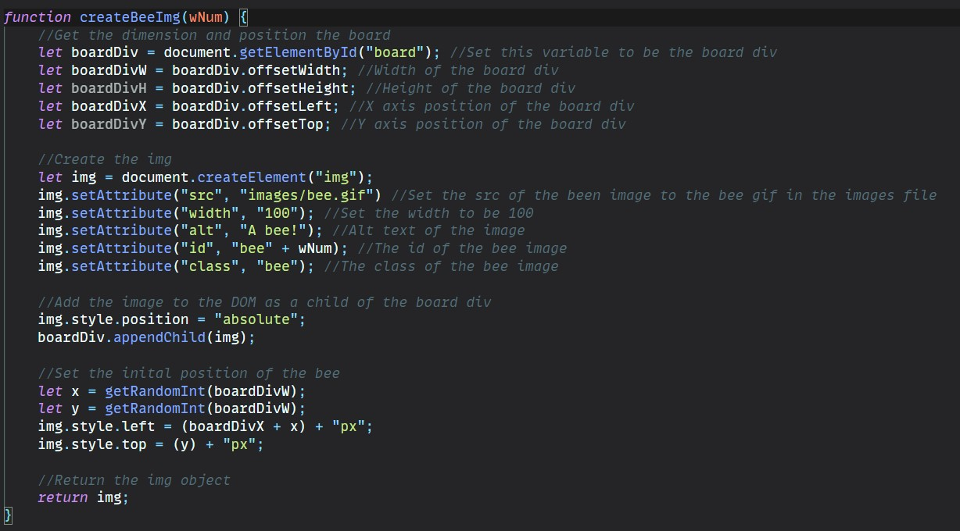

**Fig – 3.1**

First we get the board div and get the Height, Width, X axis position and Y axis position.

Then we create an element img then set the src to bee img after we set the width of the img a text and an id and a class bee.

Then we add the image to DOM as child of the board div and then set the initial positions od the bee img by using getRandomInt function and then we return img.

**Fig – 3.2**

First we create a function getRandomInt and return a random number by using Math.random() and by using Math.floor we get highest integer possible

**Part 4: Bee animation**

First we move bees in the moveBees function, then we use document.getElementById

For the input field periodTimer after getting the value we give the value to period in the updateBees function

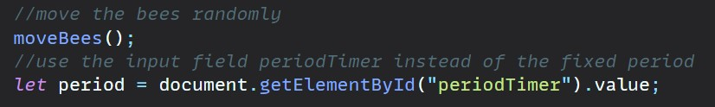 **Fig – 4.1**

**Part 5: Scores**

First, we make it function overlap by adding arguments element 1 an element 2

Then we get the rectangle around the first element and the second element assigning as left top right bottom to both element 1 and element 2.

Then we calculate the intersection between the rectangle by using Math.max, Math.min methods ,If the intersection is null it gives false if not it returns true

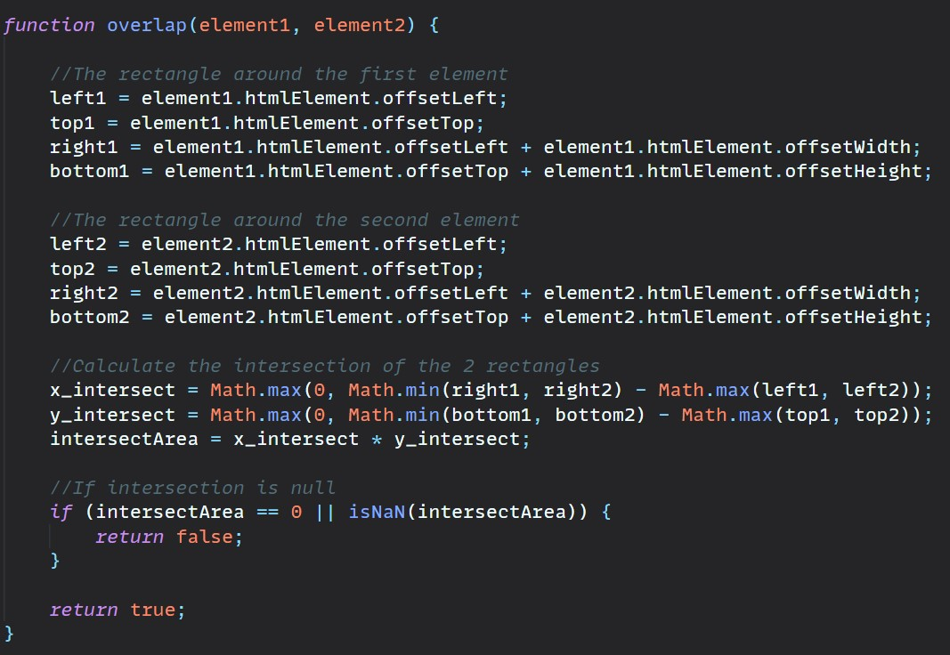 **Fig – 5.1**

If the score is less than 1000 then this updates the bee movement by the specified time interval given the user,if it hits 1000 then its score = “Game Over” and updateTimer = clearTimeout()

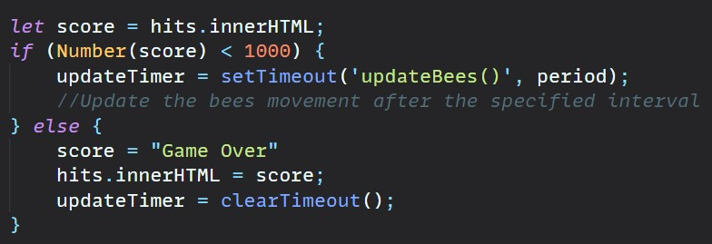 **Fig – 5.2**

Part 6: **Best duration**

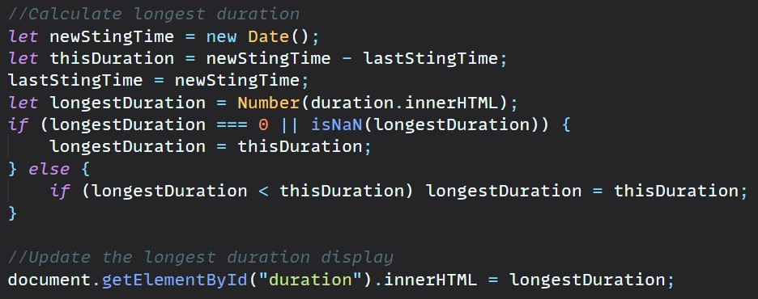

**Fig – 6.1**

We create a newStingTime and thisDuration, thisDuration = newStingTime – lastStingTime

Then lastStingTime is equal to newStingTime, then we give longest duration is a number from duration.innerHTML, If the longestDuration is 0 or null then longestDuration = thisDuration, else if longestDuration is less than this Duration of longestDuration = thisDuration, then we use getElementById of duration and it is equal to longestDuration

**Part 7: Additional features**

**1. Restarting the game**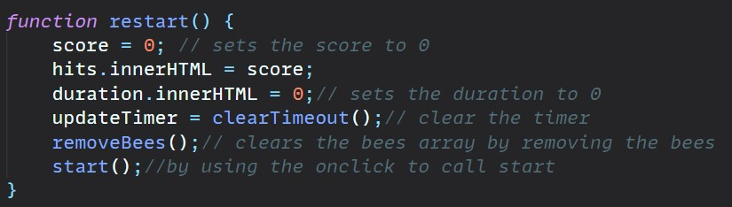

**Fig – 7.1**

By using onclick function given to the button restart it calls the function Restart() then its sets the score to 0 and hits.innerHTML to score, duration.innerHTML to 0 , its cleat the timer using clearTimeout() function then removebees function is called which clears the bees array by removing the bees and then calls the start() function to start the game.

**2. Add a bee**

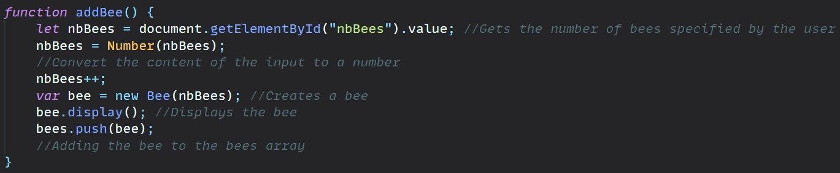

**Fig – 7.2**

In the addBee function first we the get the number of bees specified the by the user in the input field nbBees by using getElementById, then nbBees = Number(nbBees) this covert the content given in the input filed to a number, then nbBees++ which adds the bees,

Then var bee = new Bee(nbBees) this create a new bee, then we display the bee created, after push the created bee to the bee array