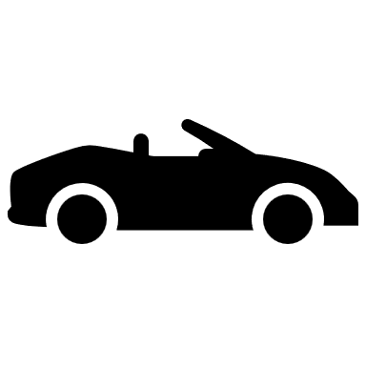

Distance:0

Score:0

Camera

