**Outline of the Goals and Tasks**

We must be able to simulate a disease with features like dengue. Dengue has 4 types of viruses which are called serotypes that affect each other because it makes a difference whether an infected person has been infected before.

Our tasks were to build a model to simulate 2 serotypes of dengue virus, perform parameter studies with different settings to know the model better, tweak the parameters to simulate the dengue disease for several years and compare AB and SD results.

**Technical Description of the Model (Agent-based Modeling)**

In order to simulate two (2) serotypes of dengue virus, we used the Agent-based modeling approach. According to Wikipedia, agent-based modeling refers to a class of [computational models](http://en.wikipedia.org/wiki/Computational_models) for [simulating](http://en.wikipedia.org/wiki/Computer_simulation) the actions and interactions of autonomous agents (both individual and collective entities such as organizations or groups) with a view to assessing their effects on the system as a whole.

The agents have various properties and behaviors. Its behavior is dependent with both the environment and its neighboring agents. An agent can get infected with two serotypes. When an agent who is infectious, has contact with another susceptible agent then there is a chance that the agent will also be infected due to this contact. If a susceptible agent is infected by the serotype 1 and becomes resistant to it, the agent can still get infected with the serotype 2 and vice versa. Only then can an agent be considered recovered if it had been infected with the two dengue serotypes and had become resistant to both.

To fully grasp the idea of simulating the effects of two serotypes of dengue virus, we implemented the SIR model. With this, the population is divided into three states: the Susceptible – healthy individuals who are not immune to the disease, the Infectious – individuals who has the disease and can transmit it, and the Resistant – individuals who had been previously infected and are now immune to the disease.

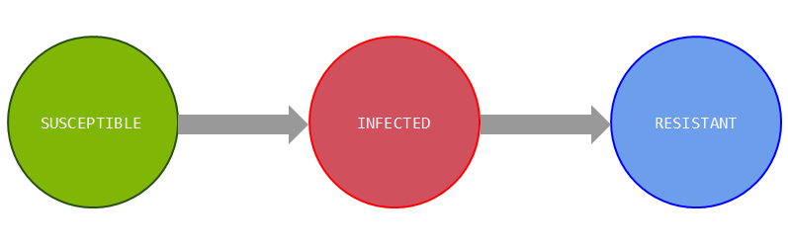

**Fig. 1 SIR Model**

Since we have to implement two serotypes, we propose an extension to the SIR model. Basically, we extended the model by adding various states to realistically represent the two serotypes. Each serotype has been given its own states, for Serotype 1, we have (Susceptible1, Infected1, Resistant1), and for Serotype 2, we have (Susceptible2, Infected2, Resistant2). With this, we were able to come up with the model:

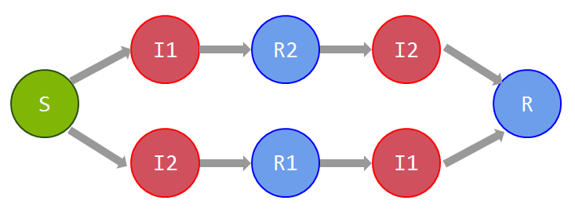

**Fig. 2 Extended SIR Model**

The model then shows how a susceptible agent has two possibilities of getting infected, either starting from Serotype 1 to Serotype 2 or from Serotype 2 to Serotype 1 until fully recovered.

In addition to our model, we also considered the behavior of an agent before getting infected. An agent is not necessarily infectious once in contact with the dengue serotype, it is given latent time before fully getting infected. The same goes with an agent getting resistant to a certain serotype. It is given days before being considered as resistant. This is represented with the variables, Alpha and Beta. Alpha is the latent time given before getting infected and Beta is the time given before getting resistant.

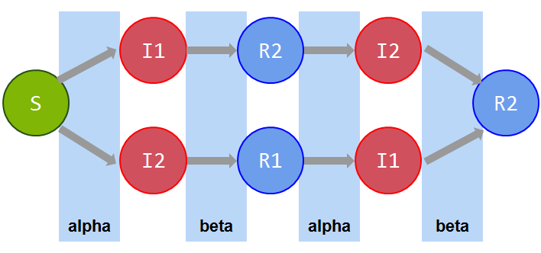

**Fig. 3 Alpha – Beta Structure**

**Discussion of results (Agent-based Modeling):**

**TEST 1**

|  |  |
| --- | --- |
| Parameter | Value |
| Population | 20 000 |
| SER1-alpha | 7 |
| SER2-alpha | 5 |
| SER1-beta | 4 |
| SER2-beta | 4 |
| Run Time | 1 year |
| Infection Probability | 0.9 |
| SER1 Init Infected | 1500 |
| SER2 Init Infected | 2000 |
| SER1 Init Resistant | 600 |
| SER2 Init Resistant | 400 |

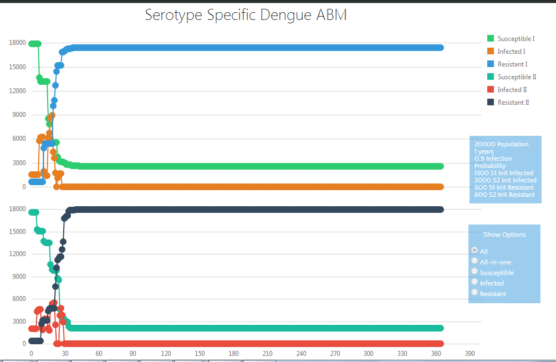

**Analysis and Interpretation:**

With an infection probability of 0.9, 1500 infected agents initially for Serotype 1, 2000 infected agents for Serotype 2, 600 resistant agents initially for Serotype 1 and 400 resistant agents initially for Serotype 2, the graph above shows that as the epidemic breaks out, the number of susceptible agents decreases while the number of infected agents increases starting at day five. It decreases at day 10 due to recovery and once again increases at day 15 because of the agents who were susceptible to the infection or those agents who recovered from the other serotype. This continues until day 30 and decreases after this day. The number of resistant agents increases rapidly and stabilizes after day 30. As you can see, the results show that with an infection probability of 0.9 and greater number of initially infected agents, the susceptible agents are more prone to the infection.

**TEST 2**

|  |  |
| --- | --- |
| Parameter | Value |
| Population | 20 000 |
| SER1-alpha | 7 |
| SER2-alpha | 5 |
| SER1-beta | 4 |
| SER2-beta | 4 |
| Run Time | 1 year |
| Infection Probability | 0.025 |
| SER1 Init Infected | 600 |
| SER2 Init Infected | 900 |
| SER1 Init Resistant | 1400 |
| SER2 Init Resistant | 1600 |

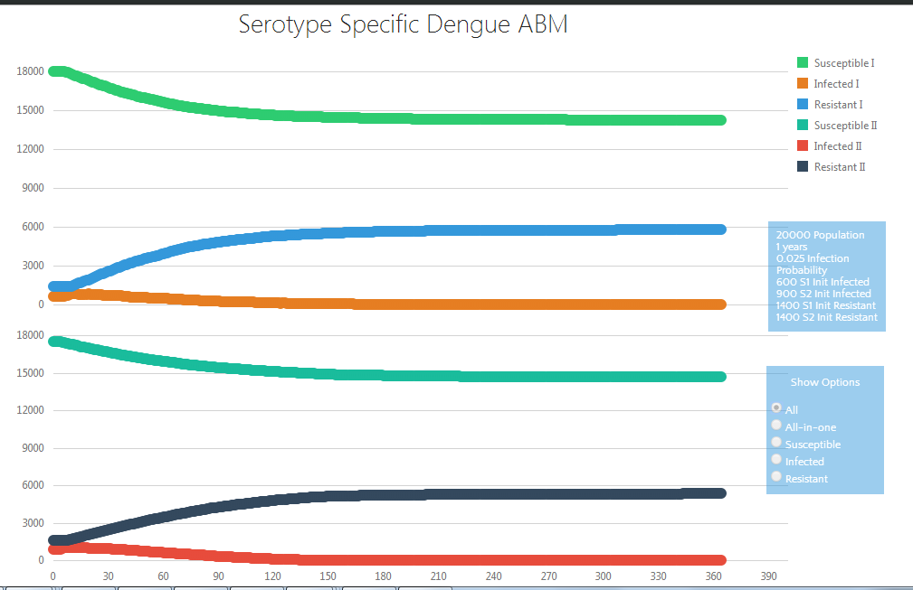

**Analysis and Interpretation:**

With an infection probability of 0.025, 600 infected agents initially for Serotype 1, 900 infected agents for Serotype 2, 1400 resistant agents initially for Serotype 1 and 1600 resistant agents initially for Serotype 2, the graph above shows that as the epidemic breaks out, the number of susceptible agents decreases while the number of infected agents increases starting at day five. It decreases starting at day 20 due to the recovery of the previous infected agents. The number of resistant agents slowly increases and stabilizes after day 210. As you can see, the results show that with a small infection probability of 0.025 and smaller number of initially infected agents, the susceptible agents are less prone to the infection.

**TEST 3**

|  |  |
| --- | --- |
| Parameter | Value |
| Population | 20 000 |
| SER1-alpha | 7 |
| SER2-alpha | 5 |
| SER1-beta | 4 |
| SER2-beta | 4 |
| Run Time | 1 year |
| Infection Probability | 0.025 |
| SER1 Init Infected | 1600 |
| SER2 Init Infected | 1400 |
| SER1 Init Resistant | 400 |
| SER2 Init Resistant | 600 |

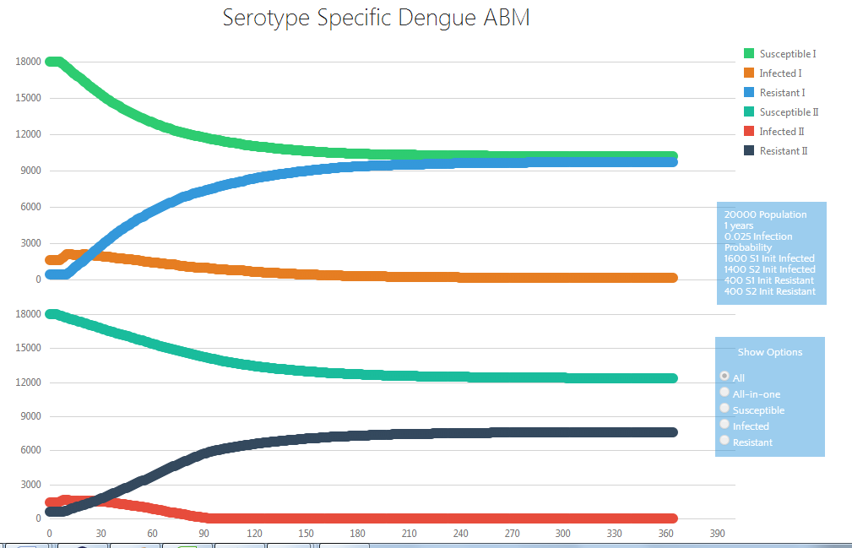

**Analysis and Interpretation:**

With an infection probability of 0.025, 1600 infected agents initially for Serotype 1, 1400 infected agents for Serotype 2, 400 resistant agents initially for Serotype 1 and 600 resistant agents initially for Serotype 2, the graph above shows that as the epidemic breaks out, the number of susceptible agents decreases while the number of infected agents increases starting at day five. It decreases starting at day 7 due to the recovery of the previous infected agents. The number of resistant agents slowly increases and stabilizes after day 270. As you can see, the results show that with a small infection probability of 0.025 but with greater number of initially infected agents, the susceptible agents are most likely prone to the infection.

**TEST 4**

|  |  |
| --- | --- |
| Parameter | Value |
| Population | 20 000 |
| SER1-alpha | 7 |
| SER2-alpha | 5 |
| SER1-beta | 4 |
| SER2-beta | 4 |
| Run Time | 1 year |
| Infection Probability | 0.2 |
| SER1 Init Infected | 2500 |
| SER2 Init Infected | 1500 |
| SER1 Init Resistant | 400 |
| SER2 Init Resistant | 600 |

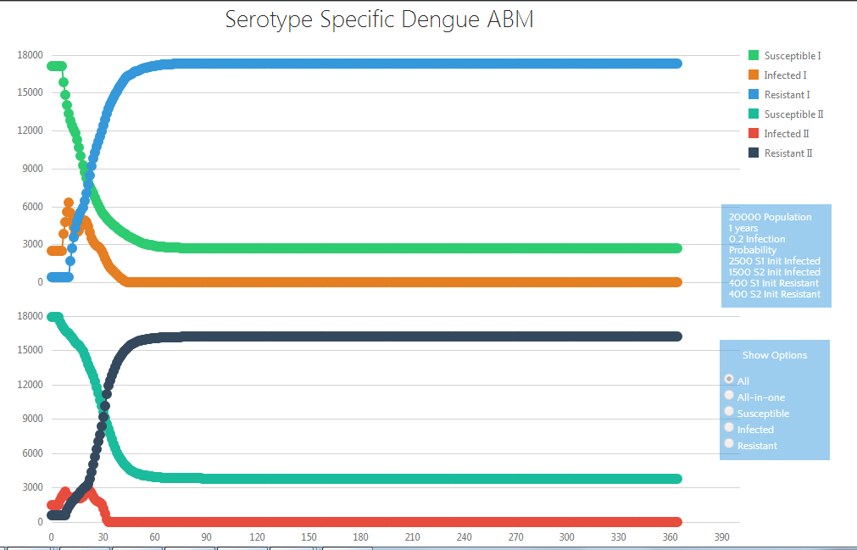

**Analysis and Interpretation:**

With an infection probability of 0.2, 2500 infected agents initially for Serotype 1, 1500 infected agents for Serotype 2, 400 resistant agents initially for Serotype 1 and 600 resistant agents initially for Serotype 2, the graph above shows that as the epidemic breaks out, the number of susceptible agents decreases while the number of infected agents increases starting at day five. It decreases at day 15 due to recovery and once again increases at day 20 because of the agents who were susceptible to the infection or those agents who recovered from the other serotype. This continues until day 27 and decreases after this day. The number of resistant agents increases rapidly and stabilizes after day 90. As you can see, the results show that with an infection probability of 0.2 and greater number of initially infected agents, the susceptible agents are more prone to the infection.

**Technical Description of the Model (System Dynamics)**

The model was built through system dynamics approach based on the SEIR (Susceptible, Exposed, Infected, and Recovered) modelling technique. It is composed of stocks (levels), flows (rates) and auxiliary variables that would make the model function as a whole. There are two possible paths that a population can get infected. The first possibility is the path from Serotype 1 to Serotype 2. If a population gets infected with Serotype 1 and recovers from it, it is already resistant to it but it is still prone to getting infected with Serotype 2. If a population gets infected with Serotype 2 and recovers from it, it is already resistant to it. The second possibility is the path from Serotype 2 to Serotype 1. If a population gets infected with Serotype 2 and recovers from it, it is already resistant to it but it is still prone to getting infected with Serotype 1. If a population gets infected with Serotype 1 and recovers from it, it is already resistant to it. Therefore, a population fully recovers if and only if it has already been infected with both serotypes. The model was built this way because of the two possibilities that a person can get infected.

**Stocks (Levels):**

|  |  |  |
| --- | --- | --- |
| Possibilities | Description | Variable Names |
| First Possibility (from Serotype 1 to Serotype 2) | Susceptible Population | S |
| Exposed Population of Serotype 1 | E1a |
| Infected Population of Serotype 1 | I1a |
| Recovered Population of Serotype 1 | R1a |
| Exposed Population of Serotype 2 | E1b |
| Infected Population of Serotype 2 | I1b |
| Recovered Population of Serotype 2 | R1b |
| Second Possibility (from Serotype 2 to Serotype 1) | Susceptible Population | S |
| Exposed Population of Serotype 2 | E2a |
| Infected Population of Serotype 2 | I2a |
| Recovered Population of Serotype 2 | R2a |
| Exposed Population of Serotype 1 | E2b |
| Infected Population of Serotype 1 | I2b |
| Recovered Population of Serotype 1 | R2b |

* Susceptible Population - healthy population
* Exposed Population – a population that may be exposed to the disease but have not yet shown infectious behavior
* Infected Population – infected population with the disease
* Recovered Population – recovered population from the disease

**Flows (Rates):**

|  |  |  |
| --- | --- | --- |
| Possibilities | Description | Variable Names |
| First Possibility (from Serotype 1 to Serotype 2) | Exposure Rate of Serotype 1 | ER1a |
| Infection Rate of Serotype 1 | IR1a |
| Recovery Rate of Serotype 1 | RR1a |
| Exposure Rate of Serotype 2 | ER1b |
| Infection Rate of Serotype 2 | IR1b |
| Recovery Rate of Serotype 2 | RR1b |
| Second Possibility (from Serotype 2 to Serotype 1) | Exposure Rate of Serotype 2 | ER2a |
| Infection Rate of Serotype 2 | IR2a |
| Recovery Rate of Serotype 2 | RR2a |
| Exposure Rate of Serotype 1 | ER2b |
| Infection Rate of Serotype 1 | IR2b |
| Recovery Rate of Serotype 1 | RR2b |

* Exposure Rate – the rate in which a population can get exposed
* Infection Rate – the rate in which a population can get infected
* Recovery Rate – the rate in which a population can be recovered

**Auxiliary Variables:**

|  |  |  |
| --- | --- | --- |
| Description | Variable Name for Serotype 1 | Variable Name for Serotype 2 |
| Infection Probability | IP1 | IP2 |
| Incubation Time | IT1 | IT2 |
| Length of Illness | LOI1 | LOI2 |
| Fractional Infection Rate | FIR1 | FIR2 |
| Fractional Recovery Rate | FRR1 | FRR2 |
| Total Infectious Contacts | TIC1a (First Possibility)  TIC2b (Second Possibility) | TIC1b (First Possibility)  TIC2a (Second Possibility) |
| Total Population | TPOP | |

* Infection Probability – probability a population can get infected
* Incubation Time – a time delay before a population can get infected
* Length of Illness – a period it takes for the disease to last
* Fractional Infection Rate
* Fractional Recovery Rate
* Total Infectious Contacts – total population of the exposed and infected
* Total Population

**Discussion of results (System Dynamics):**

**TEST 1**

|  |  |  |
| --- | --- | --- |
| Parameter | Value |  |
| S | 9400 | **First Possibility from Serotype 1 to Serotype 2**  **Second Possibility from Serotype 2 to Serotype 1** |
| E1a | 300 |
| I1a | 150 |
| R1a | 80 |
| E1b | 30 |
| I1b | 20 |
| R | 10 |
| E2a | 350 |
| I2a | 140 |
| R2a | 65 |
| E2b | 20 |
| I2b | 15 |
| IP1 | 0.9 |
| IP2 | 0.9 |
| IT1 | 7 |
| IT2 | 5 |
| LOI1 | 4 |
| LOI2 | 4 |
| TPOP | 20000 |

**Analysis and Interpretation:**

With an infection probability of 0.9, the graph of the first possibility above shows that as the epidemic breaks out, the susceptible population rapidly decreases while the exposed and infected population of Serotype 1 increases. While the exposed population of Serotype 1 decreases, the infected population of Serotype 1 decreases as well. The recovered population of Serotype 1 increases rapidly and decreases eventually because it is considered the susceptible population for Serotype 2. The fully recovered population from both serotypes increases and stabilizes at day 70. As you can see, the results show that with an infection probability of 0.9, the susceptible population are more prone to the infection. The graph of the second possibility exhibits the same trend with the graph of the first possibility.

**TEST 2**

|  |  |  |
| --- | --- | --- |
| Parameter | Value |  |
| S | 9400 | **First Possibility from Serotype 1 to Serotype 2**    **Second Possibility from Serotype 2 to Serotype 1** |
| E1a | 300 |
| I1a | 150 |
| R1a | 80 |
| E1b | 30 |
| I1b | 20 |
| R | 10 |
| E2a | 350 |
| I2a | 140 |
| R2a | 65 |
| E2b | 20 |
| I2b | 15 |
| IP1 | 0.2 |
| IP2 | 0.2 |
| IT1 | 7 |
| IT2 | 5 |
| LOI1 | 4 |
| LOI2 | 4 |
| TPOP | 20000 |

**Analysis and Interpretation:**

With an infection probability of 0.2, the graph of the first possibility above shows that as the epidemic breaks out, the susceptible population decreases while the exposed population of Serotype 1 increases. While the exposed population of Serotype 1 increases, the infected population of Serotype 1 increases as well. When the exposed population of Serotype 1 decreases, the infected population of Serotype 1 also decreases. The recovered population of Serotype 1 increases but decreases eventually because it is considered as the susceptible population for Serotype 2. As the exposed population of Serotype 2 increases, the infected population of Serotype 2 also increases. When the exposed population of Serotype 2 decreases, the infected population of Serotype 2 decreases as well. The fully recovered population from both serotypes increases and stabilizes at day 200. As you can see, the results show that with an infection probability of 0.2, the susceptible population is most likely prone to the infection. The graph of the second possibility exhibits the same trend with the graph of the first possibility.

**TEST 3**

|  |  |  |
| --- | --- | --- |
| Parameter | Value |  |
| S | 9400 | **First Possibility from Serotype 1 to Serotype 2**    **Second Possibility from Serotype 2 to Serotype 1** |
| E1a | 300 |
| I1a | 150 |
| R1a | 80 |
| E1b | 30 |
| I1b | 20 |
| R | 10 |
| E2a | 350 |
| I2a | 140 |
| R2a | 65 |
| E2b | 20 |
| I2b | 15 |
| IP1 | 0.025 |
| IP2 | 0.025 |
| IT1 | 7 |
| IT2 | 5 |
| LOI1 | 4 |
| LOI2 | 4 |
| TPOP | 20000 |

**Analysis and Interpretation:**

With an infection probability of 0.025, the graph of the first possibility above shows that as the epidemic breaks out, the susceptible population slowly decreases while the exposed population of Serotype1 slowly increases. While the exposed population of Serotype 1 slowly increases, the infected population of Serotype 1 increases as well. When the exposed population of Serotype 1 slowly decreases, the infected population of Serotype 1 also slowly decreases. The recovered population of Serotype 1 increases and stabilizes at day 25. As you can see, the results show that with an infection probability of 0.025, the susceptible population is less likely prone to the infection. The graph of the second possibility exhibits the same trend with the graph of the first possibility.

**Comparison of AB and SD Results**

|  |  |
| --- | --- |
| **Agent-based Modeling Parameters** | **System Dynamics Modeling Parameters** |
| |  |  | | --- | --- | | Parameter | Value | | Population | 20000 | | SER1-alpha | 7 | | SER2-alpha | 5 | | SER1-beta | 4 | | SER2-beta | 4 | | Run Time | 1 year | | Infection Probability | 0.2 | | SER1 Init Infected | 2000 | | SER2 Init Infected | 2000 | | SER1 Init Resistant | 500 | | SER2 Init Resistant | 500 | | |  |  | | --- | --- | | Parameter | Value | | Susceptible Population | 9400 | | SER1 Exposed | 300 | | SER1 Infected | 150 | | SER1 Recovered | 80 | | SER2 Exposed | 30 | | SER2 Infected | 20 | | SER2 Recovered | 10 | | SER2 Exposed | 350 | | SER2 Infected | 140 | | SER2 Recovered | 65 | | SER1 Exposed | 20 | | SER1 Infected | 15 | | SER1 Infection Probability | 0.2 | | SER2 Infection Probability | 0.2 | | SER1 Incubation Time | 7 | | SER2 Incubation Time | 5 | | SER1 Length of Illness | 4 | | SER2 Length of Illness | 4 | | Total Population | 20000 | |

Agent-based Modeling and System Dynamics Comparison

|  |  |
| --- | --- |
| S | 9400 |
| E1a | 300 |
| I1a | 150 |
| R1a | 80 |
| E1b | 30 |
| I1b | 20 |
| R | 10 |
| E2a | 350 |
| I2a | 140 |
| R2a | 65 |
| E2b | 20 |
| I2b | 15 |
| IP1 | 0.2 |
| IP2 | 0.2 |
| IT1 | 7 |
| IT2 | 5 |
| LOI1 | 4 |
| LOI2 | 4 |
| TPOP | 20000 |