Task 1 –

Part a - reno

Throughput

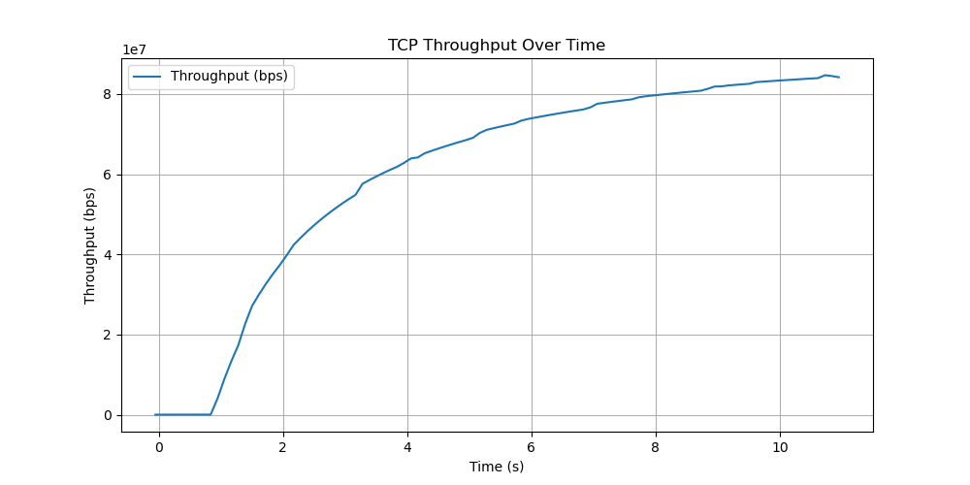

Goodput: 92.20 Mbps

Packet Loss Rate: 48.82%

Maximum Window Size: 43440 bytes

Task 2

No mitigation -

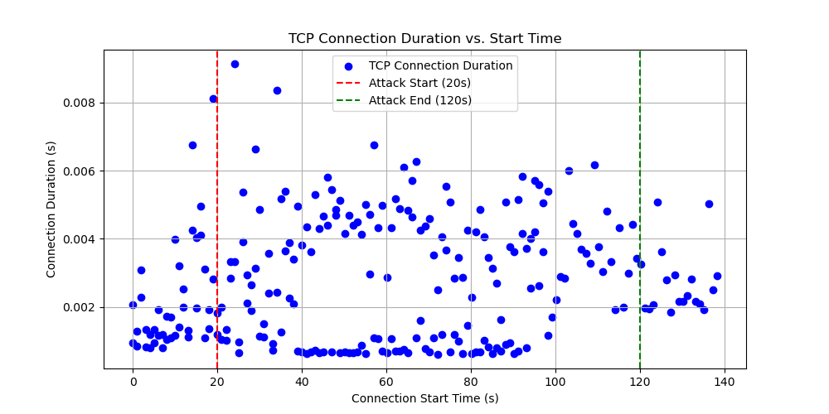

With mitigation -

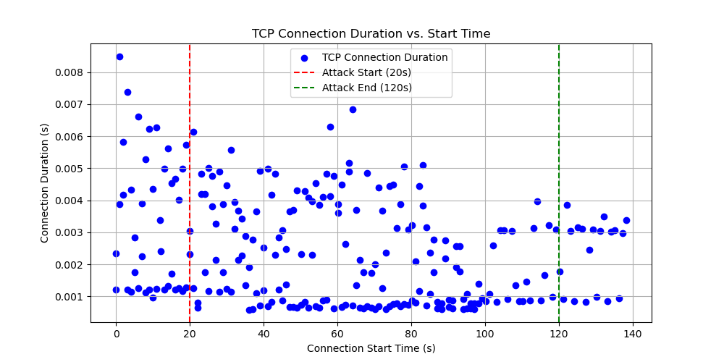

Task 3 –

TCP_NODELAY = 0, Delayed-ACK = 1

Total Duration: 100.14 sec

Throughput: 175.23 bytes/sec

Goodput: 39.56 bytes/sec

Packet Loss Rate: 49.27%

Maximum Packet Size: 106 bytes

TCP_NODELAY = 1, Delayed-ACK = 1

Total Duration: 100.14 sec

Throughput: 175.22 bytes/sec

Goodput: 39.55 bytes/sec

Packet Loss Rate: 49.27%

Maximum Packet Size: 106 bytes

TCP_NODELAY = 1, Delayed-ACK = 0

Total Duration: 100.14 sec

Throughput: 175.22 bytes/sec

Goodput: 39.55 bytes/sec

Packet Loss Rate: 49.27%

Maximum Packet Size: 106 bytes

TCP_NODELAY = 0, Delayed-ACK = 0

Total Duration: 100.14 sec

Throughput: 175.23 bytes/sec

Goodput: 39.55 bytes/sec

Packet Loss Rate: 49.27%

Maximum Packet Size: 106 bytes