Disaster Relief Management System with Weather & Landslide Prediction

Project Team Members
- Abhinav K
- Mishab E M
- Sana Fathima P
- Rinshida P

Introduction
Disasters are unavoidable events that cause severe damage to life, property, and the environment. They may occur due to natural causes such as floods, landslides, cyclones, and extreme weather conditions, or due to human activities. An effective disaster management system plays a crucial role in minimizing losses by ensuring timely response, efficient coordination, and proper utilization of resources.
Weather prediction has become an essential component of modern disaster management. Accurate forecasting enables early warnings, proper evacuation planning, and faster deployment of relief measures. This project proposes a web-based disaster relief management system integrated with weather prediction and user reporting features to improve disaster preparedness, response, and recovery.

Problem Statement
Existing disaster management systems rely heavily on manual processes and paperwork, which results in delayed responses and poor coordination among authorities, volunteers, and the public. Many available applications lack real-time communication, proper coordination mechanisms, and effective disaster prediction support. These limitations increase the risk of loss of life and property during disasters.

Objectives of the Project
- To provide an efficient disaster relief management system
- To integrate weather prediction for early disaster warnings
- To improve communication and coordination among authorities, volunteers, and the public
- To enable users to report real-time disaster issues such as floods and landslides
- To support quick evacuation, rescue, and relief operations

Existing System
Currently, several disaster-related websites and applications exist, but most of them are not properly implemented or maintained. Manual paperwork is still widely used, leading to inefficiency and delays.

Limitations of Existing System
- No timely response during emergencies
- Poor communication and coordination
- Lack of centralized disaster information system

Proposed System
The proposed system is an integrated disaster relief management platform that combines weather prediction with real-time disaster response mechanisms. The system helps authorities organize, plan, and execute disaster preparedness and recovery measures effectively.
It includes:
- Weather prediction for early warnings
- Interactive chatbot for real-time guidance
- User reporting of floods, landslides, and hazards
- Resource planning and camp management
- Volunteer coordination and emergency response tracking
This system enhances community participation and significantly reduces disaster impact through faster and more coordinated actions.

Modules Description

Admin
- Add and manage relief camps
- Manage camp coordinators
- Verify emergency response teams
- Handle complaints
- Issue notifications and guidelines
- View user-reported disaster issues
- View news

Camp Coordinator
- Stock and resource management
- Register camp members
- Identify needs and medical support
- View user disaster reports
- View news

Volunteer
- View required resources
- Collect and manage goods
- Provide services
- Request medical assistance
- View news

Public
- User registration
- View needs and donate goods
- Send emergency requests
- Report disaster incidents
- View weather predictions
- View News

Emergency Response Team
- Registration and login
- View emergency requests
- Access weather predictions
- View disaster reports
- View news
News Reporter
- Registration and login
- Manage News

Data Flow Diagram
Level 0

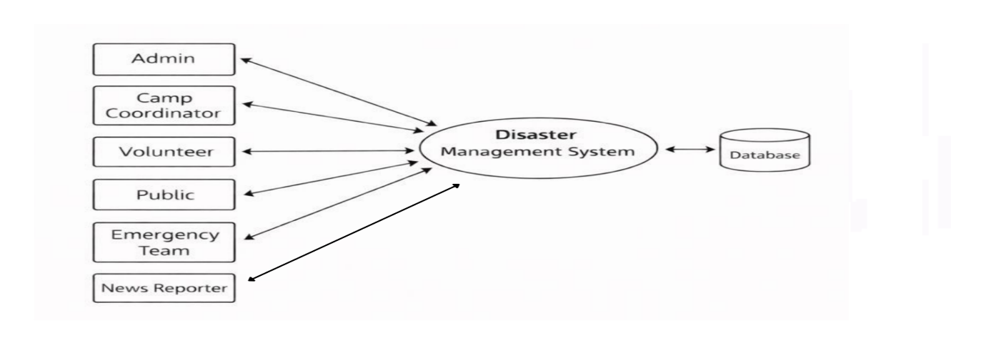

Level 1

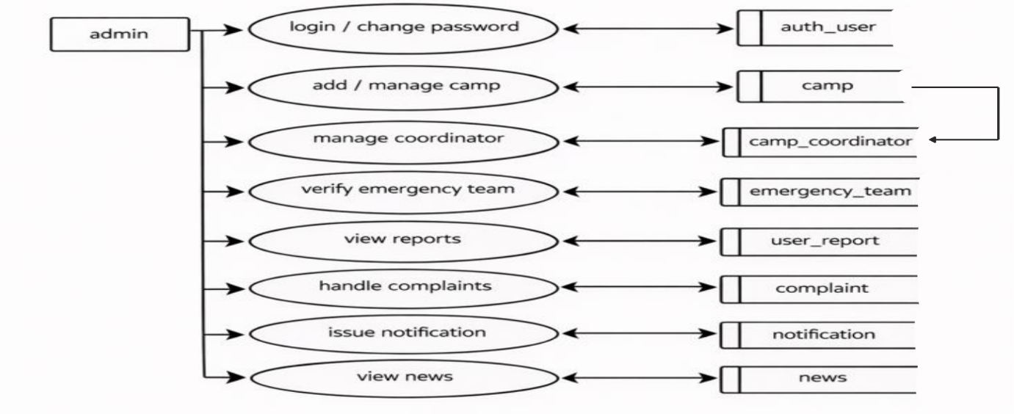

Level 2

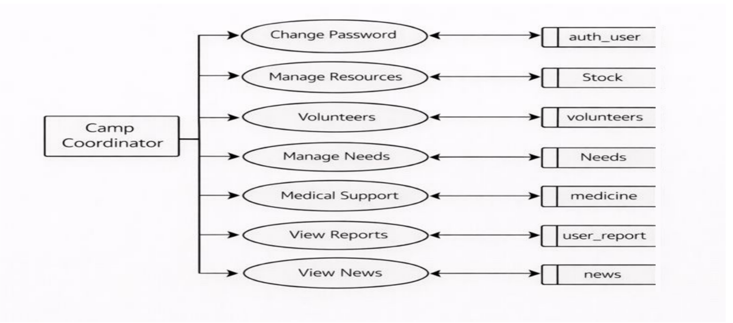

Level 3

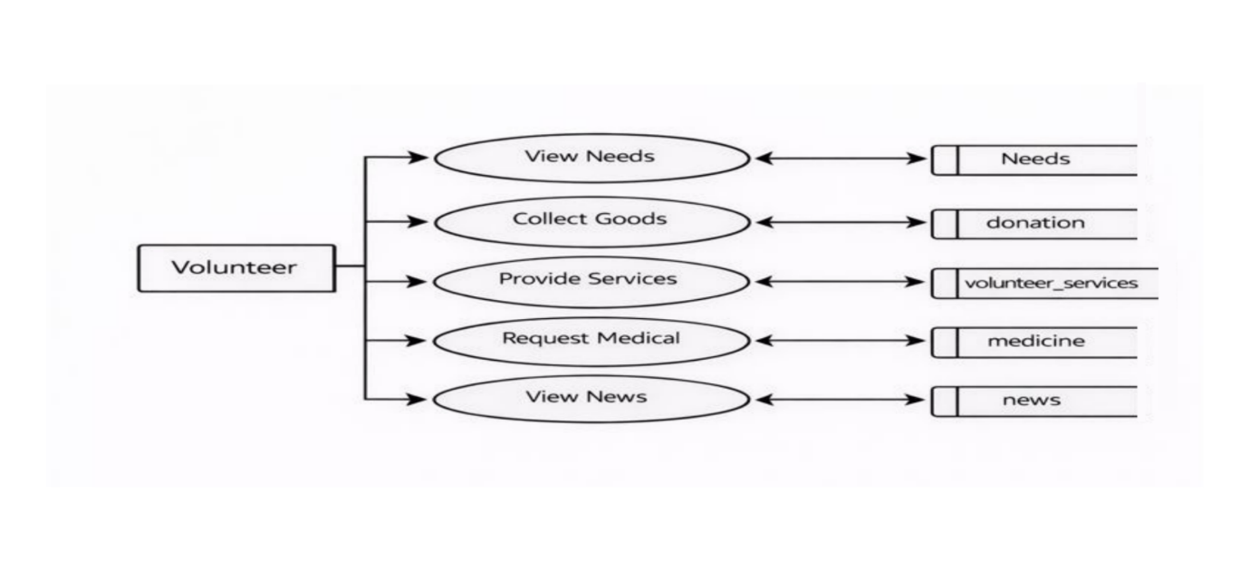

Level 4

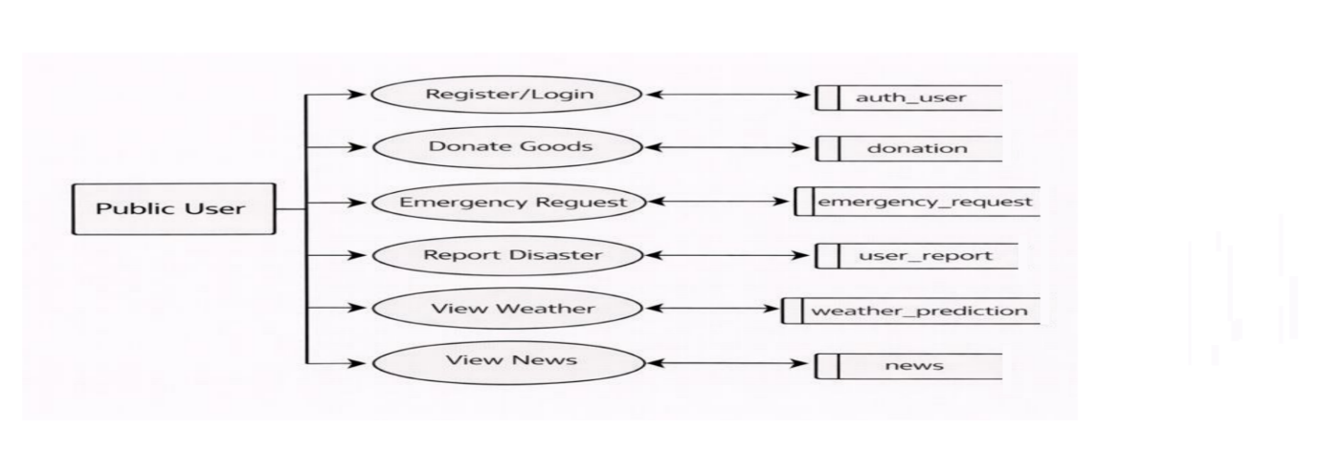

Level 5

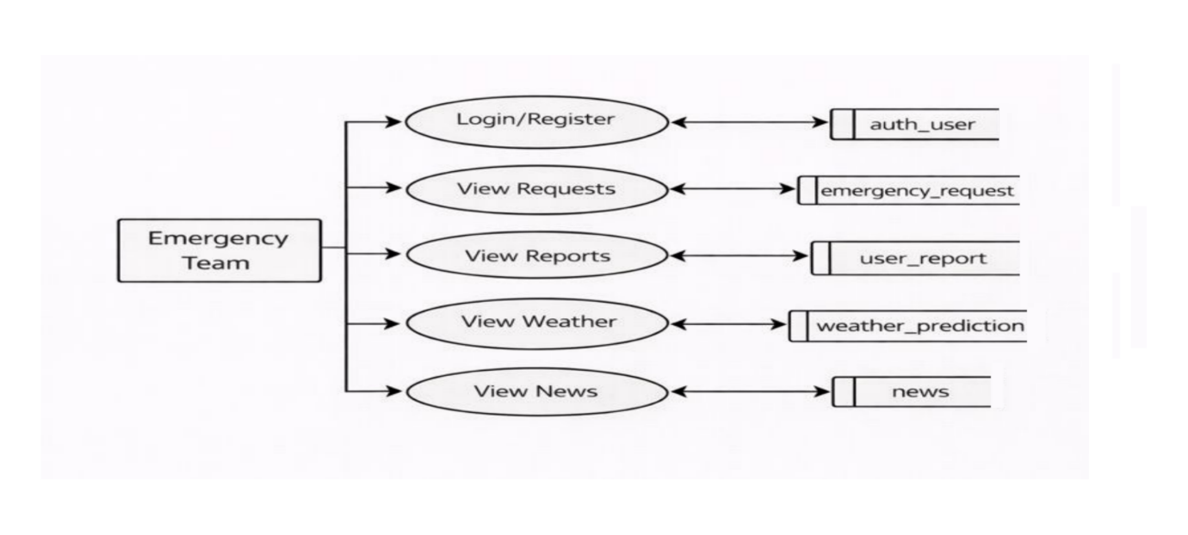

Level 6

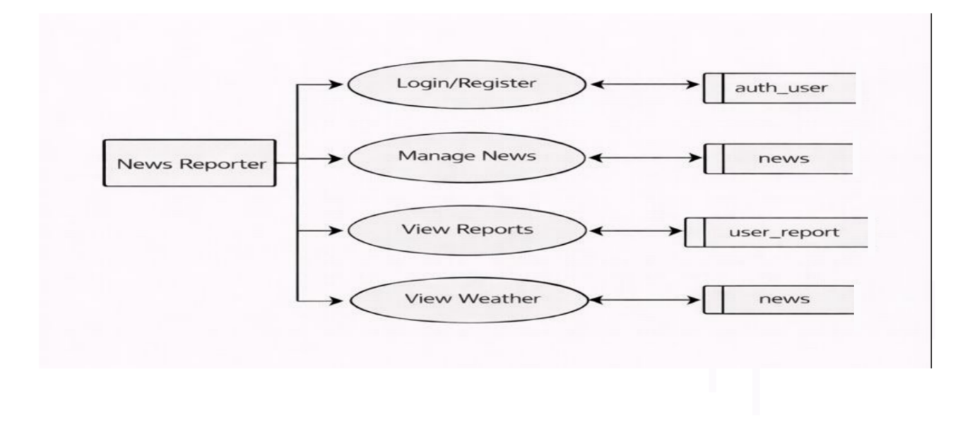

Advantages of the Proposed System
- Identifies disaster-prone locations
- Ensures fast communication and coordination
- Helps in evacuation, rescue, and relief operations
- Encourages community participation
- Reduces response time and saves lives

Hardware Requirements
- Processor: Intel Pentium or above
- RAM: 4 GB or more
- Storage: 40 GB or more
- Monitor: LED Display
- Keyboard & Mouse: Windows compatible

Software Requirements
- Operating System: Windows 8 or above
- Database: MySQL
- Front End: HTML, CSS, Bootstrap, JavaScript
- Back End: Python (Django), Flutter / Java
- IDE: PyCharm Community, Android Studio, Eclipse
- Browser: Chrome, Edge, Internet Explorer

Conclusion
The Disaster Relief Management System with Weather and Landslide Prediction provides an efficient and reliable solution for disaster preparedness and response. By integrating weather forecasting, real-time reporting, and coordinated relief operations, the system minimizes losses, improves response efficiency, and supports faster recovery during disasters.

