**HTML**

**Hyper Text Markup Language**

Heading Tags

There are 6 heading tags

<h1></h1> ==> large font size

<h2></h2>

<h3></h3>

<h4></h4>

<h5></h5>

<h6></h6> ==> smaller size font (the last size for headings)

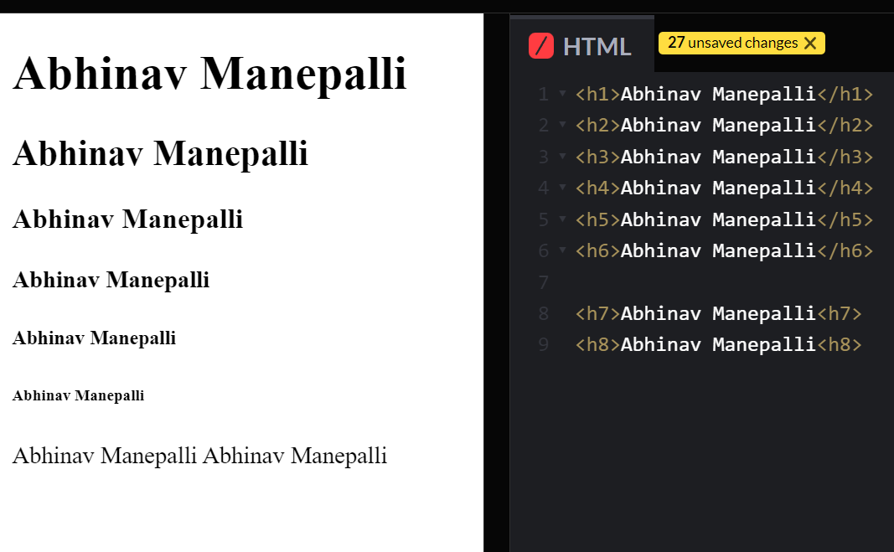

**Line Break**

**<br>**

When you give multiple spaces or type in the next line html dosent conscider it so we use line break tag

Line break dosent need an end tag

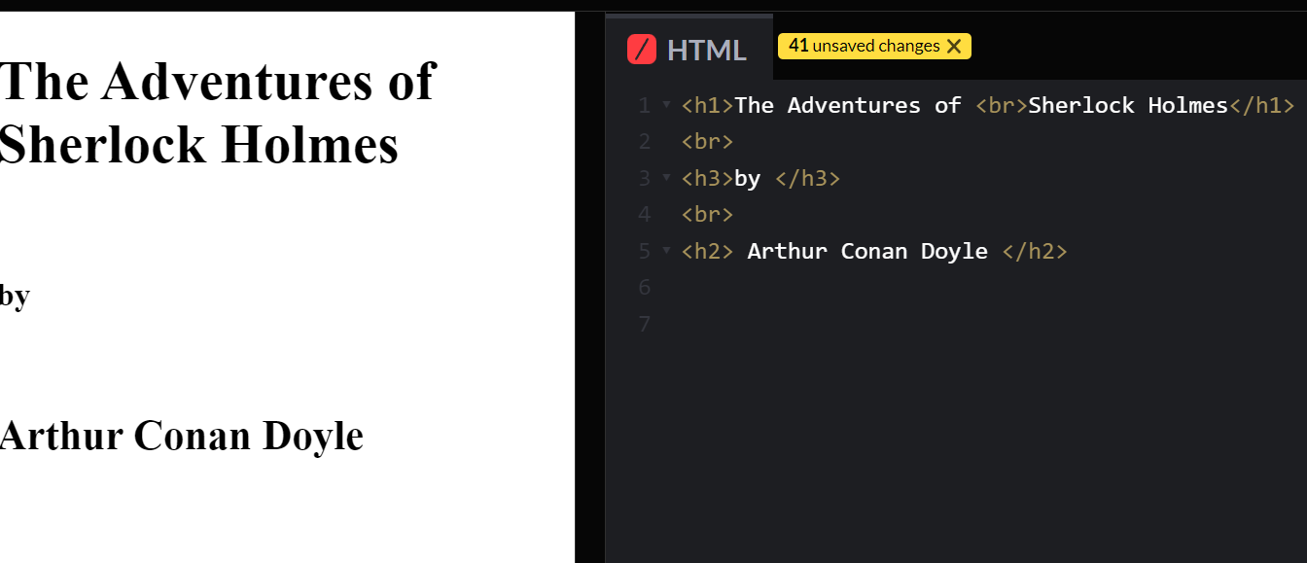

**horizontal rule**

**<hr>**

it is a horizontal line from start to end

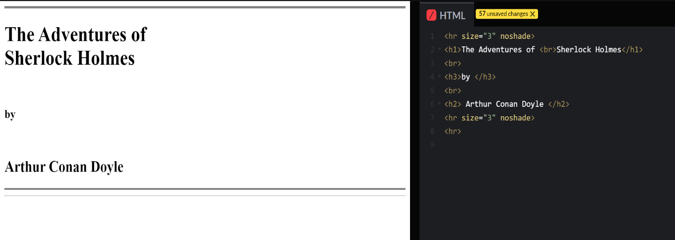Line break dosent need an end tag

in the above pic we can see that we used

<hr size = “3” noshade >

The orange colour is the HTML tag

The blue color is the HTML attribute

we can refer documentation to know about the attributes of an HTML tag

https://developer.mozilla.org/en-US/docs/Web/HTML

<hr> attributes

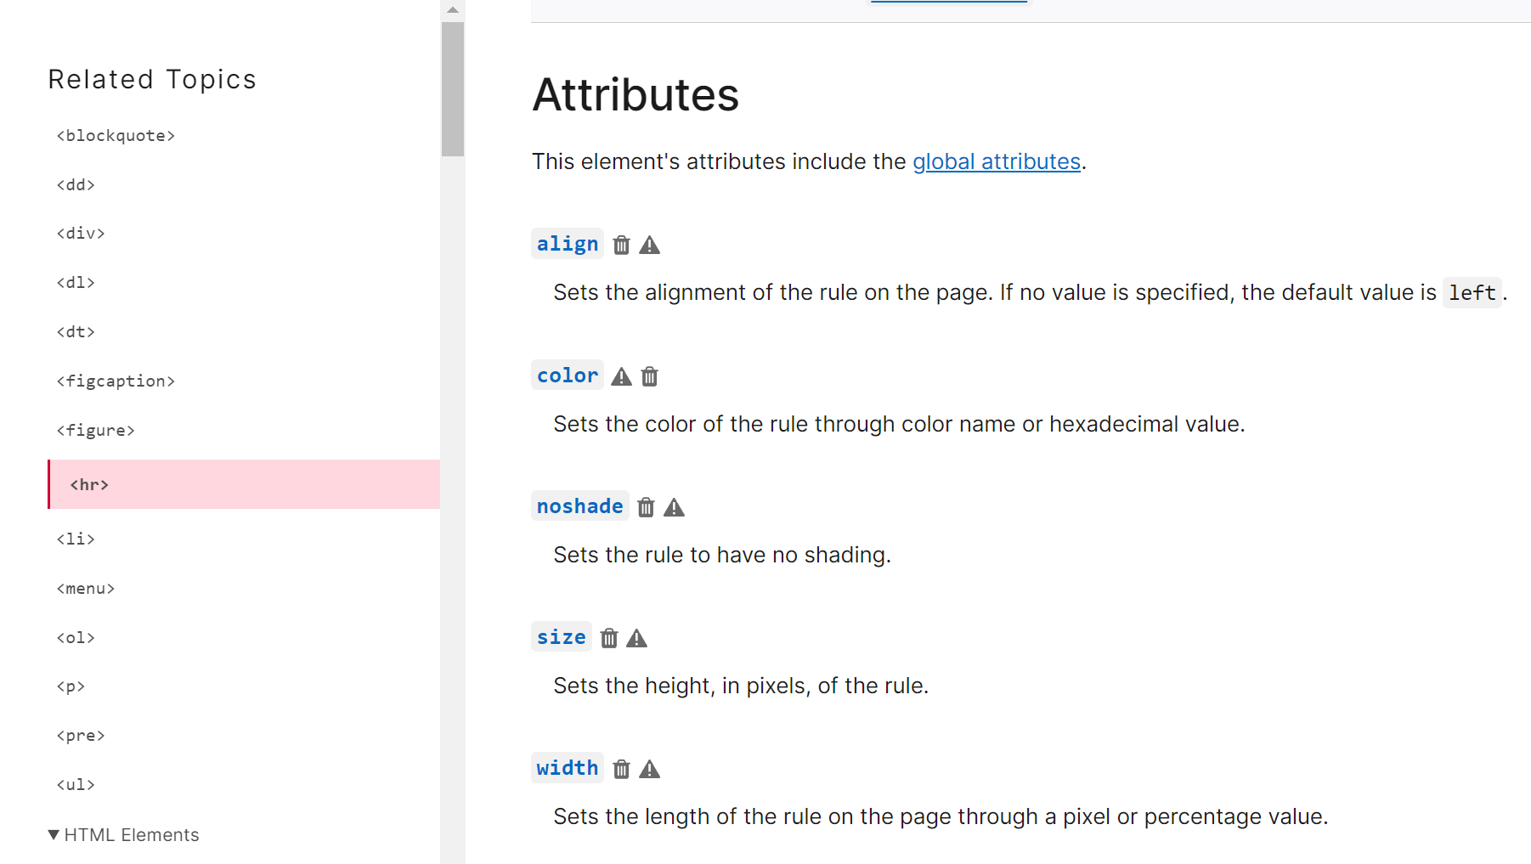

**Center Tag**

**<center></center>**

This element will align everything in between the tags in center

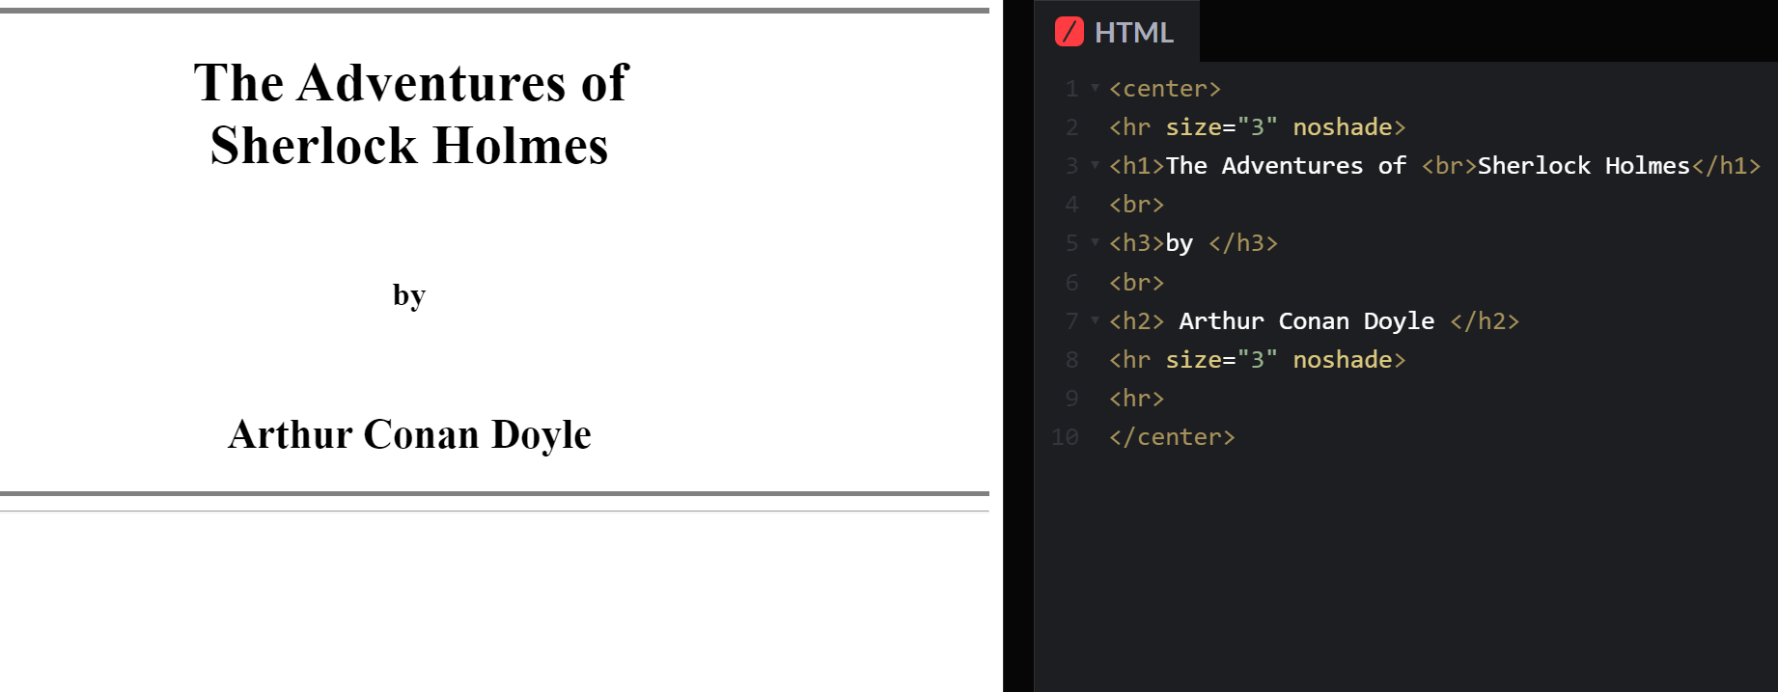

**HTML BOILER PLATE TEMPLATE**

<!DOCTYPE html>

<html>

<head>

<meta charset="UTF-8">

<title>Document</title>

</head>

<body></body>

</html>

An HTML file consists of <!DOCTYPE html> which will say the start of html

**<html></html>** this tag will consist two parts **<head></head>** and **<body></body>**

**<head></head>** consists of mainly **<title></title>** and **<meta >** tag

**<body></body>** will consist the data of the html file

**<meta>** is a self closing tag which will be responsible from SEO and encoding.

**<title></title>** will be displayed on the browser tab section

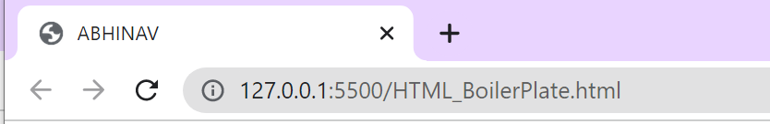

**PARAGRAPH TAG**

**<p></p>** this is a paragraph tag

**ITALIC TAG**

**<i></i>** it will just italic the text

**<em></em>** this would italic and stress the text

thus it concidered to better havea **<em></em> tag for italic**

**BOLD TAG**

**<b></b>** it will just bold the text

**<strong></strong>** it will bold the text and gives strong importance

thus it concidered to better have a **<strong></strong>** tag for bold

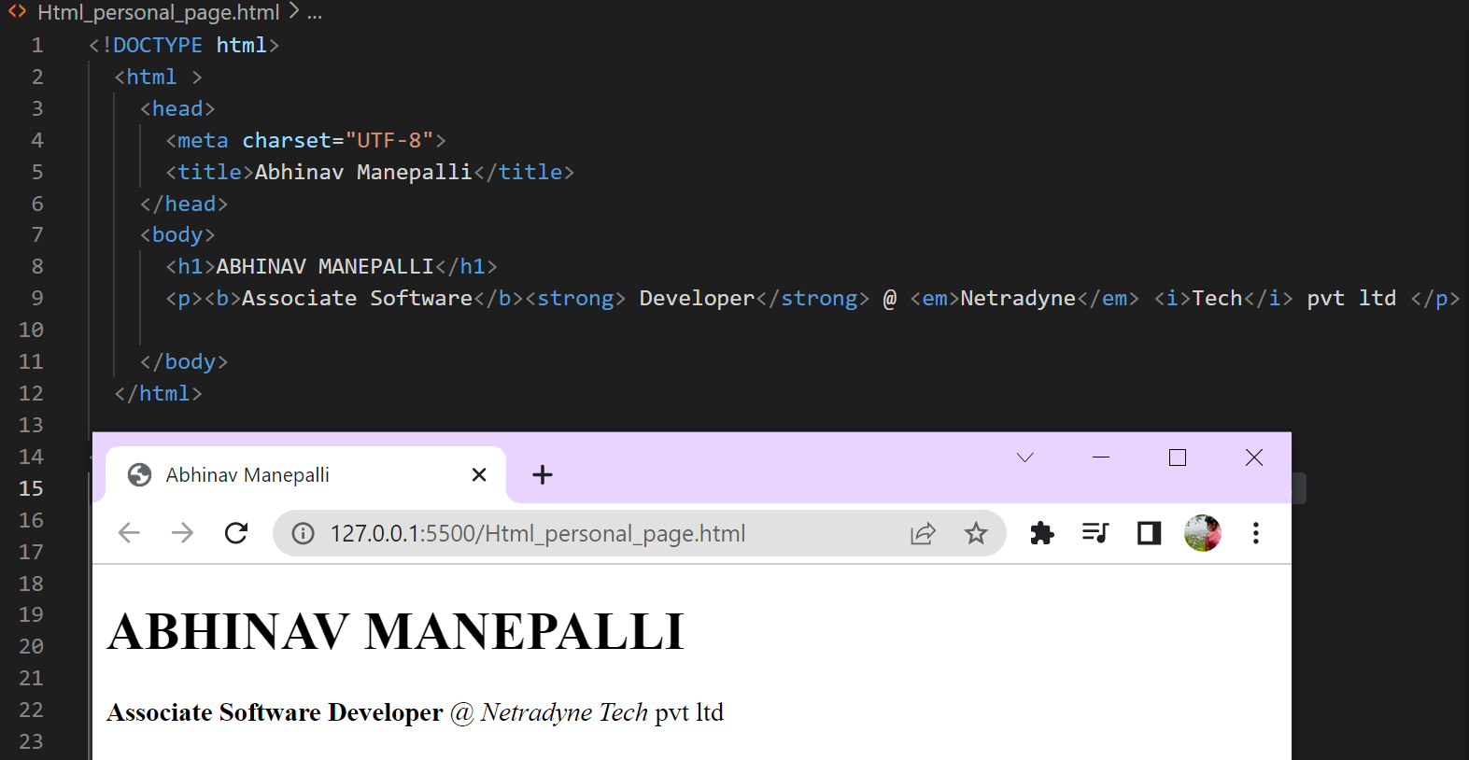

**ORDERED AND UNORDERED LIST**

an **unordered list** is some bullets which dont have an order and to access an unordered list we give **<ul></ul>**

an **ordered** **list** is something that has an particular order like 123,abc,roman numbers etc, and to access an ordered list we give **<ol></ol>**

we can also use **type=””** and **start=””** in the orderedlist attribute In type we can give a(small alphabets),A(captial alphabets),i(small roman numbers),I(large roman numbers),1(numbers)

and when it comes to start we can specify where to start from for example:

<ol type=”1” start=”5”>

**Result:**

5.abhinav

6.Meghana

<li>abhinav</li>

<li>Meghana</li>

</ol>

to tell Html its a **new** **point** we use the html tag **<li></li>**

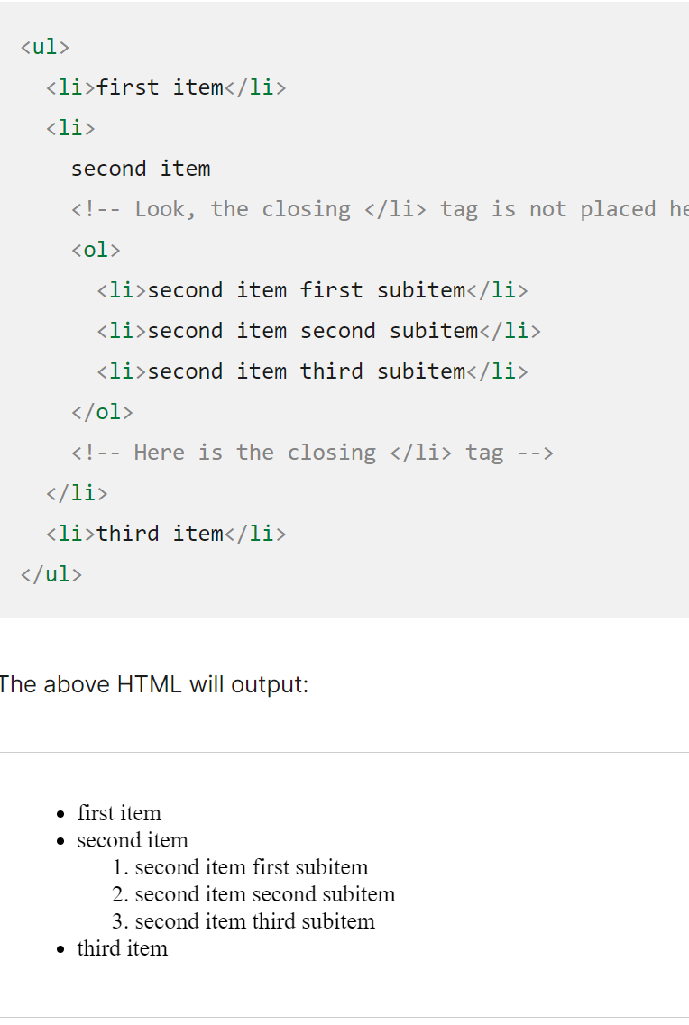we can nest both the lists

**IMAGE TAG**

An image can be added using an **<img>** tag however its a self-closing tag but it wont work unless an image address is specified

so we use the src="(IMAGE ADDRESS)" to get the image address

and in case the image cant be rendered we must show something instead of the photo so we use an alt="" attribute

**example:**

**<img src="https://miro.medium.com/fit/c/176/176/1*XEgN9pZ15mH0nbxX3hEvzQ.jpeg" alt="Abhinav Manepalli's Profile picture">**

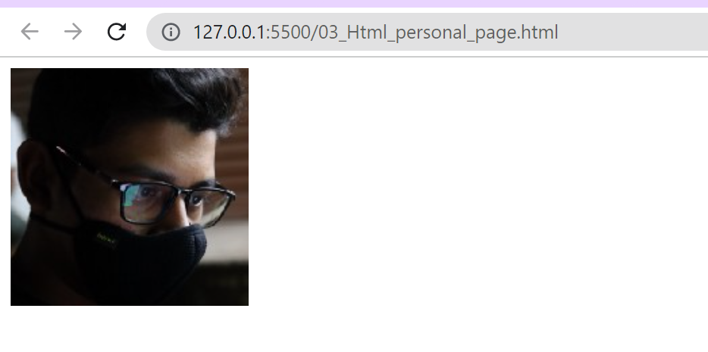

NOTE: but in the case of a photo changes or the site down the image tag will fail so its best practice to save a file to the folder and access it

**<img src="Images/abhinav.png " alt="Abhinav Manepalli's Profile picture from internal storage">**

**ANCHOR TAG**

To add links to in a html site

**<a></a>** is anchor tag which will take the user to the link when he clicks on it

we use **href=""** to give the link where we need to go to

without an href attributre its useless to have an anchor tag

Its a practice to give href="#" in case you want to add the link later

<a href="https://sasi.edu.in/”> Sasi Velivennu</a>

Html element, Attribute ,Text, Html element

**TABLES IN HTML**

**boilerplate-syntax for table**

<table>

<thead></thead>

<tbody></tbody>

<tfoot></tfoot>

</table>

<tr></tr> this is a ahtml tag used to create a row

There in no way in html to create an column but we can actully break the row into parts using the <td></td> element

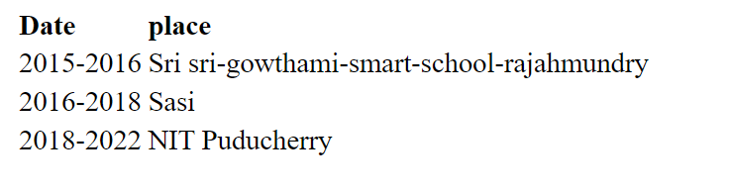 **EXAMPLE:**

<table>

<thead>

<tr>

<td><b>Date</b></td>

<td><b>place</b></td>

</tr>

</thead>

<tbody>

<tr>

<td>2015-2016</td>

<td>Sri sri-gowthami-smart-school-rajahmundry</td>

</tr>

<tr>

<td>2016-2018</td>

<td>Sasi</td>

</tr>

<tr>

<td>2018-2022</td>

<td>NIT Puducherry</td>

</tr>

</tbody>

</table>