AI DATA INSIGHT SYSTEM
Automated Pattern Detection & Intelligent Analysis Engine
AI Subject | Semester Project | Team of 4
2025–2026

1. Project Overview
The AI Data Insight System is a smart, automated tool that allows users to upload any dataset and instantly receive meaningful analysis, pattern detection, model recommendations, and plain-English summaries — without needing any manual data science expertise.
Think of it as a junior data scientist built into a web application: it reads your data, figures out what kind of problem it is, finds hidden patterns, trains the best machine learning model, and explains everything clearly.
What the system does automatically:
- Reads and understands the structure of Excel file.
- Detects patterns and correlations in the data
- Identifies whether the problem is classification or regression
- Trains 2–3 machine learning models and selects the best one
- Generates a plain-English summary of findings using an AI language model
- Displays everything in a clean, interactive web dashboard

2. Problem Statement
Most organizations and students collect data but lack the technical skills to properly analyze it. Setting up a data science pipeline requires knowledge of statistics, machine learning, and programming — skills that take years to develop.
Existing tools like Excel are too basic, while tools like Python require expert knowledge. There is a clear gap for an intelligent middle layer that can automate the entire data analysis workflow and communicate results in simple language.
This project fills that gap.

3. Project Scope

3.1 What Is Included (Semester Build)
Module | Description | Difficulty
Data Profiler | Auto-detect column types, missing values, stats | Beginner
Pattern Detection | Correlation heatmap and statistical pattern detection | Beginner–Intermediate
Problem Type Detection | Rule-based logic: classification vs regression | Beginner
Auto Model Selection | Train 2–3 models, pick best by accuracy/RMSE | Intermediate
NL Insight Generator | Google Gemini API | Beginner (API call)
Frontend Dashboard | Streamlit UI with charts and results display | Beginner

3.2 What Is Excluded (Post-Semester Upgrades)
- SHAP / LIME explainability (advanced model interpretation)
- UMAP / t-SNE advanced dimensionality reduction
- Optuna hyperparameter tuning
- Meta-learning (predict best algorithm from dataset metadata)
- FAISS vector storage for pattern history
- LightGBM and advanced ensemble models
- Custom data quality scoring formula
These features will be added after the semester to turn the project into a full portfolio piece.

4. System Architecture
The system is built as a pipeline of 5 core modules, each with a clear input and output. Data flows from the user upload through each module in sequence, with results passed to the frontend dashboard.
Pipeline Flow:
Step | Module | Input | Output
1 | Data Profiler | Excel file | Stats, column types, missing value report
2 | Pattern Detection | Cleaned dataframe | Correlation matrix and pattern visualizations
3 | Problem Type Detector | Target column analysis | Problem type label classification/regression/unsupervised analysis
4 | Auto Model Engine | Problem type + data | Best model, accuracy score, evaluation metrics
5 | NL Insight Generator | All results from above | Plain-English paragraph summary

5. Module Details

Module 1: Data Profiler
The Data Profiler is the entry point of the system. It analyses the raw uploaded file and produces a structured summary of what the data contains.
Key Tasks:
- Detect numerical, categorical, and datetime columns automatically
- Calculate missing value percentage per column
- Compute basic statistics: mean, median, std deviation, min, max
- Identify dominant categorical values (basic imbalance indication)in potential target columns
- Calculate skewness to identify non-normal distributions
Libraries Used:
- pandas — core dataframe operations
- numpy — numerical computations
- scipy.stats — skewness, kurtosis, normality tests

Module 2: Pattern Detection Engine
This is the core intelligent part of the system. It discovers relationships and structure within the dataset that are not immediately obvious.
Correlation Discovery:
- Pearson correlation for numerical columns (linear relationships)
- Spearman correlation for non-linear monotonic relationships
- Cramér’s V for categorical column relationships
Libraries Used:
- scikit-learn — statistical computations
- plotly — interactive heatmaps and visualizations

Module 3: Problem Type Detector
Before training any model, the system must understand what kind of machine learning problem the data represents. This module uses rule-based logic to determine this automatically.
Condition | Detected Problem Type
Target column is numeric and continuous | Regression
Target column has exactly 2 unique values | Binary Classification
Target column has 3–14 unique categories | Multi-class Classification
No target column provided | Unsupervised Analysis

Module 4: Auto Model Selection Engine
Based on the detected problem type, this module trains multiple models, evaluates each one, and selects the best performer automatically.
For Classification Problems:
- Logistic Regression (baseline)
For Regression Problems:
- Linear Regression (baseline)
Evaluation Method:
- Classification: Accuracy, F1-Score, ROC-AUC
- Regression: RMSE, MAE, R² Score
- Train-test split evaluation
The model with the best cross-validation score is selected and its metrics are displayed on the dashboard.

Module 5: Natural Language Insight Generator
This module takes all the output from the previous modules and sends a structured summary to a language model API. The API returns a plain-English explanation suitable for both technical and non-technical audiences.
What gets sent to the API:
- Dataset shape and column types
- Top 3 strongest correlations found
- Detected problem type
- Best model name and its accuracy/RMSE score
What the API returns:
- Executive summary: 2–3 sentences for a general audience
- Technical summary: key findings for a data science audience
- Top recommendation or next step
Implementation uses the Google Gemini API with a structured prompt to generate insights.

6. Technology Stack
Category | Technology | Purpose
Language | Python 3.10+ | All backend logic
Data Processing | pandas, numpy | Dataframe operations, statistics
Machine Learning | scikit-learn | Models and statistical analysis
Statistics | scipy.stats | Skewness, normality, correlation tests
Visualisation | plotly | Interactive charts and heatmaps
Frontend | Streamlit | Web dashboard — no HTML/CSS needed
AI Insights | Google Gemini API | Natural language summary generation

7. Week-by-Week Execution Plan
Weeks | Focus Area | Deliverable
1–2 | Setup + Data Profiler | Working profiler: stats, column types, missing value display
3–4 | Correlation Analysis + Visualization | Heatmap and KMeans cluster plot working in Streamlit
5–6 | Problem Type Detection + Pipeline Integration | Anomaly flagging + automatic problem type label
7–8 | Auto Model Selection | 2–3 models trained, best selected, metrics shown
9–10 | NL Insight Generator | API integration working, plain-English summary displayed
11–12 | Integration + Polish + Testing | Full system end-to-end tested, UI polished, demo-ready

8. Summary
The AI Data Insight System is a well-scoped, achievable, and genuinely impressive project for a team of 4 beginners over one semester. By focusing on 5 solid, working modules rather than attempting 7 partially-complete ones, the team will be able to build something that actually runs end-to-end and demonstrates real automated intelligence.
The use of a language model API for plain-English summaries adds a modern AI layer that makes the project stand out in a viva without adding significant technical complexity.
Post-semester, the system has a clear upgrade path into a full-featured AutoML portfolio project that can be showcased on GitHub, LinkedIn, and in job interviews.

9. Source Code Repository
The complete source code for the AI Data Insight System is available on GitHub:

GitHub Repository:
https://github.com/AbhinavMsh/Ai-Data-Insights

The repository includes:
• Full modular backend implementation
• Streamlit frontend application
• Sample datasets for testing
• Documentation and setup instructions

This allows easy reproducibility and further extension of the project.

10. Results and Output Screens

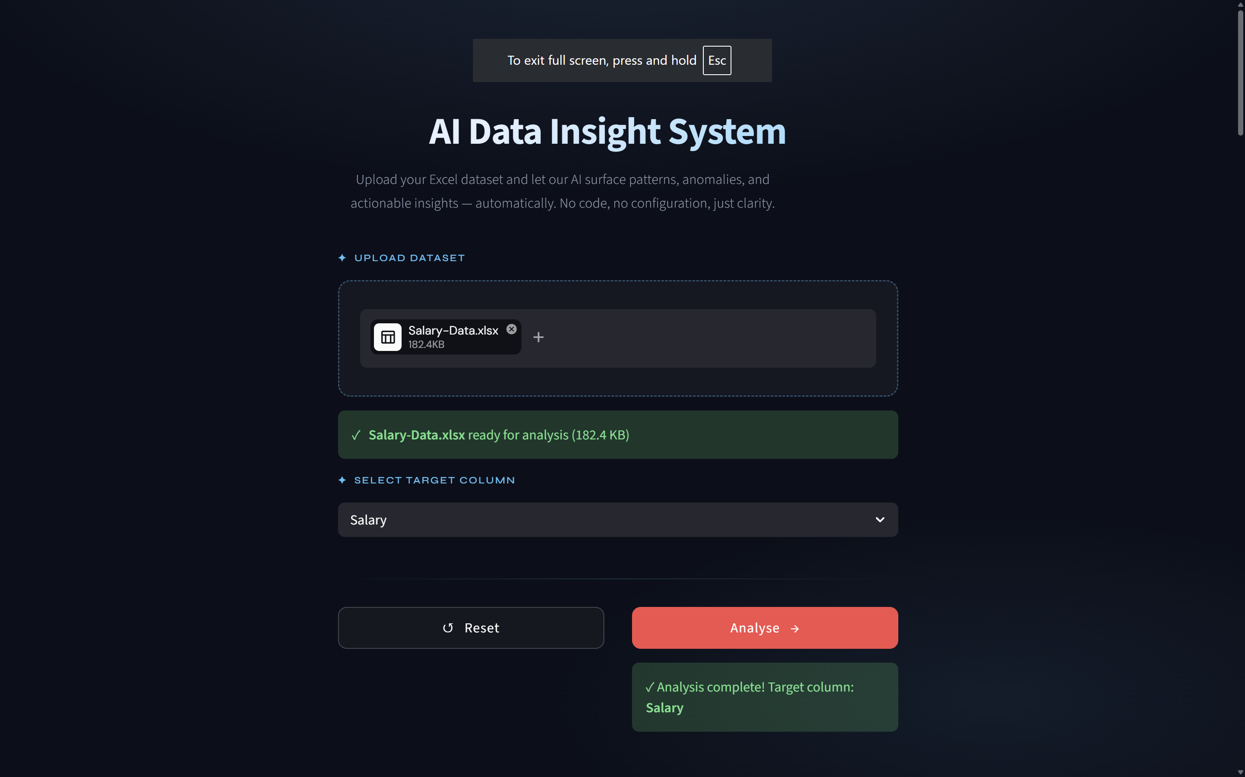

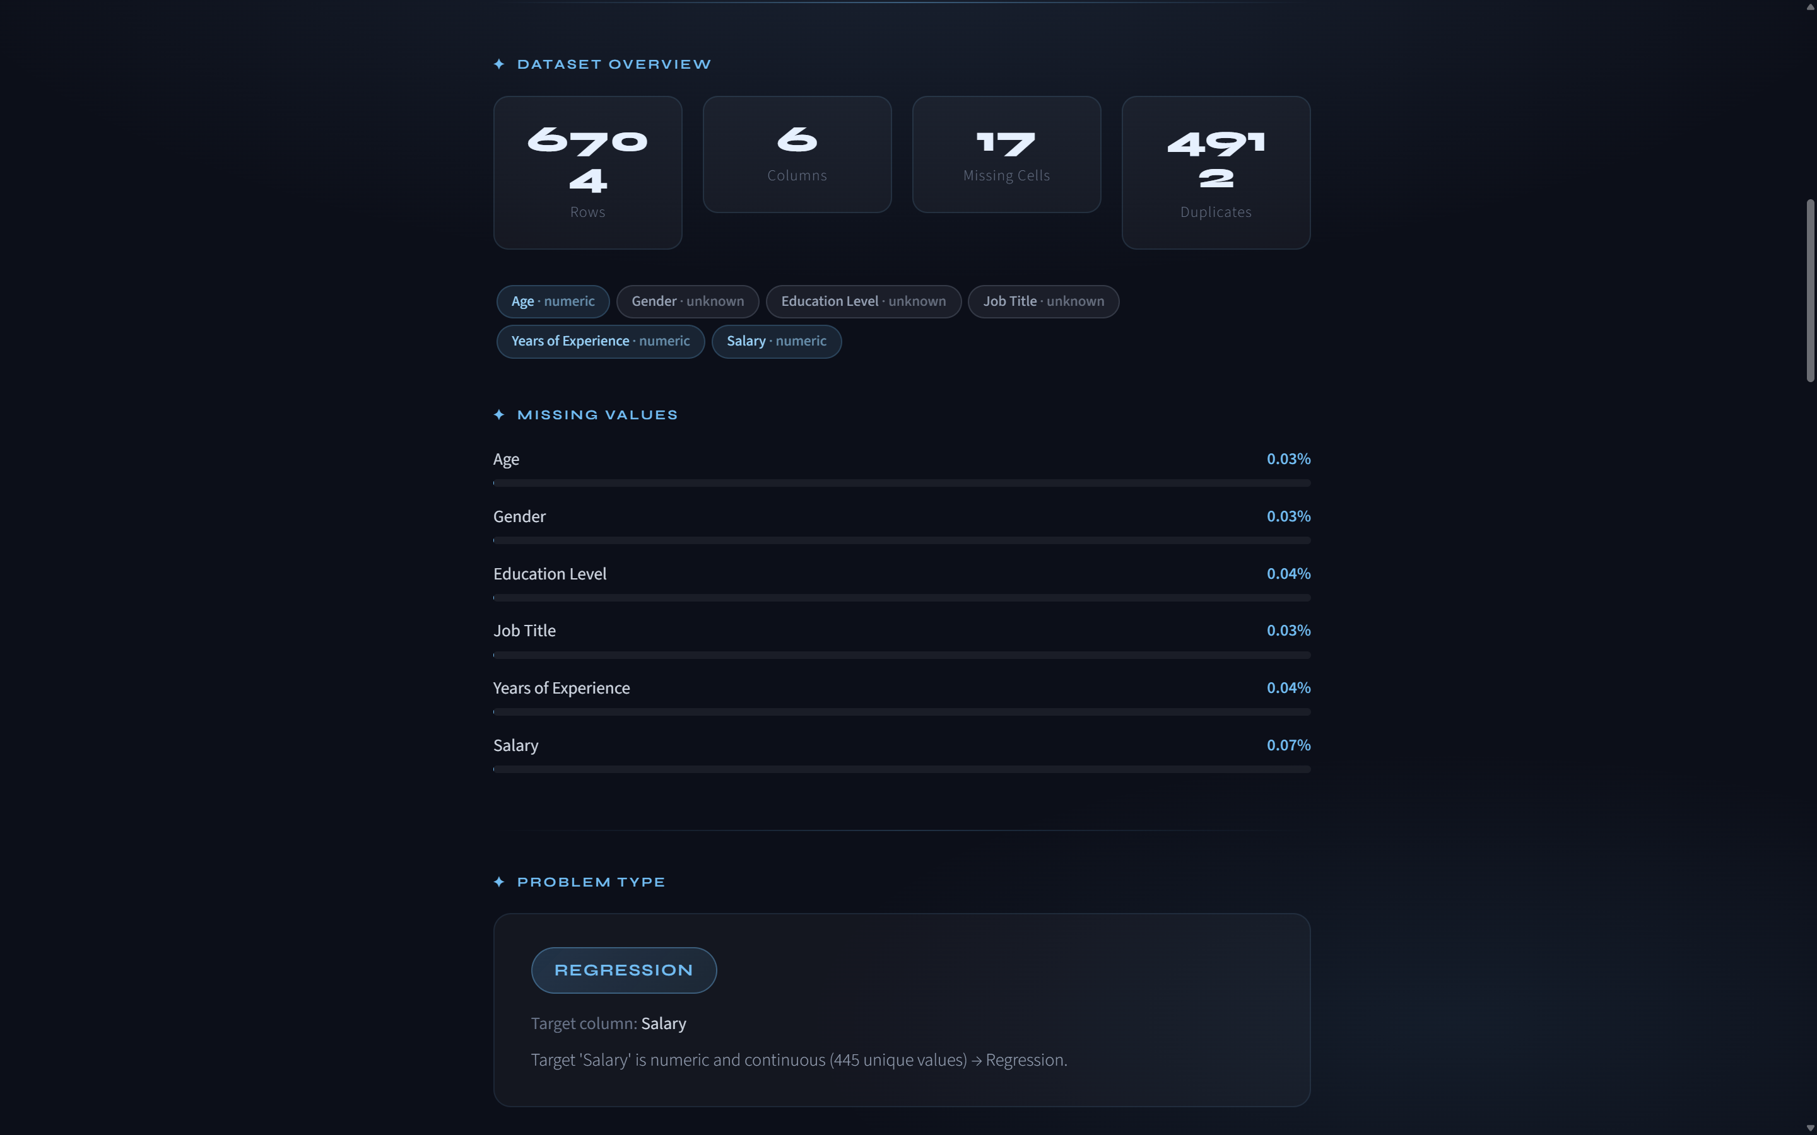

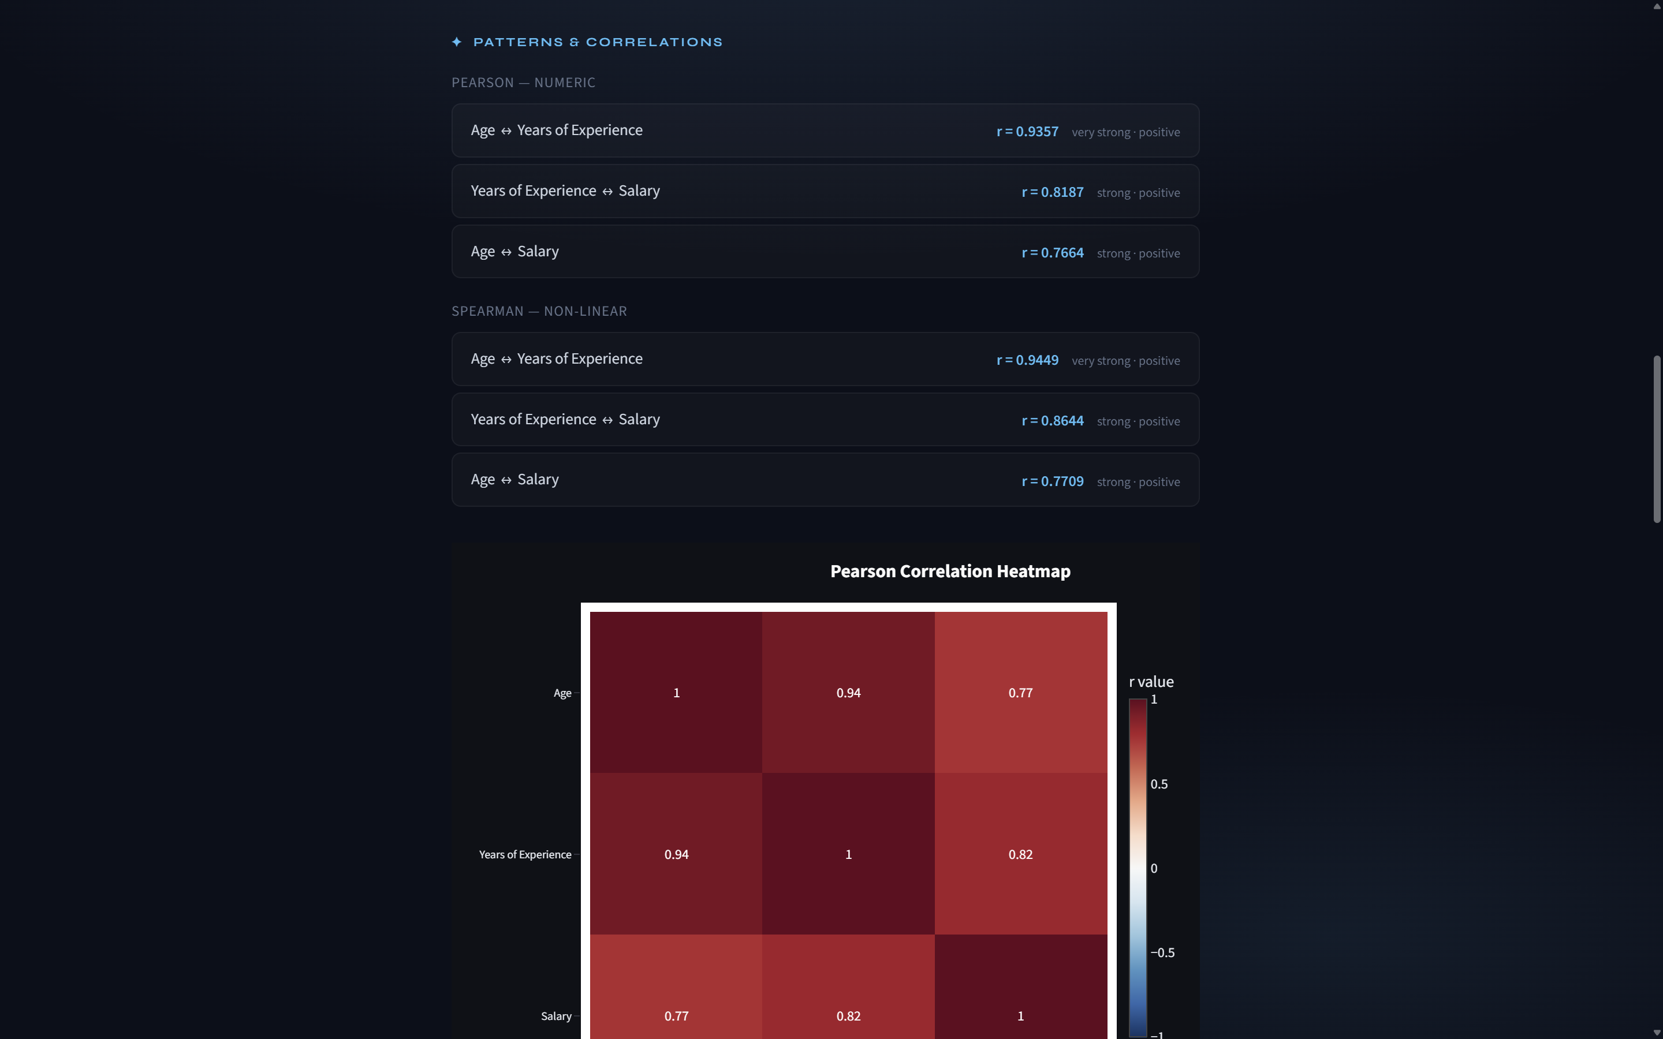

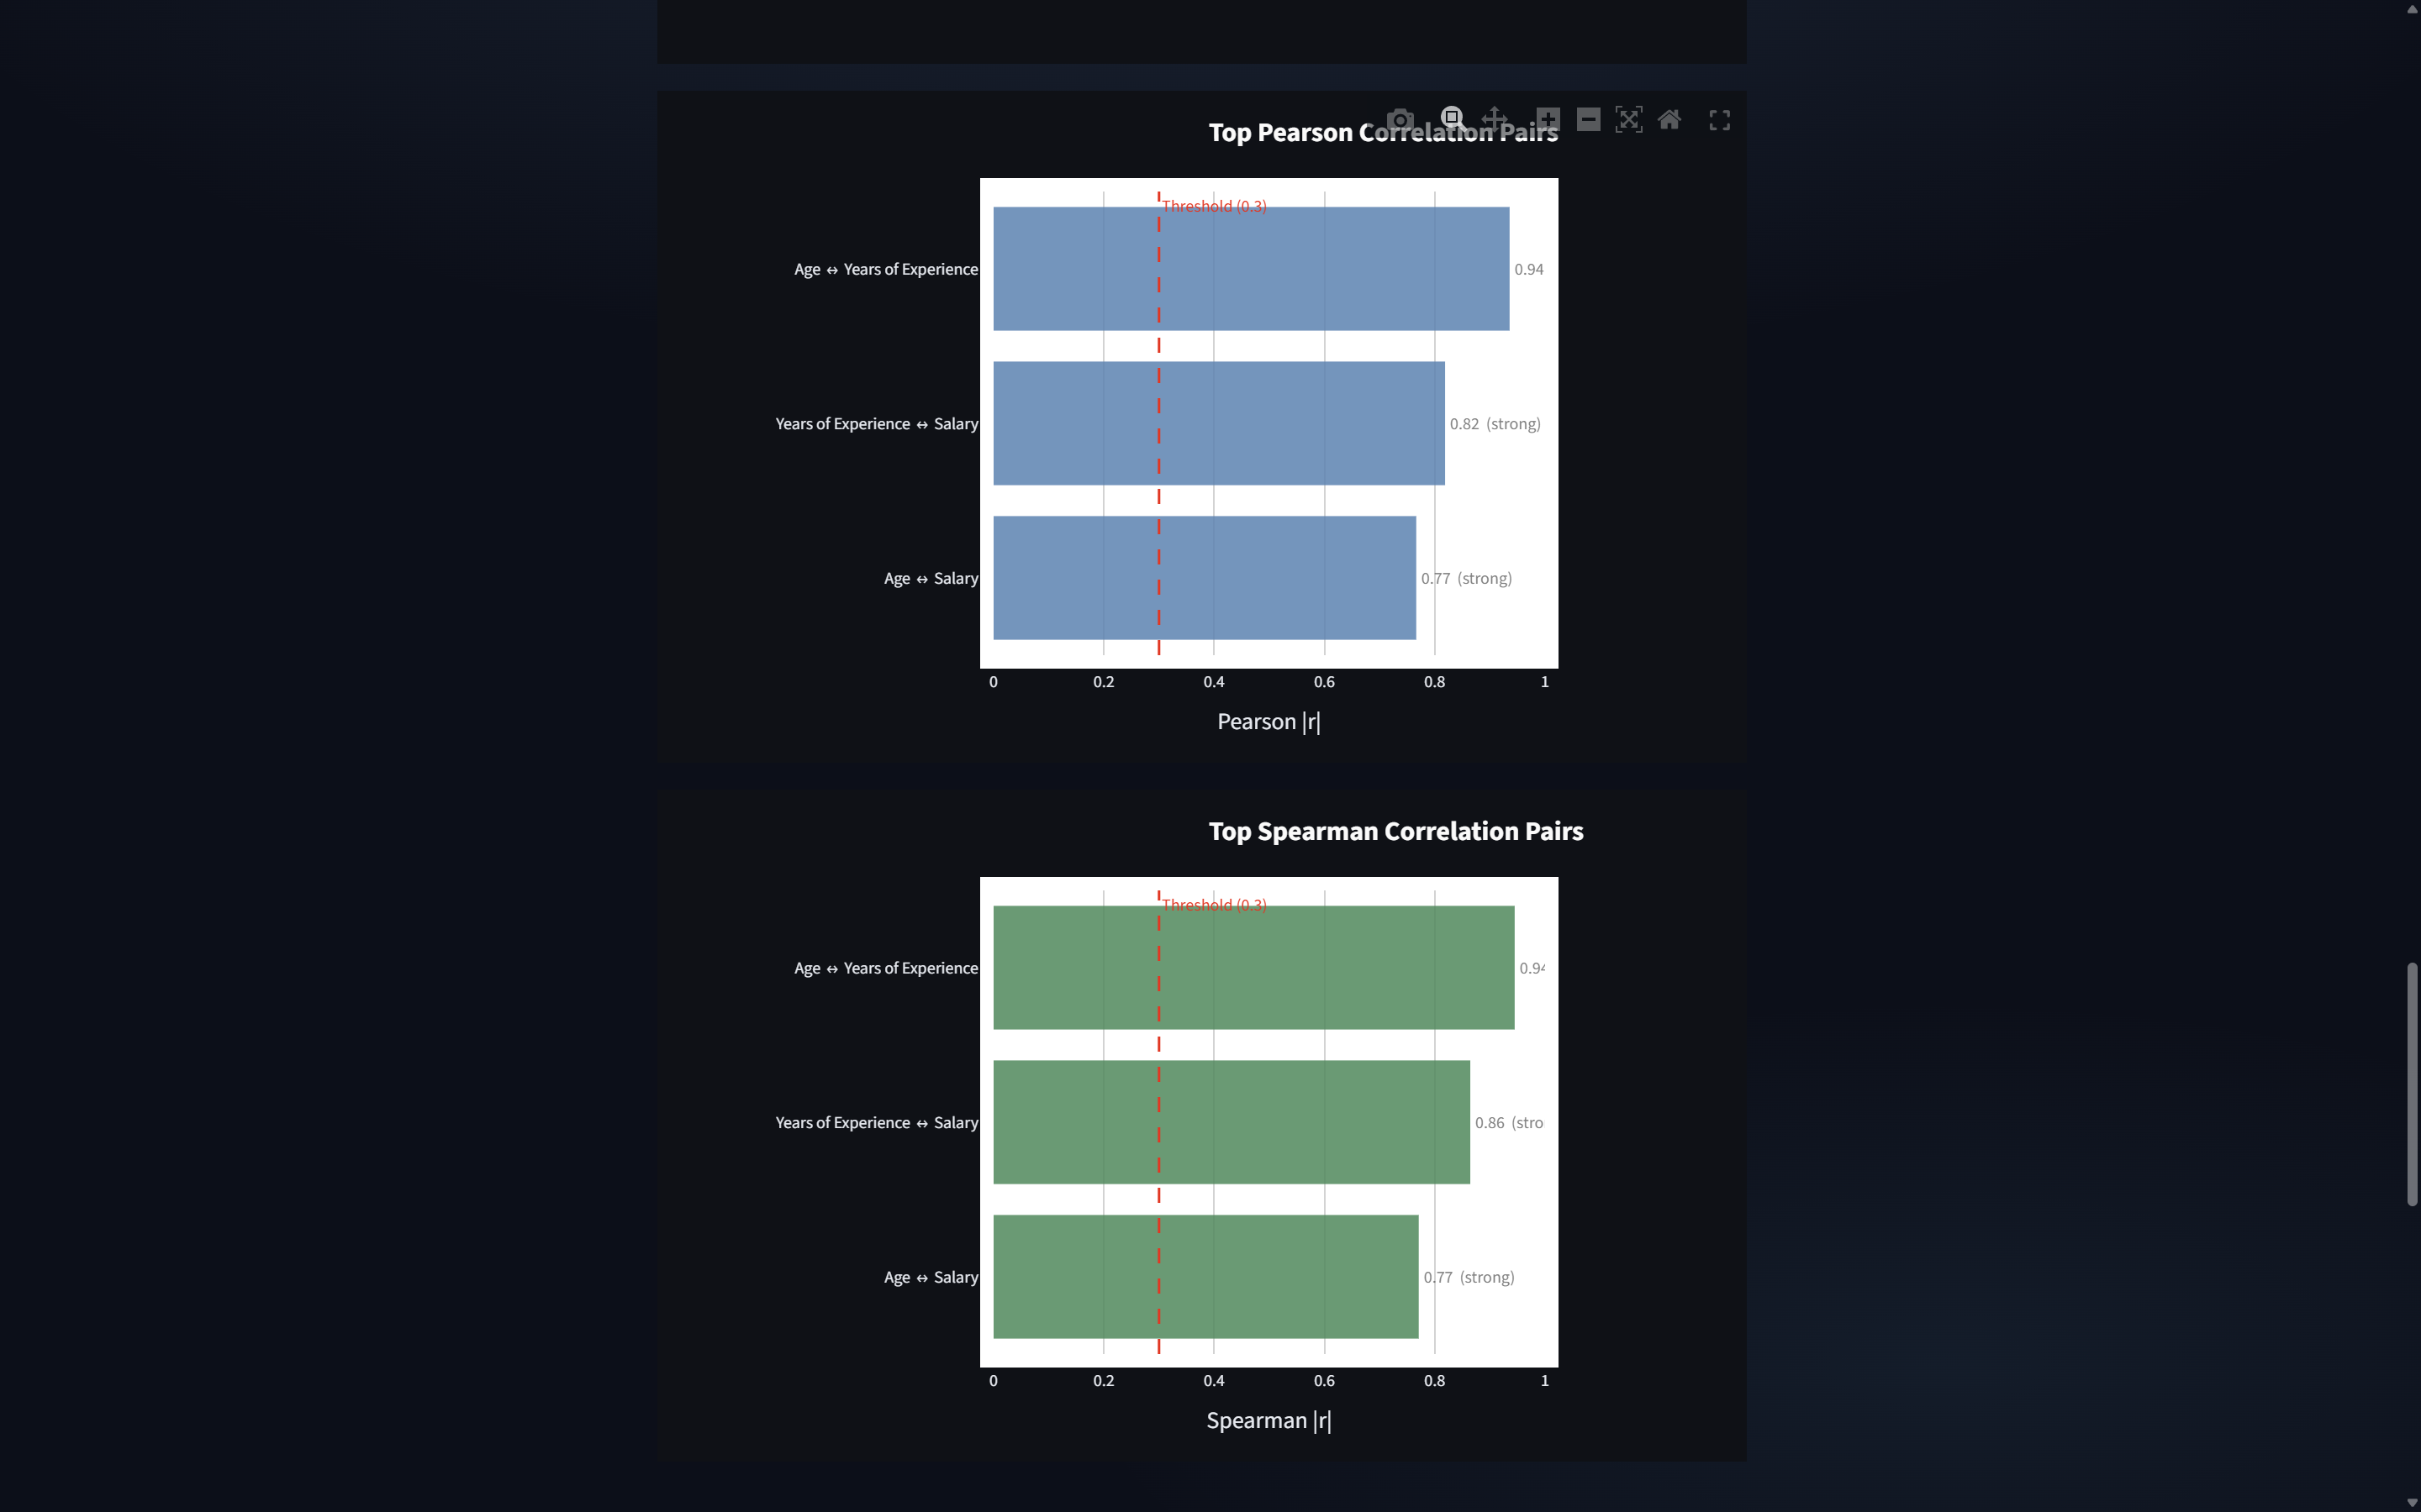

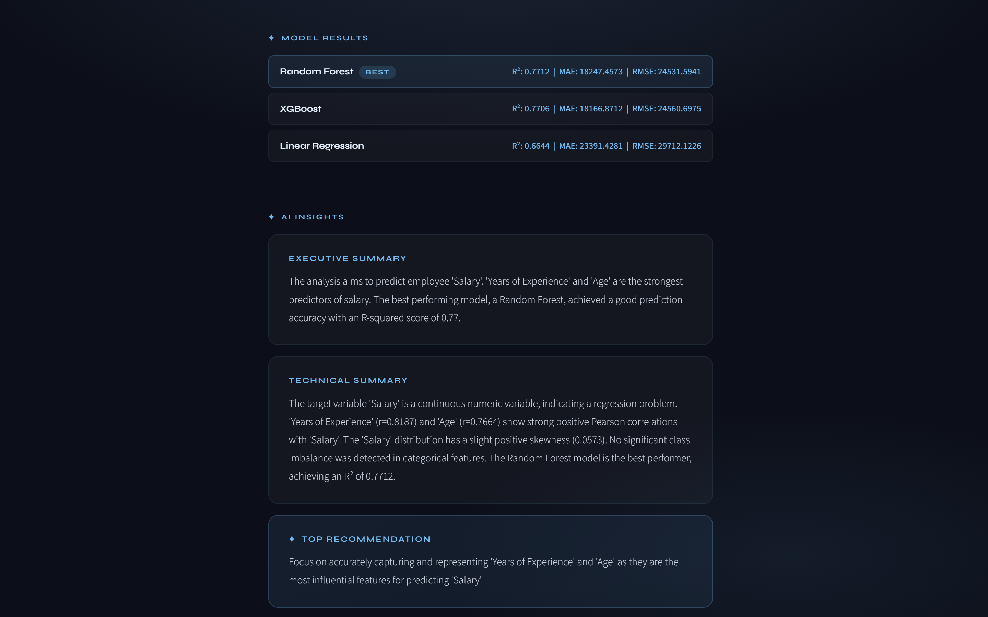

11. Conclusions
The AI Data Insight System successfully demonstrates how data analysis
can be automated using machine learning and AI techniques. The system
is capable of handling real-world datasets and providing meaningful
insights without requiring expert knowledge.

This project bridges the gap between raw data and actionable insights,
making data analysis accessible to a wider audience.

