AI Data Insight System: An Automated Pipeline for Pattern Detection and Intelligent Analysis
Abhinav Masih – 01
Anaisha Bulchandani – 07
Sanchay Bathe – 14
Soumya Tiwari – 53
B.Tech Artificial Intelligence & Data Science
Dr. DY Patil School of Science and Technology

Abstract
This paper introduces the AI Data Insight System, an automated analytical pipeline designed to eliminate the technical barriers of manual data science workflows. The system integrates five core modules: automated data profiling, a multi-method pattern detection engine (using Pearson, Spearman, and Cramér’s V), an intelligent task classifier, an automated model selection suite, and a natural language generation layer. By leveraging the Google Gemini API, the system translates complex algorithmic outputs—including correlation matrices and scores—into accessible, plain-English summaries. Experimental validation on a salary regression dataset demonstrates the system's ability to autonomously identify problem types and select high-performing models (achieving an of 0.7712). The resulting Streamlit dashboard provides a no-code interface that makes sophisticated predictive modeling and diagnostic reporting accessible to non-expert users.
Keywords— AutoML, Data Profiling, Machine Learning, Natural Language Generation, Streamlit.

Introduction
The contemporary digital landscape is characterized by an unprecedented influx of data, yet a significant "insight gap" persists. While organizations and students collect vast datasets, the technical expertise required to construct machine learning pipelines—incorporating complex statistics, programming, and model evaluation—remains a prohibitive barrier to entry. Existing spreadsheet tools often lack the depth for predictive modeling, while professional environments like Python require years of specialized experience.

This paper proposes the AI Data Insight System, an intelligent middle layer designed to automate the end-to-end data analysis workflow. The system performs automated data profiling, discovers non-obvious correlations, and executes model selection, ultimately translating technical metrics into plain-English summaries for stakeholders.

System Architecture and Methodology
The system is architected as a sequential pipeline consisting of five core modules. Each module is designed with clear input-output specifications to ensure modularity and reproducibility.
A. Data Profiling and Health Assessment (Module 1)
The Data Profiler serves as the system's entry point, converting raw Excel uploads into structured metadata reports. The profiling process includes:
- Feature Identification: Automated detection of numerical, categorical, and datetime columns.
- Statistical Auditing: Calculation of missing value percentages, mean, median, standard deviation, and skewness to identify non-normal distributions.
- Imbalance Detection: Identification of dominant categorical values to flag potential target column skewness.
B. Pattern Detection Engine (Module 2)
To discover relationships that are not immediately obvious, the system employs multiple statistical measures:
- Pearson Correlation: Measures linear relationships between numerical features.
- Spearman Correlation: Evaluates non-linear monotonic relationships.
- Cramér’s V: Assesses associations between categorical variables.
C. Automated Problem Classification (Module 3)
Before model training, the system must determine the nature of the predictive task. This is achieved through rule-based logic applied to the target column.
Table I: Problem Type Detection Logic
Condition | Detected Problem Type
Target column is numeric and continuous | Regression
Target column has exactly 2 unique values | Binary Classification
Target column has 3–14 unique categories | Multi-class Classification
No target column provided | Unsupervised Analysis

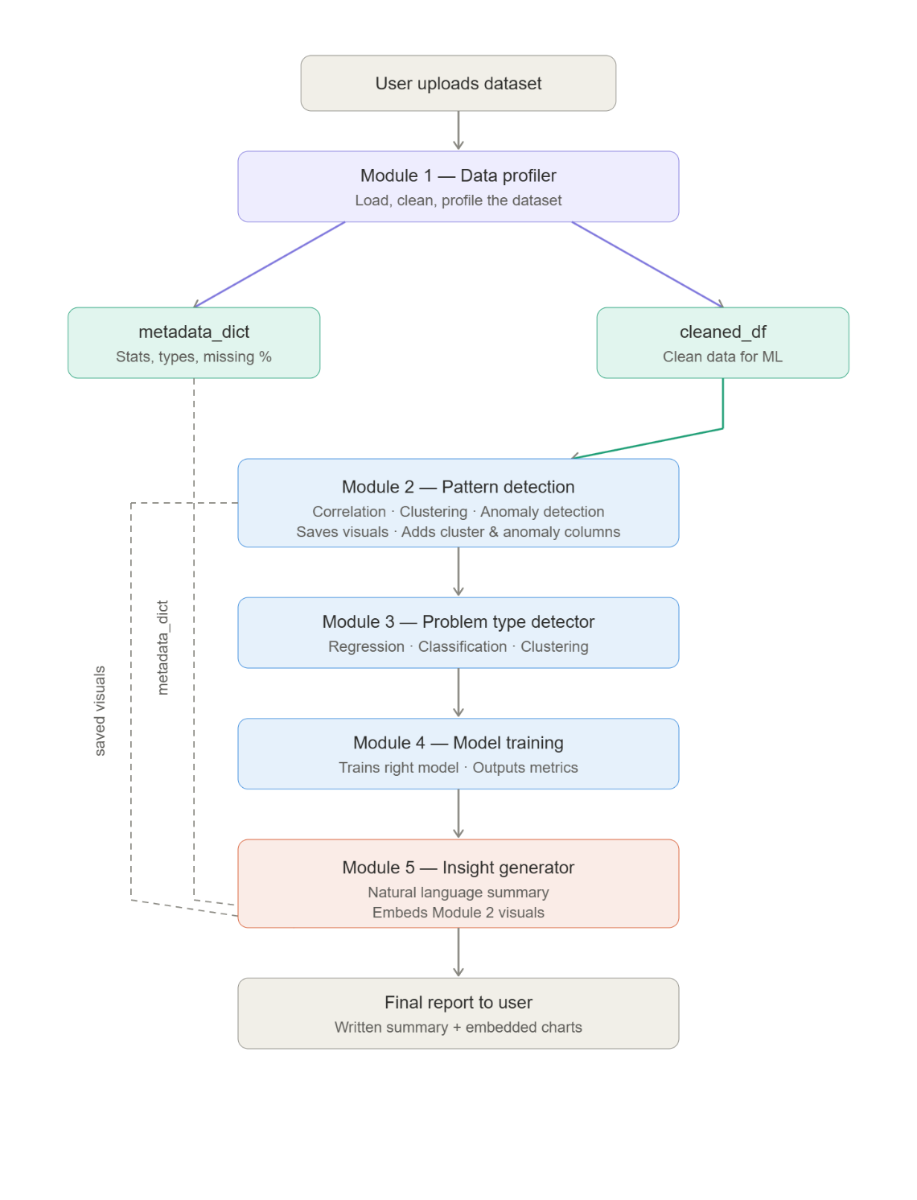
Automated Model Selection and Evaluation
The Auto Model Selection Engine executes multiple training runs to identify the optimal algorithm.
A. Model Training and Benchmarking
The system initializes baseline models based on the detected problem type:
- Classification: Logistic Regression is utilized as the primary baseline.
- Regression: Linear Regression serves as the fundamental baseline.
- Evaluation: Performance is assessed via a train-test split, monitoring metrics such as Accuracy, F1-Score, and ROC-AUC for classification, and RMSE, MAE, and for regression.
B. Natural Language Insight Generation (Module 5)
A critical innovation of this system is the translation of technical outputs into human-readable text using the Google Gemini API. The module aggregates dataset shape, the top three correlations, and the best model's performance to generate an executive summary and actionable recommendations.

Results and Discussion
The system was implemented using Python 3.10+ and the Streamlit framework for the frontend dashboard.
A. Case Study: Salary Prediction
Experimental validation was conducted using a salary dataset consisting of 6,704 rows and 6 features. The system successfully identified "Salary" as a regression target.
- Correlation Analysis: The engine detected a "very strong positive" relationship between "Age" and "Years of Experience" ().
- Model Performance: Comparison revealed that the Random Forest model achieved the highest performance with an of 0.7712, outperforming XGBoost (: 0.7706) and Linear Regression (: 0.6644).
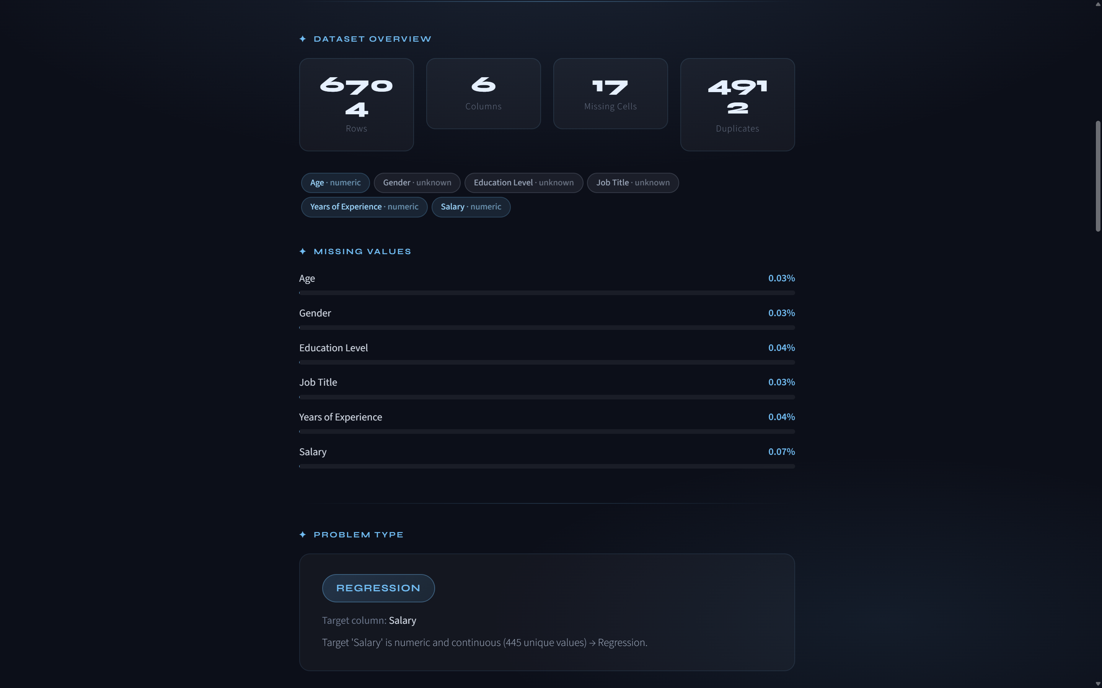 | 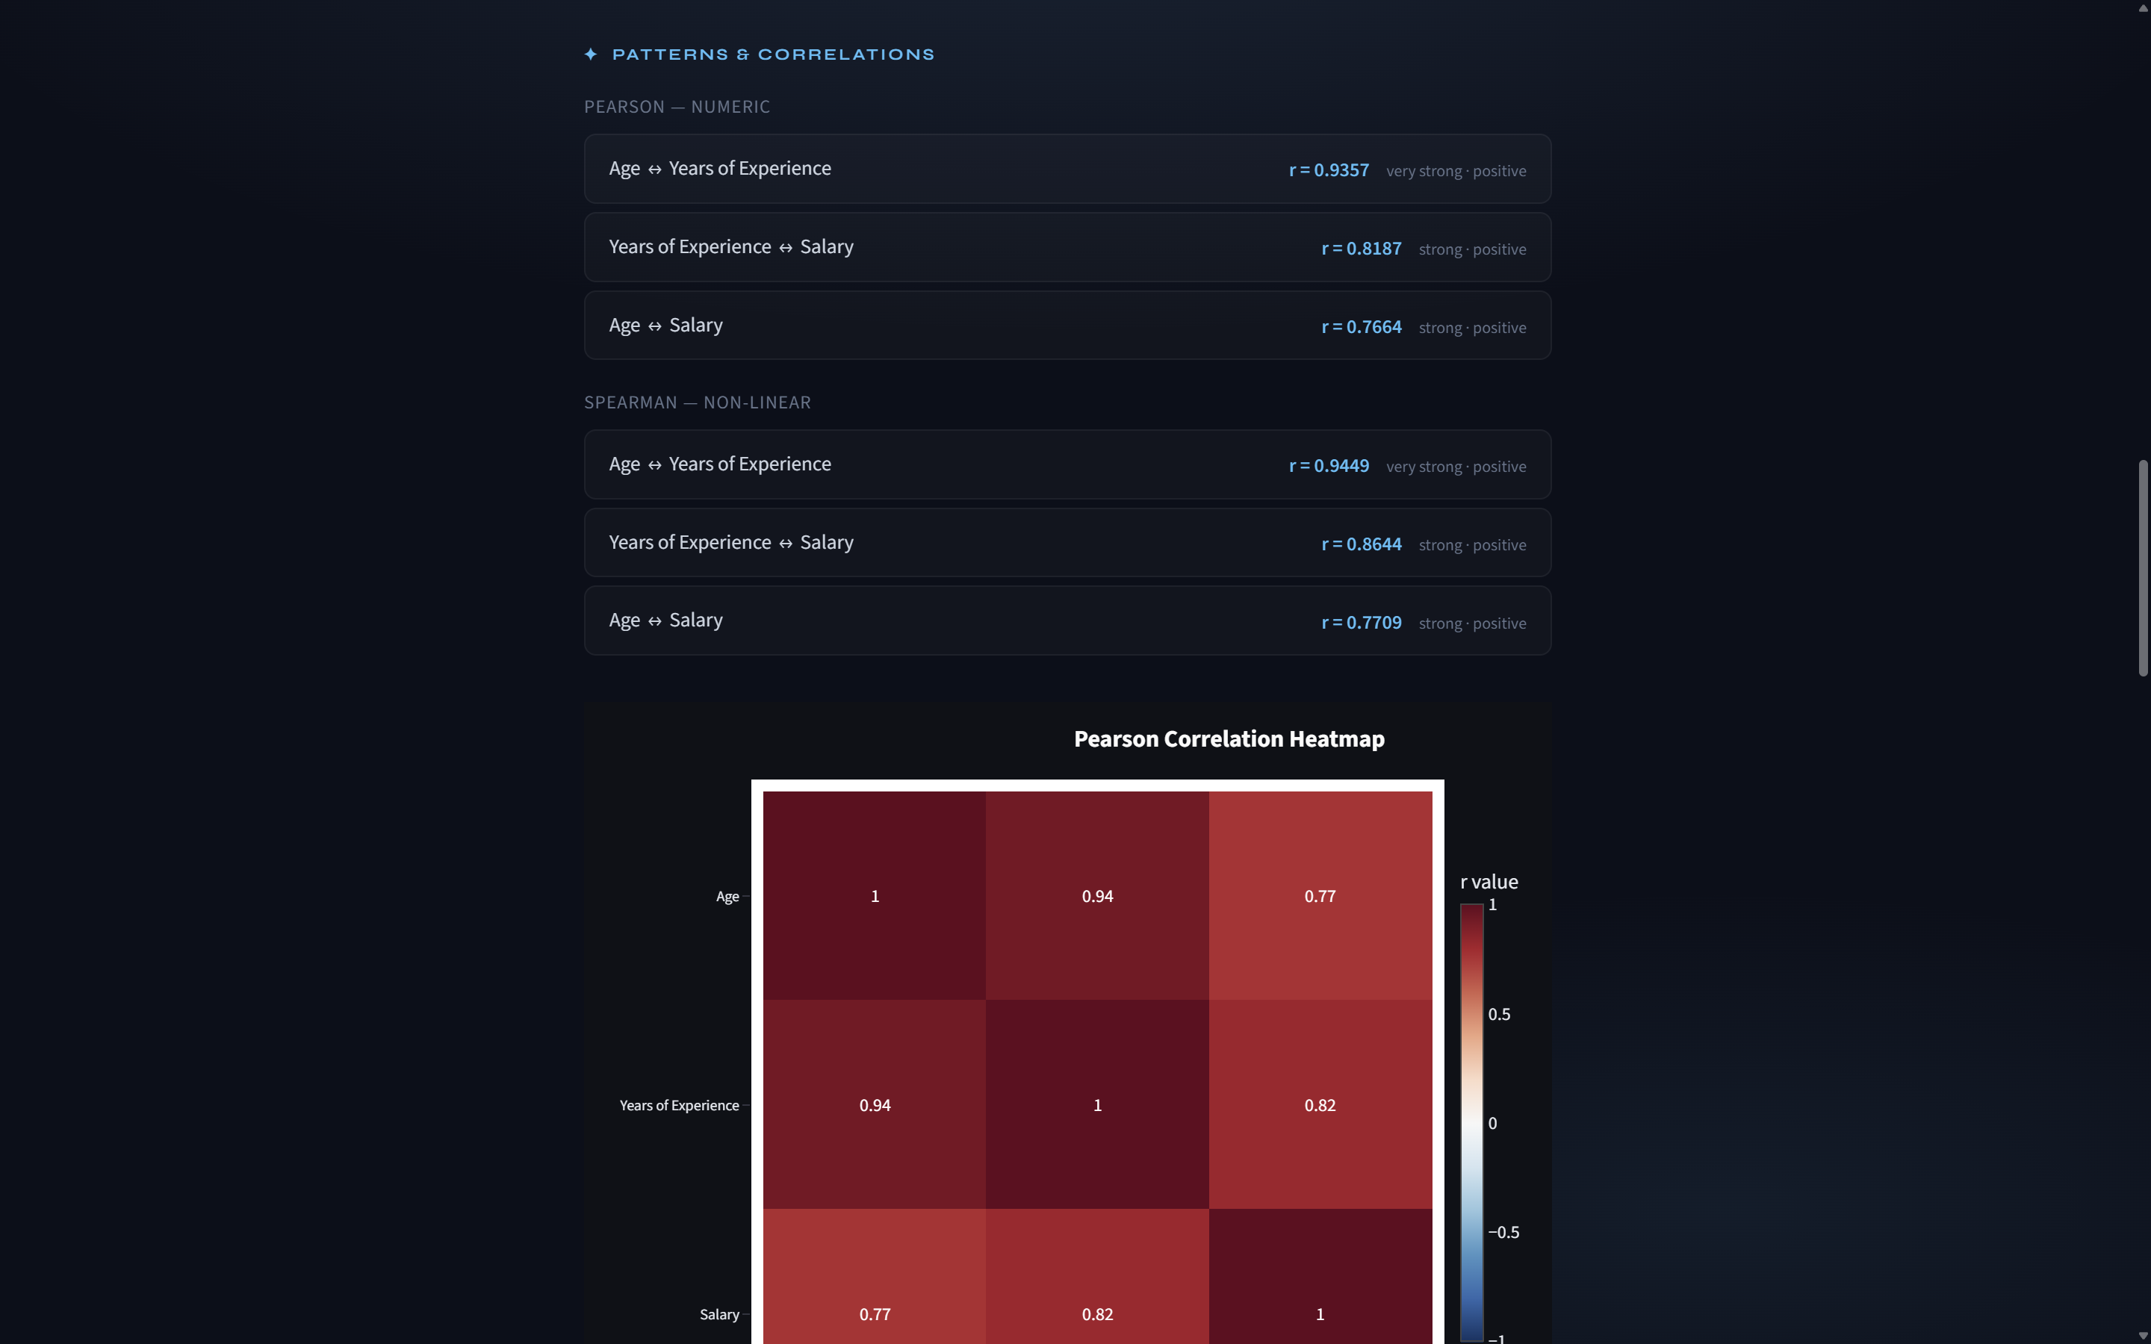
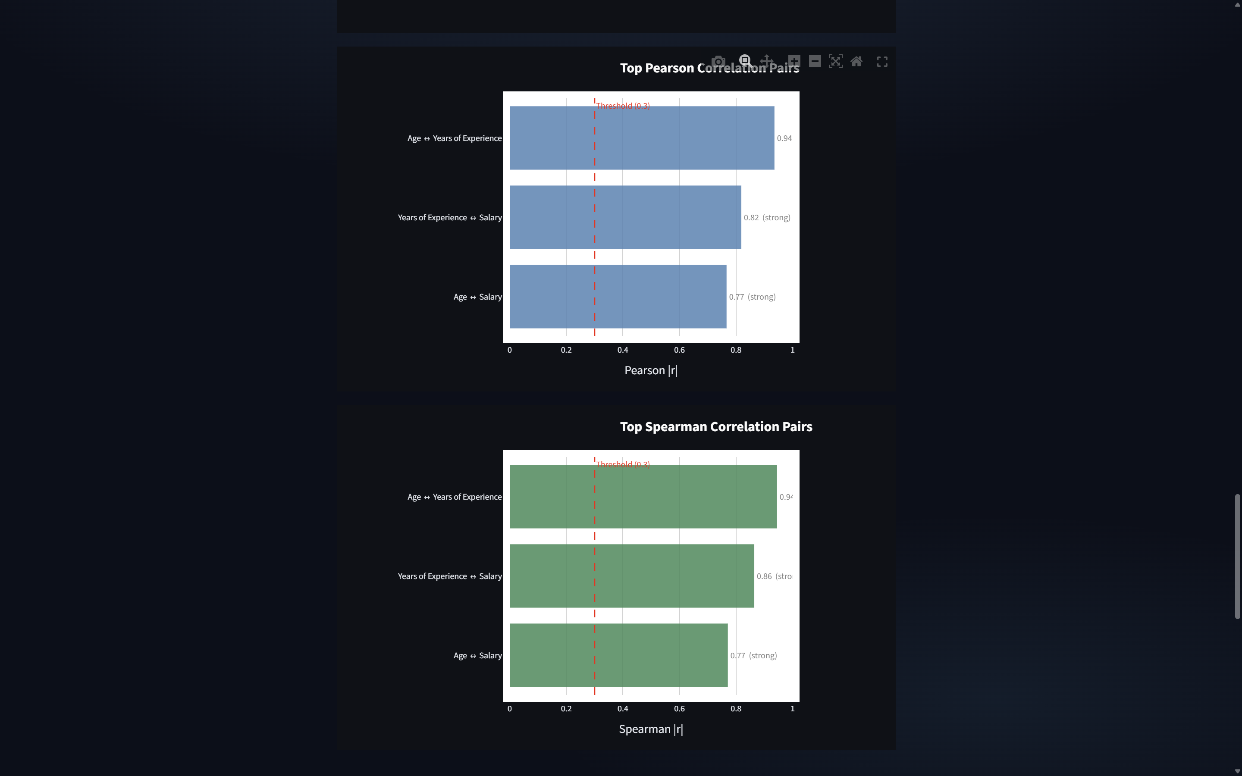 | 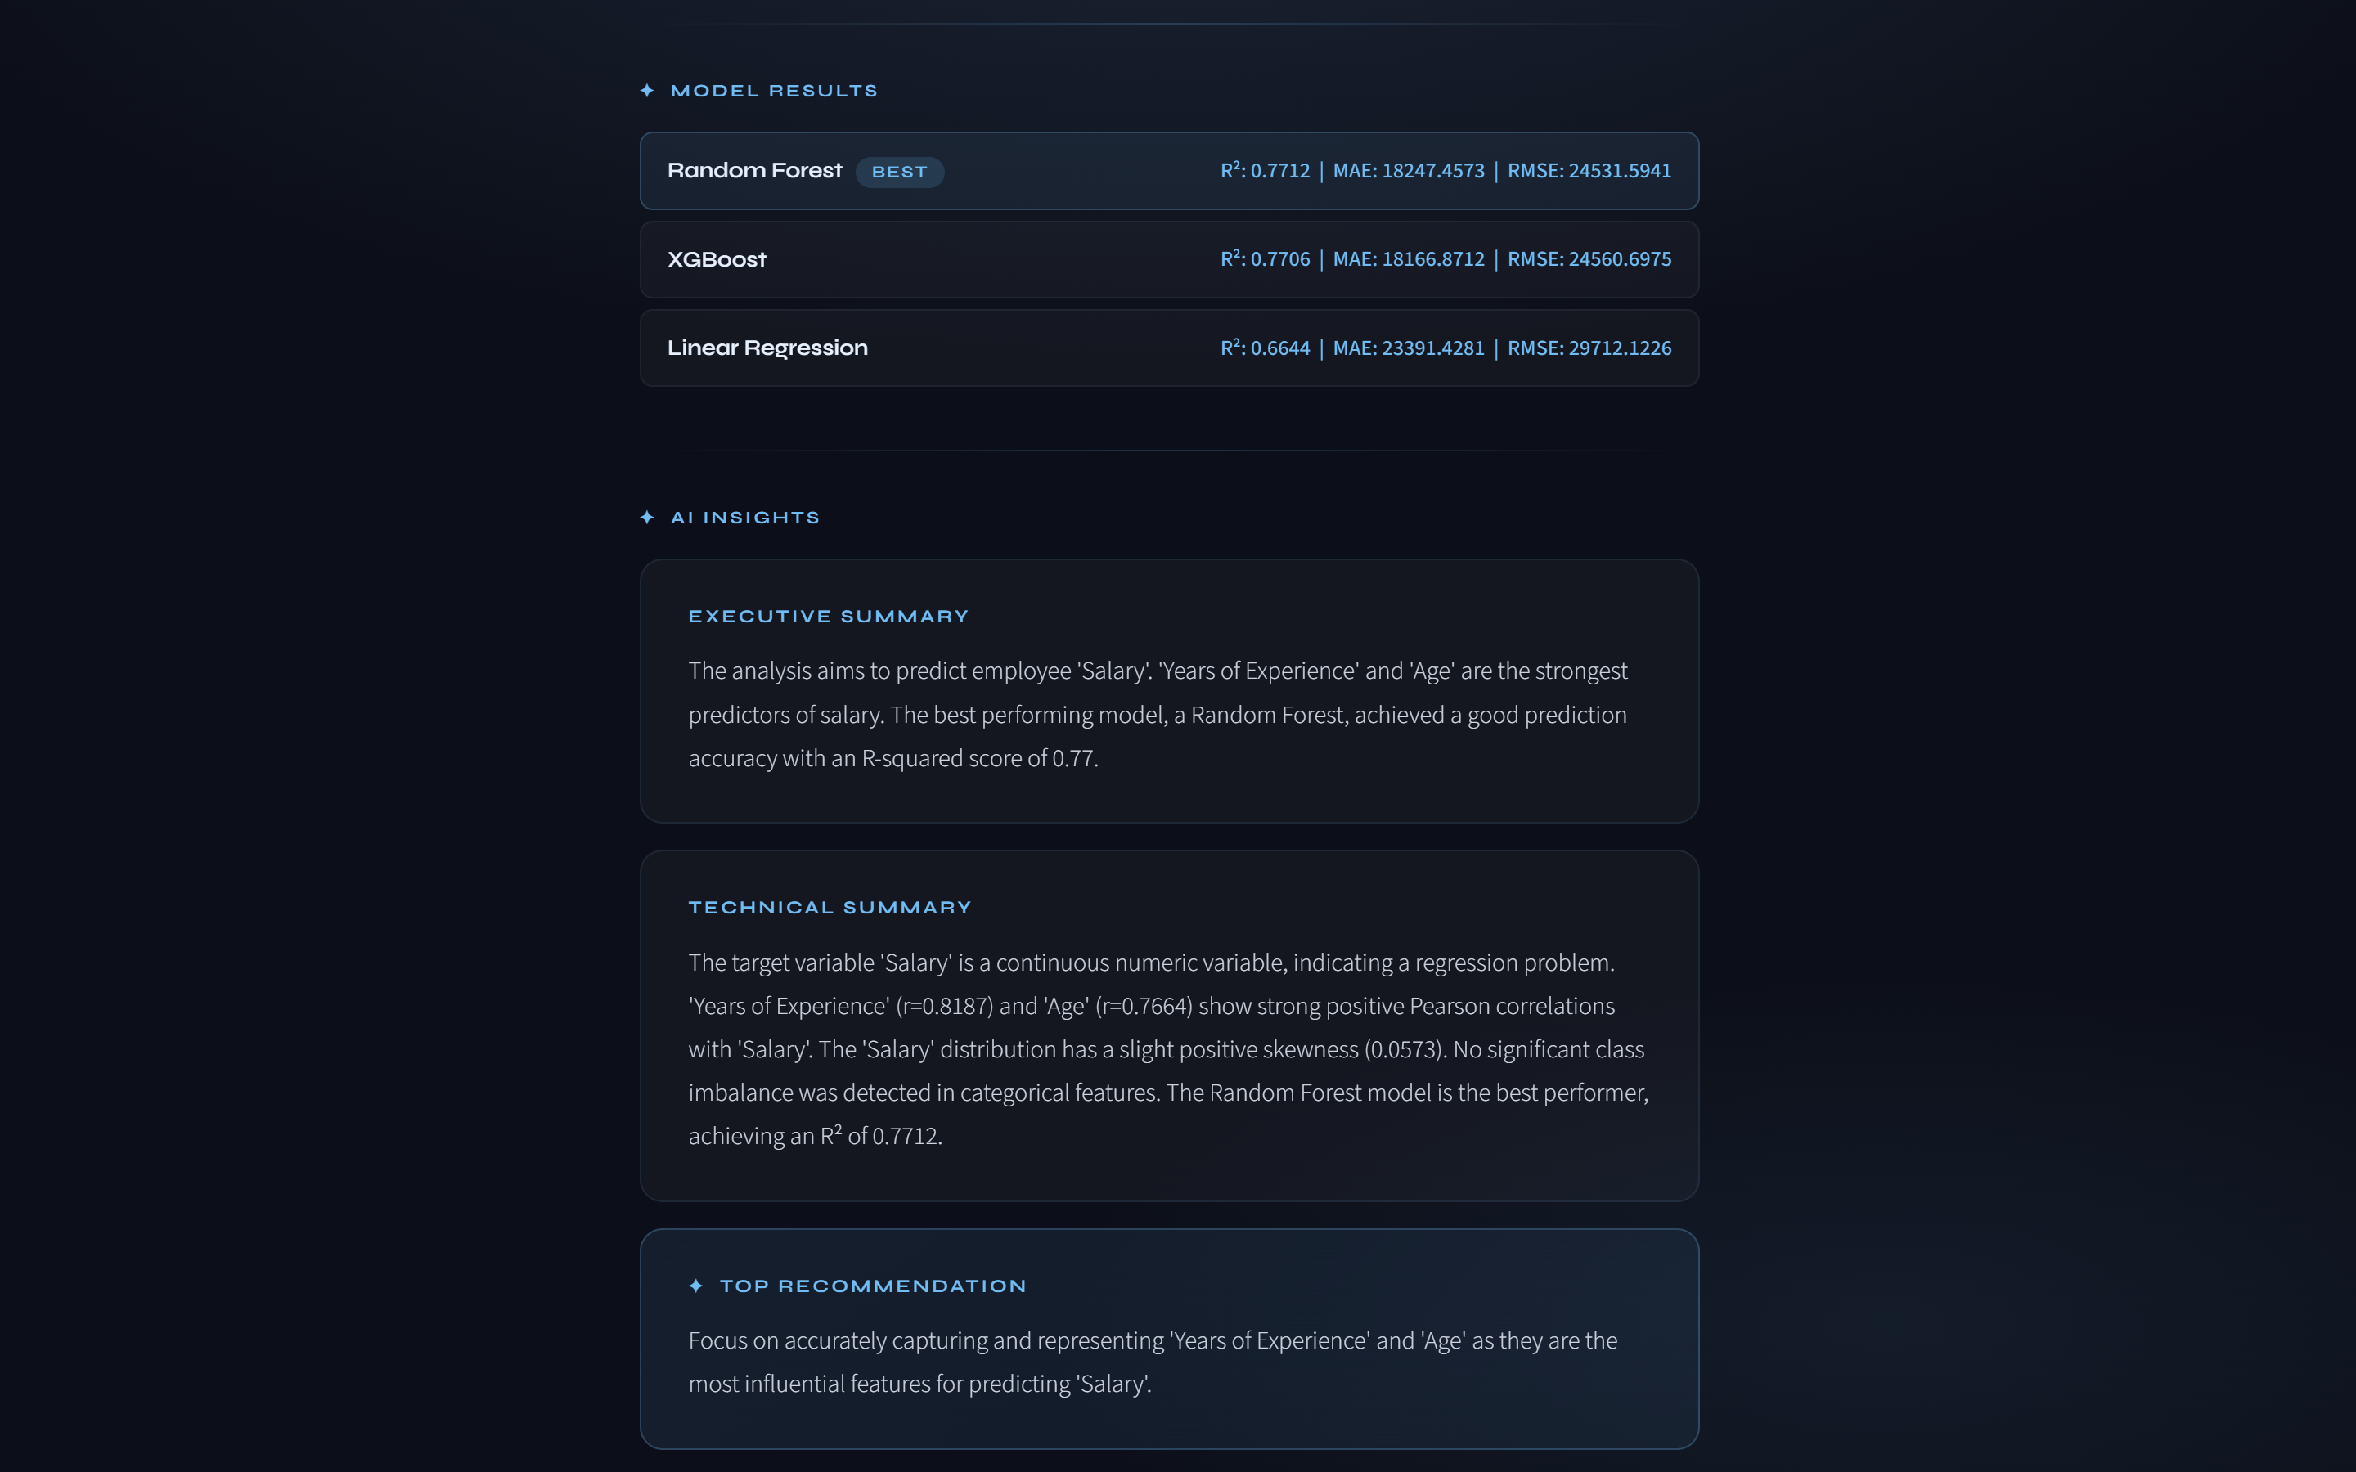

B. User Interface
The dashboard provides a no-code environment where users can simply upload an Excel file and select a target column to receive a full diagnostic report.
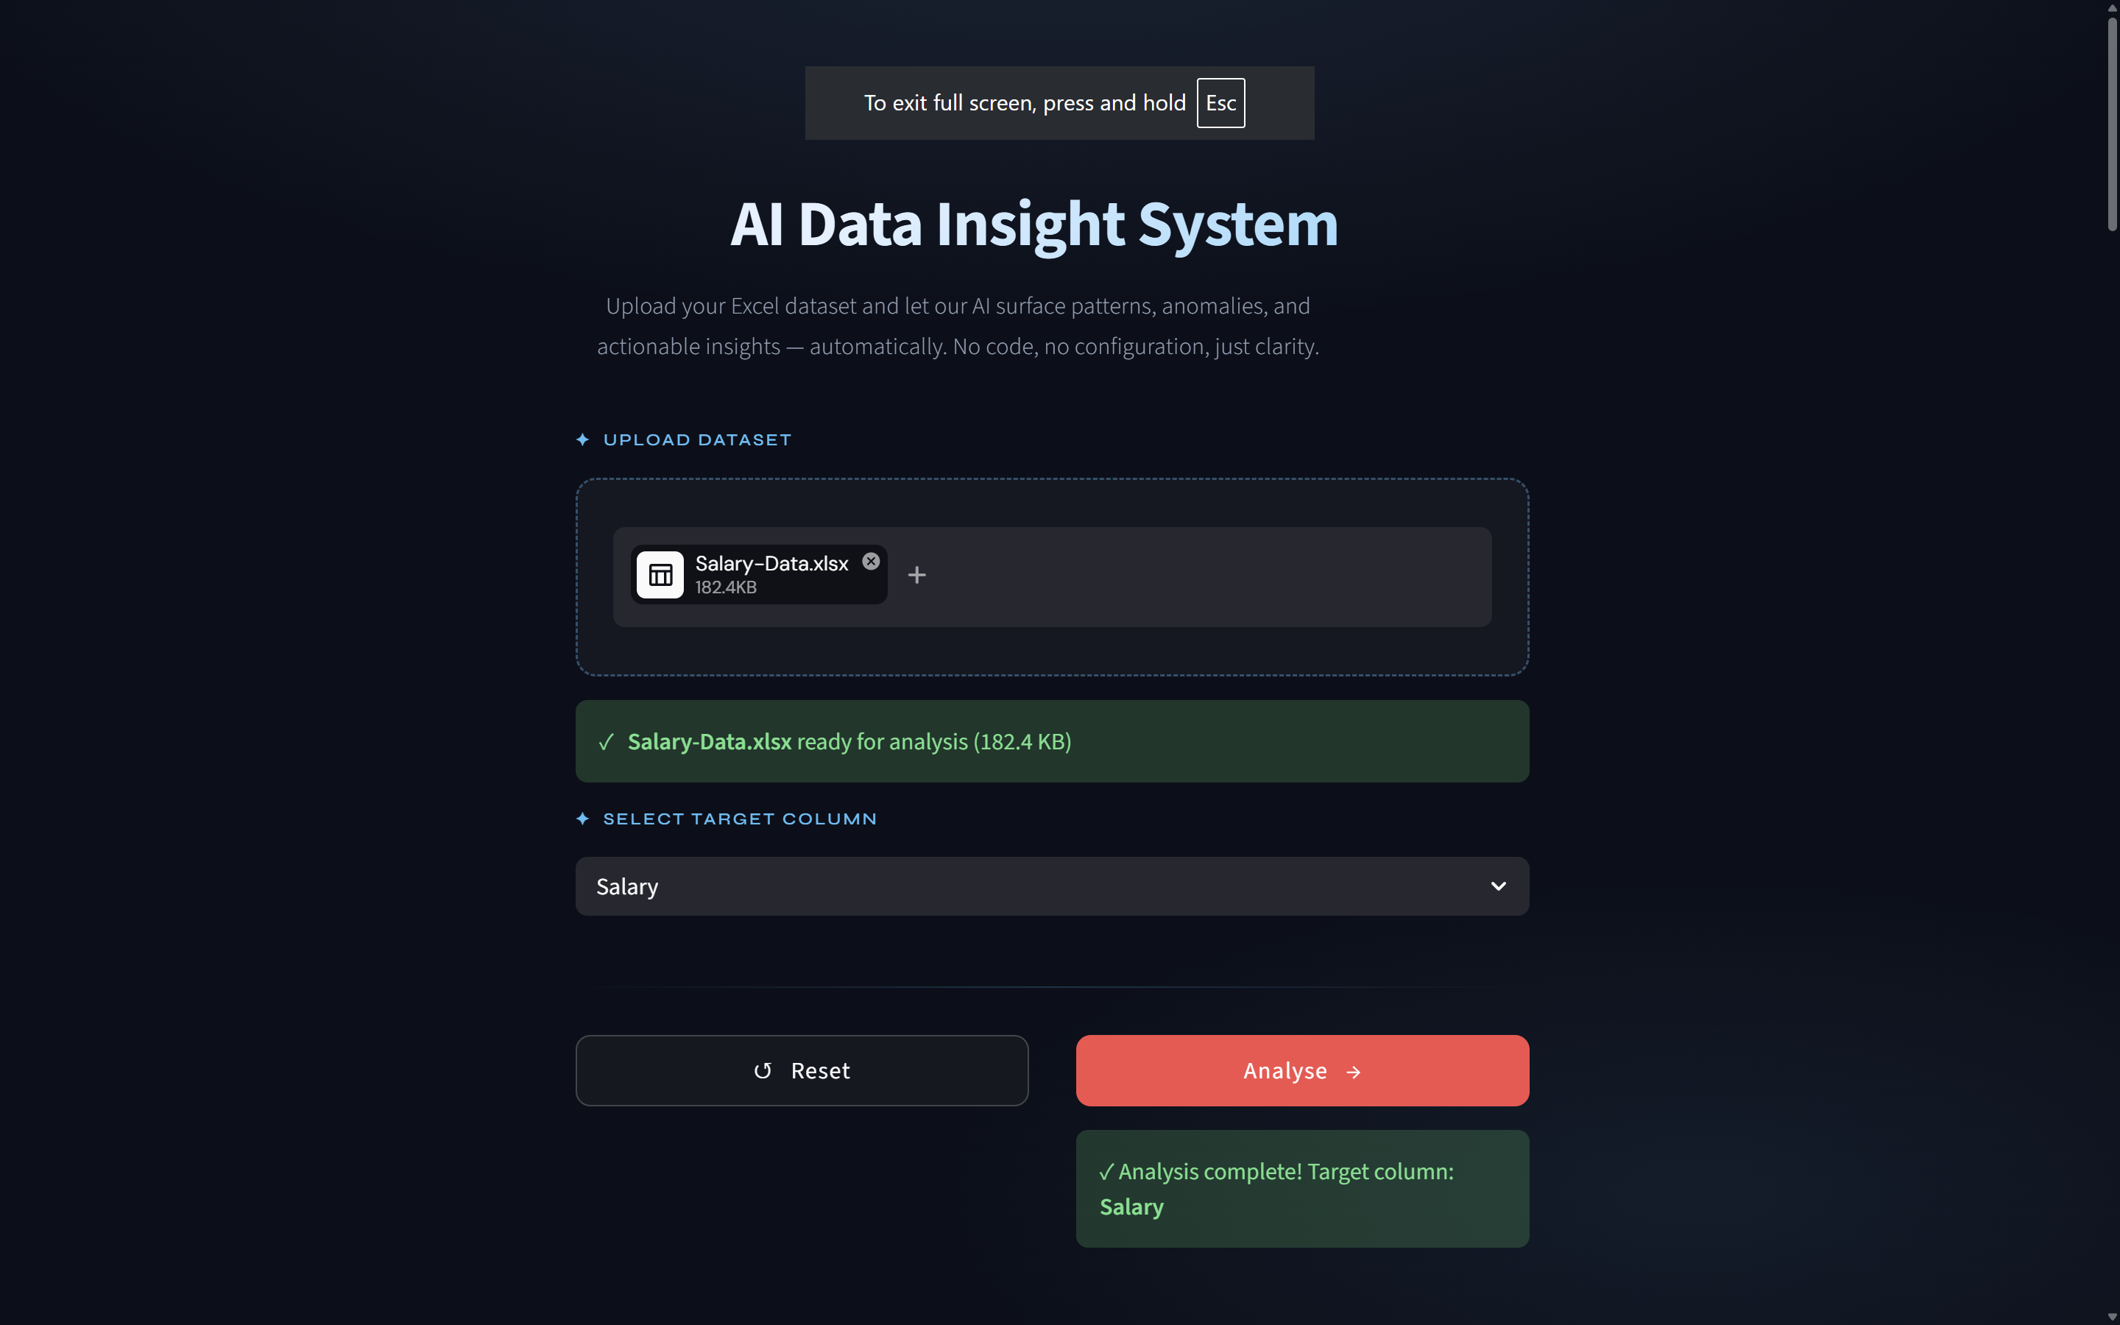

Conclusion
The AI Data Insight System successfully demonstrates how data analysis can be automated using machine learning and AI techniques. The system is capable of handling real-world datasets and providing meaningful insights without requiring expert knowledge.
This project bridges the gap between raw data and actionable insights, making data analysis accessible to a wider audience.

References
[1] pandas development team, “pandas-dev/pandas: Pandas 2.2.2,” Zenodo, 2024. [Online]. Available: https://pandas.pydata.org/
[2] F. Pedregosa et al., “Scikit-learn: Machine Learning in Python,” Journal of Machine Learning Research, vol. 12, pp. 2825–2830, 2011.
[3] Streamlit Inc., “Streamlit Documentation: The fastest way to build and share data apps,” 2024. [Online]. Available: https://docs.streamlit.io/
[4] Google AI, “Gemini API Documentation: Large Language Model Integration,” 2024. [Online]. Available: https://ai.google.dev/docs/gemini_api

