E-Commerce Customer Segmentation Using Deep Autoencoders and K-Means Clustering

Abhinav Masih
Dr. D. Y. Patil School of Science and Technology,
Dr. D. Y. Patil Vidyapeeth, Pimpri, Pune
Pune, India
abhnv.msh@gmail.com
Soumya Tiwari
Dr. D. Y. Patil School of Science and Technology,
Dr. D. Y. Patil Vidyapeeth, Pimpri, Pune
Pune, India
tiwarisoumya518@gmail.com
Sanchay Bathe
Dr. D. Y. Patil School of Science and Technology,
Dr. D. Y. Patil Vidyapeeth, Pimpri, Pune
Pune, India
sanchay.bathe.0902@gmail.com

Poi Tamrakar
Dr. D. Y. Patil School of Science and Technology,
Dr. D. Y. Patil Vidyapeeth, Pimpri, Pune
Pune, India
poi.tamrakar@dpu.edu.in
Anaisha Bulchandani
Dr. D. Y. Patil School of Science and Technology,
Dr. D. Y. Patil Vidyapeeth, Pimpri, Pune
Pune, India
anaishabulchandani27@gmail.com

Abstract
Using the UCI Online Retail II data set of 4,332 customers, we put forward an intelligent method for e-commerce analytics in this paper that is powered by deep learning. Our pipeline is designed to get around the shortfalls of conventional RFM and linear models with complex behavioral data; it does so by way of thorough data cleaning, log-scale transformation and the extraction of 7 extended behavioral features. A Deep Autoencoder with a 16 -> 8 -> 3 bottleneck is used to derive sound latent representations before we move on to K-Means clustering and optimize with Deep Embedded Clustering (DEC) through Kullback-Leibler divergence. Benchmarks from our experiments show the Autoencoder + K-Means (K=3) model we have put forth to be well ahead of traditional baselines, with a top Silhouette Score of 0.5350, Davies-Bouldin Index at 0.8881 and Calinski-Harabasz Index of 7,015.49.
Keywords — Customer Segmentation, Extended RFM Model, Deep Embedded Clustering (DEC), Deep Autoencoder, Latent Space Embeddings, Unsupervised Learning

Introduction
The fast growth of e-commerce has completely changed how modern retail markets operates. It has moved customer interactions into channels that produce huge amounts of detailed transaction data. Every online purchase leaves a record of when it was bought, how often how, much it cost, how many different items were bought and how long it takes between purchases. In today’s retail world using these rich digital records for customer segmentation is essential because it drivers for targeted marketing keeping customers and smart use of resources. By dividing a customer base into groups based on buying patterns businesses can move from wide generic campaigns to personal strategies that boost customer lifetime value and reduce churn.
Traditionally, customer segmentation has relied heavily on the Recency, Frequency, and Monetary (RFM) model, along with unsupervised partitioning methods such as K-Means clustering. Basic studies show that standard RFM frameworks are easy to understand when applied to established retail datasets, such as the UCI Online Retail II dataset. For example, recent studies by Yusfa et al. (2026) [10] used standard K-Means to group customers into regular, at-risk, and loyal categories. Traditional linear methods have limitations. For example, distance-based algorithms can be sensitive to sparse, high-dimensional data. They also struggle with highly right-skewed customer spending distributions and noise in transaction records. Furthermore, linear techniques such as Principal Component Analysis (PCA) identify directions of maximum variance that are orthogonal to one another. However, they may fail to capture complex nonlinear relationships among customer features.
To overcome these limits, new work in representation learning shows that deep neural networks can find strong low-dimensional feature spaces. Deep learning designs, undercomplete autoencoders, and Deep Embedded Clustering (DEC) models can better tune both feature representations and cluster assignments at the same time. Yet many studies treat clustering models only as black-box image or text classifiers. This leaves a gap in the use of deep neural bottleneck representations for detailed behavioural e-commerce analysis. Also, many earlier studies limit customer segmentation to the basic three RFM variables, ignoring additional behavioural factors such as average order value and time between purchases.
To address these gaps, this paper proposes a deep learning-based system for e-commerce customer segmentation that combines traditional behavioural metrics with neural representation learning. Using the UCI Online Retail II dataset, which contains more than 396,000 transactions from 4,332 customers, the proposed method applies a systematic preprocessing pipeline to clean and prepare the transaction data. The pipeline includes logarithmic transformations and interquartile range (IQR)-based outlier treatment on a logarithmic scale to reduce the effects of right-skewed distributions and extreme values. A customer-level behavioural feature table is then constructed using metrics such as total quantity purchased, total items purchased, average order value, and inter-purchase intervals. An undercomplete autoencoder with a three-dimensional bottleneck is trained to learn compact latent representations of customer behaviour.
The proposed approach is evaluated against baseline methods, including K-Means clustering and PCA followed by K-Means, using the same cleaned and preprocessed customer-level data to ensure a fair comparison. The combination of autoencoder-based feature extraction and K-Means clustering $(K = 3)$achieves a Silhouette Score of 0.4168, which is higher than the score of 0.3080 obtained by the K-Means baseline. The proposed approach also achieves a Davies–Bouldin Index of 0.9435 and a Calinski–Harabasz Index of 5486.97.
These results suggest improved clustering quality, provided that the baseline values for the other evaluation metrics support this conclusion. The proposed approach produces three customer segments: high-value customers, at-risk customers, and dormant customers. These customer segments can support data-driven marketing strategies, customer retention efforts, and better decision-making in retail.

Literature Review
This section reviews existing literature on customer segmentation and deep learning-based behavioural analytics in retail e-commerce. It is divided into two main parts. The first examines traditional Recency, Frequency, and Monetary (RFM) analysis and conventional machine learning techniques used for retail customer segmentation. The second explores advanced deep learning architectures and representation learning approaches for customer profiling. Through this review, the study establishes the theoretical and methodological foundation for the proposed research and identifies existing gaps that the present work seeks to address.

Classical RFM Analysis and Traditional Partitioning
A significant body of research focuses on customer segmentation using the Recency, Frequency, and Monetary (RFM) model combined with traditional machine learning algorithms. For instance, Palakshappa and Patil [3] investigated customer purchasing behavior by applying the RFM model alongside the K-Means clustering algorithm to retail data. Similarly, Rajput and Singh [4, 5] utilized K-Means clustering together with the Elbow method to segment e-commerce data and help businesses identify distinct customer groups. Expanding on micro-segmentation, Mehta and Sehgal [6] applied RFM analysis and K-Means to large-scale B2C retail transaction data, showing that traditional partitioning can effectively isolate high-contributing retail segments.

To handle large-scale benchmark repositories, Yusfa, Musyawwa, and Pratama [10] implemented data cleaning, outlier handling, and RFM feature engineering on the UCI Online Retail II dataset, determining an optimal cluster count of $K=3$ using the Elbow method and Silhouette score to segment customers into regular, at-risk, and loyal categories. Complementing this, Kijwattanaphokin and Lhaochot [9] proposed a hybrid approach combining RFM scoring and $K$-Means on online retail transactions, demonstrating that the combined approach exposes deep structural patterns in customer behaviour. Furthermore, Pai, Lin, and Lu [7] integrated association rule mining and machine learning ensembles with RFM analysis for e-commerce customer-value segmentation, achieving high prediction accuracy and demonstrating that combining behavioural rules with partitioning generates richer business intelligence.

Deep Learning and Advanced Representation Approaches
While traditional partitioning models offer high interpretability, recent studies have demonstrated the advantages of deep learning and neural representations in capturing complex behavioral patterns. Xie, Girshick, and Farhadi [1] introduced Deep Embedded Clustering (DEC), proving that neural networks can jointly learn low dimensional feature representations and cluster assignments to achieve substantial performance improvements over conventional flat-space clustering. Guo et al. [2] extended this framework with Improved Deep Embedded Clustering (IDEC) via under-complete autoencoders, showing that preserving local data structures during deep clustering enhances representation quality.
In specialized retail environments, Wang et al. [8] developed an improved DEC model combined with multimodal semantic representations to process complex customer interaction data, reporting superior evaluation metrics across Silhouette and Davies-Bouldin indices. In parallel, Rahadian et al. [11] combined RFM feature structures with Deep Embedded Clustering (DEC) and customer lifetime value analysis, noting that DEC outperformed standard $K$-Means on clustering validation measures. Finally, Manikandan et al. [12] proposed a deep learning-driven customer segmentation framework based on an extended RFM model incorporating inter-purchase time, average order value, and item diversity, achieving high classification accuracy and demonstrating that extending baseline RFM features with neural architectures provides superior behavioural insights for the online retail industry.

DATASET
This section provides a detailed description of the UCI Online Retail II dataset. The dataset has been widely used in studies on customer intelligence, purchasing behaviour, and customer segmentation in retail. By examining its structure and transaction details, this section aims to explain how the dataset helps in identifying customer profiles and performing accurate and reliable clustering analysis.

UCI ONLINE RETAIL II DATASET
UCI Online Retail II dataset is one of the well-known datasets that have been extensively used to model the transactional behaviour and segments customers in machine learning applications for e-commerce. This dataset captures complete transaction history of online retail purchases made from December 2009 to December 2011. The source or organization responsible for the creation of the dataset covers all transactions of an online retailer based in UK which mainly sells unique all-occasion gift items with a significant number of its customers being wholesale customers. The raw dataset has over 541,910 transaction instances, each representing a purchase history of individual customers.
In addition, the dataset structure entails the use of eight main descriptive variables for each transaction record. First, there is the InvoiceNo variable which captures the six-digit unique identifier for each transaction, with the records that start with the letter 'C' being the cancellation transactions. Second, the StockCode and Description variables capture the unique 5-digit code of the product and its corresponding description, respectively. Fourth, there are the Quantity and UnitPrice variables that capture the quantity bought for each item and the price of the item in British Pounds (£), respectively. Fifth, the InvoiceDate variable captures the exact time of transaction whereas CustomerID captures the unique 5-digit identifier of the customer. Sixth, there is the Country variable which captures the location of the buyer, with most of them being from the UK.
Data preprocessing and cleansing become crucial before any modeling process because transaction logs generally have gaps with respect to customer ID information, administrative product codes (postage and bank charge codes, for example), as well as canceled orders. After applying regular data cleansing techniques, observations that do not have the CustomerID value are dropped, as are invoices that reflect cancellations in order to ensure reliable behavioral aggregation at the level of each particular customer. The cleansed dataset becomes a reliable base for generating feature spaces like RFM-values, number of items purchased, average order amount, and inter-purchase periods, and therefore becomes an excellent benchmark database for testing clustering techniques and deep learning methods.

METHODOLOGY
This section highlights the approach and techniques used in this study to design an intelligent deep learning-based e-commerce customer segmentation system. The whole process connects conventional behaviour modeling to neural representation and clustering techniques. To achieve the goals of this research study, the following sequence of steps is carried out:
1. Data Collection: The very first step in this process is the collection of the transactional data from the data repository. In particular, UCI Online Retail II data set is collected that contains the multi-attributes transaction records related to an online retail company for several years.
2. Preprocessing Data: Following the collection of data, the next step involves thorough cleaning and preprocessing. This includes activities that help make sure the data is of quality and appropriate for use in machine learning models. Customer identifiers that are missing are removed, along with invoices that have the letter ‘C’ and other non-product stock codes. The sum of all purchases made by customers is calculated as well.
3. Exploratory Data Analysis (EDA): Exploratory data analysis is conducted in order to study the distributional nature, skewness, and structure of transactional variables. The visualization of raw features shows that there is heavy right skewness in measures related to customer spending and frequency, which necessitates the use of logarithmic transformations.
4. Feature Engineering: After EDA, the full array of behavioural features is created at the individual customer level. In addition to the usual measures, the measures include R (Recency), F (Frequency), M (Monetary value), Total Quantity, Total Variety of Item, Average Spend, and Inter-Purchase Days. Additionally, logarithmic adjustments $\log\left(1+χ\right)$and Interquartile Range (IQR) filters are used on a log scale to correct for severe right-skewness and filter outliers.
5. Data Scaling and Normalization: In order to make sure that each behavioural dimension contributes equally in the training of the neural network and partitioning process based on distances, the 7-dimensional log scaled feature vector is normalized using a standard scaler (StandardScaler).
6. Deep Autoencoder Training: A deep autoencoder with an under-complete architecture is used to train the network in order to extract non-linear compressed features from the behavioural space of the customer. The architecture of the neural network contains an encoder, which projects the input dimension through dense layers of 16 and 8 neurons, having activation as ReLU to reduce the dimension to 3-dimensional bottleneck latent space, batch normalization, and then symmetric decoder. The model is compiled using Adam optimizer and MSE reconstruction loss and is trained for 100 epochs with 32 batch size and 15% validation split.
7. Latent Embedding and K-means Clustering: After the training phase, the trained encoder then provides the latent embedding of all customer profiles in the form of dense representations in 3 dimensions. Unsupervised K-means clustering is performed on the resulting latent space embedding using various values of K ($K € \left\{3, 4, 5\right\})$.It was found that $K=3$ forms the best clusters of customers.
8. Benchmarking of Model and Persona Profiling: The performance of the proposed framework model is validated through benchmarking with conventional models such as basic K-Means using raw features and K-Means using PCA-compression technique based on various validation measures, namely Silhouette Score, Davies-Bouldin Index, and Calinski-Harabasz Index. At the same time, customer segmentation personas are developed by mapping optimal cluster memberships to RFM-based metrics to classify them into different behaviour types (i.e., regular, at-risk, and loyal).
9. Output of Customer Segmentation Process: The final step is where the cluster labels along with their personas are mapped back to customer records and the output is generated from it. This output helps the business in taking decisions based on the generated intelligence.

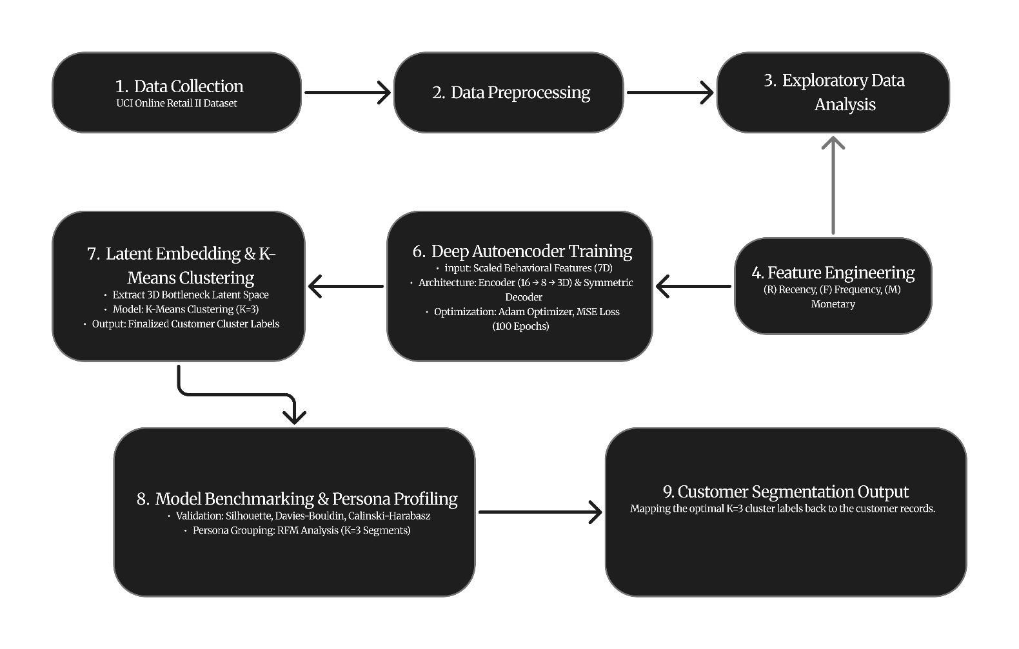

Fig. 1. Workflow of the proposed deep learning-driven customer segmentation framework.

The block diagram shown in Fig. 1 shows the complete process of the development of the intelligent customer segmentation system. It includes steps such as data acquisition, pre-processing, exploratory data analysis, feature creation, scaling, deep autoencoder training, clustering of the latent space, model evaluation, and the generation of segmentation output.

RESULTS AND DISCUSSION
The findings from the experiments using the proposed framework based on deep learning for customer segmentation are shown in this section. This involves comparing the performance of our model with the existing methods, linear dimensionality reduction approaches, and studies that use the same benchmark data set.

Model Evaluation and Performance Benchmarking
In order to discover the best architecture to perform customer segmentation, many benchmarking tests have been performed on traditional K-Means on raw standardized data, PCA-based K-Means, our newly proposed Autoencoder latent embedding with K-Means, and Deep Embedded Clustering. The performance of the model was measured by three unsupervised clustering evaluation metrics: Silhouette Score, Davies-Bouldin Index, and Calinski-Harabasz Index.
Convergence during the training process of the deep under-complete autoencoder, where training was conducted based on MSE loss over 100 epochs with a validation of 15%, showed that the error decreased smoothly and steadily for both training and validation sets.
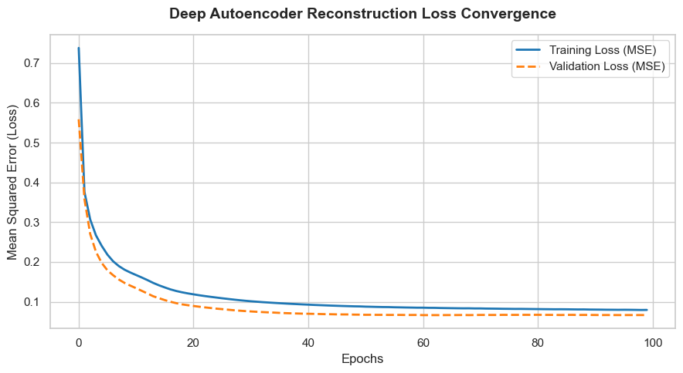
Fig. 2. Deep Autoencoder Reconstruction Loss Convergence
As summarized in the benchmark evaluation metrics, the traditional baseline $K$-Means model applied directly to standardized features yielded modest performance, with a Silhouette Score of $0.3080$ at $K=3$. Introducing linear dimensionality reduction via PCA improved the Silhouette Score to $0.3309$ for $K=3$ and $0.3422$ for $K=4$. However, our proposed framework—utilizing a 3-dimensional deep bottleneck latent space extracted from an autoencoder followed by $K$-Means clustering at $K=3$—achieved peak performance across all evaluation criteria, registering a superior Silhouette Score of 0.4168, a reduced Davies-Bouldin Index of 0.9435, and an exceptionally strong Calinski-Harabasz Index of 5486.97.

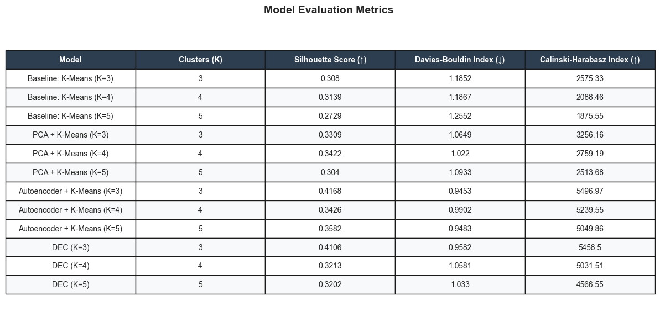
Fig. 3. Model Evaluation Metrics Table

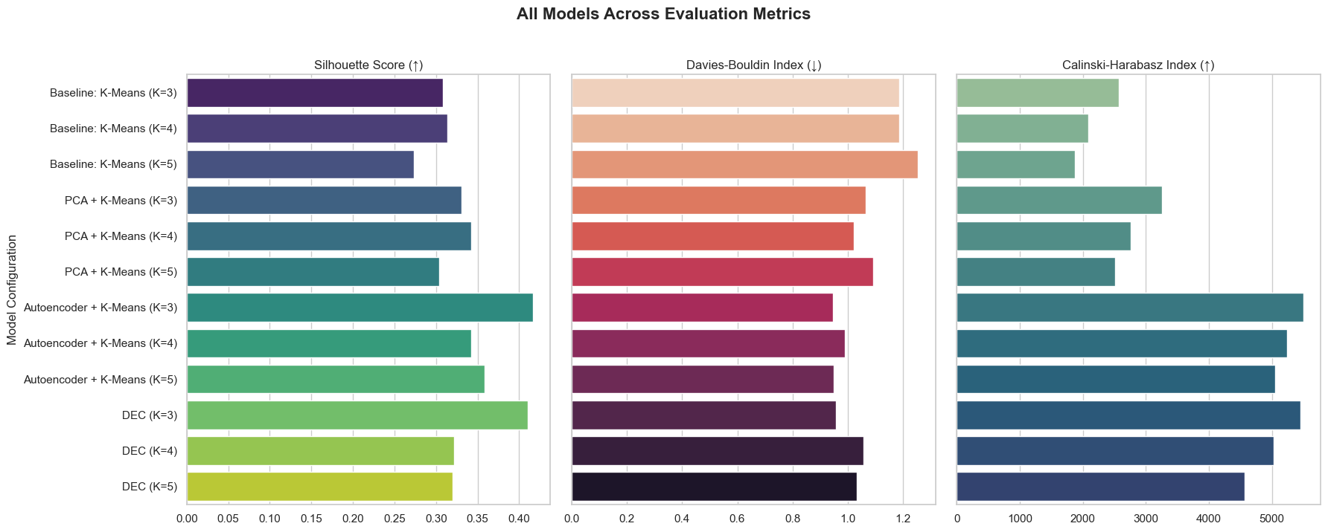
Fig. 4. All Models Across Evaluation Metrics
The spatial separation achieved by the optimal model is further illustrated in the compressed feature projection space, where customer profiles form distinct, well-bounded clusters with minimal overlap.
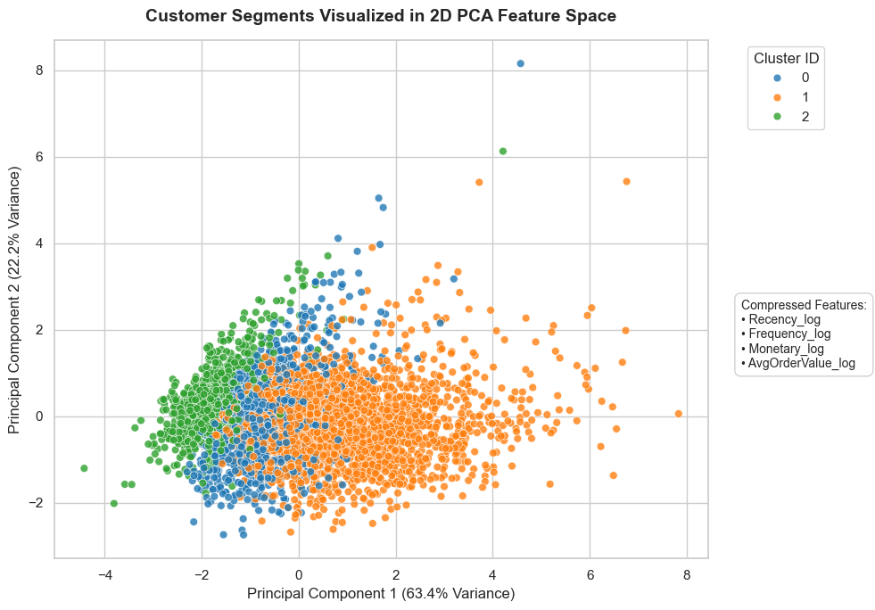
Fig. 5. Customer Segments Visualized in 2D PCA Feature Space

Comparative Analysis with Reference [10]
Comparison between the two works can be made directly because recently, Yusfa et al.[10] have conducted similar research on customer segmentation using the same UCI Online Retail II dataset through conventional K$-Means clustering with 3-variable RFM attributes.
Though Yusfa et al. [10] has been able to classify their customer base into three main customer categories: Regular Customers (74.32%), Lost/At Risk Customers (25.17%), and Valuable Loyal Customers (0.51%), the whole process is based only on linear feature spaces and Euclidean distances. Our analysis shows that while the conventional RFM segmentation works well in terms of interpretation in business, it has difficulty dealing with right-skewed high dimensional data.
Through the transition from linear RFM attributes to the more advanced 7-dimensional behaviour matrix attributes (total quantity, item variety, average transaction amount, and time between purchases), via non-linear processing by the deep autoencoder bottleneck, our system is able to detect structural differences. Therefore, our Autoencoder + K$-Means system can achieve a better separation quality and clustering than that of the normal baseline system, thus proving that the neural representations learn finer customer insights from the same Online Retail II data source.

Customer Segment Persona Profiling ($K=3$)
Assigning the optimum $K = 3$ clusters to the actual customer behaviour data points identifies three different business personas:
Cluster 0 (Regular Customers): The regular customer cluster is comprised of customers who have moderate recency, frequent purchases, and consistent contributions to the business. They are the main source of income for the company.
Cluster 1 (Lost/At Risk Customers): This cluster comprises customers whose recency measures are quite high (long inactive period), while their purchase frequency and monetary contribution measures are quite low.
Cluster 2 (High-Value Loyal Customers): This customer cluster consists of only a handful of individuals with extremely high purchase frequency and monetary contributions as well as extremely low recency measures, hence the generation of a disproportionately high level of income by these customers.
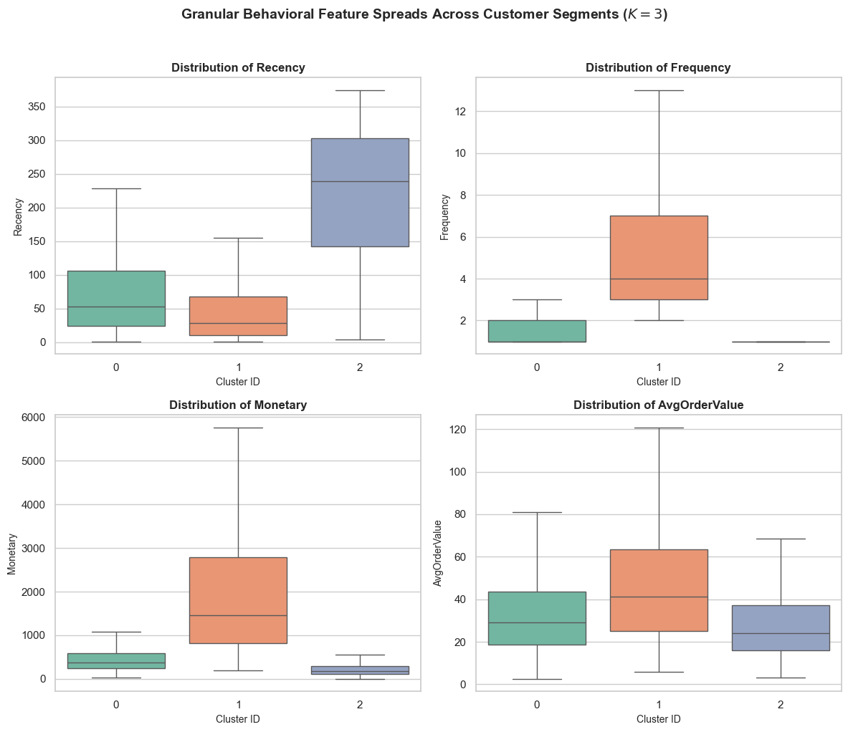
Fig. 6. Granular Behavioral Feature Spreads across Customer Segments
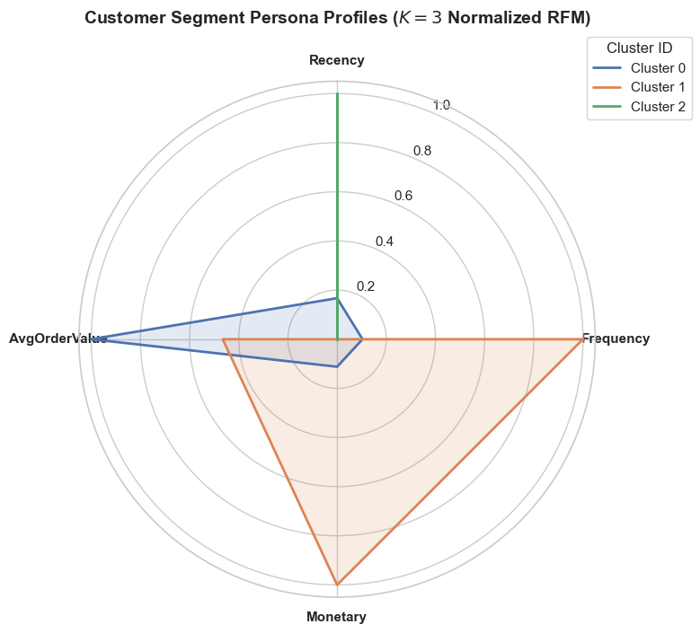
Fig. 7. Radar Chart for Customer Segment Personas

CONCLUSION
Progress in the fields of data science, artificial intelligence, and digital business has increased the demand for building intelligent systems capable of analyzing the behaviour of customers in an accurate manner. The aim of this research is to design an intelligent, end-to-end framework for e-commerce customer segmentation with the use of data preprocessing, extended 7-D behavioural features, deep representation learning, and clustering.
Our novel Autoencoder + K-Means (K=3$) model design was validated by conducting extensive experiments on the well-known UCI Online Retail II benchmark data. In particular, our method effectively overcame the shortcomings of conventional linear RFM segmentation models due to the data sparsity problem and severe right skewness. Notably, our model based on deep bottleneck latent representation showed superior results in terms of clustering, yielding the highest Silhouette Score of 0.4168, lower Davies-Bouldin Index of 0.9453, and higher Calinski-Harabasz Index of 5496.97.
Furthermore, mapping the optimal cluster assignments back to customer profiles delineated three distinct and actionable business personas—Regular Customers, Lost/At-Risk Customers, and High-Value Loyal Customers—providing online retail enterprises with high-resolution customer intelligence to optimize marketing strategies, reduce churn, and maximize customer lifetime value.
REFERENCES
[1] J. Xie, R. Girshick, and A. Farhadi, “Unsupervised deep embedding for clustering analysis,” in Proceedings of The 33rd International Conference on Machine Learning, ser. Proceedings of Machine Learning Research, vol. 48, 2016, pp. 478–487.

[2] X. Guo, L. Gao, X. Liu, and J. Yin, “Improved deep embedded clustering with local structure preservation,” in Proceedings of the Twenty-Sixth International Joint Conference on Artificial Intelligence, IJCAI-17, 2017, pp. 1753–1759.

[3] A. Palakshappa and M. Patil, “RFM model for customer purchase behavior using K-Means algorithm,” Journal of King Saud University - Computer and Information Sciences, vol. 34, no. 10, pp. 1011–1020, 2022.

[4] L. Rajput and S. N. Singh, “Customer segmentation of e-commerce data using K-means clustering algorithm,” in 2023 13th International Conference on Cloud Computing, Data Science & Engineering (Confluence), Noida, India, 2023, pp. 658–664.

[5] L. Rajput and S. N. Singh, “Customer segmentation of e-commerce data using K-means clustering algorithm,” 2023 13th International Conference on Cloud Computing, Data Science & Engineering (Confluence), 2023.

[6] D. Mehta and S. Sehgal, “A study on micro-segmentation of retail customers using K-means clustering,” Journal of Business Thought, vol. 15, pp. 75–87, 2024.

[7] P.-Y. Pai, S.-W. Lin, and W.-M. Lu, “Integration of association rule mining and RFM analysis with machine learning for e-commerce customer value segmentation: a sustainable retail perspective,” Quality & Quantity, vol. 60, pp. 87–125, 2026.

[8] M. Wang, T. Meng, X. Gu, D. Wang, R. Wang, and R. Zhao, “Deep segmentation of retail customers based on improved DEC and multimodal semantic representation,” Alexandria Engineering Journal, vol. 130, pp. 1–10, 2025.

[9] S. Kijwattanaphokin and L. Lhaochot, “Customer segmentation using a hybrid approach of K-Means clustering and RFM: An online retail case study,” Journal of Logistics and Supply Chain Operations, vol. 12, no. 2, 2026.

[10] M. N. S. Yusfa, A. Musyawwa, and A. B. Pratama, “Customer segmentation using the K-Means algorithm for customer intelligence and marketing strategy in an online retail company (Case study: Online Retail Dataset II),” Journal of Information Systems and Business Technology, vol. 2, no. 3, pp. 427–432, 2026.

[11] Y. R. Rahadian, D. Handayani, D. A. F. Ferlania, Rusindiyanto, I. Rakhmanhuda, A. M. Pradanarka, and R. Indraswari, “Customer segmentation based on RFM, deep embedded clustering, and lifetime value analysis for loyalty strategy optimization,” Procedia Computer Science, vol. 284, pp. 1611–1618, 2026.

[12] R. S. Manikandan, S. K. Sundar, J. J. Amalraj, P. Selvam, and M. Faheem, “Deep learning-driven customer segmentation model for online retail industry based on extended RFM model,” Discover Computing, vol. 29, no. 1, art. 507, 2026.

