PROJECT REPORT – WEB MUSIC PLAYER

Abhinav Masih-1
Sanchay Bathe-14
Chandan sirvi-16
Shreya Chaudhary- 54

Abstract
This project presents a simple and interactive Web Music Player built using Streamlit, Python, and basic image/audio management. The system allows users to add songs to a queue, view album art, and control playback using next and previous buttons. A custom queue data structure manages songs efficiently, enabling smooth transitions between tracks. The interface is lightweight and focuses on providing a clean user experience with sidebar-based controls and a centered main display. This project demonstrates how Python’s Streamlit framework can be used to create functional web applications with multimedia handling. The solution is suitable for beginners learning data structures, web app development, and event-driven workflows.

1. Introduction
Background
Web-based media players are widely used for music streaming and playlist management. This project aims to reproduce a simple version of such a player using Python and Streamlit, while also applying data structure concepts like queues and stacks.
Objective and Scope
- Develop a working web music player.
- Allow users to add songs into a queue.
- Provide playback controls (Next, Previous).
- Display album art dynamically.
- Use Streamlit for UI and Python Queue logic for backend processing.
Target Audience
- Beginners learning Python and Streamlit
- Students studying Data Structures (Queue, Stack)
- Anyone wanting to build simple Python-based web apps
Technology Stack
- Frontend: Streamlit
- Backend Logic: Python
- Data Structures: Custom Circular Queue + History Stack
- Media: Local MP3 files, JPG images
- Libraries: Streamlit, PIL (Pillow)

2. System Architecture
Use Case Diagram:
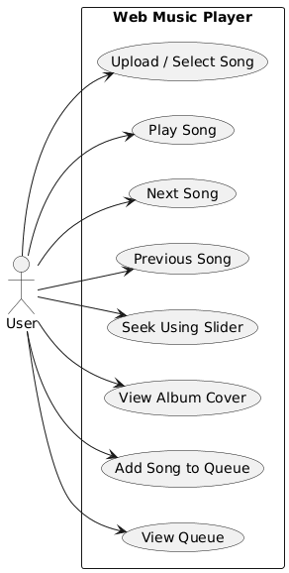

Data Flow Diagram:
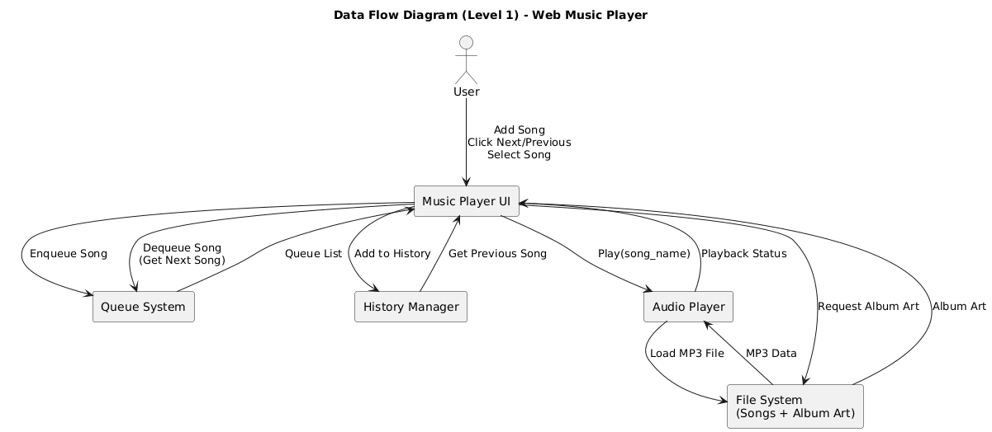
Class Diagram:
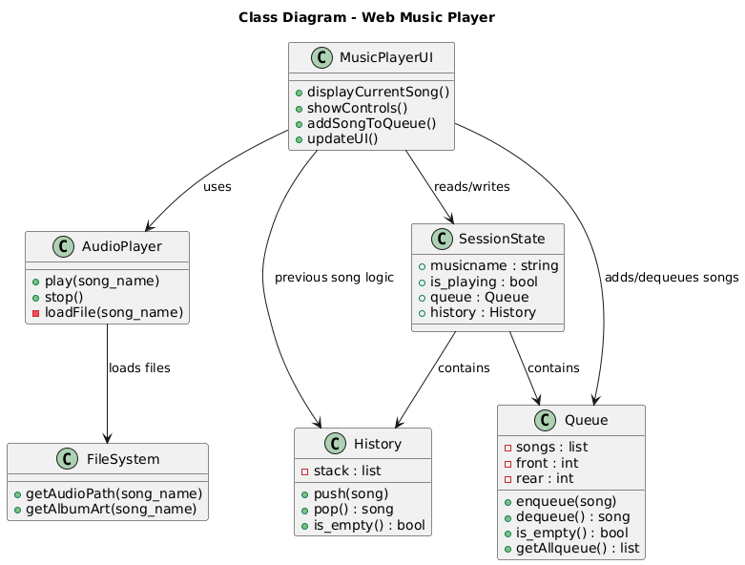
- 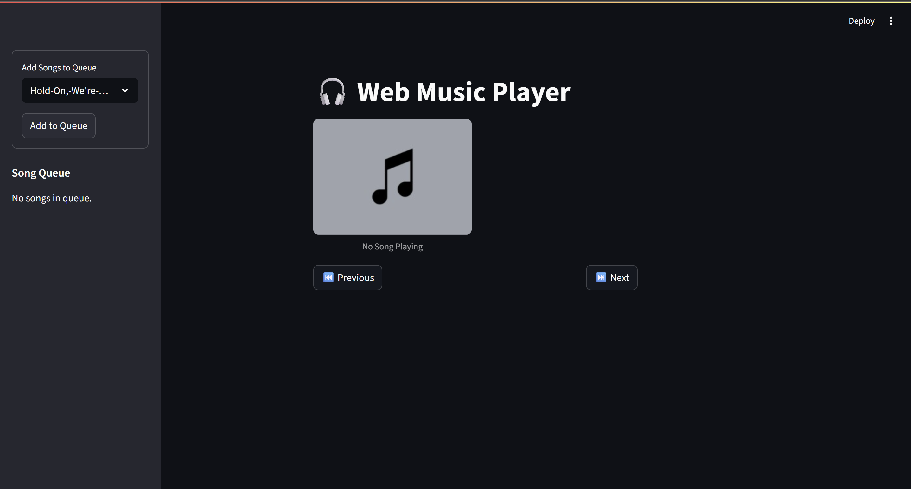Streamlit framework used to create the user interface.
- A circular queue stores upcoming songs.
- A stack stores previously played songs for the “Previous” feature.
- Album art is displayed using the PIL image library.
- Music is played using st.audio() with autoplay enabled.
- UI is divided into two parts:
  - Sidebar: Queue controls
  - Main Area: Album art, current song, playback buttons

4. Results
- The music player successfully loads and plays songs stored locally.
- Songs can be added to the queue and automatically played in order.
- Previous and Next buttons work smoothly using Stack and Queue.
- Album art changes dynamically based on the selected track.
- The UI remains clean, responsive, and centered for a better experience.
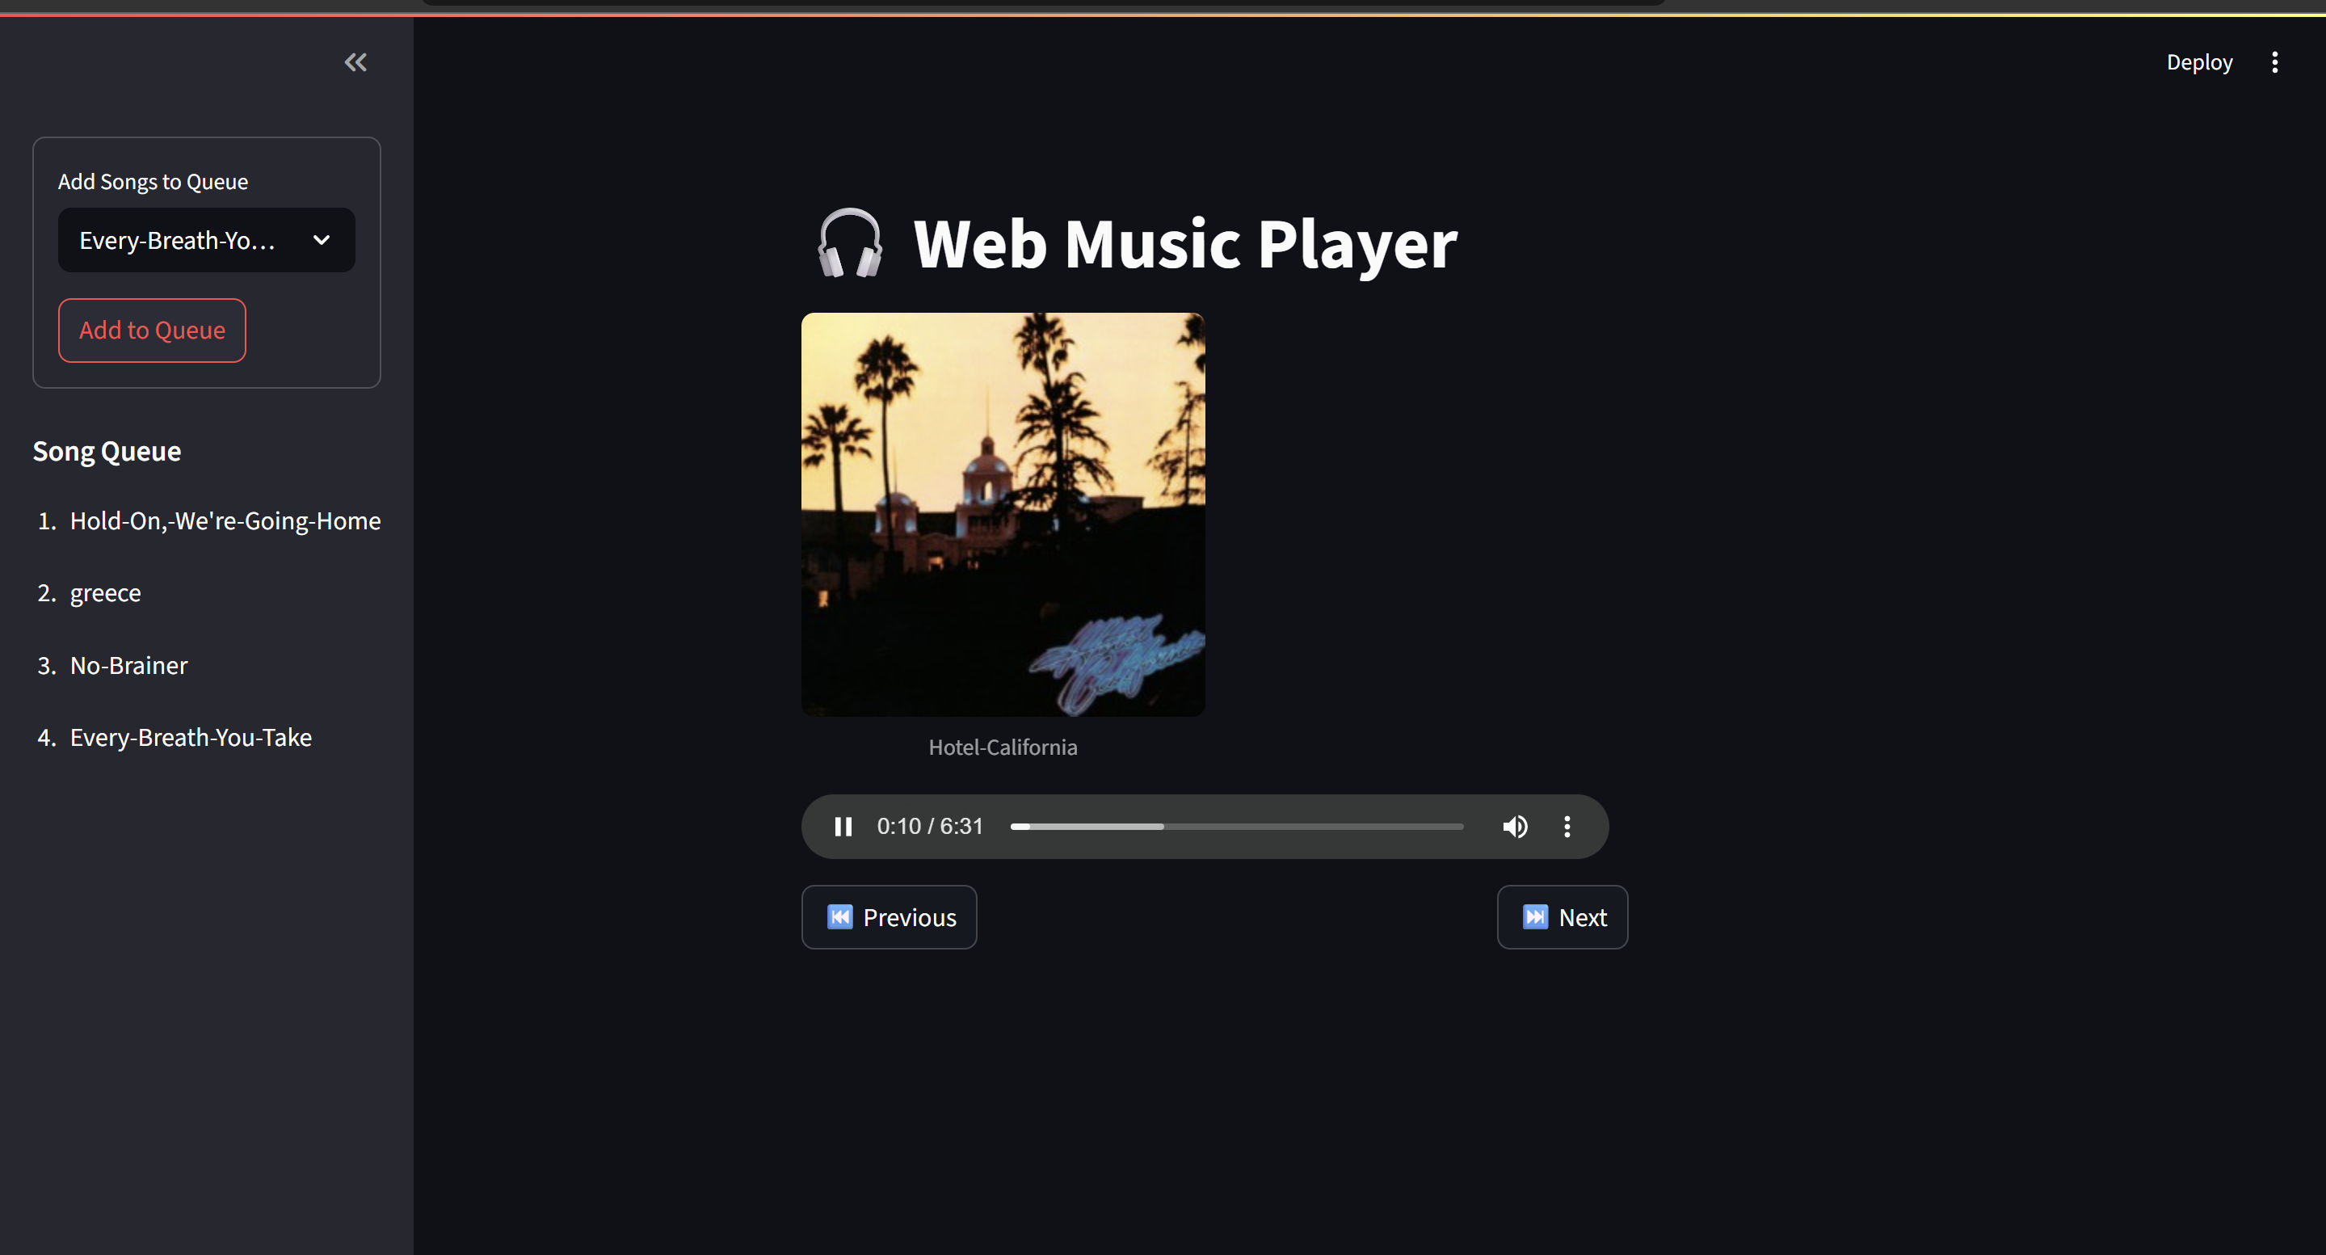

5. Conclusion
The Web Music Player project demonstrates how Streamlit and Python can be used to build a functional multimedia application while applying essential data structure concepts. The modular logic and clean UI provide an intuitive user experience. This project can be extended further by adding auto-play detection, volume control, playlist saving, or integration with APIs. Overall, the project successfully meets its goals and showcases practical web development skills.

