**Object Orient Programming in Java**

A Report submitted to the BMS College of engineering



***Submitted by***

**ABHINAV INAMDAR**

**1BM22CS0**04

***Under the supervision of***

**Prof. Swathi Sridharan Assistant Professor**

# DEPARTMENT OF COMPUTER SCIENCE AND ENGINEERING B M S COLLEGE OF ENGINEERING, BANGALORE 560019

INDEX

|  |  |  |  |
| --- | --- | --- | --- |
| SL. NO | DATE | TOPIC | Page No |
| 1 | 22/12/23 | Quadratic Equation | 3 |
| 2 | 29/12/23 | Student SGPA Calculator | 5 |
| 3 | 12/01/24 | Book Problem | 8 |
| 4 | 12/01/24 | Shapes | 11 |
| 5 | 19/02/24 | Bank Problem | 13 |
| 6 | 02/02/24 | Student External and Internal Marks | 19 |
| 7 | 16/02/24 | Exception Handling | 22 |
| 8 | 16/02/24 | Threads | 24 |
| 9 | 23/02/24 | AWT | 26 |

1.Develop a Java program that prints all real solutions to the quadratic equation ax2+bx+c = 0. Read in a, b, c and use the quadratic formula. If the discriminate b2-4ac is negative, display a message stating that there are no real solutions.

**Code:**

import java.util.*;

public class Quadratic

{

public static void main(String args[])

{

float a, b, c, d=0.0f, r1=0.0f, r2=0.0f;

System.out.println("Enter values of a, b, c: ");

Scanner read= new Scanner(System.in);

a=read.nextFloat();

b=read.nextFloat();

c=read.nextFloat();

if(a==0||b==0||c==0)

{

System.out.println("Invalid Input");

}

else

{

d=b*b-4*a*c;

if(d>0)

{

r1=(float)(-b+Math.sqrt(d))/(2*a);

r2=(float)(-b-Math.sqrt(d))/(2*a);

System.out.println("Roots are real and distinct\nR1= "+r1+"\tR2= "+r2);

}

else if(d<0)

{

System.out.println("Roots are imaginary");

}

else

{

r1=-b/(2*a);

r2=r1;

System.out.println("Roots are real and equal\nR1= "+r1+"\tR2= "+r2);

}

}System.out.println("ABHINAV INAMDAR 1BM22CS004");

}

}

# Output:

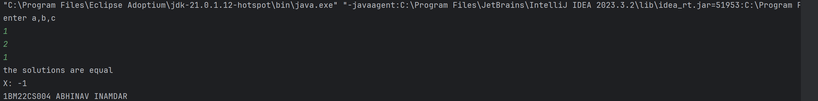

2.Develop a Java program to create a class Student with members usn, name, an

array credits and an array marks. Include methods to accept and display details and a method to calculate SGPA of a student.

# Code:

import java.util.*;  
public class Student  
{  
public static String usn,name;  
public static int credits[]=new int[5];  
public static int marks[]=new int[5];  
public void display()  
{  
System.out.println("Name of student:"+name);  
System.out.println("USN:"+usn);  
for(int i=0;i<5;i++)  
{  
System.out.println("For subject"+(i+1));  
System.out.println("Credits:"+credits[i]+"\nMarks:"+marks[i]);  
}  
}  
public void sgpa(){  
double tgp=0,sgpa;  
int tc=0;  
for(int i=0;i<5;i++){  
tc=tc+credits[i];  
tgp+=calgp(marks[i])*credits[i];  
}  
sgpa=tgp/tc;  
System.out.println("SGPA of student is:"+sgpa);  
}  
public double calgp(int m){  
if(m>=90){  
return 10.0;  
}  
else if(m>=80){  
return 9.0;  
}  
else if(m>=70){  
return 8.0;  
}  
else if(m>=60){  
return 7.0;  
}  
else if(m>=50){  
return 6.0;  
}  
else  
{  
return 0;  
}  
}  
public static void main(String args[])  
{  
Scanner input=new Scanner(System.in);  
System.out.println("Enter name of student");  
name=input.nextLine();  
System.out.println("Enter USN");  
usn=input.nextLine();  
  
System.out.println("Enter Credits and marks");  
for(int i=0;i<5;i++)  
{  
System.out.println("For subject"+(i+1));  
credits[i]=input.nextInt();  
marks[i]=input.nextInt();  
}  
Student student=new Student();  
student.sgpa();  
student.display();

System.out.println("ABHINAV INAMDAR 1BM22CS004");  
}  
}

# Output:

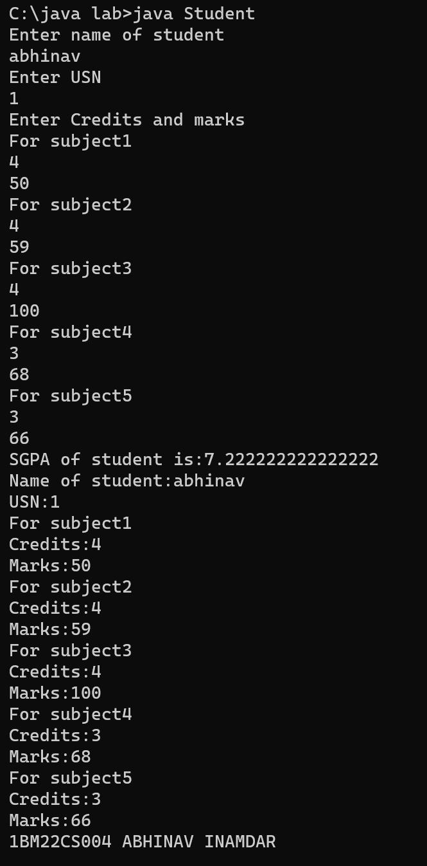

3. Create a class Book which contains four members: name, author, price, num_pages. Include a constructor to set the values for the members. Include methods to set and get the details of the objects. Include a toString( ) method that could display the complete details of the book. Develop a Java program to create n book objects.

# Code:

# import java.util.*;

# class Book

# {

# Scanner input=new Scanner(System.in);

# String name,author;

# int price,num_page;

# Book(String name,String author,int price,int num_page)

# {

# this.name=name;

# this.author=author;

# this.price=price;

# this.num_page=num_page;

# }

# String getName()

# {

# System.out.println("Enter name");

# String name1=input.nextLine();

# return(name1);

# }

# String getAuthor()

# {

# System.out.println("Enter Author");

# String author1=input.nextLine();

# return(author1);

# }

# int getPrice()

# {

# System.out.println("Enter Price");

# int price1=input.nextInt();

# return(price1);

# }

# int getPages()

# {

# System.out.println("Enter Number of pages");

# int num_page1=input.nextInt();

# return(num_page1);

# }

# void set(String name,String author,int price,int num_page)

# {

# this.name=name;

# this.author=author;

# this.price=price;

# this.num_page=num_page;

# }

# void toprt()

# {

# System.out.println("Name of book: "+name);

# System.out.println("Name of author: "+author);

# System.out.println("Price of book: "+price);

# System.out.println("number of pages of book: " +num_page);

# }

# public static void main(String args[])

# {

# System.out.println("Enter the number of books");

# Scanner sc = new Scanner(System.in);

# int n = sc.nextInt();

# Book book[]=new Book[n];

# for(int i = 0;i<n;i++)

# {

# book[i]=new Book("null","null",0,0);

# String name = book[i].getName();

# String author = book[i].getAuthor();

# int price = book[i].getPrice();

# int num_page = book[i].getPages();

# book[i].set(name,author,price,num_page);

# }

# System.out.println("THE BOOK LIBRARY");

# for(int i=0;i<n;i++)

# {

# book[i].toprt();

# }

# System.out.println("ABHINAV INAMDAR 1BM22CS004");

# }

# }

# Output:

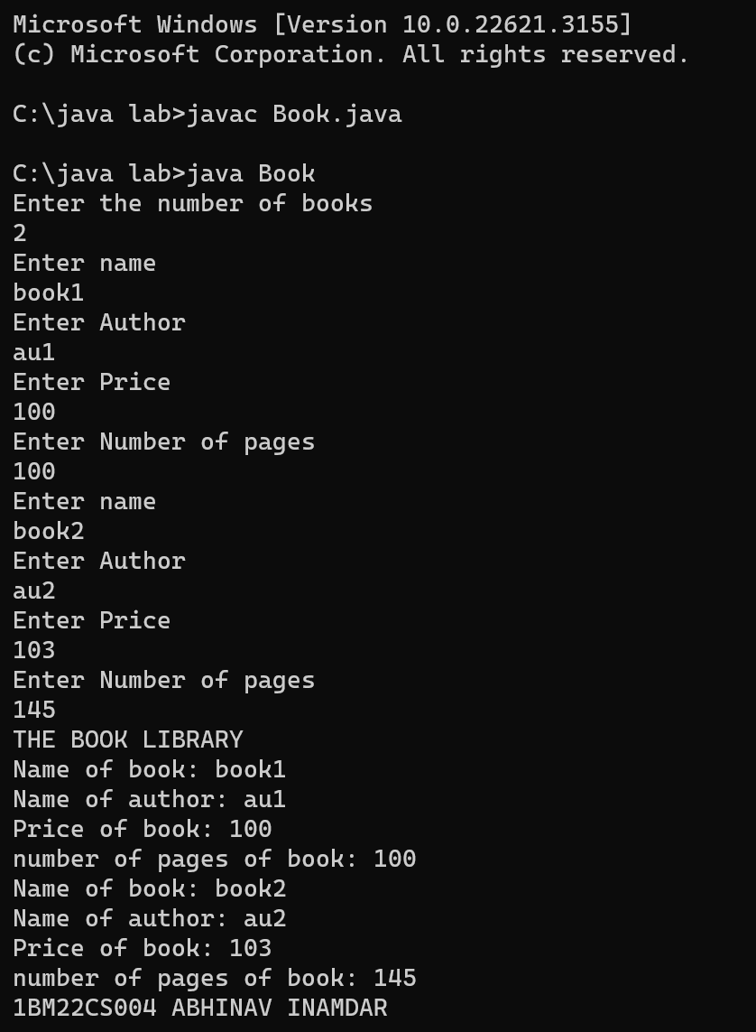

**4.** **Develop a Java program to create an abstract class named Shape that contains two integers and an empty method named printArea( ). Provide three classes named Rectangle, Triangle and Circle such that each one of the classes extends the class Shape. Each one of the classes contain only the method printArea( ) that prints the area of the given shape.**

**Code:**

**import java.util.*;**

**abstract class Shape**

**{**

**public int r1,r2;**

**abstract void printArea();**

**}**

**class Rectangle extends Shape**

**{**

**Rectangle(int r1,int r2)**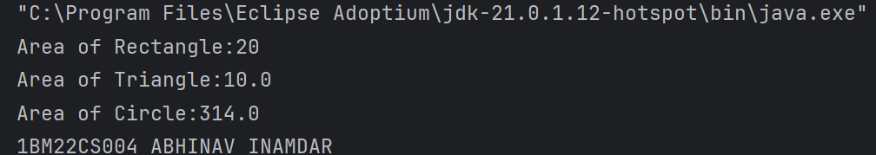

**{**

**super.r1=r1;**

**super.r2=r2;**

**}**

**void printArea()**

**{**

**System.out.println("Area of Rectangle:"+(r1*r2));**

**}**

**}**

**class Triangle extends Shape**

**{**

**Triangle(int r1,int r2)**

**{**

**super.r1=r1;**

**super.r2=r2;**

**}**

**void printArea()**

**{**

**System.out.println("Area of Triangle:"+(0.5*r1*r2));**

**}**

**}**

**class Circle extends Shape**

**{**

**Circle(int r1)**

**{**

**super.r1=r1;**

**}**

**void printArea()**

**{**

**System.out.println("Area of Circle:"+(3.14*r1*r1));**

**}**

**}**

**class Try**

**{**

**public static void main(String args[])**

**{**

**Rectangle ob=new Rectangle(10,2);**

**ob.printArea();**

**Triangle ob1=new Triangle(10,2);**

**ob1.printArea();**

**Circle ob2=new Circle(10);**

**ob2.printArea();**

# System.out.println("ABHINAV INAMDAR 1BM22CS004");

**}**

# }

# Output:



5. Develop a Java program to create a class Bank that maintains two kinds of account for its customers, one called savings account and the other current account. The savings account provides compound interest and withdrawal facilities but no cheque book facility. The current account provides cheque book facility but no interest. Current account holders should also maintain a minimum balance and if the balance falls below this level, a service charge is imposed. Create a class Account that stores customer name, account number and type of account. From this derive the classes Cur-acct and Sav-acct to make them more specific to their requirements. Include the necessary methods in order to achieve the following tasks: a) Accept deposit from customer and update the balance. b) Display the balance. c) Compute and deposit interest d) Permit withdrawal and update the balance Check for the minimum balance, impose penalty if necessary and update the balance.

# Code:

# import java.util.*;

# class Account {

# String cust_name;

# int accno;

# double bal;

# Account(String cust_name, int accno, double bal) {

# this.cust_name = cust_name;

# this.accno = accno;

# this.bal = bal;

# }

# void accept(double deposit) {

# bal += deposit;

# System.out.println("Deposit success. Balance is: " + bal);

# }

# void displayBal() {

# System.out.println("Balance is: " + bal);

# }

# }

# class CurrAct extends Account {

# double min;

# boolean chequebook;

# double service_charge;

# CurrAct(String cust_name, int accno, double bal) {

# super(cust_name,accno,bal);

# min = 1500.00;

# chequebook = true;

# service_charge = 50.000;

# }

# void minbal() {

# if (bal < min) {

# System.out.println("Below min balance");

# bal -= service_charge;

# System.out.println("Balance is: " + bal);

# }

# }

# void withdrawal(double amt) {

# this.minbal();

# bal -= amt;

# System.out.println("Withdrawal success. Remaining Balance: " + bal);

# }

# }

# class SaveAct extends Account {

# double interest;

# SaveAct(String cust_name, int accno, double bal,double interest) {

# super(cust_name,accno,bal);

# this.interest = interest;

# }

# void ChequeBook1() {

# System.out.println("NO FACILITY");

# }

# void withdrawal(double amt) {

# bal -= amt;

# System.out.println("Remaining Balance is: " + bal);

# }

# void compoundInt(double interest, int yr) {

# double it;

# it = bal * Math.pow((1 + interest / 100), yr) - bal;

# bal += it;

# System.out.println("Compound interest \n New Balance: " + bal);

# }

# }

# public class Bank {

# public static void main(String[] args) {

# System.out.println("Enter the number of customers");

# Scanner input = new Scanner(System.in);

# int n = input.nextInt();

# SaveAct[] sa = new SaveAct[n];

# CurrAct[] ca = new CurrAct[n];

# for (int i = 0; i < n; i++) {

# System.out.println("FOR CUSTOMER " + (i + 1));

# System.out.println("Enter name");

# String custName=input.next();

# System.out.println("For savings:");

# System.out.println("Enter account number, balance, rate of interest, time");

# int acc = input.nextInt();

# double bal = input.nextDouble();

# double rate = input.nextDouble();

# int time = input.nextInt();

# sa[i] = new SaveAct(custName,acc,bal,rate);

# sa[i].accept(bal);

# sa[i].compoundInt(rate, time);

# System.out.println("For current:");

# System.out.println("Enter account number, balance, presence of check (Enter 1 if check present)");

# acc = input.nextInt();

# bal = input.nextDouble();

# int j = input.nextInt();

# boolean chq = (j == 1);

# ca[i] = new CurrAct(custName,acc,bal);

# ca[i].accept(bal);

# System.out.println("For savings account:");

# System.out.println("Enter withdrawal amount");

# double amt = input.nextDouble();

# sa[i].withdrawal(amt);

# System.out.println("For current account:");

# System.out.println("Enter withdrawal amount");

# amt = input.nextDouble();

# ca[i].withdrawal(amt);

# }

# System.out.println("ABHINAV INAMDAR 1BM22CS004");

# }

# }

# Output:

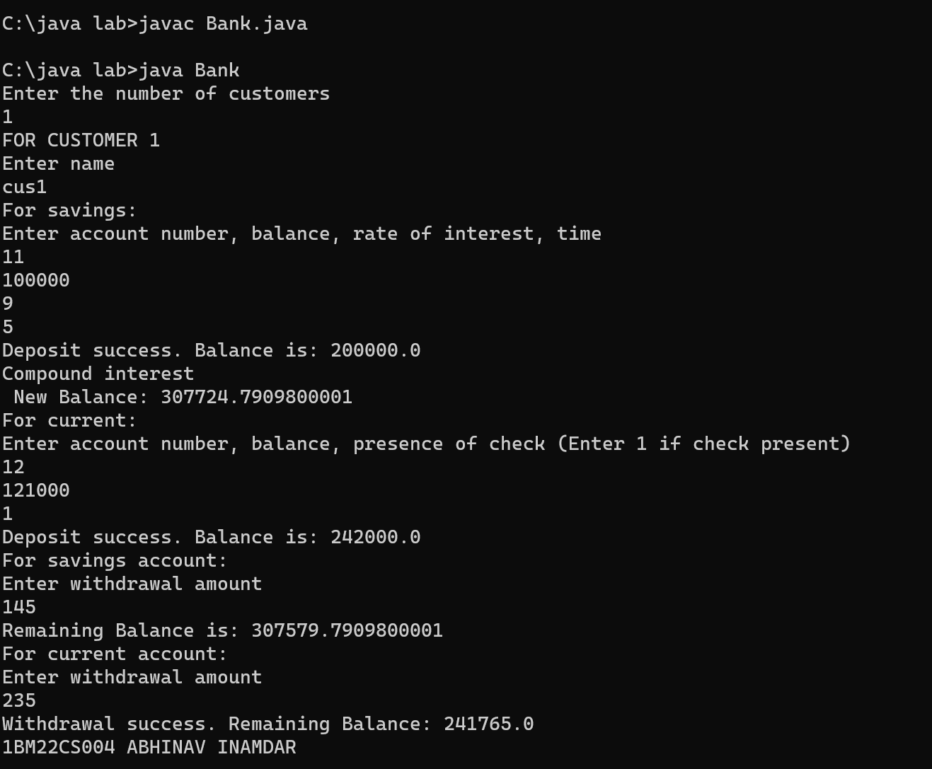

6 Create a package CIE which has two classes- Student and Internals. The class Personal has members like usn, name, sem. The class internals has an array that stores the internal marks scored in five courses of the current semester of the student. Create another package SEE which has the class External which is a derived class of Student. This class has an array that stores the SEE marks scored in five courses of the current semester of the student. Import the two packages in a file that declares the final marks of n students in all five courses.

# Code:

package CIE;

import java.util.*;

public class Student

{

public int sem;

public String usn;

public String name;

public void accept()

{

Scanner input=new Scanner(System.in);

System.out.println("Enter the student's USN,Name and Semester");

usn=input.nextLine();

name=input.nextLine();

sem=input.nextInt();

}

}

package CIE;

public class Internals

{

public int im[]=new int[5];

}

package SEE;

import CIE.Student;

public class Externals extends Student{

public int sm[]=new int[5];

}

import java.util.*;

import SEE.*;

import CIE.*;

public class FinalMarks

{

public static void main(String args[])

{

int fm[]=new int[5];

Scanner input = new Scanner (System.in);

System.out.println("Enter the number of students");

int  n = input.nextInt();

SEE.Externals st[]=new SEE.Externals[n];

CIE.Internals s[]=new CIE.Internals[n];

for(int i=0;i<n;i++)

{

st[i]=new SEE.Externals();

s[i]=new CIE.Internals();

System.out.println("Enter Details of student "+(i+1));

st[i].accept();

for(int j=0;j<5;j++)

{

System.out.println("Enter Internal Marks and Semester End Marks of subject"+(j+1));

s[i].im[j]=input.nextInt();

st[i].sm[j]=input.nextInt();

fm[j]=s[i].im[j]+st[i].sm[j];

}

System.out.println("Final marks of"+st[i].name);

for(int k=0;k<5;k++)

{

System.out.print("Course"+(k+1)+"="+fm[k]+"\n");

}

}

System.*out*.println("ABHINAV 1BM22CS004");

}

}

# Output:

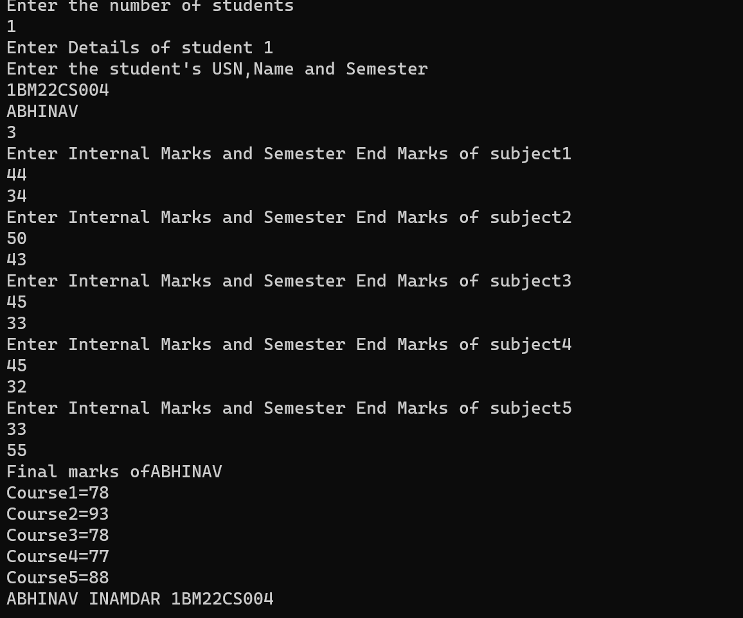

7. Write a program that demonstrates handling of exceptions in inheritance tree. Create a base class called “Father” and derived class called “Son” which extends the base class. In Father class, implement a constructor which takes the age and throws the exception WrongAge( ) when the input age=father’s age.

**Code:**

class WrongAge extends Exception  
{  
 public WrongAge(){  
 super("Age is incorrect");  
 }  
}  
class input extends Exception  
{  
 public input(){  
 super("Sons age cannot be more then Fathers");  
 }  
}  
class Father{  
 public int age;  
 Father(int age) throws WrongAge {  
 if(age<=0){  
 throw new WrongAge();}  
 this.age=age;  
 }}  
class Son extends Father{  
 public int sonAge;  
 Son(int age, int sonAge)throws input,WrongAge{  
 super(age);  
 if(sonAge<=0 ||age<=0){  
 throw new WrongAge();  
 }  
 if (sonAge > age){  
 throw new input();  
 }  
 this.sonAge=sonAge;  
 }  
}  
public class ExceptionProg {  
 public static void main(String[] args) {  
 try {  
 Father f = new Father(40);  
 Son s = new Son(1, 30);  
 System.*out*.println("Son's age:" + s.sonAge);  
 } catch (input e) {  
 System.*out*.println(e.toString());  
 } catch (WrongAge e) {  
 System.*out*.println(e);  
 } finally {

System.*out*.println("ABHINAV 1BM22CS004");

}  
 }  
}

# Output:

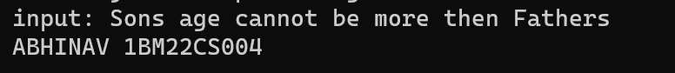

8 Write a program which creates two threads, one thread displaying “BMS College of Engineering” once every ten seconds and another displaying “CSE” once every two seconds.

# Code:

class One extends Thread{  
 public void run()  
 {  
 int i=0;  
 while(i<5)  
 {  
 try  
 {  
 System.*out*.println("BMS College of Engineering");  
 Thread.*sleep*(10000); //Sleep for 10 seconds  
 }  
 catch(InterruptedException e)  
 {  
 System.*out*.println(e);  
 }  
 i++;  
 }  
 }  
}  
class Two extends Thread  
{  
 public void run()  
 {  
 int i=0;  
 while(i<5)  
 {  
 try  
 {  
 System.*out*.println("CSE");  
 Thread.*sleep*(2000); //Sleep for 10 seconds  
 }  
 catch(InterruptedException e)  
 {  
 System.*out*.println(e);  
 }  
 i++;  
 }  
 }  
}  
public class ThreadProg {  
 public static void main(String[] args) {  
 Thread t1 = new One();  
 Thread t2 = new Two();  
 t1.start();  
 t2.start();  
 try{  
 Thread.*sleep*(60000);  
 }catch(InterruptedException e)  
 {  
  
 }  
 System.*out*.println("ABHINAV 1BM22CS004");  
 }  
  
}

# Output:

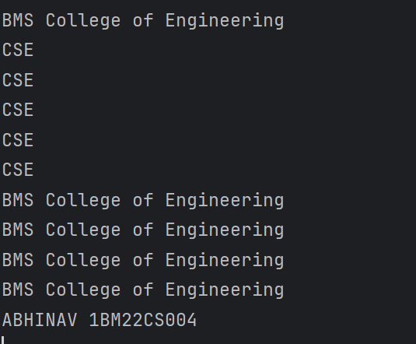

9. Write a program that creates a user interface to perform integer divisions. The user enters two numbers in the text fields, Num1 and Num2. The division of Num1 and Num2 is displayed in the Result field when the Divide button is clicked. If Num1 or Num2 were not an integer, the program would throw a NumberFormatException. If Num2 were Zero, the program would throw an Arithmetic Exception Display the exception in a message dialog box

# Code:

# import javax.swing.*;

# import java.awt.*;

# import java.awt.event.*;

# class SwingDemo {

# SwingDemo() {

# JFrame jfrm = new JFrame("Divider App");

# jfrm.setSize(275, 150);

# jfrm.setLayout(new FlowLayout());

# jfrm.setDefaultCloseOperation(JFrame.EXIT_ON_CLOSE);

# JLabel jlab = new JLabel("Enter the divider and divident:");

# JTextField ajtf = new JTextField(8);

# JTextField bjtf = new JTextField(8);

# JButton button = new JButton("Calculate");

# JLabel err = new JLabel();

# JLabel alab = new JLabel();

# JLabel blab = new JLabel();

# JLabel anslab = new JLabel();

# jfrm.add(err);

# jfrm.add(jlab);

# jfrm.add(ajtf);

# jfrm.add(bjtf);

# jfrm.add(button);

# jfrm.add(alab);

# jfrm.add(blab);

# jfrm.add(anslab);

# ActionListener l = new ActionListener() {

# public void actionPerformed(ActionEvent evt) {

# System.out.println("Action event from a text field");

# }

# };

# ajtf.addActionListener(l);

# bjtf.addActionListener(l);

# button.addActionListener(new ActionListener() {

# public void actionPerformed(ActionEvent evt) {

# try {

# int a = Integer.parseInt(ajtf.getText());

# int b = Integer.parseInt(bjtf.getText());

# int ans = a / b;

# alab.setText("\nA = " + a);

# blab.setText("\nB = " + b);

# anslab.setText("\nAns = " + ans);

# } catch (NumberFormatException e) {

# alab.setText("");

# blab.setText("");

# anslab.setText("");

# err.setText("Enter Only Integers!");

# } catch (ArithmeticException e) {

# alab.setText("");

# blab.setText("");

# anslab.setText("");

# err.setText("B should be NON zero!");

# }

# }

# });

# jfrm.setVisible(true);

# }

# public static void main(String args[]) {

# SwingUtilities.invokeLater(new Runnable() {

# public void run() {

# new SwingDemo();

# }

# });

# System.*out*.println("ABHINAV 1BM22CS004");

# }

# }

# Output:

