RTLFlow
EDA Suite 2.7.0 “Signoff”
User Guide — Workflow & Command Syntax
Seven Cadence-style tools — nclaunch · genus · modus · tempus · innovus · voltus · pegasus — each with a shell and a GUI, over Verilator/Icarus, Yosys, OpenSTA, OpenROAD, PDNSim, KLayout, Magic and Netgen.
Author: Abhinav
Version 2.7.0 · September 2026
Reference design: exp_5/count on SkyWater Sky130 HD

Contents

1. Overview
RTLFlow is one environment that carries a design from RTL to a verified GDSII. Each stage has a Cadence-style tool with its own Tcl-like shell and its own GUI, and each tool drives a real open-source engine underneath. You never call Yosys, OpenROAD or OpenSTA directly, and you never need nix-shell: RTLFlow finds the tools itself.

1.1 Tool map
RTLFlow tool | Stage | Engine underneath | Commercial equivalent
nclaunch / xrun | RTL simulation + waves | Verilator, Icarus Verilog; built-in VCD viewer | Xcelium / NCLaunch / SimVision
genus | Logic synthesis | Yosys (+ ABC), OpenSTA | Genus / Design Compiler
modus | DFT + ATPG | RTLFlow ATPG engine (scan insertion, fault simulation, PODEM) | Modus / TetraMAX
tempus | Signoff STA | OpenSTA (persistent session) | Tempus / PrimeTime
innovus | Floorplan, place, CTS, route | OpenROAD (one persistent session), OpenRCX | Innovus / ICC2
voltus | Power + IR drop | OpenSTA power, OpenROAD PDNSim | Voltus / RedHawk
pegasus | DRC + LVS | KLayout / Magic DRC, Magic + Netgen LVS | Pegasus / Calibre

1.2 Architecture
Every tool is a shell that owns its engine session. Its GUI is a separate window connected to that shell over a socket, so terminal and GUI are two views of one session: GUI actions run as ordinary shell commands and are echoed as [GUI] … in the terminal. The launcher is a separate front door that starts any tool in a terminal with its GUI attached.
RTLFlow Launcher (rtlflow -gui)
|
rtlflow>
+---------+--------+--------+--------+---------+---------+---------+
nclaunch genus modus tempus innovus voltus pegasus
Verilator Yosys RTLFlow OpenSTA OpenROAD OpenROAD KLayout/Magic
/Icarus +STA ATPG PDNSim +Netgen
| | | | | | |
GUI GUI GUI GUI GUI GUI GUI (same session)
\_________ shared project state: <project>/.rtlflow/ _____________/

2. Installation and launching

2.1 Install
cd ~/VLSI
mv rtlflow2 rtlflow2-2.6.0.bak # keep the previous version
git clone https://github.com/<you>/<repo>.git rtlflow2 # or unzip the release
~/VLSI/rtlflow2/install.sh --cadence-names
hash -r
install.sh links rtlflow into ~/.local/bin (with --cadence-names also genus, innovus, nclaunch, tempus, modus, voltus, pegasus, xrun, simvision), adds an RTLFlow EDA Suite icon to the GNOME app grid, checks Tk and runs tool discovery.
GUI requirement: GUIs use Python Tk. If doctor reports it missing: sudo apt install python3-tk

2.2 The launcher — choose which tool to run
Open it with rtlflow -gui, with gui at the rtlflow> prompt, or from the app grid. It shows one card per tool with its flow stage, whether its engines were found, and what the current project has done so far (area, WNS, coverage, DRC/LVS …, refreshed every few seconds).
- Launch — opens the tool's shell in a new terminal window with its GUI attached.
- Terminal only — opens just the shell; type gui_show later if you want the GUI.
- Change… — switch the project directory the tools start in.
- Utilities — plain rtlflow> shell, SimVision (GTKWave), KLayout, environment doctor, user guide.
The terminal emulator is detected automatically (Ptyxis, GNOME Terminal, Console, Konsole, xterm …). Override with export RTLFLOW_TERMINAL='gnome-terminal --'.
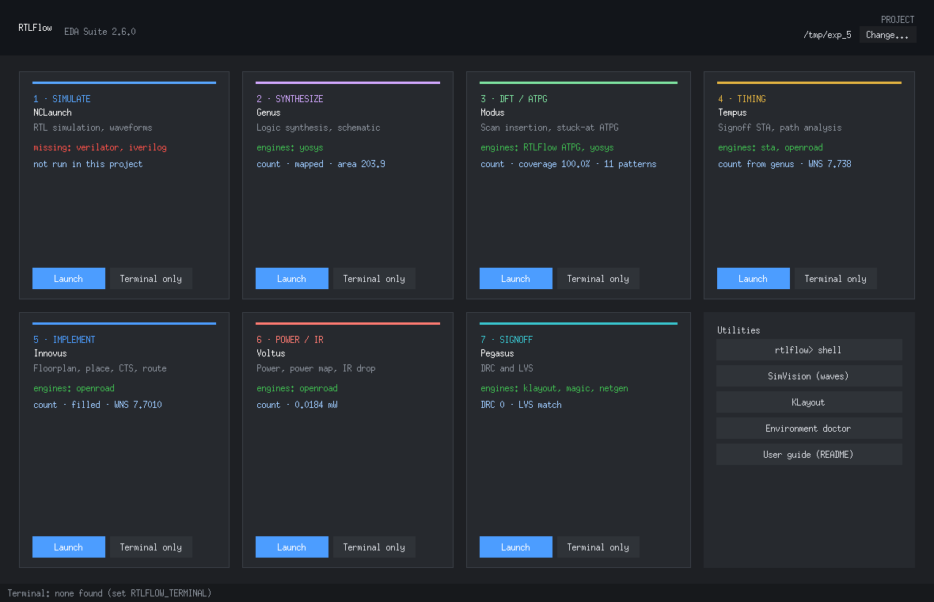
Figure 1 — RTLFlow Launcher. Screens rendered from RTLFlow's test fixtures (mock engines) — on your machine the same windows show your real OpenROAD/OpenSTA data.

2.3 Starting tools from a terminal
From rtlflow> | From bash (--cadence-names) | What opens
gui | rtlflow -gui | Launcher window
nclaunch -gui | nclaunch -gui | nclaunch N> + NCLaunch GUI (sources, waves)
genus / genus -gui | genus -gui | @genus:root: N> (+ schematic GUI)
modus -gui | modus -gui | modus N> + DFT/ATPG GUI
tempus -gui | tempus -gui | tempus N> + timing GUI
innovus | innovus | innovus N> AND layout GUI (default, like Innovus)
innovus -nowin | innovus -nowin | Terminal only; win opens the GUI later
voltus -gui | voltus -gui | voltus N> + power/IR GUI
pegasus -gui | pegasus -gui | pegasus N> + DRC/LVS GUI
xrun … -gui / simvision | xrun … -gui / simvision | Simulation then GTKWave/Surfer

Any tool accepts -files script.tcl to run a script at start-up. Inside any tool, gui_show opens its GUI and gui_hide closes it without ending the session; exit returns to rtlflow> (or bash).

2.4 Tool discovery
RTLFlow looks for each tool in this order: an RTLFLOW_<TOOL> environment variable, ~/.rtlflow/tools.conf, PATH, /nix/store (OpenLane2's packages), then common locations such as ~/.local/bin and oss-cad-suite. The PDK comes from PDK_ROOT or ~/.volare. Refresh with tools -rescan.
export RTLFLOW_OPENROAD=/nix/store/...-openroad-.../bin/openroad # one-off override
# or permanently, in ~/.rtlflow/tools.conf:
openroad = /nix/store/...-openroad-.../bin/openroad
magic = /nix/store/...-magic-vlsi-.../bin/magic

3. Shell conventions

3.1 Prompts
Tool | Prompt
rtlflow | rtlflow>
nclaunch | nclaunch 2>
genus | @genus:root: 7>
modus | modus 4>
tempus | tempus 3>
innovus | innovus 3>
voltus | voltus 2>
pegasus | pegasus 1>

The number counts commands in the session, as in Cadence tools.

3.2 Tcl-style syntax
Feature | Example | Meaning
Braces = literal list | read_physical -lef {a.tlef b.lef} | One argument holding two files; no substitution inside
Variables | set LIB ~/pdk/x.lib ; read_libs $LIB | set / $name / ${name}
Environment | read_libs $env(HOME)/.volare/… | $env(NAME) reads an environment variable
Several commands | addWellTap ; globalNetConnect ; sroute | ';' separates commands
Line continuation | floorPlan -r 1.0 0.5 \ | Trailing backslash joins the next line
Comments | # this is ignored | Whole-line comments
Globs | read_hdl -sv {rtl/*.sv} | Wildcards expand to matching files
Redirection | report_timing > rpt/setup.rpt | Writes the output to a file (>> appends)
Unix commands | !ls or sh ls -l | Run a shell command
Option prefixes | -util 0.5 for -utilization | Unique option prefixes are accepted
Engine pass-through | set_input_delay 2 -clock clk [all_inputs] | innovus/tempus/voltus forward unknown commands to OpenROAD/OpenSTA Tcl

3.3 Built-in commands (every shell)
Command | Purpose
help [pattern] | List commands by category, or search
man <cmd> | Usage and notes for one command
source [-echo] file.tcl | Run a script (each line is echoed)
set / unset / puts | Variables and printing
setenv / getenv | Environment variables
history [n] | Command history (arrow keys work too)
cd / pwd / ls | Directory commands
gui_show / gui_hide | Open / close this tool's GUI
exit / quit | Leave the tool

3.4 Logs and messages
Every session writes Cadence-style logs into .rtlflow/logs/: <tool>.logN (everything printed), <tool>.cmdN (every command including GUI actions, replayable with source) and <tool>_gui.log. <tool>.log and <tool>.cmd point to the latest.
**ERROR: (RFI-IMP-101): No design is initialised. Run ... init_design first.
**WARN: (RFV-PWR-010): Per-instance power not available from this OpenSTA build
[ERROR GPL-0302] ... <- raw engine message, passed through in red
Prefixes: RFS suite, RFN nclaunch, RFG genus, RFM modus, RFT tempus, RFI innovus, RFV voltus, RFP pegasus. Square-bracket messages come straight from OpenROAD/OpenSTA.

3.5 Project workspace
The first tool you run in a directory creates .rtlflow there; all tools share it — that is how tempus finds genus's netlist, voltus finds innovus's checkpoint, and the launcher shows progress.
<project>/.rtlflow/
project.json shared state: top, files, stage history, per-tool summaries
logs/ genus.log1, innovus.cmd2, tempus_gui.log, ...
runs/sim/ simulation builds, sim.log, <tb>.vcd
runs/synth/ RTLIL checkpoints, <top>_mapped.v, <top>.mapped.json, <top>.sdc, <top>_scan.v
runs/dft/ ATPG model, <top>.pat
runs/sta/ tempus session outputs (SDF)
runs/pnr/ live.def, reports/, timingReports/, dbs/*.odb + *.def, <top>.pnr.v, <top>.gds
runs/power/ voltus reports, per-instance voltage files
runs/signoff/ <top>.drc.lyrdb, LVS netlists and report
handoff/ <top>.invs_setup.tcl, <top>.invs_flow.tcl

4. End-to-end workflow
This chapter walks the reference design exp_5/count (design top count, testbench top tba) from RTL to signed-off GDS. Run everything from the project directory; each step can be done in the tool's GUI instead of typing.
cd ~/Desktop/SYSTEM_VERILOG/LAB/exp_5
rtlflow -gui # launcher, or: rtlflow and type the tools

4.1 Simulate — nclaunch
rtlflow> nclaunch -gui
nclaunch 1> read_hdl -sv count.sv
nclaunch 2> read_tb tba.sv
nclaunch 3> elaborate tba # simulation top is the testbench
nclaunch 4> simulate # PASS/FAIL + waves appear in the GUI viewer
In the NCLaunch GUI you can instead mark files as Design / Testbench, pick the simulation top and engine, and press Compile, Elaborate, Simulate. One-line equivalent: xrun -sv count.sv tba.sv -top tba -gui.
Waves: if the testbench has no $dumpvars, RTLFlow adds a small dump module automatically so the viewer always has data.

4.2 Synthesize — genus
rtlflow> genus -gui
@genus:root: 1> read_libs ~/.volare/sky130A/libs.ref/sky130_fd_sc_hd/lib/sky130_fd_sc_hd__tt_025C_1v80.lib
@genus:root: 2> read_hdl -sv count.sv
@genus:root: 3> elaborate count
@genus:root: 4> check_design
@genus:root: 5> create_clock -name clk -period 10 [get_ports clk]
@genus:root: 6> syn_generic ; syn_map ; syn_opt
@genus:root: 7> report_area ; report_timing ; report_qor
@genus:root: 8> write_design -innovus
Stage | Yosys work | Output
elaborate | read + hierarchy + proc | <top>.elab.il
syn_generic | synth -run :fine (technology independent) | <top>.generic.il
syn_map | techmap, dfflibmap, ABC to the liberty, tie cells | <top>_mapped.v, <top>.mapped.json
syn_opt | delay-driven ABC re-map; kept only if WNS/area improves | updated <top>_mapped.v
write_design -innovus | handoff package | handoff/<top>.v, .sdc, .invs_setup.tcl, .invs_flow.tcl

4.3 DFT and ATPG — modus
rtlflow> modus -gui
modus 1> read_netlist # genus's mapped netlist (JSON)
modus 2> build_model
modus 3> verify_test_structures # scannable flops, clock control, loops
modus 4> connect_scan_chains -chains 1 # dfxtp -> sdfxtp, scan_in -> ... -> scan_out
modus 5> build_faultmodel
modus 6> create_logic_tests # random + PODEM
modus 7> report_fault_statistics
modus 8> write_vectors
connect_scan_chains writes .rtlflow/runs/synth/<top>_scan.v. To implement the scan design, read that netlist in innovus instead of the plain one. Faults only on the scan path (scan_en, scan_in, scan_out) are credited to the chain (shift) test.

4.4 Pre-layout timing — tempus
rtlflow> tempus -gui
tempus 1> read_design -from genus # libs + mapped netlist + SDC
tempus 2> report_analysis_summary # setup/hold WNS, TNS, violating endpoints
tempus 3> report_timing -max_paths 5
tempus 4> report_slack_histogram

4.5 Implement — innovus
rtlflow> innovus # terminal + layout GUI
innovus 1> source .rtlflow/handoff/count.invs_setup.tcl
innovus 2> floorPlan -r 1.0 0.5 5 5 5 5
innovus 3> addWellTap ; globalNetConnect ; sroute
innovus 4> placeDesign
innovus 5> ccopt_design
innovus 6> routeDesign # also writes <top>.pnr.v
innovus 7> addFiller ; extractRC ; timeDesign -postRoute
innovus 8> saveDesign count_final # .odb + .def for voltus
innovus 9> streamOut count.gds # GDS for pegasus
Order matters: libraries and LEF → netlist → set_top → init_design before floorPlan. floorPlan too early fails with ORD-0050 / IFP-0038. If only the cell LEF is given, RTLFlow loads the matching tech LEF (techlef/*__nom.tlef).
Loading by hand instead of the handoff: read_libs <lib>, read_physical -lef <lef>, read_netlist .rtlflow/runs/synth/count_mapped.v, set_top count, init_design, create_clock -name clk -period 10 [get_ports clk]. The whole reference flow is saved as .rtlflow/handoff/count.invs_flow.tcl.
After | Layout GUI
init_design | No die yet; instances parked, unplaced, left of the canvas
floorPlan | Die, core, rows, IO pins; cells still parked
sroute | Power rails (and stripes, if addStripe was used)
placeDesign | Cells at OpenROAD's real placed locations, coloured by type
ccopt_design | Clock buffers added; clock nets marked; optional clock-tree flylines
routeDesign | Real metal routes per layer, vias, DRC markers if any
report_timing | Worst path highlighted in magenta with its slack

4.6 Signoff timing — tempus
tempus 1> read_design -from innovus # post-route netlist + SPEF (if extractRC ran) + SDC
tempus 2> report_analysis_summary
tempus 3> set_analysis_mode -hold ; report_timing -max_paths 10

4.7 Power and IR drop — voltus
rtlflow> voltus -gui
voltus 1> read_design -from innovus # newest saveDesign checkpoint
voltus 2> set_power_activity -global 0.2 # or: read_activity_file <sim.vcd> -scope tba/dut
voltus 3> report_power -instances # group breakdown + power map
voltus 4> analyze_rail -net VPWR -voltage 1.8 # static IR drop map (needs sroute)

4.8 Physical verification — pegasus
rtlflow> pegasus -gui
pegasus 1> read_layout # .rtlflow/runs/pnr/<top>.gds from streamOut
pegasus 2> run_drc # KLayout PDK deck (or -engine magic)
pegasus 3> run_lvs # Magic extraction vs <top>.pnr.v with Netgen
pegasus 4> view_results # layout + markers in KLayout

4.9 Checkpoints
saveDesign count_placed # innovus: dbs/count_placed.odb (+ .def)
restoreDesign count_placed # fresh OpenROAD session, DB restored
restoreDesign # list checkpoints

5. Command reference — rtlflow
Commands at the rtlflow> prompt.

Tools
Command | Syntax | Description
genus | genus [-gui] [-files script.tcl] [-batch] | Synthesis shell (Yosys + OpenSTA) — Genus-style
gui | gui | Open the RTLFlow Launcher window (pick a tool to run) Aliases: launcher
innovus | innovus [-nowin] [-files script.tcl] [-batch] | Implementation shell + layout GUI on one OpenROAD session
klayout | klayout [file.gds|.def] | Open KLayout (layout viewer / DRC) Aliases: virtuoso
modus | modus [-gui] [-files script] | DFT + ATPG shell (scan insertion, stuck-at ATPG)
nclaunch | nclaunch [-files script] | Simulation shell (Verilator / Icarus) Aliases: xcelium
pegasus | pegasus [-gui] [-files script] | Physical verification: DRC (KLayout/Magic) + LVS (Netgen)
simvision | simvision [dump.vcd|.fst] | Waveform viewer (GTKWave / Surfer)
tempus | tempus [-gui] [-files script] | Signoff STA shell (OpenSTA) — Tempus-style
voltus | voltus [-gui] [-files script] | Power + IR-drop shell (OpenSTA power, PDNSim)
xrun | xrun [-sv] files... -top tb [-gui] [-verilator|-icarus] [-define X] | One-shot compile/elaborate/simulate (Xcelium-style); -gui opens waves Aliases: irun, ncverilog

Flow
Command | Syntax | Description
status | status | Project state across genus / nclaunch / innovus Aliases: project

Environment
Command | Syntax | Description
doctor | doctor | Deep environment check (runs each tool)
setenv_pdk | setenv_pdk <PDK_ROOT> [PDK] [STD_CELL_LIBRARY] | Point RTLFlow at a different PDK for this session
tools | tools [-rescan] [-v] | Show discovered tools and PDK
version | version | Version info Aliases: getVersion

6. Command reference — nclaunch
ncvlog / ncelab / ncsim (and xm*) aliases are accepted, so the classic three-step Cadence flow works as-is.

Compile
Command | Syntax | Description
compile | compile | Lint/parse the current design + testbench sources
elaborate | elaborate [sim_top] [-engine verilator|icarus] | Build the simulation executable Aliases: ncelab, xmelab
read_hdl | read_hdl [-sv] {files} | Add design sources Aliases: ncvlog, xmvlog
read_tb | read_tb {files} | Add testbench sources

Simulate
Command | Syntax | Description
simulate | simulate [-gui] [+plusargs] | Run the simulation (-gui opens waves afterwards) Aliases: ncsim, xmsim, run
xrun | xrun [-sv] files -top tb [-gui] | One-shot compile+elaborate+simulate Aliases: irun, ncverilog

Waves
Command | Syntax | Description
simvision | simvision [file.vcd] | Open the waveform viewer (GTKWave / Surfer) Aliases: waves, gtkwave

Session
Command | Syntax | Description
clear_sources | clear_sources | Forget all sources
set_engine | set_engine verilator|icarus | Choose simulator
status | status | Simulation setup

GUI
Command | Syntax | Description
gui_hide | gui_hide | Close the GUI (session keeps running)
gui_show | gui_show | Open this tool's GUI (same session) Aliases: gui, win

7. Command reference — genus
SDC commands (create_clock, set_input_delay, …) are collected into .rtlflow/runs/synth/<top>.sdc and used by syn_map/syn_opt and by OpenSTA.

Setup
Command | Syntax | Description
get_db | get_db <attr|designs|insts|lib_cells> | Query attributes / objects
read_libs | read_libs <file.lib ...> | Read timing libraries Aliases: read_lib
read_physical | read_physical -lef {files} | Record LEF for the innovus handoff
set_db | set_db <attribute> <value> | Set a root attribute (library, init_hdl_search_path, lef_library, syn_*_effort …)

HDL
Command | Syntax | Description
check_design | check_design [-all|-unresolved|-undriven] | Lint the elaborated design (undriven, multi-driven, unresolved)
elaborate | elaborate [top] | Build the design hierarchy
read_hdl | read_hdl [-sv|-v2001|-v1995] [-define X=Y] {files} | Read RTL (SystemVerilog by default)

Constraints
Command | Syntax | Description
create_clock | create_clock -name clk -period 10 [get_ports clk] | Define a clock
read_sdc | read_sdc <file.sdc> | Read SDC constraints
report_clocks | report_clocks | List defined clocks Aliases: report_clock
set_clock_uncertainty | set_clock_uncertainty <d> [get_clocks clk] | SDC uncertainty
set_driving_cell | set_driving_cell -lib_cell X [all_inputs] | SDC driving cell
set_false_path | set_false_path -from … -to … | SDC false path
set_input_delay | set_input_delay <d> -clock clk [all_inputs] | SDC input delay
set_load | set_load <pF> [all_outputs] | SDC output load
set_output_delay | set_output_delay <d> -clock clk [all_outputs] | SDC output delay

Synthesis
Command | Syntax | Description
syn_generic | syn_generic | RTL optimisation → generic gates (technology independent)
syn_map | syn_map | Technology mapping to the target library
syn_opt | syn_opt [-effort low|medium|high] | Timing-driven re-map (ABC delay script, upsizing/buffering); kept only if QoR improves
synthesize | synthesize -to_mapped | Legacy: generic + map + opt

Reports
Command | Syntax | Description
report_area | report_area [-detail] | Area report (Yosys stat -liberty)
report_gates | report_gates | Cell usage by library cell Aliases: report_cells
report_hierarchy | report_hierarchy | Module hierarchy of the elaborated design
report_power | report_power | Power estimate (OpenSTA, default activity)
report_qor | report_qor | QoR summary — WNS/TNS via OpenSTA worst_slack queries
report_timing | report_timing [-max_paths N] [-early] | Worst path(s) through OpenSTA on the mapped netlist

Output
Command | Syntax | Description
write_design | write_design -innovus [-base_name dir/name] | Handoff package for innovus (netlist, SDC, setup script)
write_hdl | write_hdl [> file.v] | Print the mapped netlist (redirect with > file) Aliases: write_netlist
write_sdc | write_sdc [> file.sdc] | Print current constraints

GUI
Command | Syntax | Description
gui_hide | gui_hide | Close the Genus GUI
gui_show | gui_show | Open the Genus GUI (schematic / reports) on this session Aliases: gui

Session
Command | Syntax | Description
restore_session | restore_session | Reload libs/RTL/constraints from the last genus run
status | status | Synthesis state
version | version | Version info Aliases: get_version

7.1 set_db attributes
Attribute | Effect
library | Same as read_libs
lef_library | LEF recorded for the innovus handoff
init_hdl_search_path | Include directories for read_hdl
init_lib_search_path | Directories searched by read_libs
syn_generic_effort / syn_map_effort / syn_opt_effort | low | medium | high
hdl_frontend | yosys (default) or slang (if the Yosys slang plugin is installed)

8. Command reference — modus
Full-scan stuck-at model: flop outputs are pseudo-inputs and flop next-states are pseudo-outputs. Asynchronous set/reset pins driven by primary inputs are held inactive automatically; after scan insertion scan_en is constrained to 0 for capture.

Setup
Command | Syntax | Description
build_model | build_model | Build the gate-level test model Aliases: build_testmode
read_libs | read_libs <file.lib> | Liberty library (cell functions)
read_netlist | read_netlist [netlist.v|netlist.json] [-top name] | Read the mapped netlist (default: genus output)

DFT
Command | Syntax | Description
connect_scan_chains | connect_scan_chains [-chains N] [-order placement|name] | Replace flops with scan flops and stitch scan chains Aliases: insert_dft, insert_scan
report_scan_chains | report_scan_chains | Scan chain membership
verify_test_structures | verify_test_structures | DFT rule checks Aliases: check_dft_rules

ATPG
Command | Syntax | Description
build_faultmodel | build_faultmodel | Stuck-at-0/1 faults on every net
create_logic_tests | create_logic_tests [-max_random N] [-no_podem] [-backtracks N] [-time S] | Generate stuck-at patterns (random + deterministic PODEM) Aliases: run_atpg

Reports
Command | Syntax | Description
report_fault_statistics | report_fault_statistics | Fault / test coverage Aliases: report_faults_summary
report_faults | report_faults [-undetected|-redundant|-all] | List faults
status | status | Model / DFT / ATPG state

Output
Command | Syntax | Description
write_vectors | write_vectors [file.pat] | Write test patterns (scan load / capture / unload)

GUI
Command | Syntax | Description
gui_hide | gui_hide | Close the GUI (session keeps running)
gui_show | gui_show | Open this tool's GUI (same session) Aliases: gui, win

9. Command reference — tempus
Unknown commands go to the OpenSTA interpreter, so any OpenSTA command (set_false_path, report_net, …) works.

Design
Command | Syntax | Description
link_design | link_design [top] | Link the netlist Aliases: init_design, set_top
read_design | read_design -from genus|innovus | Load a design from another RTLFlow tool
read_libs | read_libs <file.lib ...> | Read liberty timing libraries
read_netlist | read_netlist <netlist.v> [-top name] | Read gate-level Verilog
read_sdc | read_sdc <file.sdc> | Read constraints
read_spef | read_spef <file.spef> | Read extracted parasitics
status | status | What is loaded

Analysis
Command | Syntax | Description
report_analysis_summary | report_analysis_summary | Setup/hold WNS, TNS and violating endpoints (Tempus-style table) Aliases: update_timing, report_summary
set_analysis_mode | set_analysis_mode -setup|-hold | Default check type for GUI/report_timing

Reports
Command | Syntax | Description
check_timing | check_timing | Unconstrained endpoints, missing clocks, loops (check_setup)
report_clocks | report_clocks | Clock definitions Aliases: report_clock
report_constraints | report_constraints [-all_violators] | DRV and timing constraint violations Aliases: report_constraint
report_power | report_power | Power (OpenSTA default activity)
report_slack_histogram | report_slack_histogram [-hold] [-bins N] | Endpoint slack distribution
report_timing | report_timing [-max_paths N] [-early|-late] [-from x] [-to y] [-through z] | Detailed timing paths

Output
Command | Syntax | Description
write_sdf | write_sdf <file.sdf> | Write SDF

GUI
Command | Syntax | Description
gui_hide | gui_hide | Close the GUI (session keeps running)
gui_show | gui_show | Open this tool's GUI (same session) Aliases: gui, win

10. Command reference — innovus
Unknown commands go to the OpenROAD Tcl interpreter, so native OpenROAD commands also work. Commands that change geometry refresh the GUI automatically.

Design Import
Command | Syntax | Description
freeDesign | freeDesign | Discard the database and restart OpenROAD
init_design | init_design [-setup {views}] | Link the design (uses read_* data or Innovus init_* variables)
read_libs | read_libs [-lib] <liberty files...> | Read timing libraries (.lib) into OpenSTA
read_netlist | read_netlist [-top name] <netlist.v ...> | Read gate-level Verilog netlist
read_physical | read_physical -lef {tech.lef cells.lef ...} | Read technology + cell LEF (tech LEF auto-found for open_pdks)
read_sdc | read_sdc <file.sdc ...> | Read timing constraints
set_top | set_top <module> | Set the top cell for init_design

Floorplan
Command | Syntax | Description
addWellTap | addWellTap [-cell name] [-cellInterval µm] | Insert well-tap cells in every row
assignIoPins | assignIoPins [-random] | (Re)place IO pins on the die edge
floorPlan | floorPlan [-site name] [-r aspect util [l b r t]] [-s W H l b r t] [-d W H l b r t] | Create die/core, rows, tracks and place IO pins Aliases: floorplan, create_floorplan

Power
Command | Syntax | Description
addStripe | addStripe -layer L -width W -spacing S -set_to_set_distance P [-start_offset O] | Add a power stripe pair to the PDN spec (built by sroute)
globalNetConnect | globalNetConnect [net -type pgpin -pin pin -all] | Connect cell power/ground pins to global nets (VPWR/VGND auto)
sroute | sroute [-nets {VPWR VGND}] | Build the power grid: follow-pin rails + any addStripe straps (pdngen)

Placement
Command | Syntax | Description
addTieHiLo | addTieHiLo [-cell {hi lo}] | Insert tie-hi/lo cells
checkPlace | checkPlace | Check placement legality Aliases: check_placement
placeDesign | placeDesign [-density 0.x] [-noOpt] [-timingDriven] | Global + detailed placement (RePlAce + OpenDP), then electrical repair Aliases: place_design, place_opt_design
refinePlace | refinePlace | Legalise placement (detailed_placement) Aliases: refine_place

Clock
Command | Syntax | Description
ccopt_design | ccopt_design [-buffers {cells}] [-root_buf cell] [-cts] | Clock tree synthesis (TritonCTS) + legalisation Aliases: clock_opt_design, clockDesign
report_ccopt_clock_trees | report_ccopt_clock_trees | Report clock tree (report_cts) Aliases: report_clock_tree

Route
Command | Syntax | Description
addFiller | addFiller [-cell {cells}] | Insert filler cells
earlyGlobalRoute | earlyGlobalRoute | Global route only (congestion estimate)
routeDesign | routeDesign [-globalDetail|-global|-detail] [-drcIter N] | Global (FastRoute) + detailed (TritonRoute) routing Aliases: route_design, route_opt_design

Timing
Command | Syntax | Description
create_clock | create_clock -name clk -period 10 [get_ports clk] | Define a clock (SDC, forwarded to OpenSTA)
extractRC | extractRC [-rules file] | Parasitic extraction: OpenRCX when routed + rules exist, else estimates Aliases: extract_rc
report_area | report_area | Design area & utilisation
report_clocks | report_clocks | Clock definitions Aliases: report_clock
report_constraints | report_constraints [-all_violators] | Constraint/DRV violations (report_check_types)
report_power | report_power | Power report (OpenSTA, default activity)
report_qor | report_qor | QoR summary: timing, area, DRVs, stage
report_timing | report_timing [-max_paths N] [-early|-late] [-nworst N] [-unconstrained] | Detailed path report (OpenSTA report_checks); worst path highlighted in GUI
timeDesign | timeDesign [-prePlace|-preCTS|-postCTS|-postRoute|-signoff] [-hold] [-numPaths N] | Timing summary table + reports (Innovus-style) Aliases: time_design

Optimization
Command | Syntax | Description
ecoPlace | ecoPlace | ECO placement legalisation Aliases: eco_place
ecoRoute | ecoRoute | ECO (incremental) detailed route Aliases: eco_route
optDesign | optDesign -preCTS|-postCTS|-postRoute [-hold] [-drv] | Repair DRVs and setup (or hold) timing (Resizer) Aliases: opt_design

Verify
Command | Syntax | Description
checkDesign | checkDesign [-all] | Netlist/constraint sanity (check_setup) Aliases: check_design
verify_antenna | verify_antenna | Antenna check (check_antennas) Aliases: verifyProcessAntenna
verify_connectivity | verify_connectivity | Open/unrouted net check Aliases: verifyConnectivity
verify_drc | verify_drc | Routing DRC (TritonRoute checker) + placement legality Aliases: verifyGeometry, verify_geometry

Output
Command | Syntax | Description
defOut | defOut [-routing] <file.def> | Write DEF Aliases: write_def
saveNetlist | saveNetlist <file.v> [-includePowerGround] | Write the current (post-opt) netlist Aliases: write_netlist, write_hdl
streamOut | streamOut <file.gds> [-view] | Stream GDSII via KLayout (DEF + LEF + std-cell GDS merge) Aliases: write_gds
write_lef_abstract | write_lef_abstract <file.lef> | Write an abstract LEF of this block Aliases: write_lef
write_sdc | write_sdc <file.sdc> | Write current constraints
write_sdf | write_sdf <file.sdf> | Write SDF delays

GUI
Command | Syntax | Description
deselectAll | deselectAll | Clear GUI selection/highlight Aliases: gui_clear_highlight, dehighlight
fit | fit | Zoom GUI to fit the die Aliases: gui_fit, zoomOut_fit
gui_dump | gui_dump <file.ps|.png> | Save the layout view to a file Aliases: dumpToGIF, save_screenshot
gui_hide | gui_hide | Close the GUI window (session keeps running)
gui_refresh | gui_refresh | Re-read the DB into the GUI Aliases: redraw
selectInst | selectInst <name|pattern> | Select & zoom to instance(s) Aliases: select_inst
selectNet | selectNet <name> | Highlight a net in the GUI Aliases: select_net, highlight_net
view_gds | view_gds [file.gds] | Open a GDS in KLayout (like opening Virtuoso)
win | win [off] | Open (or close) the layout GUI Aliases: gui_show
zoomBox | zoomBox x1 y1 x2 y2 | Zoom GUI to a box (µm)

Session
Command | Syntax | Description
getVersion | getVersion | Version info Aliases: version
restart_backend | restart_backend | Restart the OpenROAD process (clears DB)
restoreDesign | restoreDesign <name|file.odb> | Restore a saved checkpoint into a fresh session Aliases: restore_design, read_db
saveDesign | saveDesign <name> | Checkpoint the database (write_db) + shell state Aliases: save_design, write_db
status | status | Show database state Aliases: design_status, dbGet_status
tech_profile | tech_profile | Show technology profile in use

10.1 floorPlan forms
Form | Meaning
floorPlan -r aspect util [l b r t] | Core from utilisation; aspect = height/width; margins core→die in µm
floorPlan -s W H l b r t | Core width/height given
floorPlan -d W H l b r t | Die width/height given
-site name | Placement site (default from the tech profile, e.g. unithd)
-noPins | Skip IO pin placement

10.2 Classic Innovus init variables
set init_lib_file {tt.lib} ;# RTLFlow extension
set init_lef_file {tech.tlef cells.lef}
set init_verilog netlist.v
set init_top_cell count
set init_mmmc_file view.tcl ;# create_library_set / create_constraint_mode parsed
set init_sdc_file {count.sdc} ;# RTLFlow extension
init_design

11. Command reference — voltus
voltus opens its own OpenROAD session on innovus's newest saveDesign checkpoint (or live.def), with the same libraries, SDC and SPEF.

Design
Command | Syntax | Description
read_design | read_design -from innovus [checkpoint.odb] | Load the implemented design (DB checkpoint or live DEF) + libs + SDC + SPEF
status | status | What is loaded

Power
Command | Syntax | Description
read_activity_file | read_activity_file <dump.vcd> [-scope tb/dut] | Annotate switching activity from a simulation VCD (e.g. from nclaunch) Aliases: read_vcd
report_power | report_power [-instances] [-top N] | Power by group; -instances also builds the power map
set_power_activity | set_power_activity -global <activity> [-duty 0.5] | -input <a> | Default switching activity (toggles/clock)

Rail
Command | Syntax | Description
analyze_rail | analyze_rail -net VPWR [-voltage 1.8] [-source_type FULL|STRAPS|BUMPS] | Static IR-drop analysis (PDNSim) with per-instance voltages Aliases: analyze_power_grid, report_rail

GUI
Command | Syntax | Description
gui_hide | gui_hide | Close the GUI (session keeps running)
gui_show | gui_show | Open this tool's GUI (same session) Aliases: gui, win

12. Command reference — pegasus
Decks come from the PDK: libs.tech/klayout/drc (KLayout), libs.tech/magic (Magic rc), libs.tech/netgen (LVS setup) and libs.ref/<lib>/spice (cell netlists).

Setup
Command | Syntax | Description
read_layout | read_layout [file.gds] [-top name] | Layout to verify Aliases: read_gds
read_netlist | read_netlist <netlist.v|.spice> | Schematic side for LVS
status | status | Verification state

DRC
Command | Syntax | Description
report_drc | report_drc [-rule pattern] | List DRC violations
run_drc | run_drc [-engine klayout|magic] | Design-rule check with the PDK signoff deck Aliases: verify_drc
view_results | view_results | Open the layout + DRC markers in KLayout Aliases: open_klayout

LVS
Command | Syntax | Description
run_lvs | run_lvs | Extract with Magic, compare with Netgen Aliases: verify_lvs

GUI
Command | Syntax | Description
gui_hide | gui_hide | Close the GUI (session keeps running)
gui_show | gui_show | Open this tool's GUI (same session) Aliases: gui, win

13. GUI guide

13.1 Common to every tool window
- Menu bar and toolbar — every action runs the equivalent shell command on the shared session.
- Transcript + command line — live session output; type any command at the bottom prompt.
- Status bar — design/stage on the right, Busy / Ready / Failed mirrored from the shell. A failed command is shown as failed, never as done.
- Terminal ⇄ GUI — typing in the terminal updates the GUI; GUI actions appear in the terminal as [GUI] <command>. Close the window with gui_hide or the window button; the session keeps running.
- Ctrl+L focuses the command line; Window → Clear transcript.

13.2 NCLaunch
Left: project sources found in the directory (and rtl/, tb/, src/) with their role — right-click or double-click to mark Design / Testbench / Exclude — plus the simulation top and engine. Toolbar: Compile (lint), Elaborate, Simulate, SimVision (GTKWave). Right: built-in waveform viewer — signal tree (double-click to add, Add all), buses in hex/dec/bin, wheel zoom, middle-drag pan, click to place a cursor with values.
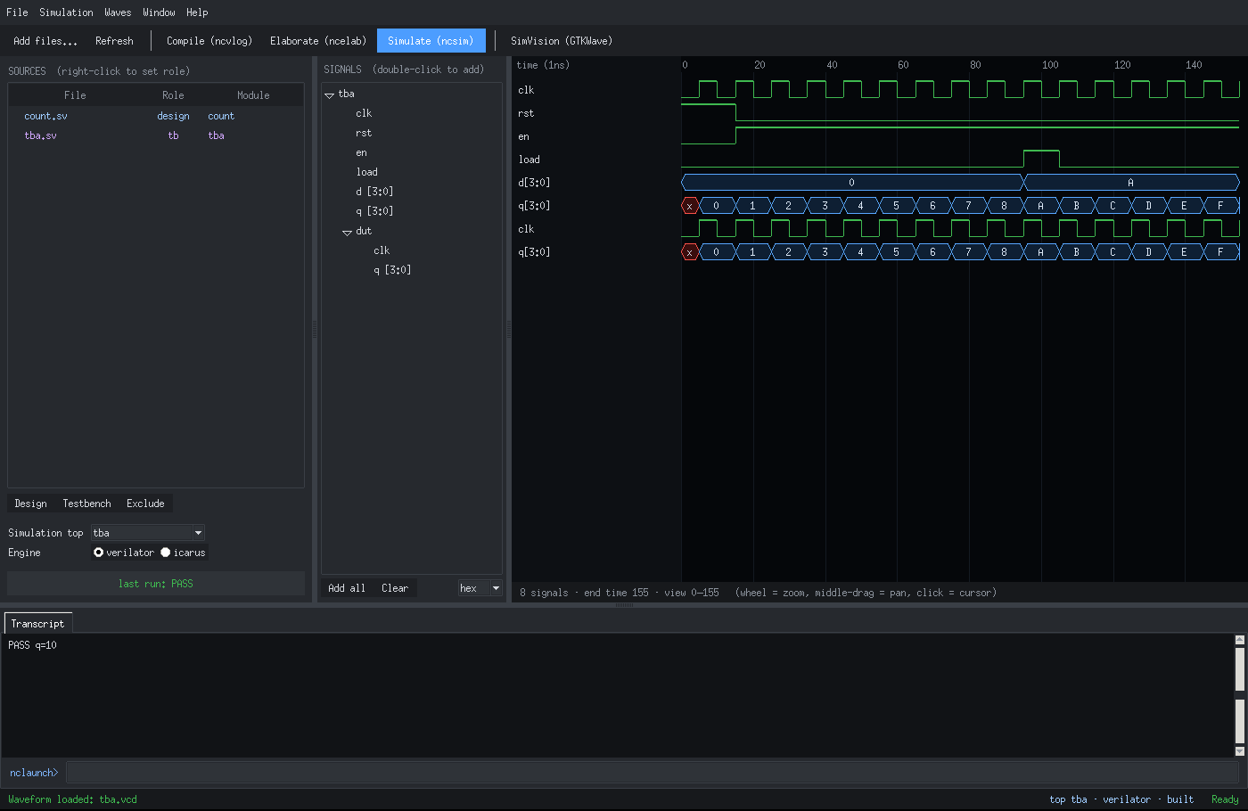
Figure 2 — NCLaunch GUI with the built-in waveform viewer. Screens rendered from RTLFlow's test fixtures (mock engines) — on your machine the same windows show your real OpenROAD/OpenSTA data.

13.3 Genus
Schematic of the real mapped netlist (Yosys JSON): inputs left, outputs right, flip-flops marked with a clock triangle, levelized by logic depth. Design browser groups instances by cell type; Report menu fills the Area / Timing / QoR tabs; report_timing highlights the worst path; Find highlights by name or cell type.
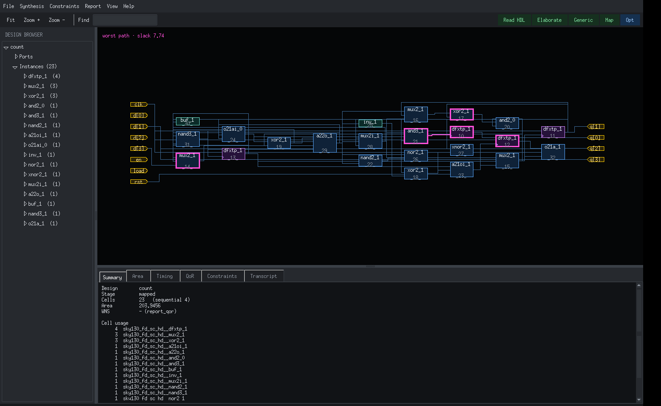
Figure 3 — Genus schematic with the worst path highlighted. Screens rendered from RTLFlow's test fixtures (mock engines) — on your machine the same windows show your real OpenROAD/OpenSTA data.

13.4 Modus
Coverage chips (fault coverage, test coverage, patterns, faults, redundant, undetected), coverage-vs-patterns curve, fault browser filtered by status (detected / chain / redundant / aborted / undetected), and a scan-chain diagram. Toolbar: Read Netlist, Build Model, Verify DFT, Insert Scan, Fault Model, Run ATPG, Write Vectors.
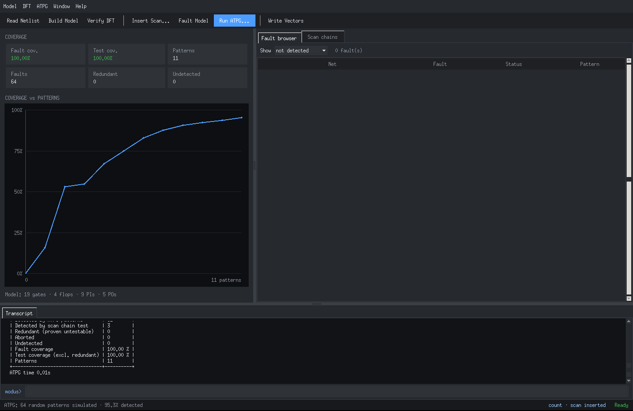
Figure 4 — Modus GUI after scan insertion and ATPG. Screens rendered from RTLFlow's test fixtures (mock engines) — on your machine the same windows show your real OpenROAD/OpenSTA data.

13.5 Tempus
Setup/Hold toggle, summary chips (WNS, TNS, violating endpoints, WHS, hold TNS, clocks), endpoint slack histogram (red = violating), path table, and a per-stage delay view showing where time is spent along the selected path; the full OpenSTA report is in the Path report tab. Load from Genus / Innovus buttons run read_design.
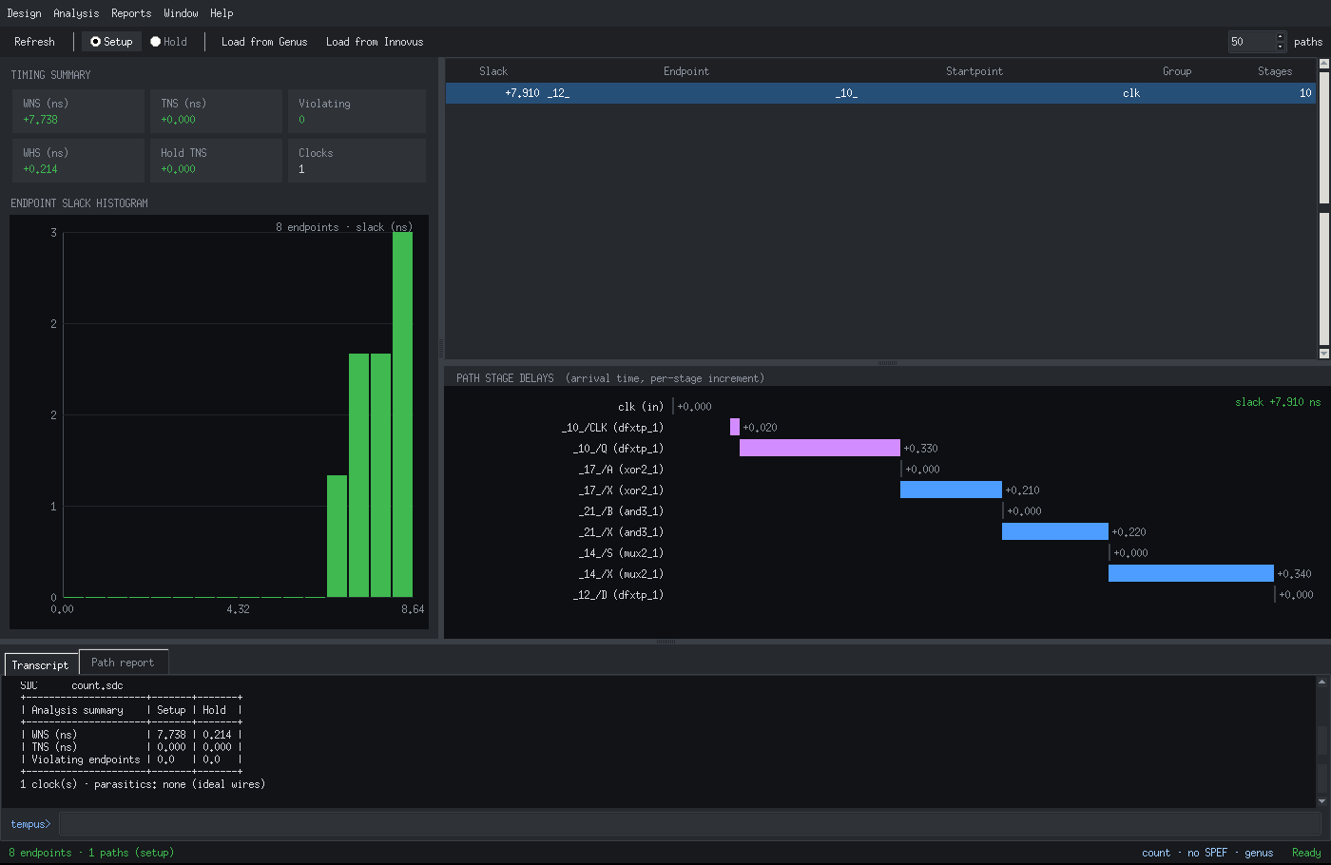
Figure 5 — Tempus GUI. Screens rendered from RTLFlow's test fixtures (mock engines) — on your machine the same windows show your real OpenROAD/OpenSTA data.

13.6 Innovus
- Menus: File, Edit, View, Floorplan, Power, Place, Clock, Route, Timing, Verify, Tools, Help.
- Flow bar: Init → Floorplan → Power → Place → CTS → Route → Timing; finished stages green, next one blue.
- Views: Floorplan (die, rows, pins, outlines), Amoeba (cells filled by class), Physical (everything).
- Right panel: Layers (object and metal visibility), Design (die, util, WNS/TNS, files), Attributes (selection); world view below.
- Timing Debug (Ctrl+T): OpenSTA path list; select a path to highlight it on the layout.
Input | Action
Wheel | Zoom at cursor
Left click | Select instance / IO pin / wire
Left or middle drag | Pan
Right drag | Zoom to box (right click alone zooms out)
Double click | Zoom to selection
f / z / Z | Fit / zoom in / zoom out
Arrow keys | Pan
k | Ruler
Esc | Clear selection and highlight
Ctrl+T / Ctrl+R / F12 | Timing Debug / re-read database / toggle transcript

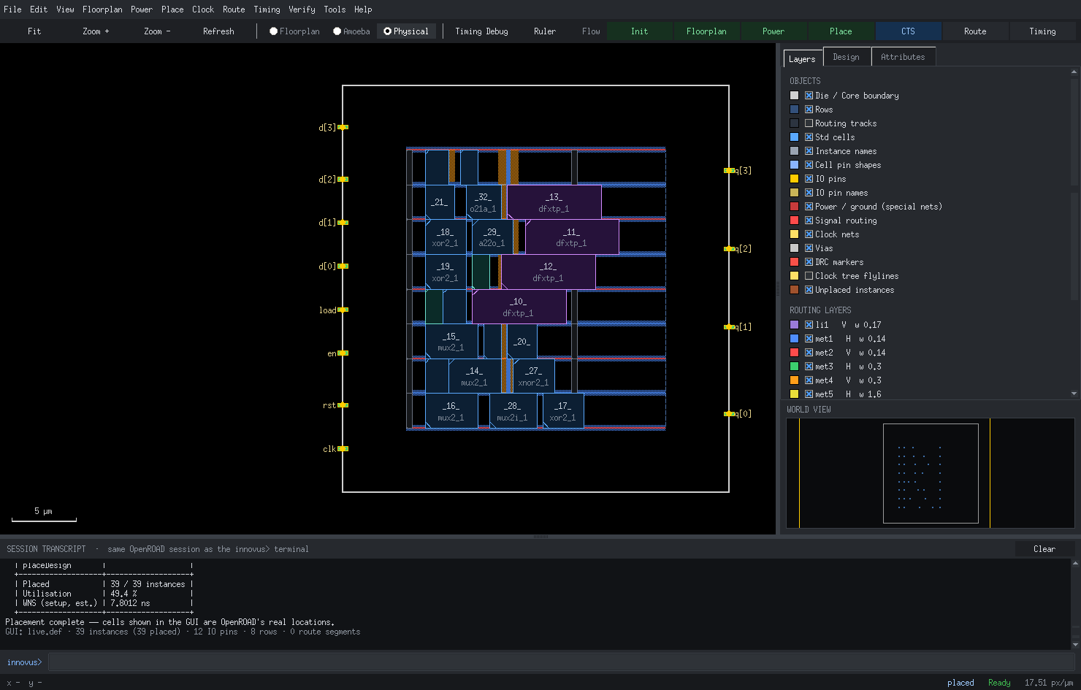
Figure 6 — Innovus layout GUI after placeDesign. Screens rendered from RTLFlow's test fixtures (mock engines) — on your machine the same windows show your real OpenROAD/OpenSTA data.

13.7 Voltus
Tabs: Power summary (stacked internal / switching / leakage by group), Power map (per-instance power as a heat map on the real layout), IR drop map (per-instance voltage drop). Right: colour legend with the numeric range, summary, and top instances — select one to zoom to it. Hover a cell for its value.
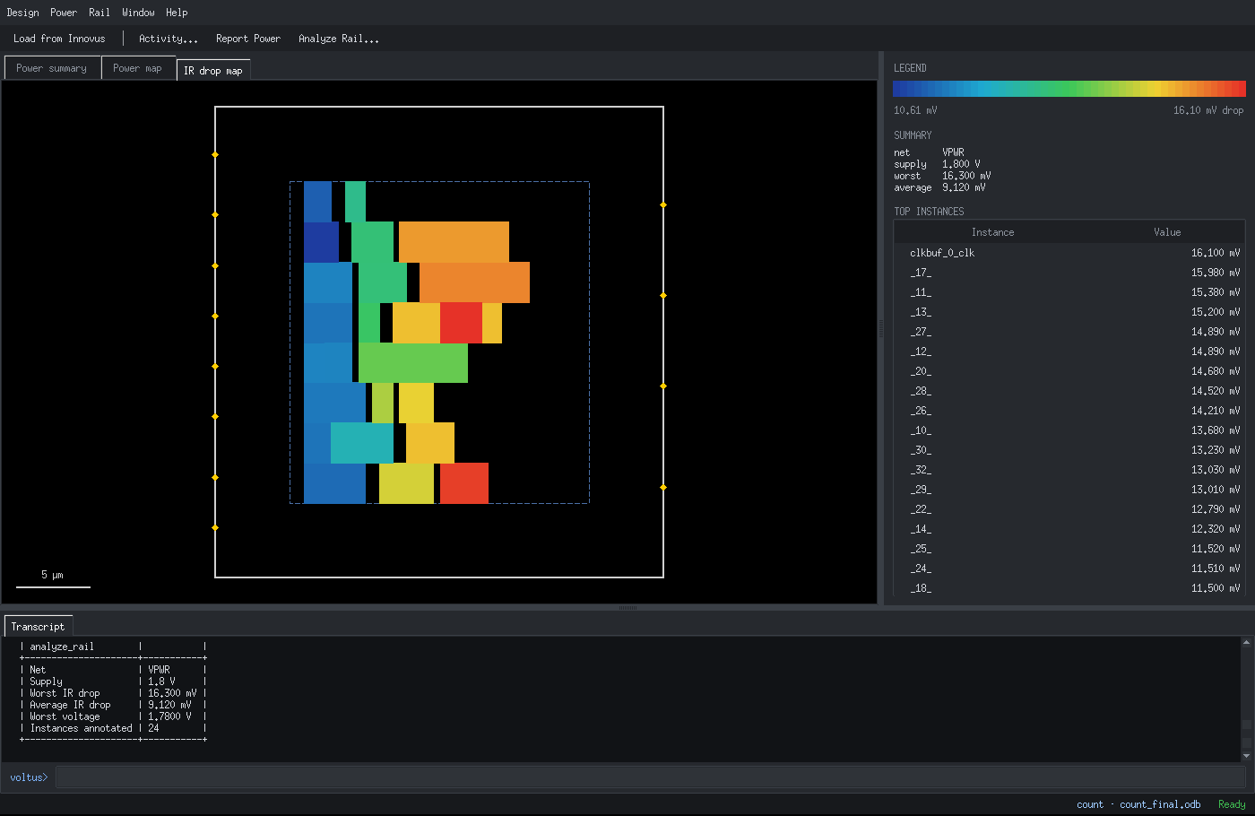
Figure 7 — Voltus IR-drop map. Screens rendered from RTLFlow's test fixtures (mock engines) — on your machine the same windows show your real OpenROAD/OpenSTA data.

13.8 Pegasus
DRC and LVS verdict badges, a violation tree grouped by rule (select a marker to zoom to it on the layout), the layout with all DRC markers drawn as crossed boxes, and the LVS report tab. Toolbar: Load Layout, Run DRC (KLayout or Magic), Run LVS, Open in KLayout (layout + marker database).
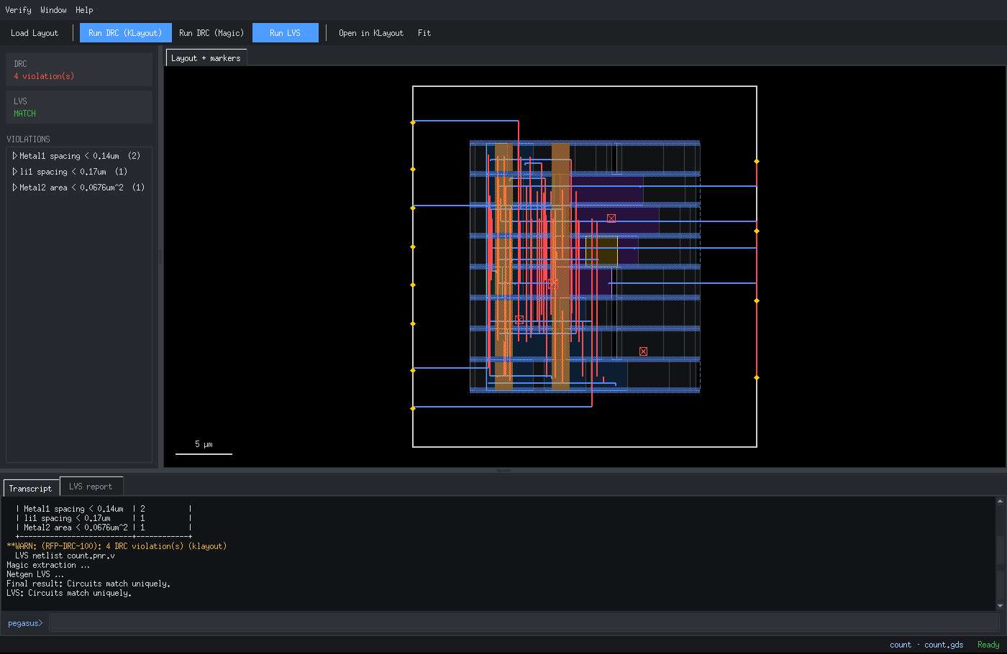
Figure 8 — Pegasus violation browser. Screens rendered from RTLFlow's test fixtures (mock engines) — on your machine the same windows show your real OpenROAD/OpenSTA data.

14. Troubleshooting
Symptom | Cause | Fix
rtlflow shows old argparse usage (shell, simulate, ncv …) | An older rtlflow earlier on PATH | type -a rtlflow; remove the old one; ./install.sh; hash -r
[ERROR ORD-0050] No tech is loaded | floorPlan before tech LEF / init_design | read_physical -lef (tech LEF auto-found), then init_design
GUI does not open: Tk missing | python3-tk not installed | sudo apt install python3-tk
GUI does not open: couldn't connect to display | No DISPLAY (ssh, tty) | Run from the desktop session, or use the tool without -gui
Launcher: no terminal found | Unknown terminal emulator | export RTLFLOW_TERMINAL='gnome-terminal --'
Tool not found | Not on PATH or in /nix/store | rtlflow> tools -rescan, or set RTLFLOW_<TOOL>
tempus read_design -from innovus: .pnr.v not found | routeDesign not run | Run routeDesign (or saveNetlist) in innovus
voltus: No innovus checkpoint | saveDesign not run | innovus: saveDesign <name>
voltus analyze_rail fails | No power grid in the DB | innovus: globalNetConnect + sroute before saveDesign
pegasus: GDS not found | streamOut not run | innovus: streamOut <top>.gds
modus: cells not modelled | Cell has no liberty function | Check the library; such cells are treated as unknown
ccopt_design: No clocks defined | No SDC | create_clock … or read_sdc before CTS
OpenROAD session killed / exited | Crash or Ctrl-C twice | restart_backend, then restoreDesign <checkpoint>

14.1 Useful checks
rtlflow> doctor # full environment check
innovus 3> status # what is loaded in the DB and the next step
innovus 4> tech_profile # site, layers, tap/tie/fill/CTS cells in use
@genus:root: 5> status # synthesis stage and netlist
modus 2> status · tempus 2> status · voltus 2> status · pegasus 2> status
logs: .rtlflow/logs/<tool>.logN and <tool>_gui.log

15. Quick reference card
Task | Command
Launcher | rtlflow -gui (or rtlflow> gui, or the app-grid icon)
Simulate + waves | nclaunch -gui → read_hdl, read_tb, elaborate tb, simulate · xrun -sv dut.sv tb.sv -top tb -gui
Synthesize | genus → read_libs, read_hdl -sv, elaborate, create_clock, syn_generic, syn_map, syn_opt
Handoff | write_design -innovus
DFT / ATPG | modus → read_netlist, build_model, connect_scan_chains, build_faultmodel, create_logic_tests
Timing | tempus → read_design -from genus|innovus, report_analysis_summary, report_timing
Implement | innovus → source .rtlflow/handoff/<top>.invs_flow.tcl
Floorplan | floorPlan -r 1.0 0.5 5 5 5 5 ; addWellTap ; globalNetConnect ; sroute
Place / CTS / Route | placeDesign ; ccopt_design ; routeDesign ; addFiller
Save / GDS | saveDesign name ; streamOut <top>.gds
Power / IR | voltus → read_design -from innovus, report_power -instances, analyze_rail -net VPWR -voltage 1.8
DRC / LVS | pegasus → read_layout, run_drc, run_lvs
GUI on/off | gui_show / gui_hide (all tools) · win / win off (innovus)
Report to file | report_timing > setup.rpt

