Title: Comprehensive Guide to VMware Installation, Linux Distro Installation, and Metasploitable 2 Framework Setup

1. Introduction

Virtualization technology has become integral to modern computing environments, allowing users to create and manage virtual machines (VMs) on a single physical host. VMware is a leading virtualization platform that provides powerful tools for this purpose. This report outlines the step-by-step process of installing VMware, setting up a Linux distribution within a VM, and subsequently installing the Metasploitable 2 framework for security testing and penetration testing purposes.

2. VMware Installation Process

2.1 Prerequisites:

Before starting the installation, ensure that your host machine meets the hardware and software requirements for VMware. Download the latest version of VMware Workstation or VMware Player from the official website.

2.2 Installation Steps:

Follow these steps to install VMware:

a. Double-click the downloaded installer file.

b. Follow the on-screen instructions to complete the installation.

c. Launch VMware and enter the license key if prompted.

d. Familiarize yourself with the interface.

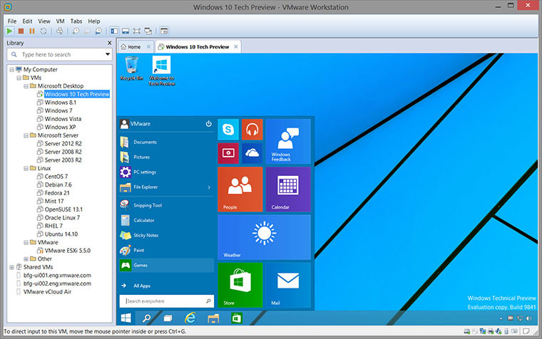

3. Installing a Linux Distribution on VMware

[https://zsecurity.org/download-custom-kali/] – directly open in VM by going to its directory and opening the file]

Manual Installation :

Kali Linux Installation Procedure

Boot

To start your installation, boot with your chosen installation medium. You should be greeted with the Kali Linux Boot screen. Choose either Graphical install or Install (Text-Mode). In this example, we chose the Graphical install.

[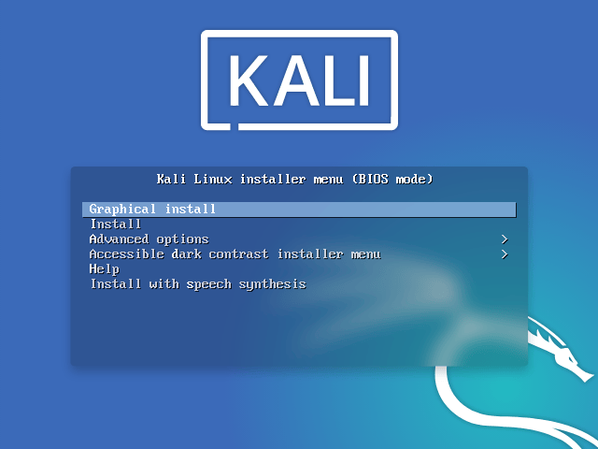](https://www.kali.org/docs/installation/hard-disk-install/boot-installer.png)

If you’re using the live image instead, you will see another mode, Live, which is also the default boot option.

[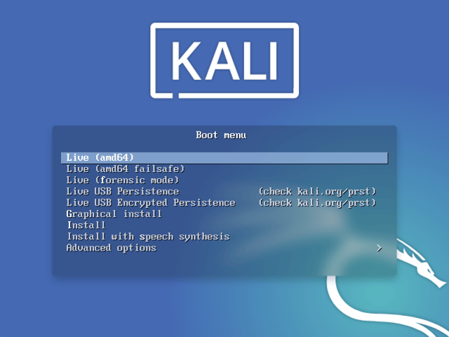](https://www.kali.org/docs/installation/hard-disk-install/boot-live.png)

Language

Select your preferred language. This will be used for both the setup process and once you are using Kali Linux.

[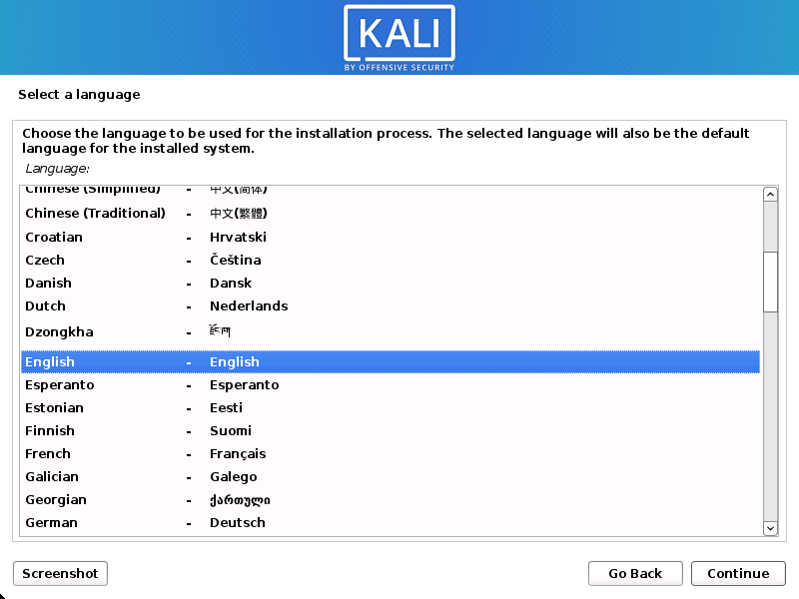](https://www.kali.org/docs/installation/hard-disk-install/setup-language-1.png)

Specify your geographic location.

[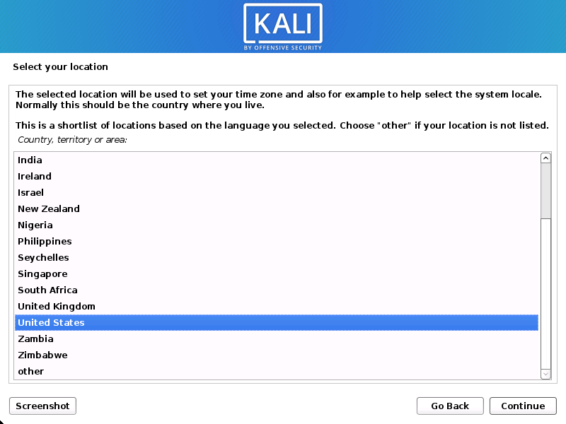](https://www.kali.org/docs/installation/hard-disk-install/setup-language-2.png)

Select your keyboard layout.

[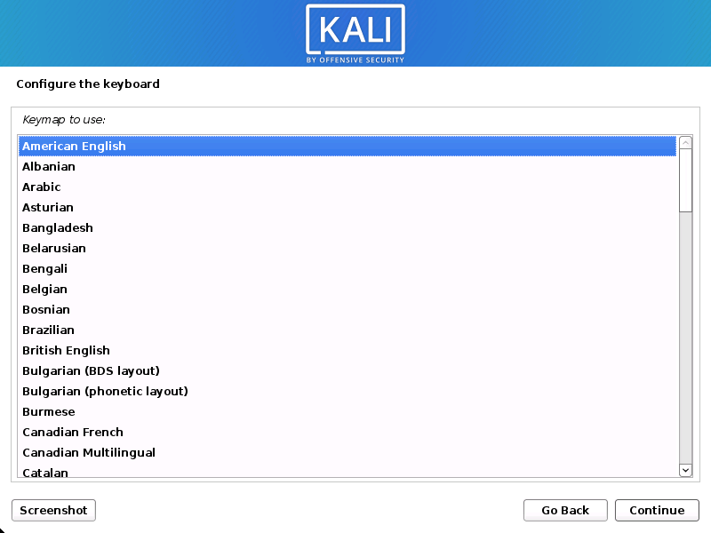](https://www.kali.org/docs/installation/hard-disk-install/setup-language-3.png)

Network

The setup will now probe your network interfaces, looks for a DHCP service, and then prompt you to enter a hostname for your system. In the example below, we’ve entered kali as our hostname.

If there is no network access with DHCP service detected, you may need to manually configure the network information or do not configure the network at this time.

If there isn’t a DHCP service running on the network, it will ask you to manually enter the network information after probing for network interfaces, or you can skip.

If Kali Linux doesn’t detect your NIC, you either need to include the drivers for it when prompted, or generate a custom Kali Linux ISO with them pre-included.

If the setup detects multiple NICs, it may prompt you which one to use for the install.

If the chosen NIC is 802.11 based, you will be asked for your wireless network information before being prompted for a hostname.

[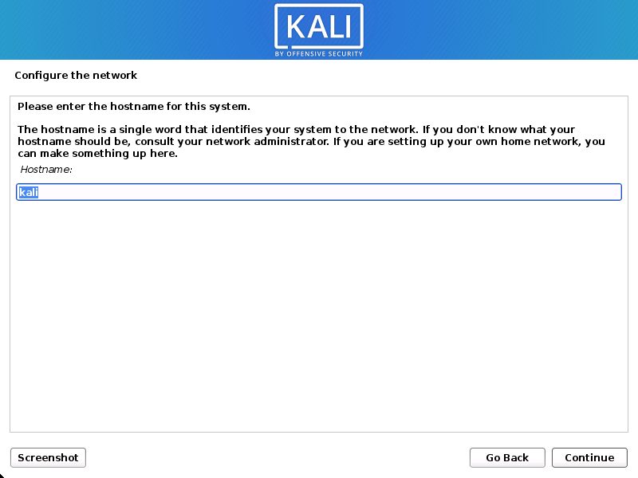](https://www.kali.org/docs/installation/hard-disk-install/setup-hostname-1.png)

You may optionally provide a default domain name for this system to use (values may be pulled in from DHCP or if there is an existing operating systems pre-existing).

[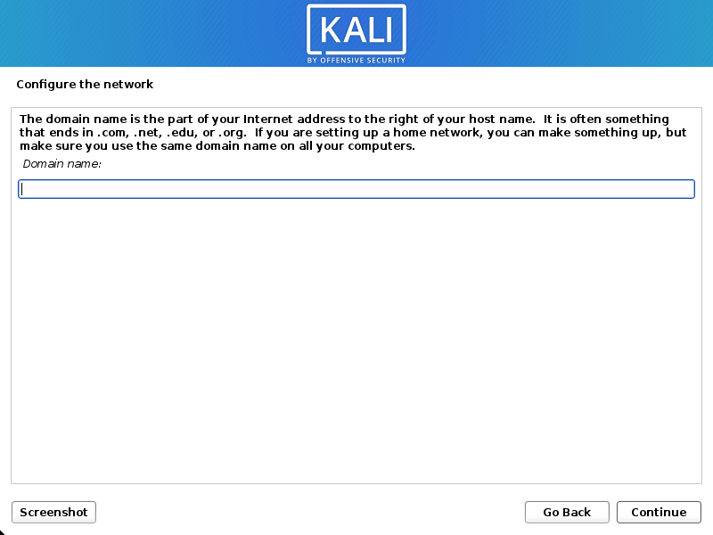](https://www.kali.org/docs/installation/hard-disk-install/setup-hostname-2.png)

User Accounts

Next, create the user account for the system (Full name, username and a strong password).

[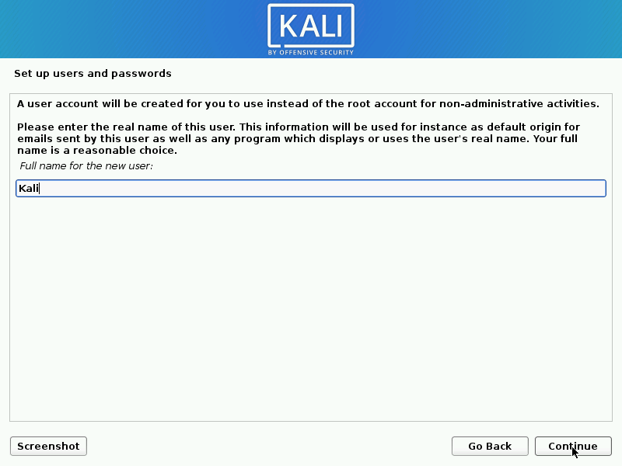](https://www.kali.org/docs/installation/hard-disk-install/setup-user-1.png)

[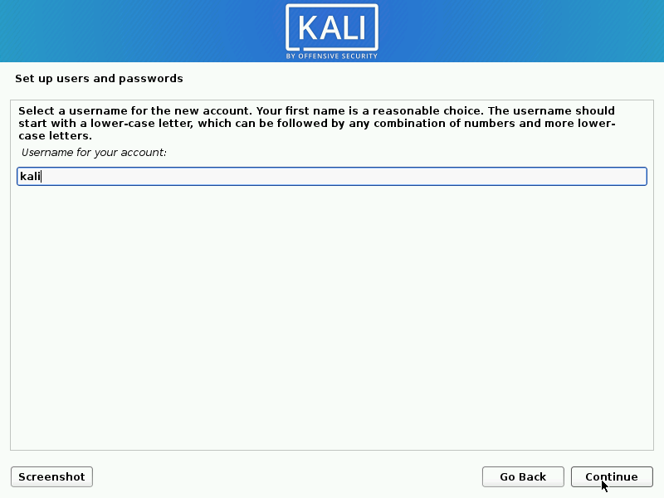](https://www.kali.org/docs/installation/hard-disk-install/setup-user-2.png)

[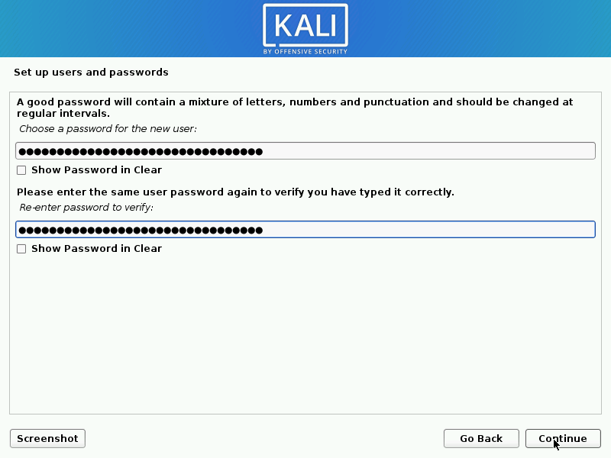](https://www.kali.org/docs/installation/hard-disk-install/setup-user-3.png)

Clock

Next, set your time zone.

[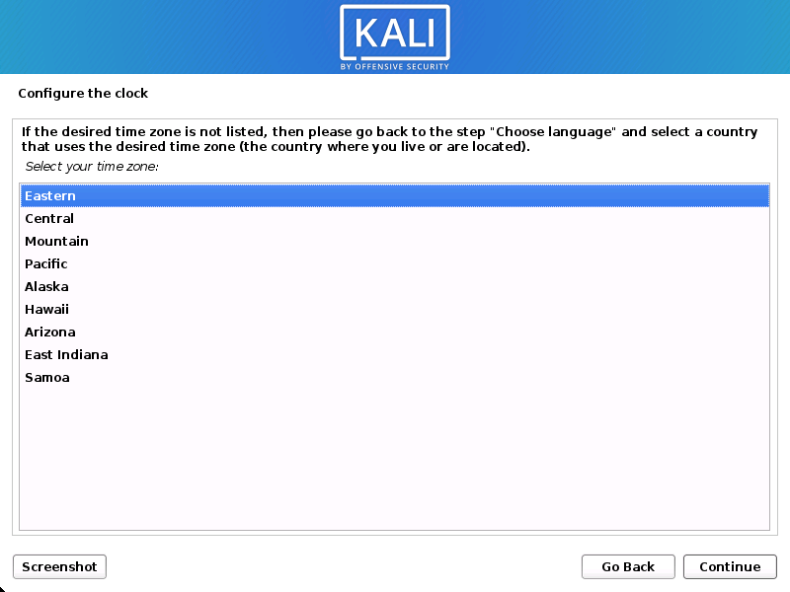](https://www.kali.org/docs/installation/hard-disk-install/setup-clock.png)

Disk

The installer will now probe your disks and offer you various choices, depending on the setup.

In our guide, we are using a clean disk, so we have four options to pick from. We will select Guided - the entire disk, as this is the single boot installation for Kali Linux, so we do not want any other operating systems installed, so we are happy to wipe the disk.

If there is an pre-existing data on the disk, you will have have an extra option (Guided - use the largest continuous free space) than the example below. This would instruct the setup not to alter any existing data, which is perfect for dual-booting into another operating system. As this is not the case in this example, it is not visible.

[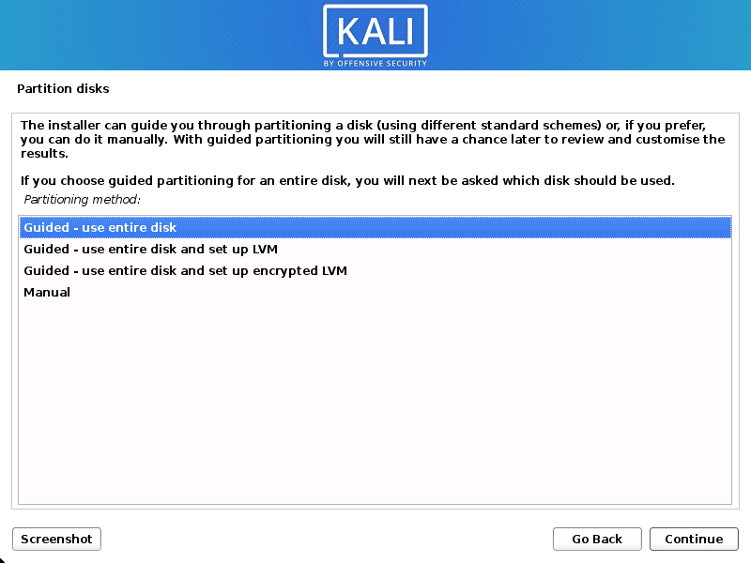](https://www.kali.org/docs/installation/hard-disk-install/setup-partition-1.png)

Select the disk to be partitioned.

[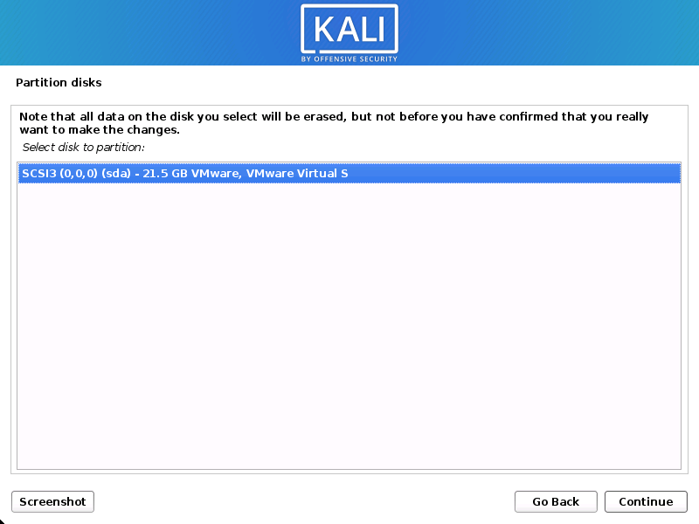](https://www.kali.org/docs/installation/hard-disk-install/setup-partition-2.png)

Depending on your needs, you can choose to keep all your files in a single partition - the default - or to have separate partitions for one or more of the top-level directories.

If you’re not sure which you want, you want “All files in one partition”.

[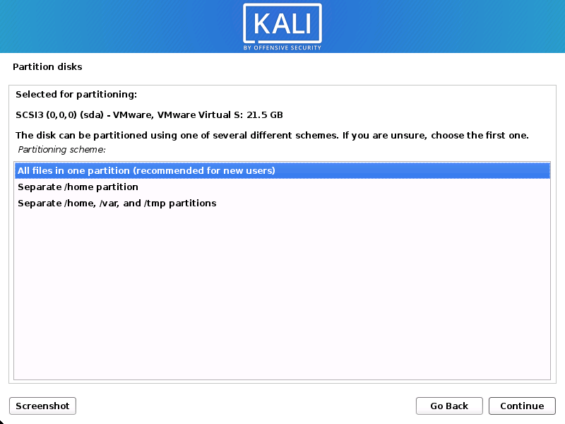](https://www.kali.org/docs/installation/hard-disk-install/setup-partition-3.png)

[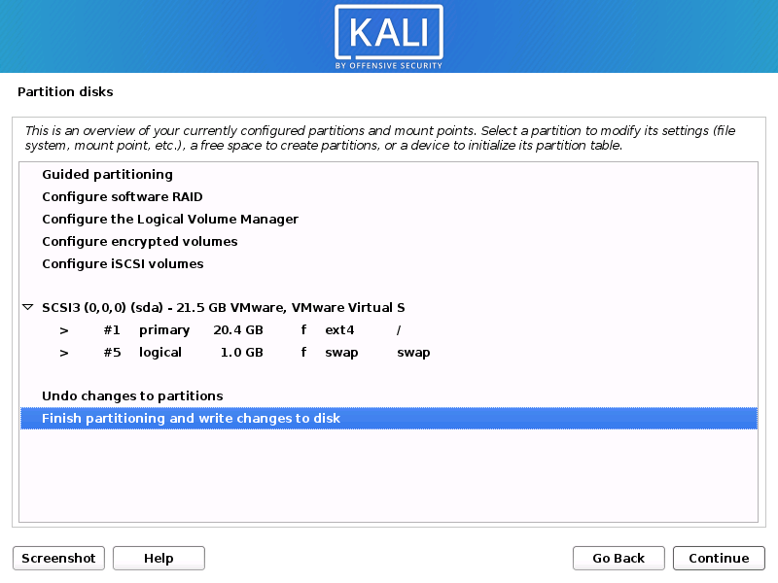](https://www.kali.org/docs/installation/hard-disk-install/setup-partition-4.png)

Next, you’ll have one last chance to review your disk configuration before the installer makes irreversible changes. After you click Continue, the installer will go to work and you’ll have an almost finished installation.

[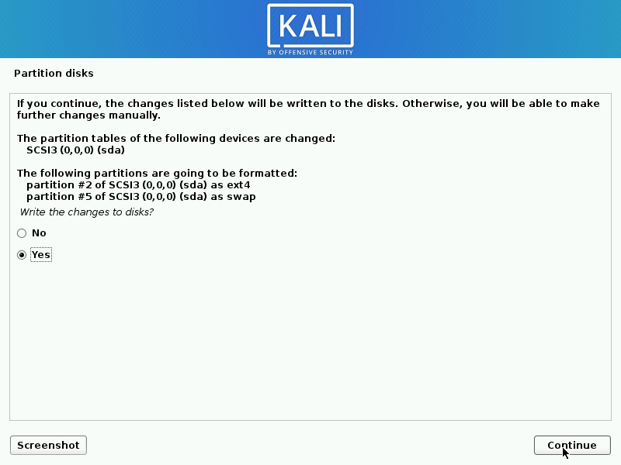](https://www.kali.org/docs/installation/hard-disk-install/setup-partition-5.png)

Encrypted LVM

If enabled in the previous step, Kali Linux will now start to perform a secure wipe of the hard disk, before asking you for a LVM password.

Please be sure a strong password is used, or else you will be prompted with a weak passphrase warning.

This wipe may take “a while” (hours) depending on the size and speed of the drive.  
If you wish to risk it, you can skip it.

Proxy Information

Kali Linux uses a central repository to distribute applications. You’ll need to enter any appropriate proxy information as needed.

[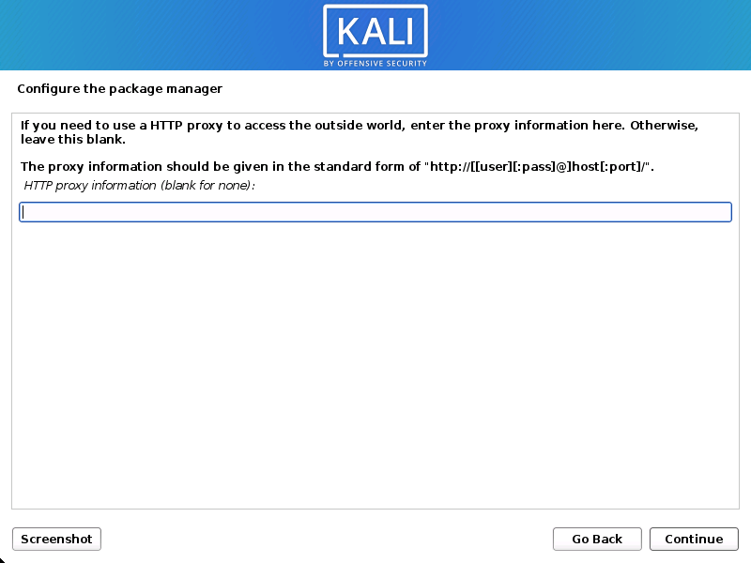](https://www.kali.org/docs/installation/hard-disk-install/setup-proxy.png)

Metapackages

If network access was not setup, you will want to continue with setup when prompt.

If you are using the Live image, you will not have the following stage.

Next you can select which metapackages you would like to install. The default selections will install a standard Kali Linux system and you don’t really have to change anything here.[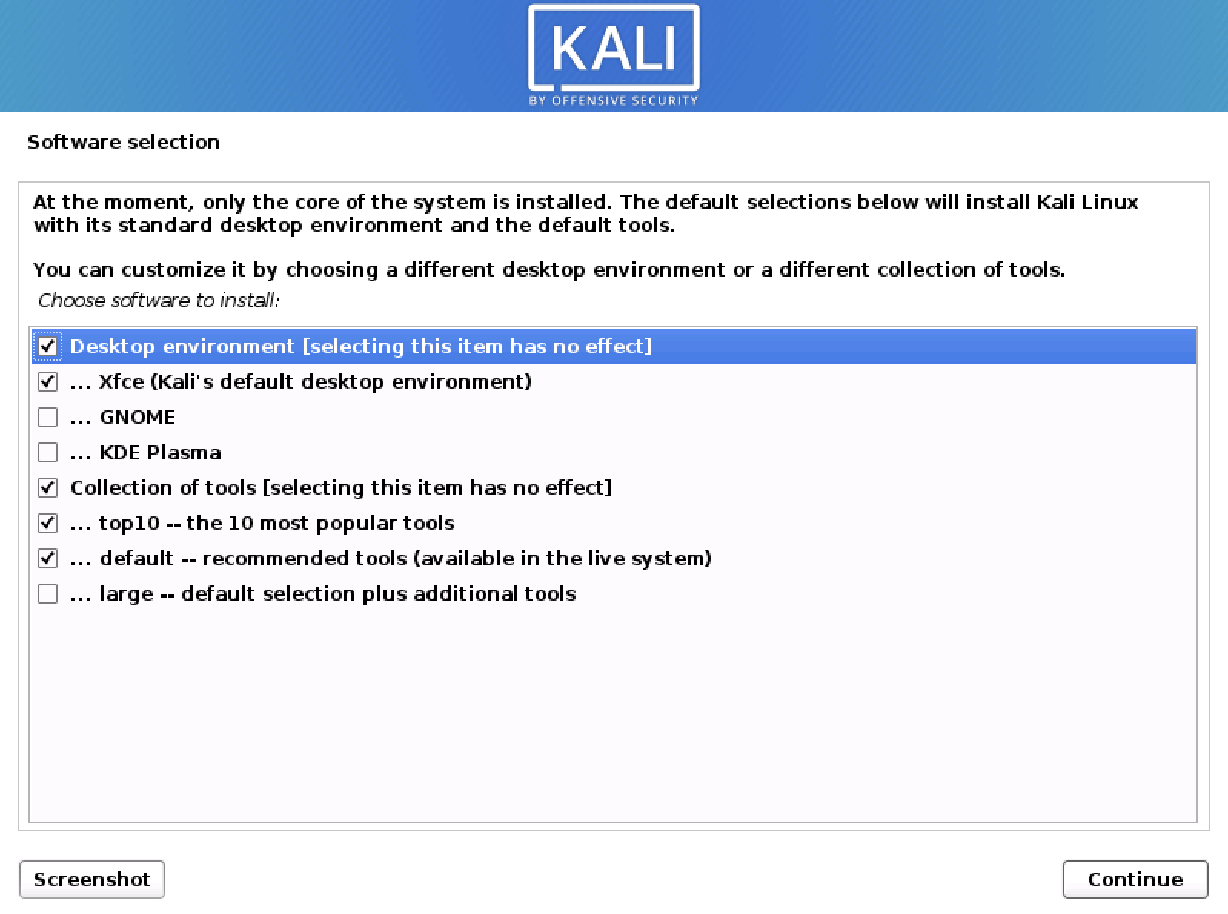](https://www.kali.org/docs/installation/hard-disk-install/setup-default-metapackages.png)

Boot Information

Next confirm to install the GRUB boot loader.

[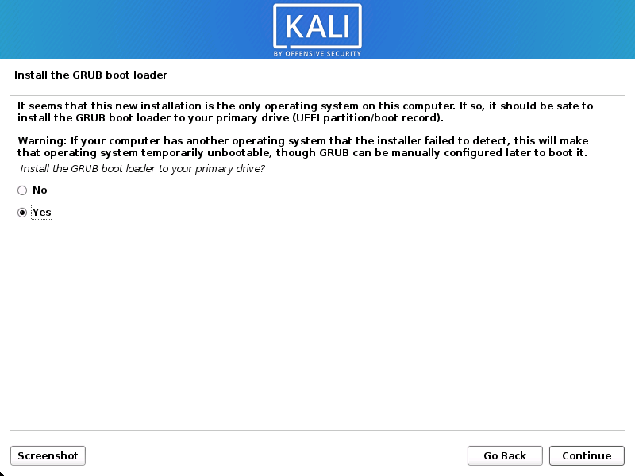](https://www.kali.org/docs/installation/hard-disk-install/setup-grub-1.png)

Select the hard drive to install the GRUB bootloader in (it does not by default select any drive).

[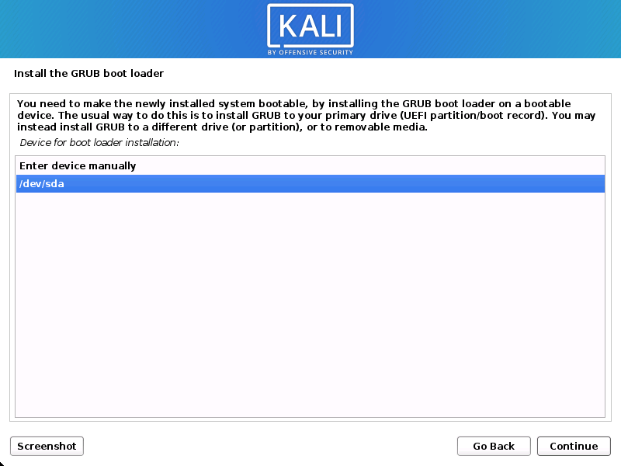](https://www.kali.org/docs/installation/hard-disk-install/setup-grub-2.png)

[Reboot](https://www.kali.org/docs/installation/hard-disk-install/" \l "reboot)

Finally, click Continue to reboot into your new Kali Linux installation.

[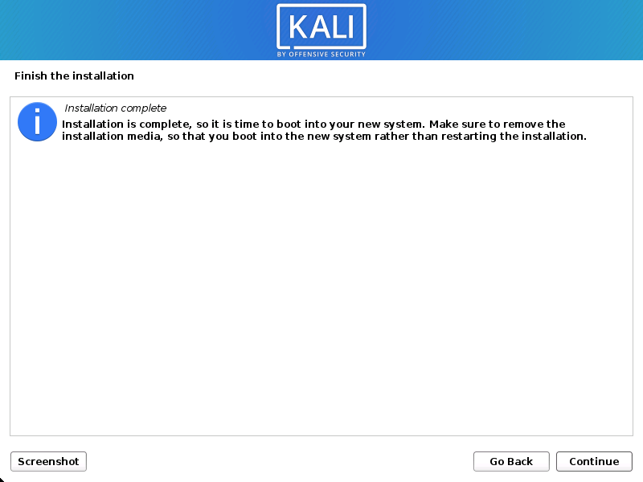](https://www.kali.org/docs/installation/hard-disk-install/setup-reboot.png)

3.1 Preparing the Virtual Machine:

a. Open VMware and click on "Create a New Virtual Machine."

b. Choose "Typical" and click "Next."

c. Select "Installer disc image file (iso)" and browse to your Linux distribution ISO file.

d. Follow the wizard to set up VM parameters like disk size, memory, and CPU.

3.2 Linux Installation:

a. Power on the VM.

b. Follow the Linux installation process, configuring settings such as language, time zone, and user accounts.

c. Complete the installation and reboot the VM.

3.3 VMware Tools Installation (Optional):

For enhanced performance and functionality, consider installing VMware Tools on the Linux VM. This involves mounting the VMware Tools ISO and running the installation script.

4. Configuration for Smooth Operation

4.1 Network Configuration:

Ensure that the VM has proper network connectivity. Use bridged or NAT networking modes based on your requirements.

4.2 Resource Allocation:

Adjust the allocated resources (CPU, memory, disk space) based on the Linux distribution's requirements and your workload.

For Kali Linux :

4.3 Snapshots and Backups:

Regularly create snapshots to capture the VM's state. Additionally, implement a backup strategy for critical VM data.

5. Installing Metasploitable 2 Framework

5.1 Download Metasploitable 2:

Retrieve the Metasploitable 2 framework from the official repository or a trusted source.

[https://sourceforge.net/projects/metasploitable/files/Metasploitable2/]

5.2 Import Metasploitable 2 as a VM:

a. Open VMware and choose "Open a Virtual Machine."

b. Browse to the Metasploitable 2 VM directory and select the VMX file.

c. Configure VM settings as needed.

5.3 Power On and Configure Metasploitable 2:

a. Power on the Metasploitable 2 VM.

b. Follow the on-screen instructions to complete the setup.

c. Ensure network connectivity and configure any necessary security settings.

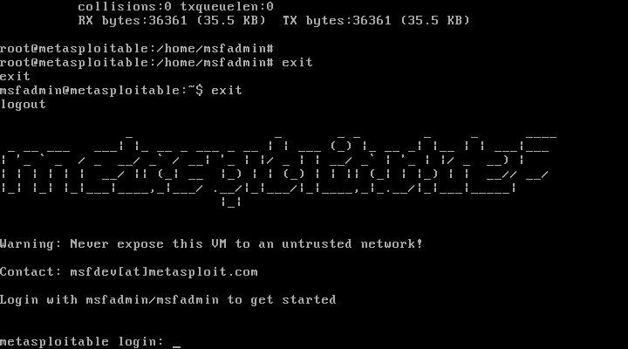

6. Conclusion

By following this comprehensive guide, users can successfully install VMware, set up a Linux distribution within a VM, and deploy the Metasploitable 2 framework for security testing. Proper configuration and adherence to best practices will contribute to the smooth operation of the virtualized environment and enhance the security testing capabilities provided by Metasploitable 2.