Make sure you have Atlas on your computer. Checkout the org.mozilla.rhino_x.x.x plugin from the Zeus SVN, then copy and paste it into your Atlas’ eclipse/dropins folder.

Open Eclipse and go to Window -> Preferences

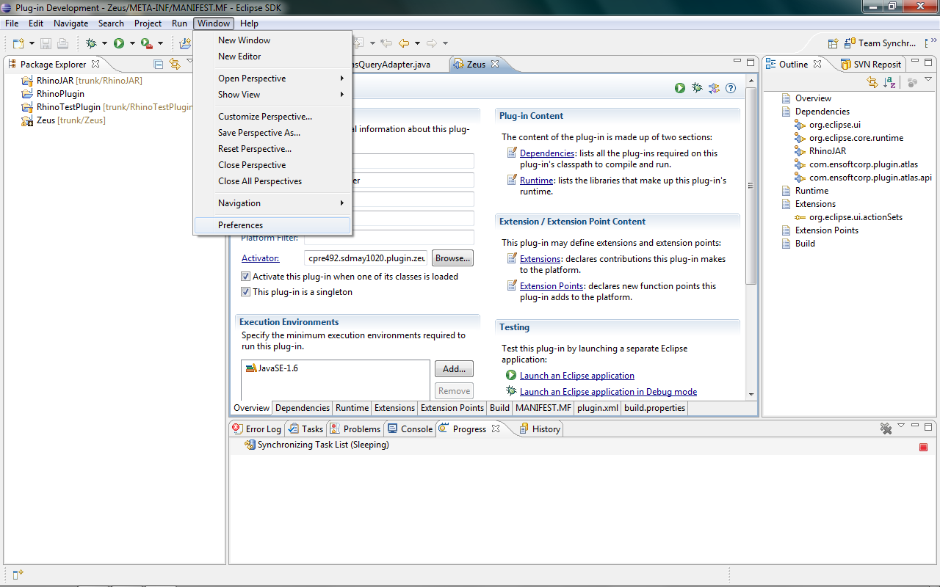

Expand Plug-in Development and click on “Target Platform”

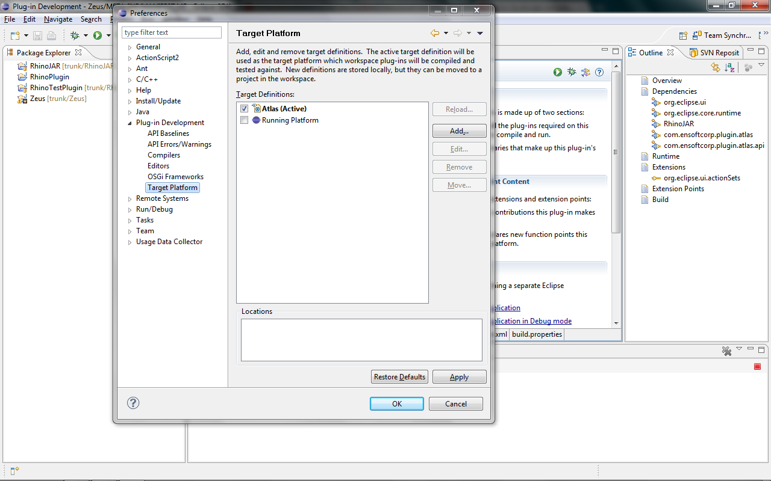

Click the “Add” button, and then “Next” (Leave the setting to “Nothing”)

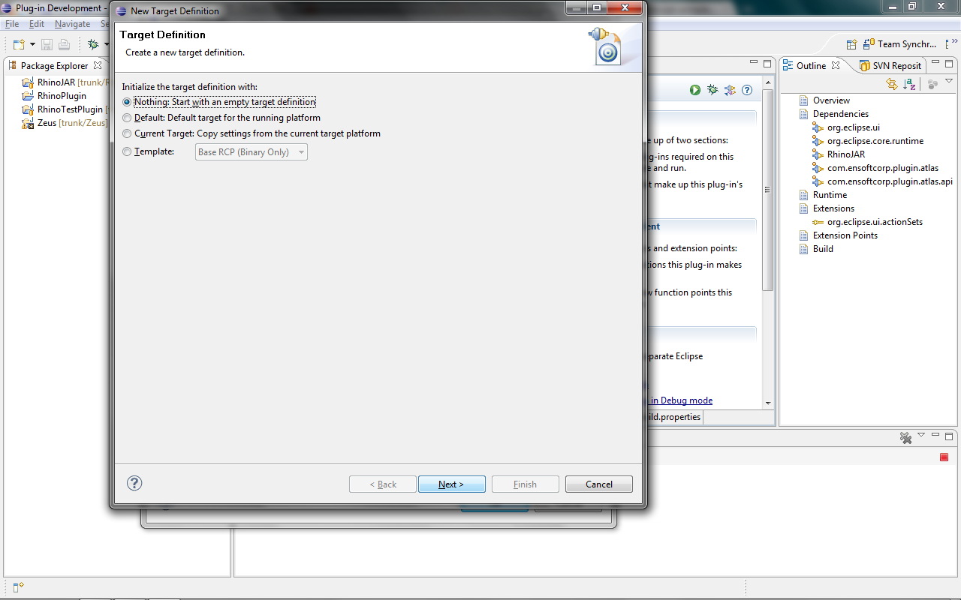

Click “Add” again

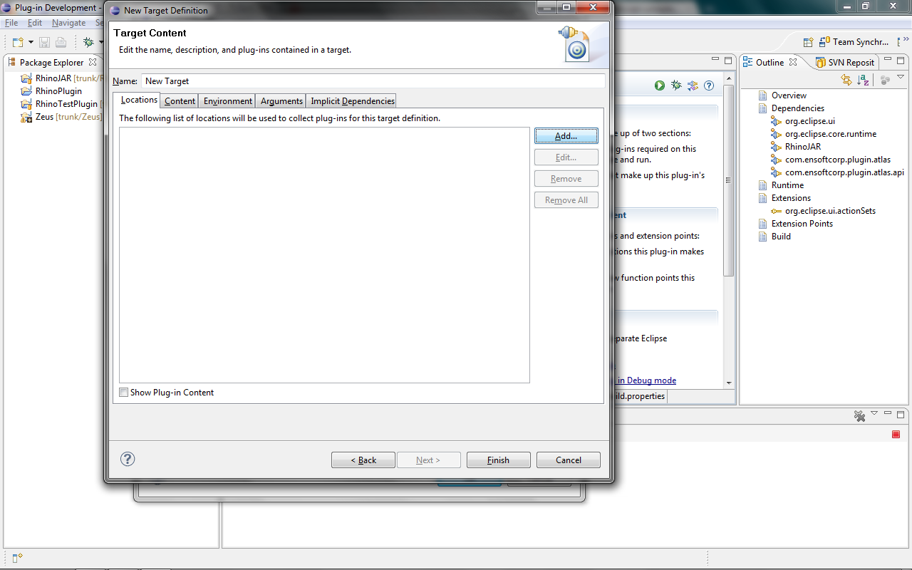

Click “Directory” and then “Next”

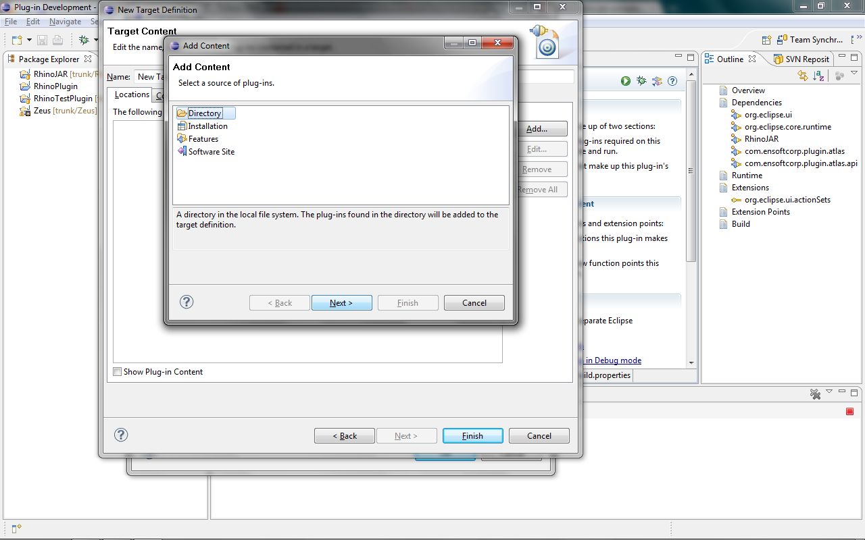

Click “Browse” and find the eclipse folder inside your Atlas folder, then click “Ok”

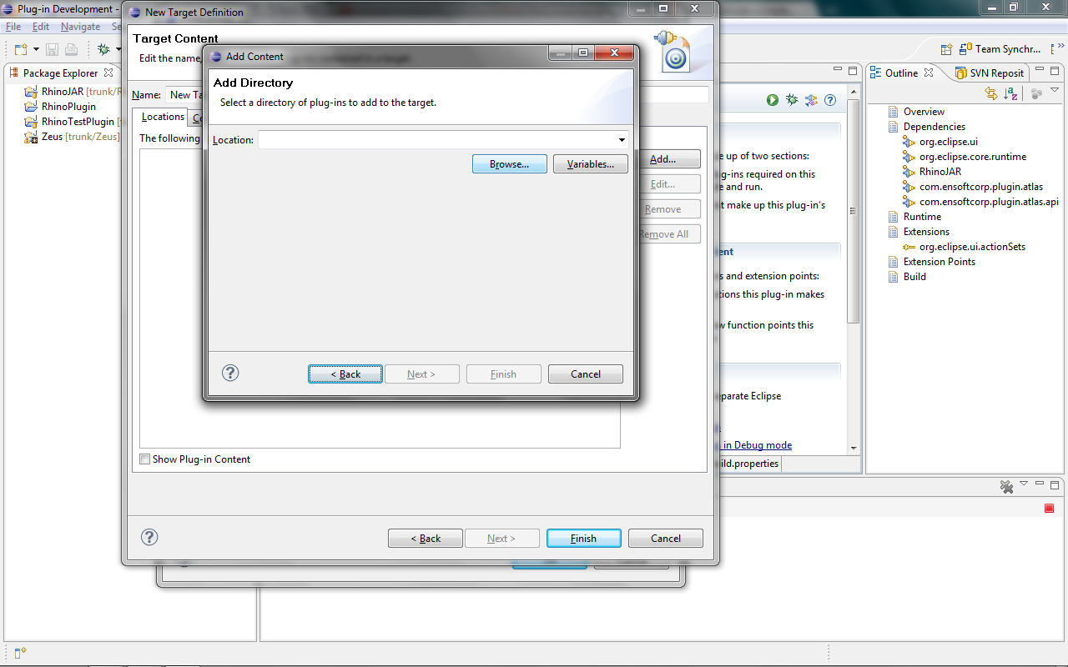

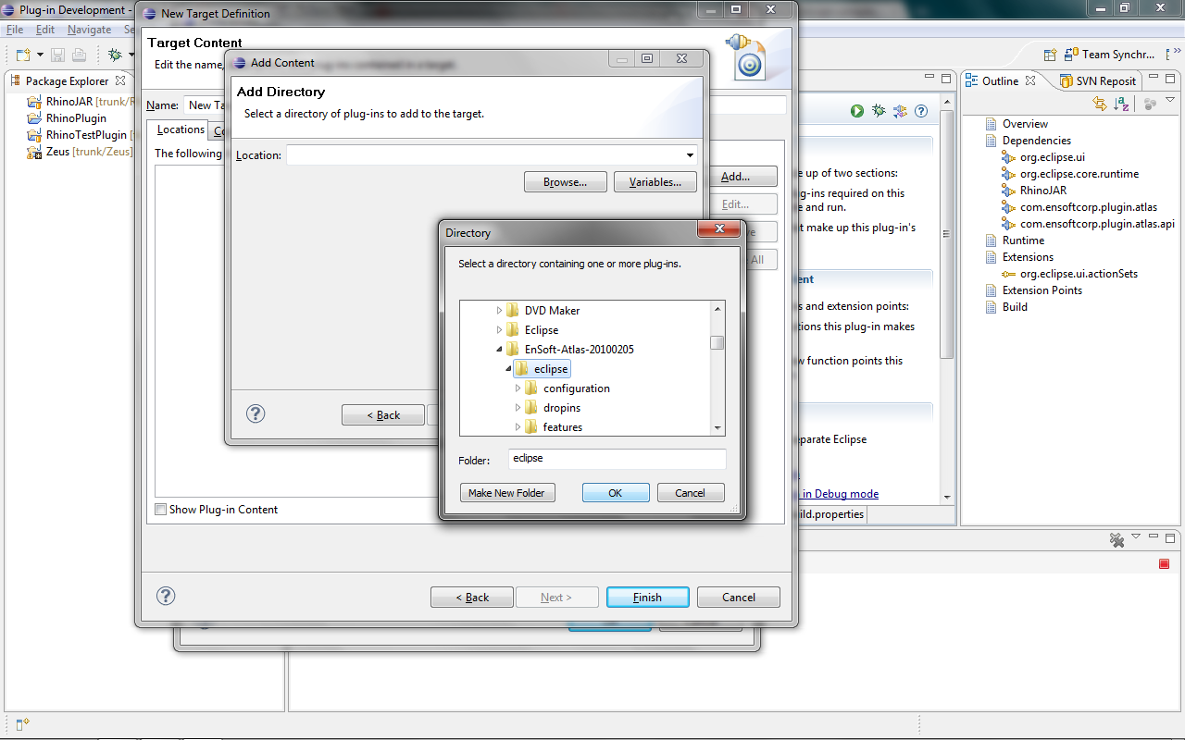

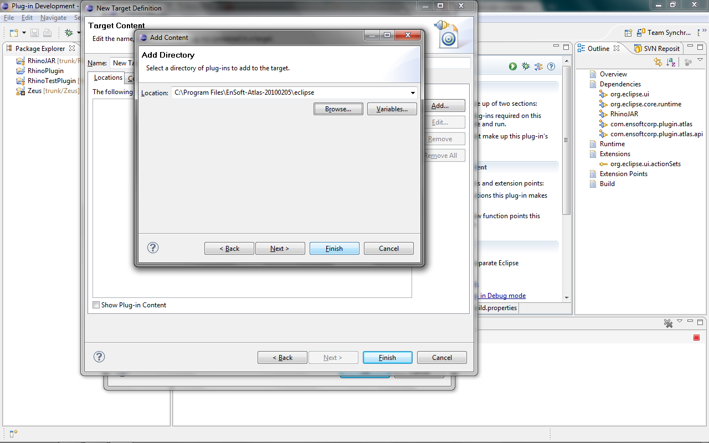

Follow the same steps to add the dropins folder inside of that same eclipse folder (it doesn’t find it recursively apparently so it has to be added manually). Then click “Finish” on the target definition.

Make sure to name your new target definition something useful, like “Atlas” or “Eclipse + Atlas”. Select the check box beside your new target definition to use it.