Git Assignment

Question1

ssh key attached and git configration done

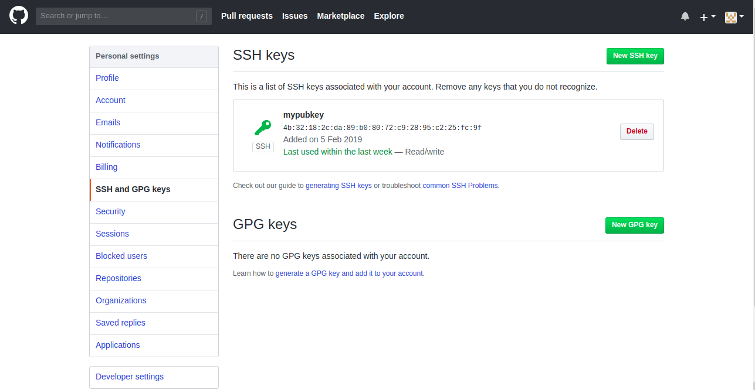

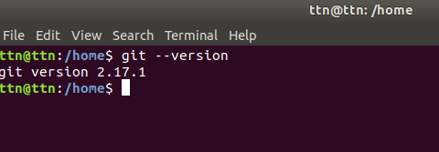

Question2

git init to initialize

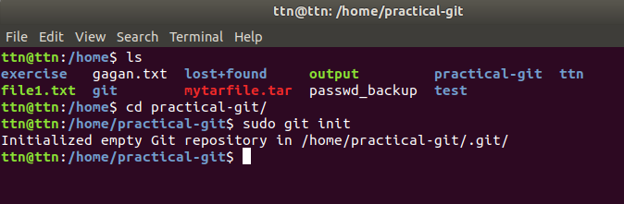

Question3

files added to repo

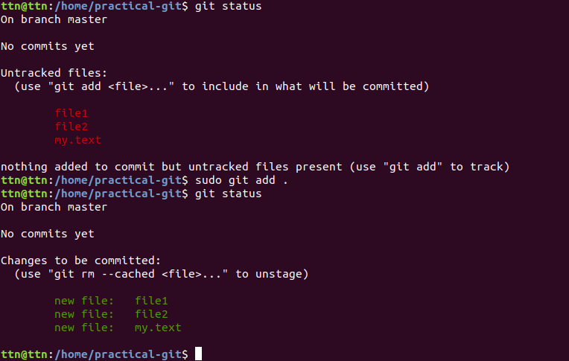

Question4

unstaged file by using “git reset HEAD file3”

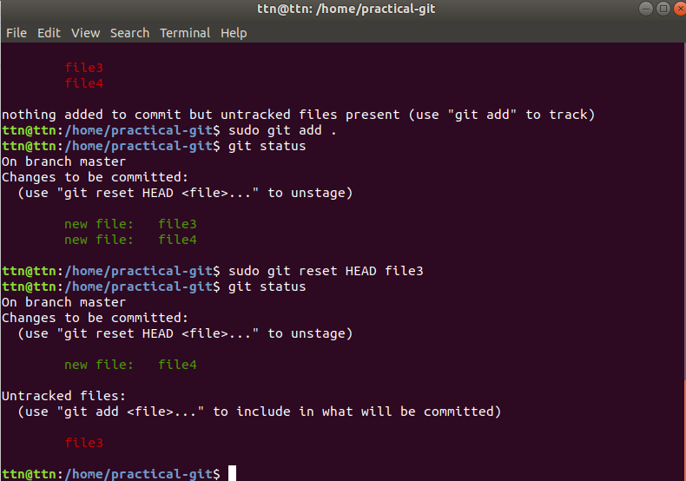

Question5

file added and commited

also be done in same line by “-am”

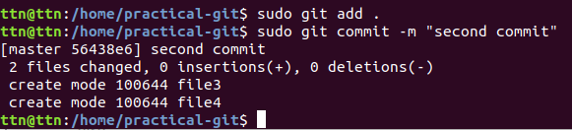

Question6

remote added by https:

also be done using ssh, which is better way.

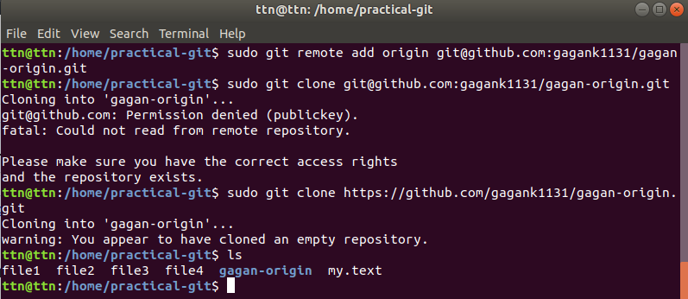

Question7

changes undo from a particular file by using “git checkout file-name”

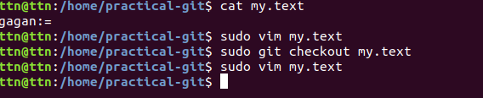

Question8

changes pushed using “ git push -u origin master”

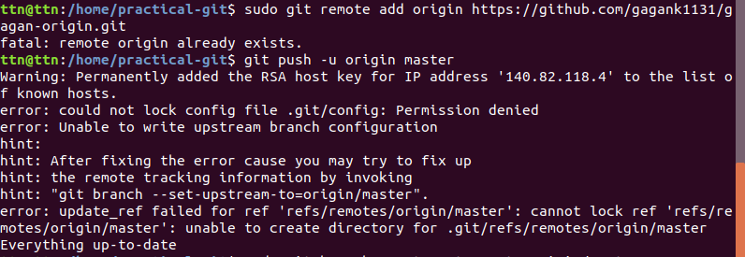

by using ssh

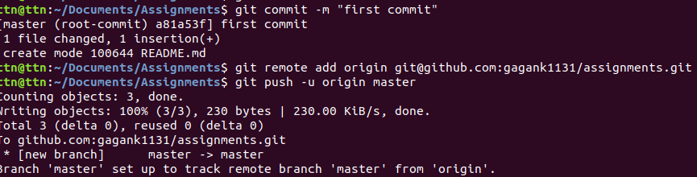

Question9

clone a repo

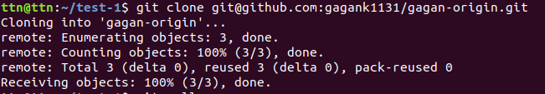

Question10

Question11

difference between file and it’s staged version

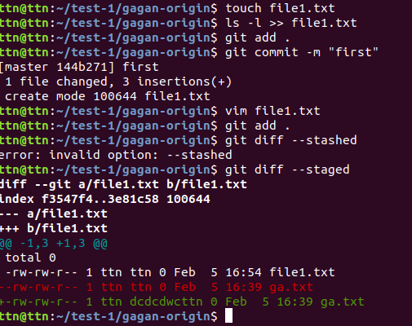

Question12

created .gitignore to not check certain files with vcs

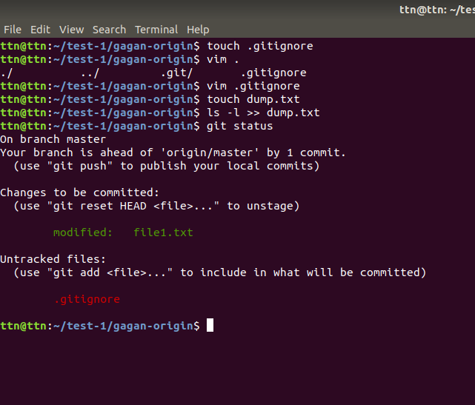

Question13

created new branch

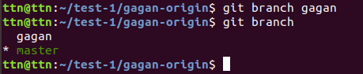

Question14

diverged different branches with different commits

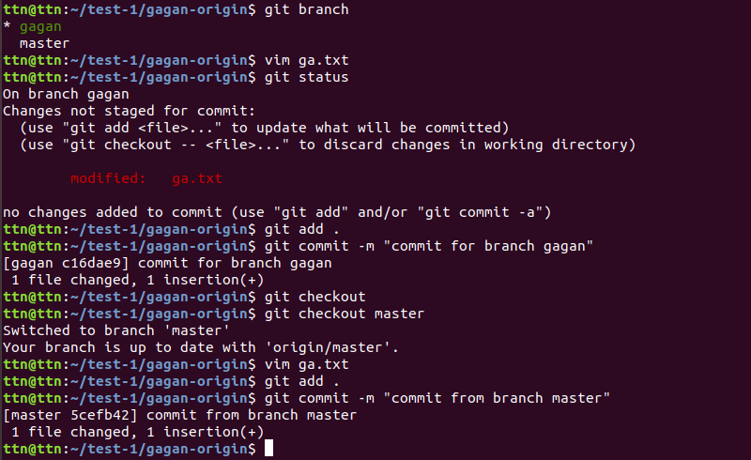

Question15

edited same file at same file on different branches and commit and it shows conflict

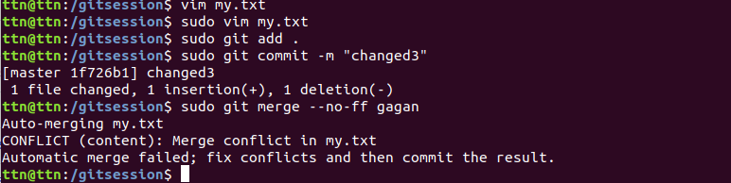

Question16

resolving merge conflict

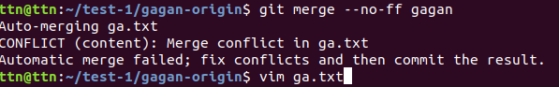

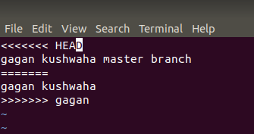

Question17

stash and pop

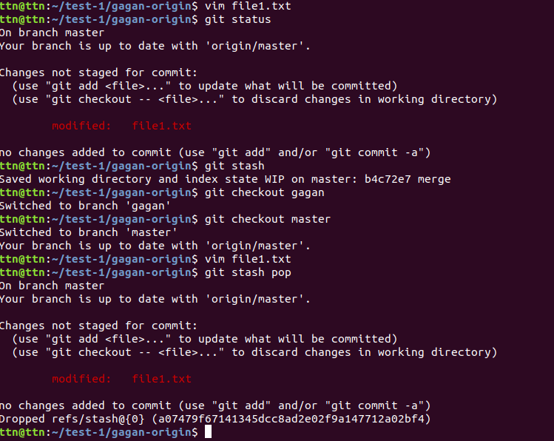

Question18

