**Medical Imaging and Report Assistant Documentation**

A Comprehensive Guide to the AI-Powered Radiology Workflow Platform

Developed by: Abhinav

Date: July 21, 2025

## Contents

**1 Introduction** **2**

**2 Key Features** **2**

**3 Technology Stack** **2**

**4 System Architecture** **2**

**5 Core Modules** **2**

**6 AI Integration** **3**

**7 Admin Dashboard** **3**

**8 Security Features** **3**

**9 Future Scope** **3**

**10 Team and Credits** **3**

# Introduction

The Medical Imaging and Report Assistant represents a cutting-edge web-based platform meticulously designed to automate and enhance radiology workflows through the power of artificial intelligence. This innovative tool integrates advanced image analysis capabilities, automatic report generation, and a Retrieval-Augmented Generation (RAG) system for medical literature search, significantly boosting productivity for radiologists, clinicians, and students alike. The platform is equipped with robust user authentication, role-based access control, image upload and annotation features, and leverages GPT/Gemini-powered report generation to deliver a comprehensive solution tailored to the needs of the medical community.

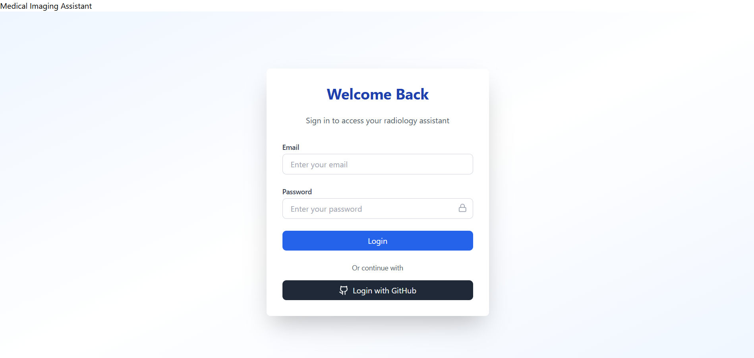

# Key Features

The assistant streamlines the radiology process by offering a suite of powerful features that cater to diverse user needs. It supports seamless OAuth authentication through Google and GitHub, ensuring secure and convenient access. The platform provides role-based dashboard access for Admin, Instructor, and Student roles, allowing tailored experiences for each user type. Users can upload, preview, and annotate medical images with ease, while the system generates structured medical reports using AI technology. A dedicated patient and report management dashboard facilitates efficient data handling, complemented by admin-only controls for managing sensitive information. Integrated statistics and summaries offer valuable insights, and the inclusion of a medical literature search powered by RAG enhances research capabilities.

# Technology Stack

The platform is built using a robust selection of modern technologies that ensure both performance and scalability across its backend and frontend components. The backend relies on FastAPI for API development, SQLAlchemy and PostgreSQL for database management, and JWT Authentication along with OAuth via Authlib for secure user access. It integrates AI capabilities through OpenAI and Gemini APIs, with RAG functionality supported by HuggingFace. On the frontend, React with Vite provides a dynamic user interface, enhanced by TailwindCSS for styling, Axios for API requests, React Router for navigation, and

Lucide Icons for a modern visual aesthetic.

# System Architecture

The systems architecture is designed with a clear separation of concerns to optimize functionality and maintainability. The React frontend manages the user interface, handles routing, and facilitates interaction with the backend through API calls. The FastAPI backend serves RESTful APIs, manages JWT tokens, and hosts AIpowered endpoints for advanced processing. A PostgreSQL database efficiently stores critical data including users, images, reports, and patient records. Additionally, AI APIs from OpenAI and Gemini process prompts to generate accurate and contextaware medical reports, forming the backbone of the platforms intelligent features.

# Core Modules

The platform is organized into distinct functional modules that address specific aspects of the radiology workflow. The Users module handles OAuth login and provides rolebased dashboard access, ensuring secure and personalized experiences. The Patients module allows users to add, edit, delete, and view comprehensive patient records with ease. The Images module supports the upload and management of medical images, complete with metadata for detailed tracking. The Reports module enables the generation of AI-powered, editable, and filterable reports that are seamlessly linked to patient data, enhancing clinical documentation.

# AI Integration

Artificial intelligence is a cornerstone of the platform, driving the creation of structured and context-aware radiology reports that meet clinical standards. Upon uploading and selecting an image, the system crafts a detailed prompt and sends it to an AI model such as GPT-4 or Gemini Pro, incorporating specifics like image description and scan type. The model then delivers clinically relevant findings and recommendations, tailored to the input data. An example prompt might request a chest Xray report with details including filename, description, and scan type, showcasing the systems ability to produce precise and actionable outputs.

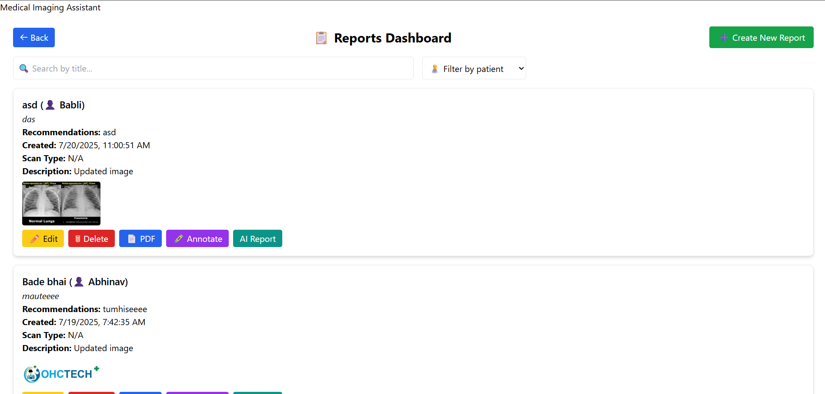

# Admin Dashboard

The admin dashboard serves as a centralized hub, offering administrators a highlevel overview and robust management options. It provides visibility into the total number of patients and reports, enabling quick assessments of system usage. Administrators can directly add new patients and reports, utilize a medical literature search feature for research support, and access advanced filtering, search, and editing tools..

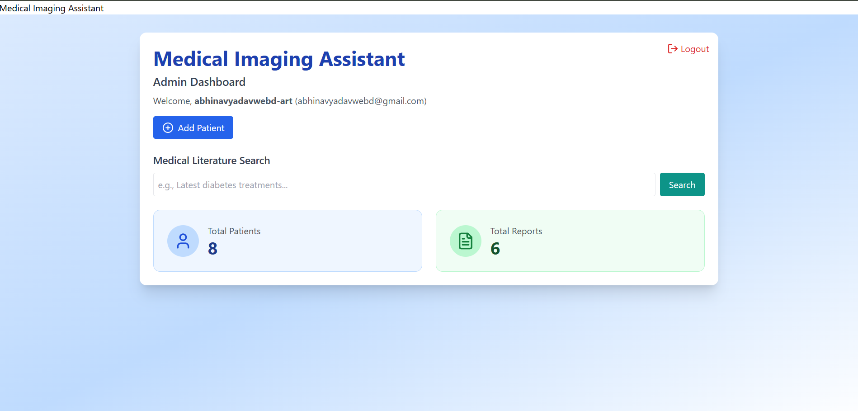

# Security Features

Security is meticulously implemented across multiple layers to protect user data and ensure system integrity. The platform employs JWT-based token authentication for secure session management, complemented by role-based access controls that restrict access to critical routes. CORS policies facilitate safe communication between the frontend and backend, while input validation using Pydantic models prevents malicious data entry. Additionally, OAuth integration ensures trusted identity login, providing a robust defense against unauthorized access.

# Future Scope

The platform holds significant potential for future enhancements that could further elevate its utility. Planned developments include the introduction of agentbased AI interaction for advanced questionanswering capabilities, a real-time DICOM viewer with enhanced annotation support, and a dockerized deployment with CI/CD integration for streamlined updates. Audit logging is also envisioned to ensure medical compliance and traceability, positioning the platform as a leader in radiology automation.

# Team and Credits

This platform was skillfully developed by Abhinav, whose dedication has brought this vision to life. The project leverages a range of tools and platforms, including VS Code for development, GitHub for version control, FastAPI and PostgreSQL for the backend, and OpenAI API, Google Gemini.