Sif Islam

Database Systems CSci 126 (Fresno State)

Prof. David Ruby

Date: 05/05/2017

*A database management system for Fresno Hospital*

This database is built to work with any hospital system. Currently we will work with a Fresno hospital as a part of initial implementation. Please remember, that this is not a final database system, it has the potential to grow into a vast database system. Thus, more and more features can easily be added to it, and it is not limited to its current capabilities. This database will currently take care of the basic requirement of a general hospital system. I will be able to keep records of wards, doctors, nurses, patients, diagnosis that patient receives, payment made by patients, appointments by patients and many others.

**Part 1. Entities in Fresno Hospital Domain Description**

* Ward
* Employee
  + Doctor
  + Nurse
* Research Lab
* Patient
* Admitted patient
* Appointment
* Diagnosis
* Payment

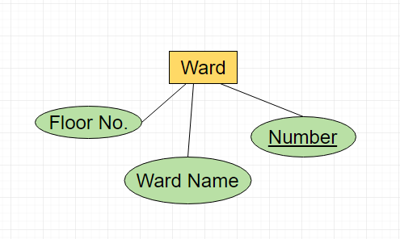

Ward Domain

* Entity Set: Wards
* Entity: Ward
* Attributes: A ward has…
  + Number (Primary key)
  + Floor No.
  + Ward name

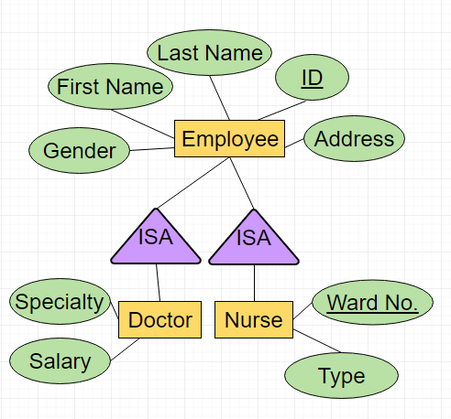Employee Domain

* Entity Set: Employees
* Entity: Employee
* Attributes: An Employee has…
  + ID (Primary key)
  + First Name
  + Last Name
  + Gender
  + Address

Doctor Domain

* Attributes: A Doctor has all employee attributes plus
  + Specialty
  + Salary

Nurse Domain

* Attributes: A Nurse has all employee attributes plus
  + Specialty
  + Ward No. (Foreign key)

Research Lab Domain

* 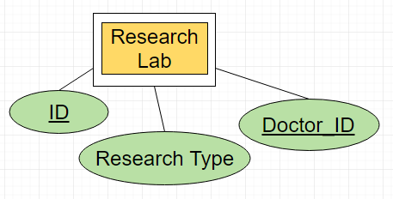Entity Set: Research labs
* Entity: Research lab
* Attributes: A Research lab has…
  + ID (Primary key)
  + Research Type
  + Doctor_ID (Foreign key)

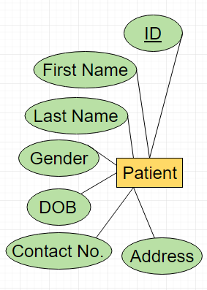Patient Domain

* Entity Set: Patients
* Entity: Patient
* Attributes: A Patient has…
  + ID (Primary key)
  + First Name
  + Last Name
  + Gender
  + DOB
  + Contact No.
  + Address

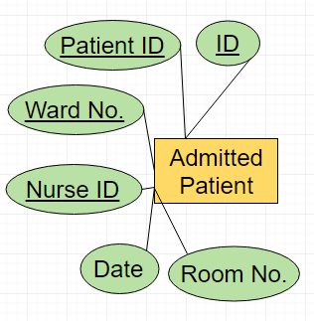Admitted Patient Domain

* Entity Set: Admitted Patients
* Entity: Admitted Patient
* Attributes: An Admitted has…
  + ID (Primary key)
  + Patient ID (Foreign Key)
  + Nurse ID (Foreign Key)
  + Date
  + Room No.

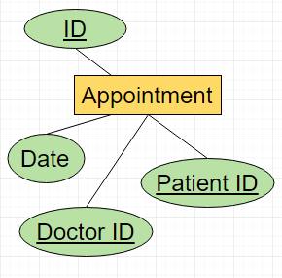Appointment Domain

* Entity Set: Appointments
* Entity: Appointment
* Attributes: An Appointment has…
  + ID (Primary key)
  + Patient ID (Foreign Key)
  + Doctor ID (Foreign Key)
  + Date

Diagnosis Domain

* Entity Set: Diagnosis
* Entity: Diagnosis
* Attributes: A Diagnosis has…
  + ID (Primary key)
  + Patient ID (Foreign Key)
  + Doctor ID (Foreign Key)
  + Date

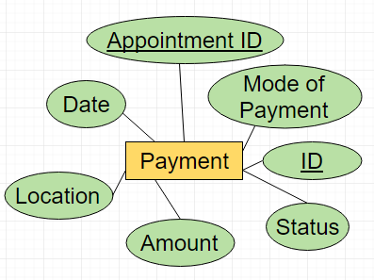Payment Domain

* Entity Set: Payments
* Entity: Payment
* Attributes: A Payment has…
  + ID (Primary key)
  + Appointment ID (Foreign Key)
  + Mode of Payment
  + Status
  + Amount
  + Location
  + Date

**Part 2. Database Design**

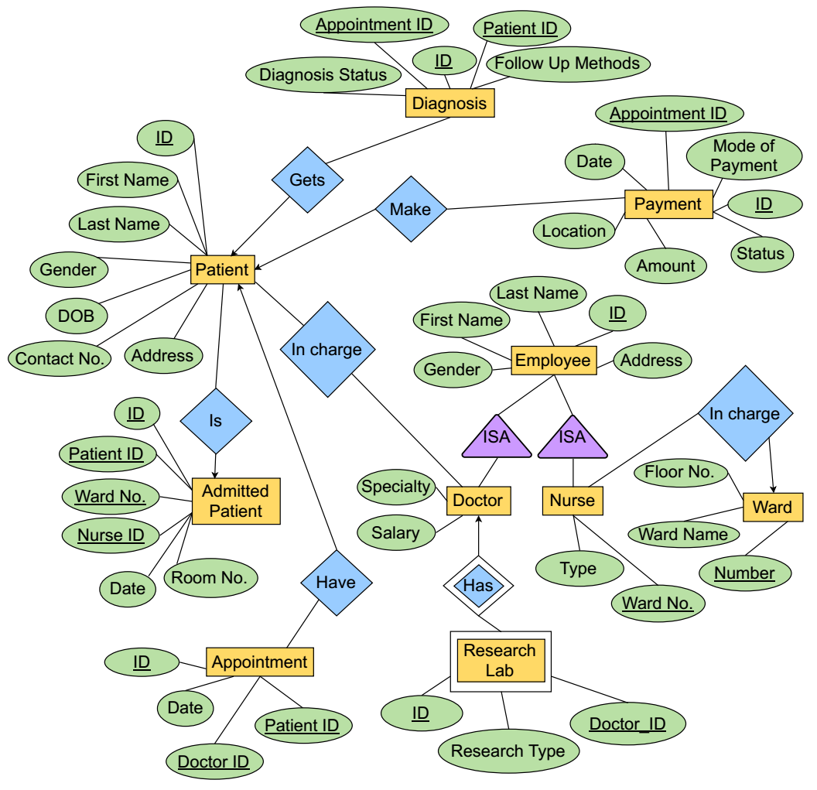

Relationships:

|  |  |  |  |
| --- | --- | --- | --- |
| **Domain 1** | **Domain 2** | **Relationship** | **Note** |
| Nurse | Ward | One-to-many | One ward can have multiple nurse, but one nurse can only belong to a single ward |
| Patient | Diagnosis | One-to-many | One patient can have multiple diagnosis |
| Patient | Payment | One-to-many | One patient can have multiple payments |
| Patient | Admitted Patient | One-to-one | One patient cannot have multiple admission at a time |
| Patient | Appointment | One-to-many | One patient can have multiple appointments |
| Doctor | Patient | Many-to-many | One patient can have multiple doctors, and one doctor can also have multiple patients |
| Doctor | Research Lab | Weak-Entity Set | Doctors may belong to a research lab |

**Part 3: Database Schema/Normal Forms**

Ward Domain will have the following SQL INSERT statement

CREATE TABLE Ward(

Ward_No VARCHAR(8) NOT NULL PRIMARY KEY,

Ward_Name VARCHAR(20) NOT NULL,

Floor_No VARCHAR(1) NOT NULL

);

Sample looks like this:

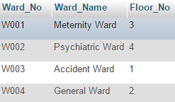

The schema is **free** from violations for:

– 3rd Normal form (all column depends on Ward_No column)

– Boyce-Codd Normal Form (All function dependencies have a key on the left-hand side)

– 4th Normal Form (there are no multi value dependencies)

Doctor Domain will have the following SQL INSERT statement

CREATE TABLE Doctor(

Doctor_ID VARCHAR(8) NOT NULL PRIMARY KEY,

Doctor_First_Name VARCHAR(20) NOT NULL,

Doctor_Last_Name VARCHAR(20) NOT NULL,

Doctor_Gender VARCHAR(1) NOT NULL,

Doctor_Specialty VARCHAR(20) NOT NULL,

Doctor_Address VARCHAR(20) NOT NULL,

Doctor_Salary VARCHAR(10) NOT NULL

);

Sample looks like this:

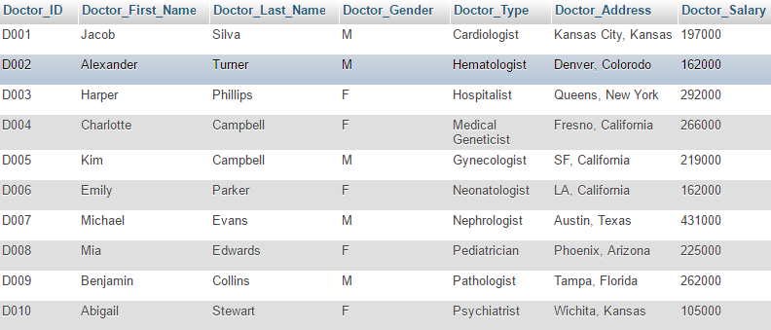

The schema is **free** from violations for:

– 3rd Normal form (all column depends on Doctor_ID column)

– Boyce-Codd Normal Form (All function dependencies have a key on the left-hand side)

– 4th Normal Form (there are no multi value dependencies)

Nurse Domain will have the following SQL INSERT statement

CREATE TABLE Nurse(

Nurse_ID VARCHAR(8) NOT NULL PRIMARY KEY,

Nurse_First_Name VARCHAR(20) NOT NULL,

Nurse_Last_Name VARCHAR(20) NOT NULL,

Nurse_Gender VARCHAR(1) NOT NULL,

Ward_No VARCHAR(8) NOT NULL,

Nurse_Type Varchar(20),

FOREIGN KEY (Ward_No) REFERENCES Ward(Ward_No)

)

Sample looks like this:

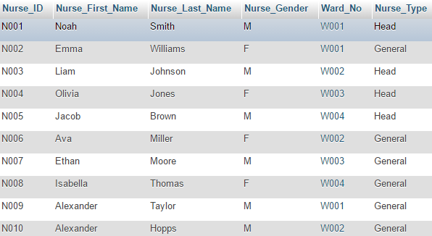

The schema is **free** from violations for:

– 3rd Normal form (all column depends on Doctor_ID column)

– Boyce-Codd Normal Form (All function dependencies have a key on the left-hand side)

The schema is a violation for:

– 4th Normal Form (Column Nurse_Type has multi value dependencies)

Patient Domain will have the following SQL INSERT statement

CREATE TABLE Patient(

Patient_ID VARCHAR(8) NOT NULL PRIMARY KEY,

Patient_First_Name VARCHAR(20) NOT NULL,

Patient_Last_Name VARCHAR(20) NOT NULL,

Patient_Gender VARCHAR(1) NOT NULL,

Patient_Date_Of_Birth DATE NOT NULL,

Patient_Address VARCHAR(20) NOT NULL,

Patient_Contact_No VARCHAR(24) NOT NULL

);

Sample looks like this:

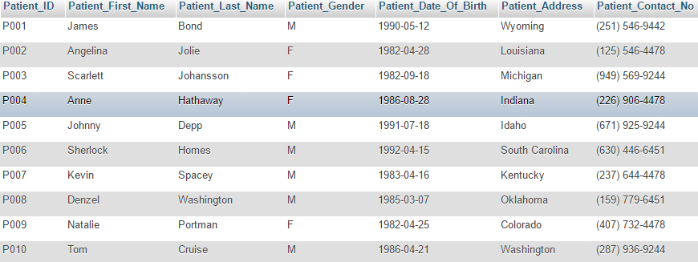

The schema is **free** from violations for:

– 3rd Normal form (all column depends on Patient_ID column)

– Boyce-Codd Normal Form (All function dependencies have a key on the left-hand side)

– 4th Normal Form (there are no multi value dependencies)

Admitted Patient Domain will have the following SQL INSERT statement

CREATE TABLE Admitted_Patient(

Admitted_ID VARCHAR(8) NOT NULL PRIMARY KEY,

Patient_ID VARCHAR(8) NOT NULL,

Ward_No VARCHAR(8) NOT NULL,

Nurse_ID VARCHAR(8) NOT NULL,

Admitted_Date_Time DATETIME NOT NULL,

Room_No VARCHAR(20) NOT NULL,

FOREIGN KEY (Patient_ID) REFERENCES Patient(Patient_ID),

FOREIGN KEY (Ward_No) REFERENCES Ward(Ward_No),

FOREIGN KEY (Nurse_ID) REFERENCES Nurse(Nurse_ID)

)

Sample looks like this:

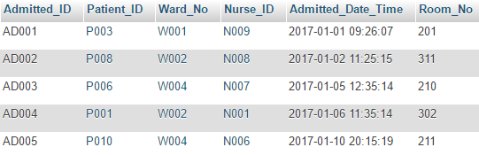

The schema is **free** from violations for:

– 3rd Normal form (all column depends on Admitted_ID column)

– Boyce-Codd Normal Form (All function dependencies have a key on the left-hand side)

– 4th Normal Form (there are no multi value dependencies)

Appointment Domain will have the following SQL INSERT statement

CREATE TABLE Appointment(

Appointment_ID VARCHAR(8) NOT NULL PRIMARY KEY,

Patient_ID VARCHAR(8) NOT NULL,

Doctor_ID VARCHAR(8) NOT NULL,

Appointment_Date_Time DATETIME NOT NULL,

FOREIGN KEY (Doctor_ID) REFERENCES Doctor(Doctor_ID),

FOREIGN KEY (Patient_ID) REFERENCES Patient(Patient_ID)

);

Sample looks like this:

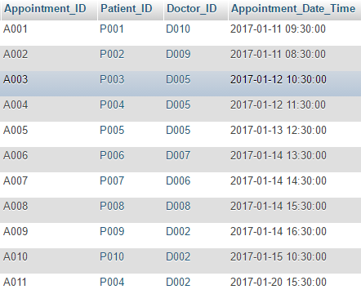

The schema is **free** from violations for:

– 3rd Normal form (all column depends on Appointment_ID column)

– Boyce-Codd Normal Form (All function dependencies have a key on the left-hand side)

– 4th Normal Form (there are no multi value dependencies)

Diagnosis Domain will have the following SQL INSERT statement

CREATE TABLE Diagnosis(

Diagnosis_ID VARCHAR(8) NOT NULL PRIMARY KEY,

Appointment_ID VARCHAR(8) NOT NULL,

Patient_ID VARCHAR(8) NOT NULL,

Diagnosis_Status VARCHAR(50) NOT NULL,

Follow_Up_Methods VARCHAR(50) NOT NULL,

FOREIGN KEY (Appointment_ID) REFERENCES Appointment(Appointment_ID),

FOREIGN KEY (Patient_ID) REFERENCES Patient(Patient_ID)

);

Sample looks like this:

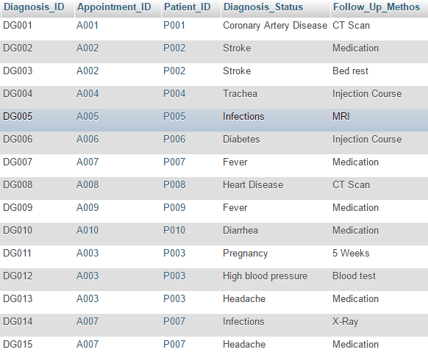

The schema is **free** from violations for:

– 3rd Normal form (all column depends on Diagnosis_ID column)

– Boyce-Codd Normal Form (All function dependencies have a key on the left-hand side)

– 4th Normal Form (there are no multi value dependencies)

NOTE: Though Diagnosis_Status column and Follow_Up_Methodes column have some data that are common, but these fields are text (comment) fields, they can contain anything, nothing (null value) or duplicates.

Payment Domain will have the following SQL INSERT statement

CREATE TABLE Payment(

Payment_ID VARCHAR(8) NOT NULL PRIMARY KEY,

Appointment_ID VARCHAR(8) NOT NULL,

Mode_Of_Payment VARCHAR(20) NOT NULL,

Payment_Date_Time DATETIME NOT NULL,

Payment_Status VARCHAR(20) NOT NULL,

Payment_Location VARCHAR(20) NOT NULL,

Amount INT NOT NULL,

FOREIGN KEY (Appoinment_ID) REFERENCES Appointment(Appointment_ID)

);

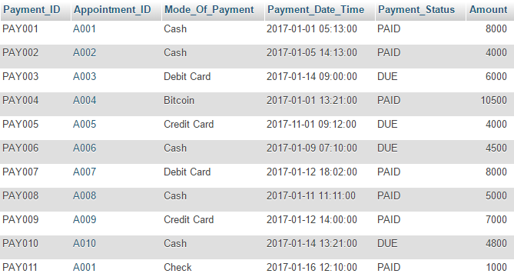

The schema is **free** from violations for:

– 3rd Normal form (all column depends on Payment_ID column)

– Boyce-Codd Normal Form (All function dependencies have a key on the left-hand side)

The schema is a violation for:

– 4th Normal Form (Column Mode_Of_Payment and Payment_Status has multi value dependencies)

Research Lab Domain will have the following SQL INSERT statement

CREATE TABLE Research_Lab(

Research_ID VARCHAR(8) NOT NULL PRIMARY KEY,

Doctor_ID VARCHAR(8) NOT NULL,

Research_Type VARCHAR(20) NOT NULL,

FOREIGN KEY (Doctor_ID) REFERENCES Doctor(Doctor_ID)

);

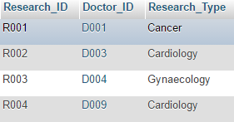

The schema is **free** from violations for:

– 3rd Normal form (all column depends on Research_ID column)

– Boyce-Codd Normal Form (All function dependencies have a key on the left-hand side)

– 4th Normal Form (there are no multi value dependencies)

**Part 4: Queries**

1. A sample select query

**- find a patient by address**

SELECT *

FROM Patient

WHERE Patient_Address='South Carolina';

Result:



2. A sample select query with AND clause

**- find a specific doctor**

SELECT *

FROM Doctor

WHERE Doctor_Gender='M' AND Doctor_Last_Name='Campbell';



3. A sample select query with build in SQL function “DATEDIFF”

**- find appointment in a given date**

SELECT *

FROM Appointment

WHERE DATEDIFF(Appointment_Date_Time, '2017-01-14')=0

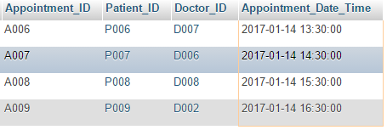

4. A sample Query with subquery

**- find the phone number of female patients who are suffering from strokes**

SELECT Patient_Contact_No

FROM Patient

WHERE Patient_ID IN

( SELECT Patient_ID

FROM Diagnosis

WHERE Diagnosis_Status like('Stroke')

)

AND Patient_Gender like('F');



5. A sample Insert Query

**- create a new appointment**

INSERT INTO Appointment VALUES

('A011','P004','D002','2017-01-20 15:30:00');

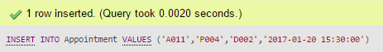

6. A sample Update Query

**- update the address of a given patient**

UPDATE Patient

SET Patient_Address='Wyoming'

WHERE Patient_First_Name ='James' AND Patient_Last_Name='Bond';

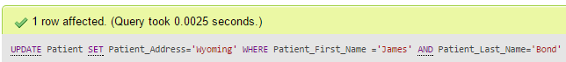

7. A more advanced select Query

**- find assigned doctors for a selected patient, and his salary**

SELECT Doctor_First_Name, Doctor_Last_Name, Doctor_Salary

FROM Appointment a, Doctor d

WHERE

d.Doctor_ID = a.Doctor_ID

AND

a.Patient_ID =

(

SELECT Patient_ID FROM Patient

WHERE Patient_First_Name= 'Scarlett'

AND Patient_Last_Name= 'Johansson'

)

;



8. Another more advanced select Query

**- find number of upcoming appointments between dates**

SELECT count(Appointment_ID) AS Appointments_Upcomming

FROM Appointment

WHERE Appointment_Date_Time

BETWEEN '2017-01-14 00:00:00'

AND '2017-01-15 23:59:00';



9. Another more advanced select Query with Aggregation

**- find total amount paid by a single patient**

SELECT SUM(Amount) AS Total_Amount_Paid_By_James_Bond

FROM Payment p, Appointment a

WHERE

a.Appointment_ID = p.Appointment_ID

AND

a.Patient_ID = (

SELECT Patient_ID FROM Patient

WHERE Patient_First_Name = 'James'

AND Patient_Last_Name = 'Bond'

);



10. Another more advanced select Query with Subquery and Order by clause

**- find patient with appointment that listed ‘fever’ as their illness**

SELECT Patient_First_Name, Patient_Last_Name

FROM Patient

WHERE Patient_ID IN

(SELECT Patient_ID FROM Appointment WHERE Appointment_ID IN

(SELECT Appointment_ID

FROM Diagnosis

WHERE Diagnosis_Status='Fever')

)

ORDER BY Patient_ID;

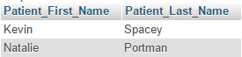

11. Query with Count clause

**- find number of nurse assigned for each ward**

SELECT Ward_No, COUNT(*) AS Nurse_Count

FROM Nurse

GROUP BY Ward_No

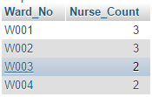

12. Query with Subquery

**- find nurses in a certain ward with patients in it**

SELECT Nurse_First_Name, Nurse_Last_Name

FROM Nurse

WHERE Nurse_ID IN (

SELECT Nurse_ID FROM Admitted_Patient

WHERE Ward_No='W001'

);



13. Another Query with Aggregation

**- find maximum payment received by the hospital by a single patient**

SELECT Mode_Of_Payment, Amount AS Max_Payment_Made_By_Patient

FROM Payment

WHERE Amount=(SELECT MAX(Amount) FROM Payment);



14. Query with Subquery and Aggregation

**- count the number of mail patient that are currently admitted in the hospital**

SELECT COUNT(Admitted_ID) AS Male_Patient_COUNT

FROM Admitted_Patient

WHERE Patient_ID IN(

SELECT Patient_ID FROM Patient

WHERE Patient_Gender='M'

);



15. Query with NOT IN clause

**- Find free nurses**

SELECT Nurse_First_Name, Nurse_Last_Name, Ward_No

FROM Nurse

WHERE Nurse_ID NOT IN (SELECT Nurse_ID FROM Admitted_Patient);

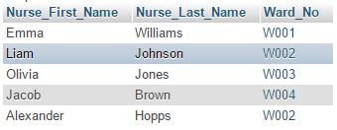

16. An advanced DISTINCT Query with Order by clause

**- Find doctors who are treating ‘Diabetes’**

SELECT DISTINCT doc.Doctor_ID, Doctor_First_Name, Doctor_Last_Name

FROM Doctor doc, Appointment a, Diagnosis dig

WHERE doc.Doctor_ID = a.Doctor_ID

AND dig.Diagnosis_Status = 'Diabetes'

AND dig.Appointment_ID = a.Appointment_ID

ORDER BY Doctor_ID;



17. Delete Query

**- remove an appointment**

DELETE FROM Appointment

WHERE Patient_ID='P004' AND Doctor_ID='D002';

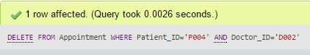

18. Insert Query (add multiple appointments)

**- create multiple appointments at the same time**

INSERT INTO Appointment VALUES

('A011', 'P001', 'D004', '2017-01-26 10:00:00'),

('A012', 'P001', 'D005', '2017-01-23 11:00:00'),

('A013', 'P005', 'D005', '2017-01-25 12:00:00');

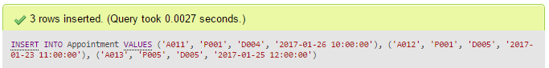

19. Verifying Insert Query

**[Appointment count for Patient P001 is now 3]**

SELECT Patient_ID, COUNT(*) AS Appointment_Count

FROM Appointment

GROUP BY Patient_ID;

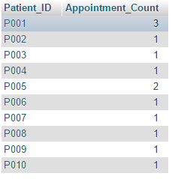

20. Select Query with HAVING keyword

**- find Doctors who have multiple appointments**

SELECT Doctor_ID,COUNT(Appointment_ID) AS Appointment_Count

FROM Appointment

GROUP BY Doctor_ID

HAVING COUNT(Appointment_ID) >= 2;

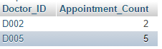

**Part 5: Application/Use Cases**

This database management system is designed to work with any hospital system. It has all the basic requirements to manage Doctors, Nurse, Patients. Including assigning nurses to specific wards and assigning doctors to patients. Doctors are also allowed to have their own (optional) research labs. This system also has the appointment scheduling and payment system build into it. Once a patient is admitted to the hospital, doctors can assign appropriate diagnosis methods that suits the patient.

As mentioned earlier, this is an open-end system, modifications are welcome. Thus, it has the room to grow big and bigger. And once this database grows to its potential, it can not only be used by a hospital system but in variety of other systems. People can perform research based on this database. For example, they can calculate the average cost of a patient visiting a hospital in a certain area, thus enabling them to compare and contrast this data to make a table/graph for some project or paper. This is just one small example; this database is not limited to calculating payments. Not only humans, but AI like IBM Watson can use this database to gather knowledge about the diagnosis of patients and increase its knowledge base allowing it to be more aware. One example for Watson would be to calculate the main type of illness that people get in a certain area. Later, Watson can use this data to determine diagnosis not only based on a person’s health but also taking the factor of patient’s location, which a real doctor might overlook. These few example proves that this system can be used for border range of tasks, including maintaining a hospital. It will grow bigger, and help may in the process.

Thank you