Image steganography using segmentation

Abhinav Chauhan
Department of Computer Science and Engineering
Manipal University Jaipur
Jaipur, Rajasthan, India.
28aanchalabhinav@gmail.com

Abstract— Nowadays multimedia messages have become the backbone of communication over internet so security of data is must before transmission of data over network. This paper presents hybrid approach of securing image i.e., combining image segmentation and steganography. Firstly, the image will be divided into blocks using some segmentation algorithm which is then hided into cover image using steganography. Experimental results of projects are also attached. Here segmentation of data is used and then steganography is used for hiding the segmented data in carrier file of some type like image, providing 2 level of security. This project intends to work on splitting and merging of image combined with steganography, its uses and techniques.
Keywords- Segmentation, Cryptography, Steganography

- INTRODUCTION

Cryptography [1] is a technique through which we convert plain text into cipher text and then cipher text is again converted into plain text. Plain text is a normal message which can be read and understood by anyone for e.g. “My name is Abhinav Chauhan” whereas cipher text is kind of a secret message which anyone can read but can’t understand. This process objective is to gain confidentiality of data. Three main concepts of network security are CIA (Confidentiality, Integrity & Availability). Fig 1 shows concept of cryptography. With the help of cryptography, we can send our messages over unsecured channel without worrying about confidentiality.

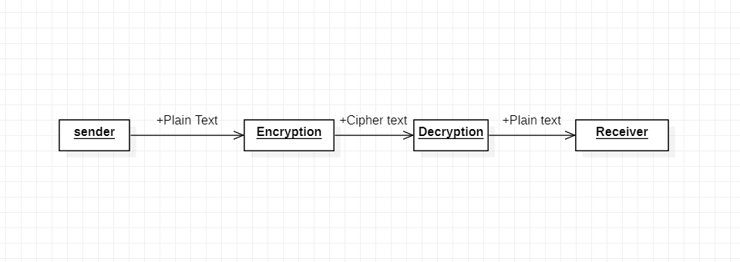

Fig 1

Steganography [2] works on the concept of hiding messages rather than encrypting it. Unlike cryptography steganography changes the existence of data rather than changing the meaning of data. Basic concept of steganography is covered writing. It is the practise of concealing messages/file/image (i.e., any type of information) within another file, message or image/video. Later the information is extracted at its destination. Fig 2 shows concept of steganography.

Sender
Embedding
Extracting
Receiver

Stego-key

Fig.2

This paper proposes hybrid approach for image security. First, the image is divided into blocks via split and merge algorithm and then the segmented image is embedded in a cover image in order to provide 2 level security to our data. Later first the splitting image is extracted and then reconstruction is done in order to get our secret image.

- LITERATURE REVIEW

Split and merge segmentation is used for image processing in which image is successively divided into quadrants or independent tiles based on a homogenous criterion and similar regions are merged to create the segmented result.. In [3] high efficiency Split-Merge based block portioning is used in which image is divided into small independent blocks and later reconstructed in order to get an original image. Fig 3 shows block diagram of split and merge segmentation.

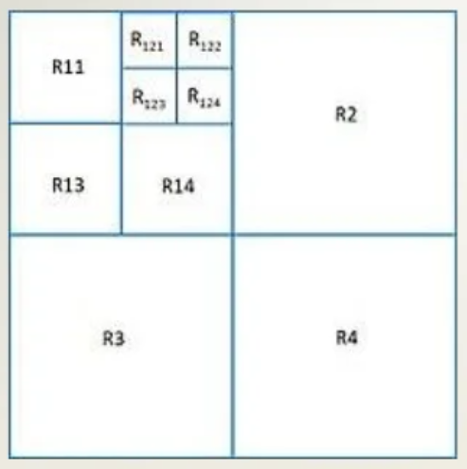
Fig. 3
Digital watermarking is the process of hiding information that can be in the form of text or data within image which can serve many purposes such as hiding sensitive information or be it content integrity or content protection. In [4] combination of LSB substitution method (which is substitution of least significant bits of the cover image with the most significant bit of the secret image) and DCT (Direct Cosine Transformation) is used. This method was used to check the duality of the watermark present in an image. We can use DCT and DWT for our image compression as a part of digital watermarking by analyzing [5] I came to know how DCT, and DWT works under different circumstances and for my implementation I chose to use DCT since this algorithm minimizes appearance of block like visualization
Of our image via blocking artifact and we are providing block like inputs to our cover image.

DCT [6] works in way that we take some data, in this case our image data and we try to represent it as the sum of lot of cosine waves that goes between 1 and -1 as shown in Fig 4.

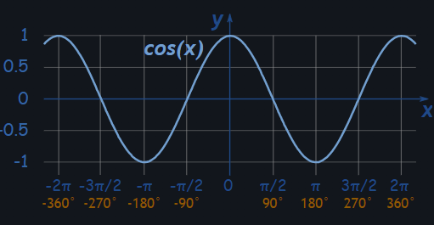
Fig. 4

As we increase the numbers of possible shapes of waves that we can produce we can generate required image, so each wave represents a small constituent of output. The way that the mathematics works is if we have a signal that is 8 bit long then we find it way to represent using 8 cosine waves of different frequencies.
In JPEG, we split each image into 8X8 pixel, groups and each of these pixel groups is separately encoded with its own discrete cosine transform. Each of those 8X8 groups can be exactly replicated by 64. In [7] a combination of scrambling and steaganography is used thus giving me overview that these two concepts can be combined to give two level security to our image.

- PROPOSED TECHNIQUE

Initially the secret image is divided into independent blocks using image segmentation technique and then the processed image is embedded into cover image using digital watermarking. The flow of the proposed technique (embedding) is shown in Fig. 5.
The algorithm for proposed technique is as follow -:
      - Input Secret Image
      - Segmentation of cover image into independent blocks
      - Input Cover Image
      - Embedding segmented image into cover image using cosine transformation.
      - Extracting watermarked image using inverse discrete cosine transformations.
      - Performing reconstruction of the segmented image
      - Getting cover image

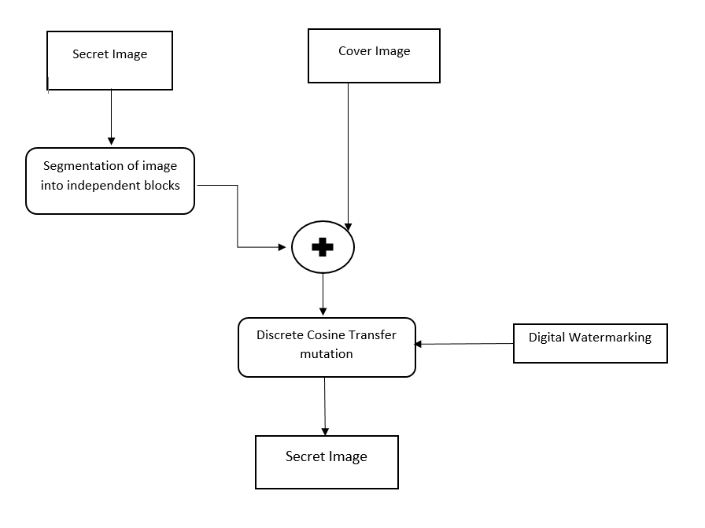
Figure. 5

The Fig. 6 shows how the secret image is extracted from the embedded image and reconstructed using reconstruction algorithm. The results of the following approach are attached in the results section.

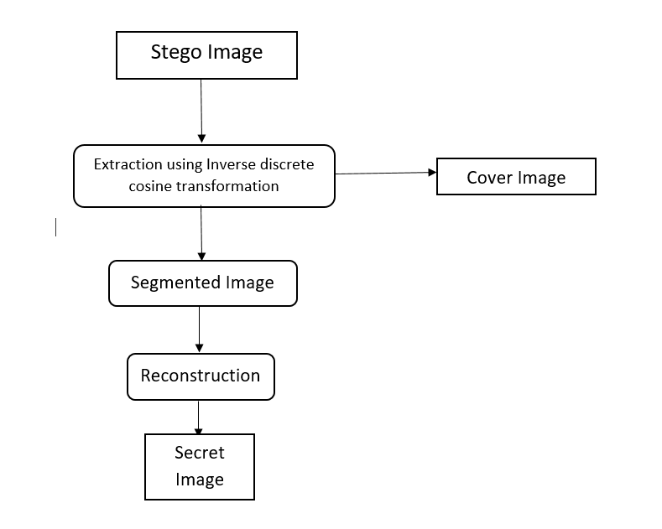
Figure. 6

- RESULTS

In this section output of the above-mentioned technique are attached. The following technique was implemented on MATLAB R2021 B version. Images of size 256X256 were used for the following implementation.
Figure 7 shows the cover image and secret image

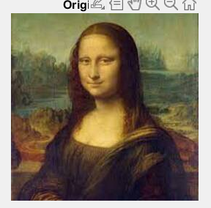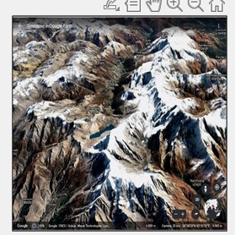
A . Cover Image B. Secret Image

Figure. 7

Figure 8 shows output of secret image after going through segmentation algorithm and Figure 9 shows our embedded image.

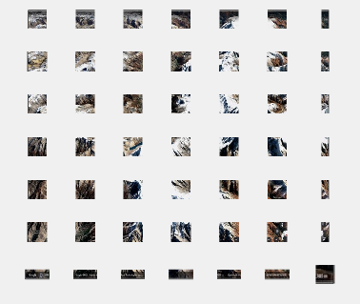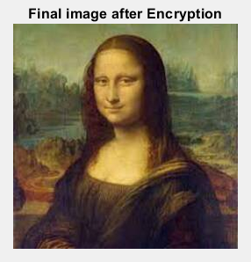

Figure 8 Figure 9

Figure 10 shows our final cover image that we got after reconstruction of segmented image that we extracted from embedded image. The difference between original and encrypted image and original cover image and cover image that we got after processing are shown since there is no visible difference, we can say that proposed technique yielded good results.

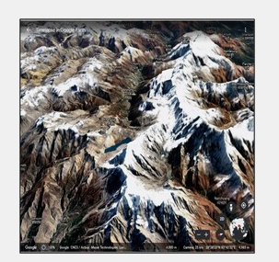

Figure. 9

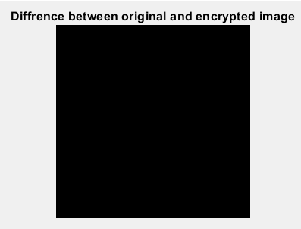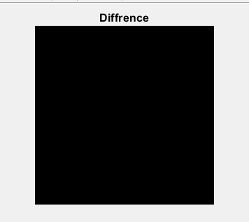

Figure. 10

Comparison using different numeric parameters such as PSNR (Peak signal to noise ratio) & MSE (Mean Square Error) [8], NCC (Normalized cross-correlation) [9], AD (Average difference) and SC (structural contents) [10] is shown below.
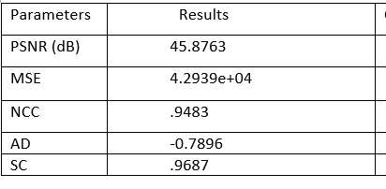

From the table it is observed that the values of SC and NCC values are ranging from .94 to .96, achieved value of PSNR is 45.8763, very high value of MSE and low value of AD which shows good quality of stego image.

- CONCLUSION

The proposed technique provides good level of security to our secret image as it has gone under two level encryption process. It is observed that the difference between the original and encrypted image is negligible. Moreover, high values of SC, NCC, MSE and low values of PSNR & AD so it can be concluded that proposed system is a good crypto system.

References:

[1] J. Saturwar and D. N. Chaudhari, "Secure visual secret sharing scheme for color images using visual cryptography and digital watermarking," 2017 Second International Conference on Electrical, Computer and Communication Technologies (ICECCT), 2017, pp. 1-4, doi: 10.1109/ICECCT.2017.8117849.
[2] N. Manohar and P. V. Kumar, "Data Encryption & Decryption Using Steganography," 2020 4th International Conference on Intelligent Computing and Control Systems (ICICCS), 2020, pp. 697-702, doi: 10.1109/ICICCS48265.2020.9120935.
[3] B. -D. Choi and S. -J. Ko, "Split-and-Merge-Based Block Partitioning for High Efficiency Image Coding," in IEEE Transactions on Circuits and Systems for Video Technology, vol. 28, no. 2, pp. 540-549, Feb. 2018, doi: 10.1109/TCSVT.2016.2615498.
[4] E. Mathur and M. Mathuria, "Unbreakable digital watermarking using combination of LSB and DCT," 2017 International conference of Electronics, Communication and Aerospace Technology (ICECA), 2017, pp. 351-354, doi: 10.1109/ICECA.2017.8212832.
[5] E. Elharar, A. Stern, O. Hadar and B. Javidi, "A Hybrid Compression Method for Integral Images Using Discrete Wavelet Transform and Discrete Cosine Transform," in Journal of Display Technology, vol. 3, no. 3, pp. 321-325, Sept. 2007, doi: 10.1109/JDT.2007.900915.
[6] B. Rajesh, M. Javed, Ratnesh and S. Srivastava, "DCT-CompCNN: A Novel Image Classification Network Using JPEG Compressed DCT Coefficients," 2019 IEEE Conference on Information and Communication Technology, 2019, pp. 1-6, doi: 10.1109/CICT48419.2019.9066242.
[7] V. k. sharma, R. Jaya Krishna, A. Singh and V. S. Rathore, "Secure Data Hiding Technique using Secret Image Scrambling," 2020 4th International Conference on Electronics, Communication and Aerospace Technology (ICECA), 2020, pp. 831-836, doi: 10.1109/ICECA49313.2020.9297456.
[8] K. Joshi, R. Yadav and S. Allwadhi, "PSNR and MSE based investigation of LSB," 2016 International Conference on Computational Techniques in Information and Communication Technologies (ICCTICT), 2016, pp. 280-285, doi: 10.1109/ICCTICT.2016.7514593.
[9] A. Parsayan, S. Poursajadi and S. Karimifar, "Scene matching NCC value improvement based on contrast matching," 2013 8th Iranian Conference on Machine Vision and Image Processing (MVIP), 2013, pp. 296-299, doi: 10.1109/IranianMVIP.2013.6779998.
[10] Y. Chen, K. Qin, S. Gan and T. Wu, "Structural Feature Modeling of High-Resolution Remote Sensing Images Using Directional Spatial Correlation," in IEEE Geoscience and Remote Sensing Letters, vol. 11, no. 10, pp. 1727-1731, Oct. 2014, doi: 10.1109/LGRS.2014.2306972.

