**Project Management Office Dashboard**

A

Major Project (CC4270) Report

Submitted in the partial fulfillment of the requirement for the award of

Bachelor of Technology

in

Computer and Communication Engineering

By:

**Abhinav Chauhan**

**199303085**

**CCE-B**

Under the supervision of:

**Dr. Vijay Shankar Sharma**

**Type of Project: External**



July 2023



Department of Computer and Communication Engineering

School of Computer and Communication Engineering Manipal University Jaipur

VPO. Dehmi Kalan, Jaipur, Rajasthan, India – 303007

Department of Computer and Communication Engineering

School of Computer and Communication Engineering, Manipal University Jaipur, Dehmi Kalan, Jaipur, Rajasthan, India- 303007

**STUDENT DECLARATION**

*I hereby declare that this project* ***Project Management Office Dashboard*** *is my own work and that, to the best of my knowledge and belief, it contains no material previously published or written by another person nor material which has been accepted for the award of any other degree or diploma of the University or other Institute, except where due acknowledgements has been made in the text.*

|  |  |
| --- | --- |
| Place: Jaipur | **Abhinav Chauhan** |
| Date: | (1993033085) |
|  | B.Tech (CCE) 8th Semester |

i

Department of Computer and Communication Engineering

School of Computer and Communication Engineering, Manipal University Jaipur, Dehmi Kalan, Jaipur, Rajasthan, India- 303007

Date: 11th July 2023

**CERTIFICATE FROM SUPERVISOR**

*This is to certify that the work entitled “****Project Management Office Dashboard.”*** *submitted by* ***Abhinav Chauhan*** *(199303085) to* ***Manipal University Jaipur*** *for the award of the degree of* ***Bachelor of Technology*** *in* ***Computer and Communication Engineering*** *is a bonafide record of the work carried out by him under my supervision and guidance from 10th January 2023 to 10th July 2023.*

**Dr. Vijay Shankar Sharma (MUJ)**

*Internal Supervisor,*

*Department of Computer and Communication Engineering*

*Manipal University Jaipur*

ii

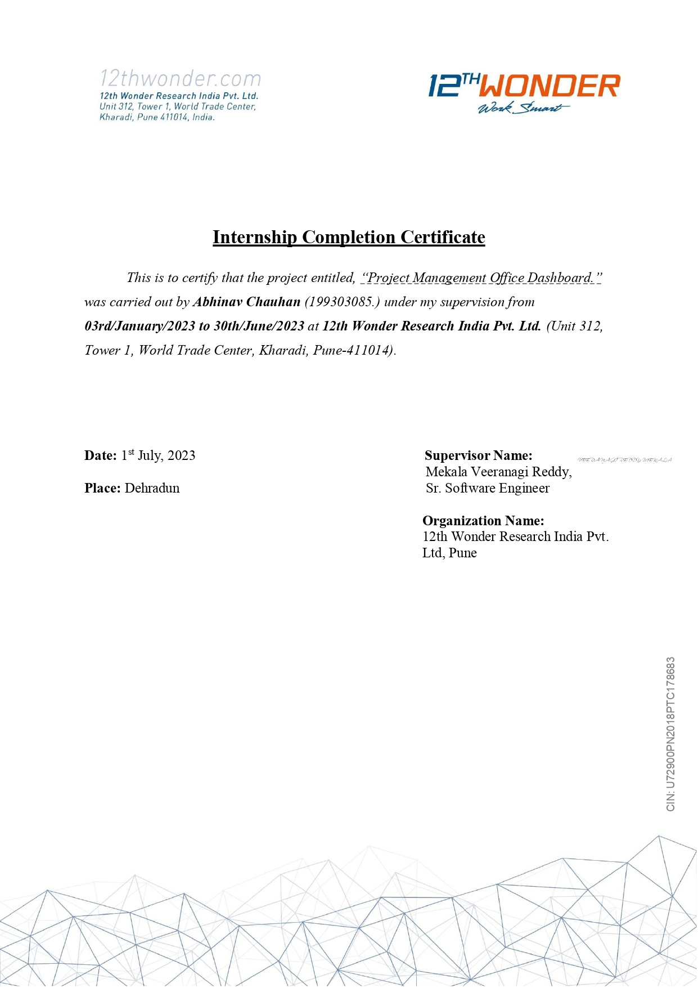

iii

**ACKNOWLEDGEMENT**

I would like to express my sincere gratitude and appreciation to all those who have contributed to the successful completion of this project and report.

First and foremost, I would like to extend my heartfelt thanks to my supervisor Mr. Veera Nagi Reddy Mekala, for his guidance, support, and valuable insights throughout the entire project. His expertise and mentorship have been invaluable in shaping this report and enhancing my understanding of project management and data analysis.

I would also like to thank the entire team at 12th Wonder Research India Pvt. Ltd. for their cooperation and collaboration. Their contributions in providing the necessary data, insights, and feedback have been instrumental in the development of the Project Management Office (PMO) Dashboard.

I am deeply grateful to everyone who participated in user testing and provided valuable feedback, helping us refine and improve the dashboard. Their willingness to engage and share their experiences has been essential in ensuring the usability and effectiveness of the dashboard.

I extend my appreciation to the authors of the various documentations and online resources that I have referenced throughout this report. Their work has provided a strong foundation for the theoretical and practical aspects of project management, data analysis, and visualization techniques.

I would also like to acknowledge the support and encouragement received from my family and friends. Their unwavering belief in my abilities and their continuous support have been a source of motivation and inspiration throughout this project.

Without the contributions and support of all these individuals and organizations, this project would not have been possible. I am truly grateful for their involvement and would like to express my deepest appreciation for their invaluable contributions.

Thank you all once again for your support, guidance, and encouragement.

iv

**ABSTRACT**

The Project Management Office (PMO) Dashboard is a powerful data visualization and analysis tool developed using Power BI. This report presents the design and implementation of the PMO Dashboard, which aims to provide project managers and stakeholders with a comprehensive view of project performance, resource utilization, and overall project health. The project involved the extraction and integration of data from a Postgres database, followed by a thorough data cleaning and modeling process. The PMO Dashboard offers valuable insights by presenting the data in an intuitive and interactive manner.

The Key features of the PMO Dashboard include the ability to track project hours, assess resource capacity and utilization, monitor resource productivity, and analyze project timelines, and track resource leave and billing information.

The PMO Dashboard incorporates user-friendly features such as color coding, interactive filters, and intuitive visualizations to enhance usability and facilitate data interpretation.

The report also highlights the integration of Power Automate for automated report notifications, ensuring timely updates for managers and stakeholders. The project faced challenges in data integration and user feedback implementation, which provided valuable insights and lessons learned.

In conclusion, the PMO Dashboard empowers project managers and stakeholders with a comprehensive and real-time view of project performance, resource utilization, and project health. Its user-friendly interface and interactive features make it an invaluable tool for effective project management and decision-making.

v

**TABLE OF CONTENTS**

|  |  |  |  |  |  |  |
| --- | --- | --- | --- | --- | --- | --- |
| Student declaration | | | | | | i |
| Certificate from Supervisor | | | | | | ii |
| Internship Completion Certificate | | | | | | iii |
| Acknowledgement | | | | | | iv |
| Abstract | | | | | | v |
| List of Figures | | | | | | vi |
| Chapter 1: Introduction | | | | | | 1 |
| 1.1 | Overview | | | | |  |
| 1.2 | Purpose & Objectives | | | | |  |
| 1.3 | Scope & Limitations | | | | |  |
|  | 1.3.1 | | | Scope | |  |
|  | 1.3.2 | | | Limitation | |  |
| Chapter 2: Methodology | | | | | | 3 |
| 2.1 | Overview of Data Analysis Approach | | | | | |
|  | 2.1.1 | | | | Data Extraction |  |
|  | 2.1.2 | | | | Data Cleaning & Preparation |  |
|  | 2.1.3 | | | | Data Modelling & Relationship Establishment |  |
|  | 2.1.4 | | | | Data Transformation & Aggregation |  |
|  | 2.1.5 | | | | Visualization & Dashboard Creation |  |
|  | 2.1.6 | | | | Data Interpretation & Analysis |  |
|  | 2.1.7 | | | | Iterative Refinement |  |
| 2.2 | Power BI: Empowering Data Visualization & Analysis | | | | |  |
| 2.3 | Harnessing the Power of DAX for Advanced Data Calculations & Manipulation | | | | |  |
| Chapter 3: Comprehensive Project Analysis and Insights | | | | | | 6 |
| 3.1 | Overview | | | | |  |
| 3.2 | Hours Tracker | | | | |  |
| 3.3 | Capacity Tracker | | | | |  |
| 3.4 | Resource Utilization Tracker | | | | |  |
| 3.5 | Demanded Hours Dashboard | | | | |  |
| 3.6 | Billing Tracker | | | | |  |
| 3.7 | Task Wise Health Tracker | | | | |  |
| Chapter 4: Power Automate Integration | | | | | | 8 |
| 4.1 | | | Uses & Processes | | |  |
| Chapter 5: User Experience & Design Considerations | | | | | |  |
| 5.1 | | Uses & Processes | | | |  |

vi

|  |  |  |
| --- | --- | --- |
| Chapter 6: Result & Achievements | | 20 |
| 6.1 | Results |  |
| Chapter 7: Challenges & Key Takeaways | |  |
| 7.1 | Findings & Insights |  |
| Chapter 8 : Conclusion | | 27 |
| Chapter 9: References | | 29 |

vii

**LIST OF FIGURES**

|  |  |  |
| --- | --- | --- |
| **Figure** | **Figure Title** | **Page No.** |
| **No.** |  |  |
| 1 | Project Wise Hours Spent | 11 |
| 2 | Resource Wise Hours Spent | 11 |
| 3 | Date Wise Hours Spent | 12 |
| 4 | Date Wise Hours Spent (Drill Down) | 12 |
| 5 | Summary Table | 13 |
| 6 | Slicer Filters | 13 |
| 7 | Project Wise Resource | 14 |
| 8 | Resource Wise Hours with Capacity | 15 |
| 9 | Project by Hours | 15 |
| 10 | Resource Wise Hours | 16 |
| 11 | Slicer Filter | 16 |
| 12 | Matrix | 25 |
| 13 | Slicer Filter | 25 |
| 14 | Count of Categorized Demanded Hours | 26 |
| 15 | Categorized Demanded Hours by Date |  |
| 16 | Summary Table |  |
| 17 | Summary Table |  |
| 18 | Slicer Filters |  |
| 19 | Matrix |  |
| 20 | Slicer Filters |  |
| 21 | Task by Type |  |
| 22 | Task by Priority |  |
| 23 | Task Wise State Health |  |
| 24 | Summary Table |  |
| 25 | Power Automate Flow |  |
| 26 | Power Automate Email Notification |  |

viii

**Chapter: 1**

**INTRODUCTION**

**1.1 Overview**

In the realm of project management, effective monitoring and control of projects are crucial for successful outcomes. To address this need, a comprehensive project management dashboard was developed as part of an internship project. This dashboard, built using Power BI, aims to provide project managers and stakeholders with valuable insights into project performance, resource utilization, and overall project health.

The internship project focused on creating a Project Management Office (PMO) Dashboard that would empower project managers to make informed decisions based on accurate and timely data. By leveraging the capabilities of Power BI, the dashboard offers a user-friendly interface for visualizing and analyzing project-related information. This introduction provides an overview of the project, highlighting its objectives and methodologies. The internship project involved extracting data from a Postgres database and implementing a rigorous data cleaning and modeling process to ensure data accuracy and reliability. Subsequently, relationships were established to facilitate effective data analysis and visualization. The PMO Dashboard encompasses various features designed to enhance project management practices. It enables tracking of project hours, assessment of resource capacity and utilization, monitoring of resource productivity, analysis of project timelines, and tracking of resource leave and billing information. The dashboard incorporates intuitive visualizations, interactive filters, and color coding to improve user experience and facilitate data interpretation.

Furthermore, the integration of Power Automate was implemented to automate report notifications and ensure timely updates for project managers and stakeholders. This streamlines the communication process and enables proactive decision-making based on the insights provided by the PMO Dashboard. Throughout the project, challenges were encountered, including data integration complexities and addressing user feedback. Valuable lessons were learned from these challenges, leading to recommendations for future enhancements and improvements. In conclusion, this project management dashboard serves as a valuable tool for project managers and stakeholders to gain comprehensive insights into project performance, resource utilization, and project health. The subsequent sections of this document will provide a detailed analysis of the specific components of the dashboard, showcasing its effectiveness in supporting data-driven decision-making and enhancing project management practices.

**1.2 Purpose & Objectives:**

The purpose of this project is to develop and implement a Project Management Office (PMO) Dashboard using Power BI, with the aim of enhancing project management practices and improving decision-making within the organization.

The PMO Dashboard serves as a centralized platform that provides project managers, stakeholders, and team members with valuable insights and real-time data to effectively monitor, analyze, and track project progress, resource utilization, and key performance indicators.

The primary objectives of the PMO Dashboard project are as follows:

1. Consolidate Project Data: The PMO Dashboard aims to centralize project-related data from various sources, including task management systems, time tracking tools, and resource allocation systems. By integrating data into a single platform, project managers can have a comprehensive and holistic view of project performance, resource utilization, and other critical project metrics.
2. Improve Data Analysis and Visualization: The project aims to leverage the power of Power BI to analyze and visualize project data in an intuitive and interactive manner. By creating visually appealing reports, charts, and dashboards, project managers can quickly identify trends, patterns, and anomalies, allowing for informed decision-making and proactive management.
3. Enhance Resource Utilization: The PMO Dashboard seeks to provide project managers with insights into resource allocation and utilization. By monitoring the capacity and workload of team members, project managers can make informed decisions regarding resource allocation, ensure optimal utilization, and identify potential bottlenecks or over/under-utilization issues.
4. Enable Real-time Tracking and Monitoring: With the PMO Dashboard, project managers can track project progress and key milestones in real-time. By visualizing task status, deadlines, and dependencies, project managers can identify potential delays, bottlenecks, or areas that require immediate attention. Real-time monitoring enables proactive management and timely decision-making to ensure projects stay on track.
5. Facilitate Collaboration and Communication: The PMO Dashboard aims to foster collaboration and communication among project stakeholders and team members. By providing a centralized platform for sharing project updates, documents, and insights, the dashboard promotes transparency, aligns project goals, and enables effective communication across the organization.
6. Streamline Workflow Processes: The integration of Power Automate with the PMO Dashboard allows for automation of repetitive tasks, such as report distribution, data updates, and notifications. By automating these processes, project managers can save time, reduce manual effort, and improve overall workflow efficiency.

By achieving these objectives, the PMO Dashboard project aims to transform project management practices within the organization. It empowers project managers with valuable data-driven insights, enhances resource utilization, facilitates effective collaboration, and streamlines workflow processes. The successful implementation of the PMO Dashboard will contribute to improved project outcomes, timely decision-making, and increased organizational efficiency.

**1.3 Scope & Limitations:**

**1.3.1 Scope:**

The scope of the Project Management Office (PMO) Dashboard project encompasses the development and implementation of a comprehensive dashboard using Power BI to support project management processes within the organization. The project focuses on the integration of data from various sources, including task management systems, time tracking tools, and resource allocation systems, to provide project managers with a centralized platform for monitoring, analyzing, and tracking project progress, resource utilization, and key performance indicators.

The PMO Dashboard includes a range of reports and dashboards, such as the Hours Tracker, Capacity Tracker, Resource Utilization Tracker, Demanded Hours Dashboard, Task Wise Health Tracker, and Billing Tracker. These reports enable project managers to gain insights into project timelines, resource allocation, task progress, leave management, and project health. The dashboard also incorporates features for filtering data, drilling down into details, and generating custom reports.

The development of the PMO Dashboard involves data modeling and analysis using Power BI's capabilities, including data cleansing, transformation, and visualization. The project team will leverage DAX (Data Analysis Expressions) to create calculated measures, KPIs, and custom calculations to enhance the analysis and reporting capabilities of the dashboard. Power Automate will be integrated to automate report distribution and streamline workflow processes.

**1.3.2 Limitations:**

While the PMO Dashboard project aims to enhance project management practices, there are certain limitations to be aware of:

1. Data Availability and Quality: The effectiveness of the PMO Dashboard relies on the availability and quality of data from the integrated sources. Incomplete or inaccurate data can impact the accuracy and reliability of the reports and dashboards generated. Efforts will be made to address data quality issues during the data cleaning and transformation process, but limitations in the source systems may still impact the overall data quality.
2. Technical Constraints: The PMO Dashboard project is subject to technical constraints, including the limitations of the Power BI platform and the availability of data connectors for integration with external systems. Certain features or functionalities desired by project stakeholders may require further customization or development beyond the project scope.
3. User Adoption and Training: The successful utilization of the PMO Dashboard relies on user adoption and proficiency in utilizing the Power BI platform.

Adequate training and support will be provided to project managers and stakeholders to ensure they can effectively navigate the dashboard and leverage its features. However, individual user preferences, varying skill levels, and resistance to change may impact the extent to which the dashboard is adopted and utilized.

1. Security and Access Control: The PMO Dashboard will handle sensitive project-related data. Adequate security measures will be implemented to ensure data confidentiality and access control. However, it is essential to consider security risks and establish appropriate user access rights and permissions to safeguard data integrity and prevent unauthorized access.
2. Organizational Context: The PMO Dashboard project is specific to the organization and its project management practices. While efforts will be made to align the dashboard with organizational requirements, it may not fully capture the unique nuances and complexities of all projects within the organization. Customization and ongoing refinement may be necessary to adapt the dashboard to evolving organizational needs.

Despite these limitations, the PMO Dashboard project represents a significant step towards improving project management practices and enabling data-driven decision-making within the organization.

By recognizing and addressing these limitations, the project team aims to maximize the benefits and utility of the PMO Dashboard while continuously refining and enhancing its capabilities.

**Chapter: 2**

**METHODOLOGY**

**2.1 Overview of Data Analysis Approach:**

The data analysis process for the project management dashboard involved a detailed and systematic approach to transform raw data into meaningful insights. Each step of the process was carefully executed, ensuring data accuracy, integrity, and facilitating effective visualization and interpretation of project-related information.

**2.1.1 Data Extraction:**

The data analysis process began with the critical step of data extraction. This involved identifying and accessing relevant data sources within the Postgres database. The project team carefully examined the database schema and data tables to determine which information was necessary for project analysis. Through the use of appropriate SQL queries, data was retrieved and extracted, ensuring the inclusion of essential project-related details such as hours spent, resource allocation, project timelines, leave records, and billing information. Multiple data extraction techniques were employed to ensure comprehensive coverage of project data, capturing all the essential elements required for in-depth analysis.

**2.1.2 Data Cleaning & Preparation:**

Once the data was extracted, the next step involved data cleaning and preparation. This phase aimed to ensure the accuracy, consistency, and reliability of the dataset. The project team meticulously reviewed the extracted data, performing a thorough examination to identify and address any issues such as missing values, outliers, inconsistencies, and data entry errors. Various data cleaning techniques, such as data validation, data profiling, and outlier detection, were applied to enhance data quality and integrity. Additionally, data normalization, standardization, and transformation techniques were implemented to ensure consistency across different data sources and improve data compatibility for further analysis.

**2.1.3 Data Modelling & Relationship Establishment:**

Data modeling played a pivotal role in the data analysis process. The project team focused on establishing relationships among various data entities to facilitate effective data analysis and visualization. Through careful analysis of the project requirements and understanding of the database schema, key data attributes were identified, and appropriate relationships were defined. These relationships allowed project managers to correlate project hours with resources, project timelines, leave records, and other relevant factors, enabling comprehensive insights into project performance and resource utilization. The establishment of these relationships formed the foundation for insightful data analysis and visualization.

**2.1.4 Data Transformation and Aggregation:**

With the relationships established, the data underwent transformation and aggregation. This phase involved applying various data transformation techniques to derive meaningful metrics, indicators, and calculated measures for analysis. Data was transformed and aggregated at different levels of granularity, such as project, resource, task, or time period. Aggregating the data allowed project managers to examine project progress, resource utilization, and overall project health from different perspectives. Summary statistics, derived measures, and key performance indicators (KPIs) were calculated to provide valuable insights and metrics to support decision-making.

**2.1.5 Visualization and Dashboard Creation:**

Once the data was transformed and aggregated, it was time to visualize and present the findings effectively. Power BI, a powerful data visualization tool, was used to create interactive and visually appealing dashboards. The project team designed intuitive and user-friendly visualizations, incorporating a variety of charts, graphs, tables, and interactive components. Color coding, legends, and tooltips were strategically utilized to highlight important information and enable easy interpretation. Interactive features like filters, slicers, and drill-down functionality allowed users to explore the data in-depth and interact with the visualizations, empowering project managers to make informed decisions based on visual insights.

**2.1.6 Data Interpretation and Analysis:**

The visualized data served as a valuable resource for data interpretation and analysis. Project managers and stakeholders carefully examined the visualizations to identify trends, patterns, anomalies, and potential issues that required attention. They could assess resource capacity, track project timelines, monitor resource leave and billing, evaluate task progress, and determine the overall health of the projects based on predefined metrics and KPIs. Through thorough data analysis, project managers gained actionable insights into project performance, resource utilization, and areas of improvement. These insights informed decision-making, enabling proactive measures to be taken to ensure successful project delivery.

**2.1.7 Iterative Refinement:**

The data analysis process followed an iterative approach, allowing for continuous refinement and improvement of the project management dashboard. Project managers and stakeholders played an active role in providing feedback, insights, and suggestions for enhancing the dashboard's usability, effectiveness, and relevance to their specific needs. The project team incorporated these inputs into subsequent iterations of the data analysis process, refining the visualizations, improving data accuracy, addressing specific requirements or challenges, and incorporating additional features or functionalities. This iterative approach ensured that the project management dashboard evolved and adapted to the changing needs of the project and the stakeholders involved, ultimately leading to better decision-making and project outcomes.

By meticulously following the above steps of data extraction, cleaning, modeling, transformation, visualization, interpretation, and iterative refinement, the data analysis process enabled project managers to gain comprehensive insights into project performance, resource utilization, and overall project health. The robust and well-structured analysis approach facilitated informed decision-making, proactive risk mitigation, and optimized project outcomes.

**2.2 Power BI: Empowering Data Visualization and Analysis:**

Power BI, developed by Microsoft, is a powerful business intelligence and data visualization tool that played a central role in the project management dashboard. It provided the platform and capabilities to transform raw data into insightful visualizations, enabling project managers to gain valuable insights and make informed decisions.

Power BI offered a range of features and functionalities that facilitated the creation of interactive and visually appealing dashboards. With its intuitive user interface, project managers could easily connect to various data sources, including the Postgres database, and import data for analysis. The data modeling capabilities of Power BI allowed for the establishment of relationships between different data entities, enabling comprehensive analysis and cross-referencing of project-related information.

One of the key strengths of Power BI was its rich library of visualization options. Project managers could choose from a wide array of charts, graphs, tables, and other visual elements to present data in a meaningful and engaging manner. The ability to customize the appearance, color schemes, and layouts of visualizations allowed for effective communication of project insights.

Furthermore, Power BI provided interactive features that enhanced the user experience. The use of filters, slicers, and drill-down functionality enabled project managers to explore the data from different perspectives and dive deeper into specific aspects of the project. This interactivity empowered project managers to perform ad-hoc analysis and dynamically adjust the view of the dashboard based on their requirements.

Collaboration and sharing capabilities were also inherent in Power BI. Project managers could easily share the project management dashboard with team members, stakeholders, and decision-makers. They could control access levels, allowing specific individuals or groups to view and interact with the dashboard. Additionally, Power BI allowed for scheduled data refreshes, ensuring that the dashboard remained up to date with the latest project data.

Power BI also integrated well with other Microsoft tools and services, providing a seamless workflow for project managers. For example, the integration with Power Automate enabled the automation of report distribution, ensuring that reports were automatically sent to managers on a regular basis. This integration helped streamline communication and fostered a proactive approach to project management.

Overall, Power BI proved to be a valuable tool in the project management dashboard development. Its robust features, flexibility, and user-friendly interface empowered project managers to transform raw data into actionable insights, enabling them to monitor project progress, optimize resource utilization, and make data-driven decisions.

**2.3 Harnessing the Power of DAX for Advanced Data Calculations and Manipulation:**

DAX (Data Analysis Expressions) offers a range of capabilities that empower project managers to perform advanced data calculations and manipulations within Power BI. Some of the key functionalities of DAX include:

1. Aggregations and Summarizations: DAX allows project managers to perform aggregations and summarizations on their data, enabling them to calculate totals, averages, minimums, maximums, and other statistical measures. This capability provides insights into project performance, resource utilization, and other key metrics.
2. Custom Measures: With DAX, project managers can create custom measures tailored to their specific analysis requirements. These measures can involve complex calculations, such as weighted averages, growth rates, or variance calculations. Custom measures enhance the analytical capabilities of the project management dashboard and enable deeper insights into project data.
3. Time Intelligence: It includes functions specifically designed for time-based calculations. Project managers can leverage these functions to perform year-over-year comparisons, period-to-date calculations, rolling averages, and other time-related analyses. Time intelligence functions enable project managers to gain insights into project trends and performance over different time periods.
4. Calculated Tables: It allows project managers to create calculated tables based on specific calculations or filters. Calculated tables are virtual tables generated within the data model, providing project managers with additional flexibility in analyzing their data. Calculated tables can be used to create subsets of data or perform complex calculations that go beyond the original data structure.
5. Data Transformation: It enables project managers to transform and manipulate data within Power BI. It offers functions for data filtering, sorting, and grouping, allowing project managers to customize their data views. This flexibility helps project managers extract relevant insights and highlight specific aspects of the project management dashboard.
6. Conditional Calculations: It supports conditional calculations, enabling project managers to perform calculations based on specific conditions or criteria. They can use functions like IF, SWITCH, and logical operators to create dynamic calculations that adapt to changing data scenarios. Conditional calculations enhance the versatility and adaptability of the project management dashboard.
7. Cross-Table Analysis: DAX facilitates cross-table analysis by leveraging relationships established in the data model. Project managers can create calculations that span multiple related tables, enabling them to perform comprehensive analysis and gain insights from interconnected data points. Cross-table analysis provides a holistic view of project performance and enhances data-driven decision-making.

Overall, DAX empowers project managers to perform a wide range of data calculations and manipulations within Power BI. It enables advanced analysis, custom measure creation, time intelligence calculations, and flexible data transformations. With its rich set of functions and operators, DAX enhances the analytical capabilities of the project management dashboard, allowing project managers to extract valuable insights from their data and drive informed decision-making.

**Chapter: 3**

**Comprehensive Project Analysis and Insights**

**3.1 Overview:**

The project management dashboard developed using Power BI and DAX encompasses a comprehensive suite of reports and dashboards, providing project managers with an extensive range of valuable insights into various aspects of their projects. These reports and dashboards serve as powerful tools for visualizing and analyzing project data, enabling informed decision-making, proactive resource management, and effective project oversight.

**3.2 Hours Tracker:**

The Hours Tracker report stands as a cornerstone in the project management dashboard, offering project managers a detailed and granular view of the hours spent on projects and by individual resources. This report serves as a valuable resource for tracking and analyzing resource utilization, identifying trends in resource allocation, and monitoring project timelines. It facilitates the understanding of how resources are investing their time and effort, shedding light on their productivity and the distribution of their efforts across different projects. With the ability to drill down into date-wise hours spent, project managers can gain deeper insights into resource performance and identify areas where optimization is needed. Furthermore, the Hours Tracker report provides various filters that allow project managers to customize their view, including the ability to select specific timelines, task types, resource names, and projects. This flexibility empowers project managers to tailor their analysis and focus on the specific dimensions that matter most to them. To enhance usability, the report incorporates color-coding to highlight instances that require immediate attention and review from managers, ensuring efficient resource management and facilitating timely interventions.

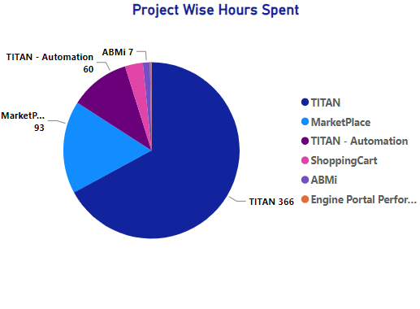

Figure 1: Project Wise Hours Spent

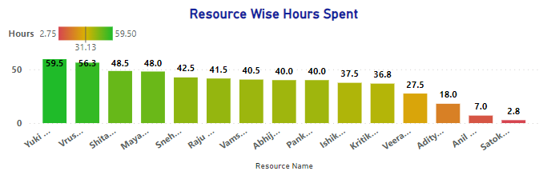

Figure 2: Resource Wise Hours Spent

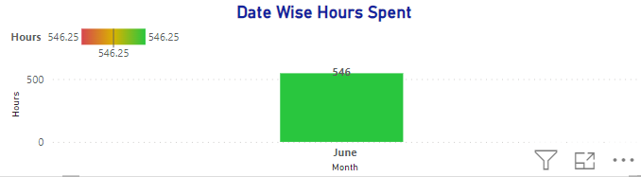

Figure 3: Date Wise Hours Spent

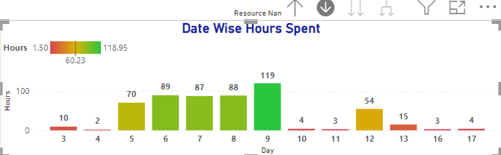

Figure 4: Date Wise Hours Spent (Drill Down)

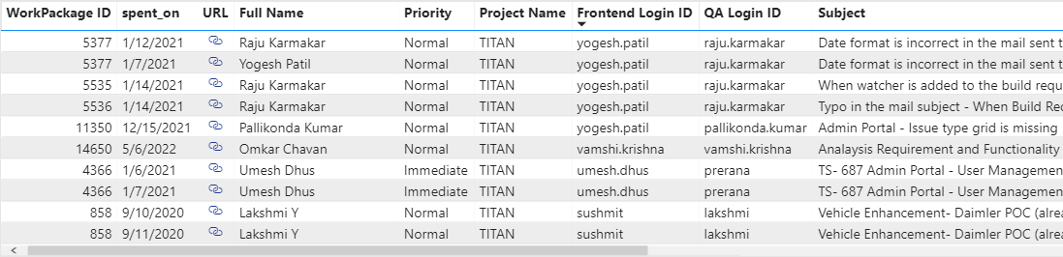

Figure 5: Summary Table

**3.3 Capacity Tracker:**

The Capacity Tracker report plays a vital role in providing project managers with a comprehensive understanding of resource capacity and allocation. By offering an insightful matrix view, this report enables project managers to evaluate whether resources are effectively utilizing their full capacity of 8 hours per day. The matrix is color-coded with a gradient, providing a visual representation of resource utilization levels. This gradient coloring allows project managers to quickly assess the level of resource utilization, with green indicating resources operating at maximum capacity and progressively transitioning to yellow, orange, and red as resource capacity decreases. Additionally, a bar graph is incorporated to provide a clear visualization of the resources that have achieved their capacity, further assisting project managers in identifying available resources for additional workload allocation. Moreover, the Capacity Tracker report provides an overview of the number of resources working on each project, facilitating workload management, balancing resource allocation, and optimizing project team composition.



Figure 6: Slicer Filters

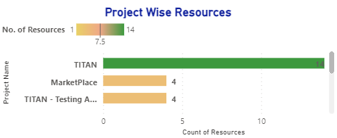

Figure 7: Project Wise Resources

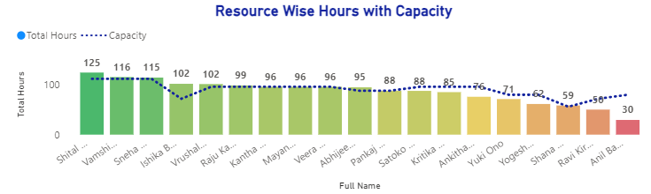

Figure 8: Resource Wise Hours with Capacity

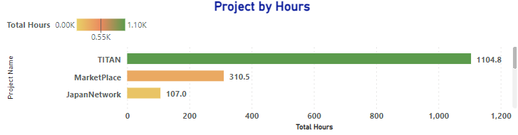

Figure 9: Project by Hours

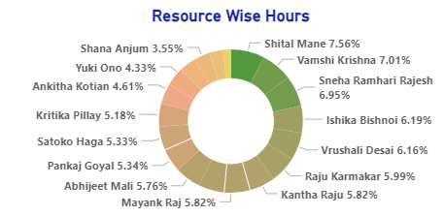

Figure 10: Resource Wise Hours

**3.4 Resource Utilization Tracker:**

The Resource Utilization Tracker report serves as a valuable tool for project managers to monitor resource availability, track their work patterns, and gain insights into their productivity. This report offers comprehensive information on resource leave status, providing project managers with a holistic view of resource availability throughout different time periods. It further enables project managers to analyze and understand the distribution of work hours on specific dates. The matrix view, utilizing a gradient color scheme, allows project managers to easily identify if resources have worked during holidays, weekdays, or weekends, aiding in tracking resource behavior and adherence to project schedules. Moreover, the Resource Utilization Tracker report provides an interactive dashboard where project managers can drill down into specific dates to view detailed tasks and the corresponding amount of time spent on each task. This level of detail enables project managers to gain deeper insights into resource productivity and task prioritization, facilitating effective resource allocation and workload balancing.



Figure 11: Slicer Filters

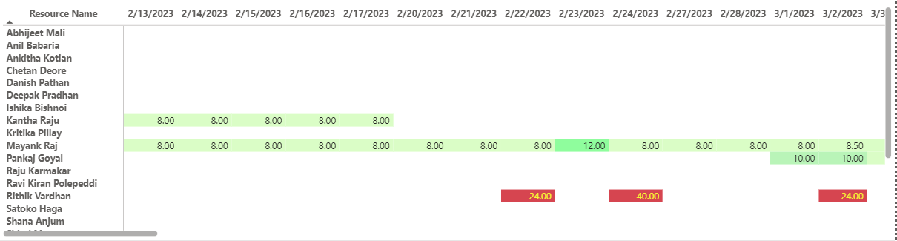

Figure 12: Matrix

**3.5 Demanded Hours Dashboard:**

The Demanded Hours Dashboard provides project managers with a comprehensive view of how many hours are demanded by each project, taking into consideration the specified start and due dates. This dashboard serves as a crucial tool for tracking project timelines, identifying potential delays, and ensuring timely project completion. By focusing on working days only, the Demanded Hours Dashboard offers insights into project progress and adherence to schedules, enabling project managers to identify projects that are on track and those that require intervention. Furthermore, the Demanded Hours Dashboard acts as an error tracker, highlighting instances where dates are not specified, resulting in negative or zero demanded hours. This serves as a reminder and encourages resources to provide accurate and complete data, promoting data integrity and reliable reporting. To enhance usability and improve the user experience, the dashboard incorporates tooltips and color-coding wherever applicable, providing intuitive visual cues and facilitating data interpretation.



Figure 13: Slicer Filters

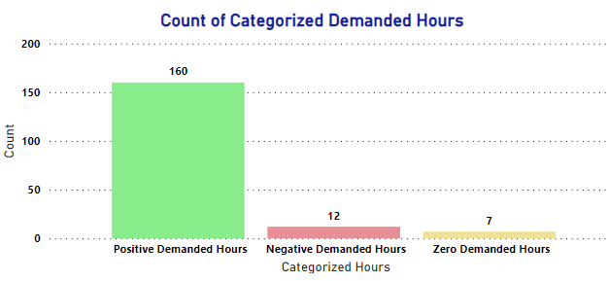

Figure 14: Count of Categorized Demanded Hours

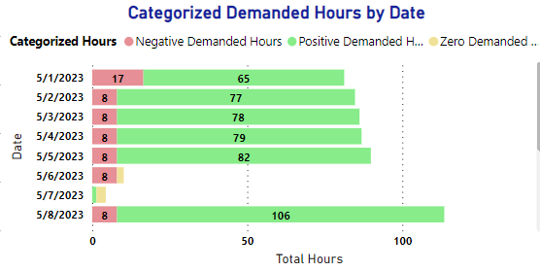

Figure 15: Categorized Demanded Hours by Date

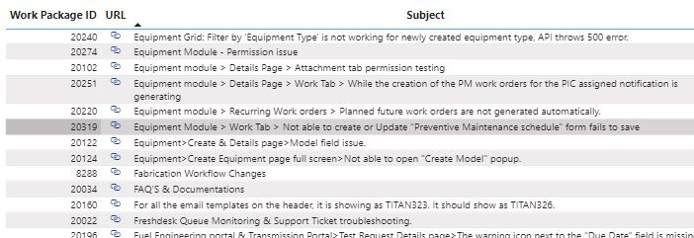

Figure 16: Summary Table

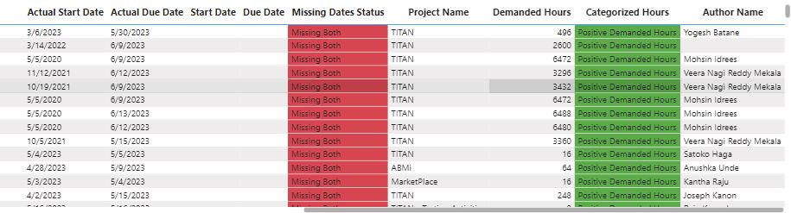

Figure 17: Summary Table

**3.6 Billing Tracker:**

The Billing Tracker report serves as a bridge between the project management dashboard and HR-based systems. By importing data from HR systems, such as Excel files, and establishing relationships with the database, this report enables project managers to gain insights into resource leave patterns and associated billing information. The Billing Tracker report provides a comprehensive overview of resource leaves categorized by type, such as paid leave, maternity leave, unpaid leave, and more. By analyzing the hours spent during leaves and distinguishing between half-day and full-day leaves, project managers can effectively monitor resource availability and plan for workload distribution accordingly. This report facilitates better resource planning, enables proactive management of resource availability, and assists in maintaining an accurate record of resource leaves.



Figure 18: Slicer Filters

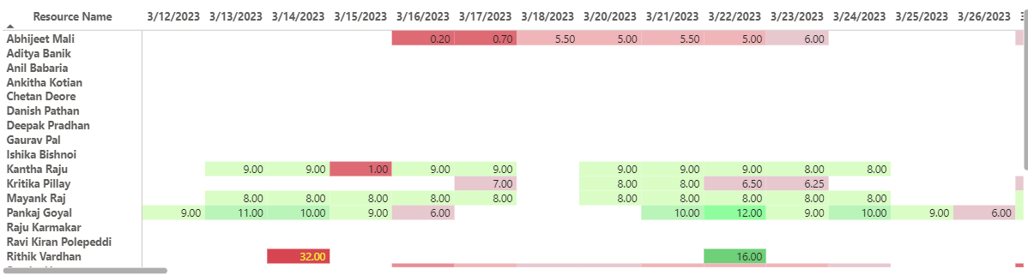

Figure 19: Matrix

**3.7 Task Wise Health Tracker:**

The Task Wise Health Tracker report offers project managers valuable insights into the health and progress of individual tasks within projects. By categorizing tasks into different categories based on their status and timelines, this report helps project managers identify potential bottlenecks, delays, and areas requiring intervention. Tasks are categorized into lagging-active, late start-proposed, and tasks in progress, providing a clear overview of task status and potential areas of concern. This classification system aids project managers in understanding the overall health of the project, identifying critical tasks, and facilitating proactive decision-making. By monitoring the health of tasks, project managers can take appropriate measures to address delays, optimize resource allocation, and ensure timely project completion.

The reports and dashboards within the project management dashboard are designed to be interactive, intuitive, and user-friendly. They empower project managers to explore and analyze project data, apply relevant filters, and extract valuable information easily. The integration of Power Automate enables automated report notifications, ensuring that project managers receive regular updates and can proactively follow up with their team members. Through the effective utilization of these reports and dashboards, project managers can enhance project visibility, optimize resource utilization, mitigate risks, and drive successful project outcomes.



Figure 20: Slicer Filters

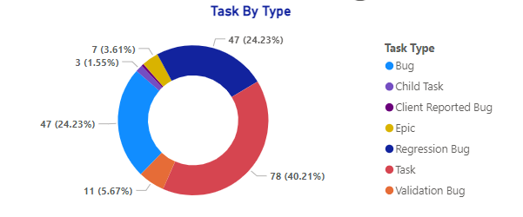

Figure 21: Task by Type

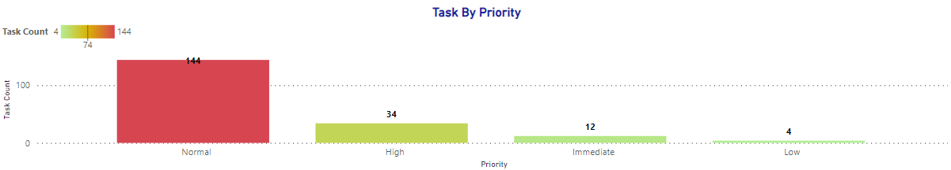

Figure 22: Task by Priority

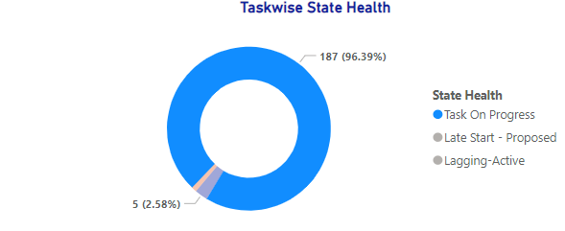

Figure 23: Taskwise State Health

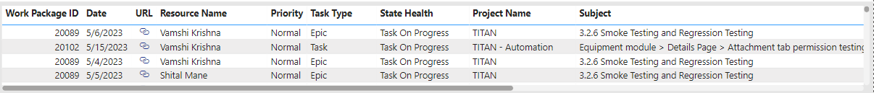

Figure 24: Summary Table

**Chapter: 4**

**Power Automate Integration**

**4.1 Uses & Process:**

In addition to the comprehensive suite of reports and dashboards, the project management dashboard incorporates seamless integration with Power Automate, a powerful workflow automation tool. This integration enhances the functionality and efficiency of the dashboard by automating various processes and enabling timely notifications and alerts.

1. Automated Report Distribution: With Power Automate, the project management dashboard enables automated report distribution to key stakeholders, including project managers, team members, and other relevant individuals. This automation eliminates the need for manual report generation and distribution, saving valuable time and ensuring that stakeholders receive the latest project updates in a timely manner. By setting up scheduled workflows, reports can be generated and sent automatically at predefined intervals, such as daily, weekly, or monthly. This automated distribution ensures that stakeholders stay informed about project progress, resource utilization, and other critical insights, promoting transparency, collaboration, and effective decision-making.
2. Proactive Notifications and Alerts: Power Automate enables the integration of proactive notifications and alerts within the project management dashboard. This functionality allows project managers to set up customized triggers and conditions based on specific events or criteria. For example, project managers can configure notifications to be sent when a project is behind schedule, a resource reaches maximum capacity, or when critical milestones are achieved. These notifications serve as timely reminders and prompts, enabling project managers to take immediate action, address potential issues, and maintain project momentum. By keeping stakeholders informed and engaged, Power Automate facilitates effective communication, fosters accountability, and supports proactive project management.
3. Workflow Automation: Power Automate empowers project managers to automate repetitive tasks and streamline workflow processes within the project management dashboard. By leveraging the wide range of connectors and pre-built templates available in Power Automate, project managers can automate data extraction, data updates, and data synchronization between different systems.

For example, project managers can automate the extraction of data from external sources, such as HR systems, financial systems, or task management tools, and integrate that data seamlessly into the project management dashboard. This automation reduces manual effort, minimizes the risk of errors, and ensures that project data is always up-to-date and accurate.

1. Custom Workflow Creation: Power Automate provides project managers with the flexibility to create custom workflows tailored to their specific needs. Using the intuitive visual interface, project managers can define triggers, actions, and conditions to automate tasks, approvals, notifications, and data updates. Whether it's creating workflows to streamline approval processes, automate data transformations, or trigger notifications based on specific events, Power Automate offers a wide range of capabilities to enhance workflow efficiency and optimize project management processes. The ability to create custom workflows empowers project managers to adapt the dashboard to their unique project requirements and organizational workflows, further improving productivity and collaboration.

By integrating Power Automate into the project management dashboard, project managers can unlock the full potential of automation, streamline processes, improve data accuracy, and enhance communication and collaboration. This integration simplifies administrative tasks, reduces manual effort, and allows project managers to focus on strategic decision-making and driving project success.

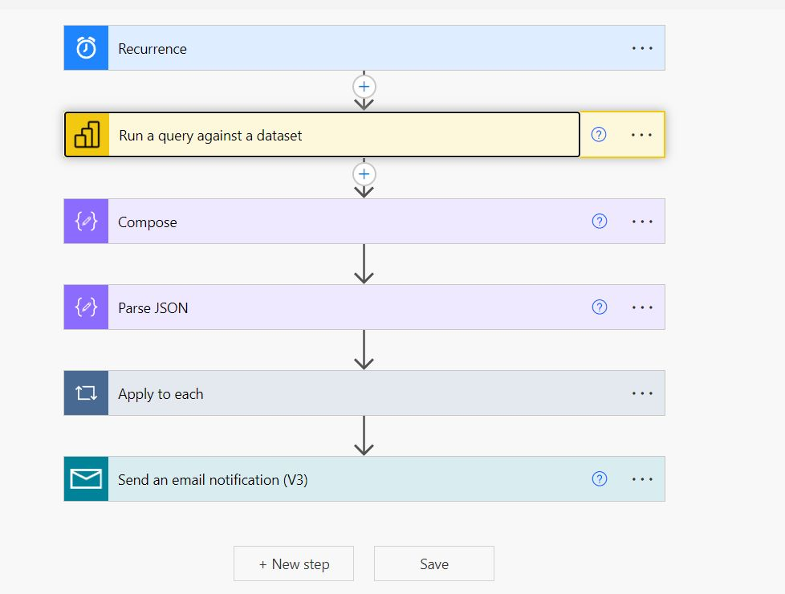

Figure 25: Power Automate Flow

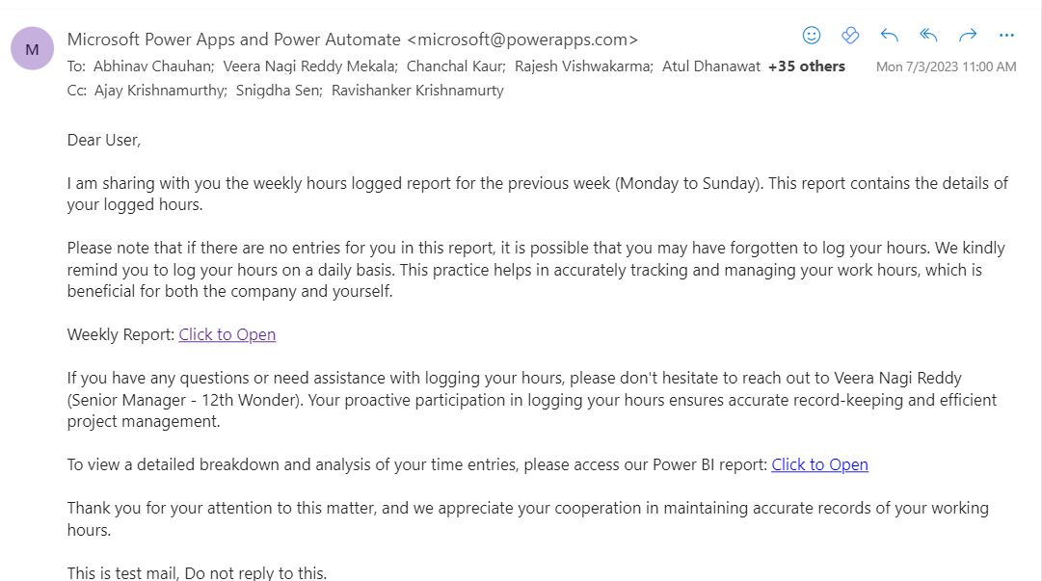

Figure 25: Power Automate Email Notification

**Chapter: 5**

**User Experience and Design Considerations**

**5.1 Uses & Process:**

When developing the project management dashboard, careful attention was given to user experience (UX) and design considerations to ensure a seamless and intuitive experience for project managers and other stakeholders. The goal was to create a visually appealing, user-friendly interface that enhances usability, promotes data comprehension, and facilitates efficient decision-making. The following design considerations were incorporated:

1. Intuitive Navigation: The project management dashboard features an intuitive navigation structure, allowing users to easily access different reports and dashboards. Clear and logical menu options, buttons, and links enable effortless navigation between various sections of the dashboard. This intuitive navigation enhances user efficiency and reduces the learning curve for new users, ensuring a smooth and seamless experience.
2. Interactive Visualizations: Visualizations within the dashboard were designed to be interactive, enabling users to explore data and gain deeper insights. Users can interact with charts, graphs, and tables to drill down into specific details, apply filters, and customize views based on their requirements. This interactivity empowers project managers to manipulate and analyze data effectively, leading to informed decision-making and improved project outcomes.
3. Consistent Design Elements: A consistent design language was applied throughout the project management dashboard, ensuring a cohesive and harmonious visual experience. Consistent color schemes, typography, and iconography were employed to provide visual cues and create a unified design. This consistency enhances usability and makes it easier for users to navigate and interpret information across different reports and dashboards.
4. Data Visualization Best Practices: Best practices for data visualization were followed to present information in a clear and meaningful way. Visual elements such as charts, graphs, and heatmaps were carefully chosen to represent data accurately and effectively. Attention was given to using appropriate chart types, color-coding, and labeling to convey information intuitively and aid comprehension. These data visualization best practices enable users to quickly grasp key insights and trends, facilitating effective decision-making.
5. Responsiveness and Accessibility: The project management dashboard was designed with responsiveness and accessibility in mind. The dashboard is responsive across different devices and screen sizes, ensuring optimal viewing and interaction experiences on desktops, laptops, tablets, and mobile devices. Additionally, accessibility features such as alt text for images, proper color contrast for text and backgrounds, and keyboard accessibility were implemented, making the dashboard usable and inclusive for all users, including those with disabilities.
6. Usability Testing and Feedback: Usability testing and feedback loops were conducted during the development process to gather insights and refine the user experience. Project managers and stakeholders were involved in the testing process, providing valuable feedback on the dashboard's functionality, ease of use, and visual clarity. Iterative improvements were made based on this feedback, resulting in an enhanced user experience that meets the specific needs and preferences of the users.

By prioritizing user experience and incorporating design considerations, the project management dashboard ensures that users can easily navigate, comprehend, and interact with the data, leading to improved productivity, better decision-making, and enhanced project management efficiency.

**Chapter: 6**

**Results and Achievements**

**6.1 Results:**

The implementation of the Project Management Office Dashboard, powered by Power BI and integrated with Power Automate, has yielded significant results and achievements, positively impacting project management processes and outcomes. The following highlights the key results and achievements obtained:

1. Enhanced Data Analysis: The Project Management Office Dashboard has revolutionized data analysis capabilities within the organization. By leveraging Power BI's robust data modeling and visualization features, project managers now have access to comprehensive and interactive reports and dashboards. These tools provide deep insights into project performance, resource utilization, task progress, and other critical project metrics. The ability to analyze data from multiple perspectives has enabled project managers to make data-driven decisions, identify bottlenecks, and optimize resource allocation, leading to improved project outcomes.
2. Improved Resource Utilization: With the Capacity Tracker and Resource Utilization Tracker reports, project managers can effectively monitor and optimize resource utilization. The Capacity Tracker report provides a clear view of resource capacity, enabling managers to identify underutilized or overloaded resources and make necessary adjustments to achieve optimal resource allocation. The Resource Utilization Tracker report offers insights into resource availability, leave status, and hours worked, facilitating efficient resource planning and reducing potential resource bottlenecks. As a result, resources are utilized more effectively, improving productivity and overall project performance.
3. Timely Project Tracking: The Hours Tracker and Task Wise Health Tracker reports have greatly improved project tracking capabilities. The Hours Tracker report provides a detailed view of hours spent on projects and tasks, allowing project managers to monitor resource productivity and identify trends. The Task Wise Health Tracker report offers a comprehensive overview of task status, helping managers identify delays, assess task health, and take proactive measures to keep projects on track. These reports enable timely project tracking, early detection of potential issues, and prompt corrective actions, resulting in improved project timelines and delivery.
4. Streamlined Workflow Automation: The integration of Power Automate has significantly streamlined workflow processes and improved operational efficiency. Automated report distribution ensures that project managers and stakeholders receive timely updates without manual intervention, saving valuable time and improving communication. Proactive notifications and alerts enable project managers to stay informed about critical events and take immediate actions as needed. Custom workflow creation facilitates automation of repetitive tasks, approvals, and data synchronization, reducing manual effort and minimizing the risk of errors. These workflow automation features have streamlined project management processes, increased productivity, and enhanced collaboration across teams.
5. Enhanced Decision-making and Collaboration: The comprehensive suite of reports and dashboards, coupled with the intuitive user experience and design considerations, has empowered project managers to make informed decisions and foster collaboration. The visualizations and interactive features enable project managers to gain actionable insights quickly and effectively communicate project status and performance to stakeholders. With access to real-time project data and visual representations, project managers can facilitate productive discussions, align stakeholders' expectations, and drive collaborative decision-making. This has resulted in improved project transparency, stronger stakeholder engagement, and better overall project outcomes.

The implementation of the Project Management Office Dashboard, along with the integration of Power Automate, has brought about significant results and achievements. It has elevated data analysis capabilities, improved resource utilization, enhanced project tracking, streamlined workflows, and fostered better decision-making and collaboration. These accomplishments have positioned the organization for more efficient and successful project management, leading to improved project outcomes and customer satisfaction.

**Chapter: 7**

**Challenges & Key Takeaways**

**7.1 Key Findings and Insights:**

Throughout the development and implementation of the Project Management Office Dashboard, several challenges were encountered, and valuable lessons were learned. These challenges and lessons have contributed to the continuous improvement of the project management processes and the effectiveness of the dashboard. The following highlights the key challenges faced and the lessons learned during the project:

1. Data Quality and Consistency: One of the primary challenges encountered was ensuring data quality and consistency across different data sources. Integrating data from various systems and databases required thorough data cleansing, validation, and transformation. The lesson learned was the importance of establishing robust data governance practices and implementing standardized data entry and maintenance procedures. Regular data audits, validation checks, and data integrity measures should be implemented to maintain data accuracy and consistency.
2. User Adoption and Training: Introducing a new project management dashboard required addressing user adoption challenges. Some team members were initially resistant to change or had limited experience with data visualization tools like Power BI. The lesson learned was the significance of providing comprehensive training and support to users. Conducting training sessions, creating user guides, and offering ongoing assistance and feedback channels helped overcome resistance and encouraged user adoption. Engaging stakeholders early in the process and addressing their concerns proactively also played a crucial role in driving user acceptance.
3. Iterative Development and Feedback Incorporation: During the development phase, it became evident that continuous iteration and feedback incorporation were vital for enhancing the dashboard's usability and functionality. The lesson learned was the importance of adopting an agile development approach. Regular feedback loops, prototype testing, and involving stakeholders in the development process allowed for timely adjustments and improvements. Embracing an iterative development mindset ensured that the dashboard evolved to meet user needs and expectations effectively.
4. Performance Optimization: As the dashboard expanded and handled larger datasets, performance optimization became a challenge. Loading and refreshing data, as well as rendering complex visualizations, required careful optimization to ensure optimal performance. The lesson learned was the significance of data modeling techniques, such as summarizing data at appropriate levels and utilizing indexing strategies. These measures helped improve query performance and enhanced the overall responsiveness of the dashboard.
5. Scalability and Future Growth: Another challenge encountered was planning for scalability and accommodating future growth. As the organization's project management needs evolved, the dashboard needed to adapt and scale accordingly. The lesson learned was the importance of designing a flexible and modular architecture that allows for seamless integration of additional data sources, new reports, and evolving requirements. Anticipating future needs and incorporating scalability considerations from the outset can save time and effort in the long run.
6. Continuous Improvement and User Feedback: An essential lesson learned throughout the project was the significance of continuous improvement based on user feedback. Regularly seeking feedback, monitoring user engagement, and conducting usability testing allowed for identifying areas of improvement and implementing necessary refinements. Incorporating user suggestions, addressing usability issues, and enhancing the overall user experience contributed to the ongoing success and adoption of the project management dashboard.

By addressing these challenges and implementing the lessons learned, the project team gained valuable insights and knowledge that will inform future projects and ensure the continuous enhancement and effectiveness of the Project Management Office Dashboard. The ability to navigate and overcome challenges and embrace lessons learned has been instrumental in creating a valuable tool for project management and driving successful project outcomes.

**Chapter: 8**

**Conclusion**

In conclusion, the development and implementation of the Project Management Office Dashboard, powered by Power BI and integrated with Power Automate, have significantly transformed project management processes and outcomes within the organization. This comprehensive dashboard has provided project managers with enhanced data analysis capabilities, improved resource utilization, streamlined workflows, and facilitated better decision-making and collaboration.

Through a rigorous data analysis process, including data extraction, cleaning, transformation, and modeling, the project team successfully harnessed the power of Power BI to create visually appealing and interactive reports and dashboards. These reports, such as the Hours Tracker, Capacity Tracker, Resource Utilization Tracker, Demanded Hours Dashboard, Task Wise Health Tracker, and Billing Tracker, have empowered project managers to gain valuable insights into project performance, resource allocation, task progress, and other critical project metrics. The integration of Power Automate has further enhanced operational efficiency by automating report distribution, enabling proactive notifications, and streamlining workflow processes.

The successful implementation of the Project Management Office Dashboard has led to notable results and achievements. Project managers can now make data-driven decisions, optimize resource allocation, and track project timelines more effectively. Resource utilization has improved, ensuring optimal capacity utilization and balanced workloads. Timely project tracking and proactive identification of potential issues have contributed to improved project timelines and delivery. The integration of Power Automate has streamlined workflow processes, saving time and reducing manual effort. The intuitive user experience and design considerations have fostered collaboration and improved stakeholder engagement.

While challenges were encountered during the project, valuable lessons were learned. These lessons include the importance of data quality and consistency, user adoption and training, iterative development, performance optimization, scalability, and continuous improvement based on user feedback. By addressing these challenges and incorporating the lessons learned, the project team has created a robust and adaptable project management tool.

In conclusion, the Project Management Office Dashboard has revolutionized project management practices within the organization. It has enabled data-driven decision-making, improved resource utilization, streamlined workflows, and fostered collaboration. The results and achievements obtained from the implementation of this dashboard position the organization for more efficient and successful project management, leading to improved project outcomes, customer satisfaction, and organizational success. The continuous enhancement and utilization of this powerful tool will undoubtedly drive future success in project management endeavors.

**Chapter: 9**

**References**

1. <https://learn.microsoft.com/en-us/dax/>
2. <https://community.fabric.microsoft.com/t5/Microsoft-Power-BI-Community/ct-p/powerbi>
3. <https://www.postgresql.org/docs/>
4. <https://developers.keka.com/docs/api-migration>
5. <https://api2.timedoctor.com/>
6. <https://learn.microsoft.com/en-us/power-automate/>