**InstaResume**

**Abhinavh Parthiban – 2022503059**

**Bose B – 2022503061**

**Activity Diagram(Including Swimlanes)**

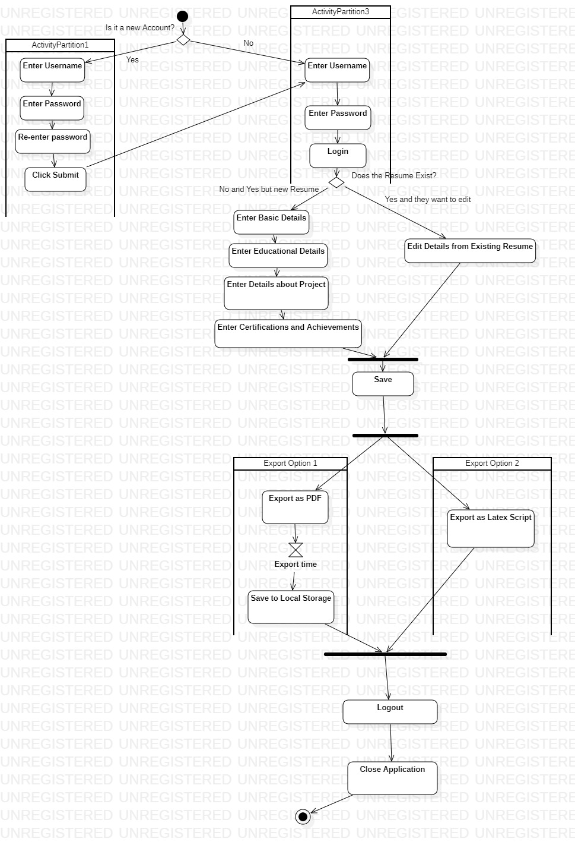

**SwimLane Diagram**

