- Make the following simulations in NS-3

Make a topology of nodes in the following way.
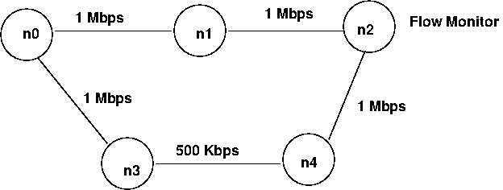
n0 starts CBR traffic at time 1.0 of rate 900 Kbps destined for n2. n0 starts another CBR traffic at time 1.5 of rate 300 Kbps destined for node n1. At time 2.0, link from n0 to n1 goes down. Use a dynamic routing protocol so that path n0-n3-n2 is used now At time 2.7, link n0-n1 comes up again. At time 3.0, CBR traffic destined for node n1 stops. CBR destined for n2 stops at time 3.5. Use a Flow monitor to monitor losses at n2. Draw a graph of percentage loss as a function of time for the duration of simulation.
Give an explanation for results you find. Compare routing if static routing was to be used.

2. Create a mesh topology of 15 nodes and implement the link-state and distance vector routing protocols (available in ns3). Study the routing table formed for each protocol and the overhead incurred. Also compare and measure the performance of routing in terms of throughput, jitter, etc for each routing protocol. Use flow monitor.

