**SQL PROGRAMMING PROJECT**

**DATABASE DESIGN  
CS6360.003  
Project--1**

**Library Management System**

**Submission:**

**Abhinav Kumar Labhishetty**

**AXL160730**

**Introduction:**A Library Management System is a system for Librarians to add borrowers and check-in or checkout, check availability of books and pay fines for late check-in of books.

**Assumptions:**Following assumptions are made in design of this Library Management System.

1. Book ids are taken from ISBN10 field provided in the CSV.
2. For the search functionality, I have assumed that when a user provides ISBN for a book the remaining fields are discarded in search query. Only title and author are included for the search for partial input. We can search by either title or author or both title and author. Partial string matching is implemented for providing efficient search results.
3. Payment of fines is assumed to be full. No partial payment of fines is accepted.
4. A user can checkout only maximum of three books at a time.
5. Update Fines does not update the fines table if there is a book that is not yet returned.
6. The digits part is 6-digit long. SSN is stored in the format ‘xxx-xx-xxxx’.

After due date a fine of $0.25 is added per day for late check-ins

**Table Layout:**

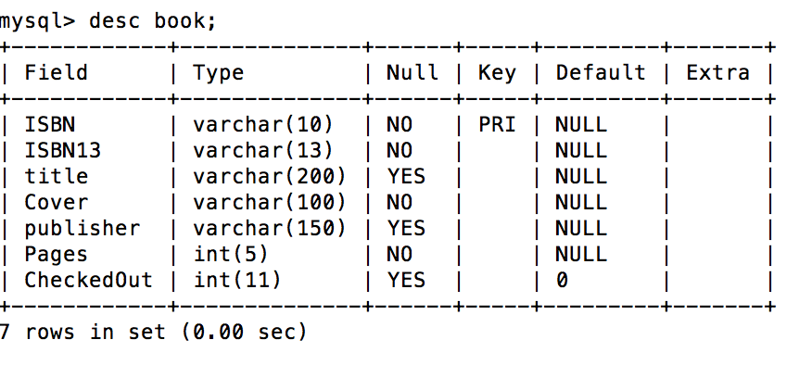

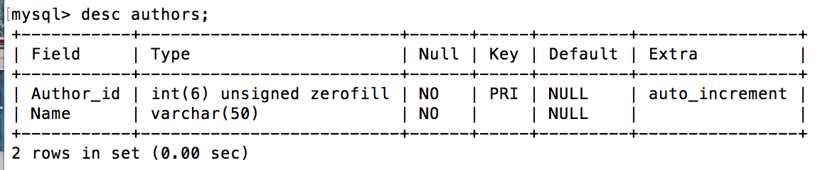

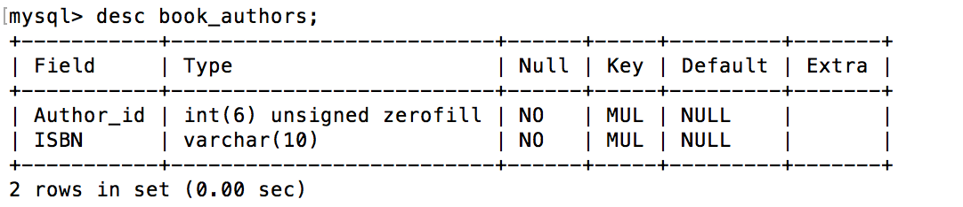

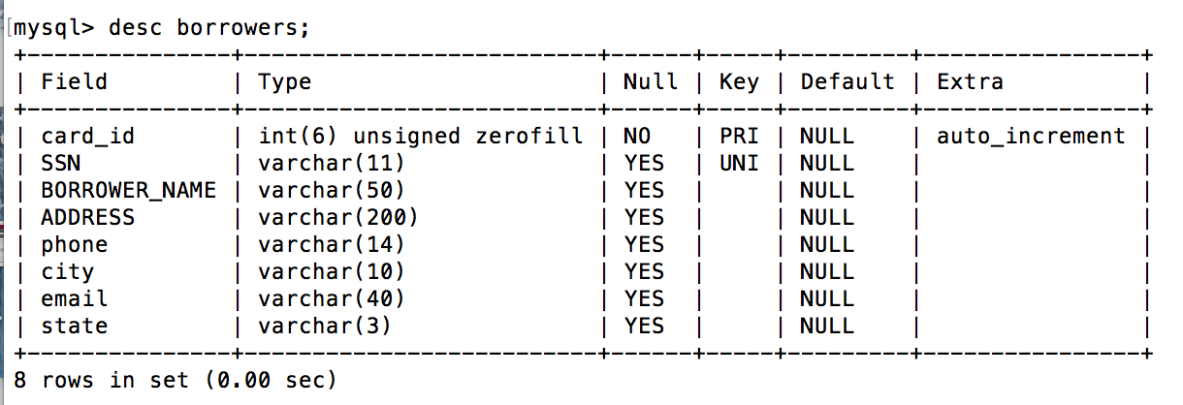

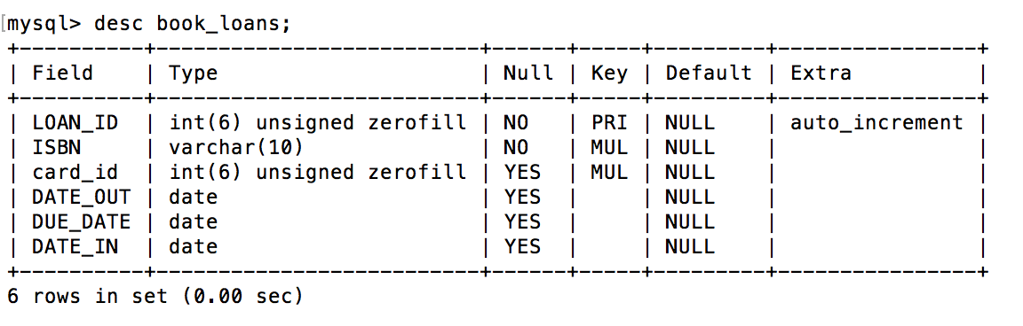

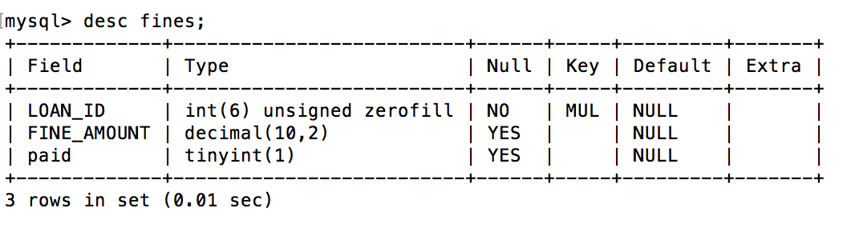

**System Architecture:**

* To implement this system, I have used Web Architecture. I have written RESTFul APIs for the implementation of the individual functionalities.
* I have also developed a web GUI for the ease of use for the librarian.
* I have used MySQL as my persistent database storage.
* REST APIs are developed in NodeJS using a driver interface to connect to MySQL server. I have used Bootstrap to develop a UI to make api calls through browser.
* To insert the data into the database, I have created a database in the MySQL.
* I have developed the data base scripts using Python modules like Pandas ,Numpy, Pymysql, for Parsing the given csv file for better visualization of data and easier and faster way to create data base table with all dependencies and all load the data into each table.
* I have used HAPI framework to create a server. I have then defined routes to individual feature that needs to be implemented. For implementing search, I’m passing the search parameters as query params.
* These query parameters are then used to perform search on the database. Partial input is accepted and appropriate string matching is implemented to provide useful search results.
* For check-in and checkout of a book, the feature is implemented as a HTTP POST request. The borrower card number and the isbn of the book are passed as request body so that these attributes can be accessed on the server side to make appropriate changes to the database.
* An attribute ‘checkedout’ is added to the books table so that whenever a book is checked in or checked out, this attribute is changed appropriately to indicate the availability of the book. A success message or appropriate error message is shown to the user as a result of this request.
* Adding a new borrower to the system is implemented as a HTTP POST request. All the required details to insert a new borrower is passed in the request body.
* After inserting borrower to the system, borrower id (library card number) is given as response to the request.
* For the updating the fines daily, I have provided a HTTP POST request. I have provided a button in the UI which fires this api call so that all fines will be updated. This api call also checks whether a new record in book loans table is past due date and inserts a new record the fines table.
* Payment of fine is PUT request which just flips a column which indicates that the fines are paid. In addition to this, I have also provided an API call to get total outstanding fines for a borrower. If no fines exist, $0 is provided as the response.