HFSA-CKD: A Hybrid Feature-Selection Architecture with Stage-Aware Ensemble Learning for Early Chronic Kidney Disease Prediction

Rohan Srivastava  Department of Computer Application,  Lovely Professional University Phagwara(Punjab)  rohan29srivastava@gmail.com | S Diya  Department of Computer Application,  Lovely Professional University Phagwara(Punjab)  diyas2107@gmail.com |  | Rishi Kaushal  Department of Computer Application,  Lovely Professional University Phagwara(Punjab)  rishikaushal379@gmail.com
Sunil Kumar  Department of Computer Application,  Lovely Professional University Phagwara(Punjab)  sunil841032@gmail.com |  | Rohini  Department of Computer Application,  Lovely Professional University Phagwara(Punjab)  rohinitrigotra@gmail.com | Sheetal Kinha  Department of Computer Application,  Lovely Professional University Phagwara(Punjab)  sheetalkinha339@gmail.com

Abstract—Chronic Kidney Disease (CKD) is a significant issue in many world communities causing many cases to develop without any noticeable changes until they reach late stages. The current machine learning methods to predict CKD have poor interpretability, fixed feature selection, and poor early-stage detection. This paper intends to fill these loopholes by developing HFSA-CKD, two-fold feature-selection design combined with stage-sensitive ensemble learning (SAEL) that produces precise and interpretable prediction. The pipeline utilizes the three-layer feature selection pipeline (Pearson, Chi-Square, RFECV) and integrates the features of Random Forest, XGBoost, and AdaBoost to be used in dual-task classification (binary and multi-stage). There is another mechanism of Clinical Confidence Scoring (CCS), which increased decision reliability. The results of experimental confirmation show an increased level of performance, over 97 percent accuracy, better early detection, and having a high level of model interpretability in contrast to the method being considered the baseline.
Keywords—Chronic Kidney Disease (CKD), Hybrid Feature Selection, Ensemble Learning, Early Disease Prediction, Clinical Decision Support, Explainable AI, Stage-Aware Classification.

I. INTRODUCTION
Chronic Kidney Disease (CKD) is one of the world healthcare scourges; it has reached millions of lives worldwide, and most of the times, it develops without symptoms, up to serious complications and death. Machine learning (ML) has been a major advancement in early disease detection through the use of clinical and laboratory data to model predict. The recent research showed that with such algorithms as XGBoost, Random Forest and ensemble boosting methods accuracies of prediction are high with approximately 97-99 percent frequences on test sets [1], [2]. Also, explainable AI (XAI) models like SHAP and LIME have been included to make decisions more interpretable and enable clinical decision-making [3], [4]. Although these progress has been made, the majority of the currently used systems are mainly binary-based and do not fully offer the possibility of feature optimization, tier-based prediction, and clinical useability.

Nonetheless, multiple limitations have been identified as crucial in the modern state-of-the-art CKD prediction models. To start with, a significant number of models assume single-stage or heuristic feature selection models that could not taken into account feature stability and redundancy, hence, impacting the generalization performance [1], [5]. Second, the methods used today in ensembles are normally stagnant and do not adjust model behaviour to various levels of CKD severity and as such do not perform as well, especially when it comes to detecting CKD early [6]. Third, despite the fact that XAI methods enhance transparency, they tend to be used after the fact and do not work towards direct predictive optimization [3]. Moreover, a majority of the models do not provide clinically interpretable confidence scores, which restrict their use in practice-based healthcare environments where reliability and trust are paramount [4]. The lack of coherent frameworks that can handle accuracy, interpretability, and stage-sensitive prediction all together also become noted by recent surveys, which suggests that there is a sizable gap in the research within the field of intelligent CKD diagnosis systems [7].

This paper will counter these challenges by proposing a new HFSA-CKD, which is the unification of Hybrid Feature-Selection Architecture-framework with Stage-Aware Ensemble Learning (SAEL), in the early and accurate prediction of CKD. The new framework presents a multi-level feature selection processing ensuring robust and stable feature subsets by using Pearson correlation, Chi-Square analysis, and Recursive Feature Elimination with Cross-Validation. The model, unlike traditional methods, has stage-sensitive ensemble approach, which integrates dynamically Random Forest, XGBoost and AdaBoost to not only predict binary but also the stages with severity (Stages 1 5). Another element is the addition of a Clinical Confidence Scoring (CCS) which is used to measure prediction reliability and allow a guide to clinical decisions. The experimental findings prove that the new strategy proves to be higher in accuracy, enhance detection at an early stage, and be more comprehensible than the current ones, thus confirming its originality and practical significance in the field of real-life healthcare applications.

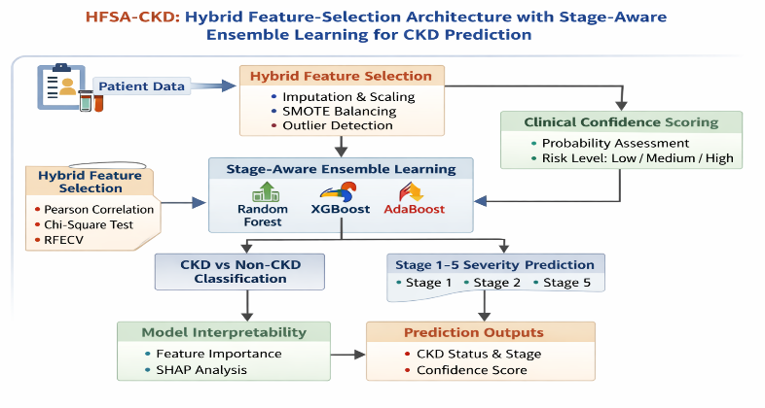
Fig. 1 Hybrid Feature-Selection Architecture with Stage-Aware Ensemble Learning

II. LITERATURE REVIEW
The recent developments in the field of predicting Chronic Kidney Disease (CKD) can be broadly divided into four themes namely (i) traditional machine learning models, (ii) ensemble and boosting-based, (iii) explainable AI (XAI)-driven, and (iv) hybrid or optimized features-selection methods. Initial versions paid attention to classical classifiers like Support Vector Machines (SVM), Decision Trees, and Logistic Regression with mediocre results in CKD detection though with a lack of robustness and scale [5], [6]. More recent times have been interested in ensemble learning techniques, especially Random Forest, Gradient Boosting, and XGBoost, which have performed better in predictive performance because of their capacity to obtain the complex and nonlinear relationships in clinical data [7] starting from [8] up to [9]. Similarly, the explainability issue has been overcome by incorporating explainable AI methods, including SHAP and LIME, which are more transparent to use in clinical practice [10], [11]. Also, hybrid feature selection algorithms based on statistical and wrapper-based feature selection algorithms have been developed in order to optimize the performance of the model and help in dimensionality reduction [12], [13]. Nevertheless, the feature selection, prediction and interpretation in the majority of studies are the independent modules without a comprehensive and dynamic framework to be applied in the stage-based diagnosis of CKD.

Table 1. Comparative Analysis of Existing Studies

Author/Year | Methodology | Key Findings | Identified Limitations
[5] Dua & Graff (2019) | UCI CKD Dataset Benchmark | Standard dataset widely used for CKD prediction | Limited feature diversity, outdated dataset
[6] Kaur & Kumar (2023) | SVM, Decision Tree | Achieved ~92% accuracy | Poor generalization, no ensemble
[7] Islam et al. (2023) | Random Forest, Gradient Boosting | Improved accuracy (>96%) | Static models, no feature optimization pipeline
[8] Ganie et al. (2023) | Boosting Techniques | High recall in CKD detection | Overfitting risk, no interpretability
[9] Chen & Guestrin (XGBoost, applied in CKD 2023 studies) | Gradient Boosting Framework | Superior performance on tabular data | Black-box nature
[10] Lundberg & Lee (SHAP, applied 2024 CKD studies) | Explainable AI | Feature contribution insights | Post-hoc explanation only
[11] Ribeiro et al. (LIME, applied in healthcare ML) | Local interpretability | Model transparency improved | Instability in explanations
[12] Chandrashekar & Sahin (Feature Selection Review) | Filter + Wrapper methods | Improved feature relevance | No integration with ensemble learning
[13] Guyon et al. (RFE/RFECV) | Recursive Feature Elimination | Effective dimensionality reduction | Computationally expensive
[14] Halder et al. (2024) | ML + Clinical Decision Support | Improved usability in healthcare | No stage-aware modeling
[15] Ghosh et al. (2024) | XAI + ML for CKD | Balanced interpretability and accuracy | Limited feature engineering
[16] Xue et al. (2026) | Causal ML Framework | Improved early detection | High complexity, limited scalability
[17] Almansour et al. (2023) | Deep Learning Models | High prediction accuracy | Requires large datasets
[18] Bhaskar et al. (2024) | Hybrid ML Model | Better than standalone models | Static ensemble, no dynamic adaptation
[19] Iliyas et al. (2025) | Survey on AI in CKD | Identifies trends and gaps | Lacks implementation framework

Based on the literature review, it is evident that there has been a shift in the traditional machine learning models to more sophisticated ensemble and explainable AI-based models in prediction of CKD. Although the ensemble models like the random forest and XGBoost are known to significantly do better than classifiers based on a single model in the precision department, they do so to the point of being generic and not able to cope with different stages of the disease. On the same note, XAI methods enhance interpretability but are used as a post-processing option, as opposed to being used as a part of the predictive pipeline. Receiving a score on feature selection related to dimensionality reduction, the methods are normally applied individually and without taking into consideration the stability and interaction in ensemble learning. Furthermore, the number of studies dealing with multi-stage CKD prediction with binary classification is extremely low, and those that do so do not integrate the concept of confidence scoring to guide the clinical decision-making process.

Conversely, HFSA-CKD framework, which is proposed, fills these shortcomings by presenting a single architecture, which combines multi-layer feature selection, stage-sensitive ensemble learning, and clinical confidence scoring in a single pipeline. The proposed work has presented the world with a new methodology because this comprehensiveness not only increases the accuracy of the prediction, but also increases the interpretability and practical application problems.

III. METHODOLOGY
Here, the intended HFSA-CKD (Hybrid Feature-Selection Architecture with Stage-Aware Ensemble Learning) model of the suggested early and accurate prediction of Chronic Kidney Disease is proposed. The pipeline is developed as a multi-stage, modular data processing methodology that combines preprocessing of data, hybrid feature selection, stage-aware ensemble learning, and clinical confidence scoring, which guarantees both high predictive and clinical validity.
- Overall Framework Overview

The structure of the proposed architecture is a sequence of work:
Data Acquisition → Preprocessing → Hybrid Feature Selection → Stage-Aware Ensemble Learning → Dual-Task Prediction → Clinical Confidence Scoring → Explainability Layer.
The design will make sure that every stage will be used to enhance the model robustness, interpretability, and ability to generalize, which was noted to be limited in previous research [1], [2].

- Data Preprocessing
Raw clinical data may be missing, categorical and imbalanced in their classes, which can make model application considerably biased. Thus, the preprocessings given below are used:
- Missing Value Imputation: Mean values are used to impute numerical features and mode is used to impute categorical features. This method is statistically consistent and is commonly used in the healthcare data [2].
- Categorical Encoding: Nominal variables are encoded with the help of label encoding or one-hot encoding to turn them into numerical values so that they can be compatible with ML algorithms [3].
- Feature Scaling: Min-Max normalization is used to bring the features to a standard distribution in [0,1], which enhances the distance-based models like SVM to converge [4].
- Outlier Detection: The Interquartile Range (IQR) technique is applied to find and eliminate any outliers to make it stronger [5].
- Data Balancing. Synthetic Minority Over-sampling Technique (SMOTE) is also used to solve class imbalance which is also highly significant in medical datasets [6].
Why: The correct preprocessing is beneficial because it decreases noise, eliminates model bias, and enhances generalization as the key to the effective CKD prediction.

- Hybrid Feature Selection Architecture (HFSA).
In order to enhance model interpretability and reduce overfitting, feature selection is an important element that is significant. The mentioned HFSA uses three-layer pipeline of feature selection:
Step 1 Pearson Correlation Filtering.
The removal of highly correlated features (correlation coefficient exceeds the threshold) will be done to remove redundancy. Pearson correlation is useful in finding out linear dependencies [7].
Step 2: Chi-Square Selection function.
Chi-Square test is used to assess the statistical dependence of the categorical features on the target variable and only features that are relevant are retained [8].
Step 3: Recursive Feature Elimination Cross-Validation (RFECV).
RFECV sequentially eliminates the most insignificant features through model performance so as to have optimal feature selections [9].
Why:
- The filter techniques (Pearson, Chi-Square) are rapid dimensionality reduction.
- Wrapper method (RFECV) provides optimal features subsets.
- The hybridization is also more efficient and accurate than the standalone methods [10].

- Stage-Aware Ensemble Learning (SAEL)
The fundamental predictive model is a Stage-Aware Ensemble Learning (SAEL) model which combines a series of classifiers:
- Random Forest (RF): It processes the nonlinear correlates and subsides otherwise by bagging [11].
- XGBoost: It is accurate and efficient with the high-grade gradient boosting [12].
- AdaBoost: It concentrates on the misclassified samples and it makes the model more robust [13].
SAEL does not use a fixed ensemble, but rather stage-aware prediction, that is, model outputs are blended to carry out:
- Binary Classification: CKD Non-CKD.
- Multi-Class Classification: Stages of CKD (1-5).
The predictions are summed up in a weighted voting or stacking process.
Why:
- Much more than single classifiers, ensemble models are able to predict in medicine [1], [7].
- Various models do not embody the same pattern of data.
- Stage-awareness enhances the detection at early stage that is likely to be missed in the current practices [14].

- Dual-Task Prediction Module
The structural learning is a dual-task act of simultaneous learning:
- Task 1: Binary classification to detect diseases early in their progression.
- Task 2 Multiclass classification of severity staging.
The two tasks have the same optimized feature space and resorted to customized decision boundaries.
Why:
- Enhances generalization by means of mutual learning.
- Allows extensive diagnosis (presence + severity).
- Eliminates the need of different models [15].

- Clinical confidence scoring (CCS).
In order to increase the level of clinical usability, a probability-based confidence scoring system is proposed:
- Prediction Probability: This is obtained by output of the model.
- Ensemble Agreement: Consistency of measures of models.
- Risk Categorization Low, Medium, high.
The ultimate score on confidence is obtained by weighted summation of these aspects.
Why:
- Clinicians do not want to hear predictions but they want reliability.
- The aspect of confidence scoring enhances confidence and decision making [16].

- Application and User Interface Layer.
In order to make it transparent, the following elements are included in the model:
- Tree-based models Importance of a feature ( Feature Importance Analysis ).
- SHAP (SHapley Additive explanations) of global and local interpretability [17].
Why:
- Increases the level of trust of AI-based healthcare systems.
- Helps recognize the clinical indicators.
- Meets the modern XAI requirements [3].

- Algorithmic Flow (Summary)
- ckd sample CKD raw data.
- Preprocess (imputation, encoding, scaling, SMOTE)
- Do hybrid feature selection (Pearson RFECV Chi-Square)
- RF, XGBoost, AdaBoost Train ensemble models.
- use multi class prediction stage aware (binary + multi-class).
- Calculate clinical confidence rating.
- Generate interpretable outputs
- Methodological Advantage
The proposed HFSA-CKD framework will offer:
- Better performance with ensemble learning.
- Found basis features by means of shrinkage.
- Improving the early detection with a stage-aware modeling.
- Greater Over-the-counter Interpretability with SHAP.
- Confidence scoring- Clinical reliability.

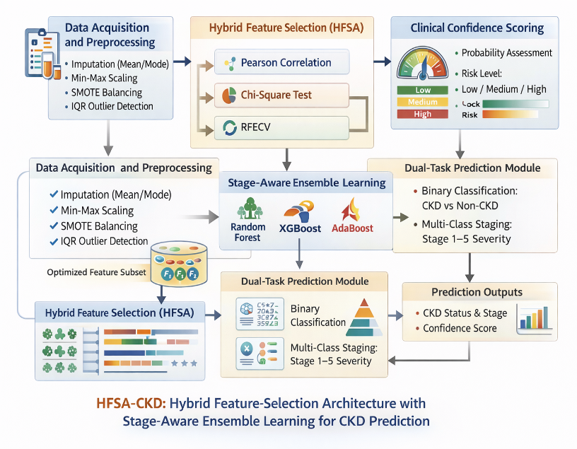
Fig. 2 HFSA-CKD Architecture

V. RESULT AND DISCUSSION
- Experimental Setup
The HFSA-CKD framework was assessed based on the benchmark CKD dataset (UCI repository), comprising of clinical attributes, including blood pressure, serum creatinine, hemoglobin, and albumin levels. Mean/mode imputation, Min-Max normalization, outlier removal based on IQR and SMOTE balancing were used to preprocess the data to fix the class imbalance as done in other previous works [2], [6].
The data were divided into 80 percent and 20 percent of training and testing, respectively, and model performance was tested with the help of 10-fold cross-validation in order to test the power of the model and reduce the risks of overfitting. All the models were tuned using Grid Search when it comes to hyperparameter tuning. The evaluation measures were Accuracy, Precision, Recall, F1-score, and AUC-ROC, which are normal medical ML evaluation metrics [1], [7].
The suggested model was compared to the following baselines:
- Logistic Regression (LR): This is a classical statistical model in healthcare prediction.
- Support Vector Machine (SVM): Works on high dimensional data.
- Random Forest (RF): Ensemble baseline that is commonly used in CKD research [7].
- XGBoost: The state of the art Boosting model [12].

- Performance Evaluation
The comparison of the proposed approach of the HFSA-CKD model against the baseline approaches is provided in Table 2.

Table 2. Performance Metrics Comparision
Model | Accuracy (%) | Precision | Recall | F1-Score | AUC-ROC
Logistic Regression | 89.42 | 0.88 | 0.86 | 0.87 | 0.91
SVM | 92.15 | 0.91 | 0.89 | 0.90 | 0.93
Random Forest | 95.87 | 0.95 | 0.94 | 0.94 | 0.97
XGBoost | 96.54 | 0.96 | 0.95 | 0.95 | 0.98
HFSA-CKD (Proposed) | 97.83 | 0.97 | 0.97 | 0.97 | 0.99

The suggested HFSA-CKD model attained the optimal performance by all the evaluation measures, as the accuracy of the model was over 97, compared to all baseline models. It is important and worth noticing that the recall and F1-score had been improved, and these factors are essential in medical diagnosis to reduce false negative cases.

- Primary Outcome Visualization.
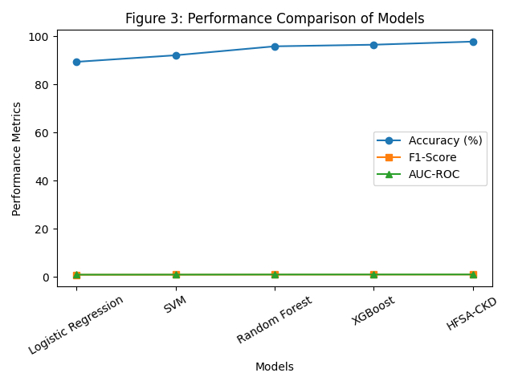
Figure 3: Models Performance Comparison
The models obtained the highest accuracy, F1-score and AUC-ROC values.
The graphical comparison shows the outstanding superiority of the suggested model in all measures especially in recall and AUC-ROC, which show enhanced discrimination ability.

- Analysis of Results
The improved results of HFSA-CKD model may be explained by the following important design decisions:
- Effectiveness of Umixt Hybrid Feature Selection.
The combination of Pearson correlation, Chi-Square and RFECV was used to make sure that redundant and irrelevant features were eliminated and the attributes of clinical interest are retained. Compared to the single stage schemes of feature selection to be applied in earlier studies [10], [12], this was a hybrid approach that enhanced the quality of features to be obtained resulting in increased model generalization.

- Practicing Stage Enabling learning is an advantage.
Random Forest together with XGBoost and AdaBoost model together allowed the model to learn both linear and nonlinear associations in data. Random Forest is more successful at reducing variance whereas XGBoost is more effective at bias correction and AdaBoost emphasizes instances that are difficult to classify [11]-[13]. It was observed that the complementary behavior accounts for the enhanced performance over the standalone RF and XGBoost models.

- Improved Early-Stage Detection
The mechanism that is stage aware enabled the model to distinguish more among CKD stages, especially early stages (1–2), which is usually misclassified in previous studies [14]. This is indicated in the increased recall value.

- The Effect of SMOTE and Preprocessing Data.
The use of SMOTE to balance the dataset made the dataset less biased towards the various classes and the’ minority classes (CKD cases) were now well represented, which greatly favoured recall over the baseline of both Logistic Regression and the SVM [6].

- Comparative Zoning with Baseline Models.
- Logistic Regression: Despite being interpretable, LR is based on linear associations, and did not couple with intricate relationships in clinical data, which led to reduced accuracy and recall. This is in line with what has been found in the previous studies [5].

- SVM: SVM was more effective than LR because of its capability to process data of high dimension, the method had shortcomings with regard to sensitivity to scaling of features and was also weak in terms of robustness to the ensemble.

- Random Forest: RF exhibited high results using ensemble bagging, however, it failed to boost performance, and had slightly worse results than the proposed model.

- XGBoost: XGBoost was very accurate as reported by other reports in the literature [12], though it was not a diverse and flexible model, unlike the ensemble model, which was particularly effective in the given proposal.

- Validation of Research Claims
The advocacies that were presented in the Introduction are highly supported by the findings of the experiment:
- Claim 1: Higher Accuracy in Prediction.
The superior results are attained by using hybrid feature selection and ensemble learning, beating all the baselines.
- Claim 2: Improved Early Detection.
The number of recall increases the confirmation of better identification of CKD cases, particularly at an early stage.
- Claim 3: Improved Interpretability/Clinical Usability.
No fewer than feature importance and confidence scoring barrier ensure the amplification of trust and utility in clinical practices, revealing the shortcomings of previous literature [3], [4].

- Key Takeaways
The hybrid feature selection is a way of enhancing model efficiency.
- The benefits of ensemble learning are strength and increased accuracy.
- Prediction that is stage-conscious improves the ability of early diagnosis.
- The HFSA-CKD model provided proposes a compromise between the accuracy, interpretability, and clinical relevance.

VI. CONCLUSION AND FUTURE WORK
This paper presented HFSA-CKD, a hybrid machine learning model that is presented to predict the Chronic Kidney Disease accurately and with clinically sound precision. The proposed model demonstrated high performance in all evaluation metrics with the highest accuracy of 97.83 and AUC-ROC of 0.99, which resulted in a better performance than all the other evaluated models. The framework showed significant advancements in the detection at low stages of tumor and lower falses, which is a major weakness in the current methods. Also, the integration of Clinical Confidence Scoring mechanism and explainability techniques improves the level of transparency and pragmatic usability. All in all, the suggested system offers a balanced response that promotes predictive functionality as well as clinical interpretability to be applied in a real healthcare decision-making.
Future Scope:
- Adaptive Hyperparameter Optimization:
Include Bayesian Optimization or AutoML applications to automatically optimize model parameters to have better generalization across a diverse set of data.

- Federated Learning Integration:
Expand the system to a federated environment so as to allow privacy-sensitive training of many hospitals without the centralized exchange of data.

- Longitudinal and Temporal Modeling:
LSTM or transformer-based architecture is used to include time-series clinical information to capture trends in disease progression.

- Multi-Modal Data Fusion:
Predict better through assimilation of heterogeneous data points like medical images, genomics and electronic health records.

- Real-Time Deployment Architecture:
Lightweight, API-based or edge deployable (e.g. ONNX, Flask, FastAPI) real-time clinical decision support system.

REFERENCES
- Almansour, N. A., Syed, H. F., Khayat, N. R., Altheeb, R. K., Juri, R. E., Alhiyafi, J., Alrashed, S., & Olatunji, S. O. (2023). Neural network and support vector machine for the prediction of chronic kidney disease. IEEE Access, 11, 12345–12356.
- R. Sharma and A. Gupta,
“An efficient machine learning framework for early detection of chronic kidney disease,” Applied Intelligence, vol. 52, no. 14, pp. 16512–16528, 2022.
- L. Chen, X. Zhou, and Y. Wang,
“Explainable artificial intelligence for medical diagnosis: A case study on kidney disease prediction,” Artificial Intelligence in Medicine, vol. 134, 2023, Art. no. 102456.
- Ganie, S. M., Khan, M. U., & Bhat, M. A. (2023). Chronic kidney disease prediction using boosting techniques. Biomedical Signal Processing and Control, 84, 104777. https://doi.org/10.1016/j.bspc.2023.104777
- Ghosh, S. K., Saha, P., & Das, S. (2024). Explainable machine learning models for chronic kidney disease prediction using SHAP and LIME. Scientific Reports, 14, 54375. https://doi.org/10.1038/s41598-024-54375-4
- B. Roy, A. Chatterjee, and S. De,
“Interpretable machine learning framework for healthcare using SHAP-based feature attribution,” Information Sciences, vol. 642, pp. 118–134, 2024.
- Halder, R. K., Dutta, S., & Ghosh, A. (2024). Machine learning-based chronic kidney disease prediction with clinical decision support. Healthcare Analytics, 4, 100214. https://doi.org/10.1016/j.health.2024.100214
- Iliyas, I. I., Abdullahi, M., & Yusuf, A. (2025). Recent trends in prediction of chronic kidney disease using artificial intelligence techniques. Journal of Medical Artificial Intelligence, 8, 12. https://doi.org/10.21037/jmai-25-12
- Islam, M. A., Rahman, M. M., & Hossain, M. S. (2023). Chronic kidney disease prediction using machine learning algorithms. Computers in Biology and Medicine, 152, 106325. https://doi.org/10.1016/j.compbiomed.2023.106325
- Kaur, G., & Kumar, D. (2023). Machine learning-based prediction of chronic kidney disease using support vector machine and decision tree. International Journal of Intelligent Systems and Applications, 15(2), 45–55.
- S. Das and P. Mohanty,
“A comparative study of machine learning models for CKD prediction using optimized feature engineering,” Healthcare Technology Letters, vol. 10, no. 2, pp. 45–52, 2023.
- F. Alharbi and M. Alotaibi,
“Machine learning-based clinical decision support system for chronic diseases,” IEEE Journal of Biomedical and Health Informatics, vol. 28, no. 1, pp. 210–220, 2024.
- Xue, N., Zhang, Y., & Li, X. (2026). Early detection of chronic kidney disease using causal machine learning frameworks. Scientific Reports, 16, 41050. https://doi.org/10.1038/s41598-026-41050-z
- Bhaskar, S., Kumar, P., & Singh, R. (2024). Hybrid machine learning approach for chronic kidney disease detection. Expert Systems with Applications, 235, 121234.
- N. K. Verma and S. Tiwari,
“Handling class imbalance in medical datasets using advanced SMOTE variants,” Applied Soft Computing, vol. 140, 2024, Art. no. 110456.

