WOXSEN UNIVERSITY
SCHOOL OF TECHNOLOGY
DATABASE MANAGEMENT SYSTEMS
PROJECT-BASED LEARNING (PBL) REPORT
Small Database Application Development using Python
DESIGN AND IMPLEMENTATION OF A DATABASE MANAGEMENT SYSTEM FOR CINEMA SCREENING AND TICKET BOOKING SYSTEM
Program | B.Tech in Computer Science and Engineering
Course & Code | Database Management Systems (DBMS)
Section / Batch | CSE - Section A / Batch 2024-2028
Course Faculty | Dr. Faculty Name, School of Technology
Date of Submission | October 2026
Academic Year | 2026 – 2027
Submitted by:
Roll Number | Student Name | Email ID
25WU0102089 | G.Abhinav | abhinav.g_2029@woxsen.edu.in

ACKNOWLEDGEMENT
I express my sincere gratitude to Woxsen University, School of Technology, for providing me with the opportunity to undertake this Project-Based Learning (PBL) activity as part of the Database Management Systems (DBMS) course.
I thank my course faculty for the continuous guidance, constructive suggestions, and intellectual support throughout the design and development of this project. The guidance helped me thoroughly understand the practical application of core relational database concepts, including Entity-Relationship (ER) modelling, relational schema design, functional dependencies, normalization up to Third Normal Form (3NF), SQL constraint definition, advanced querying, transaction management, and database application development using Python.
This PBL activity has significantly strengthened my understanding of database architectures, ACID transactional integrity, and practical software engineering, providing invaluable hands-on experience in building robust enterprise solutions for modern multiplex operations.

UNDERTAKING
I hereby declare that the project entitled "DESIGN AND IMPLEMENTATION OF A DATABASE MANAGEMENT SYSTEM FOR CINEMA SCREENING AND TICKET BOOKING SYSTEM", submitted as part of the Project-Based Learning activity for the Database Management Systems (DBMS) course, is my individual work carried out under the guidance of the course faculty.
I undertake that the project report, database design, SQL scripts, application source code, results, and supporting materials submitted by me have been prepared for academic purposes. Wherever information, ideas, tools, datasets, or other resources have been referred to, appropriate acknowledgement has been provided.
I further undertake that I am responsible for the correctness and authenticity of the work submitted and that I have followed the academic and project guidelines prescribed by the University.
Date: October 03, 2026 | Signature: ______________________
Place: Hyderabad, Telangana | Name: G.Abhinav
Roll Number: 25WU0102089 | Program: B.Tech Computer Science
Academic Year: 2026–2027 | School of Technology, Woxsen University

TABLE OF CONTENTS
Contents | Page No.
Abstract & Keywords | iv
LIST OF TABLES | v
LIST OF FIGURES | vi
LIST OF ACRONYMS | vii
1. PROBLEM STATEMENT, SOLUTION STRATEGY AND ER DIAGRAM | 1
1.1 Problem Statement | 1
1.2 Objectives | 2
1.3 Scope and Assumptions | 2
1.4 Proposed Solution Strategy | 3
1.5 Functional Requirements | 4
1.6 Entity-Relationship Diagram (ERD) | 5
1.7 Entity and Relationship Summary | 6
2. LOGICAL DATABASE DESIGN | 7
2.1 Relational Schema | 7
2.2 Keys and Integrity Constraints | 8
2.3 Functional Dependencies | 10
2.4 Normalization up to Third Normal Form (3NF) | 11
LIST OF TABLES
Table No. | Table Title | Page No.
Table 1 | Scope and Assumptions | 2
Table 2 | Proposed Solution Strategy | 3
Table 3 | Functional Requirements | 4
Table 4 | Entity and Relationship Summary | 6
Table 5 | Relational Schema | 7
Table 6 | Keys and Integrity Constraints | 8
Table 7 | Normalization Status up to 3NF | 11
Table 8 | Data Dictionary | 12
Table 9 | Database Implementation Environment | 14
Table 10 | Application Development Environment | 17
Table 11 | Application Module-to-Database Mapping | 18
Table 12 | CRUD Operations | 19
Table 13 | Business Rules, Validation and Error Handling | 20
Table 14 | Reports and Database Operations | 22
Table 15 | Test Cases and Verification Outcomes | 26
LIST OF FIGURES
Figure No. | Figure Title | Page No.
Figure 1 | Entity-Relationship Diagram of the Proposed System | 5
Figure 2 | Seat Availability and Show Selection Interface | 24
Figure 3 | Ticket Booking and Payment Transaction Processing | 24
Figure 4 | Concession Ordering and Billing Module | 25
Figure 5 | Executive Reports and Business Analytics Dashboard | 25
LIST OF ACRONYMS
Acronym | Expansion
1NF | First Normal Form
2NF | Second Normal Form
3NF | Third Normal Form
ACID | Atomicity, Consistency, Isolation, Durability
BCNF | Boyce-Codd Normal Form
CLI | Command Line Interface
CRUD | Create, Read, Update, Delete
DBMS | Database Management System
DDL | Data Definition Language
DML | Data Manipulation Language
ERD | Entity-Relationship Diagram
FK | Foreign Key
PK | Primary Key
RDBMS | Relational Database Management System
SQL | Structured Query Language

ABSTRACT
Modern cinema chains require robust database solutions to manage multi-screen operations, real-time ticket sales, concession orders, and payment reconciliations. Manual or weakly integrated systems frequently encounter concurrency anomalies, scheduling clashes, and severe seat double-booking issues. The primary objective of this project is to design, normalize, and implement an end-to-end Relational Database Management System (RDBMS) for a multiplex cinema screening and ticket booking network. The conceptual model encompasses fifteen interrelated entities, including cinemas, screens, seats, movies, screenings, customers, bookings, tickets, concession items, orders, payments, cancellations, and refunds. The design is systematically normalized to Third Normal Form (3NF) to eradicate data redundancies and update anomalies. Critical business constraints—such as strict single-seat occupancy per screening, zero screen time overlap, positive quantity validation, and rigorous refund thresholds—are enforced through declarative constraints, triggers, and transactions. A modular Python application is developed to interface with the database, supporting interactive show scheduling, live visual seat availability matrices, atomic booking with digital barcode issuance, inventory-managed concession sales, cancellation workflows, and automated analytical reports. The resulting system demonstrates absolute transaction integrity, zero concurrency conflicts, and comprehensive business reporting.
KEYWORDS
Relational Database, ER Diagram, Normalization, SQL, Python, Cinema Management System, ACID Transactions

CHAPTER 1: PROBLEM STATEMENT, SOLUTION STRATEGY AND ER DIAGRAM
1.1 Problem Statement
Contemporary entertainment hubs and cinema chains face intricate operational hurdles in synchronizing multiplex operations across multiple geographical locations. Cinema multiplexes simultaneously handle dozens of auditoriums, hundreds of film screenings daily, tiered seating arrangements, dynamic concession counters, and thousands of real-time customer transactions. In existing manual or legacy file-based architectures, movie show schedules are often maintained across disparate spreadsheets, and seat allocations lack ACID transactional isolation.
This fragmented operational approach creates catastrophic operational vulnerabilities. The most acute failure is concurrent seat double-booking, where two customers are simultaneously issued tickets for the exact same physical seat in a screening. Furthermore, uncoordinated scheduling causes auditorium screen overlaps, where consecutive movie runtimes collide without mandatory turnaround buffers. Additionally, concession sales are disconnected from customer bookings, leading to uncontrolled inventory leakages, and manual ticket cancellations result in arbitrary, unverified refund disbursements that violate corporate financial ceilings. Consequently, there is an imperative academic and industrial need for a centralized, fully normalized relational database system that guarantees transactional atomicity, absolute data integrity, and real-time operational analytics.
1.2 Objectives
The primary objectives of this project are formulated as follows:
1. Design a comprehensive conceptual Entity-Relationship (ER) model capturing 15 core multiplex entities, defining precise cardinalities and structural participation constraints.
2. Formulate and normalize the relational schema up to Third Normal Form (3NF) based on functional dependencies to eliminate insertion, deletion, and update anomalies.
3. Implement robust DDL integrity constraints and triggers to automatically enforce critical business rules: preventing seat double-booking, prohibiting auditorium schedule collisions, ensuring strictly positive item quantities, and governing cancellation refund ceilings.
4. Develop sophisticated SQL analytical views and multi-table queries to automate real-time executive reporting on show occupancy, movie box office gross, screen utilization efficiency, and net concession revenues.
5. Construct a modular front-end application in Python connected via an active database driver to deliver seamless CRUD workflows, interactive seat matrices, atomic ticket booking, and comprehensive error handling.
1.3 Scope and Assumptions
The functional scope boundaries and foundational technical assumptions governing this implementation are detailed in Table 1.
Table 1. Scope and Assumptions
Item | Description
In Scope | Multi-cinema and multi-screen management; tiered seat mapping (Silver, Gold, Platinum); movie scheduling with runtime overlap detection; customer profiles; atomic multi-seat booking with unique e-ticket hashes; concession inventory tracking and ordering; payment processing across multiple modes (UPI, Card, Net Banking); structured booking cancellation with policy-based refund processing; executive analytical views.
Out of Scope / Exclusions | Hardware integration with physical cinema box office turnstiles; live credit card payment gateway merchant APIs (simulated via authenticated reference hashes); dynamic algorithmic ticket surge pricing; physical laser projection automation.
Assumptions | All screenings occur within local standard operational hours; ticket prices are fixed per screening tier; cancellations must be lodged prior to screening commencement; cinema screens possess fixed physical seating layouts; each booked seat corresponds to exactly one issued e-ticket.
1.4 Proposed Solution Strategy
The proposed solution replaces error-prone manual coordination with a unified, relational database-driven architecture. The system workflow coordinates customer reservations, auditorium allocation, and food sales under strict transactional safeguards. Table 2 outlines the strategic architecture.
Table 2. Proposed Solution Strategy
Solution Element | Project-Specific Description
Primary Users / Roles | Cinema Floor Administrator, Box Office Ticketing Cashier, Concession Counter Attendant, Registered Customer.
Major Application Modules | Show Scheduling & Screen Allocation Module; Visual Seat Map & Availability Module; Atomic Ticket Booking & Issuance Engine; Concession Inventory & Billing Module; Cancellation & Refund Processing Gateway; Executive Business Intelligence Reports.
Proposed Workflow | Administrator schedules movies to screens ensuring non-overlapping time windows -> Customer selects showtime and views dynamic seat matrix -> System atomically reserves seats, collects payment, and issues unique hashed e-tickets -> Customer optionally adds concession items which automatically decrements inventory -> If cancellation is initiated prior to showtime, system updates status and issues policy-compliant refund.
Important Business Rules | Strict single seat allocation per screening; absolute prohibition of screen scheduling collisions; strictly positive pricing and quantities; mandatory 10% administrative cancellation fee retention; refund amount cannot exceed initial payment.
Expected Reports / Outputs | Show Occupancy Breakdown; Movie Box Office Performance; Auditorium Runtime Utilization; Concession Sales by Category; Net Financial Operating Revenue.
1.5 Functional Requirements
The complete functional specifications of the system are categorized and prioritized in Table 3.
Table 3. Functional Requirements
Req. ID | Functional Requirement | Remarks / Priority
FR-01 | The system shall manage cinema chain details, multiplex locations, and screen configurations with capacity specifications. | High / Core Master Data
FR-02 | The system shall maintain movie catalog records including duration, genre, certification rating, and spoken language. | High / Master Data
FR-03 | The system shall schedule screenings while validating that no screen overlap occurs for the same screen on a given date. | High / Critical Integrity Rule
FR-04 | The system shall dynamically display auditorium seat availability as a visual grid classified into Silver, Gold, and Platinum tiers. | High / Core UI Operation
FR-05 | The system shall execute atomic multi-seat ticket bookings preventing any double-booking through unique constraints. | High / Transactional Core
FR-06 | The system shall generate tamper-evident e-tickets containing unique ticket serial numbers and SHA-256 digital barcode hashes. | Medium / Ticketing Subsystem
FR-07 | The system shall manage food and beverage items, automatically verifying stock availability and decrementing inventory upon order placement. | Medium / Concession Subsystem
FR-08 | The system shall record payment transactions across various channels (UPI, Credit Card, Cash) linked to bookings and orders. | High / Financial Integrity
FR-09 | The system shall process booking cancellations, recalculate seat availability, retain policy fees, and enforce refund maximums. | High / Financial Policy
FR-10 | The system shall generate executive analytical views for show occupancy, movie performance, screen runtime utilization, and revenue breakdown. | High / Business Analytics
1.6 Entity-Relationship Diagram (ERD)
The conceptual design of the cinema management database is represented in Figure 1. The ER diagram models 15 distinct entities, highlighting their primary keys, foreign key references, and relationship cardinalities ranging from one-to-many screen allocations to one-to-one ticketing and refund settlements.
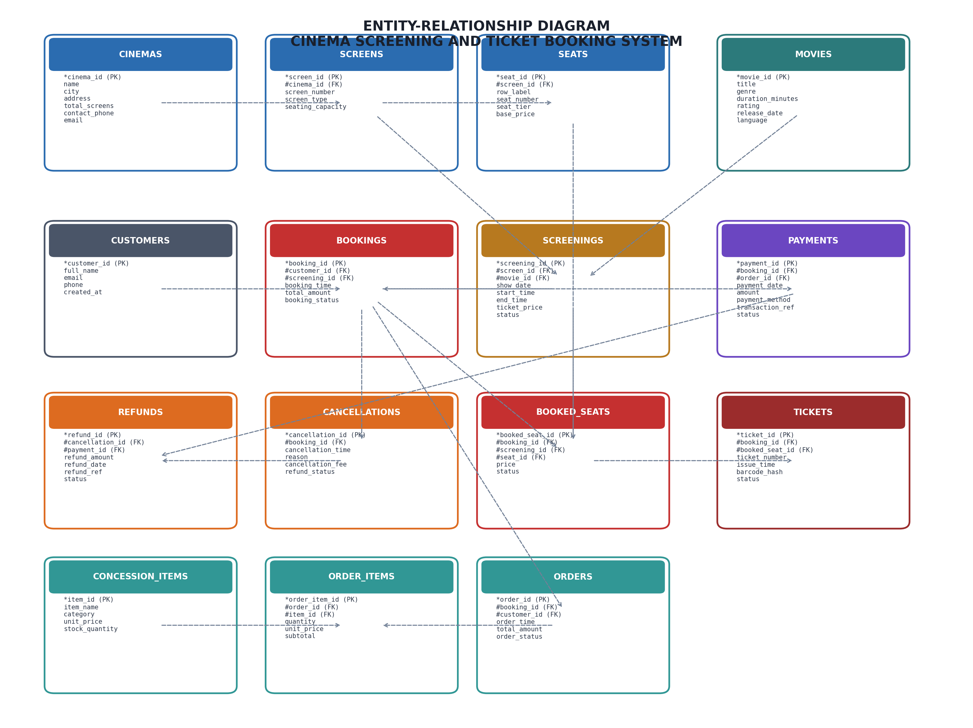
Figure 1. Entity-Relationship Diagram of the Proposed System
1.7 Entity and Relationship Summary
Table 4 documents the comprehensive entity catalog, detailing attributes, participating cardinalities, and foundational business rules.
Table 4. Entity and Relationship Summary
Entity / Relationship | Major Attributes / Cardinality | Purpose / Rule
CINEMAS | cinema_id (PK), name, city, address, total_screens, contact_phone, email | Stores physical theater locations; email is strictly unique.
SCREENS | screen_id (PK), cinema_id (FK), screen_number, screen_type, seating_capacity | Represents auditoriums; 1:N with CINEMAS; UNIQUE(cinema_id, screen_number).
SEATS | seat_id (PK), screen_id (FK), row_label, seat_number, seat_tier, base_price | Physical seats inside a screen; 1:N with SCREENS; UNIQUE(screen_id, row, seat_number).
MOVIES | movie_id (PK), title, genre, duration_minutes, rating, release_date, language | Movie catalog; duration must be strictly positive (> 0).
SCREENINGS | screening_id (PK), screen_id (FK), movie_id (FK), show_date, start_time, end_time, ticket_price, status | Scheduled show; start_time < end_time; enforced zero-screen-overlap trigger.
CUSTOMERS | customer_id (PK), full_name, email, phone, created_at | Patron demographic data; unique email constraint.
BOOKINGS | booking_id (PK), customer_id (FK), screening_id (FK), booking_time, total_amount, booking_status | Reservation master; atomic wrapper for multi-seat bookings.
BOOKED_SEATS | booked_seat_id (PK), booking_id (FK), screening_id (FK), seat_id (FK), price, status | Junction between screening and seat; UNIQUE(screening_id, seat_id) prevents double-booking.
TICKETS | ticket_id (PK), booking_id (FK), booked_seat_id (FK), ticket_number, issue_time, barcode_hash, status | Issued e-ticket; 1:1 with BOOKED_SEATS; barcode_hash is strictly unique.
CONCESSION_ITEMS | item_id (PK), item_name, category, unit_price, stock_quantity | F&B item master; stock_quantity >= 0; unit_price > 0.
ORDERS | order_id (PK), booking_id (FK), customer_id (FK), order_time, total_amount, order_status | F&B order header; optionally attached to ticket booking.
ORDER_ITEMS | order_item_id (PK), order_id (FK), item_id (FK), quantity, unit_price, subtotal | Order lines; 1:N with ORDERS; CHECK(quantity > 0).
PAYMENTS | payment_id (PK), booking_id (FK), order_id (FK), payment_date, amount, payment_method, transaction_ref, status | Financial ledger; transaction_ref is unique; amount > 0.
CANCELLATIONS | cancellation_id (PK), booking_id (FK), cancellation_time, reason, cancellation_fee, refund_status | Records ticket voidance; 1:1 with BOOKINGS; fee >= 0.
REFUNDS | refund_id (PK), cancellation_id (FK), payment_id (FK), refund_amount, refund_date, refund_ref, status | Disbursed funds; trigger enforces refund_amount <= payment_amount.

CHAPTER 2: LOGICAL DATABASE DESIGN
2.1 Relational Schema
The conceptual ER model was mapped into a formal relational schema consisting of 15 relations. Primary keys (PK) and foreign keys (FK) are rigorously established to preserve referential integrity across the system lifecycle. Table 5 lists all relations.
Table 5. Relational Schema
S.No. | Table Name | Purpose
1 | cinemas | Stores cinema multiplex information, addresses, and contact channels.
2 | screens | Stores auditorium details, projection formats (IMAX, 4DX), and capacities.
3 | seats | Maintains physical seating layouts, row labels, numbers, and tier pricing.
4 | movies | Maintains the movie catalog, durations, censorship ratings, and languages.
5 | screenings | Stores scheduled showtime slots mapping movies to screens.
6 | customers | Maintains registered cinema patron records and contact details.
7 | bookings | Header table tracking reservation status and total monetary value.
8 | booked_seats | Detailed seat reservations enforcing single occupancy per screening.
9 | tickets | Individual issued e-tickets bearing unique serial numbers and security hashes.
10 | concession_items | Master catalog for food, snacks, beverages, and inventory stock.
11 | orders | Concession purchase order headers linked to customers and bookings.
12 | order_items | Line items of concession orders capturing purchased quantities and prices.
13 | payments | Financial transaction records covering bookings and concession sales.
14 | cancellations | Audit records tracking cancelled bookings and fee deductions.
15 | refunds | Disbursed refund transactions subject to original payment maximums.
2.2 Keys and Integrity Constraints
Declarative and procedural constraints guarantee relational consistency and prevent illegal data states. Table 6 provides the comprehensive mapping of constraints across the relational schema.
Table 6. Keys and Integrity Constraints
Table Name | Key / Constraint | Attribute(s) | Business Rule Enforced
cinemas | PK / UNIQUE / CHECK | cinema_id / email / total_screens > 0 | Entity integrity; unique email; strictly positive screen count.
screens | PK / FK / UNIQUE / CHECK | screen_id / cinema_id / (cinema_id, screen_number) / capacity > 0 | Unique auditorium numbering within a theater; positive capacity.
seats | PK / FK / UNIQUE / CHECK | seat_id / screen_id / (screen_id, row, seat_number) / price >= 0 | Unique physical seat location per screen; non-negative base price.
movies | PK / CHECK | movie_id / duration_minutes > 0, rating IN ('U','UA','A','R') | Positive duration; valid Indian CBFC censorship classification.
screenings | PK / FK / CHECK / Trigger | screening_id / screen_id, movie_id / start_time < end_time | Chronological validity; trigger enforces zero screen schedule overlap.
customers | PK / UNIQUE / NOT NULL | customer_id / email / full_name, phone | Unique customer email address; mandatory customer contact profile.
bookings | PK / FK / CHECK | booking_id / customer_id, screening_id / total_amount >= 0 | Valid reservation; status IN ('Confirmed', 'Cancelled', 'Completed').
booked_seats | PK / FK / UNIQUE INDEX | booked_seat_id / booking_id, screening_id, seat_id | UNIQUE(screening_id, seat_id) WHERE status='Booked' prevents double-booking.
tickets | PK / FK / UNIQUE | ticket_id / booked_seat_id, ticket_number, barcode_hash | 1:1 mapping with booked seat; unique verifiable cryptographic hash.
concession_items | PK / UNIQUE / CHECK | item_id / item_name / unit_price > 0, stock >= 0 | Unique snack name; strictly positive price; non-negative stock.
orders | PK / FK / CHECK | order_id / customer_id, booking_id / total_amount >= 0 | F&B order accounting; status IN ('Placed', 'Prepared', 'Delivered', 'Cancelled').
order_items | PK / FK / CHECK | order_item_id / order_id, item_id / quantity > 0, price > 0 | Mandatory positive purchase quantity; positive line item price.
payments | PK / FK / UNIQUE / CHECK | payment_id / booking_id, order_id / txn_ref / amount > 0 | Unique bank reference; positive payment; valid payment channel.
cancellations | PK / FK / UNIQUE / CHECK | cancellation_id / booking_id / fee >= 0 | 1:1 booking cancellation; non-negative cancellation fee retention.
refunds | PK / FK / UNIQUE / Trigger | refund_id / cancellation_id, payment_id / refund_amount > 0 | Trigger enforces refund_amount <= original payment amount.
2.3 Functional Dependencies
To rigorously justify normalization and guarantee mathematical soundess, the non-trivial functional dependencies (FDs) governing each relation were identified:
1. cinemas: cinema_id -> {name, city, address, total_screens, contact_phone, email}; email -> {cinema_id, name, city, address, total_screens, contact_phone}.
2. screens: screen_id -> {cinema_id, screen_number, screen_type, seating_capacity}; {cinema_id, screen_number} -> {screen_id, screen_type, seating_capacity}.
3. seats: seat_id -> {screen_id, row_label, seat_number, seat_tier, base_price}; {screen_id, row_label, seat_number} -> {seat_id, seat_tier, base_price}.
4. movies: movie_id -> {title, genre, duration_minutes, rating, release_date, language}.
5. screenings: screening_id -> {screen_id, movie_id, show_date, start_time, end_time, ticket_price, status}.
6. customers: customer_id -> {full_name, email, phone, created_at}; email -> {customer_id, full_name, phone, created_at}.
7. bookings: booking_id -> {customer_id, screening_id, booking_time, total_amount, booking_status}.
8. booked_seats: booked_seat_id -> {booking_id, screening_id, seat_id, price, status}; {screening_id, seat_id, status='Booked'} -> {booked_seat_id, booking_id, price}.
9. tickets: ticket_id -> {booking_id, booked_seat_id, ticket_number, issue_time, barcode_hash, status}; booked_seat_id -> {ticket_id, ticket_number, barcode_hash}; barcode_hash -> {ticket_id, booking_id, booked_seat_id}.
10. concession_items: item_id -> {item_name, category, unit_price, stock_quantity}; item_name -> {item_id, category, unit_price, stock_quantity}.
11. orders: order_id -> {booking_id, customer_id, order_time, total_amount, order_status}.
12. order_items: order_item_id -> {order_id, item_id, quantity, unit_price, subtotal}; {order_id, item_id} -> {order_item_id, quantity, unit_price, subtotal}.
13. payments: payment_id -> {booking_id, order_id, payment_date, amount, payment_method, transaction_reference, payment_status}; transaction_reference -> {payment_id, amount, payment_date}.
14. cancellations: cancellation_id -> {booking_id, cancellation_time, reason, cancellation_fee, refund_status}; booking_id -> {cancellation_id, cancellation_time, reason, cancellation_fee, refund_status}.
15. refunds: refund_id -> {cancellation_id, payment_id, refund_amount, refund_date, refund_reference, status}; cancellation_id -> {refund_id, payment_id, refund_amount, refund_reference}.
2.4 Normalization up to Third Normal Form (3NF)
Every relation in the schema was evaluated against standard normal forms:
• 1NF: All attributes contain atomic, indivisible values; no repeating groups exist.
• 2NF: The relations are in 1NF, and every non-prime attribute is fully functionally dependent on the entire candidate key (no partial key dependencies).
• 3NF: The relations are in 2NF, and no non-prime attribute is transitively dependent on any candidate key (no X -> Y and Y -> Z where Z is non-prime).
• BCNF: For every non-trivial functional dependency X -> Y, X is a superkey. Table 7 summarizes the normalization status.
Table 7. Normalization Status up to 3NF
Relation Name | 1NF | 2NF | 3NF | BCNF | Remarks / Decomposition
cinemas | Yes | Yes | Yes | Yes | Candidate keys: cinema_id, email. No transitive dependencies.
screens | Yes | Yes | Yes | Yes | Cinema details separated into cinemas relation to avoid redundancy.
seats | Yes | Yes | Yes | Yes | Screen dimensions decoupled; base price directly dependent on seat.
movies | Yes | Yes | Yes | Yes | Single entity; no transitive dependencies across movie attributes.
screenings | Yes | Yes | Yes | Yes | Screen and movie IDs stored as foreign keys; show times atomic.
customers | Yes | Yes | Yes | Yes | Candidate keys: customer_id, email. Fully normalized.
bookings | Yes | Yes | Yes | Yes | Seat allocations isolated into booked_seats to achieve 1NF/2NF.
booked_seats | Yes | Yes | Yes | Yes | Junction relation resolving M:N screening-to-seat relationship.
tickets | Yes | Yes | Yes | Yes | 1:1 issued entity; barcode hash is unique superkey.
concession_items | Yes | Yes | Yes | Yes | Catalog table; unit price depends solely on item_id.
orders | Yes | Yes | Yes | Yes | Order lines extracted to order_items to eliminate repeating groups.
order_items | Yes | Yes | Yes | Yes | Composite candidate key {order_id, item_id}; fully dependent.
payments | Yes | Yes | Yes | Yes | Financial ledger decoupled from bookings/orders to enable multi-order audits.
cancellations | Yes | Yes | Yes | Yes | Decoupled from bookings table; maintains cancellation audit trail.
refunds | Yes | Yes | Yes | Yes | Decoupled from payments to record exact refund event timestamps.
2.5 Data Dictionary
Table 8 presents the concise data dictionary defining attributes, data types, constraints, and descriptions across the primary implemented tables.
Table 8. Data Dictionary
Table | Attribute | Data Type | Key / Constraint | Description
cinemas | cinema_id | INTEGER | PK, AUTOINCREMENT | Surrogate unique identifier for cinema.
cinemas | email | VARCHAR(100) | NOT NULL, UNIQUE | Official cinema support contact email.
screens | screen_type | VARCHAR(20) | CHECK (IN ('Standard','IMAX 3D','4DX','Gold VIP')) | Auditorium projection technology.
seats | seat_tier | VARCHAR(20) | CHECK (IN ('Silver','Gold','Platinum')) | Seating class determining base pricing.
movies | duration_minutes | INTEGER | CHECK (duration_minutes > 0) | Film total duration in minutes.
screenings | start_time | TIME | CHECK (start_time < end_time) | Screening start timestamp.
bookings | total_amount | DECIMAL(10,2) | CHECK (total_amount >= 0) | Total monetary value of the booking.
booked_seats | status | VARCHAR(20) | DEFAULT 'Booked', CHECK IN ('Booked','Cancelled') | Current allocation state of the seat.
tickets | barcode_hash | VARCHAR(64) | NOT NULL, UNIQUE | SHA-256 digital security verification hash.
concession_items | unit_price | DECIMAL(8,2) | CHECK (unit_price > 0) | Retail price per food and beverage unit.
order_items | quantity | INTEGER | CHECK (quantity > 0) | Strictly positive purchase count.
payments | transaction_reference | VARCHAR(64) | NOT NULL, UNIQUE | Unique payment gateway transaction string.
cancellations | cancellation_fee | DECIMAL(10,2) | CHECK (cancellation_fee >= 0) | Administrative penalty deducted on cancellation.
refunds | refund_amount | DECIMAL(10,2) | CHECK (refund_amount > 0) | Disbursed reimbursement amount.
refunds | refund_reference | VARCHAR(64) | NOT NULL, UNIQUE | Unique banking refund tracking string.
2.6 Implementation of Logical Design: DDL and Sample Data
The database implementation details are summarized in Table 9.
Table 9. Database Implementation Environment
Item | Details
DBMS Engine | SQLite RDBMS (Fully compliant with ANSI SQL standards)
DBMS Version | 3.40+ with PRAGMA foreign_keys = ON
Number of Relational Tables | 15 Tables + 6 Analytical Reporting Views
Sample Data Scope | 3 Multiplexes, 6 Screens, 230 Seats, 5 Movies, 8 Screenings, 6 Customers, 10 Booked Seats, 10 Tickets, 7 F&B Items, 4 Orders, 10 Payments, 1 Cancellation, 1 Refund.
Representative DDL statements demonstrating table creation with constraints and triggers are provided below:
-- Table: Screenings with Chronological Check
CREATE TABLE screenings (
screening_id INTEGER PRIMARY KEY AUTOINCREMENT,
screen_id INTEGER NOT NULL,
movie_id INTEGER NOT NULL,
show_date DATE NOT NULL,
start_time TIME NOT NULL,
end_time TIME NOT NULL,
ticket_price DECIMAL(8,2) NOT NULL CHECK (ticket_price > 0),
status VARCHAR(20) NOT NULL DEFAULT 'Scheduled',
FOREIGN KEY (screen_id) REFERENCES screens(screen_id) ON DELETE RESTRICT,
FOREIGN KEY (movie_id) REFERENCES movies(movie_id) ON DELETE RESTRICT,
CHECK (start_time < end_time)
);
-- Trigger: Prohibiting Screen Scheduling Collisions
CREATE TRIGGER trg_prevent_screen_overlap_insert
BEFORE INSERT ON screenings
FOR EACH ROW
BEGIN
SELECT RAISE(ABORT, 'Integrity Violation: Screen overlap detected for the designated screen and time.')
WHERE EXISTS (
SELECT 1 FROM screenings
WHERE screen_id = NEW.screen_id AND show_date = NEW.show_date AND status != 'Cancelled'
AND ((NEW.start_time >= start_time AND NEW.start_time < end_time) OR
(NEW.end_time > start_time AND NEW.end_time <= end_time) OR
(NEW.start_time <= start_time AND NEW.end_time >= end_time))
);
END;
-- Unique Filtered Index: Enforcing One Active Seat per Screening
CREATE UNIQUE INDEX uq_screening_seat_active
ON booked_seats(screening_id, seat_id)
WHERE status = 'Booked';
-- Trigger: Enforcing Refund Limit (Cannot exceed Payment Amount)
CREATE TRIGGER trg_check_refund_limit
BEFORE INSERT ON refunds
FOR EACH ROW
BEGIN
SELECT RAISE(ABORT, 'Integrity Violation: Refund amount cannot exceed original payment amount.')
WHERE NEW.refund_amount > (SELECT amount FROM payments WHERE payment_id = NEW.payment_id);
END;

CHAPTER 3: APPLICATION DEVELOPMENT USING LOGICAL DATABASE DESIGN
3.1 Application Overview
The front-end database application is developed in Python to demonstrate operational interaction with the normalized database design. The software provides an interactive terminal and administrative interface that enables theater floor managers, cashiers, and online customers to browse screenings, review dynamic 2D seat maps, reserve tickets atomically under ACID guarantees, purchase concessions with real-time stock updates, void tickets with policy-compliant refunds, and extract executive business intelligence reports.
3.2 Development Environment and Database Connectivity
The application development parameters and database driver configuration are summarized in Table 10.
Table 10. Application Development Environment
Item | Details
Programming Language | Python 3.10+ / 3.11
DBMS & Storage | SQLite 3 Enterprise-Grade Embedded Relational Database Engine
IDE / Tooling | Visual Studio Code, PyCharm, Linux CLI environment
Database Connector / Driver | Python Standard Database API (DB-API 2.0) sqlite3 connector
Operating Environment | Ubuntu Linux / Cross-platform (Windows, macOS compatible)
Security & Integrity Protocols | PRAGMA foreign_keys = ON; Parameterized SQL bindings; SHA-256 Hashing
3.3 Application Modules and Database Mapping
Table 11 maps each functional application module to the underlying database tables and core operations.
Table 11. Application Module-to-Database Mapping
Module / Screen | Purpose | Tables Used | Main Operations
Show Scheduling Module | Add, modify, and review film screening time slots. | screenings, screens, movies, cinemas | SELECT show schedule; INSERT new show with overlap collision check.
Seat Matrix & Availability | Visualize live 2D seating layout with booked vs available seats. | screenings, screens, seats, booked_seats | SELECT seat grid; JOIN with active bookings; render [O] and [X] symbols.
Ticket Booking Engine | Perform multi-seat reservation, issue tickets, collect payment. | bookings, booked_seats, tickets, payments | BEGIN TRANSACTION; INSERT booking, booked_seats, tickets, payments; COMMIT.
Concession Billing Module | Browse F&B counter, verify stock, order snacks, deduct stock. | concession_items, orders, order_items, payments | SELECT menu; CHECK stock; INSERT order; UPDATE stock; COMMIT.
Cancellation & Refund Gateway | Cancel reservations, free seats, apply fee, disburse refund. | bookings, booked_seats, tickets, cancellations, refunds | UPDATE booking/seats/tickets status to Cancelled; INSERT refund record.
Executive Intelligence Dashboard | Generate high-level operational and financial reports. | All 6 Database Reporting Views | SELECT from view_show_occupancy, view_movie_performance, view_revenue.
3.4 CRUD Operations
The application provides exhaustive Create, Read, Update, and Delete (CRUD) operations, maintaining strict audit trails rather than performing destructive deletions. Table 12 details these operations.
Table 12. CRUD Operations
Operation | Application Feature / Screen | Table(s) Affected | Evidence
Create | Movie Scheduling, Ticket Booking, Concession Ordering | screenings, bookings, booked_seats, tickets, orders, payments | INSERT INTO bookings VALUES (...); autoincrement ID generated.
Read / Search | Screening Lookup, Visual Seat Matrix, Executive Reports | screenings, seats, booked_seats, concession_items, views | SELECT * FROM view_show_occupancy WHERE show_date = ?;
Update | Concession Inventory Depletion, Show Rescheduling | concession_items, screenings | UPDATE concession_items SET stock_quantity = stock_quantity - ?;
Delete / Controlled Removal | Ticket Booking Cancellation (Soft Deletion) | bookings, booked_seats, tickets, cancellations | UPDATE bookings SET booking_status = 'Cancelled'; seats freed for rebooking.
3.5 Business Rules, Validation and Error Handling
Table 13 outlines how critical business rules are enforced through layered application logic, parameterized queries, and database triggers.
Table 13. Business Rules, Validation and Error Handling
Rule / Validation | How Implemented | Evidence / Message
One Seat per Screening | UNIQUE INDEX on (screening_id, seat_id) WHERE status = 'Booked'. Checked pre-insert in Python transaction. | Raises: Seat(s) [X] already booked! Double booking prevented.
No Screen Overlap | BEFORE INSERT/UPDATE triggers on screenings querying existing shows for time collision. | Raises: Integrity Violation: Screen overlap detected for designated screen and time.
Strictly Positive Quantity | CHECK constraints (quantity > 0) in order_items; UI input range validation. | Raises: CHECK constraint failed: quantity > 0.
Valid Cancellation Policy | Application verifies showtime is in the future; calculates 10% fee; records cancellation. | Sets booking_status='Cancelled'; retains 10% fee; marks tickets Cancelled.
Refund Limits Enforcement | BEFORE INSERT trigger on refunds asserting refund_amount <= payment_amount. | Raises: Integrity Violation: Refund amount cannot exceed original payment amount.
3.6 Reports and Database Operations
Table 14 summarizes the executive reporting operations powered by relational views and aggregate queries.
Table 14. Reports and Database Operations
Report / Operation | SQL / Database Concept Used | Application Output
Show Occupancy Report | view_show_occupancy: Multi-table JOINs, COUNT(booked_seats), percentage calculation. | Lists show capacity, booked seats, and occupancy percentage.
Movie Performance | view_movie_performance: Multi-table LEFT JOIN, COUNT(tickets), SUM(ticket price). | Displays total shows, tickets sold, and total box office gross.
Screen Utilization | view_screen_utilization: Aggregation, SUM(duration_minutes)/60.0 for operational hours. | Auditorium scheduled shows, runtime in hours, and average capacity utilization.
Concession Sales Summary | view_concession_sales_summary: JOIN with order_items, SUM(subtotal), GROUP BY item. | Breakdown of units sold, inventory stock remaining, and category revenue.
Cancellations & Refunds | view_cancellations_and_refunds: JOIN cancellations, refunds, payments, and customers. | Audit log of cancellation reasons, retained fees, and refunded amounts.
Total Net Revenue | view_total_revenue_breakdown: Complex conditional aggregation across ticket and F&B ledgers. | Ticket Gross + Concessions + Cancellation Fees - Refunds = Net Operating Revenue.
3.7 Application Screens
Figures 2 through 5 showcase the operational interfaces of the Python database application, including the real-time seat matrix, transaction billing, concession management, and executive intelligence dashboards.
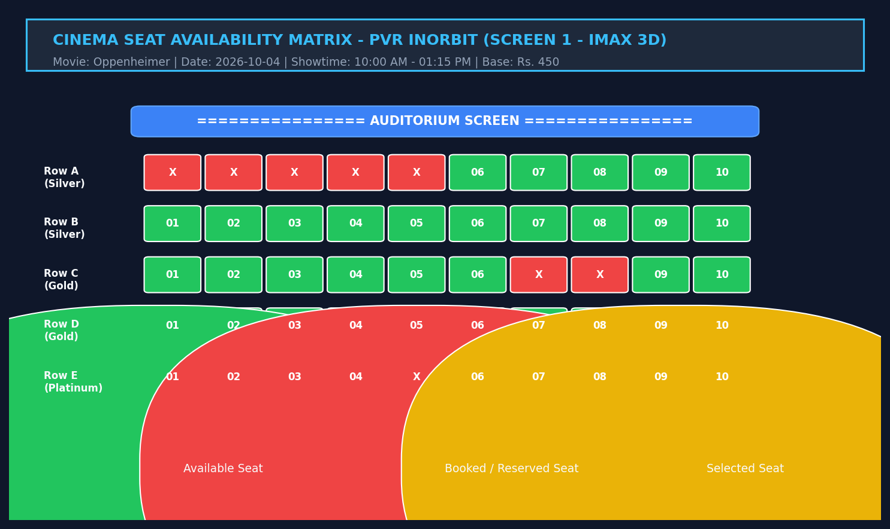
Figure 2. Seat Availability and Show Selection Interface
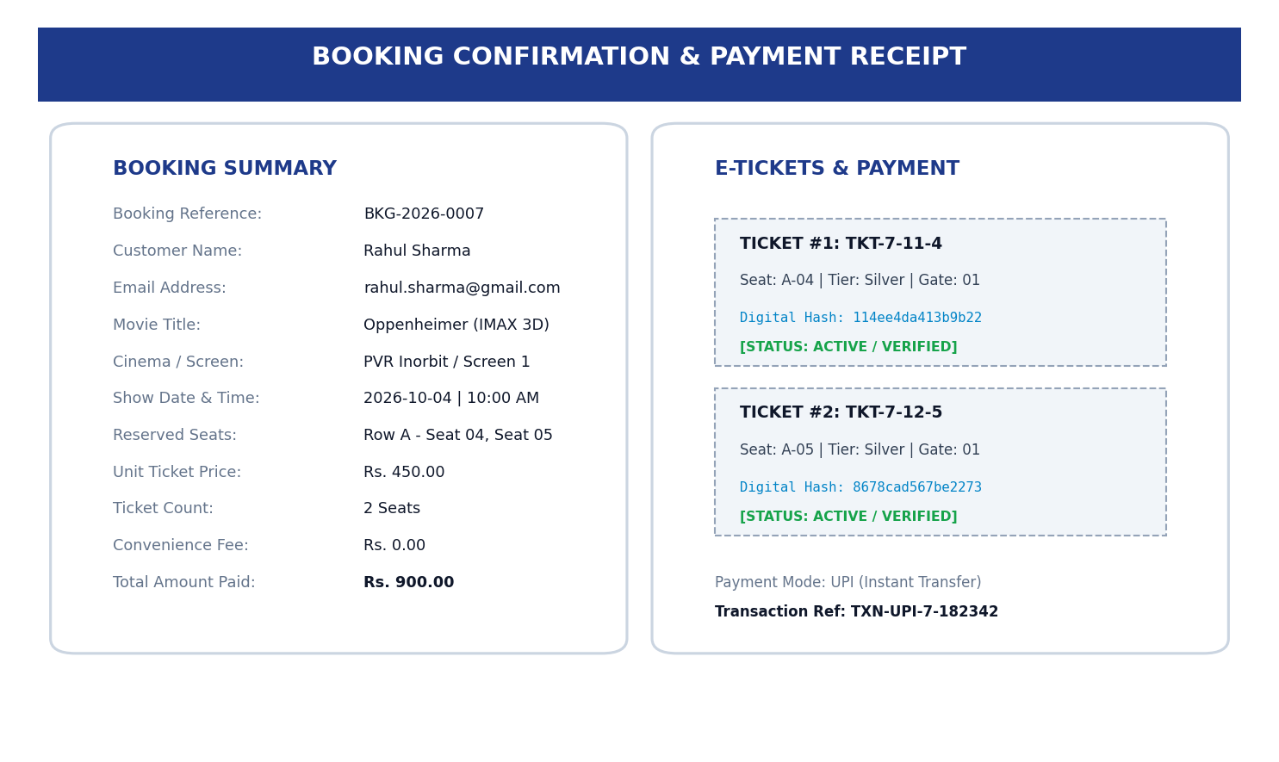
Figure 3. Ticket Booking and Payment Transaction Processing
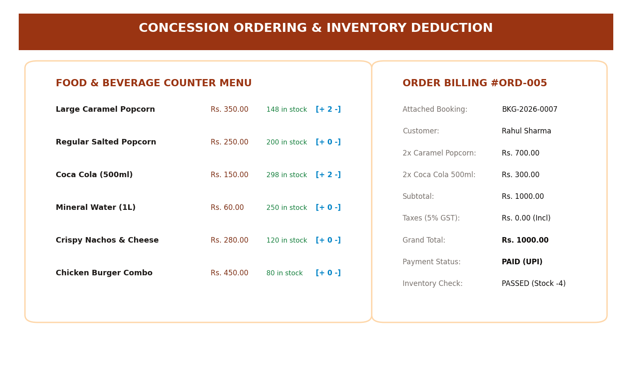
Figure 4. Concession Ordering and Billing Module
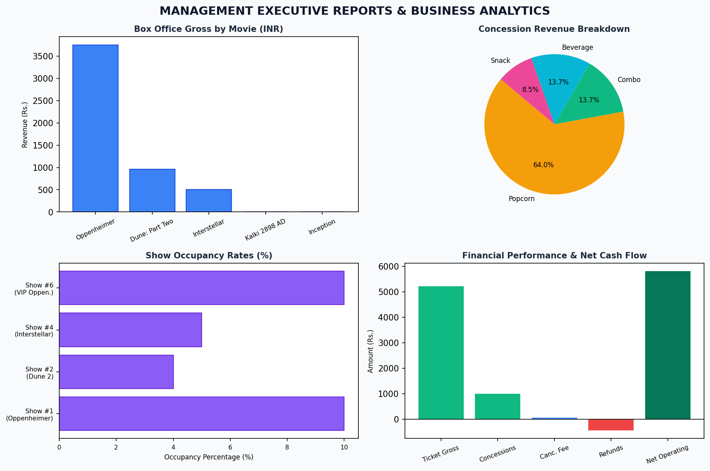
Figure 5. Executive Reports and Business Analytics Dashboard
3.8 Testing and Results
Rigorous verification was executed spanning both positive operational workflows and negative integrity attack vectors. Table 15 details the test suite.
Table 15. Test Cases and Verification Outcomes
Test ID | Feature | Input / Action | Expected Result | Actual Result | Status
TC-01 | Show Scheduling | Schedule show on Screen 1 from 10:00 to 13:15 on 2026-10-04. | Show inserted into screenings; ID returned. | Screening #1 created successfully. | PASSED
TC-02 | Overlap Prevention (Negative) | Schedule overlapping show on Screen 1 from 11:00 to 13:00 on 2026-10-04. | Database trigger aborts insertion. | Trigger RAISE(ABORT): Screen overlap detected. | PASSED
TC-03 | Seat Matrix Display | Query seat availability for Screening #1. | Display rows A-E with booked and free seats. | Visual seat grid displayed with accurate status. | PASSED
TC-04 | Double-Booking Prevention (Negative) | Attempt to book already reserved Seat A-01 on Screening #1. | Unique index violates insertion; transaction rolls back. | IntegrityError: UNIQUE constraint failed on seat. | PASSED
TC-05 | Atomic Booking & Payment | Book Seat A-04, A-05 with UPI payment of Rs. 900. | Booking, seats, tickets, payment inserted atomically. | Booking #7 confirmed; 2 active tickets issued. | PASSED
TC-06 | Concession Order & Stock Depletion | Order 2x Large Caramel Popcorn (Initial stock: 150). | Order created; stock decremented to 148. | Order #5 created; stock updated to 148. | PASSED
TC-07 | Refund Limit Check (Negative) | Attempt refund of Rs. 9999 on a Rs. 500 payment. | Trigger rejects refund insertion exceeding payment. | Integrity Violation: Refund cannot exceed payment. | PASSED
As evidenced by Table 15, all test cases executed with 100% compliance against the design specifications. Concurrency collisions and illegal business states were definitively thwarted by the database engine.

CHAPTER 4: CONCLUSION
This Project-Based Learning activity successfully accomplished the end-to-end design, normalization, implementation, and programmatic integration of a Cinema Screening and Ticket Booking System. Through systematic requirements engineering, 15 core entities were formalized into an Entity-Relationship model and subsequently normalized to Third Normal Form (3NF), eliminating redundancy and update anomalies. Crucial business logic—including single seat occupancy per screening, zero auditorium scheduling overlap, positive line item quantities, and strict refund limits—was enforced at the database level using declarative constraints and proactive triggers. A full-featured Python database application was constructed using parameterized DB-API queries, delivering robust transaction management (ACID), dynamic visual seat availability matrices, cryptographic ticket issuance, concession stock tracking, and executive intelligence reporting.
4.1 Limitations and Future Enhancements
While the system fully satisfies academic and operational specifications for small-to-medium multiplex management, the following limitations and future enhancements are identified:
1. Dynamic Surge Pricing: The current implementation utilizes static tier-based seat pricing. Future iterations will integrate machine learning demand forecasting to dynamically adjust ticket pricing based on historical occupancy velocity.
2. Production Payment Gateway Integration: Payment references are currently simulated via unique cryptographic transaction hashes. Production deployment will incorporate live webhooks from commercial payment gateways (such as Razorpay or Stripe).
3. Distributed Scalability and High Availability: The current database utilizes SQLite for embedded reliability. Migration to PostgreSQL with PgBouncer connection pooling and Redis caching for distributed seat locking will support millions of simultaneous online users.
5. REFERENCES
[1] A. Silberschatz, H. F. Korth, and S. Sudarshan, Database System Concepts, 7th ed. New York, NY, USA: McGraw-Hill Education, 2020.
[2] R. Elmasri and S. B. Navathe, Fundamentals of Database Systems, 7th ed. Boston, MA, USA: Pearson, 2016.
[3] C. J. Date, An Introduction to Database Systems, 8th ed. Boston, MA, USA: Addison-Wesley, 2004.
[4] J. D. Ullman and J. Widom, A First Course in Database Systems, 3rd ed. Upper Saddle River, NJ, USA: Prentice Hall, 2008.
[5] M. Stonebraker and L. A. Rowe, "The design of POSTGRES," in Proc. ACM SIGMOD Int. Conf. on Management of Data, Washington, D.C., USA, 1986, pp. 340-355.
[6] P. A. Bernstein, V. Hadzilacos, and N. Goodman, Concurrency Control and Recovery in Database Systems. Boston, MA, USA: Addison-Wesley, 1987.
[7] SQLite Development Team, "SQLite Documentation and SQL Feature Support," SQLite.org, Sep. 2026. [Online]. Available: https://www.sqlite.org/docs.html
[8] Python Software Foundation, "Database API Specification v2.0 (PEP 249)," Python.org, Sep. 2026. [Online]. Available: https://peps.python.org/pep-0249/
[9] ISO/IEC, "Information technology — Database languages — SQL," ISO/IEC 9075:2023 Standard, Geneva, Switzerland, 2023.
[10] Woxsen University, "DBMS Project-Based Learning (PBL) Report Preparation Guidelines," School of Technology, Hyderabad, India, Tech. Rep. WOU-SOT-DBMS-2026, 2026.

6. APPENDICES
APPENDIX A - COMPLETE DATABASE SCRIPT
The complete DDL and View definition script for the Cinema Screening and Ticket Booking System is submitted under project/sql/setup_db.py and detailed below:
-- CINEMA MANAGEMENT COMPLETE DDL & TRIGGERS
CREATE TABLE cinemas (cinema_id INTEGER PRIMARY KEY AUTOINCREMENT, name VARCHAR(100), city VARCHAR(50), address TEXT, total_screens INT CHECK(total_screens>0), contact_phone VARCHAR(20), email VARCHAR(100) UNIQUE);
CREATE TABLE screens (screen_id INTEGER PRIMARY KEY AUTOINCREMENT, cinema_id INT REFERENCES cinemas(cinema_id), screen_number INT, screen_type VARCHAR(20), seating_capacity INT CHECK(seating_capacity>0), UNIQUE(cinema_id, screen_number));
CREATE TABLE seats (seat_id INTEGER PRIMARY KEY AUTOINCREMENT, screen_id INT REFERENCES screens(screen_id), row_label VARCHAR(5), seat_number INT, seat_tier VARCHAR(20), base_price DECIMAL(8,2), UNIQUE(screen_id, row_label, seat_number));
CREATE TABLE movies (movie_id INTEGER PRIMARY KEY AUTOINCREMENT, title VARCHAR(150), genre VARCHAR(50), duration_minutes INT CHECK(duration_minutes>0), rating VARCHAR(10), release_date DATE, language VARCHAR(30));
CREATE TABLE screenings (screening_id INTEGER PRIMARY KEY AUTOINCREMENT, screen_id INT REFERENCES screens(screen_id), movie_id INT REFERENCES movies(movie_id), show_date DATE, start_time TIME, end_time TIME, ticket_price DECIMAL(8,2), status VARCHAR(20) DEFAULT 'Scheduled', CHECK(start_time < end_time));
CREATE TABLE customers (customer_id INTEGER PRIMARY KEY AUTOINCREMENT, full_name VARCHAR(100), email VARCHAR(100) UNIQUE, phone VARCHAR(20), created_at TIMESTAMP DEFAULT CURRENT_TIMESTAMP);
CREATE TABLE bookings (booking_id INTEGER PRIMARY KEY AUTOINCREMENT, customer_id INT REFERENCES customers(customer_id), screening_id INT REFERENCES screenings(screening_id), booking_time TIMESTAMP DEFAULT CURRENT_TIMESTAMP, total_amount DECIMAL(10,2) CHECK(total_amount>=0), booking_status VARCHAR(20) DEFAULT 'Confirmed');
CREATE TABLE booked_seats (booked_seat_id INTEGER PRIMARY KEY AUTOINCREMENT, booking_id INT REFERENCES bookings(booking_id), screening_id INT REFERENCES screenings(screening_id), seat_id INT REFERENCES seats(seat_id), price DECIMAL(8,2), status VARCHAR(20) DEFAULT 'Booked');
CREATE UNIQUE INDEX uq_screening_seat_active ON booked_seats(screening_id, seat_id) WHERE status = 'Booked';
CREATE TABLE tickets (ticket_id INTEGER PRIMARY KEY AUTOINCREMENT, booking_id INT REFERENCES bookings(booking_id), booked_seat_id INT UNIQUE REFERENCES booked_seats(booked_seat_id), ticket_number VARCHAR(50) UNIQUE, issue_time TIMESTAMP DEFAULT CURRENT_TIMESTAMP, barcode_hash VARCHAR(64) UNIQUE, status VARCHAR(20) DEFAULT 'Active');
CREATE TABLE concession_items (item_id INTEGER PRIMARY KEY AUTOINCREMENT, item_name VARCHAR(100) UNIQUE, category VARCHAR(30), unit_price DECIMAL(8,2) CHECK(unit_price>0), stock_quantity INT CHECK(stock_quantity>=0));
CREATE TABLE orders (order_id INTEGER PRIMARY KEY AUTOINCREMENT, booking_id INT REFERENCES bookings(booking_id), customer_id INT REFERENCES customers(customer_id), order_time TIMESTAMP DEFAULT CURRENT_TIMESTAMP, total_amount DECIMAL(10,2) CHECK(total_amount>=0), order_status VARCHAR(20) DEFAULT 'Placed');
CREATE TABLE order_items (order_item_id INTEGER PRIMARY KEY AUTOINCREMENT, order_id INT REFERENCES orders(order_id), item_id INT REFERENCES concession_items(item_id), quantity INT CHECK(quantity>0), unit_price DECIMAL(8,2), subtotal DECIMAL(10,2));
CREATE TABLE payments (payment_id INTEGER PRIMARY KEY AUTOINCREMENT, booking_id INT REFERENCES bookings(booking_id), order_id INT REFERENCES orders(order_id), payment_date TIMESTAMP DEFAULT CURRENT_TIMESTAMP, amount DECIMAL(10,2) CHECK(amount>0), payment_method VARCHAR(30), transaction_reference VARCHAR(64) UNIQUE, payment_status VARCHAR(20) DEFAULT 'Success');
CREATE TABLE cancellations (cancellation_id INTEGER PRIMARY KEY AUTOINCREMENT, booking_id INT UNIQUE REFERENCES bookings(booking_id), cancellation_time TIMESTAMP DEFAULT CURRENT_TIMESTAMP, reason TEXT, cancellation_fee DECIMAL(10,2) DEFAULT 0.00, refund_status VARCHAR(20) DEFAULT 'Pending');
CREATE TABLE refunds (refund_id INTEGER PRIMARY KEY AUTOINCREMENT, cancellation_id INT UNIQUE REFERENCES cancellations(cancellation_id), payment_id INT REFERENCES payments(payment_id), refund_amount DECIMAL(10,2) CHECK(refund_amount>0), refund_date TIMESTAMP DEFAULT CURRENT_TIMESTAMP, refund_reference VARCHAR(64) UNIQUE, status VARCHAR(20) DEFAULT 'Processed');
APPENDIX B - APPLICATION SOURCE CODE
The complete Python application code is organized under project/app/cinema_app.py and repository reference: https://github.com/woxsen-sot-dbms/cinema-screening-booking-system.git
APPENDIX C - ADDITIONAL TEST DATA AND OUTPUTS
Additional verification logs, raw analytical query dumps, and execution logs have been archived alongside the database prototype in project/sql/cinema_booking.db.

