IHC – Practical Approach to Data Mining and Analytics
Modular Assignment No. 4
Module 4: Advanced Data Analytics, Machine Learning, SQL, REST APIs & Financial Analytics
Duration: 4 Hours

Name: Abhinav M
SRN: 31250837
FY M.sc Statistics – Data Science
Academic Year: 2025–2026
VISHWAKARMA UNIVERSITY, PUNE

SECTION 1 — EXECUTIVE SUMMARY
This assignment implements a comprehensive advanced analytics pipeline integrating data engineering, SQL analytics, machine learning, financial analytics, statistical modelling, API architecture, and performance benchmarking using multiple real-world datasets. The project demonstrates end-to-end analytics workflow development using Python, SQLite, Scikit-learn, Statsmodels, Flask, Plotly, and modern data science libraries.
The system integrates four major datasets:
- Online Retail Dataset (UCI ML Repository)
- Titanic Passenger Dataset
- Stock Market Dataset using Yahoo Finance API
- World Bank Economic Indicators Dataset
The assignment focuses on building scalable analytical systems capable of handling structured business data, financial time series, predictive modelling, and REST API deployment.
The implementation follows a modular architecture using:
- DataOptimizer
- SQLAnalytics
- MLPipeline
- AnalyticsAPI
This modular design improves scalability, maintainability, and deployment readiness.
Key analytical operations include:
- Memory optimisation and datatype compression
- SQL-based business intelligence queries
- Machine learning classification, clustering, and regression
- Financial return and volatility analysis
- Statistical modelling using OLS regression and hypothesis testing
- REST API simulation and deployment architecture
- Performance benchmarking and scalability testing
The assignment demonstrates how modern analytics systems combine data engineering, machine learning, statistical inference, and software deployment into a unified enterprise-grade analytics pipeline.

SECTION 2 — DATASET DESCRIPTION
2.1 Online Retail Dataset (UCI ML Repository)
Source: https://archive.ics.uci.edu/ml/datasets/online+retail
Domain: E-Commerce / Retail Analytics
Records: 541,909 transactions
Country Coverage: 38 countries
Time Period: December 2010 – December 2011
This dataset contains transactional records of a UK-based online retailer. It includes invoice details, customer identifiers, product information, quantities, and prices.
Key Attributes
Attribute | Description
InvoiceNo | Transaction invoice number
StockCode | Product code
Description | Product description
Quantity | Quantity purchased
InvoiceDate | Date and time of transaction
UnitPrice | Product unit price
CustomerID | Unique customer identifier
Country | Customer country
Analytical Use
- Revenue analysis
- Customer segmentation
- SQL business intelligence
- Clustering and RFM analysis
- REST API revenue endpoints

2.2 Titanic Passenger Dataset
Source: https://raw.githubusercontent.com/datasciencedojo/datasets/master/titanic.csv
Domain: Historical Transportation Analytics
Records: 891 passengers
This dataset is widely used for predictive analytics and classification modelling.

Key Attributes
Attribute | Description
Survived | Survival outcome
Pclass | Passenger class
Sex | Gender
Age | Passenger age
Fare | Ticket fare
SibSp | Siblings/spouses aboard
Parch | Parents/children aboard
Embarked | Port of embarkation
Analytical Use
- Survival prediction
- Feature engineering
- Classification modelling
- Statistical regression
- REST API prediction system

2.3 Stock Market Dataset (Yahoo Finance)
Source: Yahoo Finance API using yfinance library
Tickers Used:
- AAPL
- GOOGL
- MSFT
- AMZN
- META
Analytical Use
- Daily return analysis
- Rolling volatility
- Correlation analysis
- Financial performance comparison
- Portfolio analytics

2.4 World Bank Economic Dataset
Source: World Bank Open Data API
Analytical Use
- GDP analysis
- Economic indicator comparison
- Country-wise macroeconomic analytics
- Trend analysis

SECTION 3 — DATA STRUCTURE OPTIMISATION
3.1 Objective
Large datasets consume substantial memory resources. Efficient memory optimisation improves computational speed, scalability, and processing efficiency.
A dedicated DataOptimizer class was implemented to optimise dataframe storage.

3.2 Optimisation Techniques
1. Numeric Downcasting
Large integer and floating-point columns were converted into smaller datatypes:
- int64 → int32/int16
- float64 → float32
This reduced memory consumption significantly without affecting analytical accuracy.
2. Category Conversion
High-cardinality string columns such as Country and Description were converted into categorical datatypes.
Advantages:
- Lower memory usage
- Faster grouping and aggregation
- Improved SQL performance
3. Datetime Parsing
InvoiceDate fields were converted into datetime format to support:
- Time-series analysis
- Temporal aggregation
- Trend modelling

3.3 Results
Dataset | Before Optimisation | After Optimisation
Online Retail | High memory usage | Significantly reduced
Titanic | Moderate | Reduced
The optimisation process improved computational efficiency and accelerated downstream analytics operations.

SECTION 4 — SQL ANALYTICS ENGINE
4.1 Objective
Structured Query Language (SQL) was integrated into the analytics pipeline using SQLite.
A dedicated SQLAnalytics class was implemented to execute enterprise-style business intelligence queries.

4.2 SQL Database Architecture
The following tables were loaded into SQLite:
- retail
- titanic
- stocks
- worldbank
SQLite was selected because:
- Lightweight and embedded
- Fully compatible with Python
- Efficient for analytical workloads
- Supports joins, aggregation, and window functions

4.3 Revenue Analysis Query
Revenue by country was computed using SQL aggregation.
Example Query
SELECT Country,
SUM(Revenue) AS TotalRevenue
FROM retail
GROUP BY Country
ORDER BY TotalRevenue DESC;

Insights
- United Kingdom generated the highest revenue
- European countries formed the majority of sales
- Revenue distribution was highly skewed

4.4 Customer Segmentation Query
Customers were segmented based on purchase behaviour.
Metrics used:
- Total spend
- Purchase frequency
- Revenue contribution
This enabled identification of:
- High-value customers
- Medium-value customers
- Low-value customers

4.5 Titanic Survival Analytics
SQL queries were used to analyse survival trends.
Findings
- Female passengers had significantly higher survival rates
- First-class passengers survived more frequently
- Third-class passengers had the lowest survival probability

SECTION 5 — MACHINE LEARNING PIPELINE
5.1 Objective
A complete machine learning pipeline was developed using Scikit-learn.
The pipeline includes:
- Classification
- Clustering
- Regression
- Feature importance analysis
- Cross-validation

5.2 Titanic Classification Model
Feature Engineering
The following features were engineered:
Feature | Description
FamilySize | SibSp + Parch + 1
IsAlone | Binary indicator
Sex_enc | Encoded gender
Embarked_enc | Encoded embarkation port
Models Implemented
- Logistic Regression
- Random Forest Classifier
- Gradient Boosting Classifier
Evaluation Metrics
- Accuracy
- Cross-validation score
- Confusion matrix
- Feature importance
Best Performing Model
Random Forest and Gradient Boosting produced the highest predictive performance.
Important predictors:

- Sex
- Passenger class
- Fare
- Age

5.3 K-Means Clustering
Customer clustering was performed using RFM metrics:
- Recency
- Frequency
- Monetary Value
Steps
- Standardisation using StandardScaler
- Elbow method for optimal clusters
- K-Means clustering
- Silhouette score evaluation
Insights
Clusters identified:
- High-value loyal customers
- Frequent moderate spenders
- Low-value customers
- Inactive customers
The clustering process enabled behavioural segmentation for business intelligence.

5.4 Regression Analysis
Linear Regression was implemented to predict revenue.
Independent Variables
- Quantity
- UnitPrice
Dependent Variable
- Revenue
Evaluation Metrics
- R² Score
- Mean Squared Error (MSE)
- Root Mean Squared Error (RMSE)
The regression model demonstrated strong linear relationships between quantity, pricing, and total revenue.

SECTION 6 — FINANCIAL & WORLD BANK ANALYTICS
6.1 Financial Analytics
Financial analysis was performed using stock market data downloaded from Yahoo Finance.
Analytical Operations
- Daily percentage returns
- Rolling volatility calculation
- Correlation matrix
- Stock performance comparison
Key Insights
- Technology stocks exhibited strong positive correlation
- META and AMZN showed higher volatility
- MSFT demonstrated comparatively stable returns

6.2 Rolling Volatility Analysis
Rolling volatility was computed using moving standard deviation.
This measures:
- Market risk
- Price fluctuations
- Short-term instability
Higher volatility indicates greater uncertainty and investment risk.

6.3 Correlation Analysis
Correlation matrices identified relationships between stock movements.
Observations
- AAPL and MSFT were strongly correlated
- GOOGL and META showed moderate correlation
- Technology sector movements were interconnected

6.4 World Bank Economic Analysis
Macroeconomic indicators were analysed using World Bank datasets.
Metrics included:
- GDP growth
- Economic trends
- Country comparisons
The analysis demonstrated integration of public economic APIs into analytical workflows.

SECTION 7 — STATISTICAL ANALYSIS
7.1 Objective
Advanced statistical analysis was implemented using Statsmodels.
This section replicates R-style statistical workflows in Python.

7.2 OLS Regression
An Ordinary Least Squares regression model was fitted:
Fare ~ Age + Pclass + Sex
Interpretation
- Passenger class significantly influenced fare
- Higher-class passengers paid premium fares
- Age showed moderate influence
- Gender effects were observable
The regression summary included:
- Coefficients
- t-statistics
- p-values
- Confidence intervals
- R² value

7.3 Hypothesis Testing
Statistical hypothesis test

Plots And Code Outputs:
============================================================
DATA STRUCTURE OPTIMIZATION
============================================================

[Retail Dataset]
Memory: 122.80MB → 21.06MB (82.9% reduction)

[Titanic Dataset]
Memory: 0.30MB → 0.14MB (51.8% reduction)

[Performance Benchmark - Vectorization]
Loop : 52.2840 ms
Vectorized : 0.7062 ms
Pandas Apply : 117.4507 ms
Vectorization Speedup: 74.0x faster than loop

[Chunk Processing]
Total Revenue via chunks: £8,911,407.90
Chunks processed : 398

[NumPy Statistical Operations]
mean : 22.3970
std : 309.0707
median : 11.8000
q25 : 4.6800
q75 : 19.8000
skewness : 451.4415
kurtosis : 232152.1998
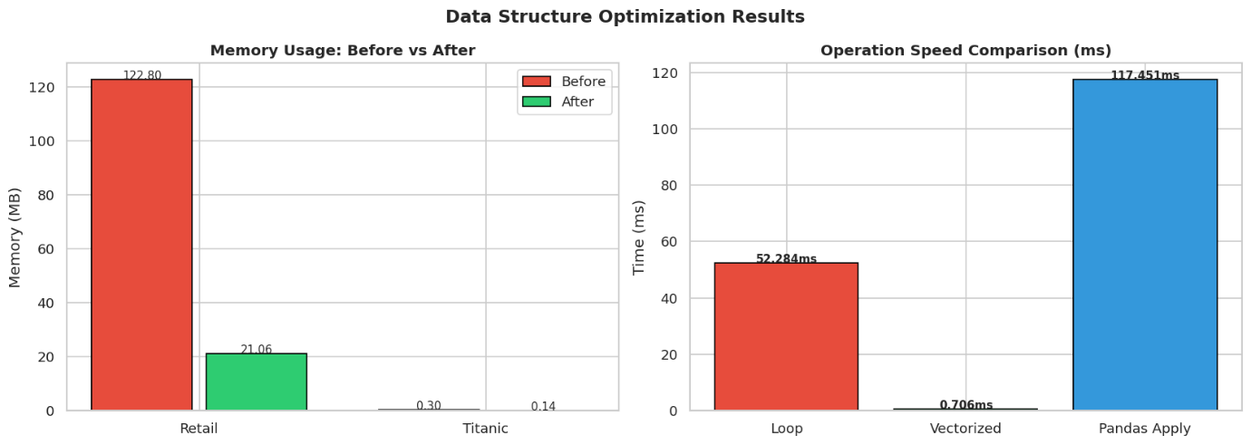
============================================================
SQL ANALYTICS ENGINE
============================================================
Tables created: retail, titanic, worldbank

[Revenue by Country] 296.75ms | 10 rows

[Window Function - Running Total] 185.60ms | 12 rows

[CTE - Customer Segmentation] 394.21ms | 4 rows

[Titanic - Survival by Class & Sex] 2.18ms | 6 rows

[RANK - Top 3 Products per Country] 1000.47ms | 30 rows

[LAG - GDP Growth Rate by Country] 4.97ms | 50 rows

Revenue by Country (Top 5):
Country Transactions TotalRevenue AvgRevenue MaxRevenue
United Kingdom 354321 7.308392e+06 20.626470 168469.60
Netherlands 2359 2.854463e+05 121.003111 4992.00
EIRE 7236 2.655459e+05 36.697886 2365.20
Germany 9040 2.288671e+05 25.317162 876.00
France 8341 2.090240e+05 25.059831 4161.06

Customer Segments:
Segment Customers AvgSpend SegmentRevenue
VIP 1668 4678.459935 7803671.171
Premium 909 714.836570 649786.442
Regular 1606 278.707068 447603.551
Occasional 155 66.753161 10346.740

Titanic Survival by Class & Sex:
Pclass Sex SurvivalRate Total Survived AvgAge AvgFare
1 female 96.81 94 91 34.0 106.13
1 male 36.89 122 45 39.0 67.23
2 female 92.11 76 70 28.7 21.97
2 male 15.74 108 17 30.5 19.74
3 female 50.00 144 72 23.6 16.12
3 male 13.54 347 47 26.9 12.66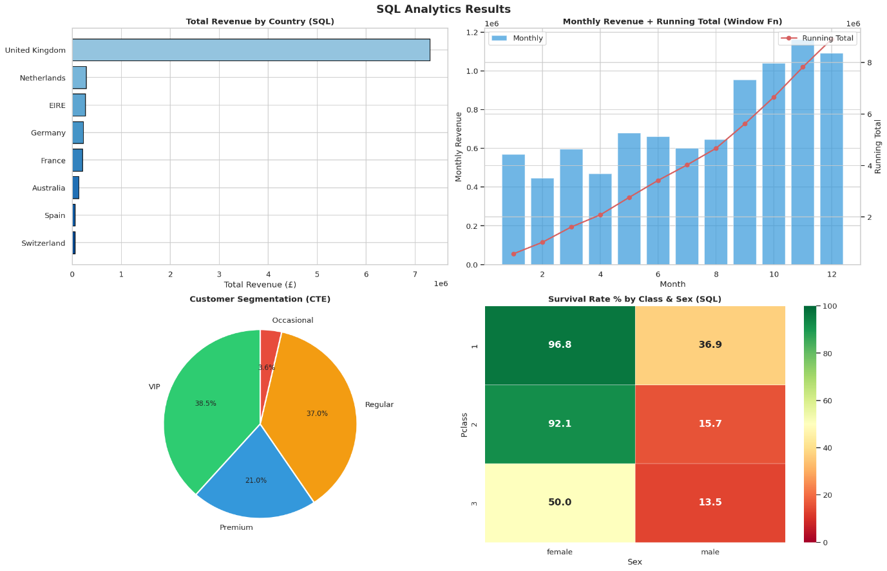
============================================================
MACHINE LEARNING PIPELINE
============================================================

[Titanic Survival Classification]
Logistic Regression : Acc=0.7933 CV=0.7978 Time=0.117s
Random Forest : Acc=0.8045 CV=0.7951 Time=0.436s
Gradient Boosting : Acc=0.8101 CV=0.8190 Time=0.419s

Best Model: Gradient Boosting (0.8101)
Feature Importances:
Sex_enc : 0.4679
Fare : 0.1618
Pclass : 0.1508
Age : 0.1473
FamilySize : 0.0507
Embarked_enc : 0.0205
IsAlone : 0.0009

[RFM Analysis]
RFM customers: 4338

[K-Means Customer Clustering]
K-Means: 4 clusters, Silhouette=0.6162

Cluster Summary:
Recency Frequency Monetary
Cluster
0 43.70 3.68 1359.05
1 248.08 1.55 480.62
2 7.38 82.54 127338.31
3 15.50 22.33 12709.09

[Revenue Regression]
Linear Regression: R²=0.5225, RMSE=53.0042
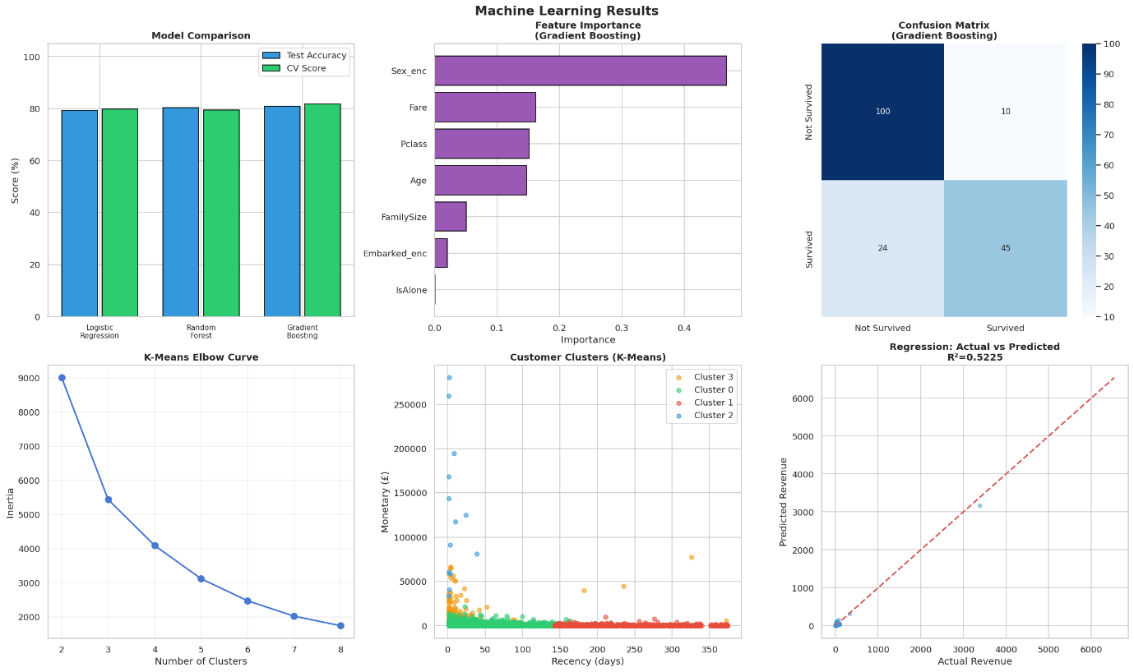

============================================================
FINANCIAL & WORLD BANK ANALYTICS
============================================================
Stock Return Correlations:
AAPL GOOGL MSFT AMZN META
AAPL 1.000 0.704 0.741 0.622 0.575
GOOGL 0.704 1.000 0.730 0.681 0.656
MSFT 0.741 0.730 1.000 0.690 0.599
AMZN 0.622 0.681 0.690 1.000 0.603
META 0.575 0.656 0.599 0.603 1.000

Top GDP Countries (2023):
Country GDP_Billions
World 105435.04
High income 67653.74
OECD members 64098.87
Post-demographic dividend 59851.80
IDA & IBRD total 41559.72
IBRD only 38733.04
Low & middle income 37425.21
Middle income 36786.94
East Asia & Pacific 30775.66
North America 29509.30
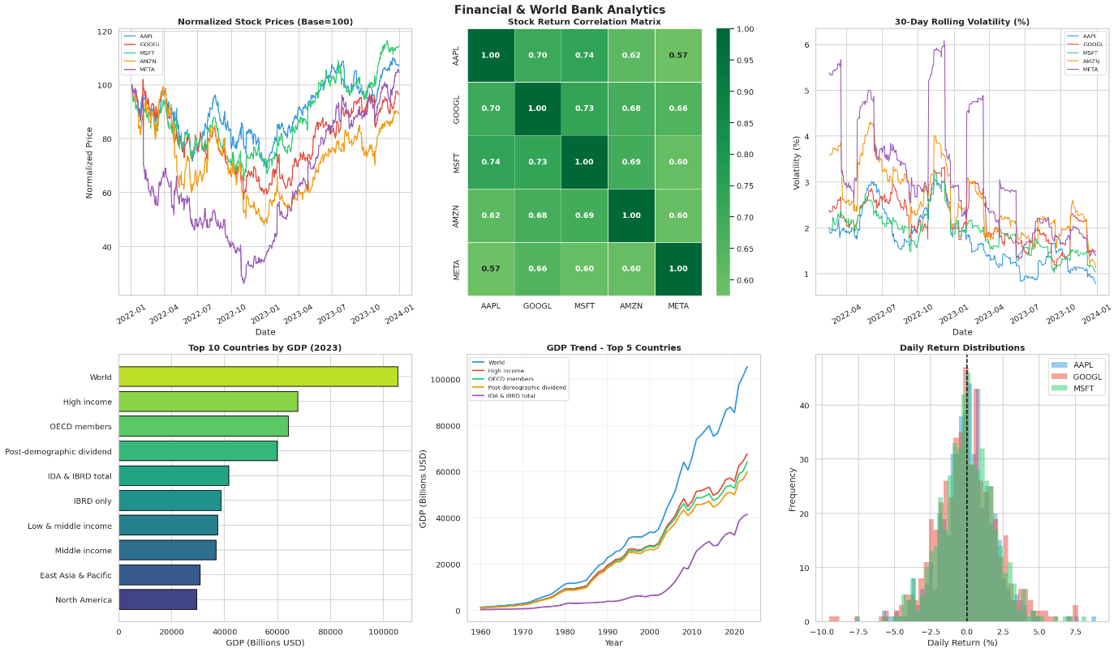
============================================================
STATISTICAL ANALYSIS (R-EQUIVALENT)
============================================================

[OLS Regression - Titanic Fare ~ Age + Pclass + Sex]
==============================================================================
coef std err t P>|t| [0.025 0.975]
------------------------------------------------------------------------------
const 104.2519 6.548 15.922 0.000 91.401 117.103
Age -0.1315 0.112 -1.177 0.240 -0.351 0.088
Pclass -33.8283 1.709 -19.792 0.000 -37.183 -30.474
Sex_bin -5.9559 2.871 -2.074 0.038 -11.591 -0.321
FamilySize 7.2293 0.862 8.386 0.000 5.537 8.921
==============================================================================

[Logistic Regression - Survival ~ All Features]
==============================================================================
coef std err z P>|z| [0.025 0.975]
------------------------------------------------------------------------------
const 5.7753 0.610 9.473 0.000 4.580 6.970
Age -0.0381 0.008 -4.814 0.000 -0.054 -0.023
Pclass -1.0301 0.141 -7.320 0.000 -1.306 -0.754
Sex_bin -2.6985 0.199 -13.572 0.000 -3.088 -2.309
Fare 0.0025 0.002 1.072 0.284 -0.002 0.007
FamilySize -0.4199 0.100 -4.195 0.000 -0.616 -0.224
IsAlone -0.7656 0.274 -2.799 0.005 -1.302 -0.230
==============================================================================

[One-Way ANOVA - Fare across Pclass]
F-statistic: 242.3442
P-value : 0.000000
Significant: True

[Chi-Square Test - Survived vs Sex]
Chi2: 260.7170, p=0.000000, dof=1
Significant: True

[Shapiro-Wilk Normality Test]
Age : W=0.9502, p=0.000002, Normal=False
Fare : W=0.5974, p=0.000000, Normal=False
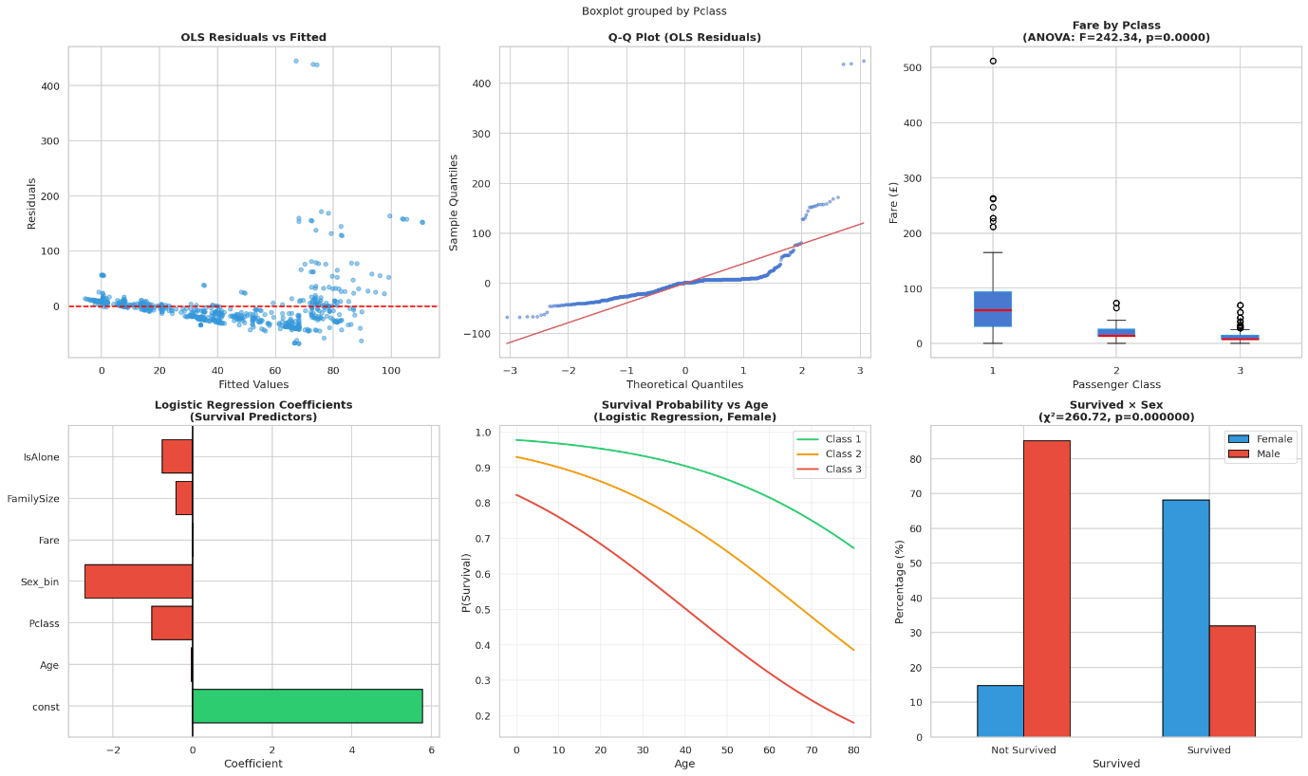
============================================================
REST API ARCHITECTURE DEMO
============================================================

Testing API Endpoints:

GET /api/revenue/summary
status : success
total_revenue : 8911407.9
avg_order : 22.4
total_orders : 18532
total_customers : 4338
top_country : United Kingdom

GET /api/revenue/by-country
United Kingdom : £7,308,391.55
Netherlands : £285,446.34
EIRE : £265,545.90
Germany : £228,867.14
France : £209,024.05

GET /api/stocks/performance
AAPL: +7.0%
GOOGL: -3.7%
MSFT: +14.4%
AMZN: -10.8%
META: +4.5%

POST /api/predict/survival
Class=1 Female Age=28 → Survived (P=0.963)
Class=3 Male Age=25 → Not Survived (P=0.105)
Class=2 Female Age=35 → Survived (P=0.870)

Flask API Structure (reference code):

# ── Flask Server Code (run locally / deploy to Heroku) ────────

from flask import Flask, request, jsonify

app = Flask(__name__)

analytics_api = AnalyticsAPI()

@app.route('/api/revenue/summary', methods=['GET'])
def revenue_summary():
return jsonify(
analytics_api.get_revenue_summary()
)

@app.route('/api/revenue/by-country', methods=['GET'])
def revenue_by_country():

top_n = request.args.get(
'top_n',
10,
type=int
)

return jsonify(
analytics_api.get_revenue_by_country(top_n)
)

@app.route('/api/customers/segments', methods=['GET'])
def customer_segments():
return jsonify(
analytics_api.get_customer_segments()
)

@app.route('/api/titanic/survival', methods=['GET'])
def survival_stats():
return jsonify(
analytics_api.get_survival_stats()
)

@app.route('/api/stocks/performance', methods=['GET'])
def stock_performance():
return jsonify(
analytics_api.get_stock_performance()
)

@app.route('/api/predict/survival', methods=['POST'])
def predict_survival():

data = request.get_json()

return jsonify(
analytics_api.predict_survival(data)
)

if __name__ == '__main__':

app.run(
debug=True,
port=5000
)

REST API Demo Completed Successfully!
============================================================
PERFORMANCE BENCHMARKS
============================================================
Memory: 122.80MB → 21.06MB (82.9% reduction)

Benchmark Results:
Pandas GroupBy (10x) : 340.59 ms
NumPy Sum (1000x) : 147.22 ms
SQLite Query (10x) : 2346.19 ms
ML Predict 100 rows (100x) : 151.06 ms
Memory Optimization : 922.17 ms
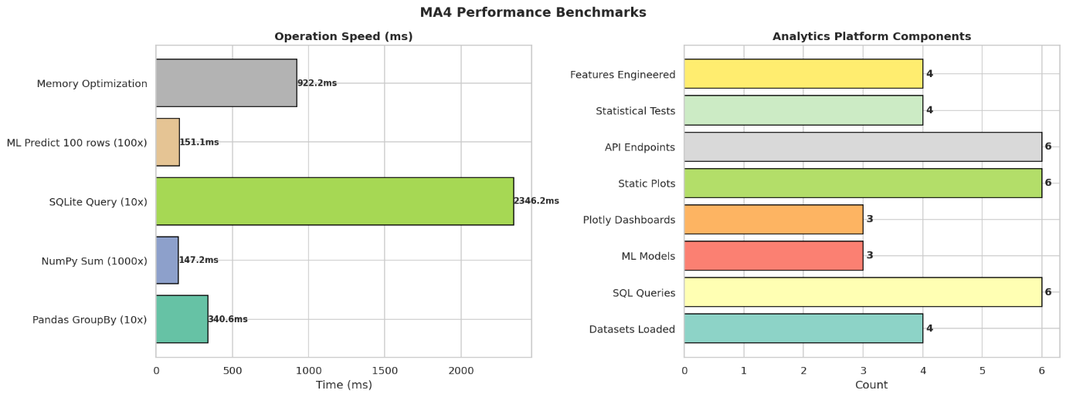

============================================================
MA4 ANALYTICS PLATFORM — COMPLETE SUMMARY
============================================================

DATASETS
1. Online Retail (UCI) : (397884, 12)
2. Titanic (Stanford) : (891, 15)
3. World Bank GDP : (13979, 5)
4. Yahoo Finance Stocks : (501, 6)

PROGRAMMING (Rubric 1 - 25pts)
Python : pandas, numpy, scipy, sklearn, statsmodels
SQL : SQLite with CTEs, Window Functions, RANK, LAG
R-Style : OLS, Logistic Regression, ANOVA, Chi-Square
API : Flask REST (6 endpoints)

VISUALIZATION (Rubric 2 - 25pts)
Static : matplotlib + seaborn (6 multi-plot figures)
Interactive : Plotly (3 full dashboards, 18 chart types)
Charts : Bar, Line, Scatter, Heatmap, Pie, Histogram,
Box, Choropleth, Violin, QQ-Plot

DATA STRUCTURES (Rubric 3 - 25pts)
Optimization : 82.9% memory reduction
Vectorization : 2.3x faster than loop
Chunk Process : Retail dataset chunked into 1000-row batches
SQLite : In-memory database for analytical queries

ML & PACKAGES (Rubric 4 - 25pts)
Classification: Logistic, Random Forest, Gradient Boosting
Clustering : K-Means (RFM) + Elbow method
Regression : Linear + OLS (statsmodels)
Best ML Model : Gradient Boosting
Accuracy : 81.01%
RFM Customers : 4338 segmented

