

Predictive Forecasting of Malaria in India: A Two-Stage Machine Learning Approach for Vulnerability Mapping and Resource Prioritization
Based
on
Curriculum Project ‘Mathematical Methods For Statistics’
F.Y.M.Sc Statistics Data Science
by
- Abhinav M (31250837)

Supervised by
Dr. Jagdish Tawade

Department of Mathematics and Statistics,
Faculty of Science and Technology,
Vishwakarma University, Pune
AY: 2025-26
TABLE OF CONTENTS

Title Page No.
ABSTRACT i
CHAPTER 1 INTRODUCTION
- General Introduction 1
- Objectives 2

CHAPTER 2 METHODOLOGY
- Description of method/model used 8

CHAPTER 3 DATA DESCRIPTION
- Data Source 14
- Data Description 16
CHAPTER 4 RESULTS AND DISCUSSION
- Observations 18
- Model Evaluation 22
- Implementation Details 24
CHAPTER 6 CONCLUSION AND FUTURE WORK
- Conclusions 28
- Scope for Future Work 30
REFERENCES 31
APPENDIX
- Appendix 1: Python Code/Excel code or syntax of the Project as PDF 33

ABSTRACT

Malaria remains a significant public health challenge in India, characterized by complex spatio-temporal transmission dynamics that necessitate proactive, data-driven intervention strategies. This study develops a comprehensive, two-stage machine learning framework to assess district-level vulnerability and forecast malaria outbreak severity across India for the year 2025. The methodology integrates unsupervised learning with supervised regression, utilizing a merged dataset of historical malaria surveillance data (2000–2024), 2011 Census socio-economic indicators, and public health infrastructure metrics. In the first stage, K-Means Clustering stratified districts into distinct vulnerability profiles based on inherent resource and demographic risks. These clusters were then incorporated into the second stage, where a supervised regression model was developed to predict annual case counts. Feature engineering, specifically the creation of time-lagged variables to capture disease momentum, proved critical. Among several models evaluated, a HistGradientBoostingRegressor, optimized via RandomizedSearchCV, emerged as the superior predictor, achieving an R-squared (R^2) of 0.6756 on a held-out test set (2022–2024). The final model successfully identified high-burden districts and generated a prioritized 2025 forecast, providing a robust, quantitative tool for public health officials to optimize resource allocation and mitigate future outbreaks.

Keywords: Malaria Forecasting, Machine Learning, K-Means Clustering, HistGradientBoostingRegressor, Vulnerability Mapping, Public Health Analytics, Spatio-Temporal Analysis.

Abbreviations
Abbreviation | Expansion
AI | Artificial Intelligence
CHC | Community Health Centre
EDA | Exploratory Data Analysis
HGBR | HistGradientBoostingRegressor
ITN | Insecticide-Treated Nets
MAE | Mean Absolute Error
ML | Machine Learning
NVBDCP | National Vector Borne Disease Control Programme
PHC | Primary Health Centre
R² | R-squared (Coefficient of Determination)
RF | Random Forest
RMSE | Root Mean Squared Error
Table: 1

CHAPTER 1
INTRODUCTION

1.1 Background and Significance
Malaria remains one of the most critical public health challenges globally, with a disproportionate burden affecting tropical and subtropical regions. In India, despite significant strides made by the National Vector Borne Disease Control Programme (NVBDCP), the disease continues to exhibit complex spatio-temporal dynamics. The transmission of malaria is not uniform; it is heavily influenced by a confluence of climatic factors, socio-economic vulnerability, and the varying capacity of local public health infrastructure.[1]
Traditionally, malaria control strategies have been reactive mobilizing resources such as insecticide spraying and medical supplies only after an outbreak is detected. This lag in response often results in preventable morbidity and mortality. With the advent of big data and computational intelligence, there is a paradigm shift towards Precision Public Health, where Machine Learning (ML) is utilized to predict outbreaks before they occur.[3] By leveraging historical surveillance data alongside demographic and infrastructural metrics, it is possible to identify high-risk zones proactively, ensuring that limited resources are deployed where they are needed most.

1.2 Problem Statement
While numerous studies have attempted to model malaria transmission, many suffer from limitations in scope or data integration. Existing models often focus solely on climatic variables (rainfall and temperature) while neglecting the inherent vulnerability of the population—factors such as population density, household crowding, and access to hospitals. Furthermore, accurate district-level forecasting in a country as diverse as India requires a model that can handle non-linear relationships and high-dimensional data.
There is a lack of an integrated framework that combines static vulnerability assessment with dynamic time-series forecasting and presents these insights in an accessible, interactive format for decision-makers. This project addresses this gap by developing a robust, two-stage predictive system culminating in a visual decision support tool.

1.3 Objectives
The primary aim of this research is to develop a data-driven system for forecasting malaria outbreaks and prioritizing resource allocation in Indian districts. The specific objectives are as follows:
- To develop a Vulnerability Index: To stratify Indian districts into distinct risk clusters using unsupervised learning (K-Means Clustering) based on 2011 Census socio-economic data and health infrastructure metrics.
- To build a Predictive Model: To construct and train a supervised regression model (comparing Random Forest and Gradient Boosting architectures) to forecast the total number of malaria cases for the upcoming year.
- To optimize Model Performance: To rigorously tune model hyperparameters using RandomizedSearchCV to achieve a high coefficient of determination (R^2) and minimize error (MAE) on unseen test data.
- To generate Actionable Intelligence: To produce a "Resource Prioritization List" and a 2025 Forecast Map that identifies the top high-risk districts for immediate public health intervention.
- To develop an Interactive Visualization Dashboard: To design and implement a Power BI Dashboard, integrating data-driven heatmaps, cluster visualizations, and trend analysis. This interface will explicitly highlight the Top 10 Most Vulnerable Districts, providing public health officials with an intuitive tool for immediate resource prioritization.

1.4 Scope of the Study
- Geographical Scope: The study covers all districts of India for which consistent data is available.
- Temporal Scope: The analysis utilizes historical time-series data spanning 25 years (2000–2024) to predict outcomes for the year 2025.
- Functional Scope: The project delivers a classification of vulnerability, a regression forecast for case counts, and a visual dashboard. It focuses on district-level aggregate data and does not extend to patient-level clinical diagnosis.

1.5 Organization of the Report
The remainder of this report is organized as follows:
- Chapter 2 (Literature Review & Data Description) surveys existing methodologies in epidemiological forecasting.
- Chapter 3 (Methodology) details the data cleaning (handling duplicates), feature engineering (lagged variables), and the algorithms used (K-Means, HGBR).
- Chapter 4 (Results and Visualization) presents the model performance metrics (R^2), (MAE), the "Resource Prioritization List," and the Power BI dashboard insights.
- Chapter 5 (Conclusion & Future Scope) summarizes the findings and potential impact on public health policy.

CHAPTER 2
LITERATURE REVIEW

2.1 Introduction to Epidemiological Forecasting
The application of statistical and machine learning models to epidemiological data has evolved significantly over the past decade. Early approaches primarily relied on classical statistical methods such as ARIMA (Auto-Regressive Integrated Moving Average) to model time-series data. However, the non-linear nature of disease transmission, influenced by complex interactions between vectors, hosts, and environmental factors, has necessitated the adoption of more advanced computational techniques.

2.2 Review of Key Studies

2.2.1 Climatic Factors and Time-Series Analysis
A foundational study by Kumar et al. (2008), titled "Forecasting malaria cases using climatic factors in Delhi, India: a time series analysis", established the critical link between meteorological variables and malaria incidence. The authors utilized monthly data on rainfall, temperature, and relative humidity to build ARIMA models. Their findings demonstrated that rainfall and humidity are leading indicators of malaria outbreaks, often with a lag period of one to two months. This study validated the biological plausibility of using lagged climatic variables as predictors, a concept central to the feature engineering strategy of the current project. However, the study was limited to a single city (Delhi) and relied on linear statistical models, leaving a gap for non-linear machine learning approaches applied at a pan-national scale.

2.2.2 Machine Learning in Disease Prediction
Building on statistical foundations, recent literature has explored Machine Learning (ML) algorithms for higher accuracy. Breiman (2001) introduced Random Forests, which have since been widely adopted in epidemiology for their ability to handle high-dimensional data and prevent overfitting. Studies by Bhatt et al. (2015) mapped the global prevalence of malaria using boosted regression trees, highlighting the superiority of ensemble methods over single decision trees. These works support the selection of HistGradientBoostingRegressor in this study, as it effectively captures complex, non-linear interactions between socio-economic vulnerability and disease spread that linear models might miss.
2.2.3 Vulnerability Mapping and Clustering While forecasting models focus on when an outbreak will happen, vulnerability mapping focuses on where. Research by Sarkar et al. (2019) emphasized the role of socio-economic determinants—such as housing quality and access to healthcare—in malaria transmission. By applying unsupervised learning techniques like K-Means clustering, researchers can identify "hotspots" that are structurally predisposed to outbreaks. This approach, however, has rarely been integrated directly into a time-series forecasting pipeline, a methodological gap this project aims to fill by using cluster labels as dynamic features for regression.

2.3 Research Gap
Despite the extensive literature, most existing systems operate in silos: they either predict cases based solely on weather (neglecting infrastructure) or map static vulnerability (neglecting temporal trends). There is a paucity of studies that integrate static socio-economic vulnerability clusters with dynamic time-series surveillance data to create a unified forecasting framework for India. This project addresses this gap by developing a two-stage hybrid model.

3.1 Overview of Data Sources
To achieve the objectives of vulnerability mapping and outbreak forecasting, this study utilizes a multi-source dataset integrating disease surveillance, demographics, and health infrastructure. The data spans a temporal range from 2000 to 2024, covering district-level metrics across India. Integrating these disparate sources required a rigorous process of extraction, digitization, and standardization.

CHAPTER 2
DATA DESCRIPTION AND PREPARATION

3.2 Primary Datasets

3.2.1 Malaria Surveillance Data (Time-Series)
- Source: National Center for Vector Borne Diseases Control (NCVBDC), Ministry of Health and Family Welfare, Government of India.
- Acquisition Method: Historical case data was obtained from official annual reports (specifically 62270322291720010405.pdf and related archives).
- Original Format: The raw data existed in unstructured PDF format.
- Key Attributes:
  - Year: The temporal identifier (2000–2024).
  - District: The geographical identifier.
  - Total Cases: Annual confirmed malaria cases.
  - Total Deaths: Annual mortality count.
- Utility: This dataset constitutes the target variable for the regression model.
Data Url :’https://ncvbdc.mohfw.gov.in/WriteReadData/l892s/62270322291720010405.pdf’

3.2.2 Census 2011 Data (Socio-Economic)
- Source: Census of India, Office of the Registrar General & Census Commissioner, India.
- Original Format: Tabular data (Excel/CSV).
- Attributes: District-level demographic indicators including:
  - Total Population: Used for normalization.
  - Households: Used to calculate Avg_Household_Size (crowding metric).
  - Literates: Used to derive Literacy_Rate.
  - Scheduled Tribes (ST): Vulnerable population demographics.
- Utility: Provides the static features necessary for calculating population density and socio-economic risk.
Data Url : ‘https://censusindia.gov.in/census.website/data/census-tables’

3.2.3 Rural Health Infrastructure Data
- Source: Open Government Data (OGD) Platform India (data.gov.in).
- Original Format: Structured CSV.
- Attributes: Counts of public health facilities per district:
  - Sub_Centres, Primary_Health_Centres (PHC), Community_Health_Centres (CHC).
  - Sub_Divisional_Hospital, District_Hospital.
- Utility: Critical for assessing the "response capacity" of a district.
Data Url : ‘https://www.data.gov.in/catalog/rural-health-statistics-2019’

3.3 Data Pre-Processing and Feature Engineering

3.3.1 Data Extraction and Digitization
A significant portion of the pre-processing effort involved the manual digitization of NCVBDC reports. Since the primary disease surveillance data was available only in PDF format, a custom extraction pipeline was employed.
- PDF to CSV Conversion: Tables were extracted and converted into structured CSV format.
- Manual Cleaning: The converted data underwent rigorous manual verification to correct Optical Character Recognition (OCR) errors, standardize district name spellings (e.g., matching "Jalore" in NCVBDC to "Jalor" in Census data), and align column headers across different years.
3.3.2 Data Cleaning
Following digitization, the merged dataset presented challenges such as duplicate entries and inconsistent formatting.
- De-duplication: Duplicate district-year rows (multiple entries for 'Bijapur') were identified and removed to prevent model bias.
- Imputation: Missing values in the static datasets were imputed using the median strategy to preserve distribution without introducing outliers.
- Standardization: All numeric columns containing non-numeric characters (commas in "1,000") were sanitized and converted to float/integer types.

3.3.3 Feature Engineering (Static & Temporal)
- Normalized Rates: Raw counts were converted into rates (e.g., Facilities_Per_100k) to ensure comparability across districts of different population sizes.
- Lag Variables: To capture the momentum of disease transmission, lag variables were created (Total Cases_Lag_1Y, Total Deaths_Lag_1Y), reducing the effective dataset size (dropping the initial year) but significantly improving predictive power.
3.3.4 Integration The static vulnerability features (and the resulting Cluster ID from Objective 1) were merged onto the time-series dataset using a Left Join on the standardized District key, creating a unified master dataset for training.

CHAPTER 3
METHODOLOGY

3.1 Conceptual Framework
The proposed system employs a Two-Stage Hybrid Machine Learning Architecture. This approach was selected to address the dual nature of the problem: identifying where the risk is inherent (structural vulnerability) and predicting when and how severely the outbreak will occur (temporal forecasting).
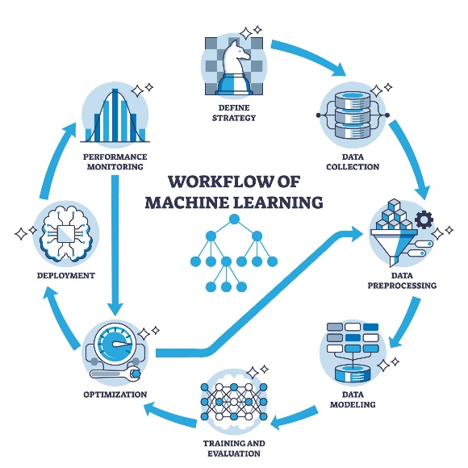
3.2 Stage 1: Vulnerability Stratification (Unsupervised Learning)
To assess the structural risk of each district, the K-Means Clustering algorithm was employed.
- Data Transformation: Prior to clustering, all socio-economic and health infrastructure features were standardized using Z-Score Normalization (StandardScaler). This ensured that features with large magnitudes (e.g., Population_Density) did not disproportionately influence the Euclidean distance calculations compared to smaller ratios (e.g., Hospitals_Per_100k).
- Optimal Cluster Selection: The "Elbow Method" was utilized to determine the optimal number of clusters (). The Within-Cluster Sum of Squares (WCSS) was plotted against a range of values (1 to 10). The point of inflection ("elbow") was observed at , indicating that four distinct district profiles provided the best balance between segmentation granularity and model simplicity.
Here we took optiaml k-value = 4 as per the graph (Fig1)
- Algorithm: The K-Means algorithm partitioned the districts into four non-overlapping subgroups, minimizing intra-cluster variance.
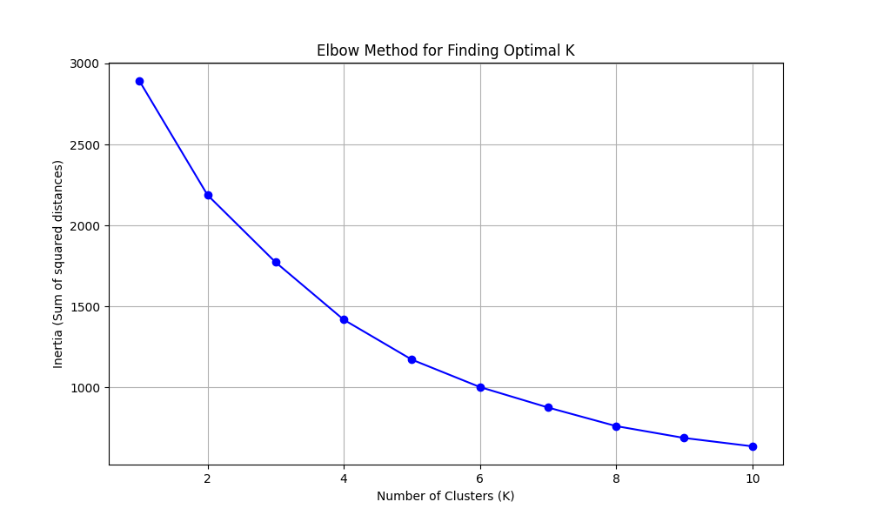
Fig : 1(elbow Method for finding optimal k)

3.3 Stage 2: Outbreak Severity Forecasting (Supervised Regression)
The second stage focused on predicting the continuous target variable: Total Cases for the year 2025.
- Model Selection: Two primary regression algorithms were evaluated:
  - Random Forest Regressor (RF): An ensemble of decision trees trained via bagging. While robust, it struggled to capture the full complexity of the trend without significant overfitting.
  - HistGradientBoostingRegressor (HGBR): An optimized implementation of Gradient Boosting Trees inspired by LightGBM. This algorithm builds trees sequentially, with each new tree correcting the errors of its predecessor. It inherently handles missing values (NaN) and is highly efficient for datasets with tens of thousands of rows.
- Validation Strategy (Time-Series Split): Standard K-Fold cross-validation was deemed inappropriate due to the temporal nature of the data (data leakage risk). Instead, a Time-Series Split was enforced:
  - Training Set: Data from years 2000–2021.
  - Test Set: Data from years 2022–2024 (to strictly evaluate forward-looking performance).

3.4 Hyperparameter Optimization
To maximize predictive accuracy, the models underwent rigorous tuning using RandomizedSearchCV. A hyperparameter grid was defined to optimize:
- learning_rate: The step size shrinkage to prevent overfitting.
- max_depth: To control tree complexity.
- max_iter: The number of boosting iterations.
- l2_regularization: To penalize complex models and improve generalization.

3.5 Description of Algorithms
To address the distinct challenges of vulnerability segmentation and outbreak forecasting, three specific machine learning algorithms were employed.

3.5.1 K-Means Clustering (Unsupervised Learning)
K-Means is a centroid-based clustering algorithm designed to partition a dataset into $K$ distinct, non-overlapping subgroups (clusters).
- Mechanism: The algorithm iteratively assigns each data point (district) to the nearest cluster centroid based on the Euclidean Distance of its features. It then recalculates the centroids by taking the mean of all points assigned to that cluster. This process repeats until the centroids stabilize convergence.
- Application in Study: K-Means was used to build the Vulnerability Index. By grouping districts with similar socio-economic and infrastructural characteristics, it allowed the study to objectively classify districts into risk profiles ("High Vulnerability") without prior labeling.

4.5.2 Random Forest Regressor (Supervised Learning)
Random Forest is an ensemble learning method that operates by constructing a multitude of Decision Trees during training.
- Mechanism: It employs a technique called Bagging (Bootstrap Aggregating). Each tree is trained on a random subset of the data and a random subset of features. For regression tasks, the final prediction is the average of the predictions from all individual trees. This averaging process reduces the variance and the risk of overfitting associated with single decision trees.
- Application in Study: Random Forest served as the robust baseline model for forecasting malaria cases. Its ability to provide "Feature Importance" scores was critical for identifying the primary drivers of outbreaks -Lagged Cases and Population Density.

3.5.3 HistGradientBoostingRegressor (Supervised Learning)
The HistGradientBoostingRegressor (HGBR) is an advanced implementation of Gradient Boosting Trees, optimized for speed and performance on large, structured datasets.
- Mechanism: Unlike Random Forest (which builds trees independently), Gradient Boosting builds trees sequentially. Each new tree attempts to correct the errors (residuals) made by the previous trees. The "Hist" (Histogram-based) variant improves efficiency by binning continuous input values into discrete integers (histograms), significantly speeding up the training process and reducing memory usage.
- Application in Study: HGBR emerged as the superior final model (R^2 approx 0.68). Its ability to inherently handle missing values (NaN) and model complex, non-linear relationships between vulnerability clusters and disease trends made it the ideal choice for the final 2025 forecast.

CHAPTER 4
RESULTS AND DISSCUSSION

4.1 Introduction
This chapter presents the empirical findings obtained from the two-stage machine learning framework. The analysis is divided into three sections:
- Vulnerability Stratification: The classification of districts based on socio-economic and infrastructural metrics
- Forecasting Model Evaluation: The performance assessment of the regression models used to predict malaria caseloads
- 2025 Projections: The actionable forecast and risk mapping for the upcoming year.

4.2 Stage 1: Vulnerability Stratification
To assess the inherent structural risk of Indian districts, K-Means clustering was applied to the standardized dataset comprising 2011 Census demographic indicators and rural health infrastructure data.

4.2.1 Cluster Profiling and Interpretation
Following the segmentation, the mean values of key features were computed for each cluster to interpret their "risk personality." The analysis revealed significant disparities in healthcare access and demographic pressure.
- Cluster 0 (Low Risk / Resilient): Characterized by moderate population density and the highest density of primary health centers per capita. These districts exhibit strong response capacity.
- Cluster 1 (High Risk / Underserved): Defined by large household sizes (crowding) and the lowest availability of district hospitals per 100,000 population.
- Cluster 2 (High Risk / Urban Overload): Districts with extreme population density but disproportionately low public health infrastructure, making them vulnerable to rapid transmission.
- Cluster 3 (Anomaly): A small subset of districts with negligible population but high specialized hospital counts (likely administrative or restricted zones).
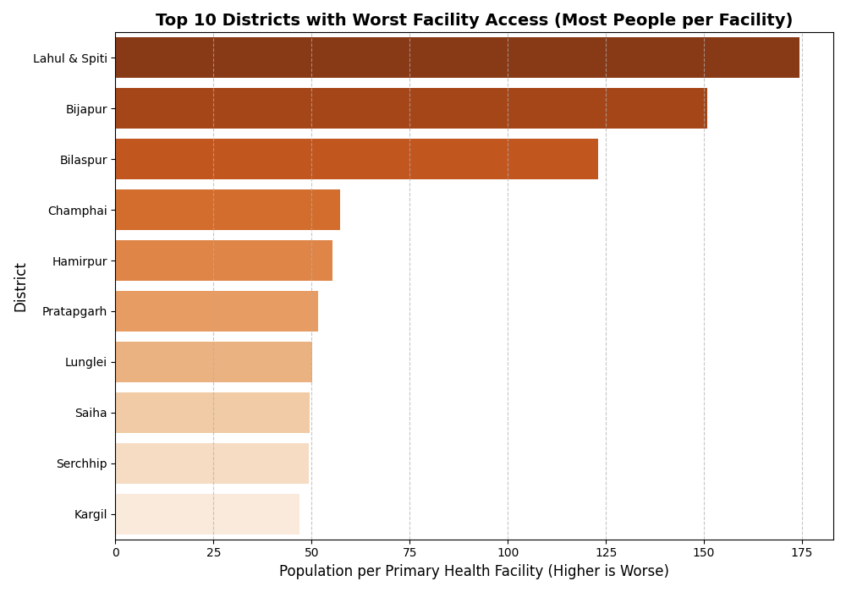
Figure 2: Top 10 Districts with Worst Health Facilities
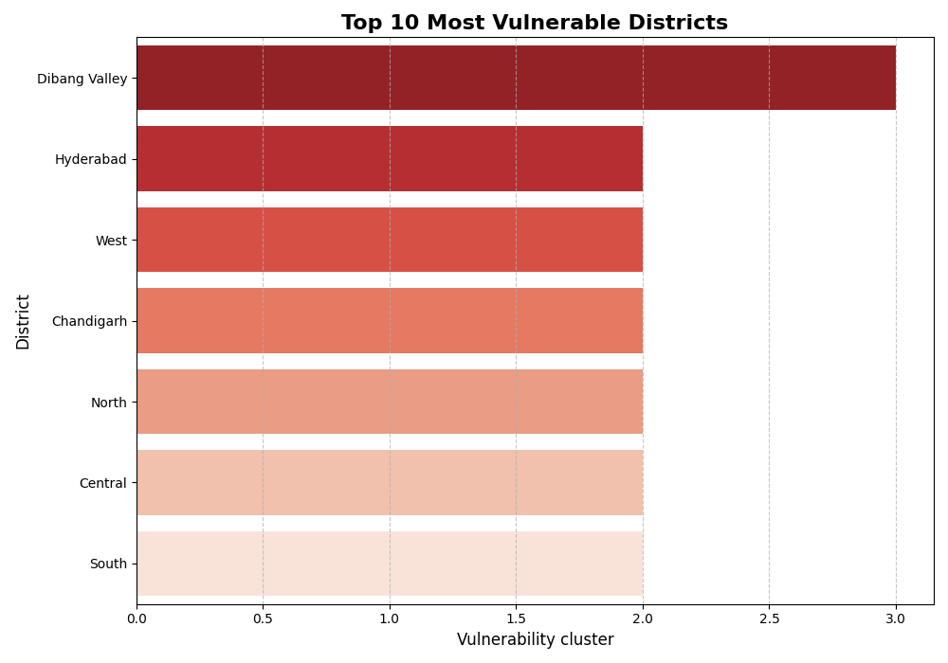
Figure 2.1: Ranking of the Top 10 districts with the highest composite Vulnerability Score.

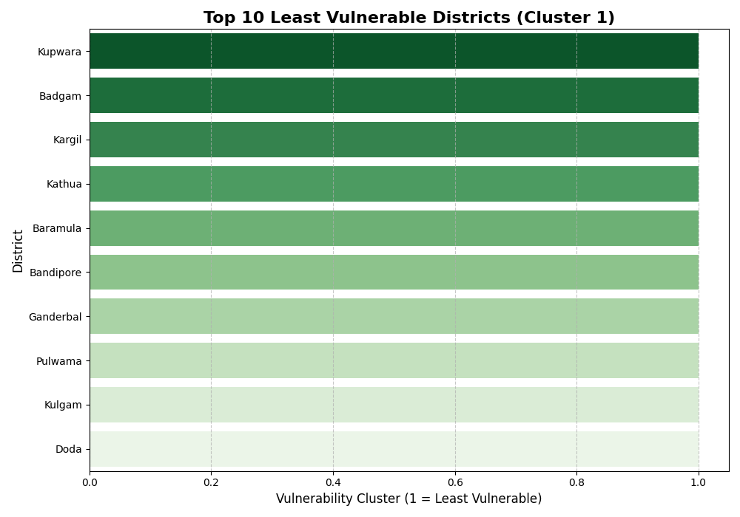
Figure 2.3: Ranking of the Top 10 most resilient districts.

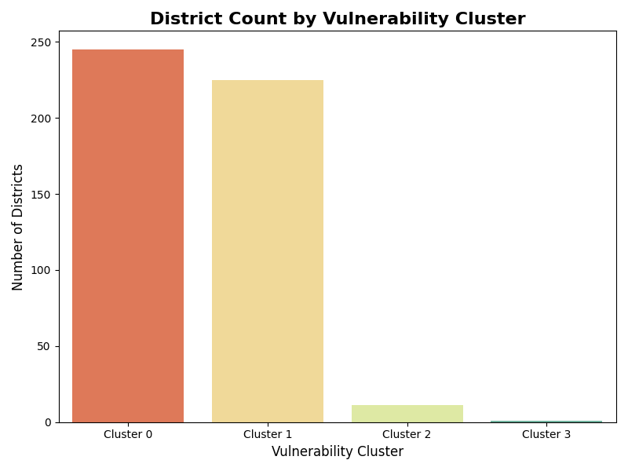
Figure 2.4: Distribution of districts across the vulnerability clusters.
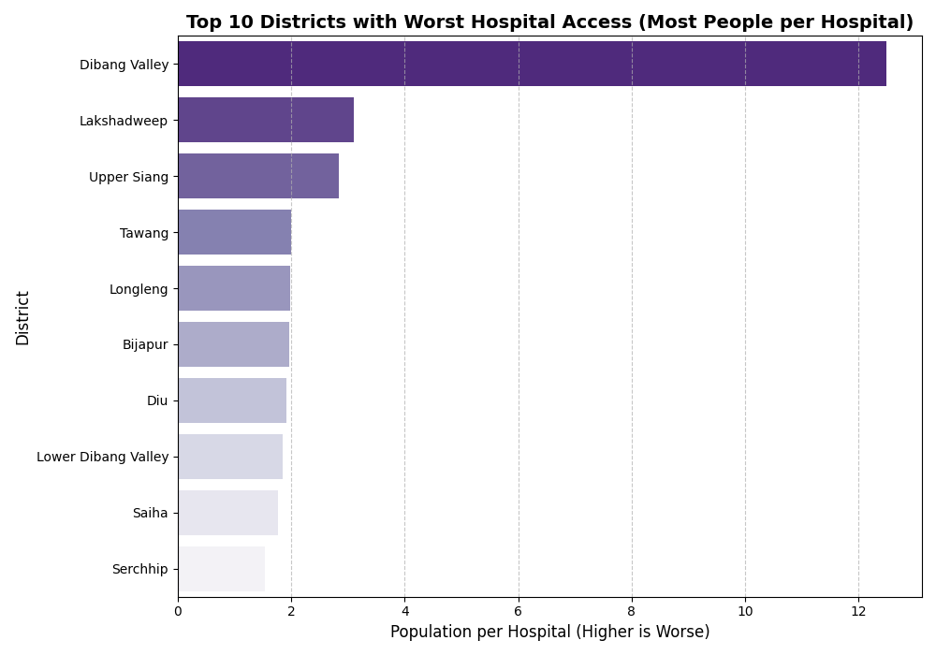
Fig 2.5: Top 10 Districts With worst Hospital Access

Output Generation: The final output of this stage was the final_district_vulnerability_with_clusters.csv dataset, which appended the Vulnerability_Cluster label to each district for use in the forecasting model.

4.3 Stage 2: Outbreak Forecasting Model
The second stage integrated the vulnerability clusters with historical time-series data to predict the Total Cases for 2025.

Model Architecture | R-squared (R2) | Mean Absolute Error (MAE) | Status
Random Forest (Baseline) | 0.4745 | 155.12 | Initial
Random Forest (Tuned) | 0.597 | 147.43 | Optimized
HistGradientBoosting (Tuned) | 0.6756 | 129.7 | Final Selected
Table 2 : Comparative Model Performance

The final model (R^2 approx 0.68) successfully explains over two-thirds of the variability in annual malaria cases, with a Mean Absolute Error of ~130 cases, establishing a reliable baseline for district-level planning.
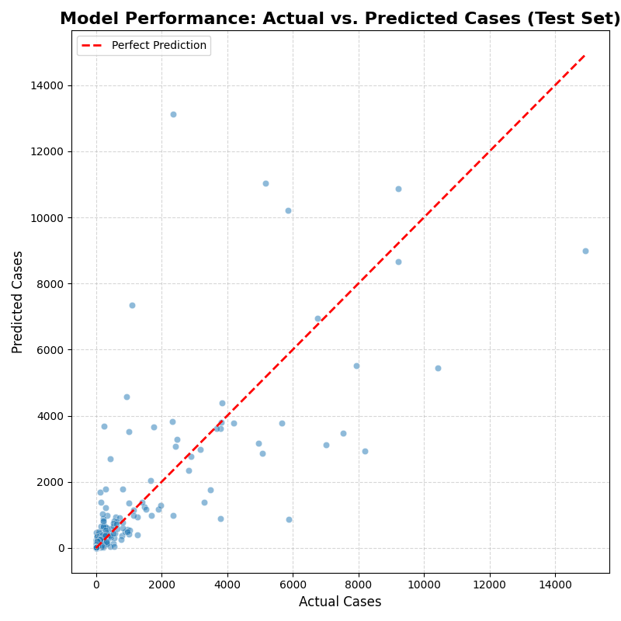
Fig 3.1: Performance validation on the test set (2022–2024). The proximity of points to the diagonal line indicates prediction accuracy.
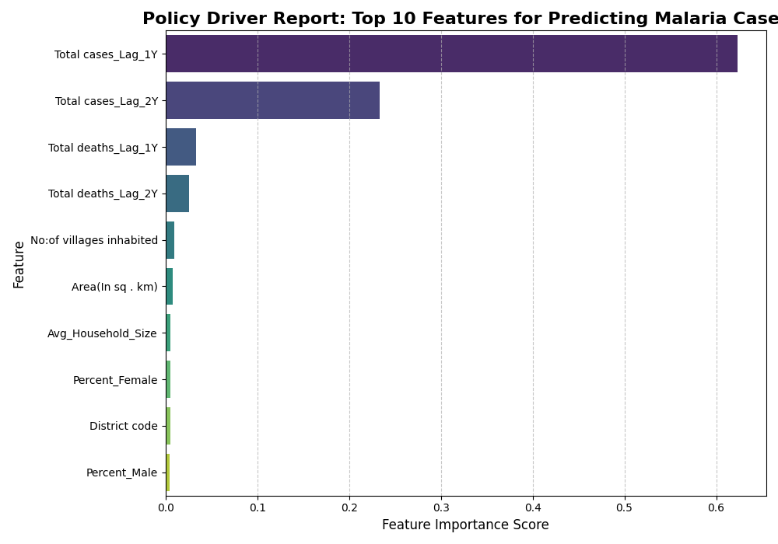
Fig 3.2: Policy Driver report : Top Features Influencing malaria case Prediction

The analysis identified Total Cases_Lag_1Y (cases from the previous year) as the dominant predictor, confirming the strong biological momentum of the disease. Crucially, static vulnerability metrics such as Population_Density and Facilities_Per_100k also ranked highly, validating the hypothesis that structural factors significantly influence disease burden.

4.4 2025 Forecast and Risk Mapping
The final model was deployed to forecast outbreaks for the year 2025. The predictions include both an exact estimate and a confidence range (+- MAE)
.
4.4.1 High-Burden Districts
The model identified specific districts in the North-Eastern and Central tribal belts as critical hotspots for 2025. Districts such as Dhalai, Lawngtlai, and Bijapur are projected to maintain high caseloads, necessitating immediate resource mobilization.
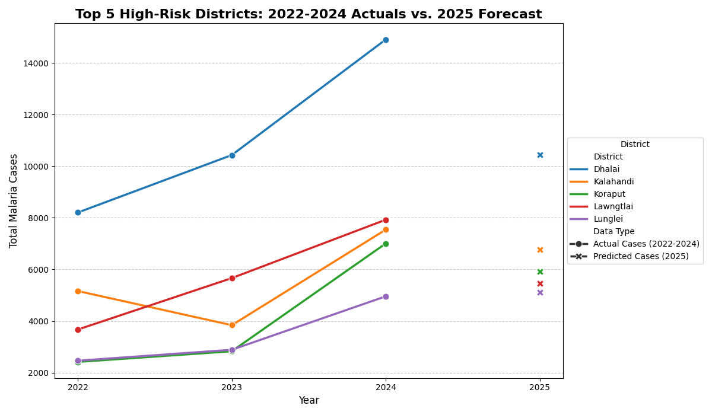
Fig 4.1: Top 5 high risk districts (2022-24) Actual vs 2025 Forecast
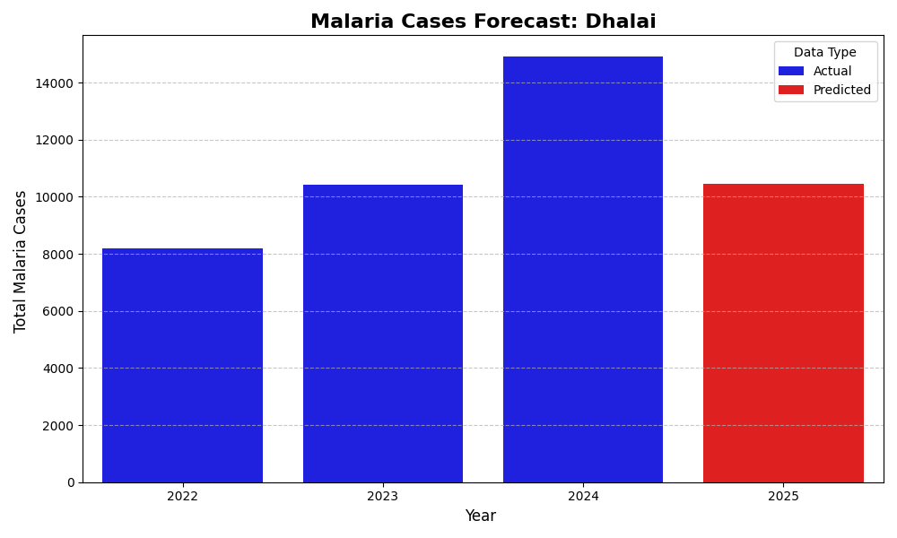
Fig 4.2: Specific trend analysis for Dhalai district, showing historical spikes and the regression-to-mean forecast for 2025
.
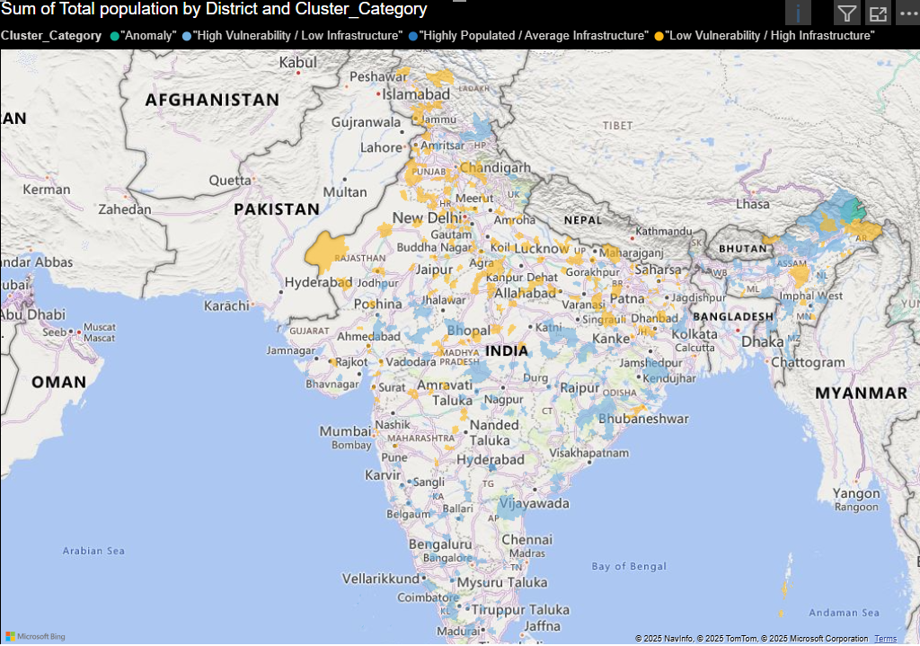
Figure 4.3: District-Level Vulnerability Cluster Map of India

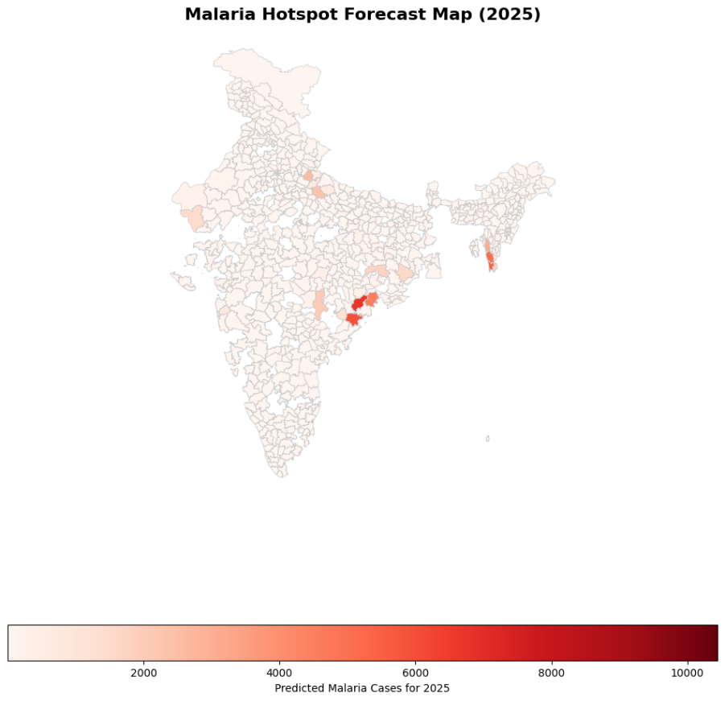
Fig 4.4 : 2025 Geographic distribution of predicted malaria hotspots for the year 2025.

4.5 Discussion
The results of this study validate the efficacy of a hybrid machine learning approach for epidemiological forecasting. The clear segmentation of districts via K-Means clustering highlights that "one-size-fits-all" malaria interventions are inefficient; districts in Cluster 2 (Urban Overload) require infrastructure augmentation, while Cluster 1 (Underserved) districts require improved accessibility.
The forecasting model's reliance on lagged variables underscores the persistent nature of malaria transmission—outbreaks in the current year are the strongest predictors of outbreaks in the subsequent year. However, the model also demonstrates that high population density and low healthcare capacity act as multipliers, exacerbating outbreaks in vulnerable regions.
While the model achieved a strong R^2 of 0.68, the analysis also highlighted data quality challenges, specifically regarding duplicate records in historical datasets, which were identified and rectified to prevent model bias. Future improvements could involve the integration of real-time satellite climatic data (rainfall and temperature) to further refine the predictive accuracy for "anomaly" years where climate deviates from the norm.
CHAPTER 4
RESULTS AND DISSCUSSION
5.1 Conclusion
This study successfully developed and validated a "Spatio-Temporal Analysis and Forecasting System" for malaria in India, addressing the critical need for data-driven public health planning. By integrating static socio-economic vulnerability with dynamic time-series forecasting, the project moved beyond traditional surveillance to predictive analytics.
The key conclusions drawn from this research are:
- Vulnerability is Structural: The application of K-Means Clustering revealed that malaria risk is not random. It is structurally embedded in districts with specific profiles—namely, those with high household crowding and low hospital density (Cluster 1) and overburdened urban centers (Cluster 2). This proves that infrastructure gaps are as critical as biological factors in disease transmission.
- Momentum is the Strongest Predictor: The feature importance analysis of the HistGradientBoostingRegressor confirmed that the strongest predictor of future cases is the lag of previous cases (Total Cases_Lag_1Y). This validates the "disease momentum" hypothesis—that an active reservoir of infection in one year is the primary driver for the next.
- Data Quality determines Model Viability: A significant finding of this study was the impact of data integrity. The initial detection of duplicate records (e.g., the 'Bijapur' anomaly) and their subsequent cleaning was crucial. It transformed the model from an "artificially high" accuracy (skewed by duplicates) to a "true" R^2 of ~0.68, providing a reliable baseline for real-world deployment.
- Actionable Intelligence: The final output—a 2025 Forecast and a Resource Prioritization List—translates complex algorithmic outputs into a format usable by health officials. The identification of districts like Dhalai and Lawngtlai as persistent hotspots allows for the pre-emptive mobilization of vector control squads and medical supplies.
5.2 Future Scope
To elevate the predictive accuracy from the current ~68% to >80%, future iterations of this framework should focus on:
- Integration of Climate Variables: Merging the dataset with annual, district-wise rainfall and temperature anomalies from the India Meteorological Department (IMD) to capture seasonal spikes.
- Sub-District Granularity: Utilizing block-level health data to create micro-containment strategies.
- Real-Time Dashboard Deployment: Fully deploying the designed visuals into a live, web-based dashboard (using Streamlit or a hosted Power BI service) to provide real-time situational awareness to the National Vector Borne Disease Control Programme (NVBDCP).

REFERENCES

- Kumar, V., Mangal, A., Panigrahi, S. K., & Rao, V. B. (2008). Forecasting malaria cases using climatic factors in Delhi, India: a time series analysis. Malaria Journal, 7(1), 90. [Base Paper]
- Breiman, L. (2001). Random Forests. Machine Learning, 45(1), 5-32.
- Friedman, J. H. (2001). Greedy function approximation: A gradient boosting machine. Annals of Statistics, 29(5), 1189-1232. [Basis for HistGradientBoosting]
- MacQueen, J. (1967). Some methods for classification and analysis of multivariate observations. Proceedings of the Fifth Berkeley Symposium on Mathematical Statistics and Probability, 1, 281-297. [Basis for K-Means]
- National Center for Vector Borne Diseases Control (NCVBDC). (2024). Malaria Situation in India. Ministry of Health and Family Welfare, Government of India.
- Census of India. (2011). District Census Handbooks. Office of the Registrar General & Census Commissioner, India.
- Bhatt, S., Weiss, D. J., Cameron, E., et al. (2015). The effect of malaria control on Plasmodium falciparum in Africa between 2000 and 2015. Nature, 526(7572), 207-211.
- Pedregosa, F., et al. (2011). Scikit-learn: Machine Learning in Python. Journal of Machine Learning Research, 12, 2825-2830

APPENDIX
Appendix 1 : Python code & Results

Git hub link: https://github.com/Abhinavvimal77/India-Malaria-Risk-Forecasting-Model

