Malarial Parasites Detection in RBC

Using Image Processing

Shipra Saraswat¹, Utkarsh Awasthi², Neetu Faujdar³

^{1,2,3}Amity University, CSE Department, Noida, Uttar Pradesh, India
¹sshipra1510@gmail.com, ²utkarshawasthi2396@gmail.com, ³neetu.faujdar@gmail.com

Abstract - The gold standard for the diagnosis of malaria is microscopy in which the blood slide is examined under a microscope, but the reliability, accuracy and timely diagnosis of the results are highly based on the proficiency of the technician examining the slide. False Detection can occur in the case of poorly skilled technician. In this research work we have proposed a system for automating the manual work done by a technician in order to cut down the human error and increasing the accuracy of the malaria diagnosis. The System is tested for a dataset of80 images of a thin blood smear. The infected cells are extracted using HSV segmentation. This approach will be beneficial for the rural areas, with a scarcity of experts.

Keywords - Malaria, RBCs, HSV segmentation, Image processing.

- INTRODUCTION

Malaria, the life threatening mosquito borne disease which took away the life of around 438,000 people in the year 2015 as an estimate by the World Health Organisation(WHO) .The disease which is caused by the parasitic protozoans of the type plasmodium. The Plasmodium Parasite is transmitted to the human blood through the bite of an infected female anopheles mosquito and travels directly to the liver and reproduce there. The parasites use the RBCs as host and reproduce asexually spreading the infection. The disease is widespread since the beginning of human history and has affected its population since then. World Health Organisation(WHO) claimedthat around half of the total population is at danger of malaria. Be that as it may, the worldwide topography of malaria is progressively unbalanced. By far most of malaria cases, malaria related deaths happen in sub -Saharan Africa, which is named as "the heartland of malaria” by the director-general of the WHO, Margaret Chan.

There are a number of techniques in order to diagnose malaria. All the techniques can be evaluated by their two features cost and performance. Both the features are directly proportional to each other, if the cost is high the performance is good and if the cost is low the performance is low.

Polymerase Chain Reaction (PCR) and Third harmonic generation (THG) belongs to the category of high cost and high performance. Through studies, it has been proved that both these techniques process high sensitivity and are very specific. However, due to their high cost, complex infrastructure and handling needs, they are not suitable for application in the malaria endemic regions. On the other hand,

Rapid diagnostic tests (RDTs) and microscopy are the low -cost methods. The gold standard for malaria diagnosis, the microscopy candetect the disease efficiently only if the technician diagnosing the slide is properly skilled, also it is a lot of time-consuming. RDTs are fast in comparison with the microscopy and can be operated by an unskilled person, but the results can be unreliable. Commercially available RDTs kits can detect a single Plasmodium parasite species and in the case, if a mixed infection is suspected, kits for all the species should be available, making the technique expensive.
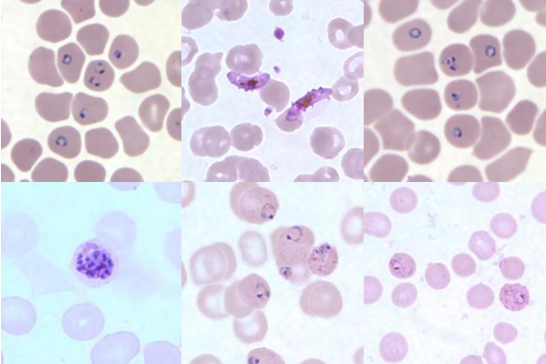

Fig. 1. Microscopic Examination of RBCs and

Plasmodium Parasites in thin blood films

Thus, an automatic approach is presented in order to minimize the cost and improve the performance of malaria diagnosis.

II. LITERATURE REVIEW

The work presented in the paper processes a blood image in order to detect and classify parasitemia in blood[1]. A statistical based approach is used in order to detect infected RBCs. Color, shape, and information of the size are used to separate the parasites. The images obtained finally are analysedstatistically in order to form a mathematical base. The shape and size of the nuclei is considered as well.

The Automated system based on image analysis “Malaria count” for parasitemia determination is presented in this paper is based on edge detection that represents cells and boundaries of parasites [2]. The system is based on the techniques including pre-processing, edge detection, linking of edge, clump splitting and detection of parasites. The methods start

978-1-5090-3012-5/17/$31.00 ©2017 IEEE

2017 6th International Conference on Reliability, Infocom Technologies and Optimization (ICRITO) (Trends and Future Directions), Sep. 20-22, 2017, AIIT, Amity University Uttar Pradesh, Noida, India

from pre-processing, that involves contrast enhancement followed by detection of edges. The system requirements are well separated and well stained cells for efficient results.

A framework for the WBCs segmentation by digital image processingis presented inSadeghian et al [3]. The process is divided into two parts. First the morphological analysis based nucleus segmentation and then pixel intensity based cytoplasm segmentation. A segmentation framework is presented which is an integration of several segmentation approaches. The dataset consists of 20 thin blood smear images. The accuracy of the nucleus and the cytoplasmic segmentation were 92 & 78 respectively. The presented framework has the ability to

and later the filtered image is enhanced by histogram equalization G. Theo et al [9]. The output is a pre-processed grayscale image.
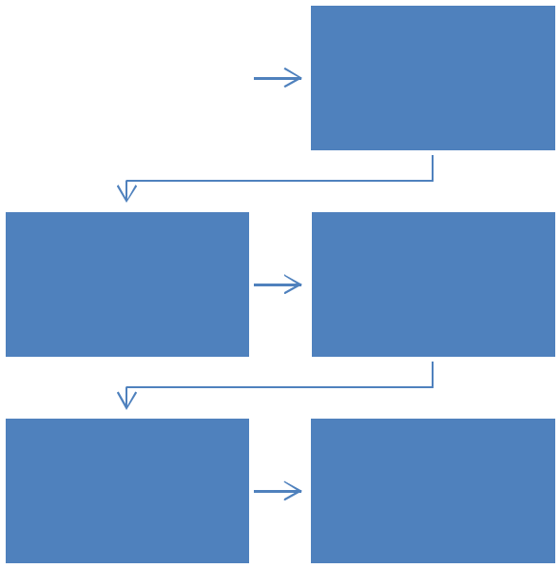

Image Acquisition | Image Pre-
Image Acquisition | Processing

extract the nucleus and cytoplasmic regions in a WBC sample image.

A morphological approach to cell segmentation is introduced by Ruberto et althat is accurate than watershed based algorithm. Non-flat disk shaped structuring elements proved to improve the normal watershed based algorithm whereas flat disk shaped structuring element separated the overlapping cells[4].The applied method is better than existing watershed segmentation.
Conversion In HUE
- VALUE Image

Enhanced Image
Extraction Of Blue
Pixel Values

Parasites Extracted

The work presented by Diaz et al. contributes to detecting the parasites of malaria by the support vector machineand artificial neural network [5]. The plan assesses a segmentation based on color to separate the pixels into 3 classes, parasite, RBCs and the background based on standard classification algorithms. KNN, Naïve Byes, SVM and ANN are four different techniques which are evaluated on different color spaces RGB, HSV, YCbCr the complex mix of colors that are presented in parasite makes the discrimination of pixels difficult.

The digital image of oil immersion view from microscopic slides captured through a capture card is done by Premaratnea[6]. The images were segmented and very converted into gray scale in order to minimize their dimensionality and then are fed into a fed forward back propagation neural network in order to train them as seen in work by K. Edwards [7].

III. METHODOLOGY

Fig.2. Methodology

3.3 Morphological Operations

In Image processing, morphological operations are the one that processes an image by applying a structuring element of a particular type and shape on the input image acting as amode for comparison. Majorly it includes dilation,erosion,opening and closing.Enlargement of the boundaries of regions of foreground pixels is done by dilation [10]. Erosion erodes the foreground pixel’s boundaries. Opening removes some foreground pixels from the edges of foreground pixel region. Closing enlarges the foreground pixel’s boundaries and basically do noise removal. The output image is created by applying a disk structuring element as the RBCs are almost circular in shape [11]. Morphological operations differentiate the cells from each other.

3.4 HSV Segmentation

The methodology consists of the following six steps:

3.1 Image Acquisition

In Image Acquisition step the input image is selected from the database. The database consists of 80 thin blood smear images collected from CDCand WEBMICROSCOPEAll the images are of equal size 300 X 300pixels. The database is browsed and an image is selected on which the further image processing operations are performed same as by S.Kamolrat [8].

3.2 Image Pre-processing

The acquired image from the database contains artifacts other than RBC’s like platelets and WBC’s. In order to remove these unwanted objects a 3*3 median filter is applied to the image

The image after a morphological operation is subjected to the segmentation.The RGB image is converted into HSV image and the three planes H, S, V are individually separated as seen by T. Sudhakar [12]. Color intensity of the red blood cells is different as compared to that of the infected cell, the infected cellsare purplish-blue in color. Thus,the blue pixel values of the regions infected with the parasites is obtained from the hue and value images. This isdone for a number of images in order to set a range for the blue pixel values in hue and value image as in work by V.Panchbhai et al [13]. The obtained bluepixels from the range are passed through the saturation image and are enhanced. The obtained image is thresholded with a proper threshold value thus extracting the parasitic regions. This property is used in order to differentiate the parasites from the RBC’s .

600

2017 6th International Conference on Reliability, Infocom Technologies and Optimization (ICRITO) (Trends and Future Directions), Sep. 20-22, 2017, AIIT, Amity University Uttar Pradesh, Noida, India

IV. RESULT AND ANALYSIS
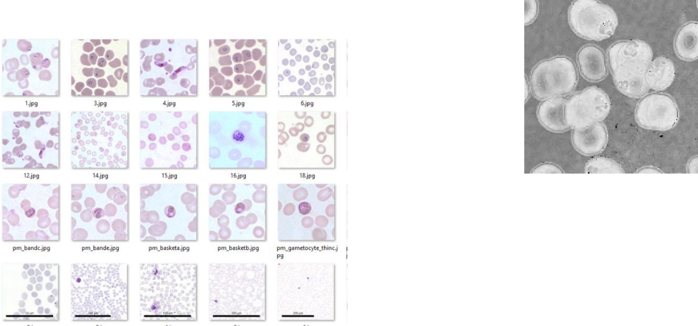

Fig. 6. HUE Output

Fig 6 illustrates, the output generated after converting the input image into hue image

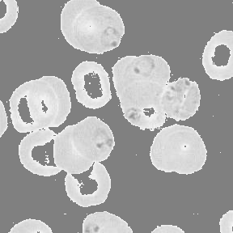

Fig. 3. Database

Fig 3 illustrates, the database consists of thin blood smear images collected from the sites CDC and WEBMICROSCOPE. The images in the dataset were resized to 300 X 300 dimensions.

Fig. 4. Input Image
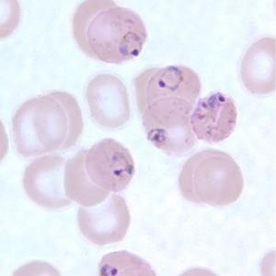

Fig 4 illustrates, one of the image selected from the database as input to our system for further processing [14].
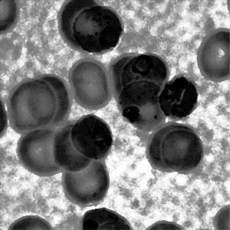

Fig. 5. Pre-processed Image

Fig. 7. VALUE Output

Fig 7 illustrates the output generated after converting the input image into value image
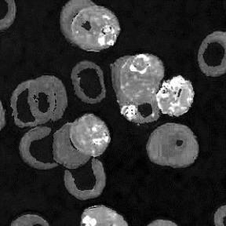

Fig. 8. Enhanced Image

Fig 8 illustrates, the output image generated after the enhancement of the blue pixel values.
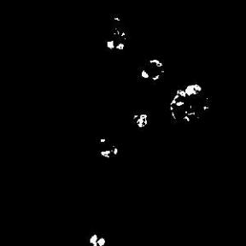

Fig 5 illustrates, the image generated after pre-processing the | Fig. 9. Extracted Parasites
input image Fig 4, which removed noise and enhanced it. | Fig 9 illustrates, the extracted regions containing the parasites.
 | 601

2017 6th International Conference on Reliability, Infocom Technologies and Optimization (ICRITO) (Trends and Future Directions), Sep. 20-22, 2017, AIIT, Amity University Uttar Pradesh, Noida, India

Fig. 10. System GUI
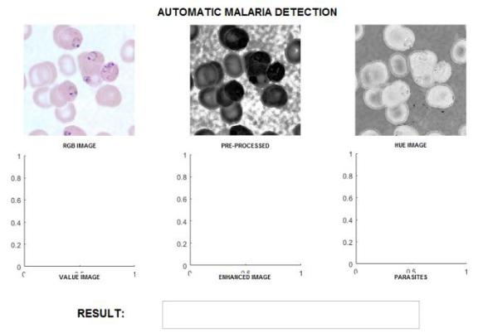

Fig 10 and Fig 11 illustrates the GUI developed using the GUIDE app of the image processing toolbox in Matlab.
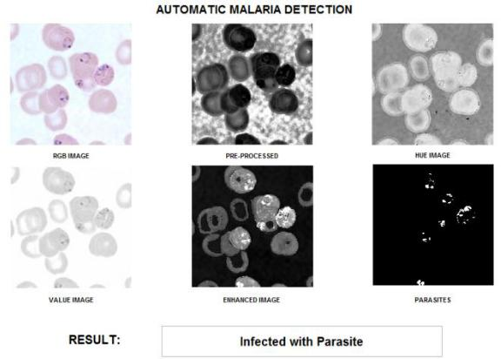

The developed system could pacify the issues that the field faced before in its dependence on technicians skill and diagnosis delay.The developed system in real scenario can become a boon to the medical field plus it could provide results as accurate as an expert. It could be advantageous in the regions where there is scarcity of proper technicians.

The two key points that persist as a challenge in the microscopic analysis of images, and of course were a challenge in this work. The sensitivity of the microscopic objects to the illumination and at the same time they are easily affected by change in setting made on the microscope. A multi– dimensional adaptation towards microscopic image analysis will bring a significant role in determining objects in different state. According to the researchers, future study should consider it to achieve better result in analysing microscopic image. Since health of biodegradable objects and diseases are variable in nature and with elapse of time new terminologies are surfaced, the research in this field is a continuous and a never ending process. Innovation of new methods with different properties and parameters of evaluation can help to cope up with new discoveries.

REFERENCES

[1] G.Diaz, A. Gonzalez, E.Romero, “A Semi-Automatic method for Quantification and Classification of Ethrocytes Infected with Malaria Parasites in Microscopic Images,”Journal of Biomedical
 |  |  | Informatics, Vol. 42, pp.296-307, 2009.
 |  | [2] Sio,W.S.S, et al, “MalariaCount:An image analysis-based
 |  |  | program for the accurate determination of parasitemia,” Journal
 |  |  | of Microbiological Methods, ISSN-0167-7012, vol. 68, issue 1,
 |  |  | pp. 11-18, 2007.
Fig. 11. GUI with results |  | [3] | F. Sadeghian, Z. Seman and A. R. Ramli, “A Framework for
Fig. 11. GUI with results |  |  | White Blood Cell Segmentation in Microscopic Blood Images
The system is developed using image processing toolbox of |  |  | Using Digital Image Processing,” Biological Procedures Online,
 |  |  | Vol. 11, no. 1, pp. 196-206, Dec. 2009.
Matlab. The system was tested for 80 sample images resulting |  | [4] | C. Di Ruberto, A. Dempster, S. Khan and B. Jarra,
in 98.5% sensitivity, 75% specificity, 95% | accuracy and |  | “Segmentation of blood images using morphological operators,”
95.7% ppv, which were calculated using equations (1), (2), (3) |  |  | Proceedings of 15th International Conference on Pattern
and (4) respectively. |  |  | Recognition Barcelona, Spain, Vol. 3, pp. 3401, 2000.
 |  | [5] Diaz G., Gonzalez F., Romero E, “Infected Cell Identification in
Sensitivity= TP/( + ) | (1) |  | thin Blood Images Based on Color Pixel Classification:
 |  |  | Comparison and Analysis,” CIARP-2007 Springer Berlin, pp.
Specificity= TN/( + ) | (2) |  | 812-821, 2007.
 |  | [6] S. P. Premaratnea, N. D. Karunaweerab and S. Fernandoc, “A
Accuracy= TP+TN(TP+FP+FN+TN) | (3) |  | Neural Network Architecture for Automated Recognition of
 |  |  | Intracellular Malaria Parasites in Stained Blood Films”, 2003.
=TP/( + ) | (4) | [7] | K.Edward, “Malaria Diagnosis in the Community:Challenges
 |  |  | and Potential Role of Rapid Diagnostic Tests (RDTs) in the
V. CONCLUSION |  |  | African Region,” African journal of Health Sciences, Vol.14,
 |  |  | pp.114-117,2007.

A Plasmodium parasites detection system by the use of thin blood smear stained with Giemsa is developed.The biggest drawback of the traditional microscopyis that it is dependence on the skills and experience of the technician, the time delay in manual counting has been solved. The use of an automated digital microscope would boost the diagnoses with high degree of certainty.

- S.Kamolrat “Standard Operating Procedure: Malaria Slide Management,” Mahidol Oxford University Research Program. Version 10.2013.

- V.Joost, G.Theo, G.Jan-Mark “Edge and Corner detection by Photometric Quasi-Invarints,” IEEE Transactions on Pattern Analysis and machine Intelligence, Vol.27, No.4,pp.625-630, 2005.

602

2017 6th International Conference on Reliability, Infocom Technologies and Optimization (ICRITO) (Trends and Future Directions), Sep. 20-22, 2017, AIIT, Amity University Uttar Pradesh, Noida, India

- WHO, “World Malaria Report,” Switzerland, 20 Avenue Appia, 1211 Geneva 27, 2015.
- The MaMic Image Database, “Thin smear blood samples for identification of Plasmodium Falciparum,” retrieved from
http://fimm.webmicroscope.net/research/momic/mamic, Last accessed on April,2017.

- T. Sudhakar, “Detection of Malaria Parasite in Blood Using Image processing,”,International Journal of engineering and innovative Technology(IJEIT), Vol.2, No.10, pp.124-126, 2013.

- V.Panchbhai, B. Damahe, V.Nagpure and N. Chopkar, “RBCs and Parasites Segmentation from thin Smear Blood cell Images,” Image, Graphics and signal Processing, Maharashtra, Vol.10, pp.54-60,2012.

- Center for Disease Control and Prevention, “Malaria sample images,” retrieved from http://www.cdc.gov/dpdx/malaria/ gallery.html#pfalringformtrophs, Last accessed on April, 2017

603

