Create SSL certificate

Buy a domain

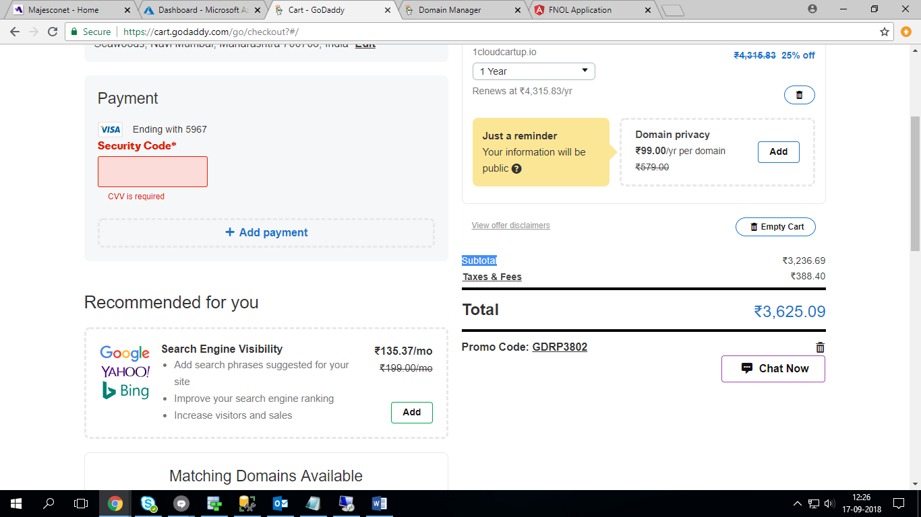

Update IP address

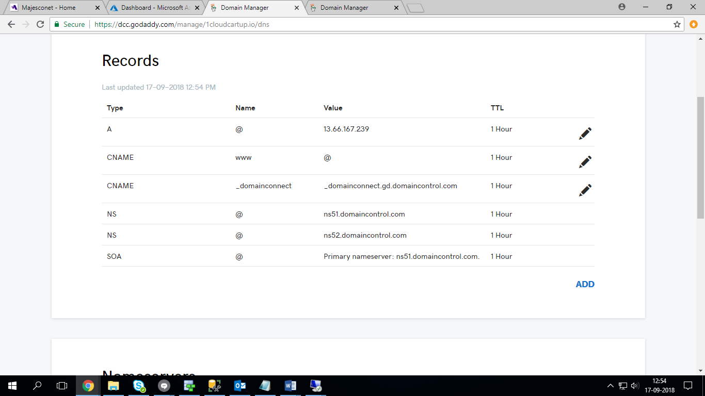

Add bindings on IIS with the domain name

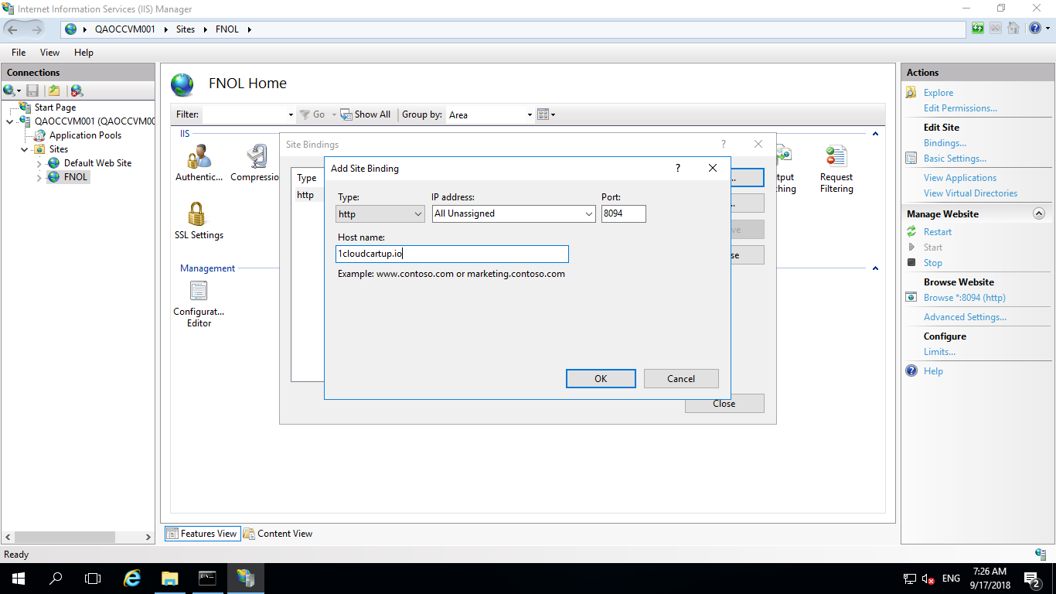

One default site should be running on port 80 before starting the process.

Download latest version of letsencrypt from the following URL:

<https://github.com/PKISharp/win-acme/releases>

unzip the folder and start the SSL creation process using powershell:

