EXECUTIVE PROJECT DOCUMENTATION
Employee Resource Management & Predictive Analytics Suite
People Analytics / HR Business Intelligence

Author | Tarimala Abhinay
Domain | People Analytics / HR Business Intelligence
Repository | https://github.com/Abhinay1503/AICTE-IBM-Data-Analytics-project.git
Project Status | Completed

1. Executive Summary
This project delivers an end-to-end data analytics and predictive pipeline designed to convert unstructured, raw HR operational data into a strategic business asset. Operating across a five-phase execution framework, the initiative addresses critical data quality issues, performs exploratory analysis, establishes an executive Power BI monitoring suite, applies statistical hypothesis testing to audit compensation practices, and evaluates predictive modeling feasibility using machine learning.

2. Project Architecture & Lifecycle
[Raw HR Data]
↓
[Phase 1: Python Wrangling]
↓
[Phase 2: Exploratory Analysis]
↓
[Phase 3: Power BI Dashboarding]
↓
[Phase 4: Statistical Testing]
↓
[Phase 5: Machine Learning]
↓
[Business Insights & Recommendations]

3. Detailed Phase Execution

Phase 1: Data Immersion & Wrangling
Objective: Clean, sanitize, and structure raw, survey-style employee data into an analysis-ready asset.
Technical Implementation:
- Processed raw input consisting of 38 records and 18 fields using Python (Pandas).
- Mapped verbose headers into standardized, programmatic field names, such as “Please enter your Dell Email ID” → Dell_Email.
- Repaired categorical inconsistencies and typos, including correction of “Anyalst” to “Analyst.”
- Enforced date-time conversion on text-based timestamps.
- Feature Engineering: Calculated Total_Compensation as Salary + Bonus to establish a holistic financial spend metric.
Deliverable: cleaned_employee_data.csv

Phase 2: Exploratory Data Analysis (EDA)
Objective: Uncover key distributional properties, cost centers, and demographic trends.
Tools & Libraries: Matplotlib, Seaborn, Pandas.
Key Visual Insights:
- Compensation Distribution: Evaluated right-skewed salary spreads across departments.
- Hierarchy Cost Analysis: Mapped total expenditure by job level, identifying Team Leads and Senior Executives as primary financial drivers.
- Demographic Equity: Constructed multi-variable boxplots assessing gender distribution across compensation bands and job levels.

Phase 3: Interactive Dashboarding
Objective: Establish a dynamic “Single Source of Truth” for executive decision-makers.
Toolstack: Power BI Desktop, Power Query, DAX.
Core Dashboard Features:
- KPI Cards: Real-time visibility into Total Spend, Headcount, and Average Bonus.
- Departmental Slicers: Interactive filtering by Team, Manager, and Quarter.
- Diversity & Inclusion Visuals: Comparative view of gender representation across organizational tiers.

Phase 4: Statistical Validation & Hypothesis Testing
Objective: Apply statistical rigor to confirm or refute visual trends observed during EDA.
Business Question: Does physical attendance status significantly drive bonus payouts?
Methodology: Independent Two-Sample T-Test via scipy.stats.
Statistical Output:
- T-Statistic: 0.0479
- P-Value: 0.9620 (α = 0.05)
Business Conclusion: Failed to reject the null hypothesis (H₀). Physical attendance has no statistically significant impact on bonus distribution in this sample. This result indicates that the observed bonus distributions do not provide statistical evidence of an attendance-based difference; other factors such as performance or role tier may warrant further analysis.

Phase 5: Machine Learning & Predictive Analytics
Objective: Build and evaluate a baseline regression model to forecast employee salaries based on organizational attributes.
Methodology:
- Encoded categorical attributes (Job_Level, Team) using One-Hot Encoding (pd.get_dummies).
- Partitioned the dataset into Training (80%) and Testing (20%) sets.
- Trained a Linear Regression model using scikit-learn.
Model Evaluation Metrics:
- Mean Absolute Error (MAE): $9,810.36
- R² Score: -0.4747
Analytical Interpretation:
- The negative R² score indicates that, on this test split, the linear model using Team and Job_Level did not explain salary variation better than a simple baseline.
- The small sample size (N=38) limits generalizability and makes model performance sensitive to the train/test split.
- The project therefore serves as a baseline study and indicates that additional features—such as tenure, performance ratings, prior domain experience, and other relevant compensation drivers—would be useful for future modeling.

4. Technical Stack Summary
Domain | Tools & Technologies
Language | Python 3.x, SQL, DAX
Data Manipulation | Pandas, NumPy
Data Visualization | Power BI, Seaborn, Matplotlib
Statistical Analysis | SciPy (scipy.stats)
Machine Learning | Scikit-Learn
Documentation & Versioning | Git, GitHub

5. Strategic Business Recommendations
- Focus on Outcome-Based Compensation: Given that the attendance test did not show a statistically significant difference in bonus distributions (p = 0.9620), HR can further evaluate performance-based KPIs alongside attendance measures when reviewing compensation practices.
- Expand Data Collection for Predictive HR: To enable more reliable automated salary benchmarking, future data collection should include variables such as Years of Experience, Projects Completed, Performance Review Ratings, tenure, and other relevant compensation factors.
- Automate Data Pipeline Ingestion: The Pandas cleaning script developed in Phase 1 can be converted into an automated ETL process to handle incoming survey batches before Power BI dashboard refresh cycles.

6. Project Outcomes
- Transformed raw survey-style HR data into a structured, analysis-ready dataset.
- Created exploratory analyses to identify compensation, hierarchy, and demographic patterns.
- Developed an interactive Power BI dashboard for HR monitoring and management reporting.
- Applied statistical hypothesis testing to evaluate an HR compensation question.
- Established a machine-learning baseline for salary prediction and documented its limitations.
- Defined practical next steps for data enrichment and ETL automation.
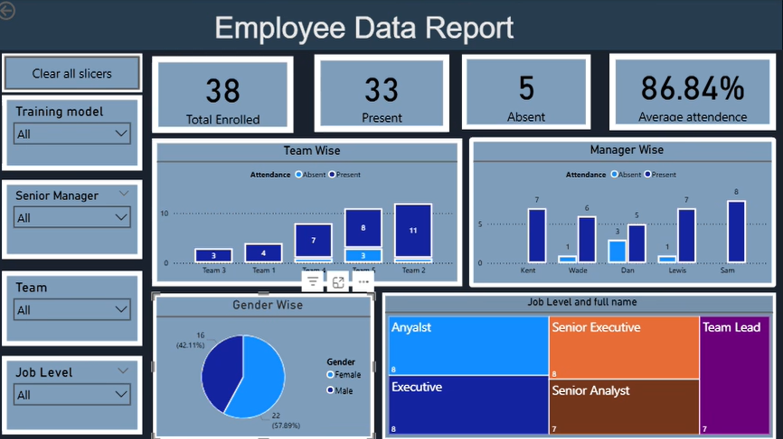

7. Conclusion
The Employee Resource Management & Predictive Analytics Suite demonstrates a complete analytics lifecycle—from raw HR data preparation through visualization, statistical validation, and predictive modeling. The project combines Python-based data engineering, Power BI business intelligence, statistical testing, and machine learning into a unified workflow. The current results provide a foundation for future iterations using larger datasets, richer employee attributes, automated ingestion, and more robust predictive models.

