**What is a sprint backlog?**

* A sprint backlog is a list of work items your team plans to complete during a project sprint.
* These items are usually pulled from the product backlog during the sprint planning session.
* A clear sprint backlog prevents scope creep by clarifying exactly what your team will be doing—and not doing—during each sprint.

**What Is a Product Backlog?**

* The product backlog is a list that compiles all the tasks and user stories that must be done to complete the whole project. But it’s not just a simple task list.
* An effective product backlog breaks down each of the backlog items into a series of steps that help the development team.

### **When should you use a sprint backlog?**

* You and your team will create a sprint backlog during your sprint planning meeting.
* The exact frequency will vary based on how long your sprints are, but you’ll likely be doing this every two weeks or once a month.
* If you're running the Scrum agile method, the [Scrum master](https://asana.com/resources/scrum-master)—with the help of the Scrum team—chooses product backlog items to tackle that week.
* If you're running a different form of Agile, this could be done by a [product owner](https://asana.com/resources/product-owner) or product manager.
* As the Scrum master or [product owner](https://asana.com/resources/product-owner), it’s responsibility to create the sprint backlog and distribute it to all project stakeholders. With the help of the product owner, you will choose backlog items based on priority.
* Then, document each task’s needs in the form of [user stories](https://asana.com/resources/user-stories). These are software features written from the perspective of the end user within a workflow.

### **Product backlog vs. sprint backlog**

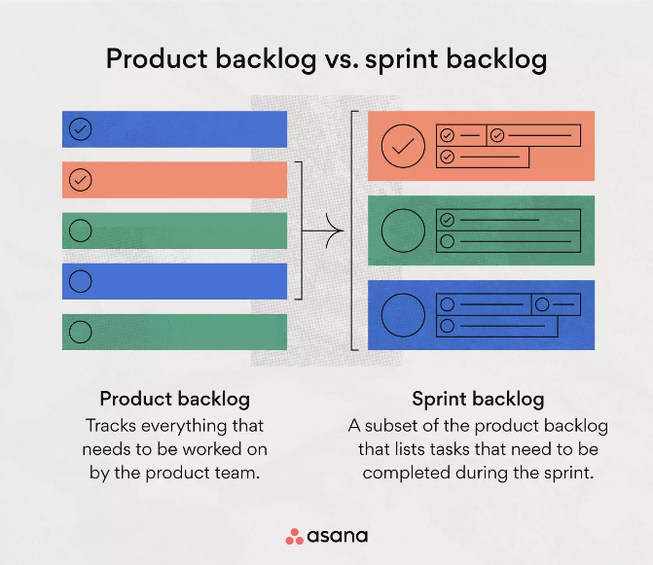

* A product backlog tracks what the product team works on.
* Depending on the size of your organization, you may have one central product backlog or multiple product backlogs for different teams.
* The product owner will refine the product backlog periodically to make sure the most important initiatives are at the top and each initiative has all of the information needed to execute against it.
* A sprint backlog is a subset of the product backlog and lists the work items to complete in one specific sprint.
* The purpose of the sprint backlog is to identify items from the product backlog that the team will work on during the sprint. This occurs during the sprint planning process.
* These items move from the product backlog into the sprint backlog and shouldn’t change once the sprint begins.

## What’s included in a sprint backlog?

* A sprint backlog should include important components like user stories and task descriptions.

**EXAMPLE OF A SPRINT PLANNING AND BACKLOG PROJECT**

For Reference:- [**https://asana.com/resources/sprint-backlog**](https://asana.com/resources/sprint-backlog)