## What is scrum?

* Scrum is an [agile project management](https://www.atlassian.com/agile/project-management) framework that helps teams structure and manage their work through a set of values, principles, and practices.
* scrum encourages teams to learn through experiences, self-organize while working on a problem, and reflect on their wins and losses to continuously improve.
* most frequently used by software development teams, its principles and lessons can be applied to all kinds of teamwork.

**why is it called Scrum?**

* It is actually inspired by a scrum in the sport of rugby. In rugby, the team comes together in what they call a scrum to work together to move the ball forward.
* **Scrum** has three pillars:

1. **Transparency:**

* Sprint Backlog: This dynamic list encompasses tasks committed to within a sprint, fostering clarity on the team's focus.
* Product Backlog: A prioritized catalog of features and requirements, aligning the team with project goals.
* Sprint Review: A platform to showcase accomplished work, enabling stakeholders to evaluate and provide valuable feedback.
* Definition of Done (DoD): A crystal-clear set of criteria that define task completion, eliminating ambiguity.

1. **Inspection :** **Sprint Planning, Daily Stand-ups, Sprint Review,** **Sprint Retrospective**
2. **Adaptation:** Adaptation, the third core principle of Scrum, goes hand-in-hand with inspection. Once the team has inspected the product and process, they adapt their strategies based on the insights gained.

The **Scrum Values** of

* **Courage**
* **Focus**
* **Commitment**
* **Respect**
* **Openness**,

Are all important elements that Scrum Team members must consider when working together.

## What is a Scrum master?

* A Scrum master is the leader of the Scrum team. They’re in charge of establishing the [Scrum methodology](https://asana.com/resources/what-is-scrum) and keeping team members focused on Scrum principles and practices.
* Scrum masters are often people-oriented and enjoy helping team members grow and improve.
* Scrum masters act as servant leaders. Instead of telling your team what to do, job is to help the team become self-reliant through techniques like self-organization and [conflict resolution](https://asana.com/resources/conflict-resolution-strategies).
* Unlike a traditional project manager, whose goal is to keep the team and project on track, SM goal also includes keeping the team aligned with the Scrum model.

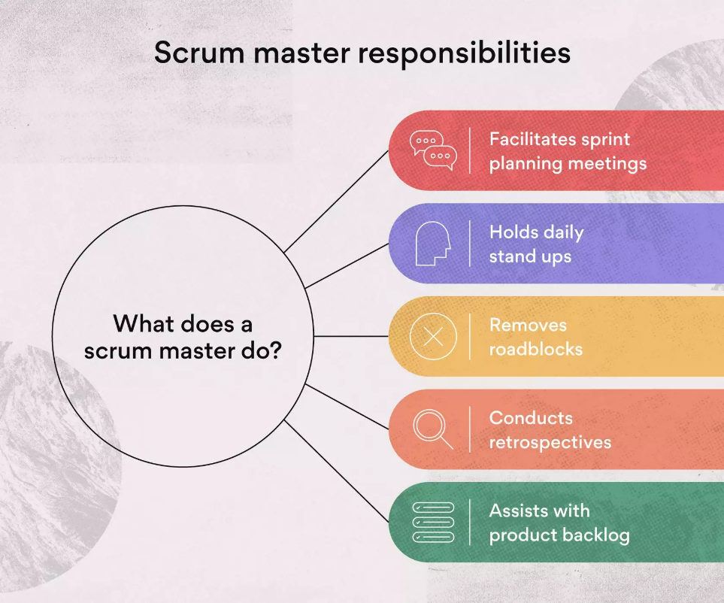

### **1. Facilitates sprint planning meetings**

* Sprint planning meetings help your Scrum team decide which items from the [product backlog](https://asana.com/resources/product-backlog) to prioritize for the next sprint.
* These meetings are [collaborative](https://asana.com/resources/team-collaboration-tips)—they typically involve the Scrum master, product manager, and the team of developers, who are all encouraged to speak up.

During a typical sprint planning meeting agenda, the Scrum team:

* Comes prepared with data and estimates to support your next sprint project.
* Confirms estimates for items on the sprint product backlog.
* Agrees on the product backlog items for the next sprint.
* Assesses the team’s capacity for the next sprint.
* Ends the meeting with a Q&A session.

These meetings emphasize collaboration, giving developers a chance to address what tasks they think deserve the most attention.

### **2. Holds daily stand-up meetings**

Daily Scrum stand-up meetings are an essential part of the Scrum framework and will be your responsibility as Scrum master. As the Scrum master, you’ll facilitate these meetings and use them to assess progress toward the sprint goal. The main questions asked in daily stand-ups include:

* What did you do yesterday?
* What will you do today?
* Is anything blocking your progress?

### **3. Removes roadblocks**

* [Problem-solving](https://asana.com/resources/problem-solving-strategies) is a key quality of any good Scrum master. As the leader of your Agile team, you’ll want to move the project along as quickly as possible and make it easier for your team members to get their work done.
* If you notice impediments that are blocking the work, your job is to solve the issue or find someone who can. A potential roadblock, for example, may include a lack of understanding between Agile teams and stakeholders. The Scrum master can solve this issue by inviting stakeholders to a few planning sessions so they’re more aware of how to be Agile.

### **4. Assists with product backlog**

* Scrum masters are leaders and team members.
* When there’s time to spare, they help developer team work through the product backlog. The product backlog may involve features, tasks, bug fixes, [technical debt](https://asana.com/resources/technical-debt), or knowledge acquisition.
* Because they have ample knowledge of Scrum and product development, they can jump in to help your fellow team members.

### **5. Conducts retrospectives**

Retrospectives are sprint review meetings held after each sprint to evaluate what went well and what didn’t. These meetings give Scrum team members a chance to identify areas for improvement during future sprints. Some questions to ask during the retrospective include:

* How did you do this sprint?
* Where and when did it go wrong in this sprint
* Which tools or techniques proved to be useful? If you could change one thing, what would it be?

## What is a sprint retrospective?

* A sprint retrospective is a review conducted after a sprint that plays a key role in the [Agile methodology](https://www.atlassian.com/agile).
* A sprint retrospective aims to determine what went well and where you had problems and identify areas where you can improve.
* Regular reviews are an essential part of [team collaboration](https://www.atlassian.com/work-management/project-collaboration/collaborative-culture/team-collaboration). By understanding what works and what doesn’t, you can improve Agile processes to simplify your next sprint.

## Who should attend a sprint retrospective meeting?

* Your sprint retrospective meeting should include the product owner, the [Scrum](https://www.atlassian.com/agile/scrum) team, the Scrum Master, and stakeholders.
* During a sprint retrospective meeting, it’s good to have a diverse array of perspectives in the room.
* Everyone can work together to analyze your latest sprint and determine what changes you need to make before starting the next portion of your project.

## Who is a Product Owner?

* A [product owner](https://www.simplilearn.com/professional-scrum-product-owner-pspo-certification-training-course) is responsible for ensuring the success of a project in Scrum. The product owner is responsible for managing and optimizing the product backlog in order to maximize the value of the product.
* A Scrum framework is an [Agile methodology](https://www.simplilearn.com/benefits-of-agile-methodology-article) that facilitates communication and self-organization within a team.
* A Product Owner is part of the [scrum team](https://www.simplilearn.com/what-is-scrum-team-article).
* The key responsibilities of a Product Owner are to define user stories and create a product backlog.
* The Product Owner is the primary point of contact on behalf of the customer to identify the[product requirements](https://www.simplilearn.com/what-is-requirement-analysis-article) for the development team.
* This product backlog will be a prioritized set of customer requirements. The Product Owner has the complete responsibility and ownership of defining and even prioritizing user requirements.
* The Product Owner must communicate with the development team to explain the product features to be implemented.
* Any queries that come from the development team must be addressed by the Product Owner on key user requirements.
* The role of the Product Owner is to maximize the value addition of the products that are developed by the [agile scrum team.](https://www.simplilearn.com/everything-you-need-to-know-about-becoming-agile-scrum-master-article)
* The Product Owner must ensure that the user stories meet customer requirements. The role of the Product Owner is critical for companies that are keen to move to an agile-based product development methodology.
* The Product Owner has to collaborate and work closely with various stakeholders such as customers, business leaders, development teams, [project managers](https://www.simplilearn.com/what-qualifications-do-you-need-to-be-a-project-manager-article), and other [stakeholders.](https://www.simplilearn.com/stakeholders-impact-on-the-projects-article)