ContextBridge
Benchmark report
Measured, not claimed.
Item | Value
Version tested | 0.3.2 (commit 30c2b62)
Date | 2026-10-12
Machine | Apple M3, 8 cores, Darwin 25.6.0 arm64
Python / Git | 3.14.6 / 2.51.0
Test volume | 86 labeled scenarios, 800 randomized trials, 15 test-suite repeats, 1,737,973 lines of real code scanned

Summary
Area | Result
Gate accuracy | 84 of 86 labeled scenarios return the expected verdict. 2 misses (listed in section 1).
Randomized testing | 799 of 800 random operation sequences agree with an independent oracle (99.9%).
Token cost | resume --check: median 65 tokens (p90 172). Full resume: median 468 (p90 539). Stays flat as projects grow because the handoff is capped.
Speed | 132 ms to check 10,000 files with 500 uncommitted changes (about 62 ms is Python startup).
Secret scanner | 100% recall on 24 covered formats (1,000 samples each); 0% on 9 uncovered formats; 24 false positives in 979,577 lines of Python stdlib.
Reliability | Test suite passed 15 of 15 repeated runs; passes on Python 3.11.13 and 3.14.6. Concurrent writers lose evidence (finding N1).
Findings | 6 new findings, listed in section 7.

What this report does not show
- It does not measure whether an AI agent completes tasks better with ContextBridge. That requires many paid agent runs against a baseline.
- Scenario expectations were written by the author. The fuzz oracle is independent code, but also by the author.
- Token counts use OpenAI-style tokenizers (cl100k, o200k) as a proxy for Claude's tokenizer, which is not available offline.
- One machine (Apple M3, macOS). Linux and Windows are covered by CI for functionality, not benchmarked.
- No other tool was installed or compared.

1. Gate accuracy
86 scenarios. Each builds a repository with a recorded test run, work items, a decision and an assumption, saves a checkpoint, applies one change, and compares the verdict from resume --json with the expected one.
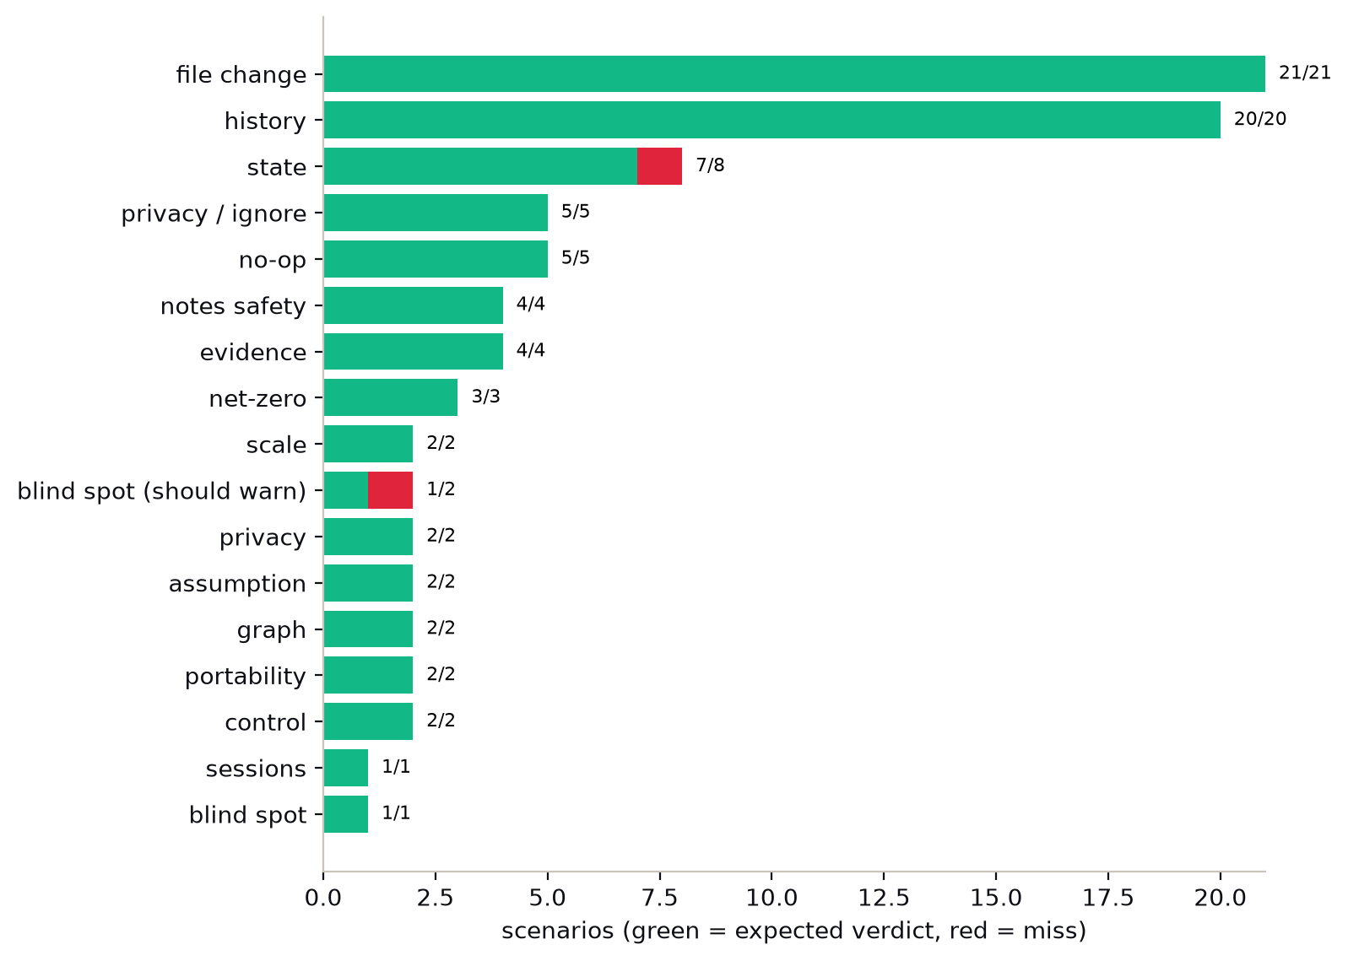
Figure 1. Scenarios by family; green matches the expected verdict.

Misses (2)
Scenario | Expected | Got
remote_ahead_unfetched  teammate pushed to origin; local clone has not fetched | REVIEW_REQUIRED | READY
state_wrong_type  state.json is a JSON list | BLOCKED | crash (traceback)
An unfetched remote is invisible by design because ContextBridge makes no network calls; run git fetch before resume.

2. Randomized testing against an independent oracle
Each of 800 trials applies 1 to 5 random operations (edit, add, delete, commit, empty commit, new branch, back to main, reset, amend, touch, ignored file, .env, stash, pop, rename, restore, tag). An independent oracle, written with plain git plumbing and content hashes, decides the expected verdict: BLOCKED if the branch changed, the checkpoint commit is no longer an ancestor, or the notes are missing; REVIEW_REQUIRED if HEAD or any non-ignored file content changed; otherwise READY. Seeds 20261012 and 777; the later seed never edits the tool's own notes.
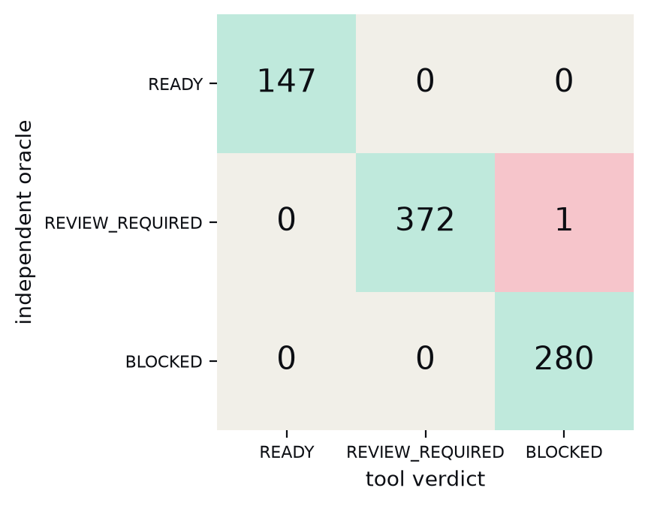
Figure 2. Oracle versus tool: 799 of 800 agree.

Disagreements (1)
Seed / trial | Operations | Oracle | Tool | What happened
20261012 / 169 | commit > env > edit > delete | REVIEW_REQUIRED | BLOCKED | contextbridge/graph.json is not valid JSON (Extra data: line 47 column 1 (char 8  The random 'edit' step appended text to a notes file under contextbridge/ that an earlier `git add -A` had committed. The tool correctly returned BLOCKED (corrupt notes); the oracle only checks that state.json exists. Harness artifact, not a tool bug. Later seeds exclude the notes from edit targets.
Seed 20261012: 399 of 400 agree.
Seed 777: 400 of 400 agree (notes excluded from edit targets).

3. Token cost
Token counts use tiktoken (cl100k_base and o200k_base) over the real output of the CLI. They are proxies: Claude's tokenizer differs, typically by a modest margin.
Output | Median | p90 | Max | Scenarios
resume --check | 65 | 172 | 15,052 | 45
resume (gate + handoff) | 468 | 539 | 15,489 | 45
The maximum comes from the scenario with 1,000 new files: the gate lists every changed file (finding N3).

Against a typical orientation dump
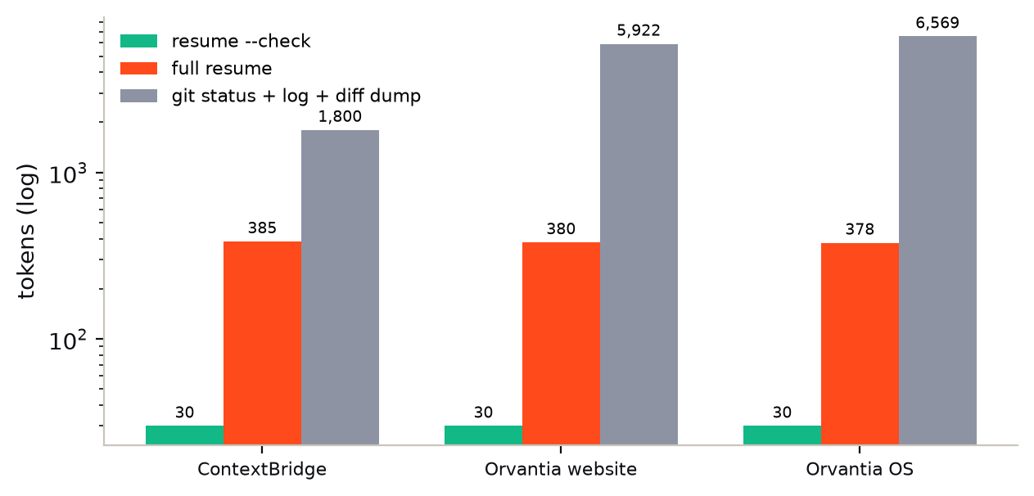
Figure 3. Tokens a fresh agent must read (log scale). The git dump is status + log -20 --stat + diff stat.
Repository | Tracked files | resume --check | Full resume | Git dump | Ratio (dump / resume)
ContextBridge (this tool) | 34 | 30 | 385 | 1,800 | 4.7x
Orvantia website | 85 | 30 | 380 | 5,922 | 15.6x
Orvantia OS | 480 | 30 | 378 | 6,569 | 17.4x
The dump is not equivalent information (no evidence, decisions or verdict); it is the size of the cheapest alternative a fresh agent might read.

Growth with project size
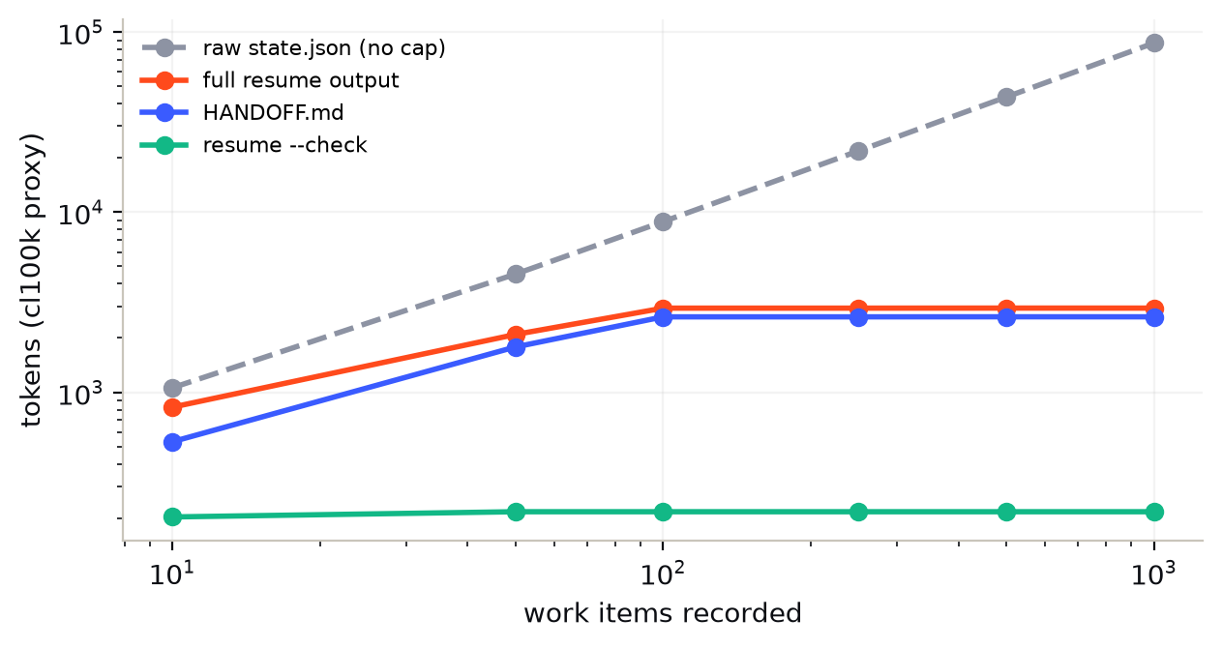
Figure 4. Tokens versus work items (log-log). The handoff is capped at the newest 25 items per list.
Work items | HANDOFF.md | Full resume | resume --check | Raw state.json
10 | 531 | 826 | 203 | 1,058
50 | 1783 | 2092 | 217 | 4,525
100 | 2621 | 2930 | 217 | 8,851
250 | 2621 | 2930 | 217 | 21,851
500 | 2623 | 2932 | 217 | 43,523
1000 | 2622 | 2931 | 217 | 86,857

4. Speed
Median of 5 runs per cell; each run is a fresh Python process, so every number includes about 62 ms of interpreter startup.
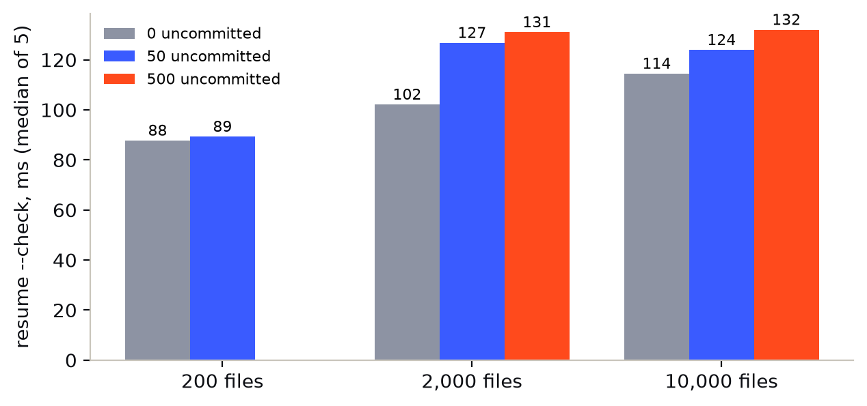
Figure 5. resume --check latency by repository size and number of uncommitted files.
Files | Uncommitted | git status | save | resume --check | drift | run overhead
200 | 0 | 15 ms | 121 ms | 88 ms | 88 ms | 92 ms
200 | 50 | 14 ms | 125 ms | 89 ms | 91 ms | 98 ms
2,000 | 0 | 14 ms | 151 ms | 102 ms | 109 ms | 109 ms
2,000 | 50 | 19 ms | 191 ms | 127 ms | 144 ms | 153 ms
2,000 | 500 | 19 ms | 204 ms | 131 ms | 131 ms | 158 ms
10,000 | 0 | 26 ms | 163 ms | 114 ms | 115 ms | 124 ms
10,000 | 50 | 26 ms | 180 ms | 124 ms | 120 ms | 128 ms
10,000 | 500 | 27 ms | 215 ms | 132 ms | 142 ms | 158 ms

Operation | Result
export / import | 67 ms / 68 ms with 500 work items (88,474 bytes)
Secret scan throughput | about 6.9 MB/s
CLI start (installed wheel) | 36 ms

5. Secret scanner
1,000 synthetic fake secrets per format. None are real credentials; they are random strings in each vendor's format.

Formats with dedicated patterns (24)
Format | Recall | Redaction clean
aws access key | 100% | 100%
aws temp key | 100% | 100%
github pat classic | 100% | 100%
github oauth | 100% | 100%
github fine grained | 100% | 100%
slack bot | 100% | 100%
google api | 100% | 100%
openai sk | 100% | 100%
anthropic sk | 100% | 100%
stripe live | 100% | 100%
stripe test | 100% | 100%
stripe restricted | 100% | 100%
sendgrid | 100% | 100%
npm | 100% | 100%
twilio | 100% | 100%
jwt | 100% | 100%
pem rsa | 100% | 100%
pem openssh | 100% | 100%
azure account key | 100% | 100%
db url password | 100% | 100%
mongodb srv | 100% | 100%
password assign | 100% | 100%
api key json | 100% | 100%
token env | 100% | 100%

Formats with no pattern (9)
Format | Recall
high entropy hex 32 | 0%
high entropy base64 44 | 0%
gcp service account private key id | 0%
short password 7 | 0%
heroku api key uuid | 0%
digitalocean pat | 0%
shopify token | 0%
mailchimp key | 0%
telegram bot token | 0%
Random hex and base64 strings and short passwords are deliberately not flagged: doing so would flag hashes, IDs and placeholders. The scanner is best-effort.

False positives on real code
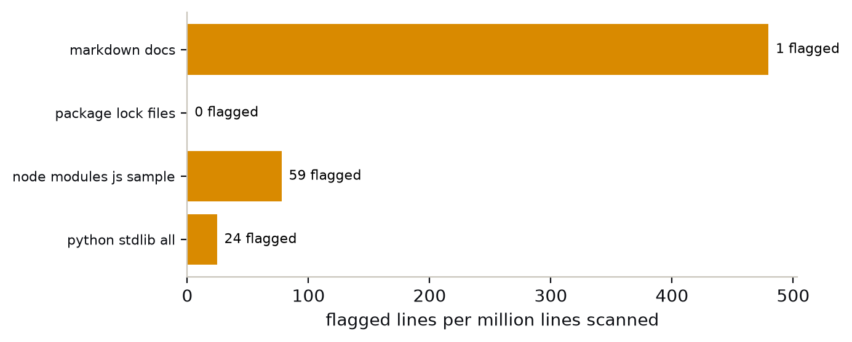
Figure 6. Lines flagged per million lines scanned.
Corpus | Files | Lines | Flagged | Per million lines
python stdlib all | 1,852 | 979,577 | 24 | 24.5
node modules js sample | 3,999 | 758,396 | 59 | 77.8
package lock files | 5 | 47,714 | 0 | 0.0
markdown docs | 27 | 2,085 | 1 | 479.6
Example false positive: self.tokens = TokenQueue(tokens[::-1])

6. Reliability and packaging

Test-suite stability
15 of 15 repeated runs passed (31 tests per run, median 7.1 s).
Python | Runs passed | Tests | Median time
Python 3.11.13 | 3/3 | 31 | 6.3 s
Python 3.14.6 | 3/3 | 31 | 7.0 s

Concurrent writers
Several processes run "contextbridge run -- true" in the same repository at once. Each reads the state, appends an entry and writes it back.
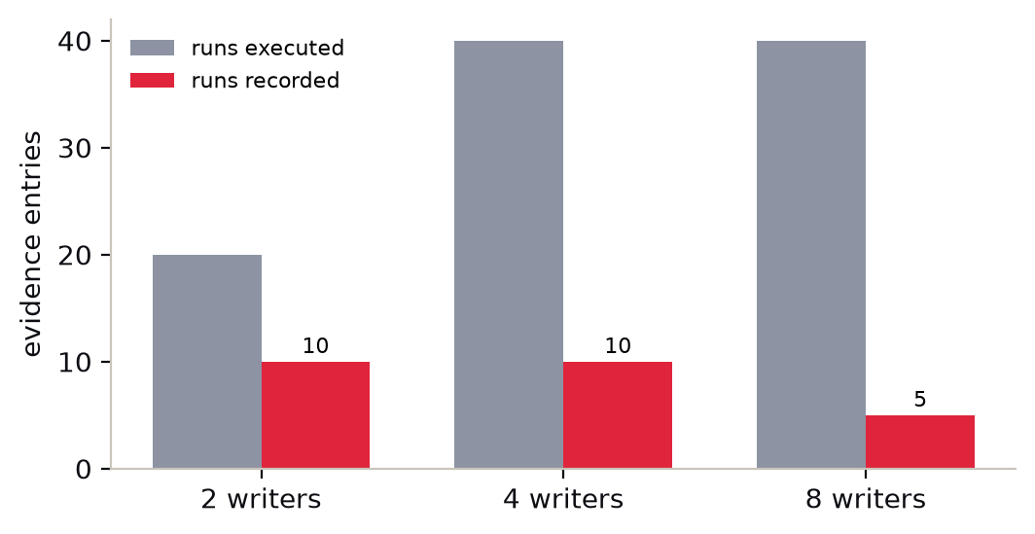
Figure 7. Evidence entries executed versus recorded.
Writers | Runs each | Executed | Recorded | Lost | state.json valid
2 | 10 | 20 | 10 | 10 | yes
4 | 10 | 40 | 10 | 30 | yes
8 | 5 | 40 | 5 | 35 | yes
Writes are atomic, so the file never corrupts, but later writes overwrite earlier ones and entries are lost.

Packaging
Check | Result
Wheel / sdist size | 23,208 / 32,380 bytes
Tests excluded from the wheel | true
Runtime dependencies | 0
Install on Python 3.11.13 | ok in 1.0 s; --version 0.3.2; end-to-end smoke test passed
Install on Python 3.14.6 | ok in 2.1 s; --version 0.3.2; end-to-end smoke test passed

7. Findings
# | Finding | Evidence | Suggested fix | Severity
N1 | Concurrent writers silently lose evidence | 8 parallel writers ran 40 test runs; only 5 were recorded (35 lost). state.json always stayed valid JSON because writes are atomic. | Lock the read-modify-write of the state files (flock on POSIX, msvcrt on Windows) and reload before each save. | medium
N2 | A malformed state.json crashes `resume` instead of returning BLOCKED | A state.json containing a JSON list produced a Python traceback (AttributeError: 'list' object has no attribute 'get') rather than a BLOCKED verdict. | Validate that the top level is an object when loading and route anything else to the existing 'not valid' BLOCKED path. | medium
N3 | Gate output is unbounded when many files change | 1,000 new untracked files produced 1,000 findings, about 15,052 tokens for `resume --check`. Typical runs are a median 65 tokens. | Summarize repeated findings: show the first few and a count, as the gate already does for unverified claims. | low
N4 | `git stash -u` and `git clean -fd` delete untracked notes | Both commands removed the untracked contextbridge/ folder; the gate then correctly returned BLOCKED (no checkpoint). With `init --local-only` the notes survived both. | Document it and recommend `init --local-only` or committing the notes. | low
N5 | The generic secret rule flags ordinary code | 24 lines flagged in 979,577 lines of Python stdlib (25 per million) and 59 in sampled JavaScript (78 per million), for example `token = self._fp.read(1)[0]`. | Ignore right-hand sides that are calls or attribute lookups; keep the rule strict for quoted literals. | low
N6 | Scanner has no pattern for several common key formats | 9 of 9 uncovered formats (Telegram, Shopify, DigitalOcean, Mailchimp, bare hex and base64 secrets…) are never flagged, by design for the entropy-only ones. | Add dedicated patterns for vendor-prefixed formats; keep the best-effort wording. | low
Earlier rounds (version string, nested repositories, scanner formats, unbounded handoff, status crash) were fixed in 0.3.2 and are re-tested here.

8. Reproduce
The harness is in the ContextBridge-Benchmark folder next to the repository (it is not part of the shipped package).
python3 bench.py speed, labeled scenarios, scanner, handoff growth
python3 bench2.py extended scenarios, fuzz, tokens, concurrency, stability, packaging
python3 merge.py && python3 charts.py && node make_docx.js

Appendix A. All labeled scenarios
Scenario | Change applied | Expected | Got
no_change | nothing changes after the checkpoint | READY | READY | ok
clone_same_history | state copied to a fresh clone of the same repo | READY | READY | ok
clone_extra_edit | fresh clone plus a local uncommitted edit | REVIEW_REQUIRED | REVIEW_REQUIRED | ok
edit_tracked_file | append to a tracked file (uncommitted) | REVIEW_REQUIRED | REVIEW_REQUIRED | ok
new_untracked_file | create a new untracked file | REVIEW_REQUIRED | REVIEW_REQUIRED | ok
whitespace_only_edit | whitespace-only edit | REVIEW_REQUIRED | REVIEW_REQUIRED | ok
chmod_only | file mode change only | REVIEW_REQUIRED | REVIEW_REQUIRED | ok
delete_tracked_file | delete a tracked, unrelated file | REVIEW_REQUIRED | REVIEW_REQUIRED | ok
delete_decision_code | delete the file a decision points at | REVIEW_REQUIRED | REVIEW_REQUIRED | ok
one_new_commit | one new unrelated commit | REVIEW_REQUIRED | REVIEW_REQUIRED | ok
five_new_commits | five new commits | REVIEW_REQUIRED | REVIEW_REQUIRED | ok
commit_touches_planned | commit edits the planned task's file | REVIEW_REQUIRED | REVIEW_REQUIRED | ok
assumption_text_removed | assumed text removed from file | REVIEW_REQUIRED | REVIEW_REQUIRED | ok
branch_switch | checkout a new branch | BLOCKED | BLOCKED | ok
detached_head | detach HEAD at same commit | BLOCKED | BLOCKED | ok
amend_head | amend the checkpointed commit | BLOCKED | BLOCKED | ok
reset_hard_back | reset --hard to the previous commit | BLOCKED | BLOCKED | ok
same_commit_new_branch_name | rename branch (same commit) | BLOCKED | BLOCKED | ok
edit_env_file | create .env (excluded by default) | READY | READY | ok
edit_own_notes | edit contextbridge/HANDOFF.md | READY | READY | ok
gitignored_change | write a git-ignored build artifact | READY | READY | ok
revert_wip_file | WIP file reverted with git checkout | REVIEW_REQUIRED | REVIEW_REQUIRED | ok
stash_wip_file | WIP file stashed | REVIEW_REQUIRED | REVIEW_REQUIRED | ok
commit_wip_file | WIP file committed unchanged | REVIEW_REQUIRED | REVIEW_REQUIRED | ok
wip_edited_again | WIP file edited further | REVIEW_REQUIRED | REVIEW_REQUIRED | ok
next_action_file_created | create the file named by --next-path | REVIEW_REQUIRED | REVIEW_REQUIRED | ok
nested_git_repo_added | a nested git repo appears as a new directory | REVIEW_REQUIRED | REVIEW_REQUIRED | ok
remote_ahead_unfetched | teammate pushed to origin; local clone has not fetched | REVIEW_REQUIRED | READY | MISS
nested_repo_edited_after_checkpoint | nested repo existed at checkpoint; edited and committed inside it afterwards | REVIEW_REQUIRED | REVIEW_REQUIRED | ok
rename_file | git mv a tracked file | REVIEW_REQUIRED | REVIEW_REQUIRED | ok
symlink_added | add a symlink to a file | REVIEW_REQUIRED | REVIEW_REQUIRED | ok
binary_file_added | add a binary file | REVIEW_REQUIRED | REVIEW_REQUIRED | ok
unicode_filename | add a file with a non-ASCII, spaced name | REVIEW_REQUIRED | REVIEW_REQUIRED | ok
failed_run_after | a test run fails after the checkpoint | REVIEW_REQUIRED | REVIEW_REQUIRED | ok
unfinished_run | a recorded run never finished | REVIEW_REQUIRED | REVIEW_REQUIRED | ok
claim_without_any_run | completed claim, zero test runs recorded | REVIEW_REQUIRED | REVIEW_REQUIRED | ok
state_deleted | contextbridge/state.json deleted | BLOCKED | BLOCKED | ok
state_corrupt | state.json truncated | BLOCKED | BLOCKED | ok
state_wrong_schema | state.json from a future schema | BLOCKED | BLOCKED | ok
touch_mtime_only | touch a tracked file (mtime only) | READY | READY | ok
git_gc | run git gc | READY | READY | ok
add_lightweight_tag | add a tag | READY | READY | ok
checkout_same_branch | git checkout main (already on it) | READY | READY | ok
worktree_added | git worktree add in a sibling dir | READY | READY | ok
ignored_200_files | 200 files under a gitignored dir | READY | READY | ok
env_local_file | create .env.local | READY | READY | ok
pem_file | create server.pem | READY | READY | ok
credentials_json | create credentials.json | READY | READY | ok
custom_ignore_pattern | create a file matching .contextbridgeignore | READY | READY | ok
edit_then_restore | edit a file then git checkout -- file | READY | READY | ok
add_then_delete_untracked | create then delete an untracked file | READY | READY | ok
commit_then_hard_reset_back | commit then reset --hard HEAD~1 | READY | READY | ok
edit_10_files | edit 10 tracked-style files | REVIEW_REQUIRED | REVIEW_REQUIRED | ok
edit_50_untracked | 50 new untracked files | REVIEW_REQUIRED | REVIEW_REQUIRED | ok
untracked_1000_files | 1000 new untracked files | REVIEW_REQUIRED | REVIEW_REQUIRED | ok
large_file_20mb | add a 20 MB file | REVIEW_REQUIRED | REVIEW_REQUIRED | ok
crlf_conversion | rewrite a file with CRLF line endings | REVIEW_REQUIRED | REVIEW_REQUIRED | ok
file_becomes_directory | delete src/b.py, create directory src/b.py/ | REVIEW_REQUIRED | REVIEW_REQUIRED | ok
case_only_rename | git mv README.md Readme.md | REVIEW_REQUIRED | REVIEW_REQUIRED | ok
newline_in_filename | file name containing a newline | REVIEW_REQUIRED | REVIEW_REQUIRED | ok
empty_commit | git commit --allow-empty | REVIEW_REQUIRED | REVIEW_REQUIRED | ok
merge_commit | no-ff merge of a side branch | REVIEW_REQUIRED | REVIEW_REQUIRED | ok
fast_forward | fast-forward main to a side branch | REVIEW_REQUIRED | REVIEW_REQUIRED | ok
cherry_pick | cherry-pick a side-branch commit | REVIEW_REQUIRED | REVIEW_REQUIRED | ok
commit_then_revert | commit then git revert it | REVIEW_REQUIRED | REVIEW_REQUIRED | ok
stash_pop_roundtrip | edit, stash, stash pop | REVIEW_REQUIRED | REVIEW_REQUIRED | ok
soft_reset_keeps_changes | commit then reset --soft HEAD~1 | REVIEW_REQUIRED | REVIEW_REQUIRED | ok
main_moved_unrelated | force main onto an unrelated commit | BLOCKED | BLOCKED | ok
detached_at_older_commit | detach at the root commit | BLOCKED | BLOCKED | ok
orphan_branch | checkout --orphan | BLOCKED | BLOCKED | ok
delete_original_branch | move to tmp and delete main | BLOCKED | BLOCKED | ok
state_empty_object | state.json is {} | BLOCKED | BLOCKED | ok
state_snapshot_null | state.json snapshot is null | BLOCKED | BLOCKED | ok
graph_corrupt | graph.json corrupt | BLOCKED | BLOCKED | ok
sessions_corrupt | sessions.json corrupt | BLOCKED | BLOCKED | ok
state_wrong_type | state.json is a JSON list | BLOCKED | crash | MISS
assumption_file_renamed | the assumed file is renamed | REVIEW_REQUIRED | REVIEW_REQUIRED | ok
decision_test_changed | a decision's test file is edited | REVIEW_REQUIRED | REVIEW_REQUIRED | ok
session_overlap_modified | modify a file claimed by two sessions | REVIEW_REQUIRED | REVIEW_REQUIRED | ok
stash_u_removes_untracked_notes | git stash -u while notes are untracked | BLOCKED | BLOCKED | ok
stash_u_with_local_only | git stash -u when notes use init --local-only | READY | READY | ok
git_clean_fd_removes_notes | git clean -fd while notes are untracked | BLOCKED | BLOCKED | ok
git_clean_fd_with_local_only | git clean -fd when notes use init --local-only | READY | READY | ok
wip_survives_untouched | WIP file left exactly as at checkpoint | READY | READY | ok
wip_plus_new_file | WIP file plus one new file | REVIEW_REQUIRED | REVIEW_REQUIRED | ok
no_evidence_no_claim_edit | no tests ever recorded, then an edit | REVIEW_REQUIRED | REVIEW_REQUIRED | ok

