AI_ Assisted_Coding _Assignment_Week-14

Name :ABHINAY Roll No:2403A52176

**Assignment Number: 14.3**

Task Description #1 – AI-generated HTML Page Task: Ask AI to generate a simple HTML homepage for a "Student Info Portal" with a header, navigation menu, and footer.

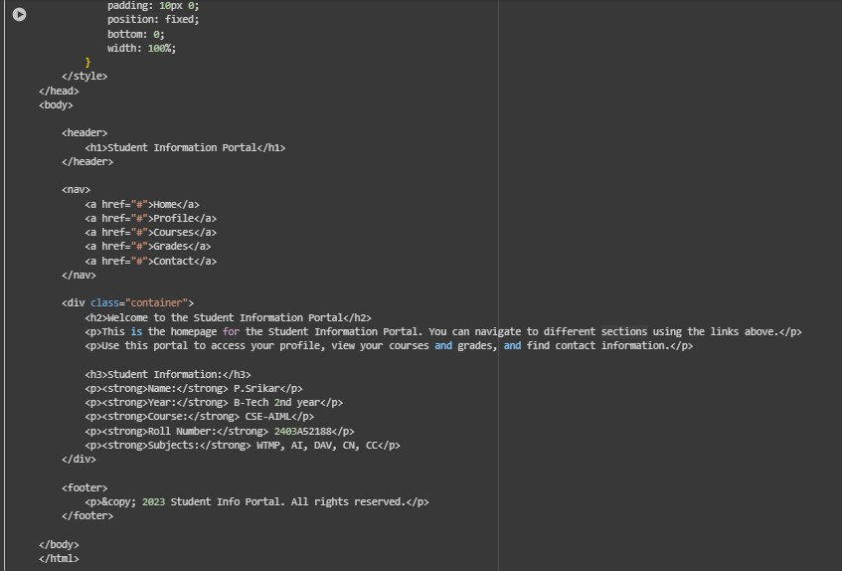Prompt : write an HTML Code that generate a simple HTML homepage for a "Student Info Portal" with a header, navigation menu, and footer show information like my name is P.Srikar , I am studying in B-Tech 2nd year course CSE-AIML roll-no : 2403A52188, subjects : WTMP , AI , DAV , CN , CC etc..

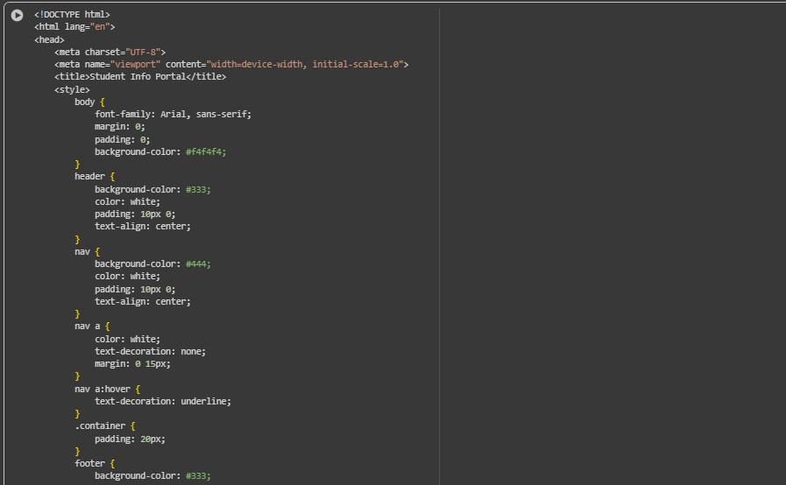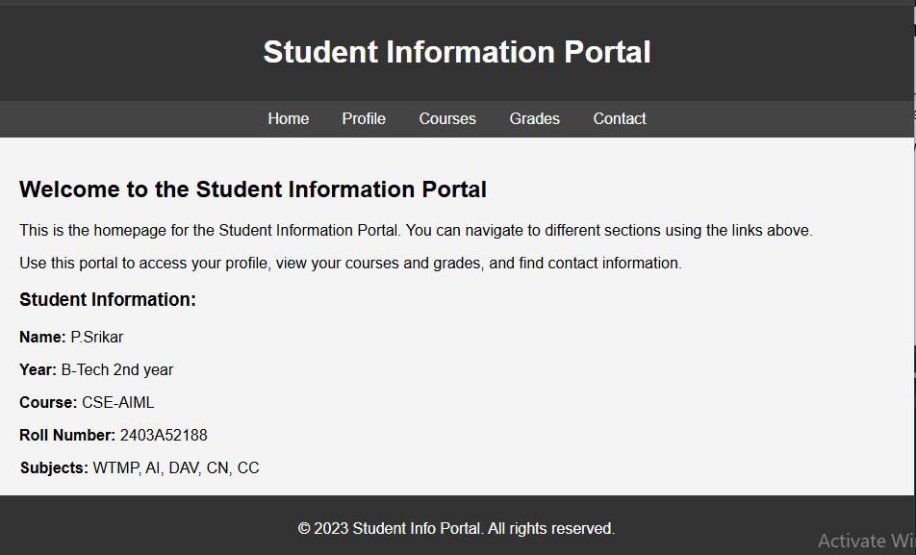

Task Description #2 – CSS Styling Task: Use AI to add CSS styling to Task #1 homepage for: • Responsive navigation bar. • Centered content section • Footer with light gray background.

Prompt : write an HTML code add CSS styling to Task #1 homepage for: • Responsive navigation bar. • Centered content section. • Footer with light gray background.

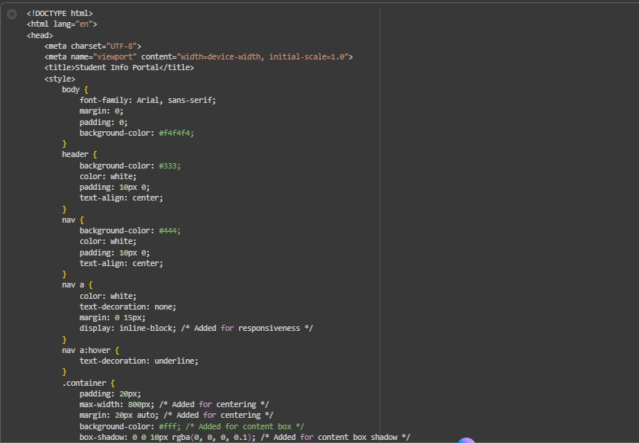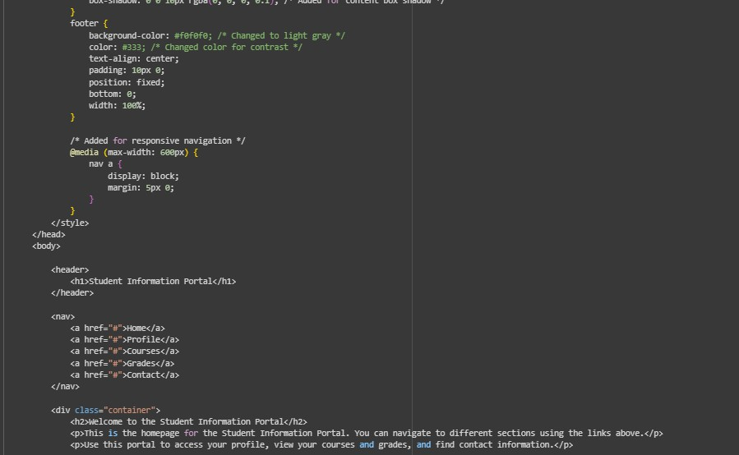

Task Description #3 – JavaScript Interactivity Task: Prompt AI to generate a JS script that validates a simple login form (non-empty username/password).

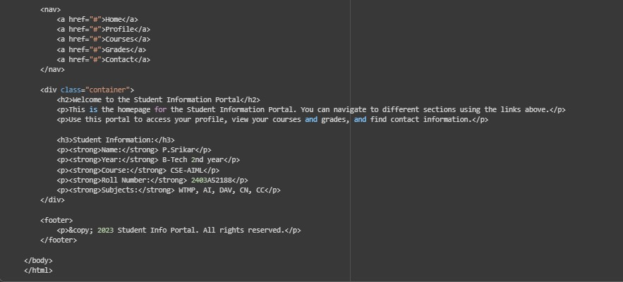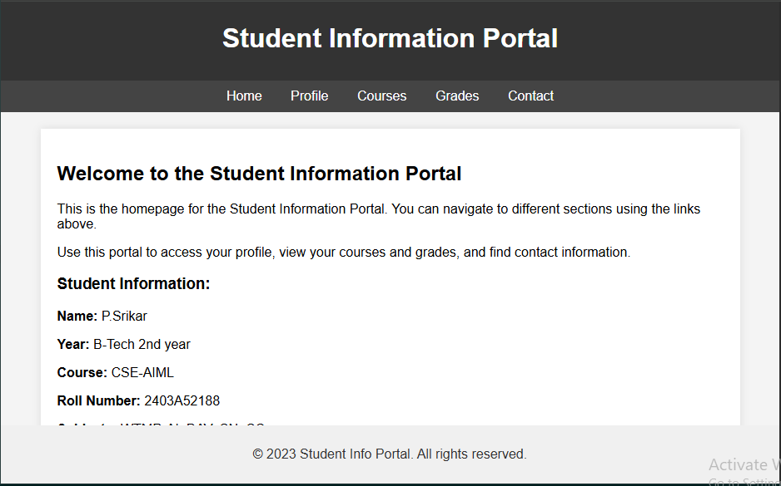

Prompt : write an HTML code that generate a JS script that validates a simple login form (non- empty username/password).Working on submit JS validation. if inputs are empty it should give error message if I login it should of the student info page add USERNAME SRIKAR PASSWORD Srikar123.

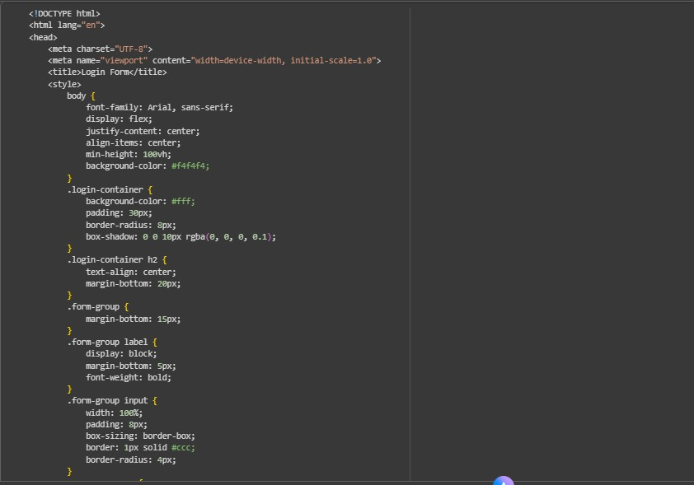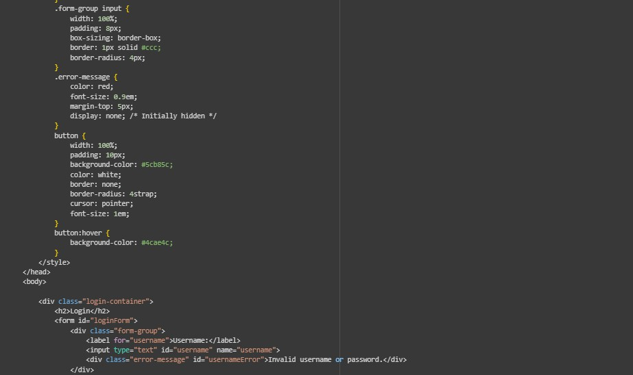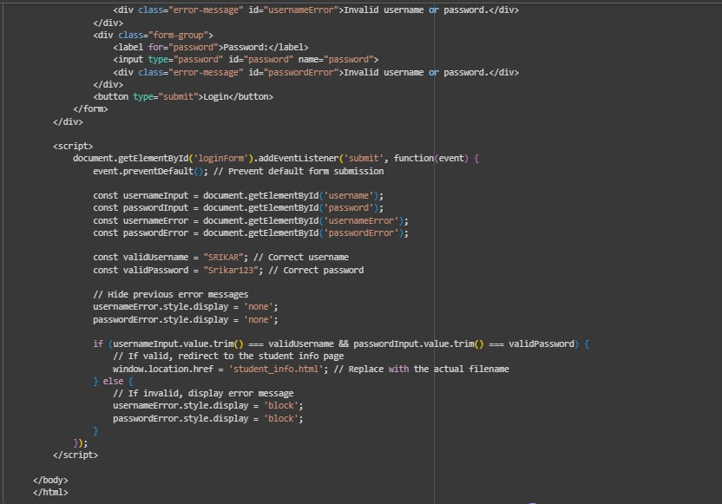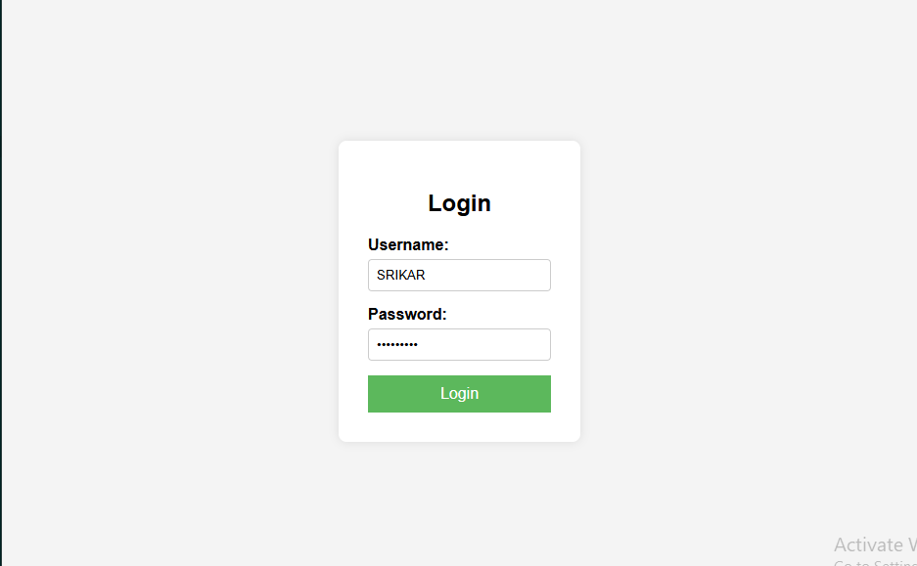

Task Description #4 – Python Backend Integration Task: Ask AI to generate a Flask app that serves the HTML form (Task #3) and prints the username on successful login.

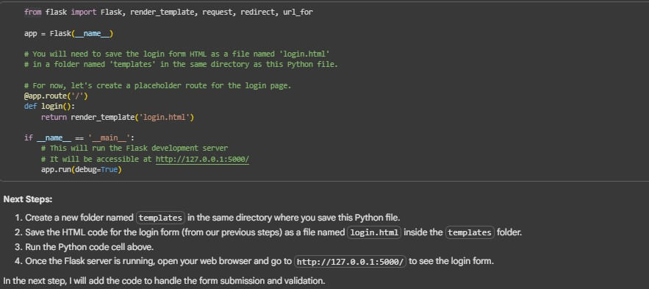Prompt :write a HTML code that enerate a Flask app that serves the HTML form (Task#3) and prints the username on successful login.