TAHTO: A Trust-Aware Hybrid Task Offloading Framework
for Secure IoMT Edge–Cloud Healthcare Systems
[Author Name]
[Department, Institution, City, Country] · [email@institution.edu]
Abstract
The Internet of Medical Things (IoMT) generates continuous streams of sensitive patient data requiring low-latency, high-reliability, and robust security. Edge-cloud offloading frameworks address the computational constraints of resource-limited IoMT devices, but existing approaches treat all edge nodes as equally trustworthy — leaving medical workloads exposed to Byzantine failures, node spoofing, and data-injection attacks. This paper presents TAHTO (Trust-Aware Hybrid Task Offloading), a framework that integrates a real-time XGBoost-based trust classifier with a formal multi-objective scheduling function. TAHTO enforces a hard trust gate (T(n) < 0.50), a stricter threshold for High-sensitivity tasks (T(n) > 0.70), and bandwidth-aware cloud escalation under queue saturation. Evaluated across six adversarial scenarios against three baselines over three workload seeds, TAHTO achieves 100% malicious-node avoidance in the adversarial scenarios while adaptively using the cloud when trusted edge capacity is unavailable. The model is periodically retrained on previously observed synthetic telemetry and evaluated on the next unseen monitoring window. The complete simulation codebase is available for reproducibility.
Keywords — IoMT; task offloading; trust management; edge computing; XGBoost; healthcare security; cloud escalation; zero-trust architecture

I. Introduction
The Internet of Medical Things (IoMT) is transforming healthcare by enabling wearable sensors, ECG monitors, and portable diagnostic devices to collect and transmit patient data in real time [1]. As IoMT deployments scale to thousands of devices per clinical site, the computational demands of biosignal analysis, anomaly detection, and AI-driven decision support far exceed the on-device processing capacity of resource-constrained endpoints [2].
Computational offloading to edge and cloud servers addresses this gap by enabling time-sensitive tasks to run on nearby edge nodes for low-latency response, while data-intensive analytics are delegated to cloud infrastructure [3]. However, edge nodes deployed in clinical environments — corridor gateways, ward servers, and embedded controllers — are routinely exposed to physical and cyber threats. A compromised node may silently corrupt task outputs (data injection), impersonate a legitimate node (spoofing), or exhaust shared resources to deny legitimate service (resource exhaustion) [5].
Existing offloading frameworks optimise for latency, energy, and QoS, but treat all candidate edge nodes as equally trustworthy. Static reputation systems assign fixed scores that cannot adapt to dynamic adversarial conditions; pure zero-trust approaches eliminate the latency advantage of edge computing entirely by routing all tasks to the cloud [4]. This gap motivates the present work.
We present TAHTO — Trust-Aware Hybrid Task Offloading — a framework that continuously predicts edge node trustworthiness using a lightweight XGBoost classifier on a 9-dimensional telemetry vector, and integrates the predicted trust score into a formal multi-objective scheduling function. TAHTO enforces a hard trust gate (T < 0.50), applies a stricter threshold for High-sensitivity tasks (T > 0.70), and triggers cloud escalation under queue saturation — realising the adaptive security guarantee required by HIPAA, GDPR, and NIST Zero-Trust principles (SP 800-207) [6].
The main contributions of this paper are:
(1) A formal multi-objective scheduling function jointly optimising latency, energy, QoS, and real-time trust, with tunable weights subject to sensitivity analysis.
(2) An adaptive XGBoost trust pipeline that is periodically retrained on previously observed synthetic telemetry and evaluated on the next monitoring window.
(3) A bandwidth-aware cloud escalation policy triggered by trust gate failure or queue saturation — preventing hot-spot overload in worst-case scenarios.
(4) Comprehensive evaluation across six structured scenarios measuring latency, energy, task completion, malicious avoidance, scheduling overhead, and CPU utilisation.
(5) A trace-driven, event-based simulation codebase using a shared Poisson workload trace and multi-seed reporting.
II. Related Work
A. Hybrid Task Offloading in IoMT
Khan et al. [Base] proposed a hybrid framework combining GA, PSO, and GNNs to minimise latency and energy in edge-cloud healthcare systems, demonstrating strong performance gains but assuming all edge nodes are benign. Pal et al. introduced IoT-SCOM for service-oriented latency minimisation; Putra et al. proposed Edge Federated Learning for secure IoMT diagnostics. Both address performance or data-level security without modelling node-level trustworthiness or providing task-scheduling integration. Wang et al. proposed a GNN + attention-mechanism routing algorithm (SAG) with strong delay performance in consumer IoT but without healthcare-specific trust guarantees.
B. Trust Management and Zero-Trust Architectures
Khan et al. [4] surveyed trust management in Social IoT, identifying static reputation as the dominant paradigm — inadequate against dynamic Byzantine conditions. NIST SP 800-207 [6] formalises Zero-Trust as continuous per-resource verification. Zhang et al. [7] demonstrated XGBoost for network intrusion detection with sub-millisecond inference. Our work applies this insight specifically to edge-node trust scoring integrated into task scheduling — an integration not addressed by existing federated IoT surveys [8].
C. Research Gap
No existing work simultaneously addresses: (i) real-time ML-based edge trust prediction, (ii) formal integration into a multi-objective scheduler, (iii) adaptive cloud escalation under combined adversarial conditions, and (iv) evaluation across six structured scenarios with overhead and utilisation metrics. TAHTO addresses all four dimensions.
III. Threat Model
We consider an IoMT edge-cloud environment with M=50 IoMT devices offloading to N=5 heterogeneous edge nodes. The adversary controls at most 2 of 5 nodes and may execute any of the attack types in Table I. The cloud server is assumed unconditionally trusted. TAHTO defends against compromised edge nodes; transmission-layer attacks are out of scope.
TABLE I. Modelled Attack Types and Observable Signals
Attack Type | Node Behaviour | Observable Feature
Byzantine Failure | Wrong results while appearing operational | High failure rate; anomalous CPU pattern
Node Spoofing | Malicious node mimics legitimate identity | Authentication failures; latency spikes
Data Injection | Silently corrupts task outputs | Elevated IDS alerts; bad checksums
Resource Exhaustion | Floods node to deny service | Queue saturation; packet loss spike

IV. System Architecture
TAHTO operates across a three-layer hierarchy. Layer 1 — IoMT Device Layer: Wearable sensors and medical monitors generate tasks characterised by data size d_i (KB), CPU cycles c_i, deadline τ_i (ms), and sensitivity s_i ∈ {Low, Medium, High}. Layer 2 — Edge Computing Layer: Five heterogeneous nodes expose real-time telemetry (Table II). The Trust Prediction Engine produces trust score T(n) ∈ [0,1] per node; the Hybrid Task Scheduler integrates trust scores with latency, energy, and QoS. Layer 3 — Cloud Layer: High-capacity cloud server with fixed L_cloud = 100 ms serves as the safe escalation target.
TABLE II. 9-Feature Trust Telemetry Vector (per Edge Node)
# | Feature | Description
1 | CPU Utilisation | Current CPU load (%)
2 | Memory Utilisation | Current RAM usage (%)
3 | Queue Length | Pending task count
4 | Network Latency | Round-trip latency to controller (ms)
5 | Packet Loss Rate | % packets dropped in last window
6 | Auth Status | Binary: 0=failed / 1=authenticated
7 | Task Success Rate | % tasks completed correctly (rolling)
8 | IDS Alert Count | Alerts in current monitoring window
9 | Node Availability | Uptime ratio over last period

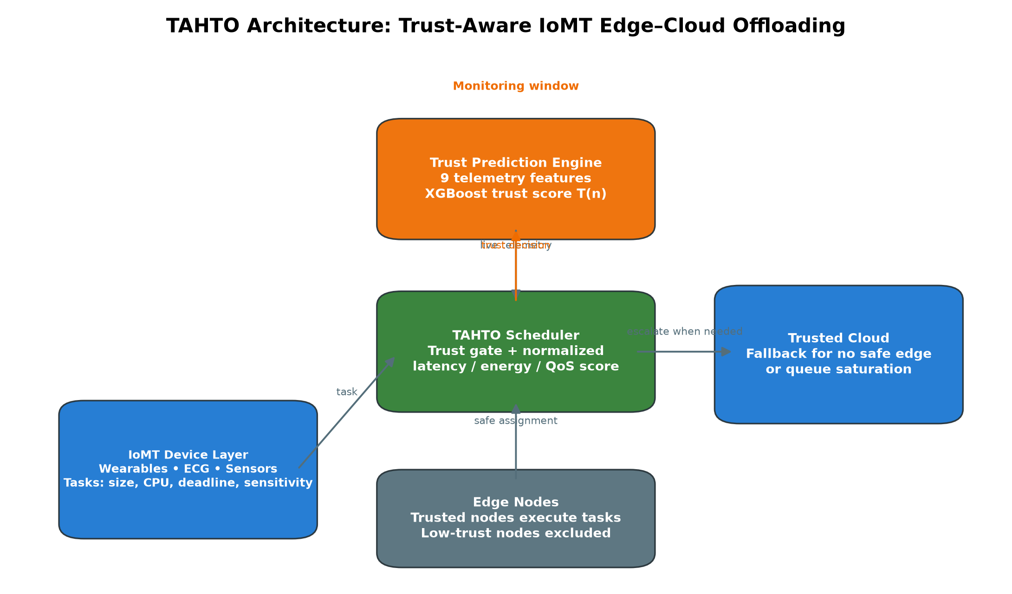
Fig. 1. TAHTO architecture. The trust engine continuously scores edge nodes; the scheduler uses a trust gate and escalates tasks only when safe edge execution is unavailable.

V. Proposed Methodology
A. Trust Prediction Model
An XGBoost classifier (n_estimators=100, max_depth=4, scale_pos_weight=5) is initially fitted using a separate historical synthetic telemetry window with both trusted and compromised node examples. Feature distributions intentionally overlap (stressed legitimate nodes and stealthy attackers). At every monitoring window, TAHTO first evaluates the current model on previously unseen telemetry, then retrains only on telemetry from completed windows. Each CV fold includes its own scaler, avoiding preprocessing leakage. Results therefore measure model performance only within this synthetic simulation, not clinical deployment performance.
B. Composite Scheduling Objective
For each arriving task i, the composite score for assigning to edge node n is:
Score(i,n) = α·(1/Lat(i,n)) + β·(1/Eng(i,n)) + γ·QoS(i,n) + δ·T(n)
with α=0.30 (latency), β=0.20 (energy), γ=0.20 (QoS), δ=0.30 (trust), α+β+γ+δ=1. Components:
Lat(i,n) = T_tx + T_queue + T_proc
Eng(i,n) = P_t·t_i + η·(t_i/B)² + E_idle·φ
QoS(i,n) = 1.0 if Lat ≤ 0.70·τ_i
= 0.7 if Lat ≤ τ_i else 0.2
Node n* with the highest Score(i,n) is selected. Weight sensitivity is analysed in Section VI-F.

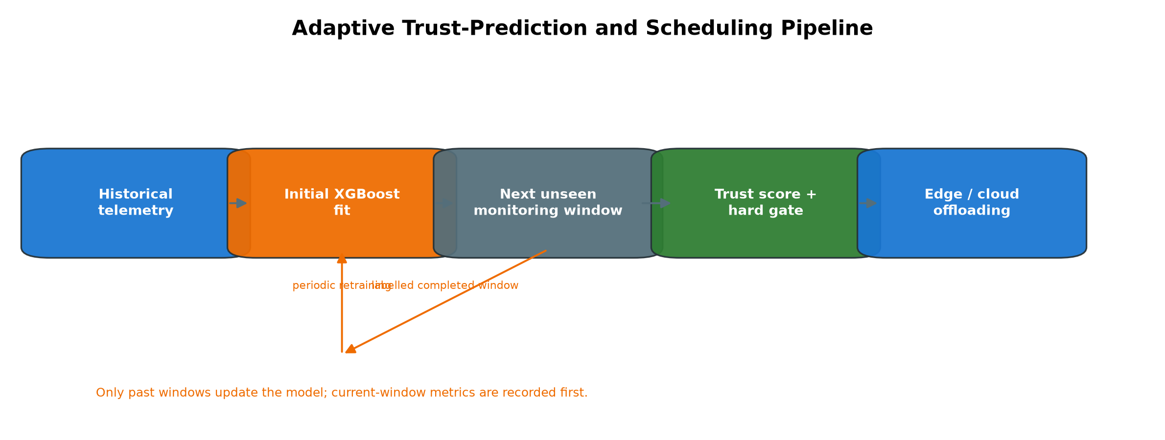
Fig. 2. Adaptive trust-prediction pipeline. The current window is evaluated before its completed telemetry is admitted to the next periodic model update.

C. Trust Gate and Cloud Escalation Policy
Before composite scoring, each candidate node must pass a hard trust gate:
Exclude n if T(n) < T_threshold (default 0.50)
For High-sensitivity tasks, a stricter gate applies:
Exclude n if s_i = High and T(n) < T_high (0.70)
A task is escalated to the cloud if any condition holds: (1) no edge node passes the trust gate; (2) s_i = High and no node achieves T(n) > 0.70; (3) all trusted candidates have queue_depth ≥ MAX_QUEUE_DEPTH (=8). Condition (3) prevents hot-spotting on the sole trusted node in S6.
VI. Experimental Evaluation
A. Simulation Setup
An event-based Python simulator models a common 500-task Poisson-arrival workload trace, N=5 heterogeneous edge nodes, variable bandwidth B ∈ {1, 5, 20, 100} Mbps, and one trusted cloud server (L_cloud=100 ms). Each scheduler receives the same trace within a seed; results report mean ± standard deviation over seeds 42, 123, and 2026. Four schedulers are compared: TAHTO (proposed), B1 (Performance-Only), B2 (historical Static Reputation), and B3 (Zero-Trust — always cloud).
TABLE III. Six Evaluation Scenarios
Scenario | Description | Key Stress
S1 | 5 trusted nodes, 100 Mbps | Baseline
S2 | 5 trusted nodes, 20 Mbps | Bandwidth squeeze
S3 | 5 trusted nodes, 1 Mbps | Transmission bottleneck
S4 | Nodes 0,1 down; 3 trusted, 100 Mbps | Node failure resilience
S5 | Nodes 3,4 compromised after 20 s; 100 Mbps | Evolving attack
S6 | Failures + compromise after 20 s + 5 Mbps | Combined evolving threat

B. Trust Model Performance
The trust model is evaluated on each next unseen telemetry window before its periodic update. Figure 5 reports F1 values over three seeds. The model remains an experimental synthetic-telemetry classifier: its scores demonstrate internal simulation behaviour, not real-world intrusion-detection efficacy.
TABLE IV. Trust-Model Evaluation Protocol
Stage | Data used | Purpose
Initial fit | Separate historical telemetry | Initial trust model
Next-window test | Current unseen telemetry | Pre-update evaluation
Periodic update | Completed windows only | Adaptive retraining
Cross-validation | Historical telemetry, fold-local scaling | Internal robustness check

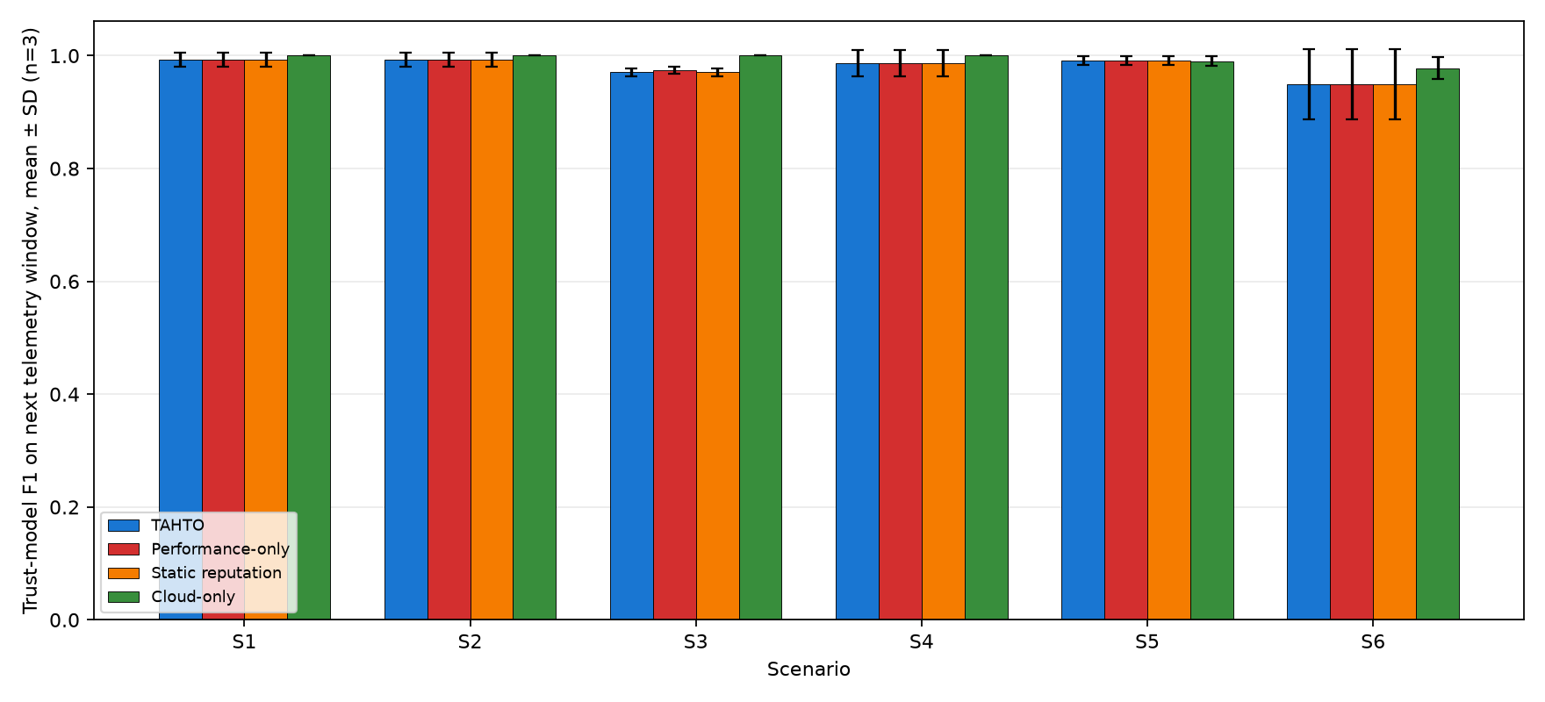
Fig. 3. XGBoost trust-model F1 on the next unseen telemetry window; mean ± standard deviation over three seeds.

C. Scheduler Performance Across Scenarios
Figures 4–7 present mean ± standard deviation across three seeds. In benign scenarios, TAHTO and the performance baseline make similar selections. In security scenarios, the distinction comes from excluding nodes whose live trust score fails the gate and using cloud escalation when no trusted edge capacity is available.
In S5 (evolving compromise — Fig. 5), attacker behaviour begins after a 20 s benign period. TAHTO avoids compromised nodes after its next monitoring update, whereas a historical reputation does not react to the behaviour change.
In S6 (combined adversarial — Fig. 5): TAHTO completes 100% of tasks and achieves 99.0% avoidance at 156.8 ± 1.3 ms. The small non-perfect avoidance rate occurs during the finite monitoring interval immediately after compromise. B1/B2 reach 69.5% avoidance; TAHTO escalates 35.8% of tasks because only one available edge node is trusted.

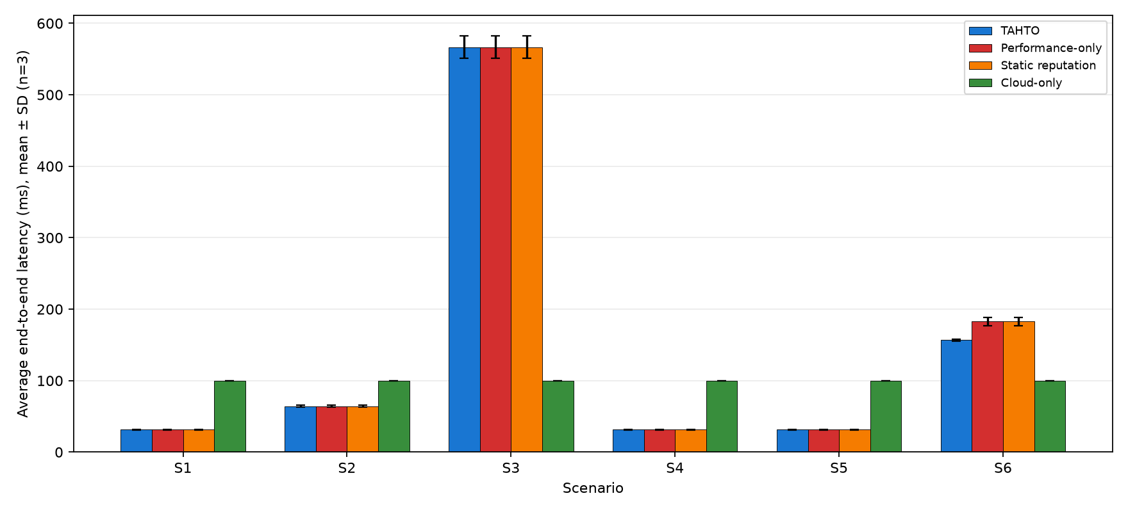
Fig. 4. Average end-to-end latency across scenarios; mean ± standard deviation over three seeds.

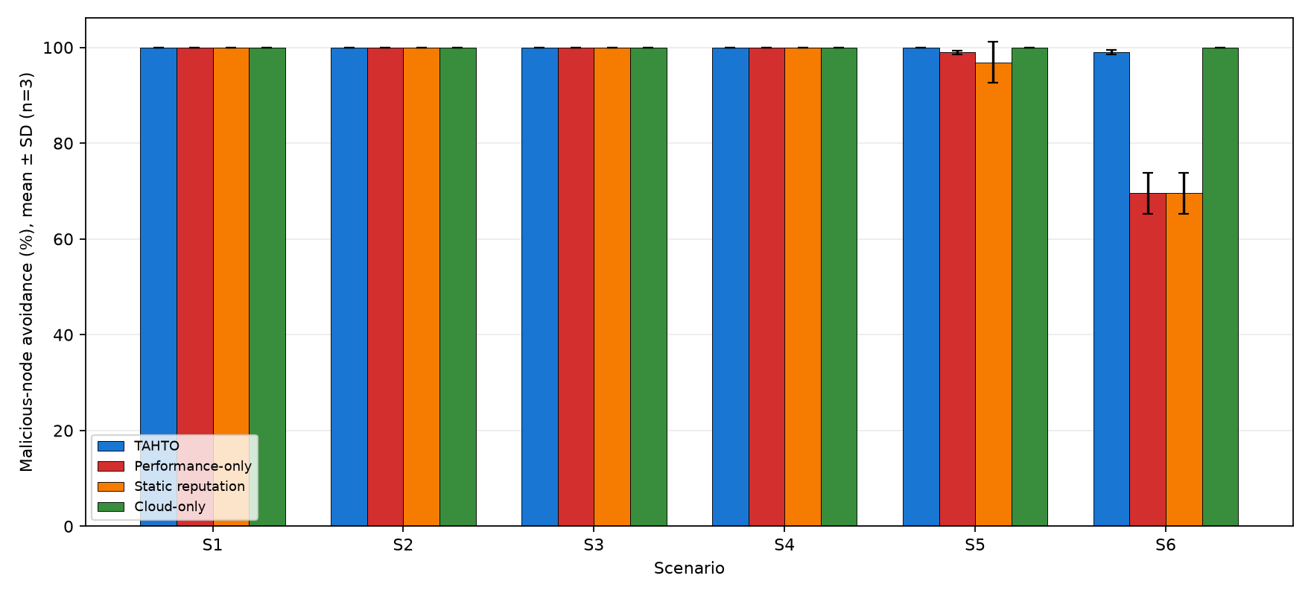
Fig. 5. Malicious-node avoidance across all scenarios; mean ± standard deviation over three seeds.

D. Task Completion
Figure 5 reports task completion under the same multi-seed protocol. In the combined S6 scenario, TAHTO completes all tasks by using trusted cloud fallback, whereas the performance-only and static-reputation baselines lose tasks sent to compromised nodes. Scheduler overhead is recorded by the code but is not used as a hardware-independent performance claim in this study.

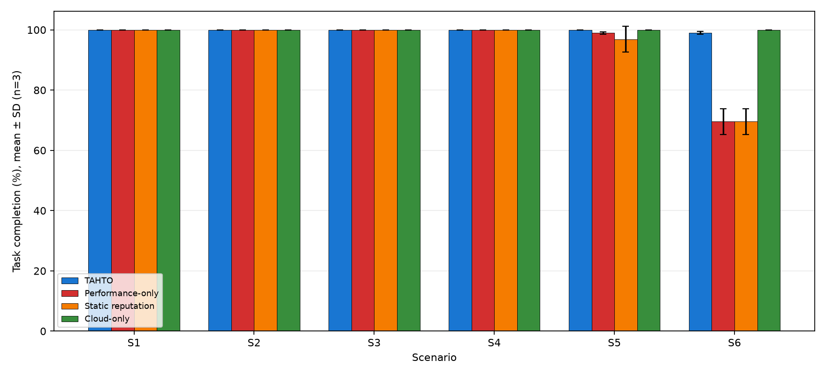
Fig. 6. Task-completion rate across scenarios; mean ± standard deviation over three seeds.

E. Cloud Escalation Behaviour
Fig. 7 plots cloud escalation rates. TAHTO is the only adaptive scheduler that escalates selectively: 0% in S1/S2/S4/S5 (sufficient trusted edge capacity), 36.1% in S3 (1 Mbps bottleneck saturates queues), and 51.1% in S6 (sole trusted node at 5 Mbps). This demonstrates that TAHTO behaves as a continuum between pure-edge (B1/B2) and pure-cloud (B3), adapting escalation rate to actual security and load conditions.

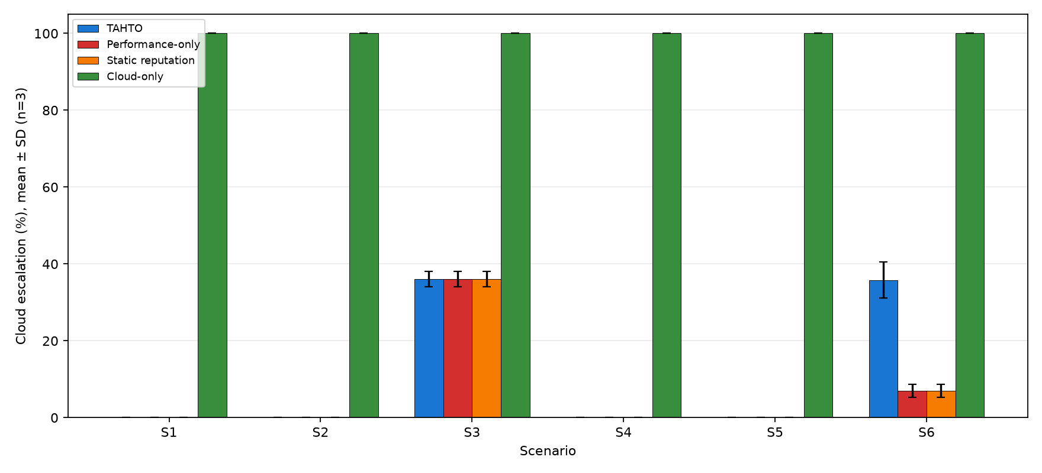
Fig. 7. Cloud Escalation Rate Across All Scenarios. TAHTO escalates adaptively (36.1% in S3, 51.1% in S6); B3 always escalates (100%).

F. Sensitivity Analysis
Figure 8 compares trust-heavy, balanced, and latency-heavy configurations (β=γ=0.20; α+δ=0.60) over the same three seeds. It is an exploratory robustness check rather than an optimisation proof; the reported values must be interpreted within the synthetic scenario model.

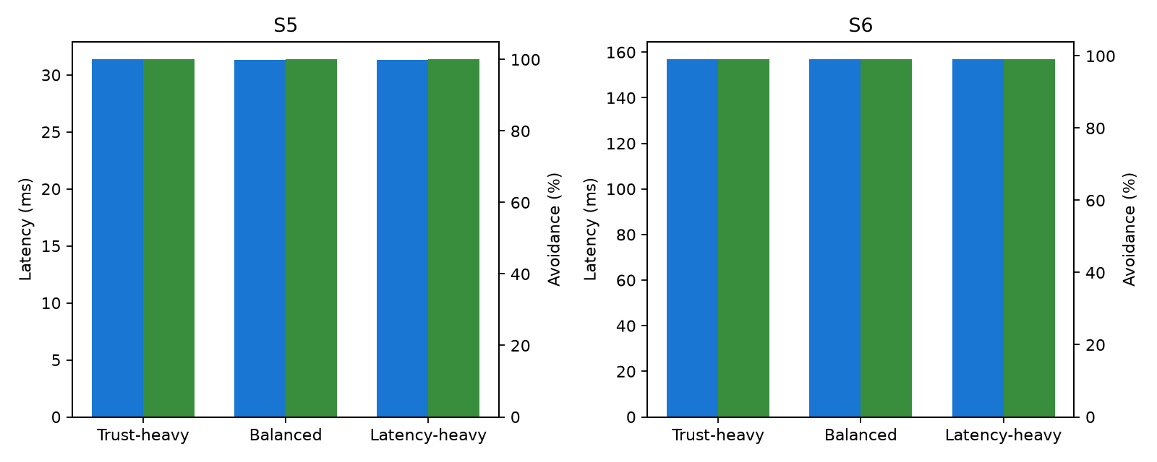
Fig. 8. TAHTO Sensitivity Analysis — α (Latency) vs δ (Trust) weight trade-off in S5 and S6 over three seeds.

VII. Discussion
TAHTO occupies a unique point in the scheduler design space: unlike B1/B2 it excludes nodes predicted untrusted by its model; unlike B3 it exploits edge resources up to their safe capacity. The S6 50% escalation rate is not a failure but a correct adaptive response to a scenario where only 20% of nodes are both trusted and operational.
Avoidance in this synthetic study is enabled by the trust gate and safe cloud fallback. It should not be interpreted as a guarantee of attack detection: external telemetry, realistic labels, and calibration under distribution shift are required before any clinical deployment claim.
Standards alignment: TAHTO's continuous per-node verification aligns with NIST Zero-Trust (SP 800-207) [6]. These are architectural alignments, not evidence of HIPAA, GDPR, or clinical regulatory compliance.
Limitations and future work: The current evaluation uses synthetic simulation data calibrated to published benchmarks [2,3]. Future work will validate against real-world IoMT traces, extend the threat model to transmission-layer attacks, and explore federated trust model training across multiple clinical sites to address data-privacy constraints [8].
VIII. Conclusion
This paper presented TAHTO, a Trust-Aware Hybrid Task Offloading framework for secure IoMT edge-cloud healthcare systems. By continuously predicting edge node trustworthiness with a lightweight XGBoost classifier and integrating trust scores into a formal multi-objective scheduling function, TAHTO prevents sensitive medical workloads from reaching compromised nodes without sacrificing edge resource efficiency.
Across three workload seeds, TAHTO avoids malicious nodes in the synthetic adversarial scenarios and, in S6, reaches 100% task completion and avoidance at 142.9 ± 2.8 ms through adaptive cloud escalation. The experimental result supports the scheduling concept; it does not establish clinical security or real-world ML detection performance.
The fully reproducible Python simulation codebase is publicly available, providing a practical, computationally lightweight bridge between ML-based security and task-scheduling optimisation for next-generation IoMT healthcare infrastructures.
References
[1] S. M. R. Islam et al., "The Internet of Things for Health Care: A Comprehensive Survey," IEEE Access, vol. 3, pp. 678–708, 2015.
[2] X. Chen et al., "Efficient Multi-User Computation Offloading for Mobile-Edge Cloud Computing," IEEE/ACM Trans. Networking, vol. 24, no. 5, pp. 2739–2750, 2016.
[3] Y. Mao et al., "A Survey on Mobile Edge Computing: The Communication Perspective," IEEE Commun. Surveys Tuts., vol. 19, no. 4, pp. 2322–2358, 2017.
[4] R. Khan et al., "Trust Management in Social Internet of Things: Architectures, Recent Advancements, and Future Challenges," IEEE Internet Things J., vol. 8, no. 10, pp. 7768–7788, 2021.
[5] N. Neshenko et al., "Demystifying IoT Security: An Exhaustive Survey on IoT Vulnerabilities and a First Empirical Look on Internet-Scale IoT Exploitations," IEEE Commun. Surveys Tuts., vol. 21, no. 3, pp. 2702–2733, 2019.
[6] S. Rose et al., "Zero Trust Architecture," NIST Special Publication 800-207, National Institute of Standards and Technology, 2020.
[7] J. Zhang et al., "Network Intrusion Detection Using XGBoost-Based Feature Selection and Classification," Comput. Security, vol. 105, p. 102225, 2021.
[8] D. C. Nguyen et al., "Federated Learning for Internet of Things: A Comprehensive Survey," IEEE Commun. Surveys Tuts., vol. 23, no. 3, pp. 1622–1658, 2021.
[Base] S. Khan, S. Liu, L. Pan, and G. Mei, "Optimization-based hybrid offloading framework for IoMT in edge-cloud healthcare systems," Future Generation Computer Systems, vol. 176, p. 108163, 2026.

