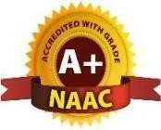
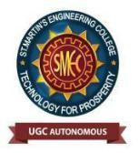
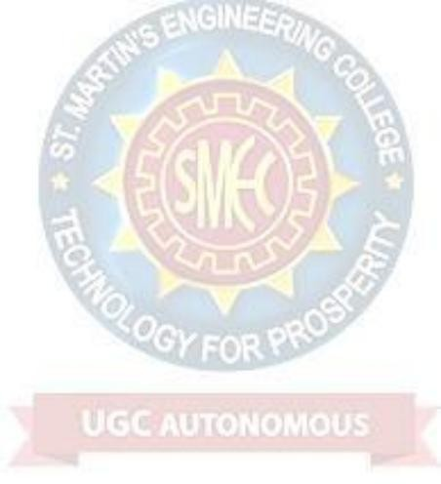
St. MARTIN’S ENGINEERING COLLEGE
UGC Autonomous
NBA & NAAC A+ Accredited Dhulapally, Secunderabad – 500100
www.smec.ac.in

