What is Database ?
A database is an organized collection of structured data, typically stored electronically in a computer system, designed for efficient storage, retrieval, and management of information.

Types of Databases

There are two main types:
1. Relational Databases (SQL)

Examples: MySQL, PostgreSQL, SQLite

Data is stored in tables (rows & columns)

You use SQL (Structured Query Language) to interact

Great for structured, relational data

2. Non-Relational Databases (NoSQL)

Examples: MongoDB, Firebase, CouchDB

Data is stored in flexible formats like JSON

Good for unstructured or changing data

SQL vs NoSQL:

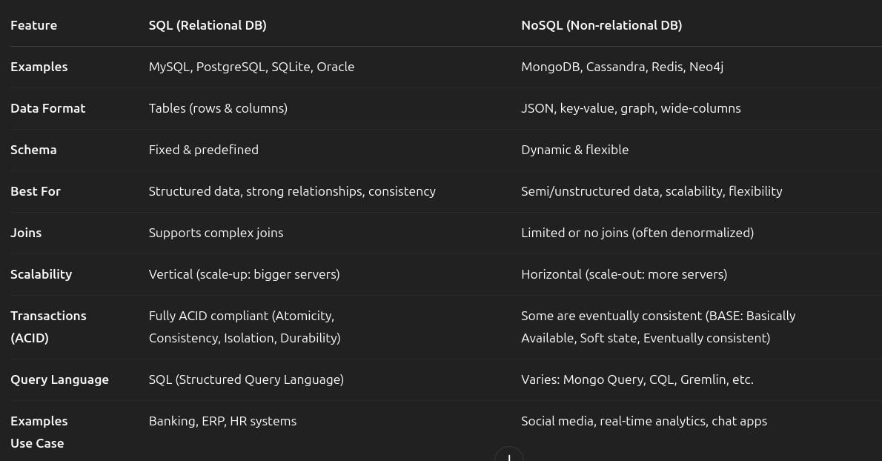

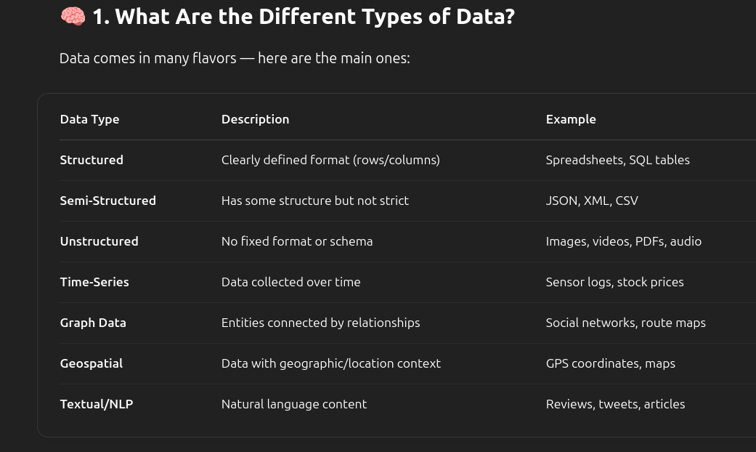

What Kind of Data Can SQL Databases Store?
SQL databases are relational and best for:

Best For:
- Structured data
- Data with clear relationships (foreign keys, joins)
- Transactional systems (banking, accounting)
- Use cases needing ACID compliance (consistency, reliability)

What Kind of Data Can NoSQL Databases Store?
NoSQL is more flexible and can handle a wider range of data types.

Best For:
- Semi-structured or unstructured data
- Frequently changing data
- High-speed ingestion (IoT, analytics)
- Data without strict relationships
- Big data and real-time apps

Can NoSQL Store Structured Data?
Yes, NoSQL can store structured data — it's just more flexible about it.
But unlike SQL (which requires a fixed structure), NoSQL databases:
- Allow structured data
- Don’t require you to define the structure up front
- Let you mix and match structures across records (called documents or items)
Example of Structured Data in NoSQL (MongoDB):
{
"_id": "user123",
"name": "Alice",
"age": 25,
"email": "alice@example.com"
}

That’s clearly structured — it has defined fields and data types:
- name: string
- age: number
- email: string
This looks similar to a SQL table row — but it’s stored as a JSON-like document in a NoSQL DB.

When Would You Store Structured Data in NoSQL?
- When you want flexibility (different records can have extra fields)
- When your app may evolve quickly (add/remove fields without changing schemas)
- When you need fast development and scalability
- When you prefer storing nested structures (which SQL struggles with)

Types of NoSQL Databases:
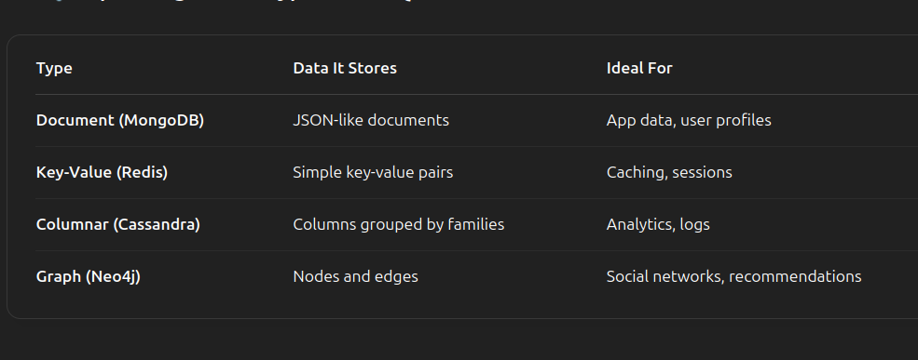

What is MongoDB?
MongoDB is a NoSQL database that stores data in a document format (like JSON). It’s designed for speed, scalability, and flexibility, and it's one of the most popular modern databases used in full-stack development.
🔹 Built for modern applications
🔹 Handles structured, semi-structured, or unstructured data
🔹 Perfect for fast-changing or large-scale data
Features of MongoDB:
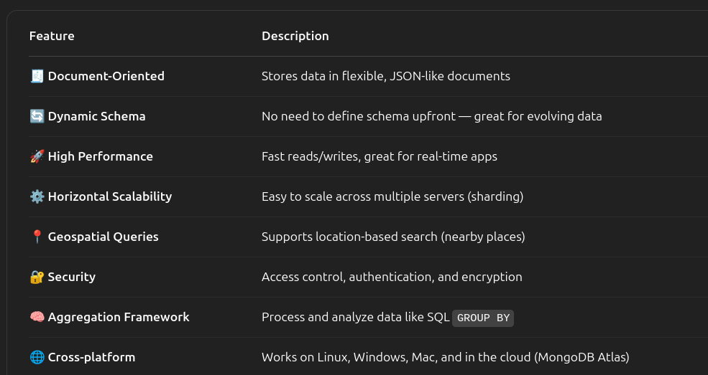
Benefits of MongoDB:

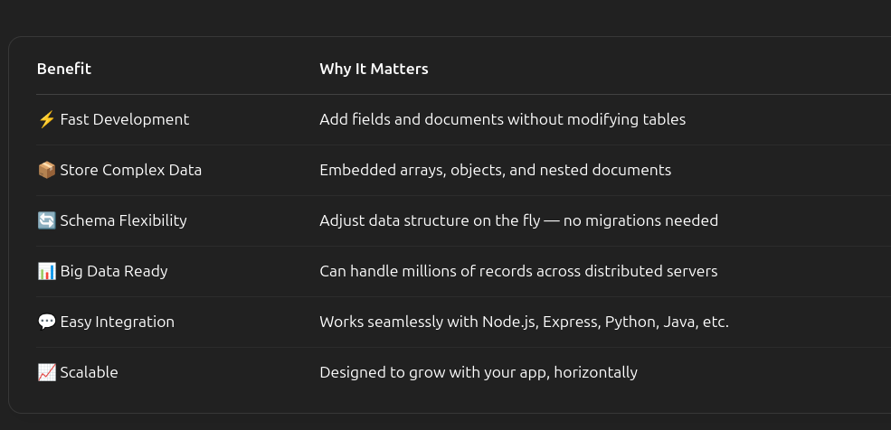
Use Cases of MongoDB:
