AMRITA VISHWA VIDYAPEETHAM, CHENNAI
B.Tech Computer Science Engineering (Cybersecurity)
20CYS401 — SECURE SOFTWARE ENGINEERING
End Semester Laboratory Examination
ONLINE BOOK REVIEW AND
RECOMMENDATION PLATFORM
Project Report: Secure Design, Implementation, Testing and Deployment
Item | Detail
Student | Abhinay Dasari
Register No. | CH.SC.U4CYS23005
Degree / Branch | B.Tech, Computer Science Engineering (Cybersecurity)
Course | 20CYS401 — Secure Software Engineering
Case study | 5. Online Book Review and Recommendation Platform
Technology | Python, Flask, SQLAlchemy, SQLite, Jinja2, Docker, Kubernetes
Date | October 2026

Contents
1. Introduction
2. Development Approach and Project Organisation
3. Requirements Engineering
4. Requirements Analysis and UML
5. Data and Information Flow Modelling
6. Software Architecture and Design
7. User Interface Design
8. Threat Modelling and Vulnerability Analysis
9. Attack Tree Analysis
10. Product Backlog and Sprint Execution
11. Secure Build and Secure Coding
12. Containerisation and Kubernetes Deployment
13. Testing and Verification
14. Logging, Monitoring and Hardening
15. End-to-End Traceability
16. Examination Compliance Summary
17. Limitations and Future Improvements
18. Conclusion
Appendix A. Repository Structure
Appendix B. Diagram Index
Appendix C. Tools Used by Phase

1. Introduction

1.1 Problem Statement
The assigned case study asks for a platform where users can discover and review books. Users must be able to search books, view book details, give ratings, write reviews, edit or delete their own reviews, and maintain a reading list. Administrators must be able to manage books and manage inappropriate reviews. The stated security focus is authentication, authorization, review manipulation, input validation and administrator privileges.

1.2 Objectives
- Deliver a working web application that implements every required user and administrator function.
- Enforce two authorization rules on the server side: a user can modify only their own reviews (Rule A), and only administrators can perform administrative operations (Rule B).
- Apply a secure software engineering lifecycle: requirements, modelling, threat analysis, secure coding, testing, containerisation and monitoring.
- Keep every artefact traceable from requirement to code, test and deployment control using permanent identifiers.

1.3 Actors
The system has two authenticated roles, USER and ADMINISTRATOR. The use case model additionally shows an Anonymous Visitor, an unauthenticated visitor who can register, log in, search and view book details but cannot rate, review or manage anything.

1.4 Scope of this Report
This report consolidates the project deliverables: the SRS, UML and data models, architecture, threat model, attack tree, backlog, secure coding demonstration, container and Kubernetes design, test results and the final traceability record. Eight diagrams generated from the project’s Mermaid sources are embedded at the points where they are discussed.
Tools used in this phase: Git, GitHub, Markdown.

2. Development Approach and Project Organisation

2.1 Scrum with XP Security Practices
The project followed Scrum for planning and delivery, combined with Extreme Programming practices that suit security-sensitive work: test-driven checks for authorization rules, continuous refactoring of security-critical modules, and frequent small commits. Short iterations allowed the authorization logic to be validated early, and the security requirements were treated as acceptance criteria on user stories rather than as a late-stage review.

2.2 Agile Principles Applied
Agile principle | Application in this project | Security benefit
Working software is the primary measure | The application was built and run before documents were finalised | Documents describe real behaviour, not intent
Welcome changing requirements | Requirement and ID changes were recorded rather than silently altered | Security requirements stay current with design
Continuous attention to technical excellence | Refactoring of review handling into a service layer | Ownership checks live in one place
Simplicity | Server-rendered Flask and SQLite instead of a larger stack | Smaller attack surface
Regular reflection and adjustment | Sprint retrospectives with improvement actions | Lessons feed back into controls

The detailed mapping, the two refactorings and the Agile risk analysis are held in docs/phase-01-agile/.

2.3 Delivery Phases
Work was organised into sixteen phases, each with a documentation folder under docs/ and evidence under evidence/. The phase-to-artefact mapping is given in Chapter 16 and the folder layout in Appendix A.
Tools used in this phase: Git (commit history as refactoring evidence), Markdown, Jira-ready CSV (backlog planning).

3. Requirements Engineering

3.1 Functional Requirements
ID | Requirement | Actor
REQ-01 | User registration and login | User
REQ-02 | Secure authentication (hashed passwords, protected sessions) | User, Administrator
REQ-03 | Search books | User, Visitor
REQ-04 | View book details and aggregated ratings | User, Visitor
REQ-05 | Rate books (1 to 5) | User
REQ-06 | Write reviews | User
REQ-07 | Edit own review: only the owner may edit | User
REQ-08 | Delete own review: only the owner may delete | User
REQ-09 | Maintain a reading list | User
REQ-10 | Administrator book management | Administrator
REQ-11 | Administrator inappropriate-review management | Administrator
REQ-12 | Secure logout and session invalidation | User, Administrator

3.2 Security Requirements
- Authentication: passwords stored only as bcrypt hashes; session cookies are HttpOnly and SameSite.
- Authorization: role checks (@admin_required) on every administrative route and object-level ownership checks on review modification.
- Input validation: ratings constrained to 1 to 5, bounded text fields, unique username, email and ISBN constraints, and parameterised ORM queries.
- Review manipulation protection: ownership enforcement, CSRF tokens on state-changing requests, and moderation fields that only administrators can set.
- Output protection: Jinja2 autoescaping and security headers (Content-Security-Policy, X-Frame-Options, X-Content-Type-Options).
- Audit logging of security events with credential scrubbing, and secure error handling that does not leak internals.

3.3 CIA Considerations
Property | Concern | Principal controls
Confidentiality | Credentials, sessions, private reading lists | bcrypt hashing, HttpOnly cookies, ownership checks
Integrity | Reviews, ratings, catalog data, audit trail | Object-level authorization, CSRF protection, validation, audit log
Availability | Public search and review pages | Health endpoint, container health checks, replicated deployment design

The full SRS and requirement matrix (with priority, authentication, authorization, audit and acceptance criteria per requirement) are in docs/phase-02-requirements/.
Tools used in this phase: Markdown (SRS and requirement matrix), Git (permanent requirement IDs tracked in the repository).

4. Requirements Analysis and UML
The use case model covers registration, authentication, discovery, rating and review, reading list management and the administrative functions. Two use cases were specified in full: UC-01 (Submit, Edit and Delete Review) and UC-02 (Administrator Moderates an Inappropriate Review). Each specification records actor, preconditions, main, alternative and exception flows, postconditions and security controls.

4.1 Scenario: Submit Book Review and Rating
- The authenticated user opens a book details page and submits a rating (1 to 5) with review text.
- The CSRF token is verified, then the session and role are checked.
- ReviewService validates the input and persists the review linked to the user and book.
- An audit entry is written and the updated page shows the aggregated rating.
- On edit or delete, ReviewService verifies that the review belongs to the requesting user. If not, the request is rejected and the attempt is logged.
Figure 1 on the next page shows the use case diagram. Edit Own Review and Delete Own Review are modelled as extensions of Write Book Review and carry the ownership control CTRL-02. Moderate Reviews includes viewing the audit log.

Figure 1: UML Use Case Diagram
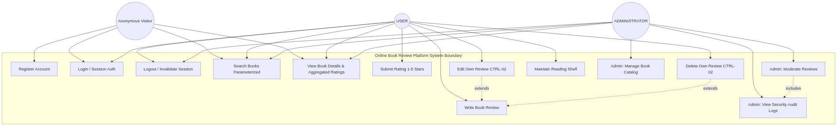
Figure 1. Use cases for Anonymous Visitor, USER and ADMINISTRATOR within the system boundary.
Actor | Use cases
Anonymous Visitor | Register Account, Login, Search Books, View Book Details and Aggregated Ratings
USER | Login, Logout, Search, View Details, Submit Rating, Write Review, Edit Own Review (CTRL-02), Delete Own Review (CTRL-02), Maintain Reading Shelf
ADMINISTRATOR | Logout, Search, View Details, Manage Book Catalog, Moderate Reviews, View Security Audit Logs
Tools used in this phase: Mermaid (use case diagram source), Markdown (use case specifications).

5. Data and Information Flow Modelling

5.1 Entity-Relationship Model
The ER model mirrors the SQLAlchemy models. Five entities are used. Ratings are stored as an attribute of the review record, constrained to 1 to 5, rather than in a separate table.
Entity | Key attributes and constraints
USERS | id (PK); username (unique); email (unique); password_hash; is_admin; created_at
BOOKS | id (PK); title; author; genre; isbn (unique); description; publication_year; created_at
REVIEWS | id (PK); book_id (FK); user_id (FK); rating; content; is_moderated; moderation_reason; moderated_by (FK to users); created_at; updated_at
READING_LIST_ITEMS | id (PK); user_id (FK); book_id (FK); status (want-to-read, reading, finished); added_at; updated_at
AUDIT_LOGS | id (PK); timestamp; user_id (FK); username; action; resource_type; resource_id; ip_address; status; details

Relationships: a user authors many reviews and maintains many reading list items; a book has many reviews and appears in many reading list items; a user generates many audit entries; an administrator moderates many reviews through moderated_by.
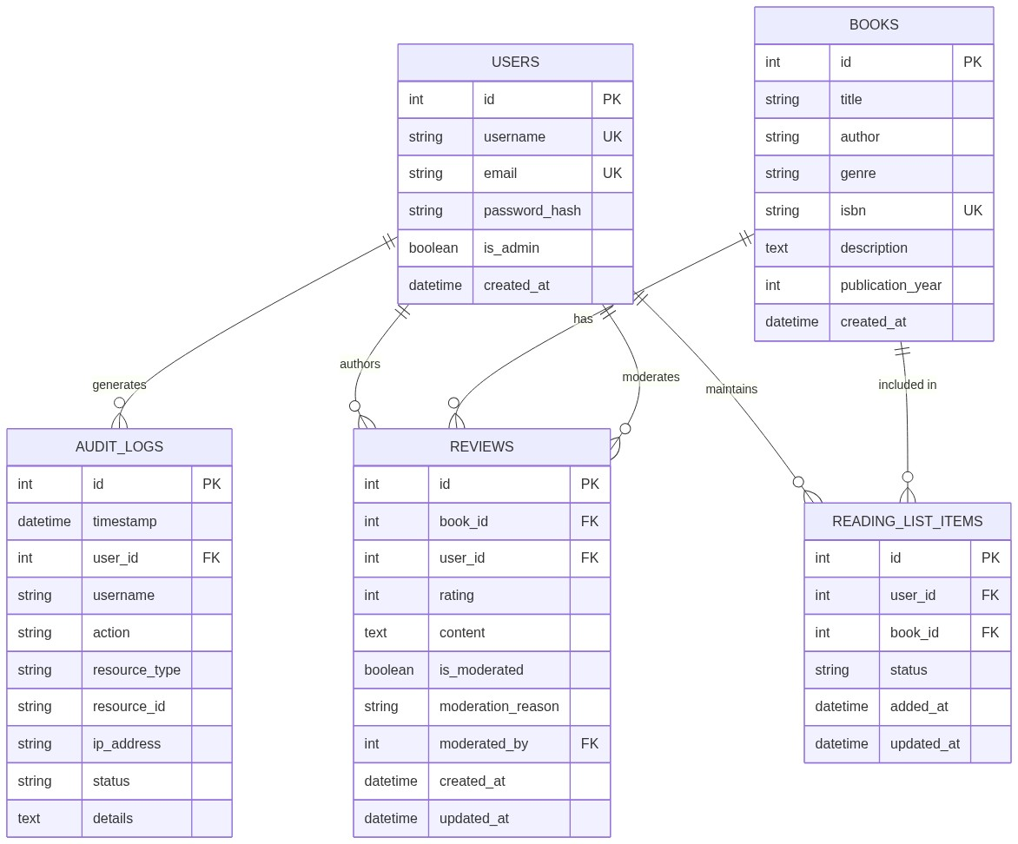
Figure 2. Entity-Relationship diagram of the book review platform.

Figure 3: Data Flow Diagram, Level 0
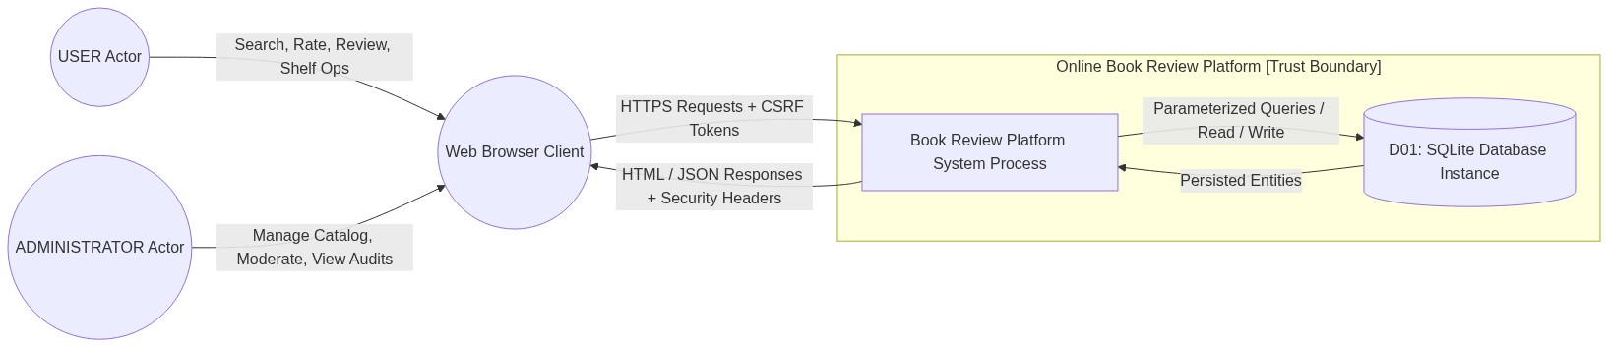
Figure 3. Level-0 (context) DFD showing external actors, the system and the primary data store.
At context level, the User and Administrator interact through a web browser. Requests carry CSRF tokens; responses carry security headers. Inside the trust boundary the application reads and writes the SQLite database (D01) using parameterised queries only.

Figure 4: Data Flow Diagram, Level 1
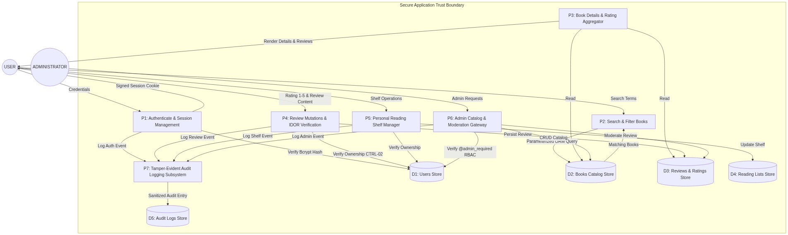
Figure 4. Level-1 DFD with processes P1 to P7 and data stores D1 to D5.
Element | Name | Role
P1 | Authenticate and Session Management | Verifies bcrypt hash against D1, issues signed session cookie
P2 | Search and Filter Books | Parameterised ORM query against D2
P3 | Book Details and Rating Aggregator | Reads D2 and D3 to render details and reviews
P4 | Review Mutations and IDOR Verification | Verifies ownership (CTRL-02), persists to D3, logs to P7
P5 | Personal Reading Shelf Manager | Verifies ownership, updates D4
P6 | Admin Catalog and Moderation Gateway | Enforces @admin_required, CRUD on D2, moderation on D3
P7 | Tamper-Evident Audit Logging | Writes sanitised entries to D5
D1 to D5 | Users, Books, Reviews and Ratings, Reading Lists, Audit Logs | Persistent stores

5.2 Trust Boundaries
Figure 5 separates the external untrusted zone (browser and potential attacker), the edge perimeter (security headers filter and CSRF verification gate), the application trust boundary (authentication, authorization, services, data access and audit) and the storage boundary. Every request must cross the edge controls before reaching the authentication and authorization tiers, and no component reaches the database except through the ORM or the audit logger.
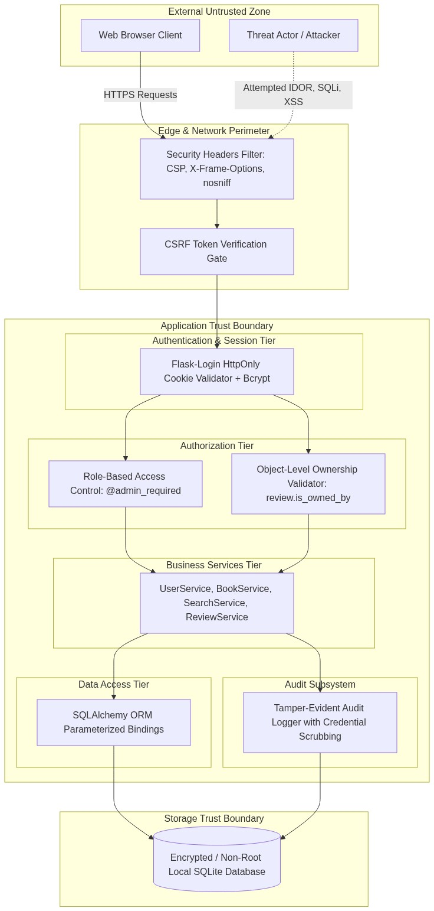
Figure 5. Trust boundary diagram.
Tools used in this phase: Mermaid (ER diagram, Level-0 and Level-1 DFDs, trust boundary diagram), SQLAlchemy models (source of the ER model), SQLite.

6. Software Architecture and Design
The application uses a layered architecture. Presentation blueprints receive requests, security cross-cutting components enforce session, CSRF, role and header policies, the service layer holds business rules including ownership verification, and the data access layer uses SQLAlchemy models over SQLite.

6.1 Components
ID | Component | Implementation (from architecture diagram)
COMP-01 | Authentication | auth.py blueprint, Flask-Login session, bcrypt
COMP-02 | User Management | UserService
COMP-03 | Book Catalog | catalog.py blueprint, BookService
COMP-04 | Search | SearchService (parameterised)
COMP-05 | Review and Rating Service | reviews.py blueprint, ReviewService with CTRL-02 ownership checks
COMP-06 | Reading List | reading_list.py blueprint, ReadingListService
COMP-07 | Administration and Moderation | admin.py blueprint, @admin_required decorator
COMP-08 | Audit Logging | Audit logger (app/core/audit.py) with credential scrubbing

6.2 Design Concepts Applied
- Layered architecture: presentation, security, service and data tiers with one-way dependencies.
- Service layer: business rules and ownership checks are kept out of route handlers.
- MVC-style separation: Flask blueprints (controllers), Jinja2 templates (views) and SQLAlchemy models.
- Object-relational mapping: all persistence through SQLAlchemy models with parameter binding.
- Decorator-based access control: @admin_required centralises role enforcement.

Figure 6: Layered System Architecture
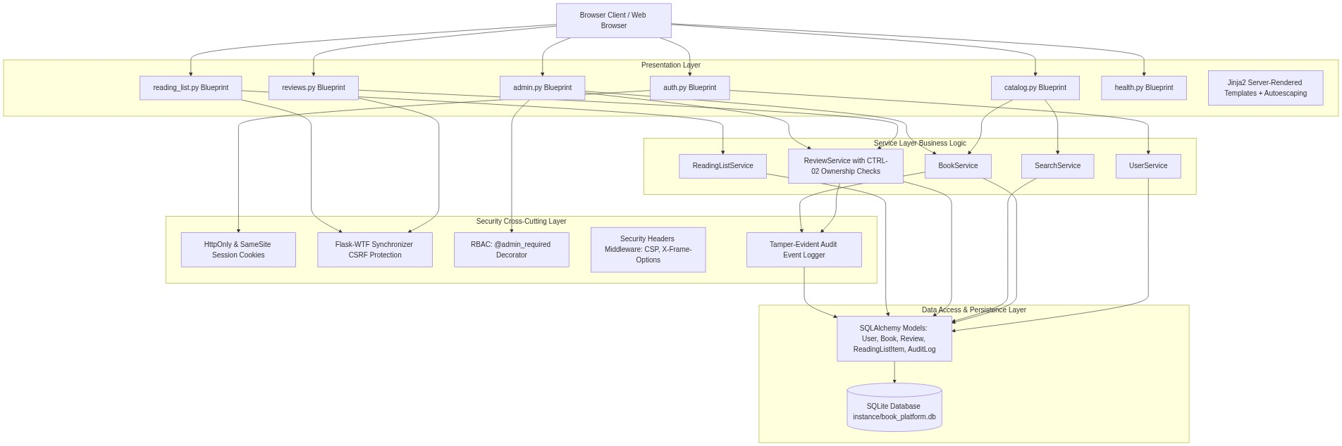
Figure 6. Layered architecture: presentation, security cross-cutting, service and data access layers.
Tools used in this phase: Mermaid (architecture diagram), Flask blueprints, Jinja2, SQLAlchemy, Flask-Login, Flask-WTF.

7. User Interface Design
The interface is server-rendered with Jinja2 templates in app/templates/ and is connected directly to the backend routes. Six screens cover the examination requirement of at least four.
No. | Screen | Purpose and security notes
1 | Login / Register | Account creation and sign-in; CSRF token, validation errors without revealing which field was wrong
2 | Book Search / Discovery | Search by title, author or genre; parameterised queries
3 | Book Details, Ratings and Reviews | Aggregated rating and reviews; edit and delete controls shown only to the owner, but enforced server-side regardless
4 | Reading List / My Reviews | Private shelf with status; ownership checked on every change
5 | Administrator Book Management | Create, update and delete books; admin-only route
6 | Administrator Review Moderation | Hide or remove inappropriate reviews with a reason; audited

Usability principles applied: consistent layout and navigation, visible feedback through flash messages, clear validation errors, confirmation before destructive actions and error prevention through constrained inputs.
Tools used in this phase: Flask, Jinja2 templates, HTML and CSS.

8. Threat Modelling and Vulnerability Analysis

8.1 Assets
The threat model identifies ten assets (ASSET-01 to ASSET-10) drawn from the data model and architecture: user credentials, user profiles, the book catalog, reviews and ratings, reading lists, administrator privileges, audit logs, session data and the database itself. Each is classified by confidentiality, integrity and availability with an owner and security requirement.

8.2 STRIDE Analysis
Ten threats (THR-01 to THR-10) were identified against the DFD elements and mapped to STRIDE categories with impact, likelihood, risk, mitigation and detection. The most critical for this case study is THR-02, tampering with another user’s review through an insecure direct object reference. The table summarises the control applied for each STRIDE category.
STRIDE category | Example in this system | Implemented control
Spoofing | Credential stuffing, stolen session cookie | bcrypt, HttpOnly and SameSite cookies, server-side session invalidation on logout
Tampering | Editing another user’s review (THR-02), CSRF | Ownership validator (review.is_owned_by), Flask-WTF CSRF tokens
Repudiation | Denying a review deletion or admin action | Audit log with user, action, resource, IP and status
Information disclosure | Leaking hashes, tokens or stack traces | Credential scrubbing in logs, secure error pages, private reading lists
Denial of service | Request flooding, oversized input | Input length limits, health checks, replicated deployment design
Elevation of privilege | Normal user calling admin routes | @admin_required server-side RBAC, is_admin flag not user-settable

8.3 Information Flow Analysis
Information flow was traced for credentials, review data and administrator session data from source through validation, authentication, authorization, processing, storage, output and logging, identifying each trust boundary crossing shown in Figures 3 to 5.

8.4 Vulnerability Analysis
Vulnerabilities were recorded with component, related threat, severity, root cause, fix and verification. The primary documented case is VUL-01, an insecure direct object reference in review editing and deletion, demonstrated locally on a separate branch and fixed on the main branch (see Chapter 11). Static analysis with Bandit and a secret scan were also run; their results are in evidence/phase-11/.
Tools used in this phase: STRIDE (threat classification method), Bandit (static analysis), Secret scan, Markdown.

9. Attack Tree Analysis
The attacker goal ATK-01 is unauthorised modification of a book review or rating. Figure 7 decomposes it into four alternative (OR) paths. Each path ends in a condition that the implemented controls close, shown in the table following the figure.

Figure 7: Attack Tree ATK-01
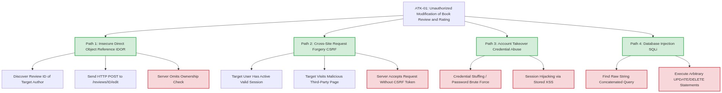
Figure 7. Attack tree for unauthorised review modification. Green nodes are attack paths; red nodes are the weaknesses each control removes.
Attack path | Weakness required | Control that blocks it
Path 1: IDOR | Server omits ownership check on /reviews/ID/edit | ReviewService ownership check (CTRL-02), request rejected and logged
Path 2: CSRF | Server accepts request without a CSRF token | Flask-WTF CSRF verification on all state-changing requests, SameSite cookies
Path 3: Account takeover | Credential stuffing or session hijacking via stored XSS | bcrypt hashing, HttpOnly cookies, Jinja2 autoescaping, CSP
Path 4: SQL injection | Query built by string concatenation | SQLAlchemy ORM with parameter binding, no raw SQL

Control types: preventive (ownership check, CSRF gate, RBAC, validation), detective (audit log of failed authorization and admin actions) and corrective (moderation and review removal by administrators).
Tools used in this phase: Mermaid (attack tree diagram), AND/OR attack tree method.

10. Product Backlog and Sprint Execution
The backlog contains ten user stories (US-01 to US-10) written in the form “As a [role], I want [function], so that [benefit]”. Each story carries an epic, priority, story points, acceptance criteria, requirement ID, use case ID and a security consideration. Work was split into two sprints: Sprint 1 for the core platform, authentication and book discovery, and Sprint 2 for reviews, reading lists, administration and security hardening.
ID | Story theme
US-01 | Register securely (user)
US-02 | Search books (user)
US-03 | View book details (user)
US-04 | Rate a book (user)
US-05 | Edit and delete own reviews (user)
US-06 to US-08 | Write reviews, maintain reading list and related user functions
US-09 | Manage books (administrator)
US-10 | Moderate inappropriate reviews (administrator)

A Jira-ready import file (docs/phase-09-backlog/jira-import.csv) was prepared. Sprint metrics, the velocity table and the burndown chart are recorded in docs/phase-10-sprint/sprint-metrics.md and are derived from the story points in the backlog.
Tools used in this phase: Jira (CSV import file prepared), Markdown, Mermaid (burndown chart).

11. Secure Build and Secure Coding

11.1 Secure Build Controls
- Secret management: no credentials in source; configuration through environment variables; .gitignore excludes .env, databases, virtual environments and logs.
- Dependency control: pinned versions in requirements.txt.
- Least privilege: the container runs as a non-root user (UID 10001).
- Static analysis: Bandit scan recorded in evidence/phase-11/bandit_scan.txt, reported in the project record as 0 High and 0 Medium findings.
- Secret scan: evidence/phase-11/secret_scan_report.txt.

11.2 Controlled IDOR Demonstration
The review modification path was used for a before-and-after demonstration kept entirely local:
Stage | Description
Before | Branch demo/idor-before: the edit and delete handlers accept any review ID without checking ownership. A test shows user B can modify user A’s review.
Issue | Broken object-level authorization (VUL-01, threat THR-02, attack path ATK-01 Path 1).
Fix | Branch main: authentication required, ownership verified in ReviewService (CTRL-02), input validated, safe error response, audit entry written.
After | The same test (test_user_b_cannot_edit_user_a_review, TEST-05) passes; the result is stored in evidence/phase-12/idor_fix_verification.txt.

The vulnerable implementation exists only on the demonstration branch and is not part of the deployed application.
Tools used in this phase: Bandit, Secret scan, .gitignore, Pinned requirements.txt, Git branches (demo/idor-before and main), pytest.

12. Containerisation and Kubernetes Deployment

12.1 Docker
- Multi-stage build keeps build tools out of the runtime image.
- The application runs as an unprivileged user (UID 10001).
- Dependencies are version-pinned and a .dockerignore keeps secrets and local files out of the image.
- A health check probes the /health endpoint; the service listens on port 5050 and the SQLite file is on a mounted volume (instance/).
- docker-compose.yml provides a one-command local run.

12.2 Kubernetes Design
Figure 8 shows the deployment architecture: a bookplatform namespace containing a two-replica Deployment with runAsNonRoot enabled, a ClusterIP Service mapping port 80 to 5000, a ConfigMap (bookplatform-config) for non-secret settings, a Secret (bookplatform-secret) for sensitive values, and liveness and readiness probes on /health. No cloud resources are required; the target is a local Minikube or kind cluster.

Figure 8: Deployment Architecture
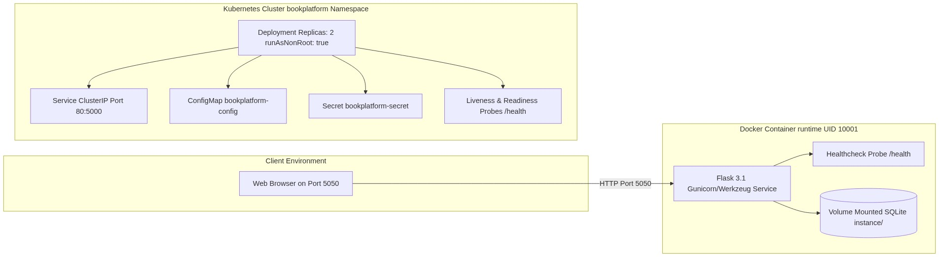
Figure 8. Docker runtime and Kubernetes deployment architecture.
Tools used in this phase: Docker, Docker Compose, .dockerignore, Gunicorn, Kubernetes manifests (kubectl, with Minikube or kind as the local target), Mermaid (deployment diagram).

13. Testing and Verification
The automated suite lives in tests/ and, as recorded in evidence/phase-14/pytest_output.txt, reports 23 of 23 tests passing across the following categories:
Category | Coverage
Unit tests | Password hashing, rating validation, review ownership logic, search
Authentication and authorization | Login and logout, anonymous redirects, normal user blocked from admin routes, user B blocked from editing user A’s review
Integration | Login, submit review, persist, retrieve
Fuzzing | Malformed and hostile input on review text, search and rating boundaries
End-to-end | Register or login, search, view, rate, review, reading list

Test identifiers are linked to requirements; for example TEST-05 verifies REQ-07 through the IDOR test.
Tools used in this phase: pytest, Fuzzing tests, Flask test client.

14. Logging, Monitoring and Hardening

14.1 Audit Logging
The AuditLog model (app/core/audit.py) records timestamp, user, action, resource type and ID, IP address, status and details for security-relevant events such as logins, authorization failures, review changes and administrator actions. A scrubbing step removes credentials and tokens before an entry is stored, so passwords and secrets are never logged.

14.2 Monitoring
A /health endpoint supports Docker health checks and Kubernetes probes. Recommended signals to monitor are failed login counts, authorization failures, HTTP 4xx and 5xx rates, administrator actions and container restarts.

14.3 Hardening Summary
Area | Control
Access control | Server-side RBAC and object-level ownership checks
Sessions | HttpOnly, SameSite cookies; server-side logout
Transport and headers | CSP, X-Frame-Options, X-Content-Type-Options; TLS to be terminated at a reverse proxy or ingress
Container | Non-root user, pinned dependencies, health check, no secrets in image
Kubernetes | Namespace isolation, non-root security context, ConfigMap and Secret separation
Data | ORM parameter binding, unique constraints, rating range constraint
Tools used in this phase: Python audit logger (app/core/audit.py), SQLAlchemy AuditLog model, /health endpoint, Docker HEALTHCHECK, Kubernetes liveness and readiness probes.

15. End-to-End Traceability
The critical requirement REQ-07 (only the owner of a review may edit it) is traced through the full chain below, using identifiers recorded in the project.
ID | Artefact
REQ-07 | Edit Own Review
UC-01 | Submit, Edit and Delete Review
DFD-P04 | Review mutations and IDOR verification process
THR-02 | STRIDE tampering: review modification through IDOR
ATK-01 (Path 1) | Attack tree: IDOR exploitation
VUL-01 | Insecure direct object reference
US-05 | User story: edit and delete own reviews
CTRL-02 | Object-level authorization check in ReviewService
TEST-05 | test_user_b_cannot_edit_user_a_review
Result | Passed; evidence/phase-12/idor_fix_verification.txt

Tools used in this phase: Git, Markdown, pytest (TEST-05 evidence).

16. Examination Compliance Summary
The table maps each project phase to its primary artefact as recorded in the project’s final report.
Phase | Title | Primary artefacts | Status
1 | Agile Process and XP Security | docs/phase-01-agile/ | Documented
2 | Requirements (SRS) | docs/phase-02-requirements/srs.md | Documented
3 | UML Use Cases | docs/phase-03-uml/use-cases.md | Documented
4 | Data Flow and Trust Boundaries | docs/phase-04-data-flow/ | Documented
5 | Architecture | docs/phase-05-architecture/ | Documented
6 | User Interface | docs/phase-06-ui/, app/templates/ | Implemented
7 | Threat Modelling (STRIDE) | docs/phase-07-threat-model/ | Documented
8 | Attack Tree | docs/phase-08-attack-tree/ | Documented
9 | Backlog and Stories | docs/phase-09-backlog/, jira-import.csv | CSV prepared
10 | Sprint Metrics | docs/phase-10-sprint/ | Documented
11 | Secure Build and SAST | evidence/phase-11/ | Scans recorded
12 | Secure Coding, IDOR Demo | docs/phase-12-secure-coding/ | Demonstrated
13 | Containerisation | docker/Dockerfile, docker-compose.yml | Implemented
14 | Testing | tests/, evidence/phase-14/ | Tests recorded
15 | Logging and Monitoring | docs/phase-15-monitoring/, app/core/audit.py | Implemented
16 | Hardening and Review | docs/phase-16-hardening/, SECURITY.md | Documented

Tools used in this phase: Markdown, Git, Evidence files under evidence/.

17. Limitations and Future Improvements

17.1 Current Limitations
- SQLite is suitable for demonstration but not for concurrent production use; the database file is not encrypted at rest.
- TLS is not terminated by the application itself; HTTPS requires a reverse proxy or Kubernetes ingress.
- Rate limiting and account lockout are basic and are not backed by a distributed store.
- Kubernetes manifests and a GitHub Actions workflow are part of the design; the runtime output from a cluster deployment and a CI run should be attached as evidence where available.
- Backlog data is supplied as a Jira import file; no live Jira board was used.

17.2 Future Improvements
- Migrate to PostgreSQL with encrypted storage and managed backups.
- Add multi-factor authentication for administrators and an admin-action approval workflow.
- Add book recommendation scoring based on ratings and reading list history.
- Integrate OWASP ZAP dynamic scanning and container image scanning into the CI pipeline.
- Centralise logs and alerts in a monitoring stack with automated alerting on authorization-failure spikes.

18. Conclusion
The Online Book Review and Recommendation Platform delivers every function in the problem statement and concentrates its security effort on the five areas named in the case study. Authentication is protected by hashed passwords and hardened sessions; authorization is enforced server-side through role checks and object-level ownership verification; review manipulation is addressed by ownership checks, CSRF protection and audit logging; input is validated and passed to the database only through parameterised ORM queries; and administrator privileges are confined to explicitly protected routes. The threat model, attack tree and traceability chain tie each control back to a requirement, and the controlled IDOR demonstration shows the vulnerable and fixed behaviour with the same test.

Appendix A. Repository Structure
Path | Contents
app/ | Flask application: blueprints, services, models, templates, core/audit.py
tests/ | Unit, authorization, integration, fuzzing and end-to-end tests
docs/phase-01 to phase-16 | Phase documentation (agile, SRS, UML, data flow, architecture, UI, threat model, attack tree, backlog, sprint, secure coding, monitoring, hardening)
evidence/ | Scan output, pytest output and IDOR verification results
docker/, docker-compose.yml, .dockerignore | Container build and local run configuration
PROJECT_STATUS.md, SECURITY.md, requirements.txt, .gitignore | Status tracking, security policy, pinned dependencies, ignore rules
Git branches | main (secure implementation) and demo/idor-before (controlled vulnerable demonstration)

Appendix B. Diagram Index
No. | Diagram | Source file | Report figure
01 | UML Use Case Diagram | 01_use_case_diagram.mmd | Figure 1
02 | Entity-Relationship Diagram | 02_er_diagram.mmd | Figure 2
03 | Data Flow Diagram, Level 0 | 03_dfd_level_0.mmd | Figure 3
04 | Data Flow Diagram, Level 1 | 04_dfd_level_1.mmd | Figure 4
05 | Trust Boundary Diagram | 05_trust_boundary_diagram.mmd | Figure 5
06 | Layered System Architecture | 06_system_architecture.mmd | Figure 6
07 | Attack Tree ATK-01 | 07_attack_tree_atk01.mmd | Figure 7
08 | Deployment Architecture | 08_deployment_architecture.mmd | Figure 8

Appendix C. Tools Used by Phase
Phase / chapter | Tools | Used for
1. Introduction | Git, GitHub, Markdown | Version control and documentation
2. Development approach | Git, Markdown, Jira-ready CSV | Refactoring history, planning
3. Requirements | Markdown, Git | SRS, requirement matrix, permanent IDs
4. UML and analysis | Mermaid, Markdown | Use case diagram and specifications
5. Data and information flow | Mermaid, SQLAlchemy models, SQLite | ER diagram, DFDs, trust boundaries
6. Architecture | Mermaid, Flask blueprints, Jinja2, SQLAlchemy, Flask-Login, Flask-WTF | Layered design and security components
7. User interface | Flask, Jinja2, HTML and CSS | Six connected screens
8. Threat modelling | STRIDE, Bandit, secret scan | Threat classification and static analysis
9. Attack tree | Mermaid, AND/OR attack tree method | ATK-01 decomposition
10. Backlog and sprints | Jira CSV import file, Markdown, Mermaid | Stories, sprints, burndown
11. Secure build and coding | Bandit, secret scan, .gitignore, requirements.txt, Git branches, pytest | Static checks, IDOR before and after
12. Docker and Kubernetes | Docker, Docker Compose, Gunicorn, kubectl (Minikube or kind target) | Containerisation and deployment design
13. Testing | pytest, fuzzing tests, Flask test client | 23 recorded tests
14. Logging and hardening | Audit logger, AuditLog model, /health, Docker HEALTHCHECK, Kubernetes probes | Audit trail and health monitoring
15. Traceability | Git, Markdown, pytest | REQ-07 to TEST-05 chain
16. Compliance summary | Markdown, Git, evidence files | Phase-to-artefact mapping

