TASK 2 (Tree Debugger) || Date – 09-November-2022
REASON

Initially the children list was not asscociated with the object getting instantiated, So the same list was getting used again and again as a global list and same values out of the global list were getting worked upon and so on and so forth hence Infinte Loop was there.

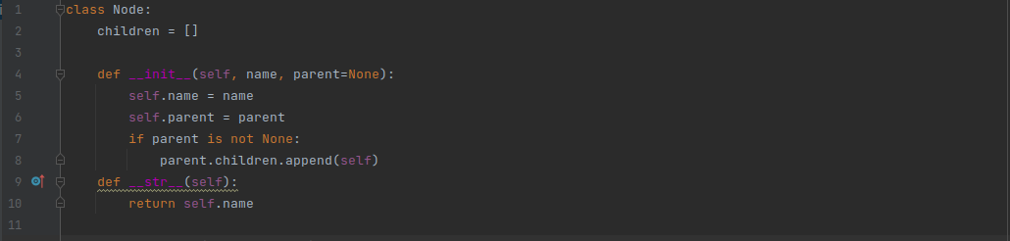
As in line no 2 the reson for Infinte Loop can be found.

FIX

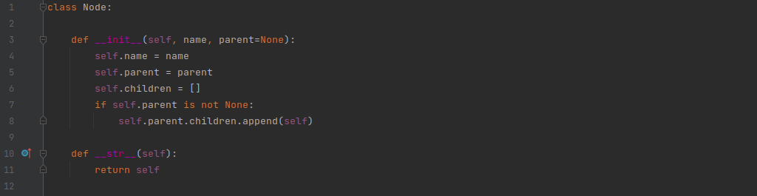
As in line no 6 the code is refractored

1 In the refractored snippet, the children list has been kept associated to the object of the children getting instantiated so the direct children of every node take place in only its parents children list hence no repeatition of functions via same arguments.

2 The Fix is done by using the self keyword which associated the member variables and member list to the a specific object ie it creates separate children list memory places for separate objects differently.

3 Now after the fix is applied the code results in a mush better finite and structured output
of a breadth first Traversal of a Tree.

