JUnit Testing
Exercise 1: Setting Up JUnit in a Java Project
Introduction
This document outlines the steps required to set up JUnit 4 in a Java project using Maven. JUnit is a widely-used framework for unit testing Java applications. This exercise demonstrates how to configure a Maven-based Java project, add JUnit dependencies, and write a simple test case.
Project Setup
Step 1: Create a New Maven Project
- Open Eclipse → File > New > Project > Maven Project
- Use archetype: maven-archetype-quickstart
- Set Group Id: com.example
- Set Artifact Id: JUnitDemo
- Finish setup

Step 2: Add JUnit Dependency
In the pom.xml add the following dependencies
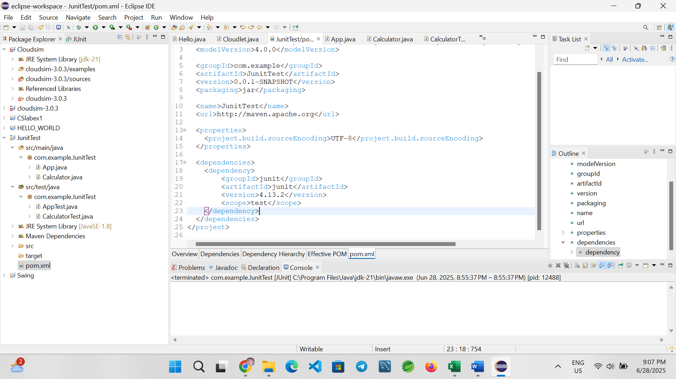
Step 4: Create java class named as Calculator.java
package com.example.JunitTest;

public class Calculator {
public int add(int a, int b) {
return a + b;
}
}
Step 4: Create Test class named as CalculatorTest.java
package com.example.JunitTest;

import org.junit.Test;
import static org.junit.Assert.*;

public class CalculatorTest {

@Test
public void testAdd() {
Calculator calc = new Calculator();
int result = calc.add(2, 3);
assertEquals(5, result);
}
}
Step 5: Running the test
- Right-click on CalculatorTest.java → Run As > JUnit Test
- You should see a green bar indicating that the test passed successfully ✅
Output:
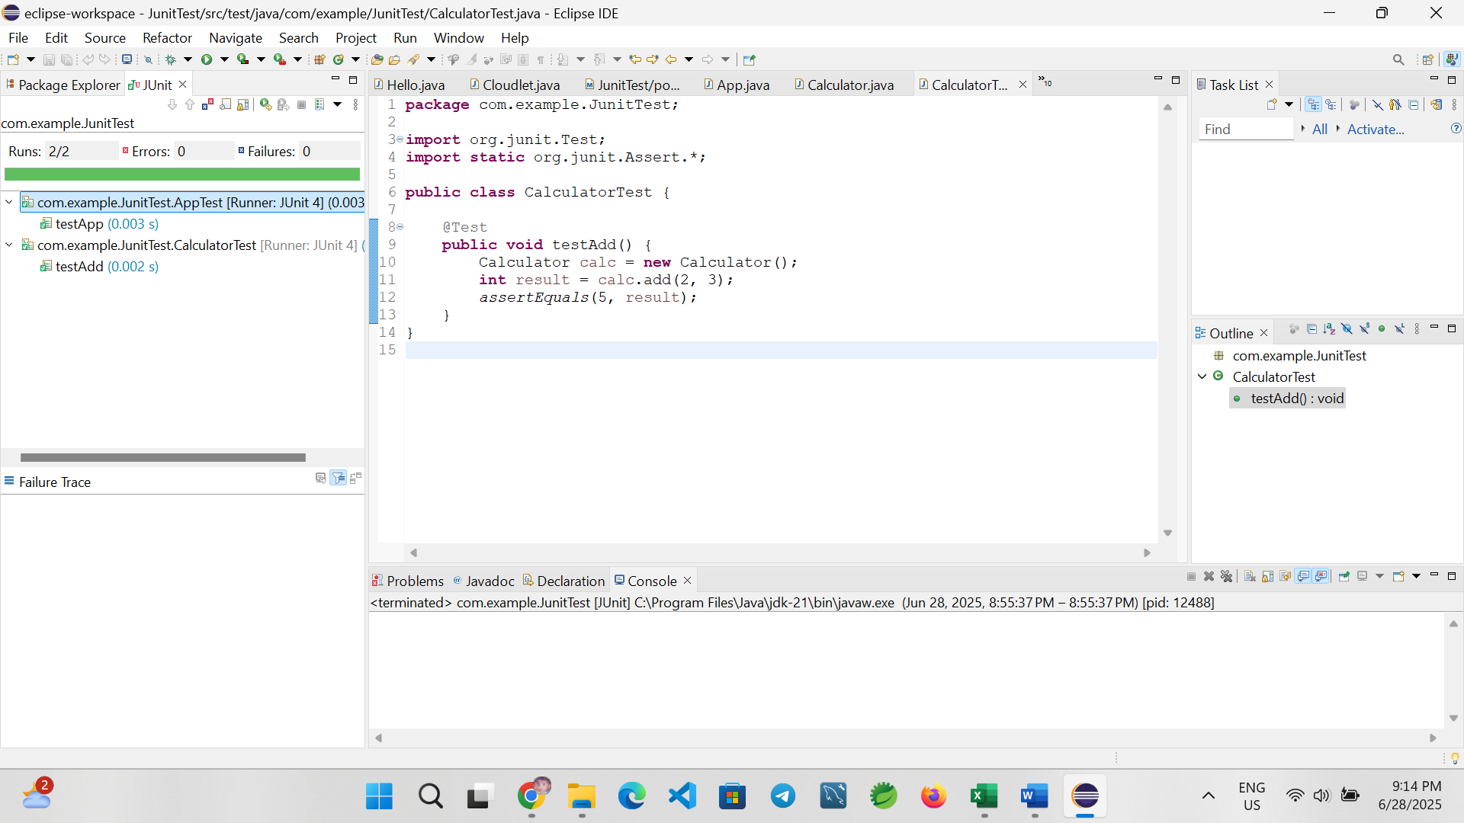

Exercise 3: Assertions in Junit
Introduction
This exercise demonstrates how to use various JUnit assertions to validate test results in Java. Assertions are essential for checking expected vs actual outcomes during unit testing.
Project Setup
Step 1: Create a New Maven Project
- Open Eclipse → File > New > Project > Maven Project
- Use archetype: maven-archetype-quickstart
- Set Group Id: com.example
- Set Artifact Id: JUnitDemo
- Finish setup
Step 2: Add dependencies in the pom.xml
Created a Maven-based Java project named AssertionsDemo and added the JUnit 4.13.2 dependency in the pom.xml.
<dependency>
<groupId>junit</groupId>
<artifactId>junit</artifactId>
<version>4.13.2</version>
<scope>test</scope>
</dependency>

Create a test class using Junit assertion
package com.example.JunitTest;
import org.junit.Test;
import static org.junit.Assert.*;
public class AssertionsTest {
@Test
public void testAssertions() {
// Assert equals
assertEquals(5, 2 + 3);
// Assert true
assertTrue(5 > 3);
// Assert false
assertFalse(5 < 3);
// Assert null
assertNull(null);
// Assert not null
assertNotNull(new Object());
}
}
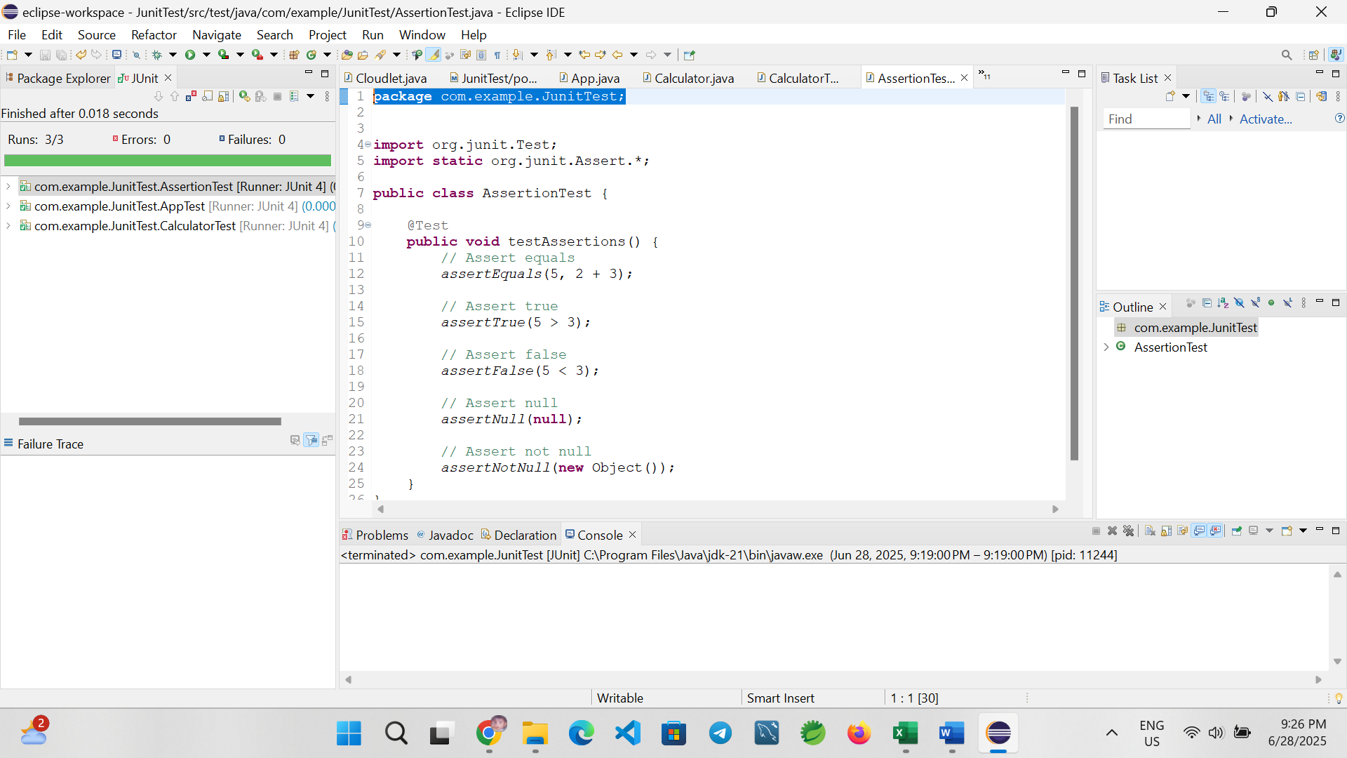
Conclusion
This exercise successfully demonstrates the use of various JUnit assertions including assertEquals, assertTrue, assertFalse, assertNull, and assertNotNull. These are foundational tools for writing effective unit tests.

Exercise 4: AAA Pattern, Setup, and Teardown
Introduction
This exercise demonstrates how to structure unit tests using the Arrange-Act-Assert (AAA) pattern and how to implement test fixtures in JUnit using @Before and @After annotations. These practices ensure tests are clean, reusable, and easy to maintain.
Project Setup
Step 1: Create Maven Project
- Open Eclipse → File > New > Maven Project
- Select archetype: maven-archetype-quickstart
- Group ID: com.example
- Artifact ID: AaaPatternDemo
- Finish
Step 2: Add JUnit Dependency in pom.xml
<dependency>
<groupId>junit</groupId>
<artifactId>junit</artifactId>
<version>4.13.2</version>
<scope>test</scope>
</dependency>
package com.example;

public class Calculator {
public int add(int a, int b) {
return a + b;
}

public int subtract(int a, int b) {
return a - b;
}
}
JUnit Test Class with AAA Pattern
package com.example;

import org.junit.After;
import org.junit.Before;
import org.junit.Test;
import static org.junit.Assert.*;

public class CalculatorTest {

private Calculator calc;

@Before
public void setUp() {
// Setup (runs before every test)
calc = new Calculator();
System.out.println("Setup: Calculator initialized");
}

@After
public void tearDown() {
// Teardown (runs after every test)
System.out.println("Teardown: Test completed");
}

@Test
public void testAdd() {
// Arrange
int a = 5, b = 3;

// Act
int result = calc.add(a, b);

// Assert
assertEquals(8, result);
}

@Test
public void testSubtract() {
// Arrange
int a = 10, b = 4;

// Act
int result = calc.subtract(a, b);

// Assert
assertEquals(6, result);
}
}
Running the Test
- Right-click CalculatorTest.java → Run As → JUnit Test
- You should see:
  - Console output showing setup and teardown logs
  - Green bar = test passed
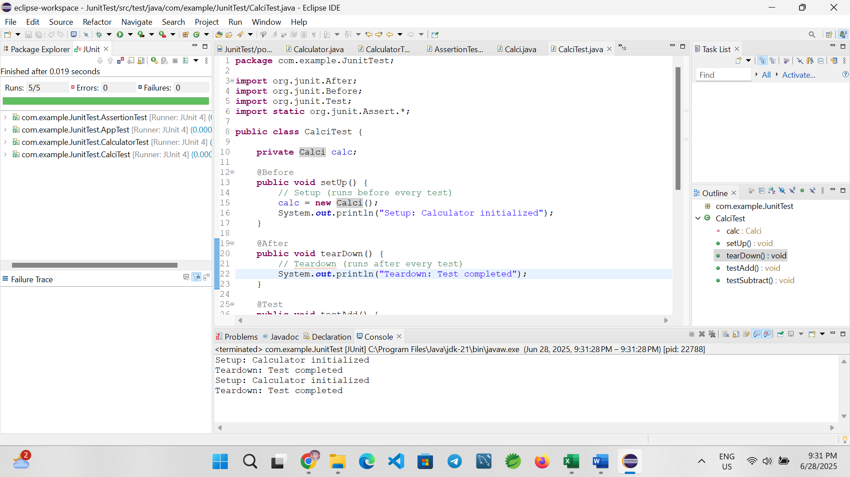

Conclusion
This exercise successfully demonstrates writing organized test cases using the Arrange-Act-Assert pattern, and managing test fixtures with @Before and @After in JUnit. This helps isolate test logic and ensures each test starts with a clean setup.

