Exercise 1: Control Structures

Introduction

This document demonstrates the use of PL/SQL control structures in Oracle by implementing three real-world banking scenarios involving customers and loans. We create the required tables, populate them with data, and execute PL/SQL blocks to meet the business requirements.

Table Design

Create CUSTOMERS table

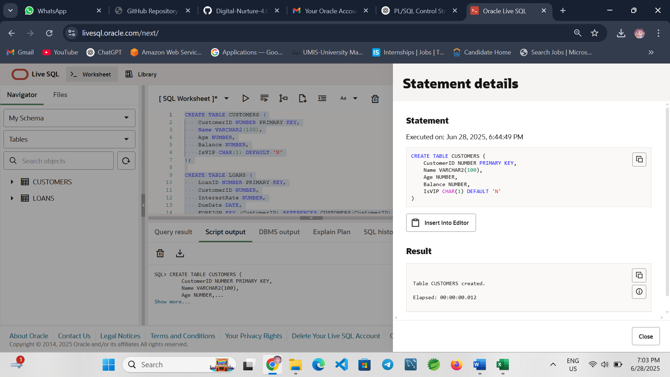

Create LOANS table

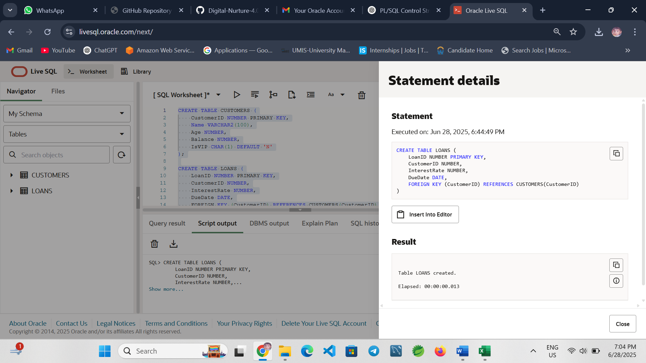

Scenario 1 – Apply Interest Discount for Customers Over 60

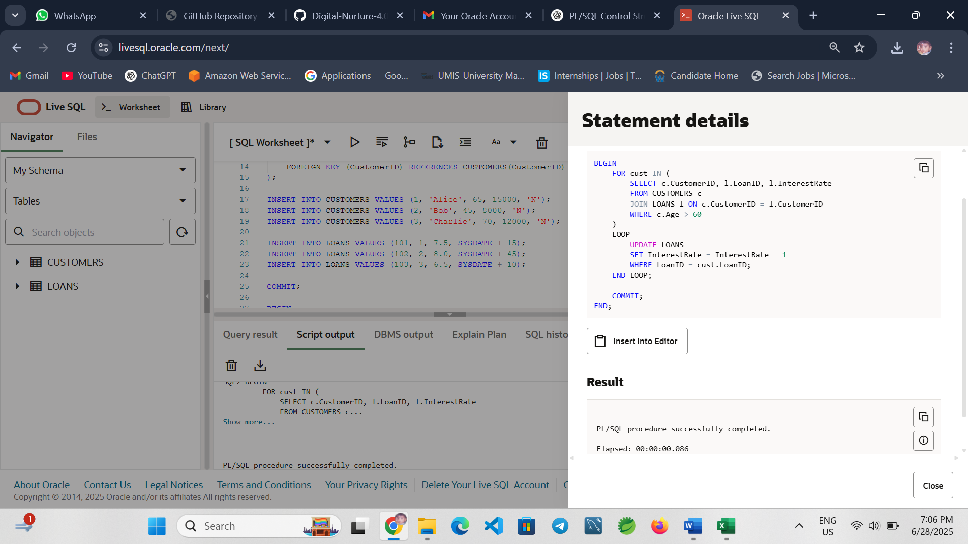
Explanation: Loops through each senior customer and applies a 1% interest rate discount.

Scenario 2 – Mark Customers as VIP Based on Balance

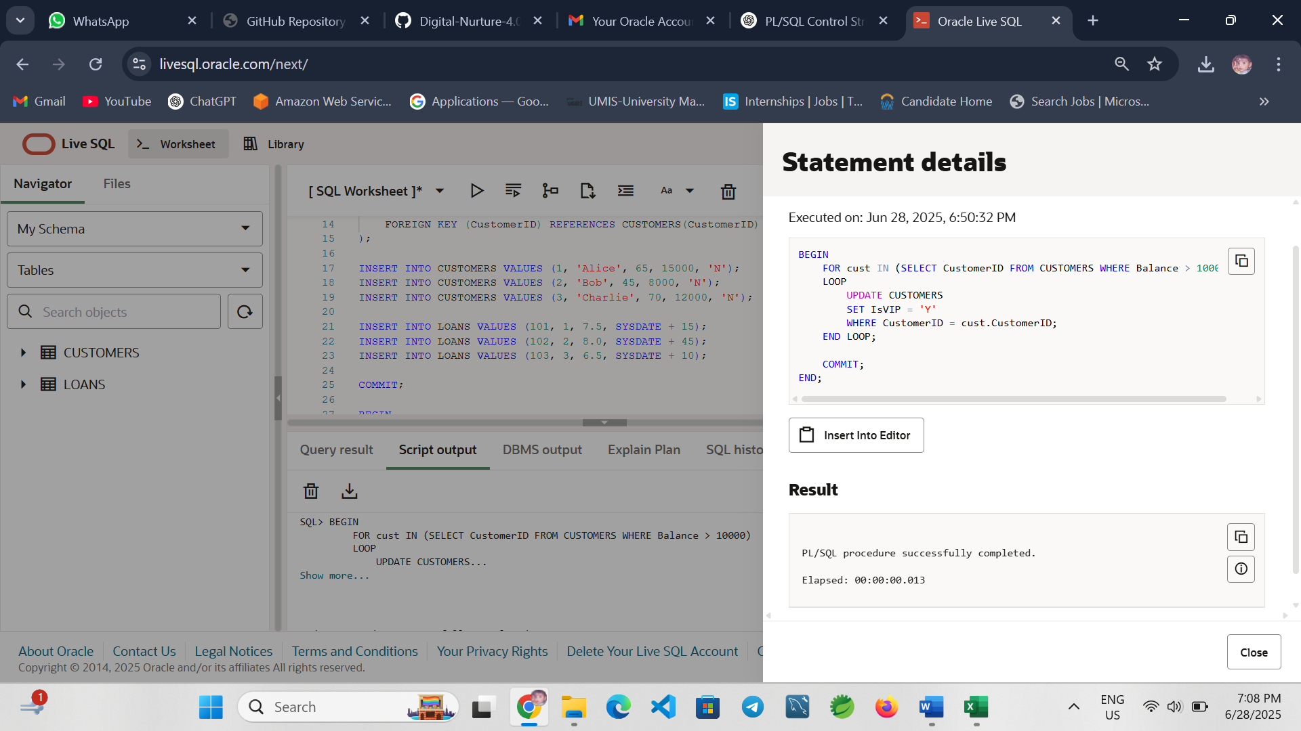
Explanation: Promotes customers with a balance greater than $10,000 to VIP status.

Scenario 3 – Send Loan Due Reminders

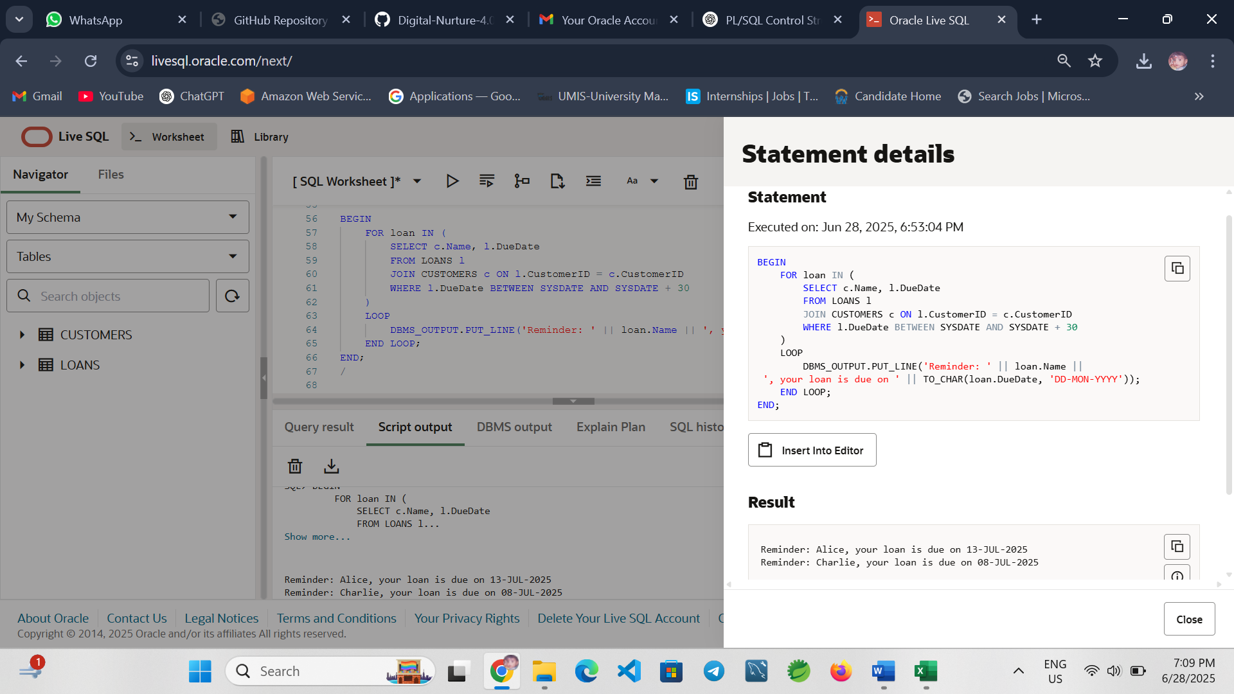
Explanation: Prints reminders for loans due in the next 30 days.
Conclusion

This exercise demonstrates the use of PL/SQL control structures like loops and conditional logic to perform real-world banking operations such as applying discounts, updating customer status, and printing reminders.

Exercise 3: Stored Procedures

Introduction

This exercise demonstrates the use of stored procedures in PL/SQL for various banking operations including interest processing, employee bonus updates, and inter-account fund transfers.

Create Necessary Tables

Savings Accounts Table
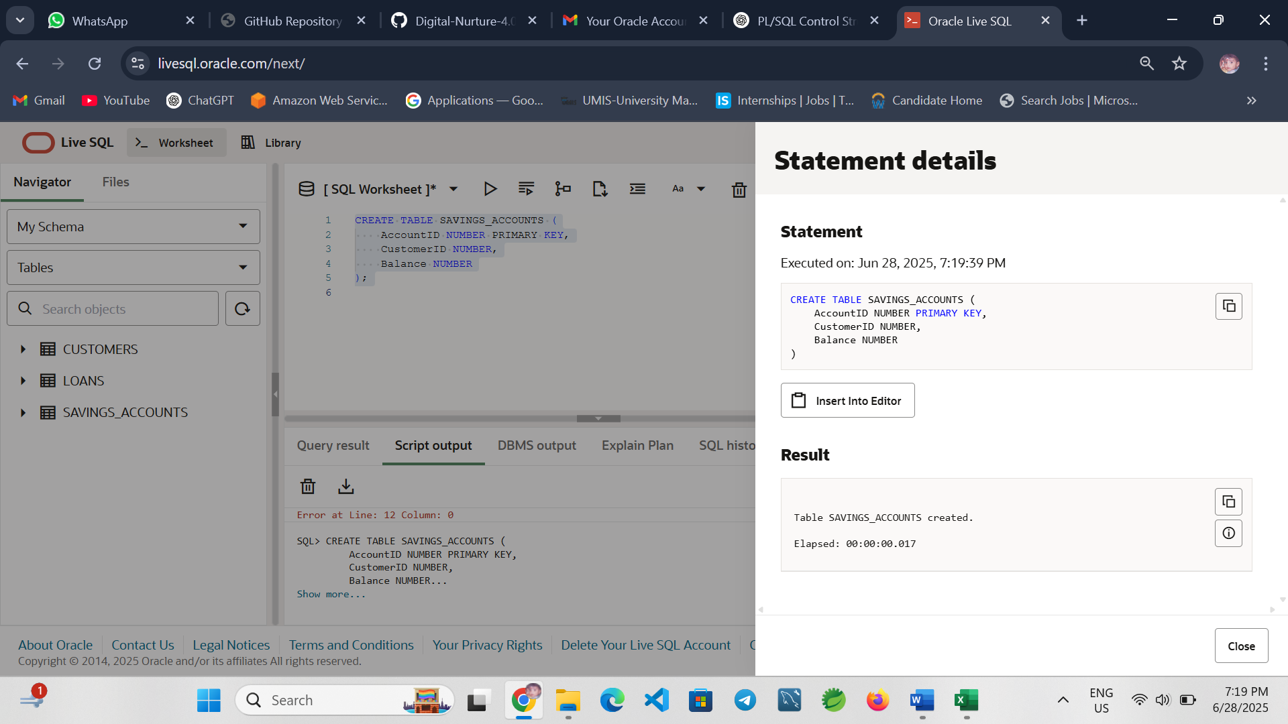

Employees Table
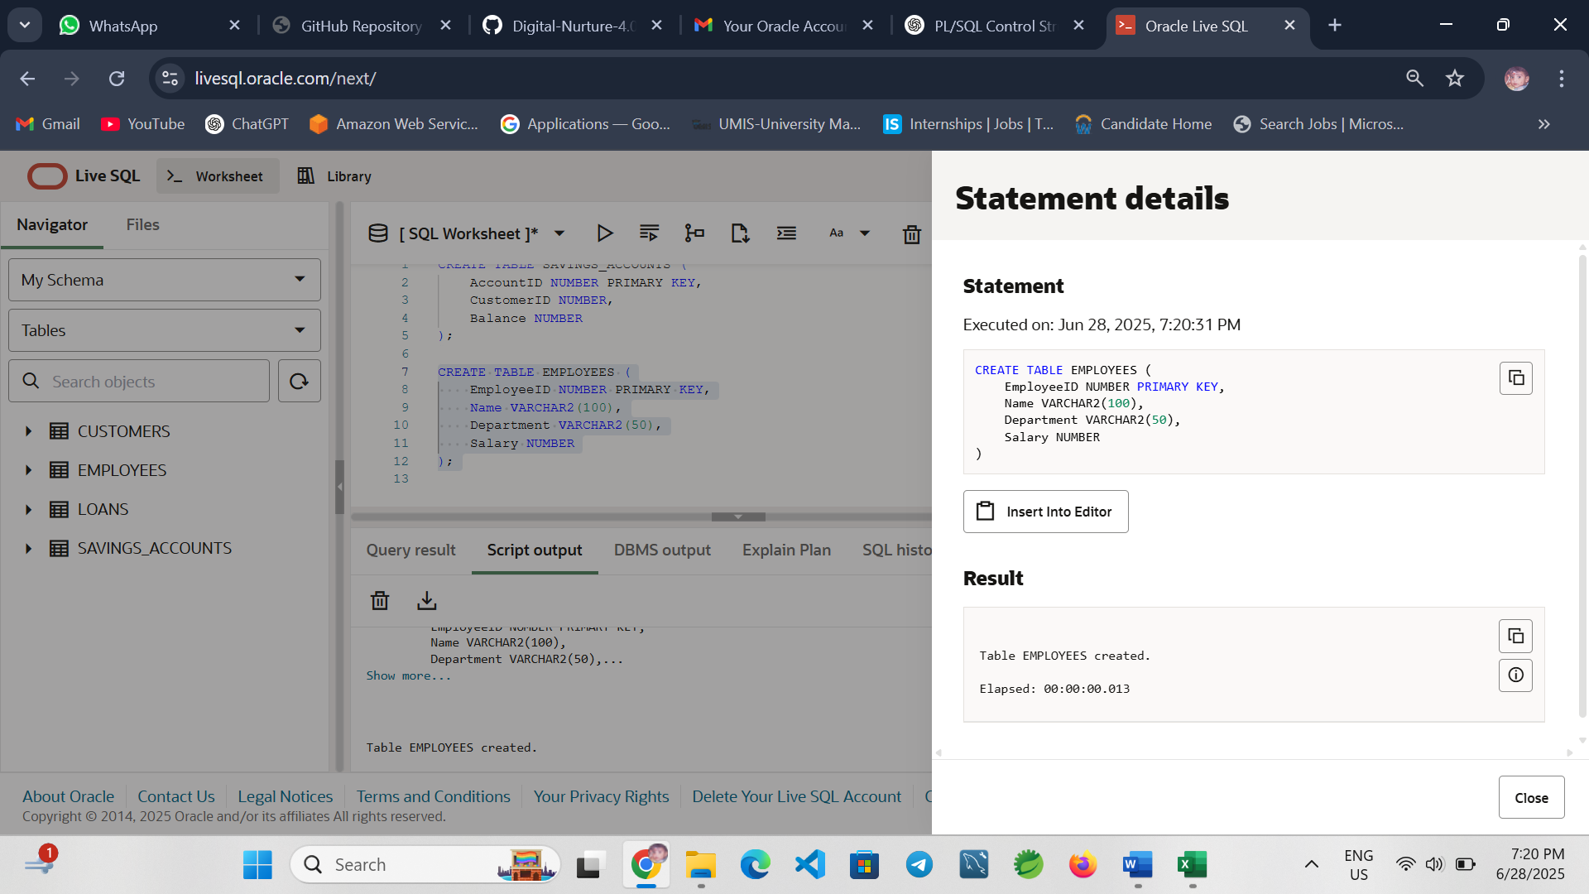

Accounts Table for Fund Transfer
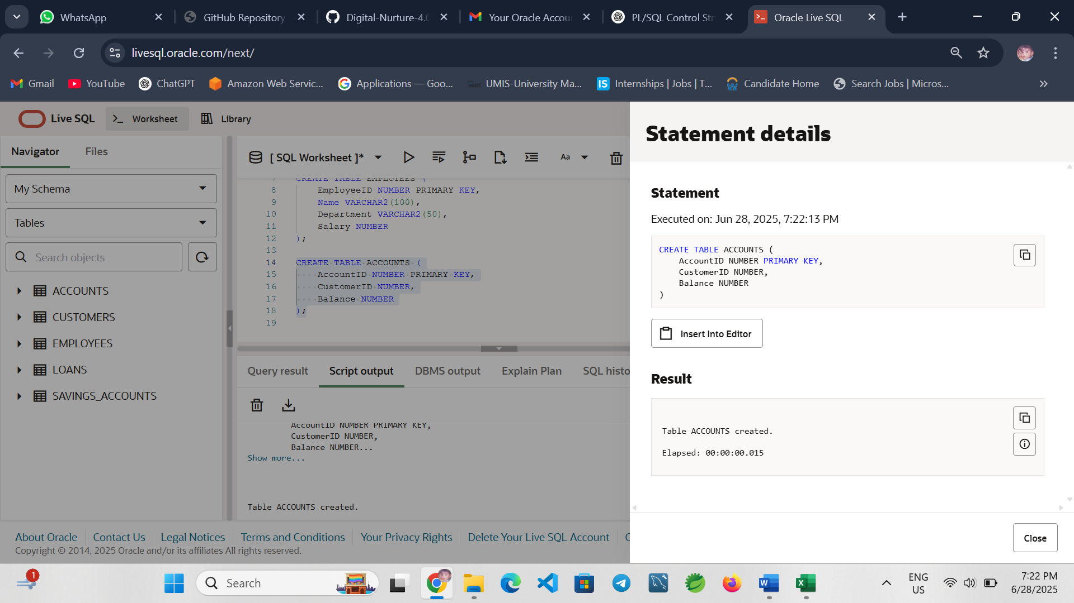

Write Stored Procedures

Scenario 1: ProcessMonthlyInterest
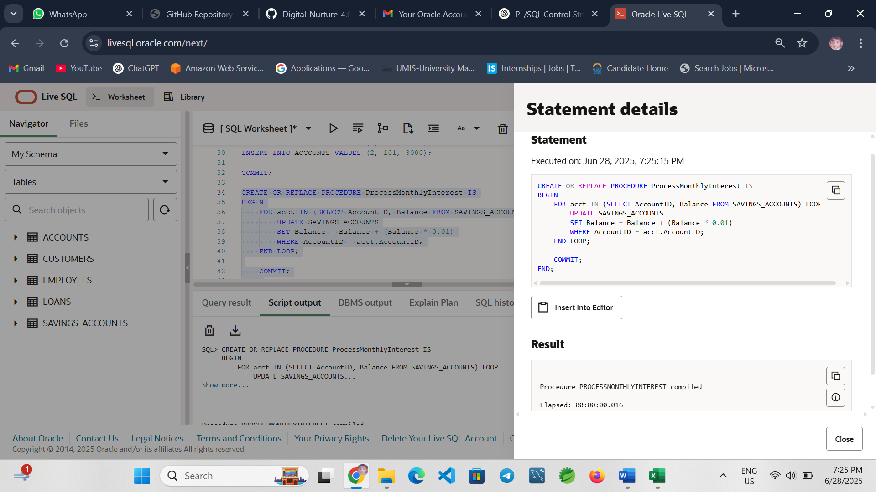
Explanation: Adds 1% interest to each savings account balance.

Scenario 2: UpdateEmployeeBonus
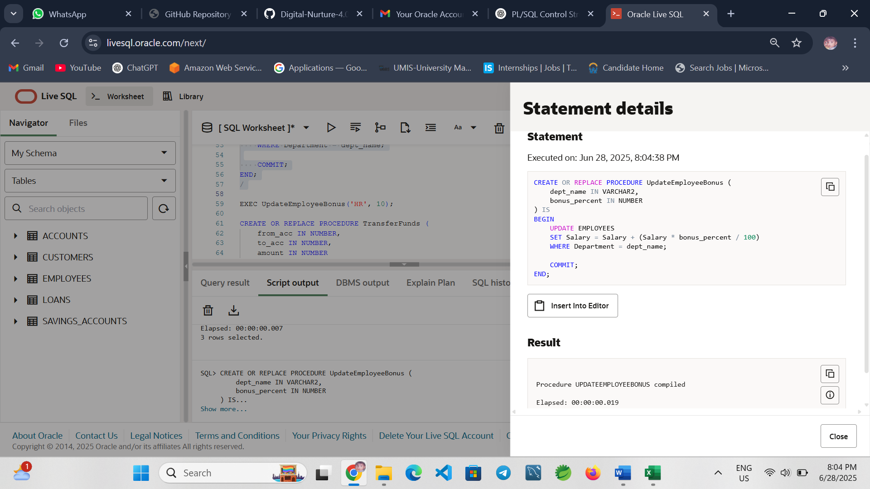
Explanation: Adds a percentage bonus to salaries in the given department.
Scenario 3: TransferFunds
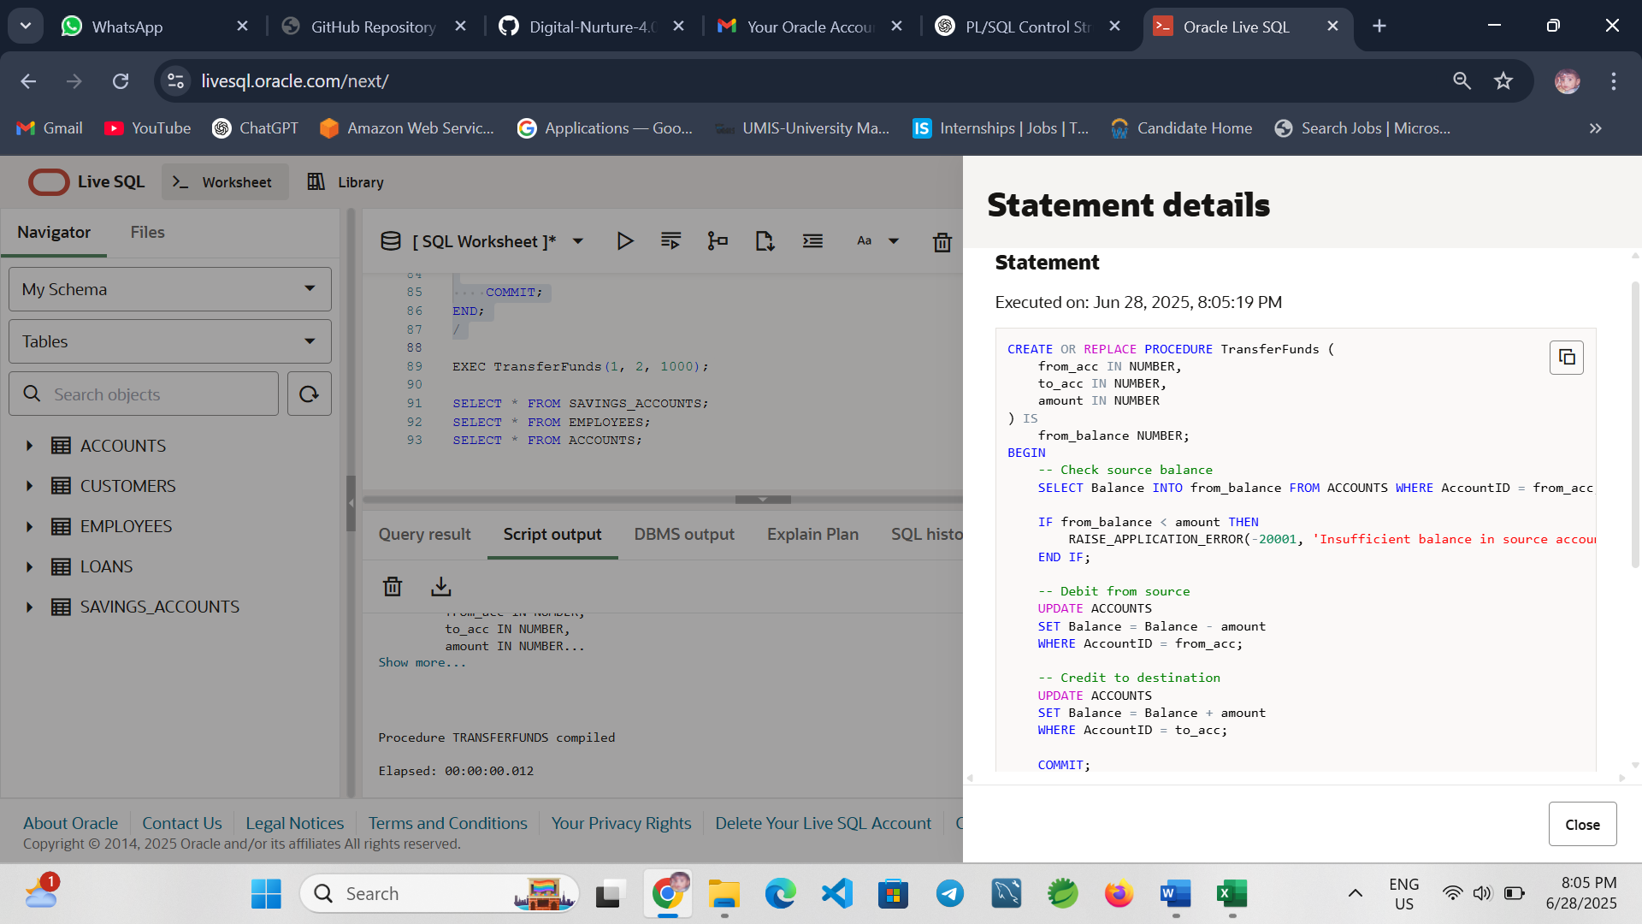

Conclusion
This exercise demonstrated how PL/SQL stored procedures can automate key banking tasks like applying interest, updating employee bonuses, and transferring funds securely. These procedures improve efficiency, maintain data integrity, and support scalable banking operations.

