1Install docker   
 copy first and second command.....

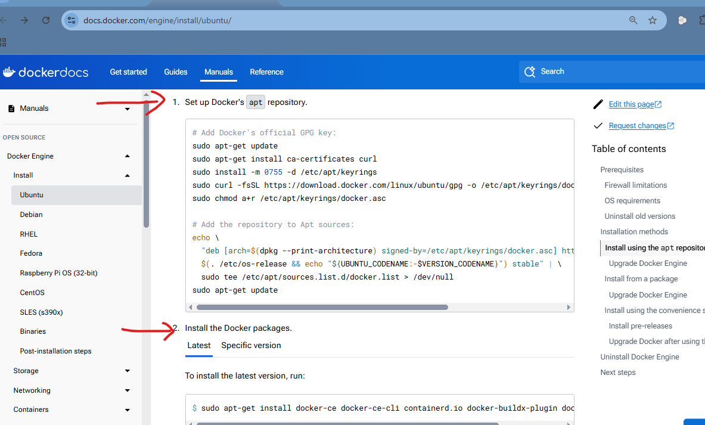

2...Scroll down

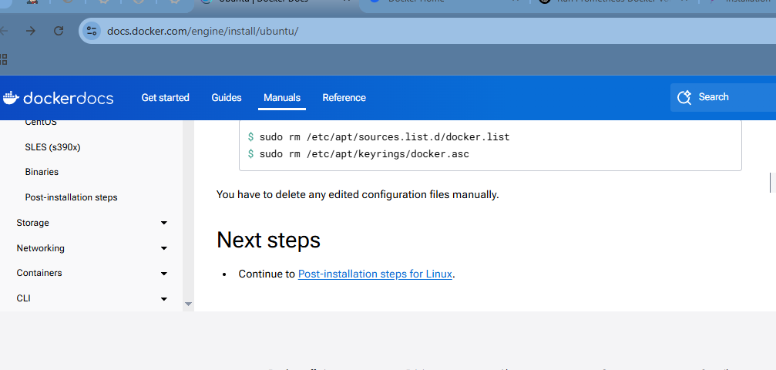

3...Install 3 commands.....

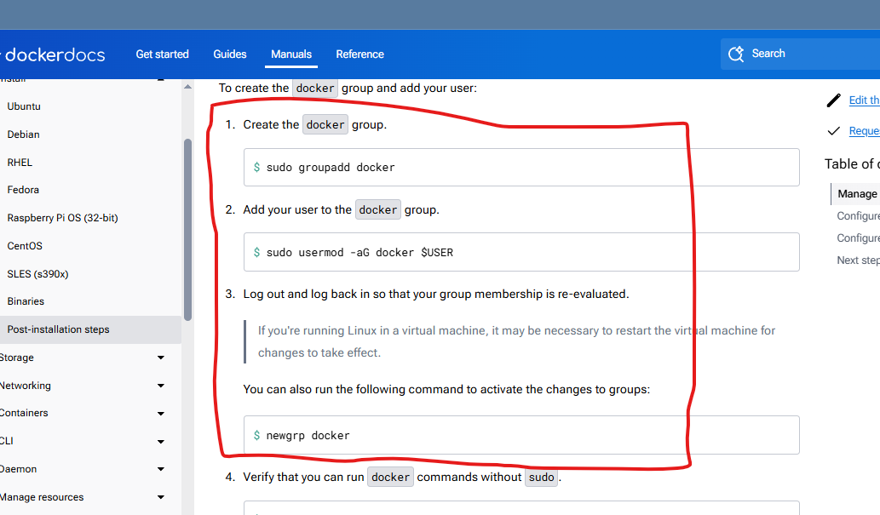

4........i nstalll maven... in command line.....

sudo apt install maven –y......

5....Go to manage jenkins > credentials > add credentials and enter

Username of your dockerhub and generated token ....in password....

Id ---- ----docker-token...

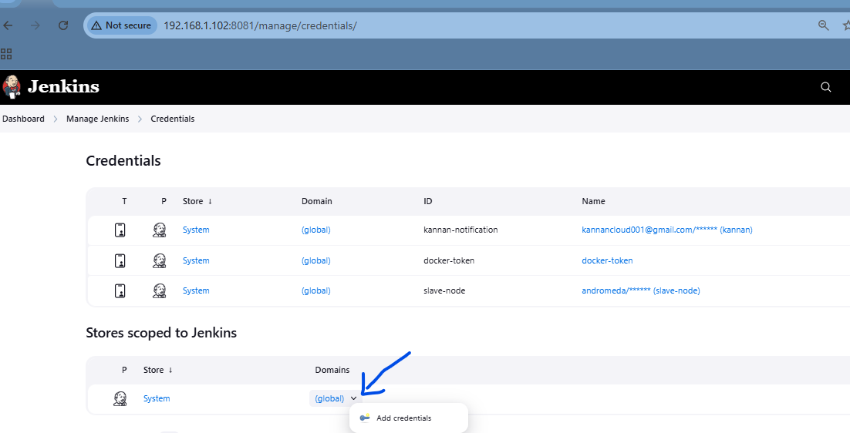

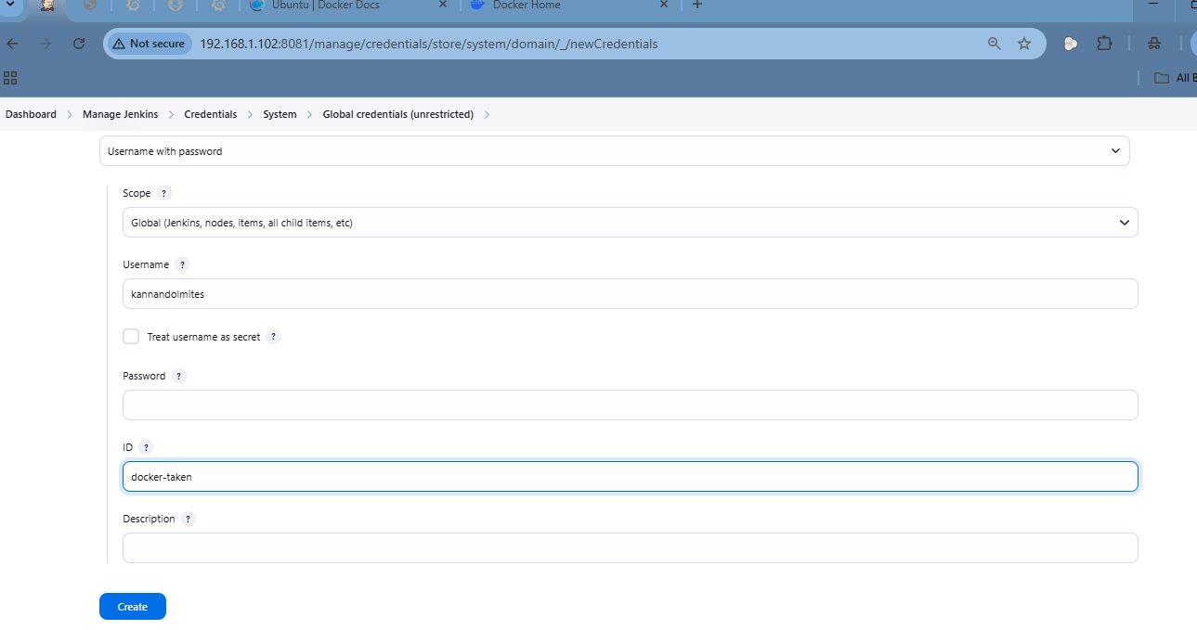

6.....Generate token in dockerhub....

7......Account settins >> personal access token >>

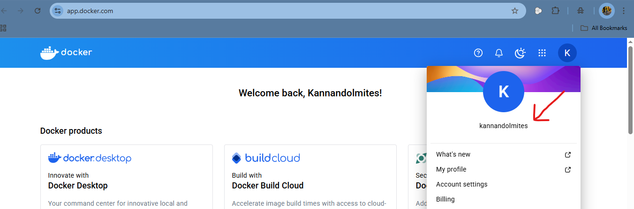

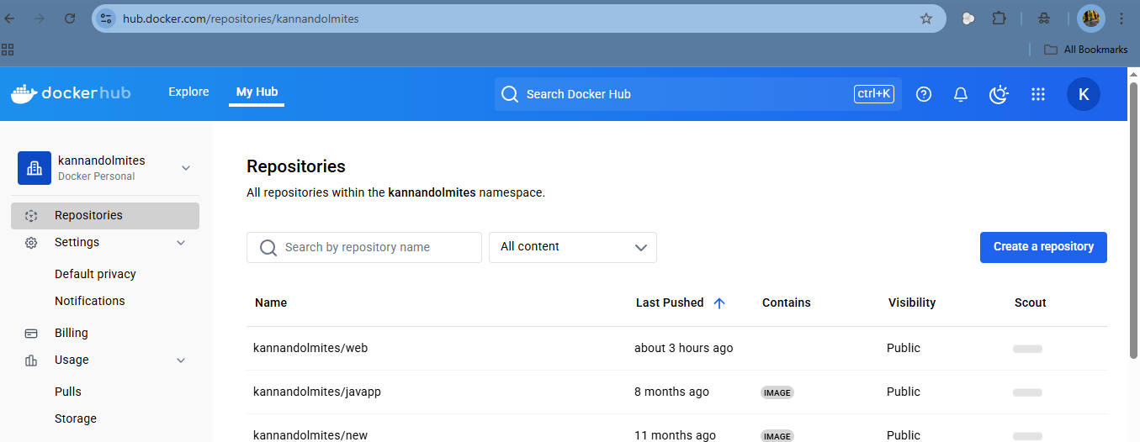

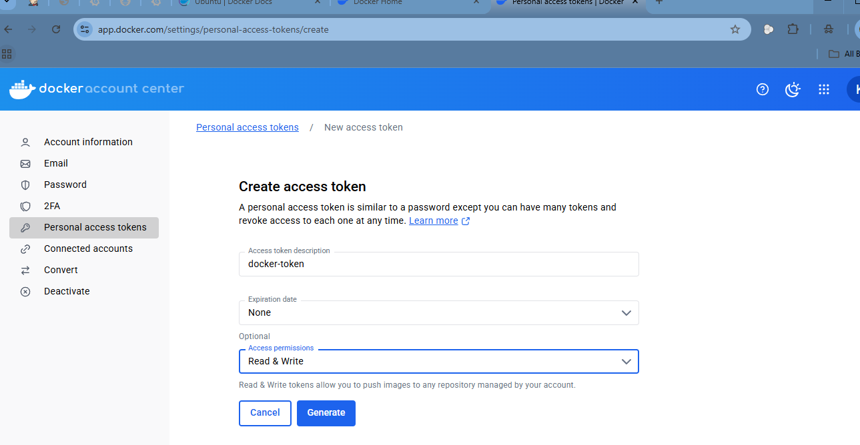

8....Create pipeline job and Copy and paste in pipeline box....

pipeline {

agent any

environment {  
 DOCKERHUB_CREDENTIALS = credentials('docker-token')  
 APP_NAME = "kannandolmites/kannan"   
}  
  
stages {   
 stage('SCM Checkout') {  
 steps {  
 git branch: 'main', url: 'https://github.com/lily4499/lil-node-app.git'  
 }  
 }  
   
 stage('Build docker image') {  
 steps {   
 sh 'docker build t $APP_NAME:$BUILD_NUMBER .'  
 }  
 }  
   
 stage('login to dockerhub') {  
 steps {  
 sh 'echo $DOCKERHUB_CREDENTIALS_PSW | docker login -u $DOCKERHUB_CREDENTIALS_USR --password-stdin'  
 }  
 }  
   
 stage('push image') {  
 steps {  
 sh 'docker push $APP_NAME:$BUILD_NUMBER'  
 }  
 }  
}

9.....And one more curly braces in last ....

like tis....



