Tasksnap Journal - A Productivity Tracker 2.0

BITS ZC4999T: Capstone Project

by

Saipa Abhinaya

202117bh109

Capstone Project work carried out at

HCLTech, Nagpur



BIRLA INSTITUTE OF TECHNOLOGY & SCIENCE

PILANI (RAJASTHAN)

Ocotber 2025

Birla Institute of Technology & Science, Pilani

Work-Integrated Learning Programmes Division

BITS ZC499T: Capstone Project Pre Final Evaluation Sheet

Bits ID: 202117bh109
Student Name: Saipa Abhinaya
Email Address: 202117bh109@wilp.bits-pilani.ac.in
Employing Organization & Location: HCLTech, Nagpur

Mentor Name:
Email Address:
Employing Organization & Location: HCLTech, Lucknow

Capstone Project Title: Tasksnap Journal - A Productivity Tracker 2.0

Capstone Project Final Evaluation (Please put a tick ( ) mark in the appropriate box)

S No. | Evaluation Component | Excellent | Good | Fair | Poor
1. | Final Capstone Project Report
2. | Final Seminar and Viva-Voce

S.No. | Evaluation Criteria | Excellent | Good | Fair | Poor
1 | Technical/Professional Competence
2 | Work Progress and Achievements
3 | Documentation and expression
4 | Initiative and Originality
5 | Research & Innovation
6 | Relevance to the work environment

Please ENCIRCLE the Recommended Final Grade: Excellent / Good / Fair / Poor

Remarks of the Mentor: Very innovative application.

DETAILS OF EXAMINER AND MENTOR
 | Mentor | Additional Examiner
Name | Suresh | Savita
Qualification | MCA | BEE(E)
Designation | Consultant | Senior Specialist
Employing Orgn and Location | HCLTech, Banglore | HCLTech, Banglore
Phone No.  (with STD Code) | +91-9916243495 | +91- 8904515927
Email Address | suresh.mamillapalli@hcltech.com | savita.khanapeth@hcltech.com
Signature |  | 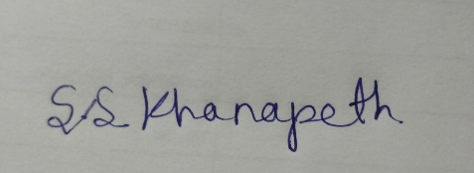
Date | 03/10/2025 | 03/10/2025

